Mapping scientific communities at scale
Hafsa Aallat¹
February 2025
¹ French Ministry of Higher Education and Research, Paris, France
Keywords: French publications, IPCC, IPBES, Machine learning, NLP, open data, open source, scanR, OpenAlex

1. Motivation

1.1 Presentation of IPCC and IPBES: Working Groups and dates
The IPCC (Intergovernmental Panel on Climate Change) assesses scientific information on climate change, providing reports to guide policymakers. It has three working groups sees as three main topics :
- Working Group I (WGI) focuses on the physical science of climate change.
- Working Group II (WGII) examines climate change impacts, adaptation, and vulnerabilities.
- Working Group III (WGIII) addresses climate change mitigation strategies.
The Sixth Assessment Report (AR6) was released in stages between 2021 and 2022.
The IPBES (Intergovernmental Science-Policy Platform on Biodiversity and Ecosystem Services), established in 2012, assesses biodiversity and ecosystem services. It produces thematic and regional assessments, with the Global Assessment Report (2019) highlighting biodiversity loss and the need for urgent action.
Both platforms provide crucial scientific assessments that inform global climate and biodiversity policies.

1.2 Limits of the French Court of Audit study
In 2023, the French Court of Audit conducted a study on France’s scientific output related to environmental transition. After hearings with the Directorate General for Research and Innovation (DGRI) and research operators, the Court analyzed the bibliography cited in the sixth IPCC report. The study found that French publications are the most cited in the physical sciences of climate change, highlighting the global impact of French research in this field.
However, this evaluation has important limitations. The IPCC bibliography is based on high-impact publications often from top journals, making it quite selective. This selection prioritizes more visible and well-known works, leaving out other important research that may not be as visible but still in the same topics as IPCC report. While this reflects France’s scientific excellence, it does not fully represent the diversity of French scientific contributions to ecological transition.

1.3 How can we explore and recognize french publications related to the same topics as IPCC and IPBES report from a global point of view ?
To fill this gap, we propose using a larger dataset, such as scanR. ScanR has a significantly higher coverage of publications with at least one French affiliation compared to other sources, contributing 92% to the overall aggregated corpus. This is much higher than databases like Scopus (67%), WoS (58%), or PubMed (29%), making ScanR a more comprehensive tool for capturing French scientific publications (Chaignon and Egret 2022). Unlike the IPCC’s restricted approach, ScanR includes publications with at least one French affiliation, showing a larger view of research. This could allow us to capture a more diverse range of topics related to climate change physical science, adaptation and mitigation.
Initially, we will replicate the Court of Audit analysis of the IPCC bibliography to identify the main topics and their proportion of French contributions. Then, we will expand our study to know the top institutions, labs, regions, and researchers that provide solutions to the challenges of environemental transition in France, based on IPCC bibliography. In a second time, we will create a model that can recognize a publication about IPCC similar topics, and apply the model to scanR publications. At the same time, we will conduct a similar analysis for the IPBES bibliography, following the same approach to identify the French contributions, and exploring less visible but valuable research related to biodiversity and ecosystem services.

2. IPCC and IPBES Bibliography Analysis and Model
We propose a method to analyze the bibliographies of IPCC and IPBES reports.

2.1 Data Collection and Cleaning
For each report, we collect the references:
- For IPCC report, we collect citations in .bib format for each chapter of each working group (n.d.a).
- For IPBES report, we gather all citations via Zotero (n.d.b).
Once the data is collected, we clean the DOI (Digital Object Identifier) of each publication. The DOI should follow a specific format starting with ‘10.’. Any publication without a valid DOI is not considered.

2.2 Data Enrichment
After cleaning, the data contains features such as DOI, title, and main author. However, we still lack information such as institutions, researchers, countries, and topics associated with each publication. To fill in the gap, we enrich the data by importing additional features from OpenAlex for each publication with a valid DOI. These features include: countries, year, topics, title, author names, institutions, RORs (Research Organization Registry) and journals.
OpenAlex is an international open-access database that provides metadata on research papers, authors, journals, and institutions. It aims to make academic information more accessible and supports data analysis and knowledge discovery in various fields. OpenAlex is a valuable tool for researchers and educators. We use the Api to import the features.
Next, we use the Biblioglutton Python library to fill in missing DOIs based on the title and main author. We also verify that the year retrieved from OpenAlex matches the year in the original dataset.

2.3 Data storage and visualization
Once the data is enriched with openAlex features, we edit the data and push them on a cluster elastic-search. As an exemple, for one publication (for a better visibility the data is troncated). Some publications are used by both reports, with the following keys:
{
"doi": "10.1126/science.aaw6974",
"year": "2018",
"title": "Impacts of 1.5 °C global warming on natural and human systems",
"rors": [
["https://ror.org/00rqy9422", "AU"],
["https://ror.org/03ztgj037", "DE"],
["https://ror.org/05sbt2524", "FR"],
["..."]
],
"ipcc": [
{ "name": "wg1_chap_01", "wg": "1", "chap": 1 },
{ "name": "wg2_chap_01", "wg": "2", "chap": 1 },
{ "name": "wg2_chap_02", "wg": "2", "chap": 2 },
{ "name": "wg2_chap_04", "wg": "2", "chap": 4 },
{ "name": "wg2_chap_07", "wg": "2", "chap": 7 },
{ "name": "wg2_chap_08", "wg": "2", "chap": 8 },
{ "name": "wg2_chap_12", "wg": "2", "chap": 12 },
{ "name": "wg2_chap_13", "wg": "2", "chap": 13 },
{ "name": "wg2_chap_14", "wg": "2", "chap": 14 },
{ "name": "wg2_chap_15", "wg": "2", "chap": 15 },
{ "name": "wg2_chap_16", "wg": "2", "chap": 16 },
{ "name": "wg2_cross_chap_1", "wg": "2_cross", "chap": 1 },
{ "name": "wg2_cross_chap_4", "wg": "2_cross", "chap": 4 },
{ "name": "wg3_chap_01", "wg": "3", "chap": 1 },
{ "name": "wg3_chap_04", "wg": "3", "chap": 4 }
],
"authors_name": [
["Ove Hoegh‐Guldberg", ["AU"]],
["Daniela Jacob", ["DE"]],
["Michael A. Taylor", ["JM"]],
["..."]
],
"institutions_names": [
["University of Queensland", "AU"],
["German Climate Computing Centre", "DE"],
["University of the West Indies", "JM"],
["..."]
],
"countries": ["CHN", "GBR", "FRA", "..."],
"ipbes": [{ "chapter": "4" }],
"topics": [
"Impact of Climate Change on Human Migration",
"Geoengineering and Climate Ethics",
"Economic Implications of Climate Change Policies"
]
}
After that we used Highcharts, a graphic tool to visualize the graphs. At the same time, we plot the graphs also with python by making elastic-search requests.

2.4 Create a database
In the enriched database derived from the IPCC and IPBES publications, each publication is associated with the following attributes:
- A unique identifier (DOI)
- The publication year
- A title that best summarizes the publication
- The main topics covered by the publication: publications in OpenAlex are tagged with Topics using an automated system that takes into account the available information about the work, including title, abstract, source (journal) name, and citations
- The names of the journals in which the publication was published
Out of the 53,258 IPCC publications available on OpenAlex, only 48,219 have non-empty titles, topics, and journal names.
The goal is to identify these 48,219 publications that are not cited by the IPCC to form our training dataset. After the analysis phase, we were wondering how to make a database with data from IPCC bibliography and data from other subjects than IPCC topics.
Initially, we explore the data from the reports and analize:
- Their temporal distribution
- The main topics
- The main journals were the publications are released
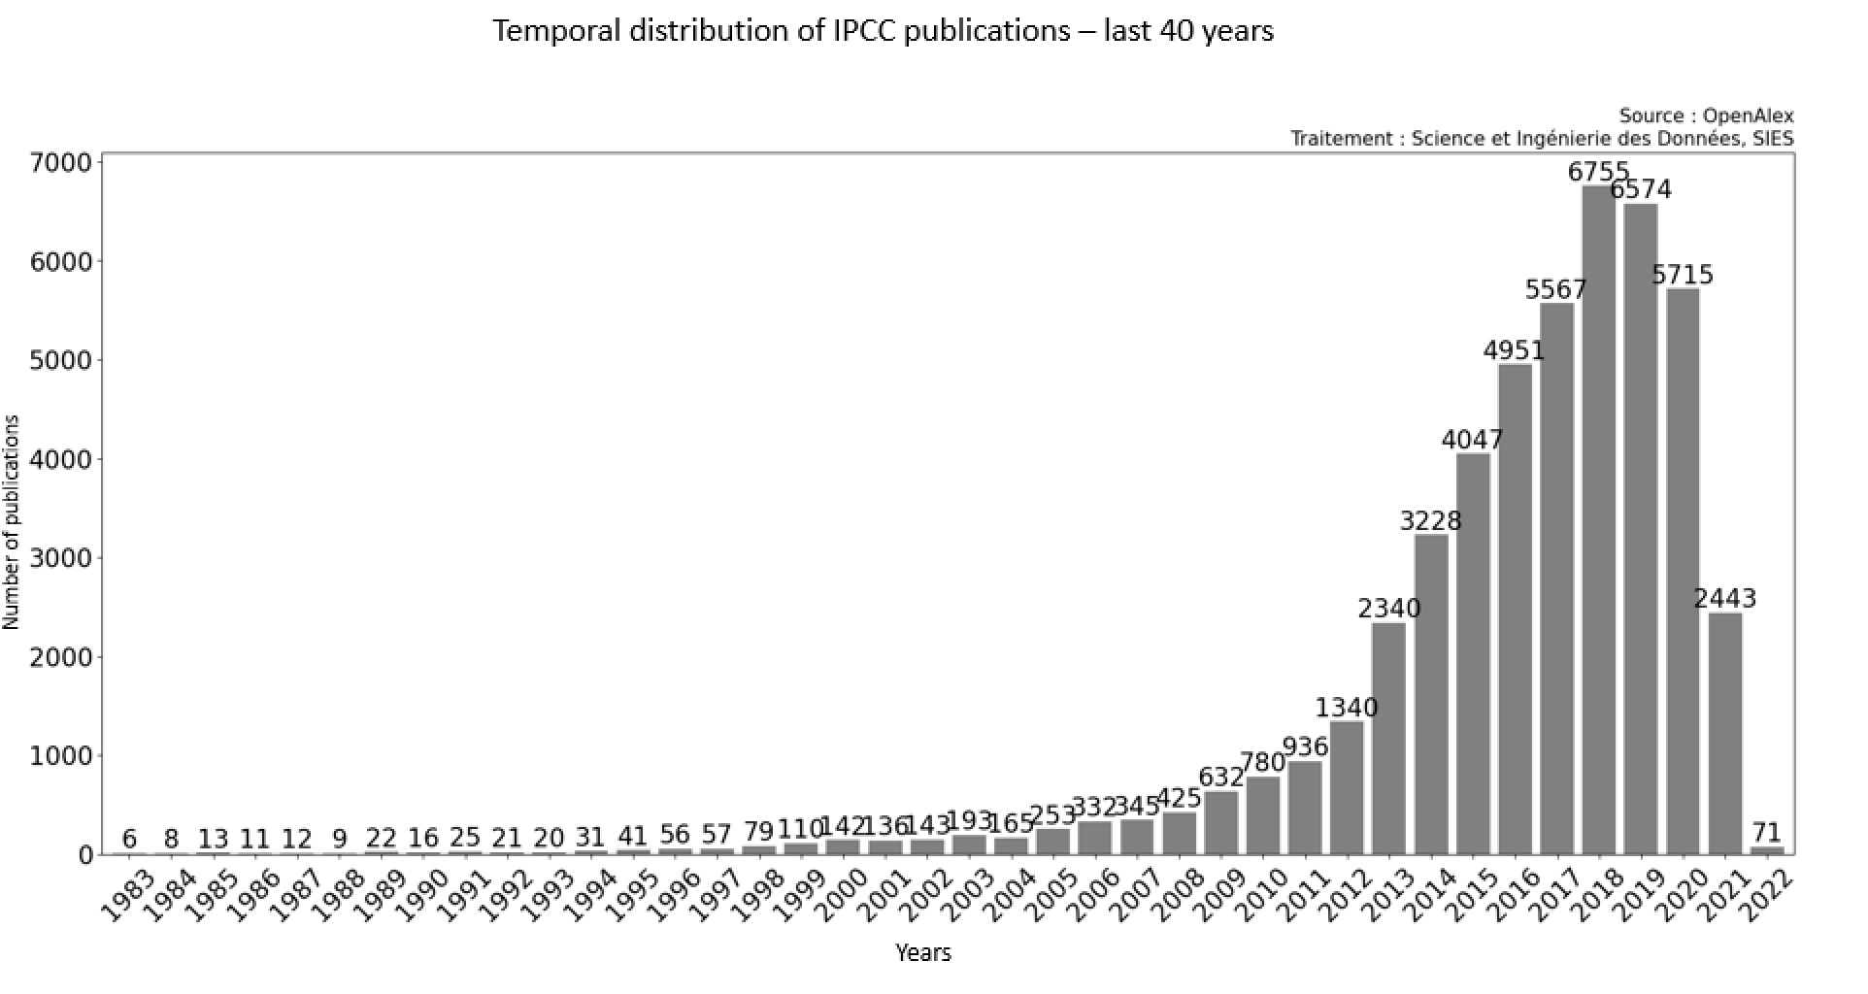 Temporal distribution of French IPCC publications.
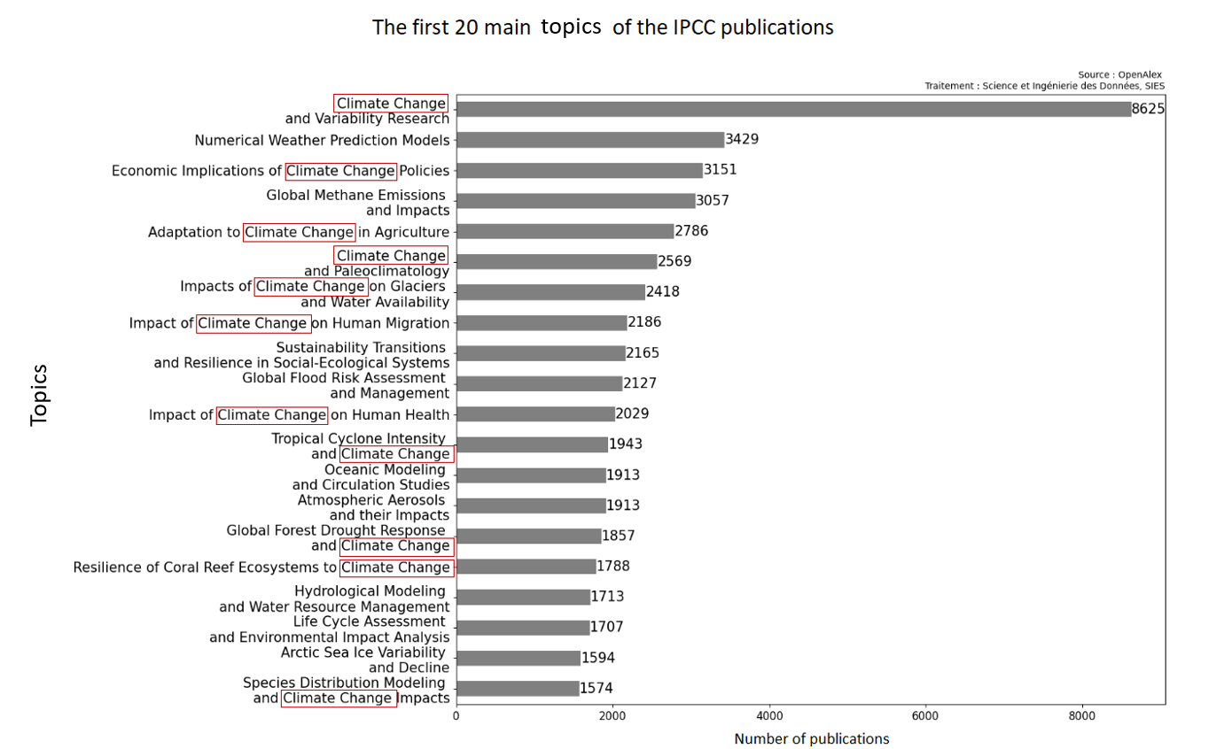 Topics distribution of French IPCC publications.
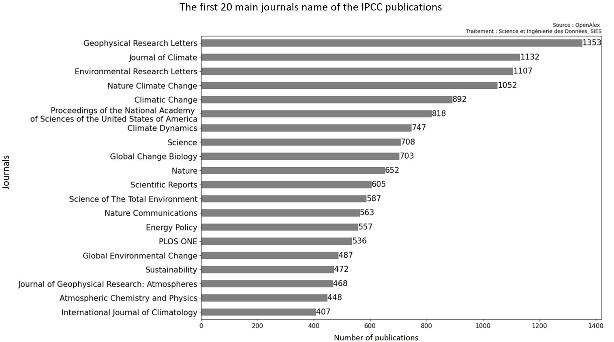 Journals distribution of French IPCC publications.
We conclued that the publications from the reports are recents, less than 10 years old for 90% of them. Some keywords seems to appear frequently, like “Climate Change” and IPCC publications are mainly released by scientific journals.
Using the OpenAlex API, we found 48,219 publications that meet the following criteria:
- Publications that are not cited by the IPCC.
- Publications that do not contain specific terms according to the top topics, such as “climate change” or “environmental impact” in their topics, ensuring that our model remains unbiased.
- Publications that have a global temporal distribution equivalent to the IPCC’s cited publications. For example, in 2018, there were 6,755 publications cited by the IPCC, so we retrieve 6,755 publications from OpenAlex that exclude certain topics. This process is repeated for each year in the temporal distribution of IPCC publications.
We conduct the exact same method for the IPBES report.

2.5 Train the model
Once the dataset is complete, we split it in two:
- 80% of data will be used to train the model
- 20% will be used as a test base
To train the model, we use fasttext. FastText is a library developed by Facebook AI Research for learning word representations and text classification. Unlike Word2Vec, FastText breaks words into subwords, improving its ability to handle rare or out-of-vocabulary words. It’s fast, efficient, and supports multilingual models, making it ideal for various natural language processing tasks like sentiment analysis and text classification.
Fasttext enable to vectorize and apply a linear regression on the data. We try 2 kind of model:
- a model that determine if a publication is align with the same topics as the IPCC or IPBES report.
- a model to be applied only to “IPCC-like” publications, to determine the most relevant working group and identify whether the publication focuses on physical science, adaptation, or mitigation.

2.6 Comparative analysis of country contributions to IPCC Reports
In the first part of our analysis, we examined the publications from IPCC reports and compared the contributions of different countries. Now, we want to evaluate these contributions from a global perspective.
To simplify the process, we apply filters, as using the initial model (IPCC-like vs. non-IPCC) proves to be too resource-intensive. Instead, we focus on a easier approach.
We begin by analyzing French publications tagged as “IPCC-like” in ScanR by using the model. We identify the topics and frequently appearing words in the titles and abstracts of publications related to the IPCC reports. Based on this analysis, we establish filters to apply to a sample that is 42 times larger than ScanR: OpenAlex.

3. Results

3.1 France in the publications cited by the IPCC Reports

French publications cited by the IPCC and IPBES
A total of 3,925 French publications are cited in the IPCC reports out of a total of 53,258 publications. This represents 7.4% of the total publications cited. France holds the 7th position in the ranking, just behind Canada and China.
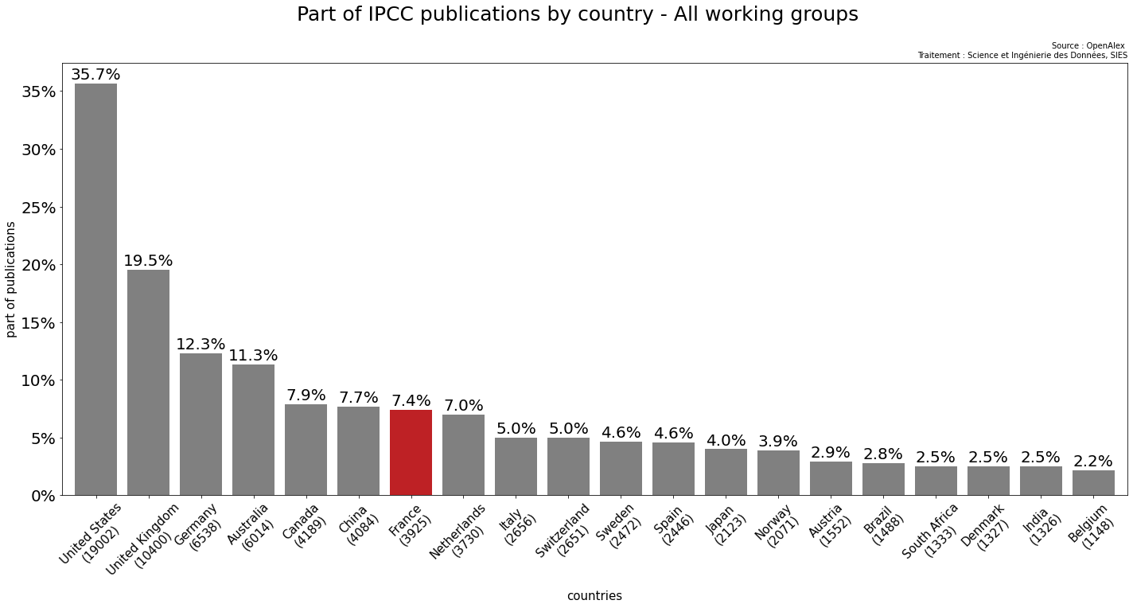 Part of IPCC publications by country for all working groups.
In the IPBES reports, 458 French publications are cited out of a total of 6106. This represents 7.5% of the total publications cited. France holds the 7th position as well in the ranking, just behind Germany and Netherlands.
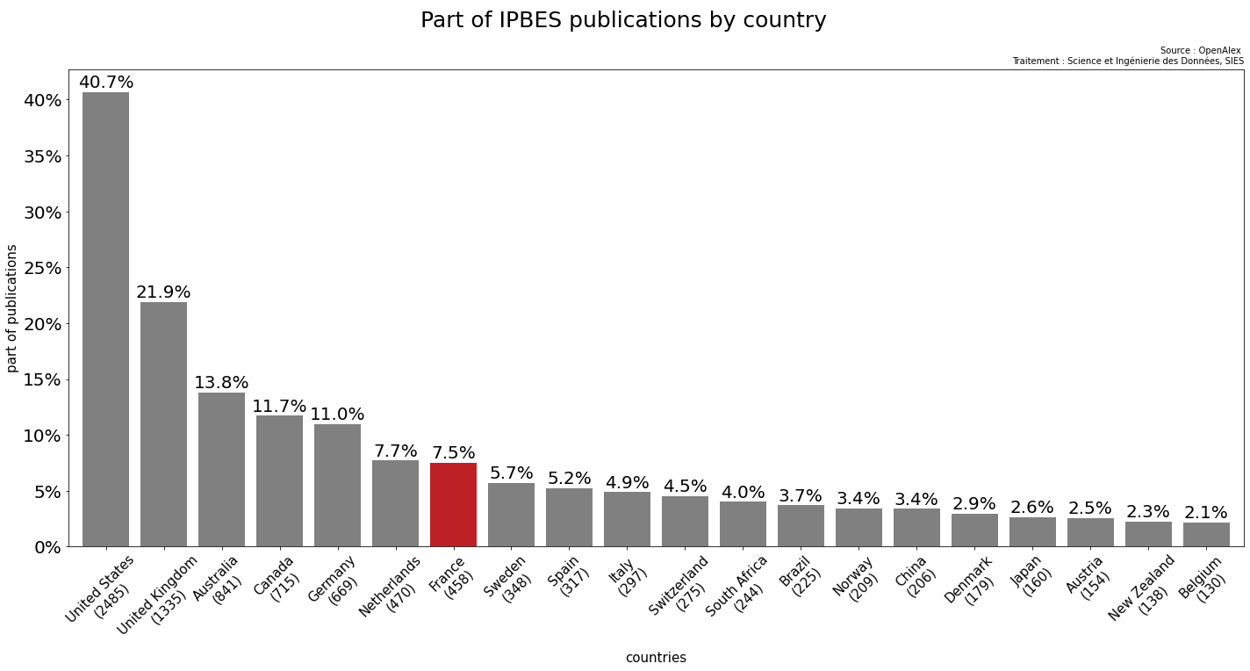 Part of IPBES publications by country.

France’s position in specific research areas
France leads in publications related to physical sciences but is less frequently cited in areas concerning adaptation and mitigation.
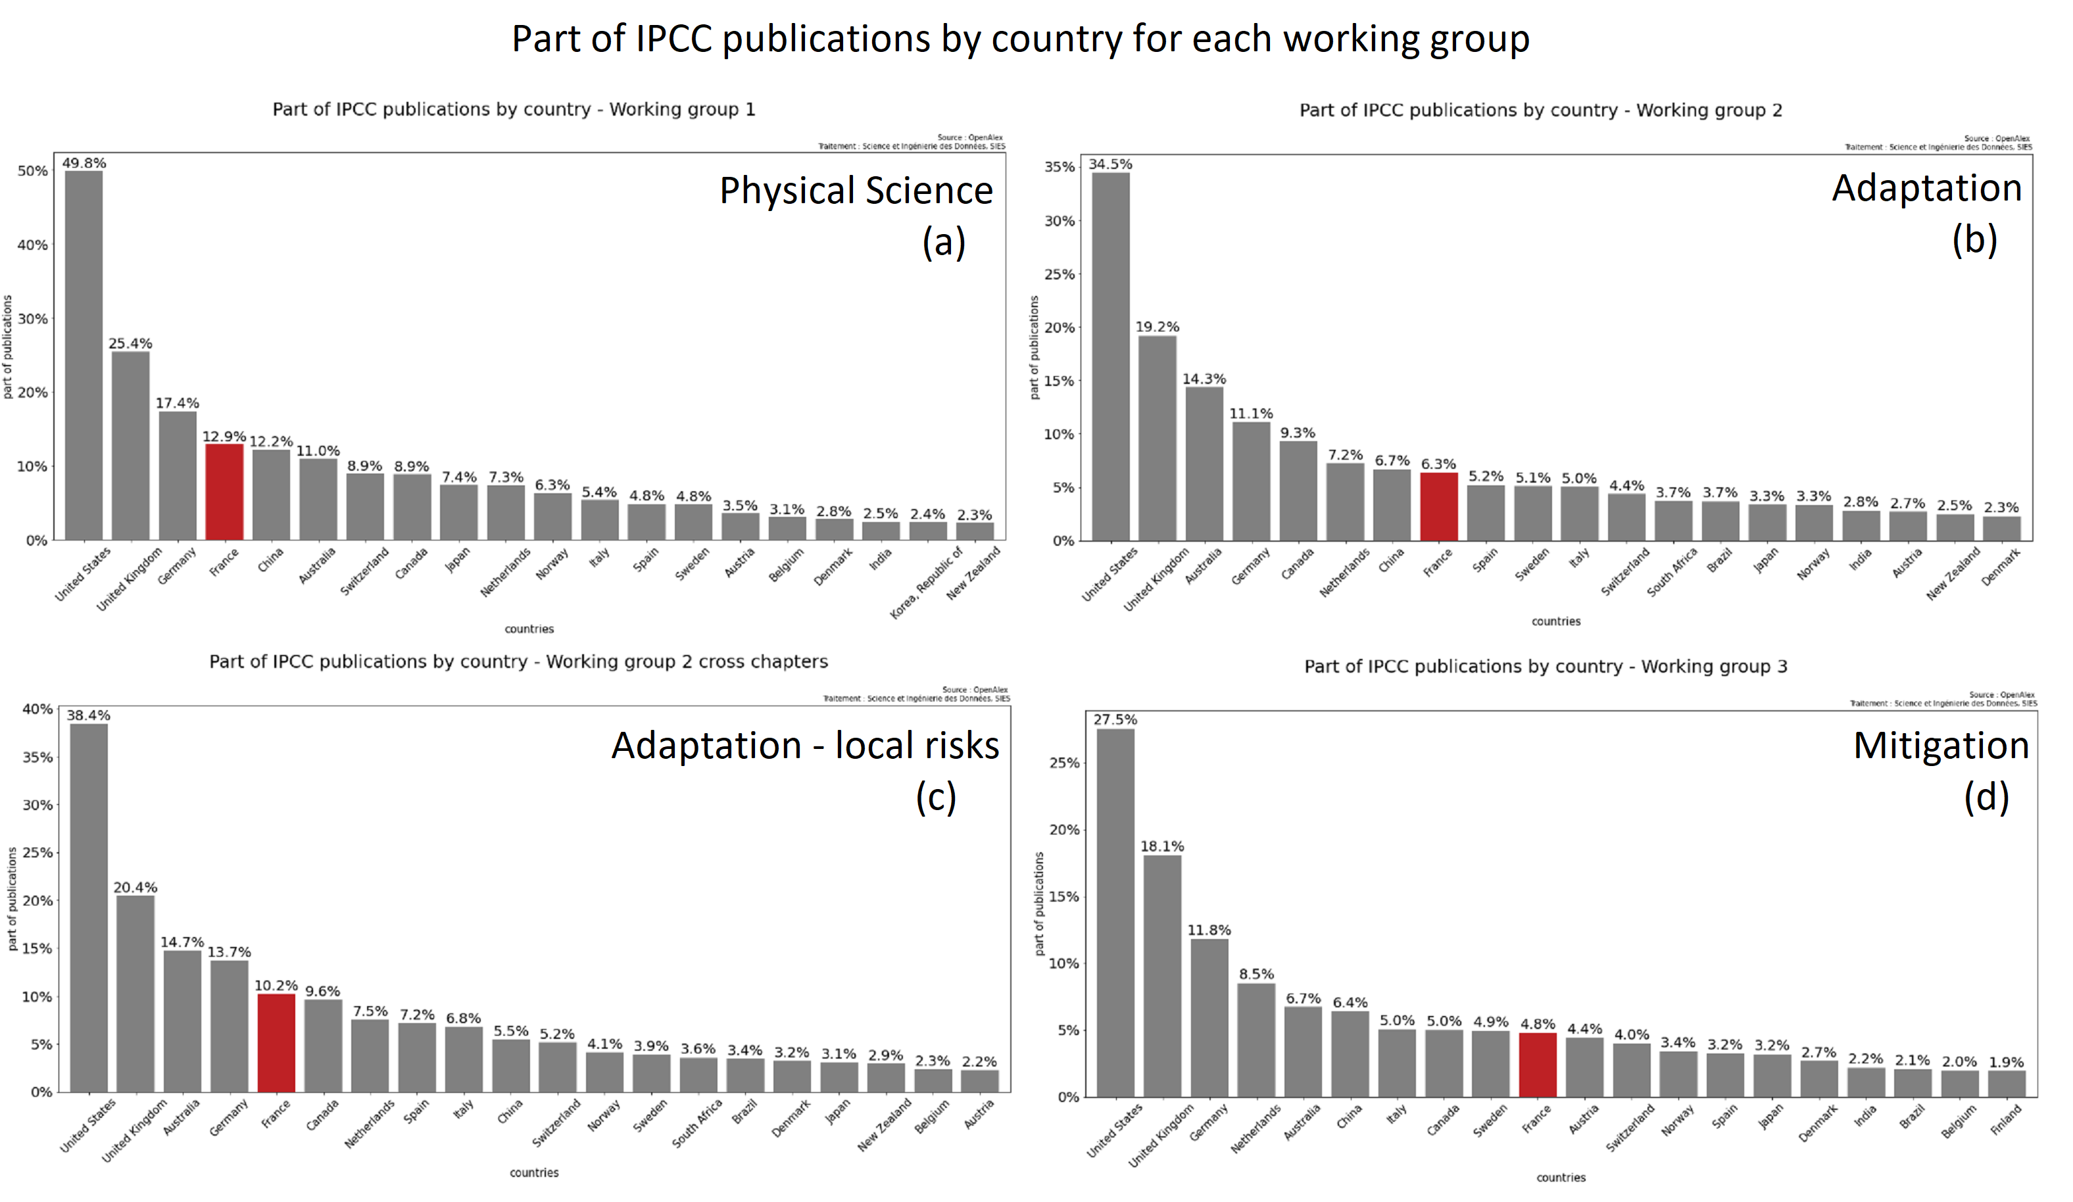 Part of IPCC publications for each working groups.
French publications are more concentrated than those from other countries on theoretical sciences (a), as well as on documenting the impacts and risks related to ecosystems such as coral reefs, forests, and deserts (cross chapters from the second working group, the (c) image in Part of IPCC publications for each working groups).
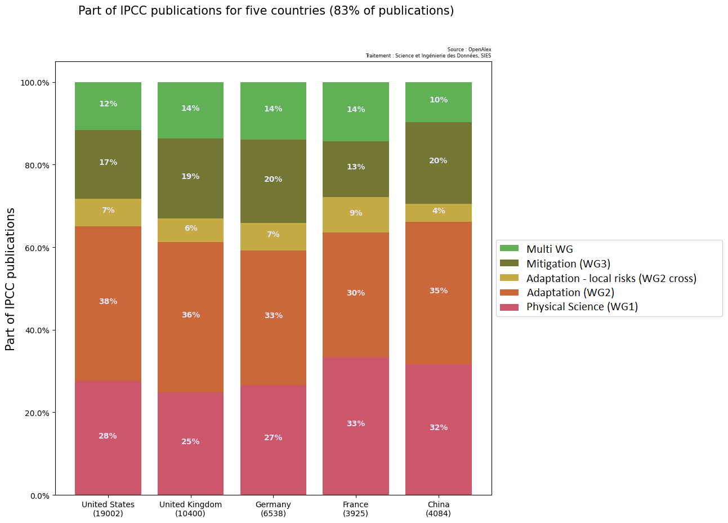 Part of IPCC publications for five countries.
These findings align with the results from the French Court of Audit, which also highlights a strong focus on physical sciences, with less emphasis on adaptation and mitigation strategies.

Top Institutions, Laboratories, and Researchers in France
In France, the CNRS (National Centre for Scientific Research) is a leader in IPCC and IPBES publications, with IRD (Research Institute for Development) also making significant contributions.
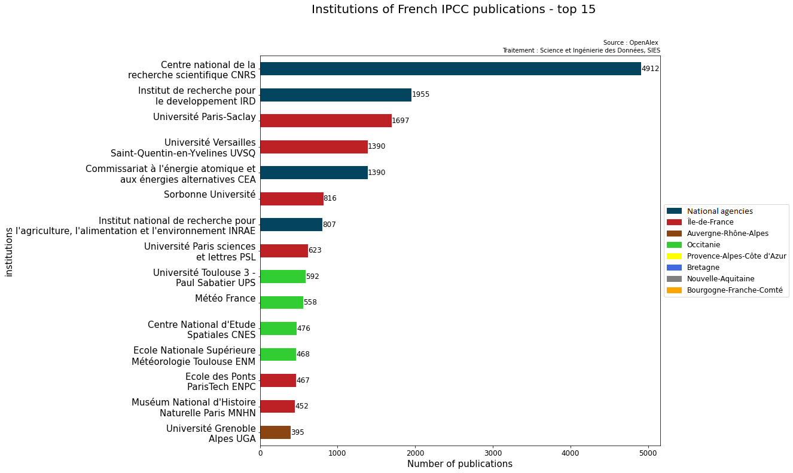 French institutions contributing to IPCC publications. 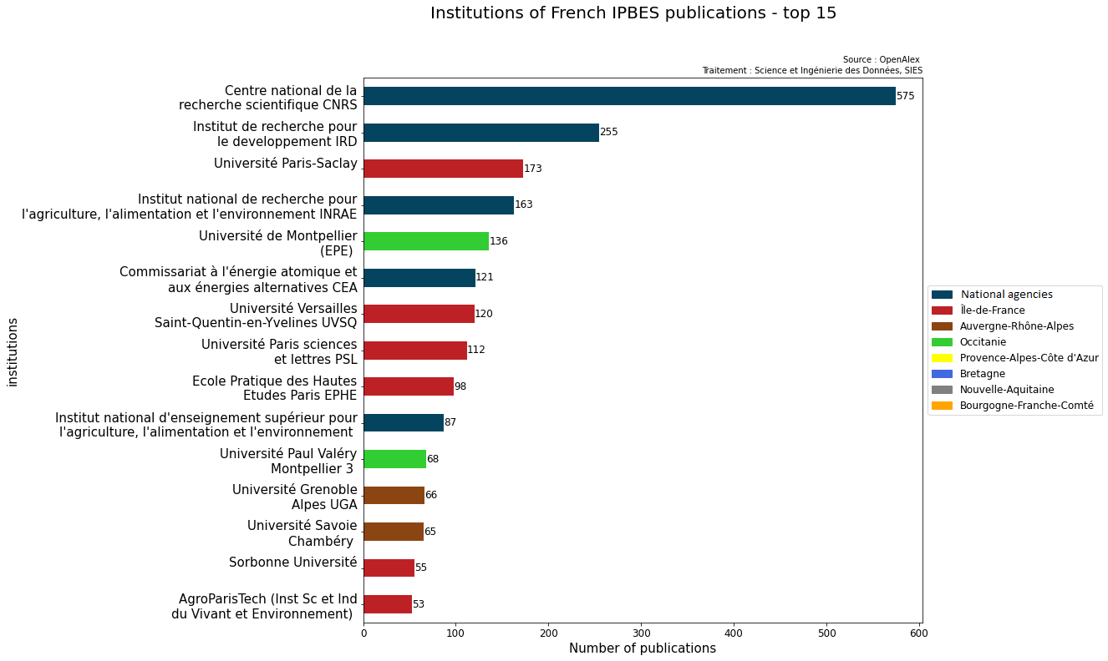 French institutions contributing to IPBES publications.
We can see that a certain number of national organizations are present in both report, we can detect a certain territorial disparity already at the institutional level. The institutions most active in the publications cited by the IPCC are located mainly in Île-de-France, Toulouse and Grenoble. And those of the IPBES are located in Île-de-France, Grenoble, Chambery and Montpellier.
The Climate Science Laboratory is another key player in climate research, leading the way in IPCC and IPBES publications.
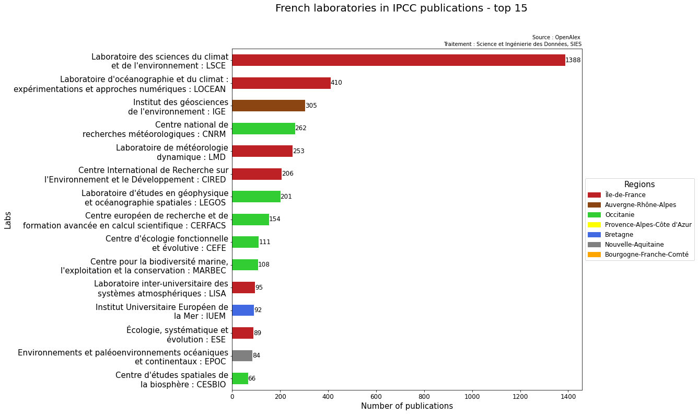 French laboratories contributing to IPCC publications. 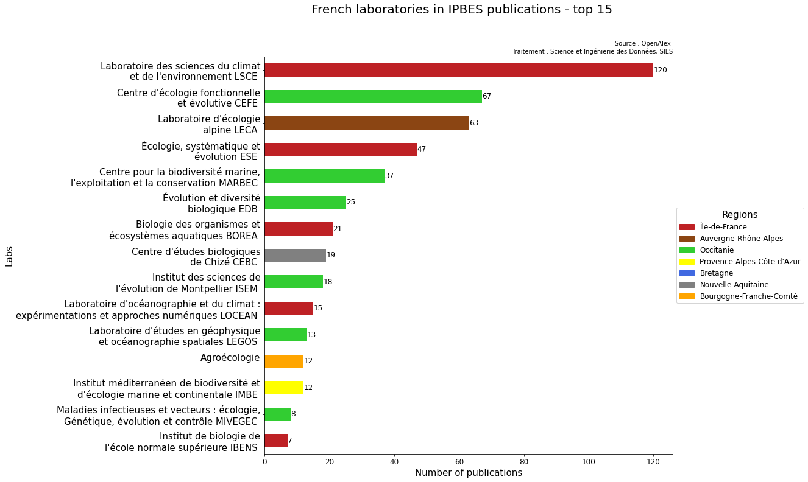 French laboratories contributing to IPBES publications.
The laboratories most active in the publications cited by the IPCC are located mainly in Île-de-France, Toulouse, Grenoble, Bretagne and Bordeaux. And those of the IPBES are located in Île-de-France, Montpellier, Grenoble, Toulouse, Chizé, Dijon and Marseille.
French researchers are also highly involved, with some contributing to both IPCC and IPBES reports.
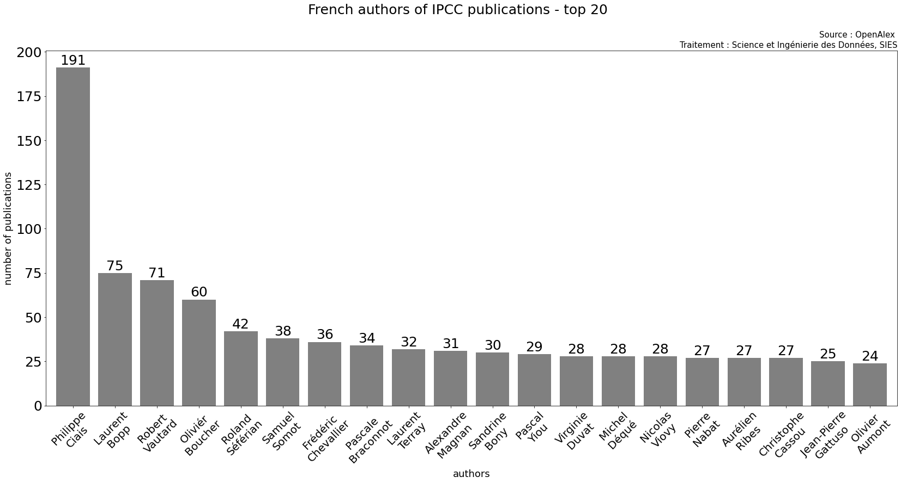 French authors contributing to IPCC publications. 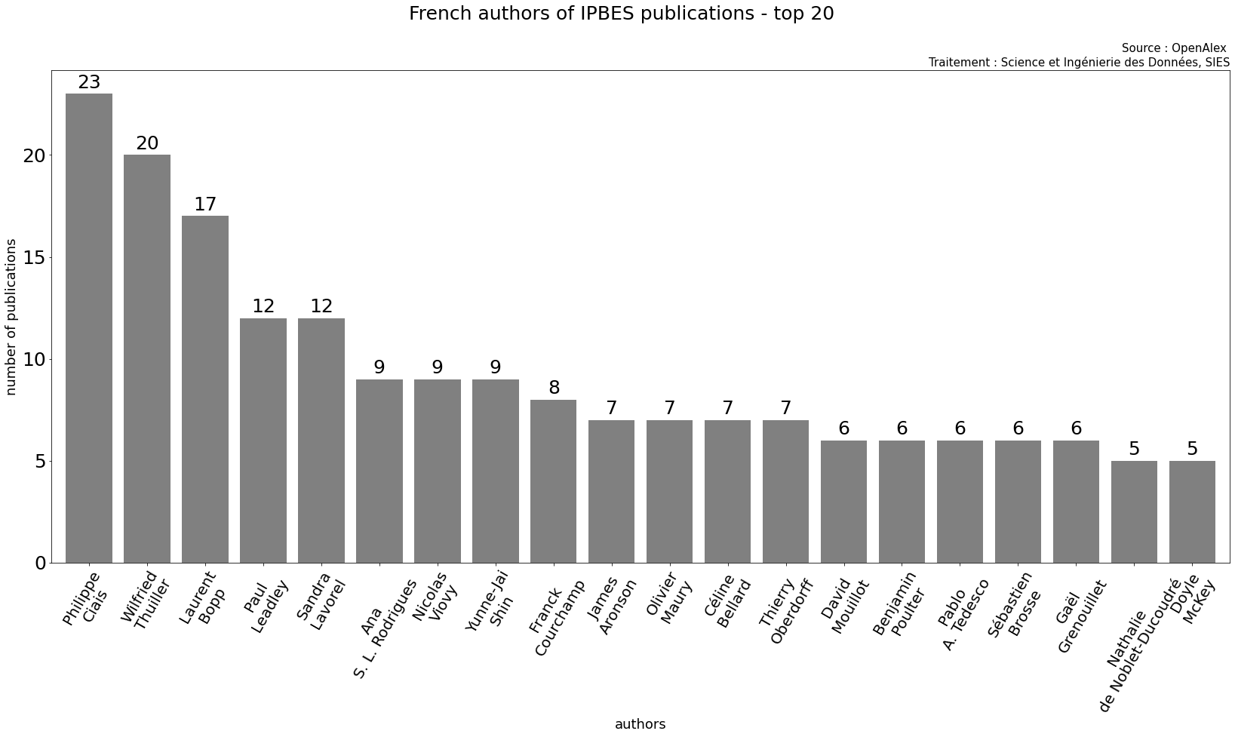 French authors contributing to IPBES publications.

3.2 Models performances
Out of the 19,288 publications in the IPCC test set, 18,788 publications are correctly predicted, representing 97% of the total publications.
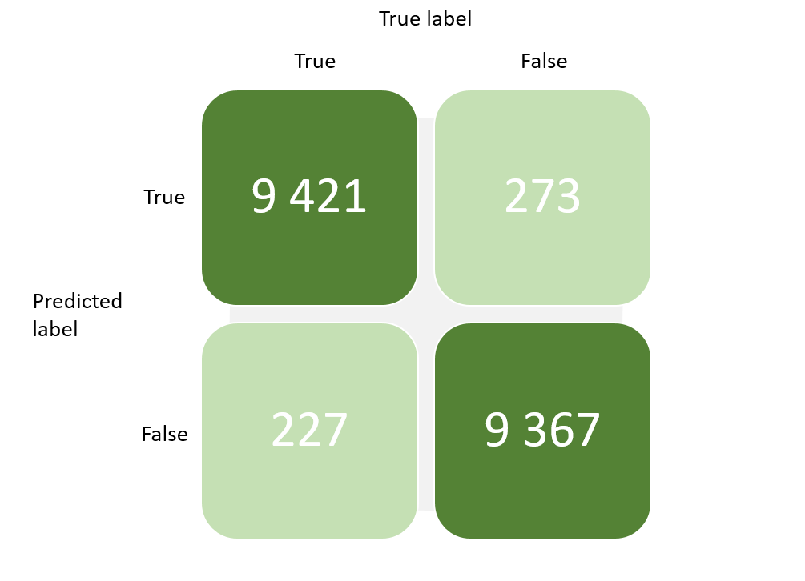 Confusion matrix showing the performance of the first IPCC model.
When a publication is identified as “IPCC-like,” a second model is applied to classify it into the appropriate working group. The second model predicts which working group the publication is most likely associated with.
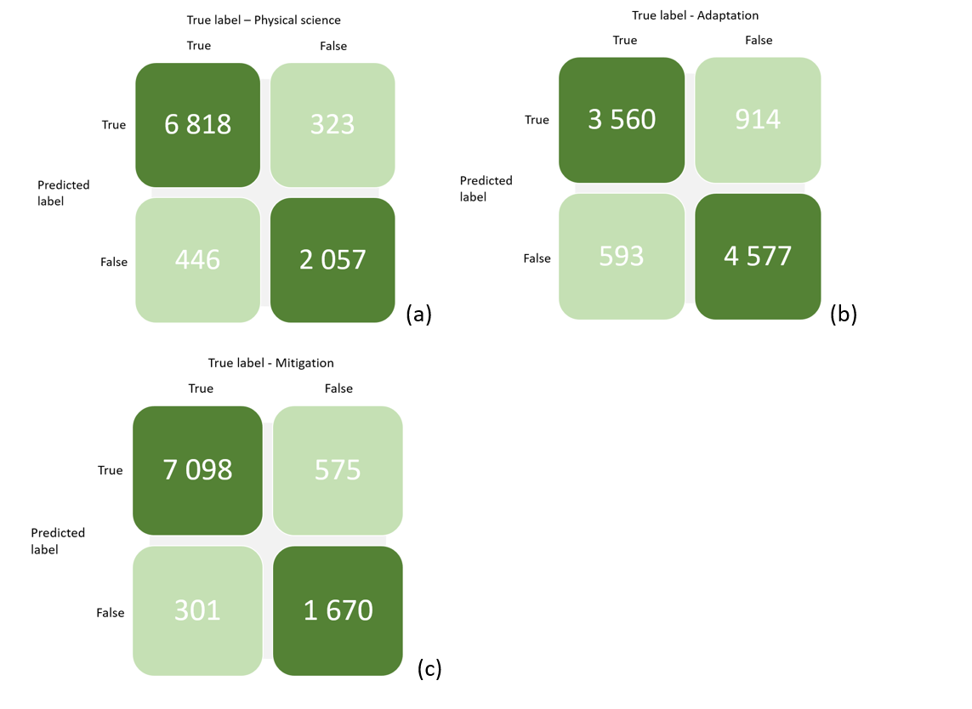 Confusion matrix illustrating the performance of the second IPCC model, which categorizes publications by working group.
For each working group, there are 9,644 publications in the test set. The model performance for each group is as follows:
- For Physical Science, 8,875 publications are correctly predicted, representing 92% of the publications in this category.
- For Adaptation, 8,137 publications are correctly predicted, representing 84% of the publications in this category.
- For Mitigation, 8,768 publications are correctly predicted, representing 91% of the publications in this category.
However, for the Adaptation and Mitigation categories, the model shows a significant number of false positives. This suggests that the model tends to overestimate the number of publications categorized as belonging to these groups. This overestimation indicates that the model might be more likely to label publications as “Adaptation” or “Mitigation” than is strictly accurate, leading to a higher rate of false positives in these categories.

3.3 The models on ScanR publications

3.4 On OpenAlex

4. Code availibility
The code developed is open source and available online on GitHub https://github.com/dataesr/teds

References
Chaignon, Lauranne, and Daniel Egret. 2022. “Identifying Scientific Publications Countrywide and Measuring Their Open Access: The Case of the French Open Science Barometer (Bso).” Quantitative Science Studies 3 (1): 18–36. https://doi.org/10.1162/qss_a_00179.
n.d.a. https://www.ipcc.ch/report/ar6.
n.d.b. https://www.zotero.org/groups/2333077/ipbes_global_assessment/library.

