K-Mix MIDI Remote Script for Ableton Live.

By Evan Bogunia

Installation:

After downloading the K-Mix_RemoteScript repository, you’ll need to place the K-Mix folder into your MIDI Remote Scripts directory:

1. Locate your Ableton Live 9 application (must be original, not alias or shortcut).
2. Ctrl-click on the .app file and select “Show Package Contents”
3. Now go into the “/Contents/App-Resources/MIDI Remote Scripts” folder.
4. Copy the “K-Mix” folder into the “Midi Remote Scripts” folder.

You can know open Live, and select the K-Mix as a Control Surface. This script will operate with the ‘out-of-the-box’ settings for the K-Mix. Select MIDI bank 1, and you are good to go. The Script has a view of 8 tracks + the Master, and 6 Scenes.

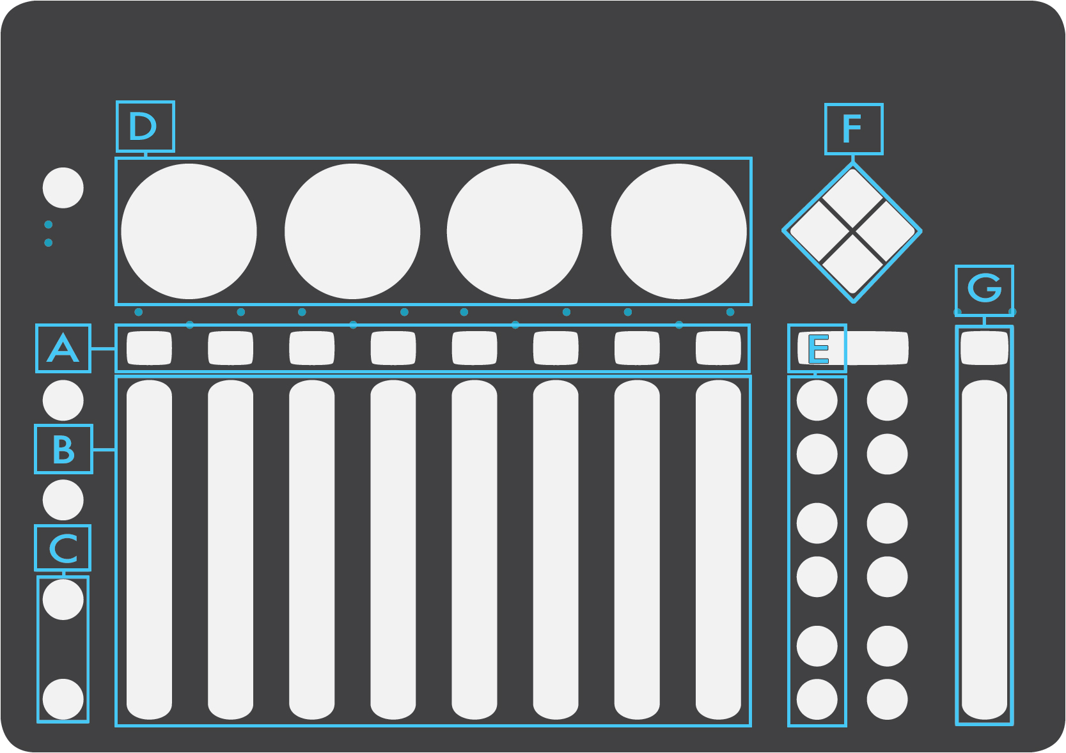

A. Track Select Buttons. These buttons select and focus a track.

B. Faders: These control track volume, when in Mix mode, and device parameters, when in Device Mode.

C .Mode Select Buttons: The bottom (VU) button selects Mix Mode. The top button (Fine) selects Device Mode.

D. Rotaries: The first rotary controls panning of the selected track, the other three rotaries control send level to A, B, and C.

E. Scene Launch Buttons: These buttons will launch the corresponding scene.

F. Session Navigator: The diamond pad will navigate the session.

G. Master fader and select button: This functions just as the track faders, except it is always in Mix Mode.