**Project Charter**

**Overview**

Scotia Bank Dashboards – Data Insights and Agile Research

DataFix is planning to create an environment that will store SB data that is shared that can then be compared with multiple data sources that are available in the DataFix data warehousing environment and to create data dashboards that will be available to SB data analysts and SB banking executives and analysts.

In this environment we can share a representative data sampling that provide an alignment of SB data against the study of behavior over time.

This environment will facilitate integration with other key partners like IPSOS for stats and research on consumer and shopper, customer experience, society and provide an Agile Research

Feasibility study – steps to prepare data sources and kpis for modelling and dashboarding

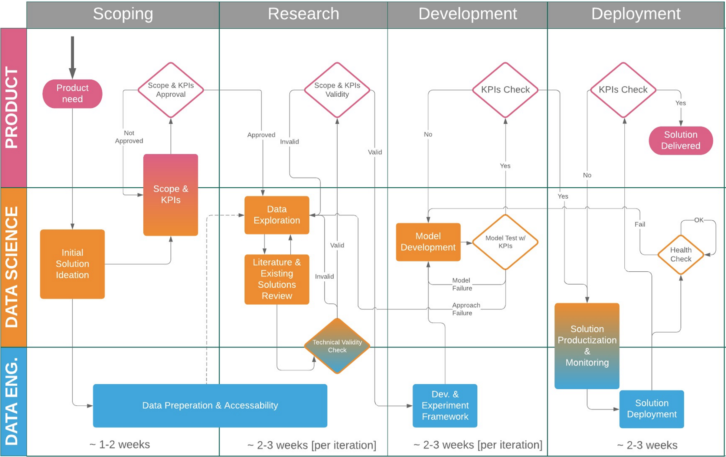

**Scope**

The scope of the project should be listed

*Scope IN*

The scope of the DataFix Dashboard project includes the activities listed below:

* Data sources that include:
  + SB Credit Bureau data
  + MPAC data
  + Teranet data
  + Uploaded data from the SB customer
  + Other
* Establish a set of dashboards that show data insights and provide access to agile research
* Establish a set of reports that can be accessed adhoc and also sent to subscribed users

*Scope OUT*

To be defined

**Major Milestones**

Milestones required for a successful project include:

* All vendors and partners selected
* Prelim meetings with all partners planned and scheduled
* Business Development plan and preparation of marketing campaign materials
* Design of data ingestion, preparation and transformation environment by tech team
* Contracts or orders complete with all vendors where applicable
* Data staged and prepared for dashboard development lifecycle
* Dashboards UI/UX designed with the customer and the data insights team ready for build
* Build of an initial set of reports and dashboards
* Pricing determined for revenue planning and contracting
* Demos with SB planned and scheduled

**Major Deliverables**

A list of the major deliverables that will result from the project:

* Statement of agreement with IPSOS and other vendors or data source providers
* Infrastructure in place to support
* Architecture diagrams and docs
* Information security and management policy and compliance prep and statements for SB and vendor partner awareness
* Establishment of data management operations, marketing and other processes required to build the program out to maintain for SB and to prepare for service provision to other banks
* Team staffing/roles identified and assigned, including work schedules
* Establishment of data management operations policies, including hours of operation

**Assumptions**

The assumptions in creating the project are:

**Constraints**

Identified constraints:

Business Need or Opportunity

Provide a concise statement of the business need or opportunity that led to the creation of the project.

TBD

Preliminary Cost for the Project

A statement is to be provided indicating how the cost of the project will be defined and controlled.

The team lead (WkH) will assemble a proposal based on expected costs for review by HwW.

Project Charter Acceptance

The names, titles, and signature lines of the individuals who will sign-off on the Project Charter is provided.