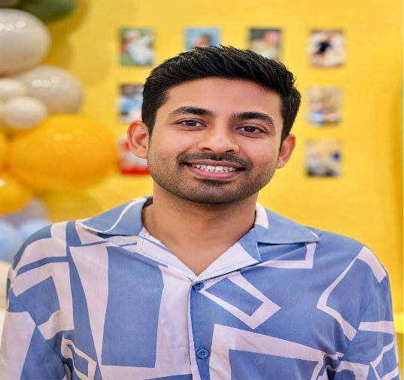
Personal Information
Name: Fahim
Birth Year: 1988
Height: 5' 6"
Citizenship: USA
Current Residence: Fresh Meadows, New York
Born & Raised: Dhaka, Bangladesh
Hometown: Raipur, Lakshmipur, Bangladesh
email: fahimuddinbd@gmail.com

About Me
Fahim was born and raised in Dhaka in a family where Islamic values, education, and service to others were deeply emphasized. Family holds a special place in his heart, and he hopes to build a future family rooted in faith, compassion, knowledge, and service to those in need.
He is described by his friends as caring, inquisitive, and someone with a wholesome sense of humor. He hopes to find a companion with whom he can grow up in Deen, support one another through life's journey, and build a loving and faith-centered family together.

Education
Master of Science in Computer Science
Campbellsville University, USA
Bachelor of Computer Science & Engineering
American International University-Bangladesh (AIUB)
Major: Software Engineering

Professional Background
Principal Data Architect — TriNet
Currently working as a Principal Data Architect.
Previous Experience:
- Data Engineer — Discover
- Data Engineer — ViacomCBS
- Data Engineer — Verizon
- Software Engineer — AT&T

Family Background
Father: Late Taslim Uddin
- Profession: Private Service
- Hometown: Raipur, Lakshmipur, Bangladesh
Mother: Mrs. Farida Yeasmin
- Profession: Homemaker
- Hometown: Raipur, Lakshmipur, Bangladesh
Brother: Nahim Uddin
- Education: Bachelor of Business Administration, University of Greenwich, London
- Currently working in Italy

Hometown & Family Roots
Fahim's family roots are in Raipur, Lakshmipur, Bangladesh. He was born and raised in Dhaka and currently resides in Fresh Meadows, New York.

Interests & Hobbies
- Hiking and exploring nature
- Road trips and discovering hidden places
- Traveling to unique destinations
- Exploring new cities
- Trying different cuisines
- Learning about new cultures and experiences

Looking For
He hopes to find a kind, caring, and compassionate life partner who values Deen, family, personal growth, and lifelong companionship. Someone who is willing to support one another in becoming better Muslims, building a loving family, and contributing positively to the community.

