|  |  |
| --- | --- |
|   **International School** | **Assignment-1**  **CMU-SE 433 CIS - Software Process & Quality Management**    **2023-2024** |
| **Score:** | **Student Name: Nguyễn Thành Đạt**  **Student ID: 26211242012** |

**Assigment - 1**

**Q1: What is Software Process and Quality Management? Elaborate its Importance in terms of Information Technology Companies to improve process and Quality? Illustrate SPQM with some examples and also enlist some of the  Principal Quality Factors impacting Software Quality?**

**What is Software Process and Quality Management?**

“Software Process and Quality Management is leading people in planning, organizing, and controlling a set of steps to produce instructions for the computer that achieves a goal of satisfying a customer’s needs.”

**Elaborate its Importance in terms of Information Technology Companies to improve process and Quality?**

* Increase in development team productivity.
* Improve product quality.
* SPQM ensures that software products are developed to meet the required quality standards.
* Bring down rework costs as soon as you detect your defects in the software development lifecycle.
* Increase software credibility and quarterly profit.
* Save time and budget.

**Illustrate SPQM with some examples and also enlist some of the Principal Quality Factors impacting Software Quality?’**

**Example:** Flight management system, chemical factory, medical equipment. A failure in the operation of software systems in these industries can have a huge impact, even catastrophic.

**Enlist some of the Principal Quality Factors impacting Software Quality?**

* **Functional suitability:** The degreee of completeness, correctness, and appropriateness of the software's functionality.
* **Reliability:** The degree of consistency, availability, fault-tolerance, and recoverability from errors of the software system.
* **Performance efficiency:** The level of the software's response times, throughput, and utilization of hardware and software resources.
* **Security:** The degree of confidentiality, integrity, non-repudiation, accountability, and authenticity of the software.
* **Maintainability:** The degree of modularity, reusability, analyzability, modifiability, and testability of the application.
* **Usability:** The level of the software's learnability and operability.

**Q2: What is Cost of Quality? Explain four areas of quality with example?**

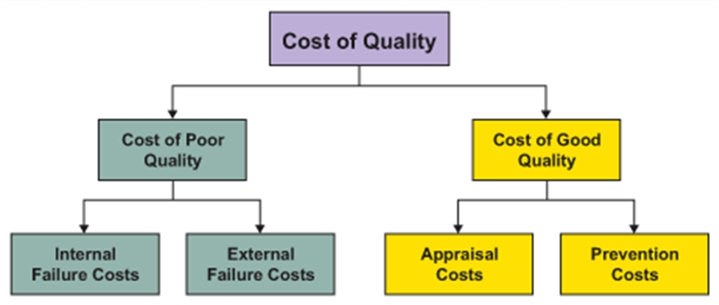

**Figure 1:** *Cost of Quality Diagram*

**What is Cost of Quality?**

Concept originated in the 1960’s

Deming, Juran and Crosby “Quality is free”

Primarily applied to manufacturing

Heavily adopted by the Japanese

Now being applied to Software and therefore IT

**Explain four areas of quality with example?**

**• Internal Failure:** The internal failure cost incurred by the manufacturing company stemmed from the need to rework and discard defective products identified during the final inspection before shipment.

**• External Failure:** The external failure cost for the electronics company included expenses related to customer returns, warranty claims, and reputation damage due to a product recall triggered by a widespread defect.

**• Appraisal Costs:** The appraisal costs accrued by the software development team involved extensive testing, code reviews, and quality audits to ensure the software met stringent performance and security standards before release.

**• Prevention Costs:** The prevention costs invested by the pharmaceutical company encompassed quality planning, continuous employee training, and rigorous process improvement initiatives to proactively minimize the risk of manufacturing defects in their medications.

**Q3: What is CMMI Model? Explain the working of the model with proper steps? Why CMMI Model is good for Software Companies? Enlist top 10 Companies in the world using CMMI and explain how CMMI is improving their process and quality?**

**What is CMMI Model?**

An integrated capability model that includes software and systems engineering capability assessment.

The model has two instantiations:

• Staged where the model is expressed in terms of capability levels;

• Continuous where a capability rating is computed.

**Explain the working of the model with proper steps?**

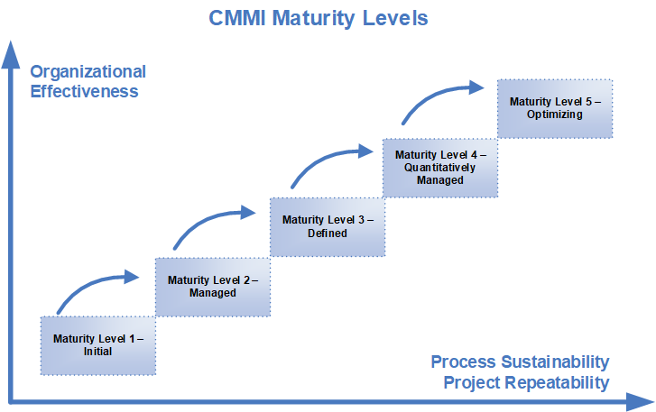

**Figure 2:** *CMMI Maturity Levels Diagram*

* **Initial:** Essentially uncontrolled. No Focus - Project success primary depends on individuals and their heroics.
* **Repeatable:** Product management procedures defined and used. Project Management - Basic project management processes are established to track cost, schedule, and functionality. The necessary process discipline is in place to repeat earlier successes on projects with similar applications.
* **Defined:** Process management procedures and strategies defined and used. Engineering Process - The software process for both management and engineering activities is documented, standardized, and integrated into a standard software process for the organization. All projects use an approved, tailored version of the organization's standard software process for developing and maintaining software.
* **Managed:** Quality management strategies defined and used. Product and Process Quality - Detailed measures of the software process and product quality are collected. Both the software process and products are quantitatively understood and controlled.
* **Optimising:** Process improvement strategies defined and used. Continuous Process Improvement - Enabled by quantitative feedback from the process and from piloting innovative ideas and technologies.

**Why CMMI Model is good for Software Companies?**

The Capability Maturity Model Integration (CMMI) is a process and behavioral model that helps organizations streamline process improvement and encourage productive, efficient behaviors that decrease risks in software, product, and service development.

**Enlist top 10 Companies in the world using CMMI and explain how CMMI is improving their process and quality?**

1. **IBM:** utilizes CMMI to elevate software and system development processes, aiming for higher maturity levels to enhance predictability and control in projects.
2. **Lockheed Martin:** implements CMMI practices to elevate the quality and reliability of complex aerospace and defense systems and software.
3. **Raytheon:** a major player in defense, adopts CMMI to boost efficiency in development processes and ensure the delivery of high-quality products.
4. **Northrop Grumman:** leverages CMMI to enhance processes related to system engineering, software development, and project management in the aerospace and defense sector.
5. **Accenture:** integrates CMMI practices into software development and project management to ensure consistent quality in client projects.
6. **Siemens:** uses CMMI to refine software development processes, particularly in industrial automation and control systems.
7. **Tata Consultancy Services (TCS):** implements CMMI practices to mature its software development and delivery processes in IT services and consulting.
8. **Infosys:** a major IT services company, adopts CMMI to improve process efficiency and deliver high-quality software solutions to clients.
9. **Boeing:** enhances the quality and reliability of aircraft and aerospace systems through the implementation of CMMI practices.
10. **Cognizant:** embraces CMMI to refine software development and project management practices in its multinational IT services and consulting operations.

**Q4: Compare Waterfall and Agile Software Development Model? Explain with example?**

**Compare Waterfall and Agile Software Development Model?**

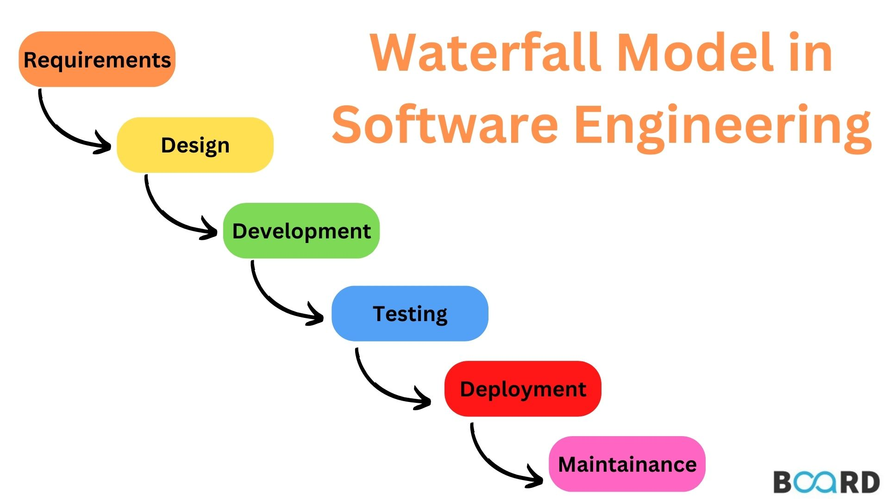

**Figure 3:** *CMMI Maturity Levels Diagram*

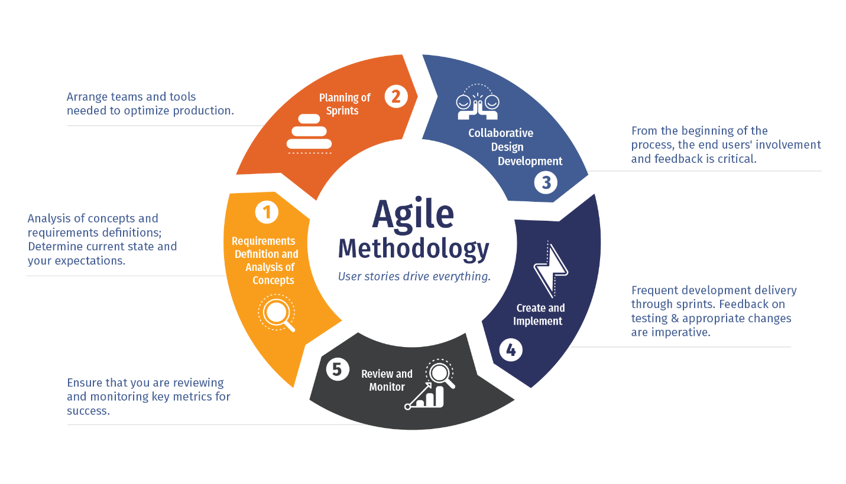

**Figure 4:** *CMMI Maturity Levels Diagram*

|  |  |  |
| --- | --- | --- |
|  | **Waterfall** | **Agile** |
| **Timeline** | Waterfall has a fixed timeline. The idea is that the start and finish of the project are already mapped out from the beginning. | Agile is a lot more flexible and accounts for experimenting with different directions. Rather than a fixed timeline, the schedule adapts as the project progresses. The Agile Manifesto, an online document released in 2001 by a group of software developers, says team members are expected to, “​​Deliver working software frequently, from a couple of weeks to a couple of months, with a preference to the shorter timescale.” |
| **Client Involvement** | Once the end goal is established, Waterfall does not involve the client or project owner during the process, apart from specific check-ins or for deliverables. The course of the project is outlined from the start, so incorporating client feedback is not an ongoing part of the process. | A fundamental part of Agile is including clients in the project development at every step. The Agile Manifesto states, “Our highest priority is to satisfy the customer through early and continuous delivery of valuable software.” Therefore, business owners are expected to be involved and give feedback to the software development team as they progress through the different phases of the project. |
| **Flexibility** | Waterfall is not as flexible as Agile because each phase needs to be fully completed before moving on to the next phase. The project is also planned out ahead of time, making this management system ideal for teams with a clear vision of where they are headed from start to finish. | Flexibility is built into the Agile method. Agile values short bursts of work, which are called sprints. The method welcomes adapting to different directions, incorporating new information even at a later stage of the project. |
| **Budget Fixed** | The budget for projects using the Waterfall methodology is generally fixed. Because the project is determined from start to finish, there is less room to change the budget mid-project. | Agile is open to adaptation, encourages experimentation and welcomes changes of direction, even in later phases of the project. Because of this, the budget tends to be more flexible. |

**Explain with example?**

**Scenario:** A specific application with numerous advanced feature requirements must be ready for sale in 8 months.

In the example with the traditional Waterfall methodology, only after the 8-month process is complete does the customer experience the actual product. Also, if the need for significant changes arises, developers must push the release ahead by a few weeks.

It is clear why Agile is far more effective than Waterfall. In the Agile example, by the end of 8 months, the application will not only be ready and already in wide use but also significantly more refined than if produced using the Waterfall method.

**Q5: Explain ITIL model and elaborate the working with proper diagram? Highlight 5-9 Companies in world using ITIL model and also explain how ITIL helped them to improve the productivity? List Unique 10 Differences between CMMI and ITIL with special stress on Productivity and Continuous Improvement?**

**Explain ITIL model and elaborate the working with proper diagram?**

ITIL goes beyond simply defining the relationship between the IT organization and the business. ITIL is a framework for effectively managing IT services throughout the entire service lifecycle. The ITIL framework offers guidance and best practices for managing the five stages of the IT service lifecycle: service strategy, service design, service transition, service operation and continual service improvement.

**• Benefits include:**

* Provision of IT services becomes more customer-focused.
* Services are described better.
* Better management of quality.
* Improved communication within IT organization.

**• Risks include:**

* Can take a long time and requires significant effort to use.
* Over-engineered procedures can be seen as bureaucratic obstacles.
* No real benefit if there is a fundamental lack of understanding about what the relevant processes should provide.

**ITIL and Day-to-Day Work**

• Resolving incidents and problems

• Creating change requests

• Software development

• Software releases

• Hardware and Software research

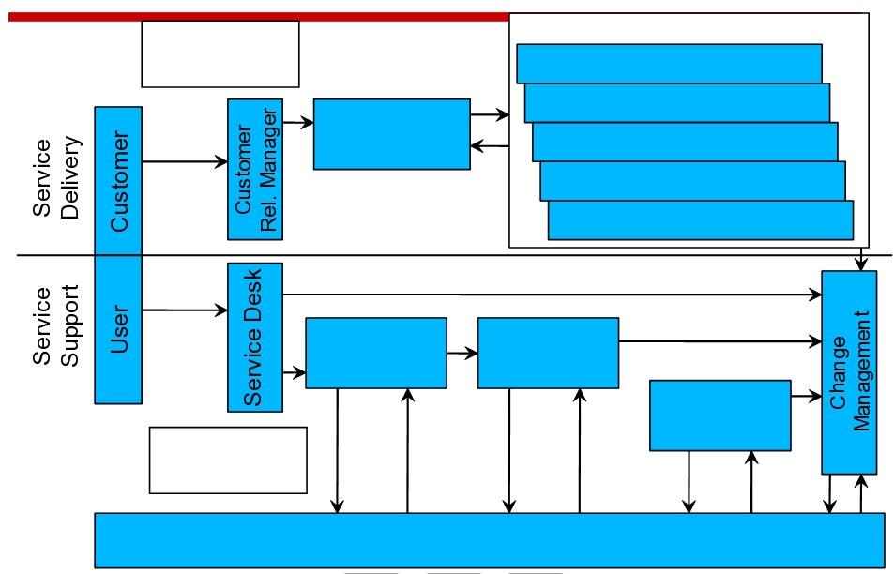

**Figure 5:** *ITIL Process Diagram*

**Highlight 5-9 Companies in world using ITIL model and also explain how ITIL helped them to improve the productivity?**

1. **Microsoft:** Microsoft has implemented ITIL practices to enhance the efficiency of its IT service management and support processes.
2. **IBM:** IBM is known for adopting ITIL to improve the delivery of IT services and align them with business objectives.
3. **HP (Hewlett Packard):** HP has historically utilized ITIL practices to improve IT service delivery and customer satisfaction.
4. **Procter & Gamble (P&G):** P&G has implemented ITIL to optimize IT processes and ensure effective delivery of IT services.
5. **Cisco Systems:** Cisco has adopted ITIL to streamline IT service management processes and enhance overall IT efficiency.
6. **Accenture:** a global consulting and professional services firm, has incorporated ITIL practices to improve the efficiency of its IT service management and delivery processes.
7. **Oracle:** a multinational computer technology corporation, has integrated ITIL practices into its IT service management processes to enhance service quality and responsiveness.
8. **Infosys:** a major IT services company, has implemented ITIL practices to optimize IT processes and enhance the overall quality of its IT services.

**List Unique 10 Differences between CMMI and ITIL with special stress on Productivity and Continuous Improvement?**

|  |  |
| --- | --- |
| **ITIL** | **CMMI** |
| ITIL is a set of comprehensive and coherent codes of best practices, and ITIL scope extend to controlling and managing all aspects of IT related operations. | Capability Maturity Model Integration (CMMI) is aprocess improvement approach whose goal is to help organizations improve their performance. CMMI can be used to guide process improvement across a project. a division, or an entire organization. Currently supported is CMMI Version 1.3 |
| ITIL is a non-proprietary tool that encourages the private sector to develop services and products such as training, consultancy, and tools to support ITIL. | CMMI helps “integrate traditionally separate organizational functions, set process improvement goals and priorities, provide guidance for quality processes, and provide a point of reference for appraising current processes. CMMI currently addresses three areas of interest: Product and service development — CMMI for Development (CMMI-DEV), Service establishment, management, and delivery — CMMI for Services (CMMI-SVC), and Product and service acquisition — CMMI for Acquisition (CMMI-ACQ). CMMI models provide guidance for developing or improving processes that meet the business goals of an organization. A CMMI model may also be used as a framework for appraising the process maturity of the organization. |
| ITIL helps us understand and develop all of the areas within our infrastructure | CMMI focuses on software process maturity continuous improvement |
| ITIL is broader in scope and provides a framework for IT service management and operations including a hardware life cycle. ITIL is the first choice of organizations for standards related to operations and the infrastructure side of IT | CMMI is the de facto quality standard for software development, integration, deployment, and maintenance processes in organizations |
| ITIL addresses IT operations issues such as security, change and configuration management, capacity planning, troubleshooting, and service desk functions. | CMMI is geared specifically to software development organizations and focuses on continuous improvement  The application of CMMI helps the organization gain competency and expertise in software or product development |
| ITIL applications help align the entire IT process and resources of the organization to business processes | ITIL uses best practices to create well defined processes for ITSM CMMI provides a guide for selecting processes that best fit an organization’s needs |
| The United Kingdom’s Office of Government Commerce (OGC) developed the IT Infrastructure Library (ITIL) in 1986 to provide guidance for service management. These set of guidelines has since then emerged as the international de facto standard framework of best practices for IT service management and infrastructure. ITIL originated as a collection of books, each covering a specific practice within the IT service management. | Carnegie Mellon University (CMU)’s Software Engineering Institute developed the first Capability Maturity Model (CMM) in 1990, and followed it up with the Capability Maturity Model Integration (CMMI) that integrated multiple CMMs. |
| ITIL is not prescriptive and orders the processes in sets ITIL provides solutions on how to undertake the requirement analysis. | CMMI model is not a process but a description of effective process characteristics. It recommends requirement analysis but does not specify how to do a requirement analysis. |