Hampshire ‘County’ GHG Emissions (v2.0)

2018/19 snapshots and trends over time using the latest BEIS/DESNZ district level data

Ben Anderson ([b.anderson@soton.ac.uk](mailto:b.anderson@soton.ac.uk))

Last run at: 2023-07-28 17:14:54.31977

# 1 About

This report is a contribution to the Hampshire County Council Climate Change [Expert Stakeholder Forum](https://www.hants.gov.uk/landplanningandenvironment/environment/climatechange/whoweworkwith/climatechangeforumevent)’s Data sub-group.

Code: <https://github.com/HCC-CCECF-DataGroup/hampshire-ghg-emissions/tree/main/rmd> (mirrored from <https://git.soton.ac.uk/SERG/hcc-engagement/hampshire-ghg-emissions>)

If you are viewing this report as a web page then you can also click on the ‘code’ buttons to reveal the code used in each section.

Feedback: <https://github.com/HCC-CCECF-DataGroup/hampshire-ghg-emissions/labels/v2>

## 1.1 History

* Version 2.0 - [updated to use 2023 DESNZ CO2e data]

## 1.2 License

This report is (c) University of Southampton and is published under the [CC-BY-4.0 license](https://creativecommons.org/licenses/by/4.0/). You may share, re-use or adapt for commercial or non-commercial purposes with citation.

## 1.3 Citation

If you wish to use any of the material in this report please cite as:

* Anderson, Ben (2023) *Hampshire ‘County’ GHG Emissions (v2.0): 2018/19 snapshots and trends over time using the latest BEIS/DESNZ district level data**, Report to the Hampshire County Council Climate Change* [*Expert Stakeholder Forum*](https://www.hants.gov.uk/landplanningandenvironment/environment/climatechange/whoweworkwith/climatechangeforumevent). University of Southampton: Southampton.

# 2 Introduction

This report estimates greenhouse gas (GHG) emissions from the Hampshire County using:

* estimates of total annual [*territorial-based*](https://www.ons.gov.uk/economy/environmentalaccounts/articles/netzeroandthedifferentofficialmeasuresoftheuksgreenhousegasemissions/2019-07-24#measuring-the-uks-progress-to-net-zero) **CO2e** emissions for the period 2005 onwards using the latest local authority district level data from [BEIS 2023 data](https://www.gov.uk/government/collections/uk-local-authority-and-regional-greenhouse-gas-emissions-national-statistics);
* estimates of total annual [*territorial-based*](https://www.ons.gov.uk/economy/environmentalaccounts/articles/netzeroandthedifferentofficialmeasuresoftheuksgreenhousegasemissions/2019-07-24#measuring-the-uks-progress-to-net-zero) **CO2e** emissions for 2018/19 using the [CSE Impact tool](https://impact-tool.org.uk/download) dataset;
* estimates of total annual [*consumption-based*](https://www.ons.gov.uk/economy/environmentalaccounts/articles/netzeroandthedifferentofficialmeasuresoftheuksgreenhousegasemissions/2019-07-24#the-uks-carbon-footprint) **CO2e** emissions for 2018/19 using the [CSE Impact tool](https://impact-tool.org.uk/download) dataset.

The analysis is carried out for the ‘Wider Hampshire’ area, i.e. *all 14* local authority districts in the Hampshire County **including the unitary authorities of Portsmouth, Southampton and the Isle of Wight**. Note that this differs from the baseline estimated for the Hampshire County Council [Climate Change Strategy](https://www.hants.gov.uk/landplanningandenvironment/environment/climatechange/whatarewedoing/climatechangestrategy) by The Carbon Trust which *excluded* Portsmouth, Southampton and the Isle of Wight.

# 3 Carbon Trust estimates

As background to the Hampshire County Council [Climate Change Strategy](https://www.hants.gov.uk/landplanningandenvironment/environment/climatechange/whatarewedoing/climatechangestrategy), the Carbon Trust was asked to establish baseline emissions for the County **excluding Southampton, Portsmouth and Isle of Wight**. This baseline was converted to the proportion of emissions from different energy sources and reported as a trend plot on p14 of the Strategy as shown below. This highlighted that the main components of emissions were:

* Industry & Commercial (~ 39%)
* Transport (~ 37%)
* Residential energy use (~ 24%).

Total kT CO2e baseline values were not included in this report.

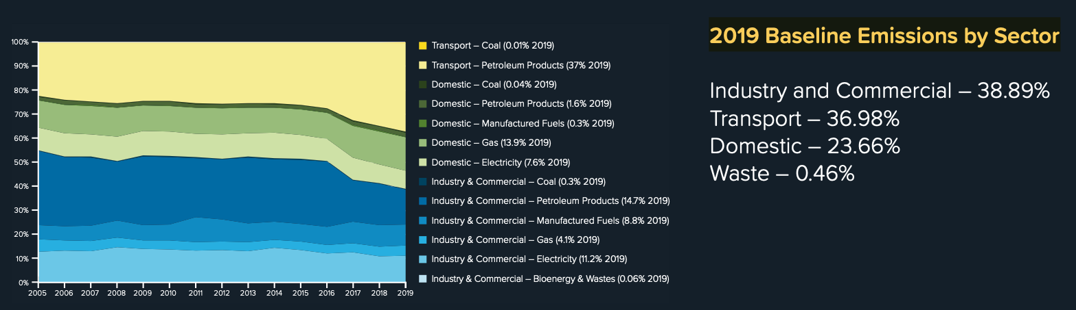

Hampshire emissions (CarbonTrust, 2020)

However the HCC Climate [Change Strategic Framework of Programmes](https://www.hants.gov.uk/landplanningandenvironment/environment/climatechange/whatarewedoing/strategicpriorities) which lays out the estimated Total kT CO2e and % reduction for a range of proposed actions, enables the following baseline values to be imputed:

* Industry & Commercial emissions = 3,278 kT CO2
* Transport emissions = 3,157 kT CO2
* Residential emissions = 2,011 kT CO2

Using the proportion values in the figure above, this gives a total of 8,446 kT CO2 for the 11 districts.

# 4 BEIS/DESNZ: Territorial CO2 emissions (2005 to current)

These official local authority/district level [BEIS/DESNZ National Statistics](https://www.gov.uk/government/collections/uk-local-authority-and-regional-greenhouse-gas-emissions-national-statistics) use the end-user territorial emissions method(*“meaning CO2 emissions that occur within the UK’s borders”*). As a result international aviation and shipping are *excluded* from these estimates.

Note also that:

“*The end user basis for reporting emissions has been chosen for this dataset because it accounts for the emissions from energy use at the local level and does not penalise local areas for emissions from the production of energy which is then ‘exported’ to and used in other areas.*” ([technical report](https://assets.publishing.service.gov.uk/government/uploads/system/uploads/attachment_data/file/1168163/uk-local-and-regional-ghg-emissions-2005-to-2021-technical-report.pdf), p8)

The following code loads the data and reports basic checks. A full data description can be found in Section 10.1.

## Number of emissions categories: 31

## Number of districts: 14

## Total emissions for 2019: 9409 kT CO2

## Total emissions deemed to be 'within the scope of influence of LAs' for 2019: 7623 kT CO2

BEIS have produced a useful [mapping tool](https://naei.beis.gov.uk/laco2app/) which can be used to compare the spatial distribution of different emissions sources at district level.

## 4.1 Trends over time

Figure 4.1 shows trends over the period 2005 to 2019 for the CO2 emissions sources in the data. Overall there has been a clear reduction in emissions over the time period. The categories have been colour-coded so that related categories have similar colours in the palette.

## Saving 5 x 6 in image

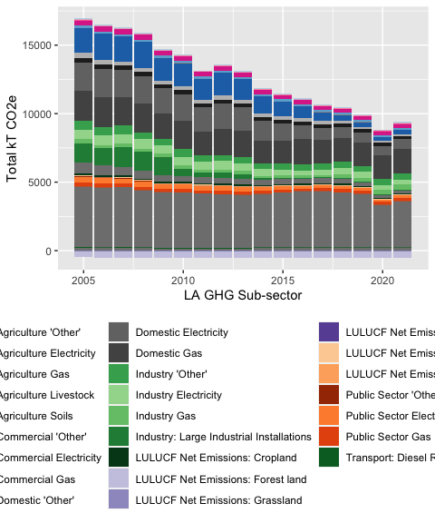

Figure 4.1: BEIS CO2 emissions by category (Hampshire)

Figure 4.2 shows trends over time for these categories using a line plot to make it easier to see which categories have declined. This makes the recent trends in the reduction of emissions from the increasingly decarbonised electricity grid clearly visible. There has also been a slight decline in emissions due to domestic gas use but few other sources show substantial change except for ‘*large industrial installations*’.

## Saving 5 x 6 in image

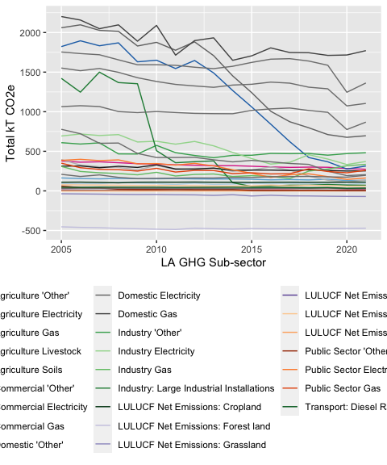

Figure 4.2: BEIS CO2 emissions by category (Hampshire)

Figure 4.3 shows an interactive version of the same plot. Hovering over specific lines is useful for identifying the sources.

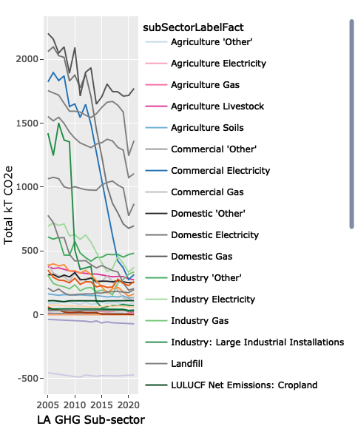

Figure 4.3: BEIS CO2 emissions by category (Hampshire)

## 4.2 2019 baseline

Table 4.1 shows the total CO2 emissions under this method for 2019 for all 14 districts.

Table 4.1: BEIS CO2e emissions (kT, 2019)

| Total kT CO2e |
| --- |
| 9,409.2 |

Note that the total emissions deemed to be ‘within the scope of influence of LAs’ for 2019 is 0 kT CO2e. Categories deemed by BEIS to be outside local authorities’ scope of influence in this data are:

* all forms of land-use, land-use change and forestry
* Transport: (Motorways)
* Transport: Diesel Railways

Table ?? shows the total emissions for 2019 ordered by category. Figure 4.4 shows the data as a bar plot ordered by value. The largest emissions sources under this method are clearly visible (domestic gas, transport and domestic electricity).

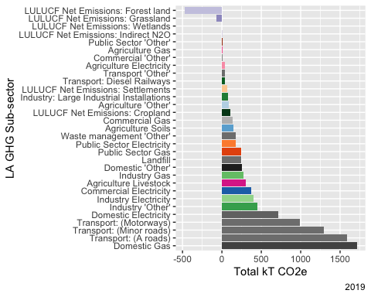

Figure 4.4: BEIS CO2e emissions by category (Hampshire, 2019 ordered by emissions value)

## Saving 5 x 4 in image

Figure ?? shows a cumulative emissions plot for the BEIS 2019 data ordered by the emissions source’s magnitude. The largest increments are therefore due to domestic gas use and various forms of transport. The plot uses vertical lines to show the sources which comprise 50%, 75% and 90% of the total emissions. The plot curls due to the source categories with negative emissions such that the final point represents the total ‘net’ emissions.

## Saving 5 x 4 in image

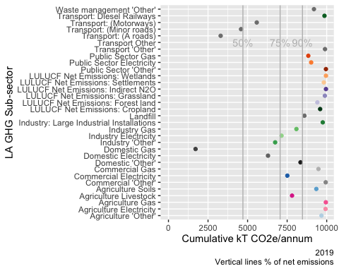

Figure 4.5: Plot of cumulative emissions (BEIS, 2019)

Thus, if we focus on BEIS territorial CO2 only then 75% of emissions are due to:

* Domestic gas: 1,711 kT (18 %));
* Transport (Motorways, A roads and minor roads combined): 3,868 kT (Total: 41 %);
* Domestic electricity: 711 kT (8 %))

Taken together the domestic (residential) emissions comprise 26 % of the estimated total.

Negative CO2 emissions (sequestration) sources are:

* Forest: -476 kT
* Grassland: -67 kT - note that this does not include methane emissions from grazing livestock nor N2O emissions from waste
* Wetlands: 0.029 kT - this is perhaps surprisingly small given the coastal nature of the County and the existence of a number of wetland habitats. it may be worth investigating [the underlying data](https://naei.beis.gov.uk/reports/reports?report_id=1025) to confirm.

As Figure ?? showed, these levels of sequestration currently provide a negligible offset to the overall emissions. Note also that cropland was a net emitter at 109 kT.

Figure 4.2 showed that the only emissions sources showing substantial decreases over time have been electricity due to grid decarbonisation and (potentially) reductions in some industrial activity as well as the use of ‘Other fuels’ by industry. Although emissions from domestic gas use have also fallen over time they appear to have stabilised since 2014. Perhaps of most concern given their dominant contribution however is the relative stability of road transport emissions over the 2005 - 2019 period.

## 4.3 Latest data (2021)

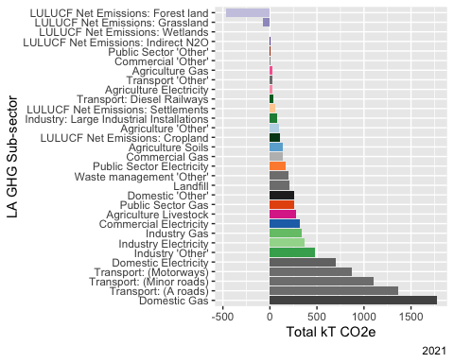

## Saving 5 x 4 in image

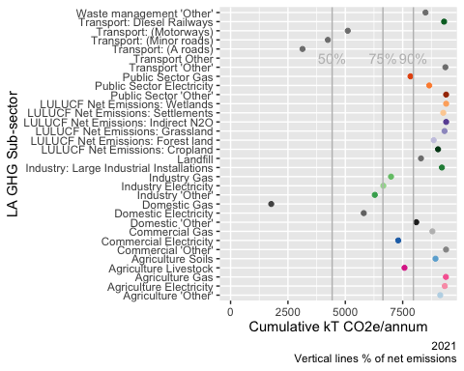

## Saving 5 x 4 in image

# 5 CSE: Territorial-based all GHG emissions (2018/19 data)

The first of the CSE datasets estimates emissions under the territorial method **but including international aviation and shipping** and includes *all GHG* emissions - [carbon dioxide, methane, nitrous oxide and fluorinated gases](https://naei.beis.gov.uk/overview/ghg-overview). As the non-CO2 gases have [different warming potentials](https://unfccc.int/process-and-meetings/transparency-and-reporting/greenhouse-gas-data/frequently-asked-questions#eq-9) compared to CO2, emissions are reported in terms of CO2e (carbon dioxide equivalent) rather than simply in terms of kT of gas emitted. The sum of kT CO2e for each source therefore represents the total contribution of all of the emissions to climate warming *allowing for their different warming potentials*.

The *inclusion* of GHGs other than just CO2 means that identical categories in the CSE data will most likely have higher emissions estimates than the original BEIS equivalent which only accounted for CO2. As an example, Transport emissions are based on the BEIS CO2 Transport emissions in the BEIS pre 2020 data (no GHGs other than CO2) but were “*adjusted to account for [additional] non-CO2 greenhouse gas emissions*”. This is explained in detail in the [CSE methodology paper](https://impact-tool.org.uk/methodology):

*“Total CO2e emissions have been estimated for most sectors by comparison of CO2, N2O and CH4 emission factors for the most prevalent fuel type in the sector and factoring the CO2 emissions accordingly. The exceptions are other transport and LULUCF due to the diverse nature of emission sources; in these cases the CO2 figures have been used as-is.”* (p14)

For aviation and shipping:

*“National emissions data from these sources are reported by the NAEI, and have been apportioned on a population basis.”* (p15)

Finally, fluorinated gases (F-gases):

*“are apportioned commensurate with non-domestic electricity emissions, as systems utilising such gases are most prevalent in non-domestic buildings and electrically powered equipment).”* (p15)

The following code loads the data and reports basic checks. A full data description can be found in Section 10.2.

## Number of emissions categories: 20

## Number of districts: 14

## Total emissions check: 12110 kT CO2e

## 5.1 2019 baseline

Table 5.1 shows the total emissions for 2019. This is Inf % increase from the BEIS figure.

Table 5.1: CSE territorial emissions (Hampshire, 2019)

| Total kT CO2e |
| --- |
| 12,109.7 |

Table 5.2 shows the total emissions for 2019 by category. Figure 5.1 shows the data as a bar plot. Note that some of the categories do not exactly match those used in the BEIS data but the colour palettes have been kept as similar as possible.

Ignore the (t CO2e) in the table and plot labels - both the table and plot show kT for easy comparison (labels to be fixed).

Table 5.2: CSE all territorial emissions by category (Hampshire, 2019)

| variable | Total kT CO2e | % of gross |
| --- | --- | --- |
| Housing - Mains gas (t CO2e) | 1,657.5 | 12.8 |
| Housing - Electricity (t CO2e) | 841.3 | 6.5 |
| Housing - Oil (t CO2e) | 294.0 | 2.3 |
| Housing - LPG (t CO2e) | 38.0 | 0.3 |
| Housing - Biomass (t CO2e) | 8.0 | 0.1 |
| Housing - Coal (t CO2e) | 11.0 | 0.1 |
| Industrial and commercial - Electricity (t CO2e) | 1,110.0 | 8.6 |
| Industrial and commercial - Mains gas (t CO2e) | 702.5 | 5.4 |
| Industrial and commercial - Other Fuels (t CO2e) | 443.4 | 3.4 |
| Industrial and commercial - Large industrial consumers (t CO2e) | 81.5 | 0.6 |
| Agriculture - Fuel (t CO2e) | 106.7 | 0.8 |
| Agriculture - Livestock and crop-related emissions (t CO2e) | 350.4 | 2.7 |
| Aviation (t CO2e) | 1,202.6 | 9.3 |
| Shipping (t CO2e) | 479.0 | 3.7 |
| Diesel fuelled railways (t CO2e) | 45.3 | 0.3 |
| F-gases (t CO2e) | 374.1 | 2.9 |
| Road Transport (t CO2e) | 4,054.6 | 31.3 |
| Other Transport (t CO2e) | 31.2 | 0.2 |
| Waste management (t CO2e) | 703.7 | 5.4 |
| Land use, land-use change, and forestry (t CO2e) | -425.2 | -3.3 |

## Saving 5 x 4 in image

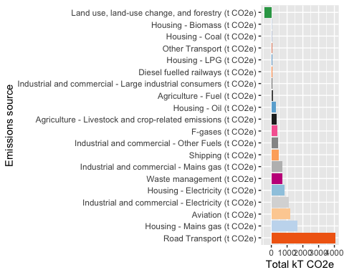

Figure 5.1: CSE all territorial emissions by category (Hampshire, 2019 ordered by emissions value)

Figure 5.2 shows a cumulative emissions plot for the CSE territorial data ordered by the emissions source’s magnitude. The largest increments are therefore due to personal transport, domestic gas use and aviation. The plot shows the sources which comprise 50%, 75% and 90% of the total emissions. The plot curls due to the source categories with negative emissions such that the final point represents the total ‘net’ emissions.

## Saving 5 x 4 in image

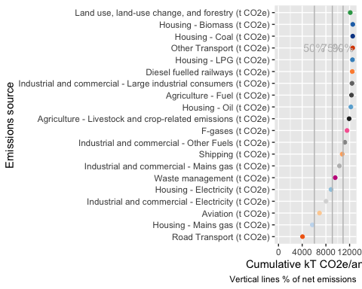

Figure 5.2: Plot of cumulative emissions (BEIS, 2019)

Thus, if we focus on CSE territorial *all GHG* emissions, 75% of emissions are due to:

* Road transport: 4,055 T CO2e (33 % of total)
* Housing (domestic) gas: 1,657 T CO2e (14 % of total)
* Aviation: 1,203 T CO2e - flights and freight (10 % of total)
* Industrial & commercial electricity: 1,110 T CO2e (9 % of total)
* Domestic electricity: 841 T CO2e (7 % of total)

These figures draw attention to the significant emissions due to aviation which are not included in the BEIS LA level data. They also draw attention to the level of *all GHG* emissions from waste management. Indeed, 102 % of the 29 % increase from the BEIS figure comprises emissions from:

* *Aviation* (1,203 kT CO2e - i.e. flights & freight - 10 % of total);
* *Waste management* (704 kT CO2e - 6 % of total);
* *Shipping* (479 kT CO2e - 4 % of total) and
* *F-Gases* (374 kT CO2e - 3 % of total)

Note that under the CSE approach, Agriculture - Livestock and crop-related emissions amount to 350 T CO2e compared to the BEIS value for Cropland at 109 T CO2e which gives some indication of the additional emissions due to methane (noting that fuel used for agriculture is already in a separate category under the CSE approach - see [methodology, p15](https://impact-tool.org.uk/static/doc/Impact-methodology-paper-v1.6.pdf)).

# 6 CSE: Consumption-based all GHG emissions (2018/19 data)

These are calculated under the consumption emissions method and include *all* greenhouse gas emissions. They are also therefore presented in kT CO2e.

The following code loads the data and reports basic checks. A full data description can be found in Section 10.3.

## Number of emissions categories: 15

## Number of districts: 14

## Total emissions check: 13633 kT CO2e

## 6.1 2019 baseline

Table 6.1 shows the total emissions for 2019.

Table 6.1: CSE consumption emissions (Hampshire, 2019)

| Total kT CO2e |
| --- |
| 13,633.3 |

Table 6.2 shows the total emissions for 2019 by category. Figure 6.1 shows the data as a bar plot. Note that most of the categories do not exactly match those used in the BEIS/CSE territorial-based data but again, the colour palettes have been kept as similar as possible.

The largest emissions sources under this method are clearly visible (purchased goods, services and food/diet and gas-use).

Ignore the (t CO2e) in the label - the plot shows kT for easy comparison (labels to be fixed).

Table 6.2: CSE all consumption emissions ordered by category (Hampshire, 2019)

| Source | Total kT CO2e | % of gross |
| --- | --- | --- |
| Consumption of goods and services - Purchase of goods (t CO2e) | 2,623.4 | 19.2 |
| Consumption of goods and services - Use of services (t CO2e) | 1,194.7 | 8.8 |
| Consumption of goods and services - Other consumption related emissions (t CO2e) | 1,034.1 | 7.6 |
| Food and diet - Meat and fish (t CO2e) | 1,722.0 | 12.6 |
| Food and diet - Other food and drink (t CO2e) | 1,413.7 | 10.4 |
| Housing - Mains gas (t CO2e) | 1,657.5 | 12.2 |
| Housing - Electricity (t CO2e) | 841.3 | 6.2 |
| Housing - Oil (t CO2e) | 294.0 | 2.2 |
| Housing - LPG (t CO2e) | 38.0 | 0.3 |
| Housing - Biomass (t CO2e) | 8.0 | 0.1 |
| Housing - Coal (t CO2e) | 11.0 | 0.1 |
| Travel - Flights (t CO2e) | 969.8 | 7.1 |
| Travel - Public transport (t CO2e) | 399.2 | 2.9 |
| Travel - Private transport (t CO2e) | 1,378.2 | 10.1 |
| Waste - Waste (t CO2e) | 48.4 | 0.4 |

## Saving 5 x 4 in image

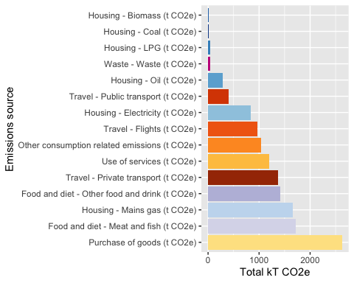

Figure 6.1: CSE all territorial emissions ordered by category value (Hampshire, 2019 ordered by emissions value)

Figure 6.2 shows a cumulative emissions plot for the CSE territorial data ordered by the emissions source’s magnitude. The largest increments are therefore due to consumption of goods and services, food and diet (meat & fish) and mains gas use. The plot shows the sources which comprise 50%, 75% and 90% of the total emissions.

## Saving 5 x 4 in image

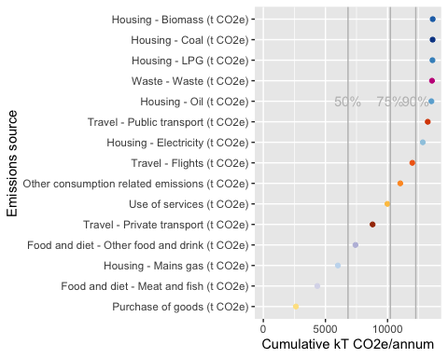

Figure 6.2: Plot of cumulative emissions (BEIS, 2019)

Thus, if we focus on CSE consumption-based emissions which include emissions ‘outsourced’ to other geographical areas (including overseas), 75% of emissions sources are due to:

* Purchased goods: 2,623 kT CO2e ( 19 %)
* Food and diet - meat & fish: 1,722 kT CO2e ( 13 %)
* Domestic gas: 1,657 kT CO2e as before ( 12 %)
* Food and diet - other: 1,414 kT CO2e ( 10 %)
* Private transport:1,378 kT CO2e ( 10 %)
* Use of services: 1,195 kT CO2e ( 9 %)

Emissions due to Flights (970 kT CO2e) are lower than the territorial based Aviation emissions values since emissions due to freight are included under ‘Goods and services’.

This approach to emissions accounting shows the extent to which the consumption of goods and services, diet and food as well as transport and domestic gas use dominate Hampshire’s ‘consumption’ emissions footprint.

# 7 District level total emissions by method

Table 7.1 and Figure 7.1 show the total emissions under each method and source per district. As expected, in all cases CSE territorial emissions are higher than BEIS territorial emissions. Similarly, in most cases CSE consumption emissions are higher than territorial emissions except for Winchester, Test Valley, Basingstoke and Deane and New Forest. More detailed analysis of the underlying data would be required to understand the reasons for this.

Table 7.1: Totals per district by method and source (kT)

| District | BEIS territorial emissions (kt CO2, 2019) | CSE territorial emissions (kt CO2e) | CSE consumption emissions (kt CO2e) |
| --- | --- | --- | --- |
| Basingstoke and Deane | 1,115.4 | 1,351.7 | 1,309.4 |
| East Hampshire | 641.4 | 854.1 | 994.4 |
| Eastleigh | 593.2 | 748.8 | 902.3 |
| Fareham | 498.2 | 638.5 | 799.9 |
| Gosport | 221.3 | 305.2 | 497.1 |
| Hart | 500.3 | 628.4 | 782.8 |
| Havant | 425.0 | 556.3 | 786.0 |
| Isle of Wight | 626.4 | 788.7 | 999.8 |
| New Forest | 989.0 | 1,389.7 | 1,352.9 |
| Portsmouth | 802.4 | 1,117.3 | 1,192.4 |
| Rushmoor | 383.1 | 471.9 | 624.9 |
| Southampton | 783.6 | 1,039.2 | 1,386.2 |
| Test Valley | 920.7 | 1,136.3 | 986.4 |
| Winchester | 909.2 | 1,083.8 | 1,018.7 |

## Saving 5 x 4 in image

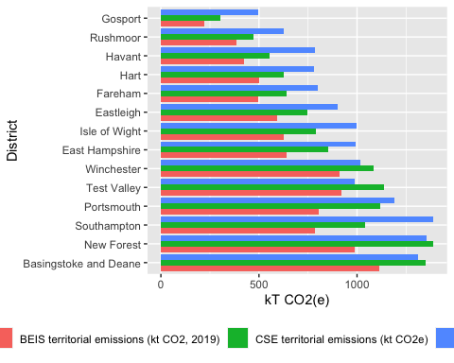

Figure 7.1: Total emissions per district by method

# 8 Discussion

Overall, the total GHG emissions for Hampshire in 2018/19 under different methodologies were found to be:

* Carbon Trust analysis (11 districts *excluding* Portsmouth, Southampton and the Isle of Wight): **8,446** kT CO2
* BEIS territorial CO2e:
  + **7,197** kT CO2e (11 districts *excluding* Portsmouth, Southampton and the Isle of Wight),
  + **9,409** kT CO2e (14 districts *including* Portsmouth, Southampton and the Isle of Wight)
* CSE territorial emissions (all GHG, all 14 districts): **12,110** kT CO2e - 29 % higher than the BEIS total
* CSE consumption emissions (all GHG, all 14 districts): **13,633** kT CO2e

Given that the Carbon Trust area *excludes* Portsmouth, Southampton and the Isle of Wight it is unclear why this total is similar to the ‘14 local authorities’ BEIS data.

Which of these accounting methods we choose to focus on depends what we want to show and what we want to achieve. The same is true of the emissions subcategories. The BEIS data gives a partial view on territorial emissions as it excludes all non-CO2 emissions and also excludes aviation (flights & freight) and shipping. The CSE territorial emissions data includes these ‘missing’ emissions and so gives a much larger total. The CSE consumption emissions are (generally) larger still because they include emissions ‘off-shored’ by our consumption of goods and services produced outside the Hampshire area.

Table 8.1 compares the Carbon Trust, BEIS and CSE data for 2018/19 to the extent that it is possible to do so from the data reported here.

Table 8.1: Comparing 2018/19 emissions baselines (values = kT CO2e or %)

| Source | CarbonTrust | Carbon Trust % | BEIS | BEIS % | CSE Territorial | CSE Territorial % | CSE Consumption | CSE Consumption % |
| --- | --- | --- | --- | --- | --- | --- | --- | --- |
| Residential | 2,011 | 22.7 | 2,680.2 | 28.5 | 2,849.8 | 23.5 | 2,849.8 | 20.9 |
| Transport | 3,157 | 36.1 | 3,945.2 | 41.9 | 4,085.8 | 33.7 | 1,777.3 | 13.0 |
| Industry & Commercial | 3,278 | 38.8 | 1,722.6 | 18.3 | 2,337.4 | 19.3 |  |  |
| Aviation |  |  |  |  | 1,202.6 | 9.9 | 969.8 | 7.1 |
| Consumption of goods & services |  |  |  |  |  |  | 4,852.3 | 35.6 |
| Food & diet |  |  |  |  |  |  | 3,135.7 | 23.0 |
| Other |  |  | 1,061.2 | 11.3 | 1,634.1 | 13.5 | 48.4 | 0.4 |

The table shows that the two main policy foci of the Hampshire County Council Climate Change Strategy - Transport and Residential - contribute at least 30% of emissions irrespective of the emissions accounting method used.

The Carbon Trust estimate for Industrial & Commercial emissions for the ‘11 districts’ appears to be considerably larger than the comparable BEIS ‘14 districts’ value. This may be due to the exclusion in the BEIS data of single large power stations whose emissions are ‘shared’ across all grid electricity users, not just those in the relevant district. As a result the BEIS proportions for Transport and Residential emissions are higher (77% combined) compared to 58% in the Carbon Trust estimates for 11 districts.

Although the ‘14 districts’ BEIS and CSE (territorial) main categories are broadly similar in terms of kT CO2(e), the percentage contribution of Transport and Residential emissions are considerably lower (56%) for the CSE data. This is due to the **inclusion of additional sources in the CSE data** such as Aviation (10%, shown) shipping and F-gases as well as *all GHG* emissions (not just CO2) from transport, waste, agriculture, and others (see Table 5.2 for details). Collectively these represent over 20% of county-wide emissions under the CSE territorial methodology.

Finally, the CSE consumption emissions data demonstrates the significant contribution that consumption of services as well as food and diet make to our ‘extended’ emissions footprint if we consider the emissions we have effectively off-shored to other geographical areas. This method transfers all of the industrial/commercial emissions and a significant proportion of the Transport/Aviation emissions to ‘Good and services’ and ‘Food and diet’ (i.e. supply chain transportation and distribution). As a result emissions from homes and private transport comprise only 33% of the total under this approach, flights a further 7% while the total for consumption of goods and services & food is ~58%

# 9 Recommendations and future work

Based on the preceding discussion, this report makes the following recommendations to HCC:

* use *all* territorial emissions (e.g. due to aviation, shipping, F-gases) and *all GHGs* (i.e. [carbon dioxide, methane, nitrous oxide and fluorinated gases](https://naei.beis.gov.uk/overview/ghg-overview)) in the annual [BEIS district level emissions data](https://www.gov.uk/government/collections/uk-local-authority-and-regional-carbon-dioxide-emissions-national-statistics) as the benchmark for:
  + estimation of baseline emissions;
  + transparent modelling of the potential impact of HCC programmes on CO2 emissions;
  + annual assessment of the district and county level emissions reduction progress;
  + assessment of the impact of district and county level emissions reduction policies where feasible;
* This will enable:
  + robust baselining of emissions for **all territorial GHGs**, not just CO2;
  + transparent modelling of the potential impact of HCC programmes on *all territorial GHGs*;
  + effective monitoring of reductions in emissions of *all territorial GHGs* over time.
* include a section in the HCC’s annual Climate Change Report which:
  + reviews the mapping between current HCC programmes and the major emissions sources under each emissions accounting method;
  + reviews the capability and capacity of County and District Authorities to influence the emissions sources for which no current programmes exist (c.f. the [Committee on Climate Change’s recommendations](https://www.theccc.org.uk/publication/local-authorities-and-the-sixth-carbon-budget/) as part of the 6th Carbon Budget and the more recent [National Audit Office 2021 report](https://www.nao.org.uk/report/local-government-and-net-zero-in-england/) on local government capabilities with respect to net zero in England);

Future work could:

* use the BEIS district level and (aggregated to) county level data to establish [Science Based Targets](https://sciencebasedtargetsnetwork.org/take-action-now/take-action-as-a-city/) for emissions reduction that align with or improve upon national ‘net-zero’ targets;
* analyse the district level emissions to understand their distributions according to the different methodologies and hence inform district level prioritisation where this is not already in hand;
* use [the underlying LULUCF data](https://naei.beis.gov.uk/reports/reports?report_id=1025) to investigate the relatively low sequestration attributed to wetlands in the Hampshire area;
* compare the results reported here with a similar analysis of the [CREDS Place-Based Carbon Calculator](https://www.carbon.place/data/) consumption-based footprint data.

# 10 Appendix: Data

## 10.1 Data details: BEIS

Original data (all districts)

Table 10.1: Data summary

|  |  |
| --- | --- |
| Name | beis_orig |
| Number of rows | 523643 |
| Number of columns | 15 |
| Key | NULL |
| _______________________ |  |
| Column type frequency: |  |
| character | 10 |
| numeric | 5 |
| ________________________ |  |
| Group variables | None |

**Variable type: character**

| skim_variable | n_missing | complete_rate | min | max | empty | n_unique | whitespace |
| --- | --- | --- | --- | --- | --- | --- | --- |
| Country | 0 | 1 | 5 | 16 | 0 | 5 | 0 |
| Country Code | 0 | 1 | 0 | 9 | 391 | 5 | 0 |
| Region | 0 | 1 | 5 | 24 | 0 | 13 | 0 |
| Region Code | 0 | 1 | 0 | 9 | 391 | 13 | 0 |
| Second Tier Authority | 0 | 1 | 0 | 28 | 391 | 152 | 0 |
| Local Authority | 0 | 1 | 4 | 54 | 0 | 377 | 0 |
| Local Authority Code | 0 | 1 | 9 | 11 | 0 | 376 | 0 |
| LA GHG Sector | 0 | 1 | 6 | 16 | 0 | 8 | 0 |
| LA GHG Sub-sector | 0 | 1 | 8 | 45 | 0 | 32 | 0 |
| Greenhouse gas | 0 | 1 | 3 | 3 | 0 | 3 | 0 |

**Variable type: numeric**

| skim_variable | n_missing | complete_rate | mean | sd | p0 | p25 | p50 | p75 | p100 | hist |
| --- | --- | --- | --- | --- | --- | --- | --- | --- | --- | --- |
| Calendar Year | 0 | 1 | 2012.99 | 4.90 | 2005.00 | 2009.00 | 2013.00 | 2017.00 | 2021.00 | ▇▆▆▆▇ |
| Territorial emissions (kt CO2e) | 0 | 1 | 16.74 | 95.02 | -2892.14 | 0.04 | 0.49 | 4.66 | 10542.35 | ▁▇▁▁▁ |
| CO2 emissions within the scope of influence of LAs (kt CO2e) | 0 | 1 | 11.67 | 47.75 | 0.00 | 0.00 | 0.00 | 0.00 | 4027.53 | ▇▁▁▁▁ |
| Mid-year Population (thousands) | 391 | 1 | 172.28 | 116.21 | 2.21 | 100.09 | 136.68 | 211.72 | 1157.16 | ▇▂▁▁▁ |
| Area (km2) | 391 | 1 | 672.72 | 1653.91 | 3.15 | 98.35 | 279.33 | 680.08 | 26473.95 | ▇▁▁▁▁ |

## 10.2 Data details: CSE territorial

Original data (all districts)

Table 10.2: Data summary

|  |  |
| --- | --- |
| Name | cse_terr_orig |
| Number of rows | 331 |
| Number of columns | 23 |
| Key | NULL |
| _______________________ |  |
| Column type frequency: |  |
| character | 2 |
| numeric | 21 |
| ________________________ |  |
| Group variables | None |

**Variable type: character**

| skim_variable | n_missing | complete_rate | min | max | empty | n_unique | whitespace |
| --- | --- | --- | --- | --- | --- | --- | --- |
| id | 0 | 1 | 9 | 9 | 0 | 331 | 0 |
| name | 0 | 1 | 4 | 35 | 0 | 331 | 0 |

**Variable type: numeric**

| skim_variable | n_missing | complete_rate | mean | sd | p0 | p25 | p50 | p75 | p100 | hist |
| --- | --- | --- | --- | --- | --- | --- | --- | --- | --- | --- |
| Housing - Mains gas (t CO2e) | 0 | 1 | 190852.62 | 182673.33 | 0.00 | 97220.00 | 131038.45 | 223354.21 | 1385272.76 | ▇▁▁▁▁ |
| Housing - Electricity (t CO2e) | 0 | 1 | 86663.13 | 83524.18 | 1943.34 | 44655.72 | 63196.10 | 93121.88 | 663982.08 | ▇▁▁▁▁ |
| Housing - Oil (t CO2e) | 0 | 1 | 37606.39 | 69741.81 | 1.04 | 714.59 | 8789.51 | 48160.27 | 441375.15 | ▇▁▁▁▁ |
| Housing - LPG (t CO2e) | 0 | 1 | 4167.07 | 7371.96 | 0.00 | 469.25 | 1778.23 | 4239.50 | 61245.83 | ▇▁▁▁▁ |
| Housing - Biomass (t CO2e) | 0 | 1 | 771.86 | 1168.18 | 0.52 | 159.88 | 405.37 | 853.88 | 8950.32 | ▇▁▁▁▁ |
| Housing - Coal (t CO2e) | 0 | 1 | 1829.39 | 2952.05 | 0.00 | 427.02 | 845.21 | 1835.48 | 20794.73 | ▇▁▁▁▁ |
| Industrial and commercial - Electricity (t CO2e) | 0 | 1 | 132300.07 | 137891.68 | 2252.58 | 59765.86 | 86400.95 | 141105.07 | 923959.45 | ▇▁▁▁▁ |
| Industrial and commercial - Mains gas (t CO2e) | 0 | 1 | 113795.30 | 125630.61 | 0.00 | 42721.85 | 70456.50 | 130151.33 | 858852.28 | ▇▁▁▁▁ |
| Industrial and commercial - Other Fuels (t CO2e) | 0 | 1 | 53872.07 | 68865.42 | 1180.35 | 19306.49 | 33291.08 | 54312.41 | 475748.40 | ▇▁▁▁▁ |
| Industrial and commercial - Large industrial consumers (t CO2e) | 0 | 1 | 73703.57 | 409783.50 | 0.00 | 20.27 | 551.86 | 7433.72 | 6255114.95 | ▇▁▁▁▁ |
| Power generation (t CO2e) | 0 | 1 | 202476.76 | 820528.91 | 0.09 | 7.46 | 1783.81 | 13920.26 | 8217271.92 | ▇▁▁▁▁ |
| Agriculture - Fuel (t CO2e) | 0 | 1 | 16214.05 | 31376.01 | 19.35 | 1050.88 | 5662.08 | 17396.81 | 263250.12 | ▇▁▁▁▁ |
| Agriculture - Livestock and crop-related emissions (t CO2e) | 0 | 1 | 94318.64 | 209795.51 | 0.00 | 2268.33 | 20513.89 | 80007.64 | 1837654.01 | ▇▁▁▁▁ |
| Aviation (t CO2e) | 0 | 1 | 130491.98 | 134944.30 | 1357.78 | 62146.89 | 85907.73 | 154781.14 | 1118247.31 | ▇▁▁▁▁ |
| Shipping (t CO2e) | 0 | 1 | 51973.77 | 53747.08 | 540.79 | 24752.54 | 34216.27 | 61647.92 | 445387.71 | ▇▁▁▁▁ |
| Diesel fuelled railways (t CO2e) | 0 | 1 | 6482.85 | 9255.80 | 0.00 | 786.59 | 2905.88 | 7627.29 | 66721.19 | ▇▁▁▁▁ |
| F-gases (t CO2e) | 0 | 1 | 44589.47 | 46474.02 | 759.20 | 20143.06 | 29119.96 | 47557.04 | 311404.67 | ▇▁▁▁▁ |
| Road Transport (t CO2e) | 0 | 1 | 418242.72 | 490108.99 | 491.38 | 181517.18 | 295469.30 | 440058.82 | 4070305.68 | ▇▁▁▁▁ |
| Other Transport (t CO2e) | 0 | 1 | 7998.78 | 14329.64 | 194.29 | 1348.54 | 2844.33 | 8448.24 | 118796.62 | ▇▁▁▁▁ |
| Waste management (t CO2e) | 0 | 1 | 87630.55 | 118715.34 | 47.04 | 21207.78 | 45799.40 | 93602.67 | 811864.78 | ▇▁▁▁▁ |
| Land use, land-use change, and forestry (t CO2e) | 0 | 1 | -21778.97 | 79199.08 | -1114266.33 | -22216.81 | -5665.84 | -1378.72 | 290789.88 | ▁▁▁▇▁ |

## 10.3 Data details: CSE consumption

Original data (all districts)

Table 10.3: Data summary

|  |  |
| --- | --- |
| Name | cse_cons_orig |
| Number of rows | 331 |
| Number of columns | 17 |
| Key | NULL |
| _______________________ |  |
| Column type frequency: |  |
| character | 2 |
| numeric | 15 |
| ________________________ |  |
| Group variables | None |

**Variable type: character**

| skim_variable | n_missing | complete_rate | min | max | empty | n_unique | whitespace |
| --- | --- | --- | --- | --- | --- | --- | --- |
| id | 0 | 1 | 9 | 9 | 0 | 331 | 0 |
| name | 0 | 1 | 4 | 35 | 0 | 331 | 0 |

**Variable type: numeric**

| skim_variable | n_missing | complete_rate | mean | sd | p0 | p25 | p50 | p75 | p100 | hist |
| --- | --- | --- | --- | --- | --- | --- | --- | --- | --- | --- |
| Consumption of goods and services - Purchase of goods (t CO2e) | 0 | 1 | 268862.96 | 254028.37 | 3253.64 | 137135.19 | 187813.51 | 297865.53 | 2009457.74 | ▇▁▁▁▁ |
| Consumption of goods and services - Use of services (t CO2e) | 0 | 1 | 122686.78 | 115963.99 | 1703.23 | 62807.03 | 83275.82 | 138173.10 | 916269.26 | ▇▁▁▁▁ |
| Consumption of goods and services - Other consumption related emissions (t CO2e) | 0 | 1 | 103039.49 | 98010.77 | 680.97 | 53703.24 | 72993.60 | 112484.27 | 786593.11 | ▇▁▁▁▁ |
| Food and diet - Meat and fish (t CO2e) | 0 | 1 | 180030.07 | 169391.00 | 2258.79 | 89337.21 | 123557.75 | 206969.04 | 1335364.18 | ▇▁▁▁▁ |
| Food and diet - Other food and drink (t CO2e) | 0 | 1 | 146601.40 | 138141.41 | 1707.71 | 73927.36 | 101001.71 | 166610.40 | 1093305.47 | ▇▁▁▁▁ |
| Housing - Mains gas (t CO2e) | 0 | 1 | 190852.62 | 182673.33 | 0.00 | 97220.00 | 131038.45 | 223354.21 | 1385272.76 | ▇▁▁▁▁ |
| Housing - Electricity (t CO2e) | 0 | 1 | 86663.13 | 83524.18 | 1943.34 | 44655.72 | 63196.10 | 93121.88 | 663982.08 | ▇▁▁▁▁ |
| Housing - Oil (t CO2e) | 0 | 1 | 37606.39 | 69741.81 | 1.04 | 714.59 | 8789.51 | 48160.27 | 441375.15 | ▇▁▁▁▁ |
| Housing - LPG (t CO2e) | 0 | 1 | 4167.07 | 7371.96 | 0.00 | 469.25 | 1778.23 | 4239.50 | 61245.83 | ▇▁▁▁▁ |
| Housing - Biomass (t CO2e) | 0 | 1 | 771.86 | 1168.18 | 0.52 | 159.88 | 405.37 | 853.88 | 8950.32 | ▇▁▁▁▁ |
| Housing - Coal (t CO2e) | 0 | 1 | 1829.39 | 2952.05 | 0.00 | 427.02 | 845.21 | 1835.48 | 20794.73 | ▇▁▁▁▁ |
| Travel - Flights (t CO2e) | 0 | 1 | 99293.70 | 97880.76 | 1263.94 | 49836.38 | 70791.32 | 104950.66 | 755526.40 | ▇▁▁▁▁ |
| Travel - Public transport (t CO2e) | 0 | 1 | 42579.54 | 40346.20 | 650.93 | 21713.78 | 29766.72 | 46779.59 | 316474.05 | ▇▁▁▁▁ |
| Travel - Private transport (t CO2e) | 0 | 1 | 145632.98 | 140132.03 | 2106.17 | 75665.79 | 105668.52 | 151288.59 | 1113486.12 | ▇▁▁▁▁ |
| Waste - Waste (t CO2e) | 0 | 1 | 6970.62 | 9644.02 | 98.62 | 2610.51 | 4438.13 | 8138.54 | 107477.57 | ▇▁▁▁▁ |

# 11 Appendix: R environment

Analysis completed in 29.02 seconds ( 0.48 minutes) using [knitr](https://cran.r-project.org/package=knitr) in [RStudio](http://www.rstudio.com) with R version 4.3.1 (2023-06-16) running on x86_64-apple-darwin20.

## 11.1 R packages used

* base R (R Core Team 2016)
* bookdown (Xie 2016a)
* data.table (Dowle et al. 2015)
* flextable (Gohel 2021)
* knitr (Xie 2016b)
* rmarkdown (Allaire et al. 2018)
* skimr [skimr]

# Appendix: References

Allaire, JJ, Yihui Xie, Jonathan McPherson, Javier Luraschi, Kevin Ushey, Aron Atkins, Hadley Wickham, Joe Cheng, and Winston Chang. 2018. *Rmarkdown: Dynamic Documents for r*. <https://CRAN.R-project.org/package=rmarkdown>.

Dowle, M, A Srinivasan, T Short, S Lianoglou with contributions from R Saporta, and E Antonyan. 2015. *Data.table: Extension of Data.frame*. <https://CRAN.R-project.org/package=data.table>.

Gohel, David. 2021. *Flextable: Functions for Tabular Reporting*. <https://CRAN.R-project.org/package=flextable>.

R Core Team. 2016. *R: A Language and Environment for Statistical Computing*. Vienna, Austria: R Foundation for Statistical Computing. <https://www.R-project.org/>.

Xie, Yihui. 2016a. *Bookdown: Authoring Books and Technical Documents with R Markdown*. Boca Raton, Florida: Chapman; Hall/CRC. <https://github.com/rstudio/bookdown>.

———. 2016b. *Knitr: A General-Purpose Package for Dynamic Report Generation in r*. <https://CRAN.R-project.org/package=knitr>.