Business Language Layer (BLL): A Business-Centric Layer for Explainable Artificial Intelligence
Oyeleke Olayemi Seun¹’* James Wandiya² Cecilia Eze¹ Ocheme Charisa¹ Emmanuel Tomiwa Agboola¹
¹ DataLab Technology Limited, Abuja, Nigeria · ² African Institute for Mathematical Sciences (AIMS Senegal), Mbour, Senegal
* Corresponding author: Oyeleke Olayemi Seun, Senior Data Scientist, DataLab Technology Limited, Abuja, Nigeria. Email: o.oyeleke@datalabanalyticshub.com
Abstract
Organizations increasingly depend on artificial intelligence for decisions made under uncertainty, yet most AI-assisted decision support stops at prediction. Post hoc explainability methods such as SHAP and LIME attribute a prediction to input features but do not communicate what it means for the business or what action should follow. This paper introduces the Business Language Layer, an assisted-explainability reasoning layer that consumes conventional explanation output and re-expresses it as a costed, traceable decision brief through four functions: interpret, contextualise, quantify and recommend. We instantiate the layer on 96,171 real orders from the Olist Brazilian e-commerce dataset. On a held-out temporal split the underlying model attains an area under the ROC curve of 0.839 and average precision of 0.348 against a no-skill value of 0.063; isolating probability calibration reduces the Brier score by 83%, establishing calibration as a precondition for converting probabilities into monetary estimates. Attribution magnitude and predictive dependence rank features differently, with consequences for explanation surfaces intended to drive action. A separate synthetic Nigerian environment demonstrates architectural portability. Monetary estimates rest on stipulated cost parameters, and no controlled study of human decision-making was conducted.
Keywords: calibration, decision support systems, explainable artificial intelligence, feature attribution, human-centred artificial intelligence
1. Introduction
Organizations increasingly adopt artificial intelligence to support decisions under demand volatility, supplier disruption, logistics constraints and changing customer expectations. Most AI-assisted decision support generates a prediction and then relies on post hoc explainability — SHAP, LIME and related methods — to answer one question: why did the model predict this?
These methods quantify the contribution of individual input features, improving transparency, but they remain model-centric. They do not communicate business implications, operational consequences, financial impact or recommended actions, leaving decision-makers to perform the translation themselves. In practice that translation falls to data scientists or analysts, which introduces delay and limits the system’s practical usefulness.
We propose and prototype an interactive assisted-explainability layer, the Business Language Layer (BLL), which consumes conventional XAI output and re-expresses it as business consequence, contextual reasoning and costed recommendation. Rather than stopping at why did the model predict this, the layer answers what does this mean for the business, what are the operational and financial implications, and what should be done next. It sits above existing XAI techniques and consumes their explanations as inputs; neither the model nor the explainer is modified.
Throughout, we distinguish four kinds of claim — measurements on real Olist data, real values converted to naira for presentation, estimates derived from stipulated cost parameters, and properties of a synthetic environment. Section 4.7 sets out this hierarchy, and every figure caption names the evidence class of the values it contains. The distinction is load-bearing for a framework whose purpose is to convert a statistical quantity into a monetary one.
1.1 Contributions
- A business-centric reframing of explainability, articulating the translation gap between model-centric XAI and business decision-making.
- The Business Language Layer, which consumes XAI output and re-expresses it through interpret, contextualise, quantify and recommend.
- An empirical instantiation over a model trained and evaluated on 96,171 real Olist orders.
- A portable architecture, demonstrated through a synthetic Nigerian environment, with a statement of what testing the domain-agnostic claim would require.
- An empirical argument for actionability: attribution magnitude and predictive dependence rank features differently, so a layer ranking factors by attribution alone may surface drivers no operator can change.
2. Background and Related Work
Our design draws on two lines of work. Wang et al. (2019) derived explanation types from theories of human reasoning and demonstrated them in a clinical decision-support interface combining a predicted-risk panel, a local feature-attribution panel and — most importantly — a counterfactual rule naming the minimum change required to alter the prediction, which turns a technical explanation into intervention guidance. He et al. (2025) showed the same pattern in a conversational XAI assistant for loan approval.
Speckmann et al. (2025) proposed IXAII, an interactive explainable AI interface organising explanation provision around the information needs of different user groups rather than the output format of the explainer. IXAII supports seven explanation types: Inputs, What, How, Why, Why not, What if and When — the last being the inputs required to reach a desired output.
2.1 Derivation of the architecture
From IXAII we adopt the premise that an explanation interface should support several explanation types, chosen by the user’s information need. Our four functions map onto that taxonomy: interpret serves Why; quantify and recommend serve What If and When; the comparative panel serves Why Not. From Wang et al. (2019) we adopt the counterfactual layer — a decision-maker needs to know what would have to change, not only what mattered. From He et al. (2025) we adopt progressive disclosure.
What none supplies is a change of register. All three present explanations in the model’s own terms — features, probabilities, thresholds — and leave translation into business consequence to the reader. None attaches a monetary consequence, ranks available actions by cost, or discloses which interventions the data cannot evaluate. The gap is not that prior work explains badly; explanation and decision support are different tasks, and the literature has concentrated on the first.
The contribution of this study is the integration: a layer that consumes an existing explanation without retraining, maps each attribution to a business statement through an auditable glossary, prices the available alternatives, declares which interventions the data cannot support, and preserves traceability from every business statement to its originating attribution. We do not claim prior work proposed this architecture.
3. The Business Language Layer
3.1 The translation gap
Conventional XAI output is faithful to the model but expressed in a register that does not answer the questions a decision-maker holds. Figure 1 contrasts what an explainer returns — feature-attribution scores for a late-delivery prediction — with the operational and financial questions a business user needs answered. The explanation is correct, yet none of its attributions tell the user whether to ship the order, what it will cost, or which order to prioritise.
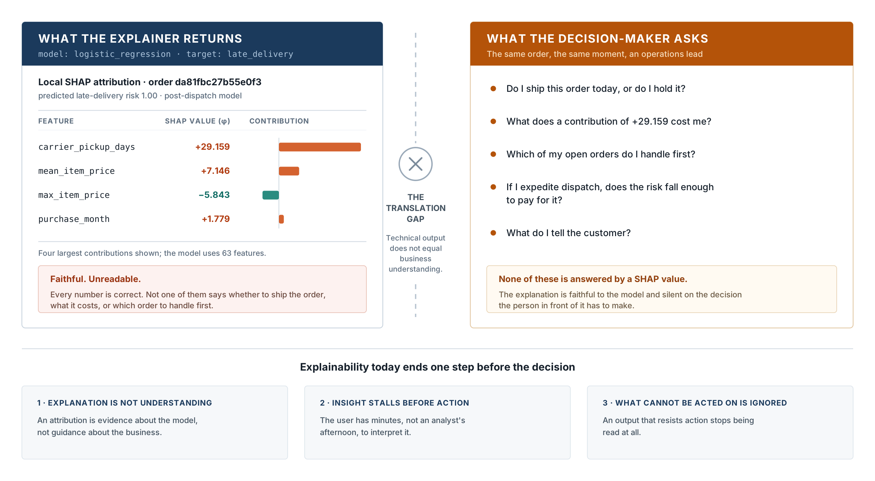
Figure 1. The explainability gap. The left panel reproduces the model’s own attributions for the order in Figure 5a; the right panel lists the questions an operations lead holds at the same moment. Source: Authors’ creation (2026).
3.2 Architecture and core functions
The BLL sits on top of an existing model and its explainer, leaving both untouched. As shown in Figure 2, it re-expresses the explanation through four sequential functions — interpret, contextualise, quantify, recommend — carrying a prediction from raw output to a decision and its expected outcome. Because the layer reads the explanation rather than the model, it introduces no retraining and no second predictive model.
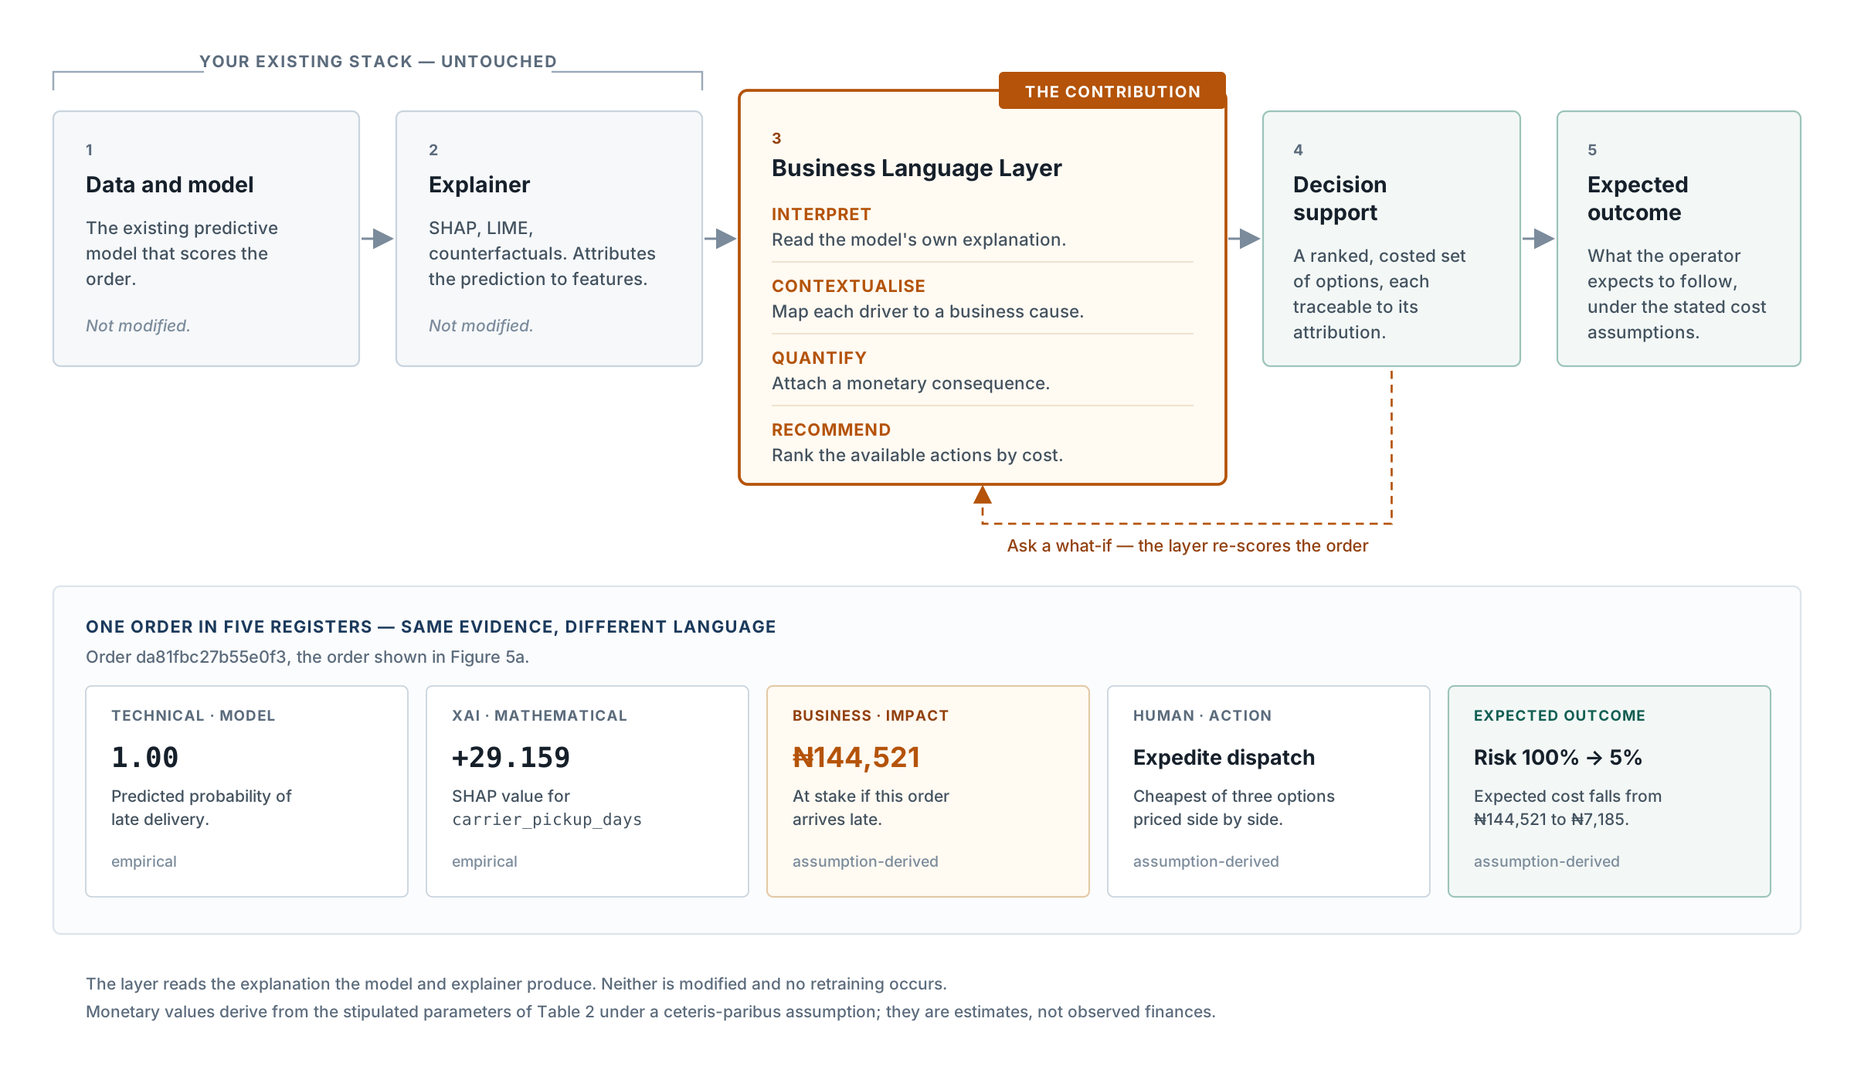
Figure 2. The Business Language Layer and its place in an existing analytics pipeline. The layer reads the explanation the model and explainer produce; neither is modified and no retraining occurs. The lower band shows the same order — da81fbc27b55e0f3, the order of Figure 5a — in each register: the model’s probability and the SHAP attribution are empirical, while the monetary figures and the expected outcome are assumption-derived from Table 2 and are estimates rather than recorded results. Source: Authors’ creation (2026).
3.3 Actionability and the lever distinction
The layer distinguishes features a business can change from those it can only observe. Shipping distance predicts lateness but cannot be altered once an order is placed; dispatch speed both predicts and can be acted upon. The glossary records this explicitly, and only features marked as levers enter the recommendation engine.
Where the data does not support a plausible intervention, the layer names the intervention and the missing field rather than omitting it. An option silently dropped looks like an option that never existed; an option shown as unavailable, with its reason, tells the user something about the data they are relying on. Section 5.3 supplies the empirical motivation for both choices.
4. Data and Methods
4.1 Data selection and Nigerian context
Because publicly available Nigerian order-level e-commerce datasets with both promised and actual delivery information are limited, the empirical evaluation uses the Olist Brazilian e-commerce dataset, a real-world transaction dataset providing the required order, seller, product, logistics and delivery information. The use of Olist is intended to provide a reproducible empirical test of the proposed framework rather than to represent Nigerian transaction behaviour. To examine contextual applicability in Nigeria, a separate synthetic Nigerian environment was developed using Nigerian locations, logistics scenarios and explicitly documented assumptions. The synthetic environment is therefore treated as a contextual demonstration rather than empirical evidence of Nigerian market behaviour. Validation with anonymised real-world Nigerian logistics or e-commerce data is identified as an important direction for future work.
4.2 Dataset and currency
The dataset (Olist & Sionek, 2018) records 99,441 orders placed on a Brazilian marketplace between September 2016 and August 2018, across nine relational tables, under a CC BY-NC-SA 4.0 licence. These are real commercial transactions released in anonymised form: identifiers are surrogate keys and company names in review text were replaced before release, no individual is identifiable, and this analysis uses no free-text review content. The dataset records both the promised and the actual delivery date, so lateness is directly observable rather than inferred.
Monetary values are denominated in Brazilian reais. For contextual presentation they are reported here in Nigerian naira, converted per order at the official annual average exchange rate for that order’s purchase year, derived from IMF International Financial Statistics official rates for both currencies (2016: ₦72.63/BRL; 2017: ₦95.86/BRL; 2018: ₦83.86/BRL; value-weighted effective rate ₦83.86/BRL). Conversion is applied per order because the cross-rate moved more than 20% across the window. The conversion provides a common naira representation of monetary scale and does not imply that the underlying transactions occurred in Nigeria or represent Nigerian market prices.
4.3 Target, grain and censoring
The target is binary: whether an order was delivered after the date promised at purchase. Only delivered orders with a recorded delivery date are retained. A right-censoring filter then removes orders whose promised date falls within 30 days of the last observed delivery, since such orders cannot yet be known to be late and retaining them would label an unknown outcome as on-time. Table 1 records the effect of each stage. All features are aggregated to order grain before modelling; the order-items table contains 112,650 rows, and joining at that grain would count multi-item orders more than once and weight the evaluation toward larger baskets.
Table 1. Construction of the modelling table
Stage | Orders | Late rate
Raw order records | 99,441 | —
Delivered, with a recorded delivery date | 96,470 | 8.11%
After 30-day right-censoring filter | 96,171 | 8.14%
Source: Authors’ creation (2026).
4.4 Leakage controls and evaluation split
Three classes of variable were excluded. Post-outcome fields — the actual delivery date, realised duration, delay, and the customer review and its timestamps — are derived from or revealed with the outcome. Fields unavailable at prediction time: carrier-handover timing is knowable only after handover, so two scenarios are evaluated separately — pre-dispatch (62 features, known at order time) and post-dispatch (63 features, additionally admitting handover timing). The distinction is operational: a pre-dispatch prediction supports a wider set of interventions; a post-dispatch prediction is more accurate but arrives later. Unbounded time counters — cumulative counts and tenure — increase monotonically with calendar time, so under a temporal split their evaluation values fall outside the training range entirely; bounded equivalents expressed as rates to date were retained instead.
The data were split by purchase date rather than at random: orders placed on or before 30 April 2018 train (70,883 orders), later orders evaluate (25,288). A random split would permit training on later months and evaluating on earlier ones, letting the model score well by memorising which periods had elevated late rates — information unavailable at deployment. It is also the harder test: the late rate falls from 8.81% in training to 6.25% in evaluation, so the distribution evaluated against differs measurably from the one learned.
4.5 Model, calibration and protocol
A logistic regression classifier was fitted within a pipeline performing all preprocessing inside cross-validation, with SMOTE (Chawla et al., 2002) applied inside the same pipeline so synthetic minority examples are generated only from training folds.
Calibration was applied separately. Resampling trains the classifier on an artificially balanced distribution, so its outputs rank cases correctly but are not probabilities of anything observable, and because the layer multiplies the predicted probability by a monetary exposure a miscalibrated probability propagates a multiplicative error into every monetary figure. Platt scaling (Platt, 2000; Niculescu-Mizil & Caruana, 2005) was fitted on a held-out slice taken by date: the classifier on the first 56,706 training orders (to 26 February 2018), the mapping on the 14,177 that follow (2,011 late). Taking the slice by date means the mapping is learned on data later than the classifier saw, matching deployment. Sigmoid scaling was preferred to isotonic because it is strictly monotone and cannot alter ranking.
Models are evaluated using ROC AUC, average precision and the Brier score (Brier, 1950). Average precision is reported alongside the evaluation positive rate, which is the no-skill value, because on an imbalanced problem an absolute average precision is uninterpretable without it. The operating threshold minimises expected cost rather than defaulting to 0.5, using the parameters of Table 2.
Table 2. Cost parameters — all values are stipulated assumptions, not measured finances
Parameter | Value | Role
Cost of a missed late delivery | 25 | Classification threshold selection
Cost of a false alarm | 4 | Classification threshold selection
Refund exposure | 0.42 × order value | Component of exposure
Repeat-purchase risk | 0.46 × order value | Component of exposure
Support handling cost | ₦1,200 (fixed) | Component of exposure
Intervention cost | ₦400 (fixed) | Cost of acting
Note. The first two are dimensionless ratios setting where the flagged queue begins. The remaining four produce every monetary figure in this paper. The two shares are proportional to order value; the two fixed amounts are stated directly in naira rather than converted, because converting a stipulated quantity would imply it had been measured elsewhere. Because the support cost is fixed, exposure can exceed order value on a small order. Section 8.2 reports the sensitivity of the resulting recommendations. Source: Authors’ creation (2026).
4.6 Reproducibility
All randomness is seeded, and the pipeline is implemented as a package with 159 automated tests, including a regression test fingerprinting the feature table — row count, column list, late rate and per-column statistics to 10⁻⁶ — so any change altering its output fails a test rather than producing a silently different result. The empirical and synthetic environments are separated structurally: each owns its directories, every trained model records the environment that produced it, and loading a model into the wrong environment raises an error. Reproducibility in this sense is a necessary condition for verification, not a claim about external validity.
4.7 Evidence classes and reading convention
The claims here rest on four kinds of support, and the distinction matters because the layer deliberately converts a statistical quantity into a monetary one. Empirical values are measured on real Olist data (Section 5). Empirical, currency-converted values are real Brazilian transactions expressed in naira per Section 4.2. Assumption-derived values — every exposure, expected loss, net saving and recommendation in Section 6 — are computed from Table 2 and are estimates under those parameters, not observed finances. Synthetic values are properties of the simulation of Section 7. A fifth category is proposed but unmeasured: the benefits in Section 8.3 concerning what a human understands, decides or trusts. Every figure caption names the evidence class of its values, without exception.
5. Empirical Results
5.1 Predictive performance and calibration
Table 3 reports performance on the held-out temporal evaluation set, for the deployed post-dispatch model and for the pre-dispatch variant that sees only fields available before handover.
Table 3. Model performance on the held-out temporal evaluation set (n = 25,288)
Model | AUC | Average precision | Brier | Threshold | Recall | Precision
No-skill (predict base rate) | 0.500 | 0.0625 | 0.0586 | — | — | —
Logistic regression, pre-dispatch | 0.7413 | 0.1549 | 0.0602 | 0.2572 | 0.2424 | 0.1990
Logistic regression, post-dispatch | 0.8389 | 0.3482 | 0.0514 | 0.2074 | 0.5608 | 0.2585
Note. All models calibrated. Threshold selected by expected cost. The positive rate in the evaluation set is 6.25%. All values empirical. Source: Authors’ creation (2026).
The post-dispatch model attains an AUC of 0.8389 and average precision of 0.3482 — 5.6 times the no-skill value of 0.0625, the more informative comparison on an imbalanced problem. At the cost-optimal threshold it identifies 56.1% of late deliveries, with 25.9% of flagged orders in fact late. The pre-dispatch model is materially weaker, which quantifies the cost of predicting before handover is observed: an operational trade-off to be stated rather than a deficiency to be corrected.
Calibration was isolated by holding the fitted classifier constant and evaluating it with and without the sigmoid mapping (Figure 3). The Brier score falls 83.3%, from 0.3085 to 0.0514, while AUC and average precision are unchanged to six decimal places — the expected consequence of a strictly monotone transformation, and a correctness check that it passed.
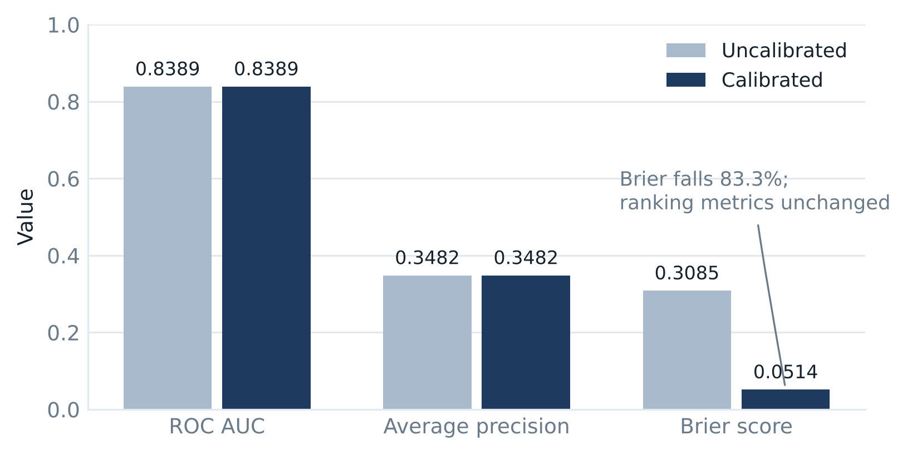
Figure 3. Effect of probability calibration on the same fitted classifier. Ranking metrics are unchanged; only the Brier score moves. All values empirical. Source: Authors’ creation (2026).
The practical consequence is the threshold. Before calibration the cost-minimising cutoff sits at 0.8247 on a problem with a 6.25% base rate — a value that cannot be interpreted as a probability of anything. After calibration it sits at 0.2074. For a system that displays a probability to a non-technical reader and multiplies it by an order value, this is the difference between a number that carries meaning and one that does not; calibration is therefore a precondition for this layer rather than a refinement.
One qualification. Across 500 evaluation orders the mean predicted probability is 0.1126 against an observed late rate of 6.25% — over-prediction of roughly 1.8 times, consistent with the mapping having been fitted on an earlier window while the base rate continued to fall. Monetary figures should therefore be read as upper estimates (Section 9.2).
5.2 Delivery lateness and customer satisfaction
Among 95,527 orders carrying a review, those delivered late received a mean review score of 2.5651 against 4.2942 for those on time — a difference of −1.7291 stars on a five-point scale (95% bootstrap CI [−1.7680, −1.6925], 2,000 resamples; Mann–Whitney U = 150,189,672, p < .001; rank-biserial correlation 0.5538), on 7,661 late and 87,866 on-time orders.
The effect is large and its interval narrow. It is nonetheless an association, not a causal estimate: a difference in group means with no covariates, on observational data in which lateness is not randomly assigned. It establishes the magnitude of what is at stake in a late delivery — the quantity the layer translates into business consequence — not what preventing one would recover.
5.3 What drives lateness, and what can be acted upon
Two complementary analyses of feature influence were conducted, and their disagreement is itself a finding. Permutation importance (Breiman, 2001) was measured on the held-out evaluation set by shuffling each feature and recording the drop in AUC (Figure 4). Dispatch-related features account for 4.4 times the predictive dependence of routing and geography, the three largest individual contributions being working days available within the promised window (0.219), the length of the promised window (0.141) and time to carrier handover (0.131). On this dataset late delivery is predominantly a dispatch problem rather than a routing problem — a conclusion with a direct operational reading, since dispatch timing is under the seller’s control in a way distance is not.
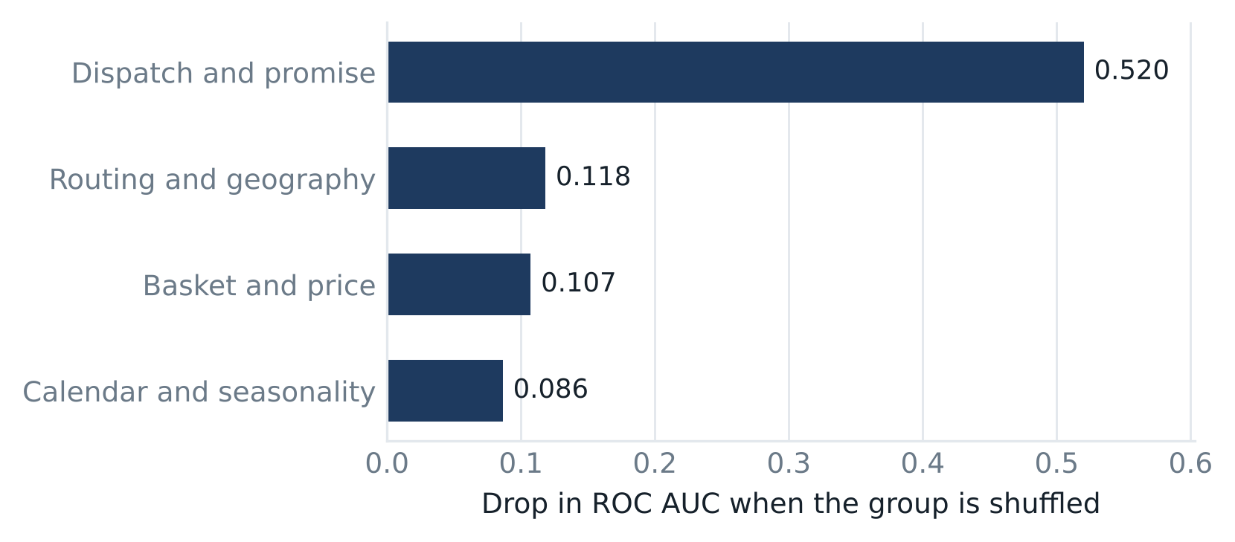
Figure 4. Permutation importance by feature group, held-out evaluation set. Values are the drop in ROC AUC when each group is shuffled. All values empirical. Source: Authors’ creation (2026).
The second analysis used SHAP attributions (Lundberg & Lee, 2017), computed against a background sample from the training period. The two rankings diverge substantially (Table 4).
Table 4. Divergence between attribution magnitude and predictive dependence
Feature | SHAP rank | Permutation rank
Purchase month | 1 | 8
Purchase quarter | 2 | 9
Purchase year | 3 | outside top 20
Working days in window | 4 | 1
Time to carrier handover | 7 | 3
Note. All values empirical. Source: Authors’ creation (2026).
The two measures answer different questions: SHAP quantifies how much a model uses a feature in forming a prediction, permutation importance how much predictive performance depends on it. A feature can be used heavily and yet be substitutable, in which case shuffling it costs little because correlated features absorb the loss.
The divergence matters for the contribution advanced here. An explanation surface ranking contributing factors by attribution magnitude would present seasonality as the dominant driver — faithful to the model and useless to an operations lead, because no available action changes the month in which an order was placed. Ranking by predictive dependence instead surfaces three factors that are all operational levers. This is the empirical basis for the lever distinction of Section 3.3: faithful attribution and actionable attribution are empirically not the same ordering.
Because three calendar features dominate the attribution ranking, the model was refitted without them. Removing the purchase year alone costs 0.019 AUC and reduces recall from 0.5608 to 0.4329; removing all three costs 0.023 AUC. The features therefore carry genuine signal, consistent with the marketplace’s declining late-delivery rate across the window. This creates a deployment caveat the evaluation cannot itself test: every calendar value in the evaluation period also occurs in training, so a model deployed on an unseen year would have no learned effect to apply, and 0.019 AUC is what is at risk.
6. The Layer as a Decision Surface
6.1 From a probability to a decision
A calibrated probability is not a decision. It says how likely lateness is; it does not say whether that warrants action, what action is available, or whether acting costs less than the consequence. Figure 5 shows the layer operating on two real Olist orders at opposite ends of the risk distribution: one at the top (5a), one close to the operating threshold (5b).
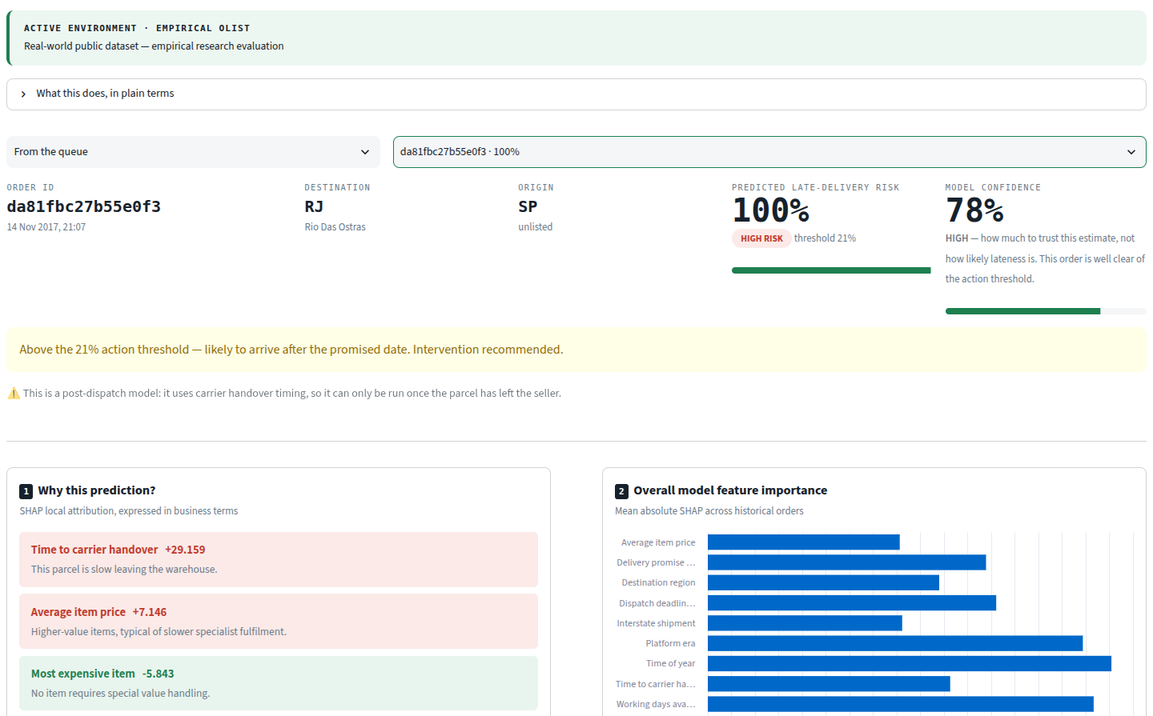
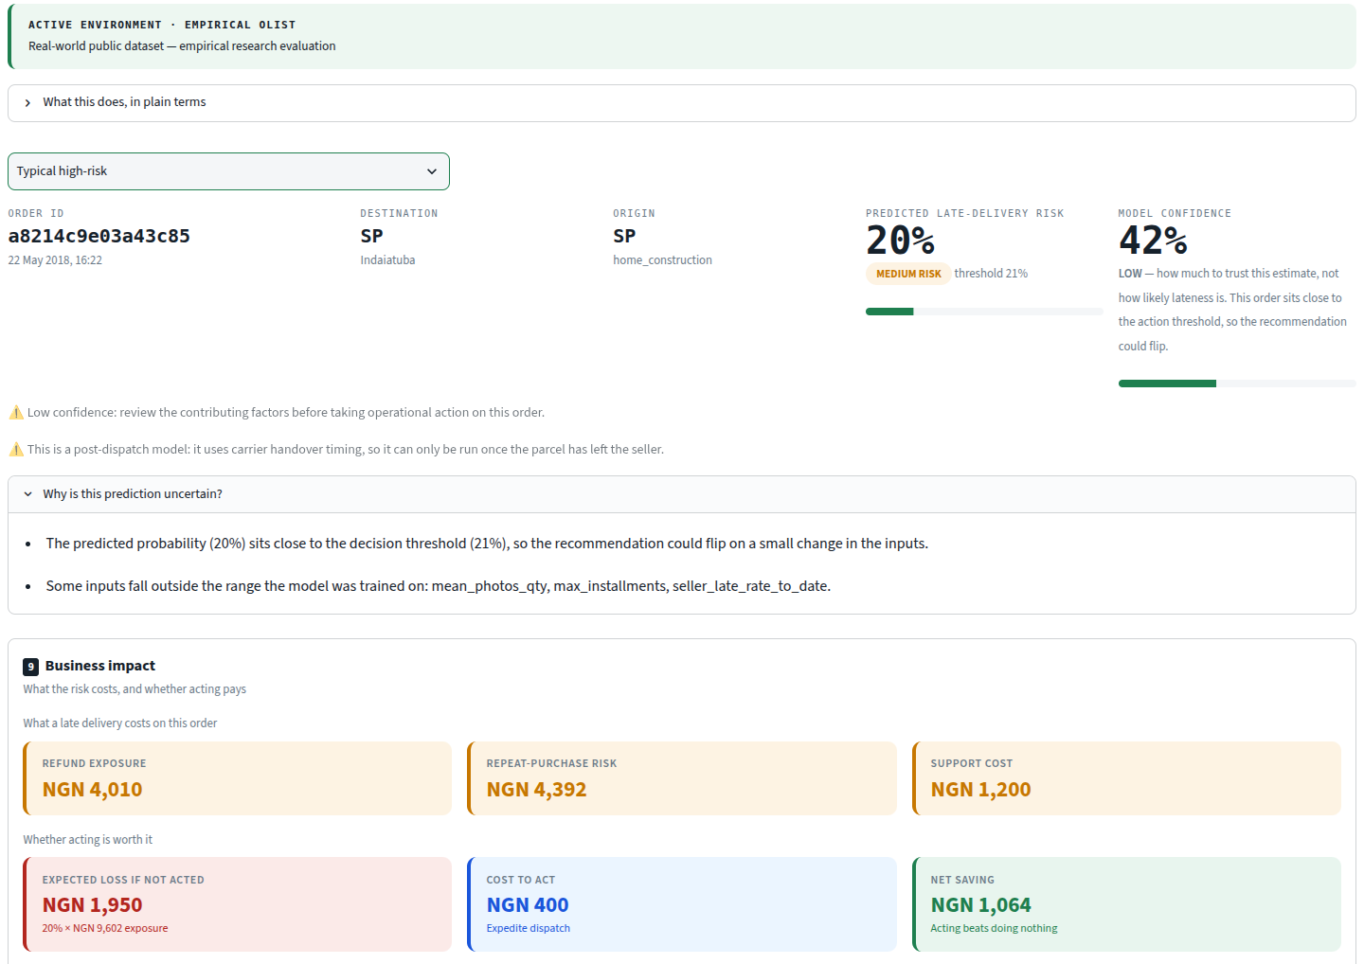
Figure 5. The Business Language Layer on two real Olist transactions. (a) Order da81fbc27b55e0f3 (14 November 2017, São Paulo to Rio das Ostras), at the top of the model’s risk distribution: the environment banner, the predicted risk and estimate confidence, and the model’s attributions rendered as business statements. (b) Order a8214c9e03a43c85 (22 May 2018), close to the operating threshold, with the uncertainty disclosure naming the three inputs that fall outside the model’s training range, above the business-impact panel in naira. Risk estimates, attributions and historical comparisons are empirical model output; order values are empirical, currency-converted (Section 4.2); exposure, intervention cost and net saving are assumption-derived from Table 2 and are not observed finances. The costed options for both orders are given in Table 5, and the business-impact panel’s summary line is quoted in Section 6.1. Source: Authors’ creation (2026).
Interpret. The layer converts SHAP attributions into sentences in the reader’s vocabulary. For order (a) the largest contribution is time to carrier handover (+29.159), rendered as “This parcel is slow leaving the warehouse”. The mapping is an explicit, auditable table rather than generated text, and features with no entry are flagged as unmapped rather than given invented language.
Contextualise. Two panels place the order against evidence independent of the model: its nearest historical neighbours, matched only on features knowable before delivery, and a comparison with its closest match (Section 6.3).
Quantify. Order (a) is worth ₦162,864 [converted]. Exposure is built from Table 2 — a refund share of ₦68,403, repeat-purchase risk of ₦74,918 and a fixed support cost of ₦1,200, totalling ₦144,521 [assumption]. Order value and exposure are kept distinct deliberately: a late delivery does not destroy an order’s value but triggers a refund, places repeat custom at risk and generates a support contact. Nor are they nested — because the support cost is fixed rather than proportional, exposure can exceed order value on a small order, as in Figure 5b, where the interface states both side by side: “This order is worth ₦9,547. A late delivery puts ₦9,602 at stake — refund and repeat-purchase risk, both shares of order value, plus a fixed ₦1,200 support cost.”
Recommend. Options are priced against doing nothing (Table 5). In (a) expediting carries the lowest total expected cost, ₦136,936 below shipping as-is. Extending the promise does not move this order’s risk and is shown rather than hidden, so the reader sees it was considered and rejected on the evidence.
Table 5. Costed options for the two orders in Figure 5
 | Risk after action | Action cost | Expected loss
(a) order da81fbc27b55e0f3, risk 100%
Ship as-is | 100% | ₦0 | ₦144,521
Expedite dispatch (recommended) | 5% | ₦400 | ₦7,185
Extend the promise | 100% | ₦400 | ₦144,521
(b) order a8214c9e03a43c85, risk 20%
Ship as-is | 20% | ₦0 | ₦1,950
Expedite dispatch (recommended) | 5% | ₦400 | ₦486
Extend the promise | 15% | ₦400 | ₦1,412
Note. Risk after action is recomputed by passing the perturbed order through the deployed pipeline; it is a model estimate under a ceteris-paribus assumption, not a causal guarantee. Monetary values are assumption-derived. Source: Authors’ creation (2026).
6.2 Two cost structures, and why they can disagree
Figure 5b appears at first to contradict itself. The predicted risk of 20% falls below the 20.74% classification threshold, so the order is not flagged. Yet the layer still reports expediting as the lowest-cost option, by ₦1,064.
The two answer different questions under different cost structures. The classification threshold minimises expected misclassification cost across the whole evaluation set using the weights of Table 2 — a population property, setting where the flagged queue begins. The recommendation compares this order’s expected costs under the separate business cost model, whose stipulated parameters encode a different ratio between the cost of acting and the cost of being wrong.
An order can therefore sit below the flagging threshold while still having lower expected cost if acted upon, under the stated assumptions. We do not claim the intervention is objectively correct in such a case, only that it carries lower expected cost given Table 2’s parameters; Section 8.2 reports how far that moves when they vary. The interface surfaces the divergence rather than reconciling it silently, since suppressing the recommendation would discard an inference the system had already made.
6.3 Capability disclosure and what changes between cases
A recommendation engine can only evaluate levers the data supports. Four plausible interventions — courier tier, fulfilment centre, weather, seller rating — are disabled and named with the reason given, because the Olist dataset records none of them; the interface lists each alongside the missing field in its model-card view. Simulating them would require inventing both the control and the figure it produces. Disclosing their absence costs the interface an apparent capability and buys a defensible one.
The two orders make the same four functions produce very different screens (Table 6).
Table 6. The decision surface across two orders
 | Figure 5a | Figure 5b
Predicted risk | 100% | 20%
Position against the 20.74% threshold | well above | just below
Estimate confidence | 78%, high | 42%, low
Out-of-range inputs reported | none | three named
Nearest-neighbour similarity | 12% | 88%
Neighbours that arrived late | 9 of 10 | 0 of 10
Levers reaching the lower risk band | 1 of 4 | 3 of 4
Recommended action | expedite dispatch | expedite dispatch
Note. All values are empirical model output or recorded historical outcomes for the two displayed orders. Neighbour counts describe those orders’ local neighbourhoods only. Source: Authors’ creation (2026).
Similar-order evidence is local. The 9-of-10 and 0-of-10 figures describe each order’s ten nearest historical neighbours. They are not a measure of model accuracy, a validation statistic, or a statement about the population; Section 5 reports the population-level evaluation. The mean similarity figures show why the caution is necessary: the high-risk order’s neighbours are only 12% similar to it, so its 9-of-10 rests on a thin comparison, while the near-threshold order’s neighbours are 88% similar, making its 0-of-10 a closer analogy. Neighbour evidence is weaker precisely where the prediction is most extreme, because extreme orders have fewer close matches, so the interface reports mean similarity alongside the outcome count.
Confidence and levers. Figure 5b carries low estimate confidence, and the interface explains why: the probability sits close to the decision threshold so the recommendation could flip, and three input values fall outside the training range. Confidence here describes how much the estimate should be trusted, not how likely lateness is. For order (a) three of four levers cannot reach the lower risk band at any value; for (b) three of four can, and each change is evaluated independently so the effects do not compose. That a system can report no single action is sufficient matters: Section 8.4 observes that a fluent costed recommendation is more persuasive than a raw attribution, including when the model is wrong. A layer that only ever produced confident recommendations would exhibit that failure mode; one that reports structural risk, low confidence and out-of-range inputs does not.
6.4 What these figures do and do not establish
Figure 5 shows the layer running end to end on real data and producing a traceable decision brief across different cases. It does not establish that an operations lead reaches a better decision with it, more quickly, or with better-calibrated trust. Those are properties of the human using the interface, and no study here measures them.
The figures in this section are screen captures from the running system; an earlier draft used designed mockups. Preparing the captures incidentally exposed five implementation defects mockups could not have exhibited: a cached risk vector surviving an environment switch, so one environment’s predictions were indexed against another’s orders; nine geographic features with no glossary entry, which the layer correctly reported as unmapped; a summary sentence describing the full order value as at risk where the arithmetic beside it used exposure; a later revision of that sentence which assumed exposure was contained within order value, a relation that does not hold on small orders; and a style rule rendering text typed into the interface’s own controls invisible. The first and third would otherwise have entered this paper as claims. The point is narrow: captures from a running system expose defects static mockups conceal, because a mockup renders what its author intended rather than what the system does.
7. Synthetic Nigerian Demonstration Environment
7.1 Purpose and construction
Section 4.1 stated the constraint: no public Nigerian dataset records both promised and actual delivery dates at order level. Two questions remain. Does the architecture transfer to a different geography, calendar and currency without modification? And can the framework be demonstrated publicly without a licensed dataset?
The generator emits nine tables matching the Olist schema, so the existing pipeline consumes them without special-casing. That schema parity is the architectural mechanism: cleaning, feature engineering, leakage controls, splitting, censoring, SMOTE, calibration, SHAP and the layer itself are the same code over different inputs. Only three things differ, all supplied by an environment object rather than branched on in the modelling path: the raw directory, the holiday calendar and the geographic bounding box. Geography covers 18 Nigerian cities at real coordinates across all six geopolitical zones, with corridor friction applied per zone and penalties for inter-zone movement (×1.18) and river crossings (×1.10) [synthetic]; the calendar carries Nigerian public holidays, a late-December commercial peak and the two Eid periods.
Lateness is not imposed. Transit time is generated causally from distance, corridor friction, parcel weight, non-working days and a noisy shock, and lateness is whatever falls out of comparing arrival against the promise. A discarded generator design drew the label first and back-filled timestamps, silently forcing roughly 20% of nominally on-time orders late. Noise is deliberately large: a generator making lateness a clean function of distance would be learnable to near-perfect accuracy and would make the explanation layer look far more decisive than any real deployment. Generation is seeded, a verification mode regenerates twice and fails the build if the outputs differ, and 23 of the 159 tests cover this environment.
7.2 Results, and how to read them
The build produces 77,444 modelling rows from 80,000 generated orders at a 9.31% late rate, split at 30 June 2024 into 52,853 training and 24,591 evaluation orders [synthetic]. Table 7 places the two environments side by side, and Figure 6 shows the interface running unmodified on the synthetic one.
Table 7. Model performance in the two environments
 | Empirical Olist [empirical] | Synthetic Nigerian [synthetic]
Modelling orders | 96,171 | 77,444
Late rate | 8.14% | 9.31%
Evaluation orders | 25,288 | 24,591
ROC AUC | 0.8389 | 0.8632
Average precision | 0.3482 | 0.5191
Brier score | 0.0514 | 0.0737
Decision threshold | 0.2074 | 0.2839
Note. The two columns are not comparable as evidence. The left reports measurements on real transactions; the right reports properties of a simulation. They are placed together to make the methodological point stated below, and for no other purpose. Source: Authors’ creation (2026).
In the synthetic Nigerian demonstration environment the model achieved an AUC of 0.8632 and average precision of 0.5191. These results reflect the simulated environment and do not constitute evidence of model performance on real Nigerian e-commerce data.
The comparison must be read in a specific direction, because the intuitive reading is wrong. The synthetic environment scores higher on both ranking metrics — average precision 0.5191 against 0.3482, nearly 50% in relative terms. This is not evidence that delivery risk is more predictable in Nigeria, nor that the framework performs better there. A generator produces cleaner relationships than a logistics network does: the simulated problem has a known functional form, bounded noise and no unmeasured confounding, so a model recovers more of the signal placed there. Higher apparent performance in a synthetic environment is therefore a reason to discount it, not to credit it — the gap measures the simplification, not the capability. A second symptom points the same way: the highest-risk synthetic order is scored at essentially certainty, which real delivery prediction rarely approaches.
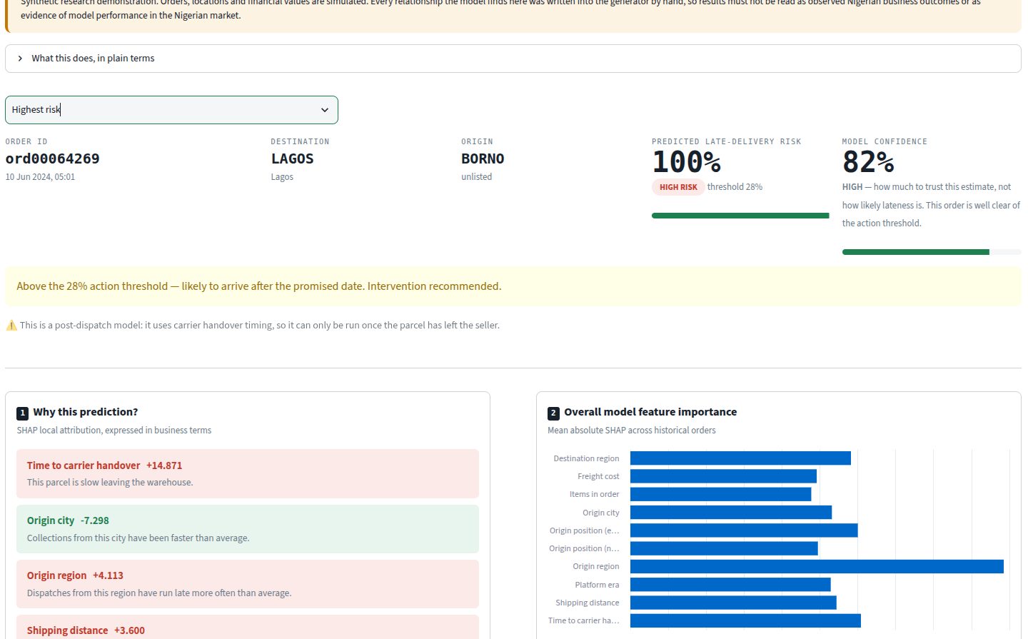
Figure 6. The same interface, unmodified, on the synthetic Nigerian demonstration environment, showing the highest-risk generated order (ord00064269, Lagos to Borno). All values synthetic: orders, locations and monetary values are simulated, and every relationship the model recovers was encoded in the generator, so no value shown constitutes evidence about Nigerian e-commerce. The environment banner, visible at the top of every page, cannot be dismissed. Source: Authors’ creation (2026).
7.3 What the environment can and cannot establish
Every relationship the model recovers here was placed there by the generator; the SHAP values are computed correctly, but what they recover is the configuration file. The following must not be read as findings about Nigerian commerce: that northern corridors run slower than southern ones; that inter-zone shipments carry a transit penalty; that geography dominates dispatch as a driver of lateness, the opposite of the empirical result in Section 5.3; or any monetary figure. That reversal is the clearest illustration — in the empirical data dispatch outweighs routing by 4.4 times [empirical]; in the synthetic environment geography leads [synthetic]. The two are not in tension, because only one is a measurement.
Three claims are supportable: the architecture is portable, one pipeline serving two environments with no modification to the modelling path; the contextual adaptation works, the layer operating in naira over Nigerian routes against a Nigerian calendar with capability disclosure correctly reporting which levers the dataset supports; and a reproducible public demonstration exists requiring no licensed dataset.
8. Discussion
8.1 What the empirical evaluation supports
Three findings bear on the framework rather than only on the dataset.
Calibration is a precondition. Isolating the sigmoid mapping reduced the Brier score 83.3% and moved the operating point from 0.8247 to 0.2074, ranking metrics unchanged. For a conventional classifier the threshold shift is an implementation detail; for this layer it is structural, because the probability is multiplied by a monetary exposure. Any system converting model output into money inherits this requirement.
Faithful and actionable attribution are different orderings. SHAP ranked seasonal features highest, permutation importance ranked dispatch features highest, and both are correct about what they measure. For an explanation surface that drives action, ranking by attribution alone would surface drivers no operations lead can change.
A decision-support layer should be able to decline. On the evaluation sample the layer recommends no intervention on 360 of 500 orders under the stated parameters: the most common output of this decision surface is to do nothing. We report this because a system recommending action on every order would be easier to demonstrate and harder to trust.
8.2 Sensitivity of the economic estimates
Section 6.2 argued that an order may fall below the classification threshold while intervention still carries lower expected cost under the stated assumptions. That argument is only as strong as the assumptions. The recommendation compares, per option, expected cost = risk(option) × exposure(order value) + action cost, where exposure = (refund share + churn share) × order value + support cost. Only risk is measured. A one-way sensitivity analysis was run over each stipulated quantity across a range extending well beyond the chosen value, on 500 held-out evaluation orders (Table 8).
Table 8. Break-even intervention cost per order (500 evaluation orders)
Percentile | 10th | 25th | Median | 75th | 90th
Break-even action cost | ₦29 | ₦69 | ₦178 | ₦453 | ₦983
Note. Computed at the refund, churn and support parameters of Table 2. All values are assumption-derived; the underlying risks are empirical. Source: Authors’ creation (2026).
At the stipulated intervention cost of ₦400, 28.0% of orders break even above it — intervening carries lower expected cost for roughly one order in four. For the median order it does not. The recommendation to act is not a general property of high-risk orders; it is a property of particular orders under particular parameters.
Across the full parameter grid, the recommendation agrees with the one given at the stated values 88.8% of the time. But only 1.8% of orders have a recommendation that never changes anywhere in the range, and 17.6% change in more than a quarter of settings. Both should be read together: the first says the system is not fragile, the second that no monetary conclusion is assumption-free and that for a sixth of orders the recommendation is genuinely contingent. We regard the pair as the honest bound on every naira figure here. This constrains the economic claims and not the empirical ones — varying refund share does not move the AUC, the calibration effect, the review association or the feature-dependence results, and no amount of empirical accuracy makes an assumption-derived saving into an observed one. A fuller treatment would vary the parameters jointly, using values elicited from an operator.
8.3 Benefits: computable, deployment-dependent, and proposed
The benefits the layer is designed to deliver do not share an evidential standing, and Table 9 separates them accordingly. Four of the ten can be measured without human participants, and computing them is immediate work rather than a research programme. The remaining six concern human outcomes. No study in this paper measures any of them, and none is claimed as achieved.
Table 9. Benefit claims by evidential status
Benefit | Status | Proposed measure
Actionable insight — every explanation names an available intervention | Computable now | Share of explanations carrying a feasible action
Comparative reasoning — alternatives priced side by side | Computable now | Option coverage against the available action space
Traceability — each statement carries its originating attribution | Computable now | Trace completeness; internal audit pass rate
Disclosure — recommendations declare which features they used | Computable now | Protected-attribute disclosure rate
Financial and operational framing | Requires deployment | Predicted variance against realised outcome
Business-centric explainability | Proposed | Users able to state the business consequence unaided
Business-language translation | Proposed | Register match against the organisation’s vocabulary
Human-centred communication | Proposed | Time to comprehension in think-aloud studies
Designed to support improved decision-making | Proposed | Decision latency; decision reversal rate
Scenario exploration | Proposed | What-if queries per session; depth of probing
Note. “Computable now” means derivable from the implementation without human participants; these have not yet been computed and reported. “Proposed” means the benefit concerns what a person understands, decides or trusts and requires a controlled study. Source: Authors’ creation (2026).
8.4 The persuasion problem
One consideration is intrinsic to the approach. Because the layer re-expresses an attribution as a fluent costed recommendation, its output is more persuasive than the attribution it came from — including where the model is wrong. A reader who treats “+0.134 for freight_value” with appropriate caution may not treat “acting now saves ₦136,936” the same way, though the second is the first plus four stipulated numbers.
This makes several design choices load-bearing: calibration, because the monetary figure scales with the probability; preservation of the original attribution alongside every business statement, so a claim can be checked; capability disclosure, so an unavailable lever is named rather than omitted; and the system’s willingness to report low confidence, out-of-range inputs and the absence of any sufficient lever. Figure 5b shows all three at once while still pricing the options.
9. Limitations and Future Work
9.1 No controlled user study
This paper reports no controlled study of human decision-making, and no claim about comprehension, decision speed, decision quality or trust is supported by evidence collected here. The benefits in the lower half of Table 9 remain intentions. Specifying what such a study would require is more useful than restating its absence: a within-subjects design, with operations and analytics staff seeing matched orders under a SHAP-only and a Business Language Layer condition, would permit measurement of time to decision and decision quality against held-out ground truth. The measure that matters most is appropriate reliance — whether a participant correctly rejects the recommendation when the model is wrong. A study measuring only speed and confidence would risk validating the persuasion identified in Section 8.4 rather than the decision quality.
9.2 Scope and constraints on the empirical evidence
The evaluation uses one dataset, one domain and one geography. The architecture is domain-agnostic by construction, but this paper demonstrates portability only across environments sharing a schema, not across domains; instantiation in finance or clinical triage would test the claim properly.
Three constraints should be stated plainly. The review-score relationship is associational, a group mean difference without covariates on data in which lateness is not randomly assigned. Calibration decays (Section 5.1), so monetary figures are upper estimates and periodic recalibration is a deployment requirement; a full reliability analysis has not been conducted. Calendar features limit transfer across time: every calendar value in the evaluation period also occurs in training, so this evaluation cannot test an unseen year, and 0.019 AUC is what is at risk.
9.3 Economic estimates rest on stipulated parameters
The four cost parameters were chosen, not elicited or measured. Section 8.2 reports the consequence. Parameters should be elicited from an operator, the sensitivity analysis should vary them jointly, and predictions should be logged against realised outcomes so the predicted-versus-realised comparison becomes computable.
9.4 The synthetic environment is not external validation
Section 7 establishes portability and reproducibility, not real-world validity. No figure from that environment is evidence about Nigerian commerce. Validation requires anonymised order-level data from a Nigerian logistics or e-commerce operator recording both promised and actual delivery dates; the absence of a suitable publicly available Nigerian order-level dataset containing those fields is what limited empirical Nigerian validation in this study, and obtaining such data is the primary direction for future work. In order of what would most strengthen the claims: a controlled user study with appropriate reliance as a primary measure; validation on real Nigerian operator data; instrumentation of the four computable benefits; joint sensitivity analysis with elicited parameters; and instantiation in a second domain.
10. Conclusion
This paper introduced the Business Language Layer, an assisted-explainability reasoning layer that consumes conventional explainability output and re-expresses it as business intelligence, and reported an empirical instantiation of it.
Established empirically. On 96,171 real Olist orders evaluated on a held-out temporal split, the model attains an AUC of 0.8389 and average precision of 0.3482 against a no-skill value of 0.0625. Isolating probability calibration reduced the Brier score 83.3% and moved the operating point from 0.8247 to 0.2074 with ranking metrics unchanged, establishing calibration as a precondition for any layer that multiplies a probability by a monetary exposure. Late delivery is associated with a mean review-score difference of −1.7291 stars (95% CI [−1.7680, −1.6925]). Dispatch features outweigh routing by 4.4 times in predictive dependence while attribution magnitude ranks seasonal features highest — a divergence with direct consequences for explanation surfaces intended to drive action.
Demonstrated. The architecture runs unmodified over a second environment with Nigerian geography, calendar and currency, supported by a seeded generator, structural isolation and automated tests. This demonstrates portability and provides a reproducible public demonstration requiring no licensed dataset; it establishes nothing about Nigerian commerce.
Contributed. The layer between a faithful explanation and a defensible decision: the distinction between features that can be acted upon and features that merely predict; capability disclosure; traceability from each business statement to its originating attribution; and the costing of alternatives, so a recommendation arrives with its own justification.
Not established. No controlled study of human decision-making was conducted, and benefits concerning comprehension, decision speed, decision quality and trust remain design intentions. Every monetary figure derives from stipulated cost parameters, and a sixth of recommendations change under plausible variation of them. Validation with real Nigerian operator data remains outstanding.
The position taken here is deliberately narrow, and bounded by the evidence reported. We do not claim that the Business Language Layer improves human decisions. We claim that it converts a faithful explanation into a costed, traceable, disclosure-bearing decision brief without retraining the model; that this conversion has requirements — calibration foremost — which this evaluation quantifies; and that the layer’s value for the people who must act on it is a question this work makes testable rather than one it answers.
Ethical statement. The study used a publicly available, anonymised transaction dataset and involved no human participants. Formal ethical approval was not required.
Funding. This research received no specific grant from any funding agency in the public, commercial, or not-for-profit sectors.
Conflicting interest. The authors declare no conflict of interest.
Data availability. The Olist Brazilian E-Commerce Public Dataset is publicly available on Kaggle under a CC BY-NC-SA 4.0 licence; it is not redistributed with this work. The analysis code, synthetic environment generator, test suite and evaluation outputs are available at https://github.com/datalabteamworld/BLLforExplainableAI. The synthetic environment is generated independently of the Olist data and is reproducible from a fixed seed.
Use of generative AI. During the preparation of this work the authors used Claude (Anthropic) to draft and revise the manuscript text, to produce Figures 1 and 2, and to assist with the analysis, verification and plotting code. The research question, study design, dataset selection, modelling pipeline and all empirical results are the authors’ own. No data, empirical results or references were generated by the tool; every reported value was computed by the analysis code released with this work, and every reference was verified against its original source. The authors reviewed and edited all content and take full responsibility for the content of the publication.
References
Breiman, L. (2001). Random forests. Machine Learning, 45(1), 5–32. https://doi.org/10.1023/A:1010933404324
Brier, G. W. (1950). Verification of forecasts expressed in terms of probability. Monthly Weather Review, 78(1), 1–3. https://doi.org/10.1175/1520-0493(1950)078<0001:VOFEIT>2.0.CO;2
Chawla, N. V., Bowyer, K. W., Hall, L. O., & Kegelmeyer, W. P. (2002). SMOTE: Synthetic minority over-sampling technique. Journal of Artificial Intelligence Research, 16, 321–357. https://doi.org/10.1613/jair.953
He, G., Aishwarya, N., & Gadiraju, U. (2025). Is conversational XAI all you need? Human-AI decision making with a conversational XAI assistant. In Proceedings of the 30th International Conference on Intelligent User Interfaces (pp. 907–924). Association for Computing Machinery. https://doi.org/10.1145/3708359.3712133
International Monetary Fund. (2026). International financial statistics: Official exchange rate (LCU per US$, period average) [Data set].
Lundberg, S. M., & Lee, S.-I. (2017). A unified approach to interpreting model predictions. In Advances in neural information processing systems 30. Curran Associates. https://papers.nips.cc/paper_files/paper/2017/hash/8a20a8621978632d76c43dfd28b67767-Abstract.html
Niculescu-Mizil, A., & Caruana, R. (2005). Predicting good probabilities with supervised learning. In Proceedings of the 22nd International Conference on Machine Learning (pp. 625–632). Association for Computing Machinery. https://doi.org/10.1145/1102351.1102430
Olist, & Sionek, A. (2018). Brazilian e-commerce public dataset by Olist [Data set]. Kaggle. https://www.kaggle.com/datasets/olistbr/brazilian-ecommerce
Platt, J. C. (2000). Probabilistic outputs for support vector machines and comparisons to regularized likelihood methods. In A. J. Smola, P. Bartlett, B. Schölkopf, & D. Schuurmans (Eds.), Advances in large-margin classifiers (pp. 61–74). MIT Press.
Ribeiro, M. T., Singh, S., & Guestrin, C. (2016). “Why should I trust you?”: Explaining the predictions of any classifier. In Proceedings of the 22nd ACM SIGKDD International Conference on Knowledge Discovery and Data Mining (pp. 1135–1144). Association for Computing Machinery. https://doi.org/10.1145/2939672.2939778
Speckmann, P., Nadj, M., & Janiesch, C. (2025). IXAII: An interactive explainable artificial intelligence interface for decision support systems (arXiv:2506.21310). arXiv. https://arxiv.org/abs/2506.21310
Wang, D., Yang, Q., Abdul, A., & Lim, B. Y. (2019). Designing theory-driven user-centric explainable AI. In Proceedings of the 2019 CHI Conference on Human Factors in Computing Systems (pp. 1–15). Association for Computing Machinery. https://doi.org/10.1145/3290605.3300831

