PHP Store:
Readme
Version 0.1
Modification Date: 11/8/26
Authors: Egor Chibisov

Contents
1 Overview 2
2 Installation 3
2.1 Pre-requirements: 3
2.2 Installation 3
3 Store usage 4
4 Search usage 4
5 Permissions usage 4
5.1 Details page 4
5.2 Thank you page 5

Revision history
Date | Name | Description
06/09/2008 | Egor Chibisov | Created
25/09/2008 | Egor Chibisov | Updated after bug fixes and integration.
07/09/2009 | Egor Chibisov | Updated: added pre requirements section 2.1

Overview
Store consists of 3 pages: Catalog (catalog.php), Details (details.php), and Thank You (thankyou.php).
All pages have the same shared header (header.php). Header adds Adobe logo and search functionality.
“Details” and “ThankYou” pages share the same footer (footer.php). Footer adds “Return to catalog” functionality. Upon return, catalog will be positioned of the last selected book.
Other files used in store are:
- config.php – includes constants and variable definition.
Main constants are:
path to store xml file: define('CATALOG_XML_FILE', "books.xml")
path to store configuration xml define('CFG_XML_FILE', "config.xml")
- functions.php – include common functions, used in store;
- xmlinit.php – xml initialization lines, common for all pages;
- books.css – store’s cascade style sheet, used by all pages;
- books.xml – actual list of books, included in store. This file can have different name and should be defined in config.php. File is coming from ACS4 server export.
- Config.xml – store configuration, includes shared secret, store ID, server URL and some other settings. This file can have different name and should be defined in config.php.
- index.htm- html file, contain redirection to catalog.php
- index.php- php file, contain redirection to catalog.php
- subfolder /images/ contains adobe logo and “no image” images.

Installation

Pre-requirements:

You can use phpinfo.php script within the store folder, to gather the information regarding current php configuration. Please make sure that the section DOM exists. If it does not - please install php-xml package or refer to the "store_php_sample_known_issues.doc" document.
Section DOM of phpInfo might look like that:
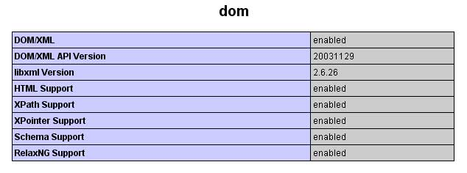

Installation
Store does not require any installation other then copy it to any subfolder within the web site folder. If the web site’s root domain is www.domain.com and store’s files were copied to /bookstore/ subfolder, then final store url will be www.domain.com/storefolder/
Known installation issues are described in “store_php_sample_known_issues.doc” document.

Store usage
Supposed store use case is:
- Open catalog page. Choose the book and click purchase/details shortcut.
- Review book’s details, enforce some permissions (if needed), click on “purchase” or “borrow” button
- See order information and resulting permissions, click on “download” link to start book download and open it in ADE.

Search usage
Search implemented is a single line search, where search key can be one word, several words or regular expression. Upon receiving of search request, store script will try to validate entered search key as a regular expression. If it is not a valid regular expression, then regular word search will be performed. Entered phrase will be separated to words (space, comma and semicolon are valid delimiters).
Search applies entered keywords to book’s Title, Description, Author and Book ID fields. If you entered several words, then search will apply every word to every field and shows all matches.

Permissions usage
Store shows default book’s permissions on Details page.
Store allows changing (enforcing) book’s permissions on Details page. Store does not allow making permissions any weaker.

Details page
On Details page store shows the permissions, defined in store’s xml file.
If no <permissions /> tag specified – we treat it as “all allowed”.
If tag <permissions /> is specified but is empty – it means “all denied”.
Following construction is the same as missing <permissions /> tag , and means “all allowed”
<permissions>
<display /> // display unlimited
<excerpt /> // copy -unlimited
<print /> // print unlimited
</permissions>

In the following case permissions for copy and printing are missed, and therefore are denied:
<permissions>
<display /> // display unlimited but copy and print are denied.
</permissions>

Details page also contains “Restrict Permissions Further” form, which allows user to enforce some or all books permissions.
In order to enable permissions enforcing, checkbox on the left of every permissions type should be checked.

Thank you page
Permissions shown on “Thank You” page are the result of “Restrict Permissions Further” forms submissions.
These permissions will enforce default book permission. It cannot make permissions weaker, server will ignore all permissions requests which are weaker then default permissions.

