If you by mistake have created a “git” file / folder in your github that would look like this 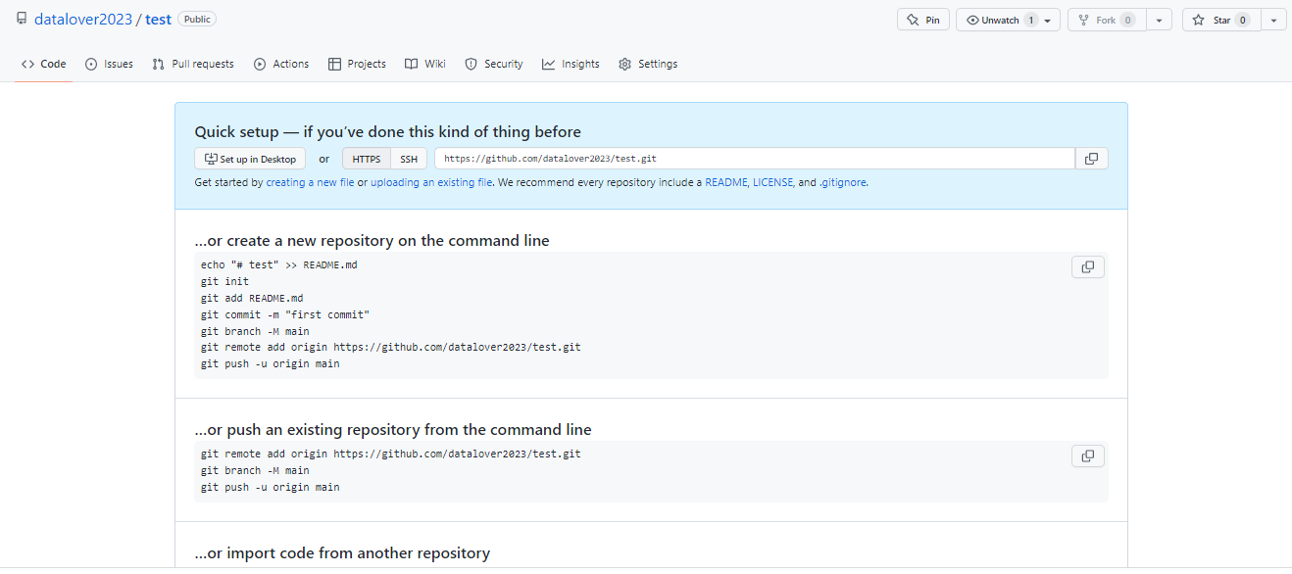

and you want to delete it…

Or a “classic” **repository** like here below example of Test_1 and want to delete it…

Follow this steps:

1. **Go on the main page of your github and click on “Repositories” and then on the repository you’d like to delete (Test_1)**

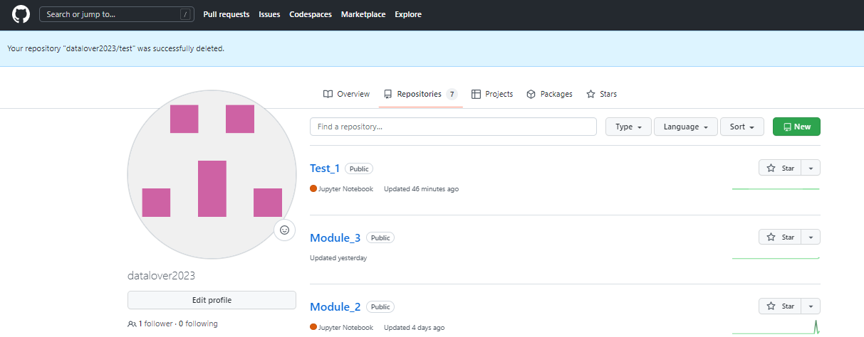

1. **It will redirect you to the folder Test_1…**

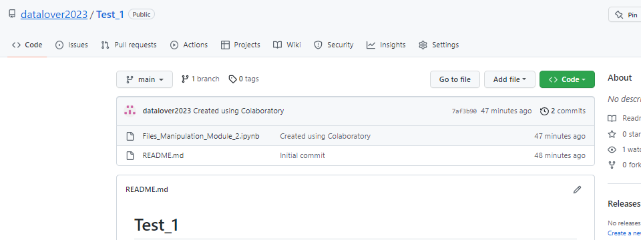

1. **Click on « Settings »**

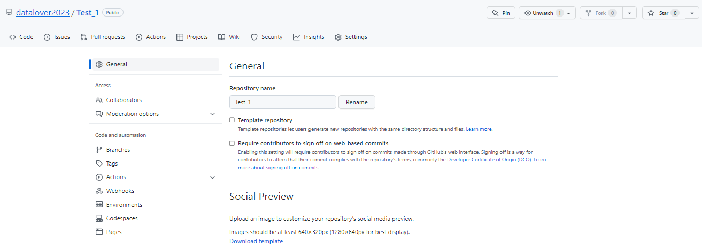

1. **Scroll down to « Danger Zone » ... and click on “Delete this repository”** 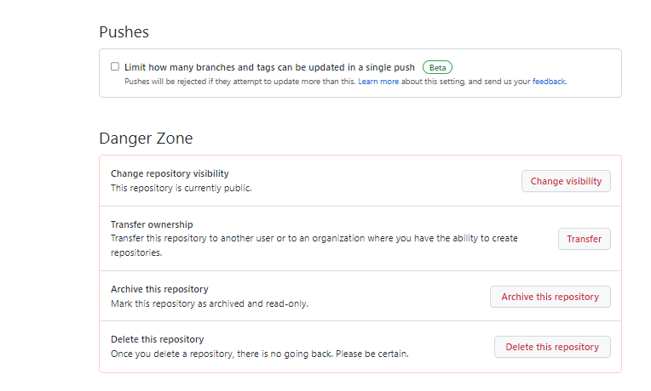

**5. It will ask you to confirm by typing the path to your repository and the click on ‘I understand the consequences…”**

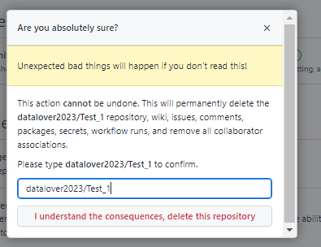

1. It may ask you to confirm the access…

