**Download from GitHub**

1. **Go to github page where you like to download** <https://github.com/datalover2023> …

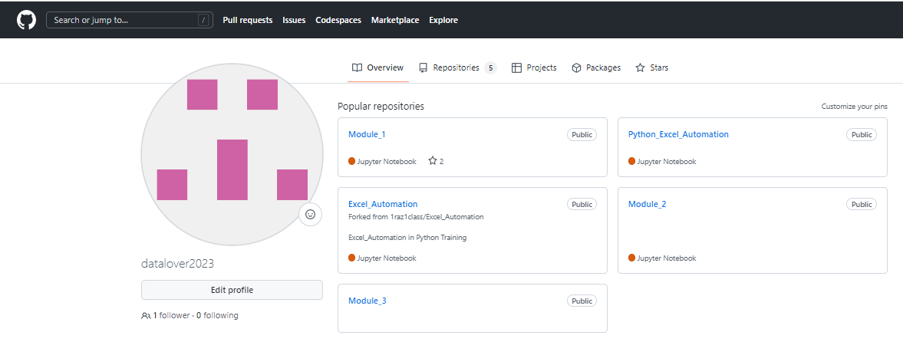

1. **Click on the repository you’d like to download (ex. Module_2)**

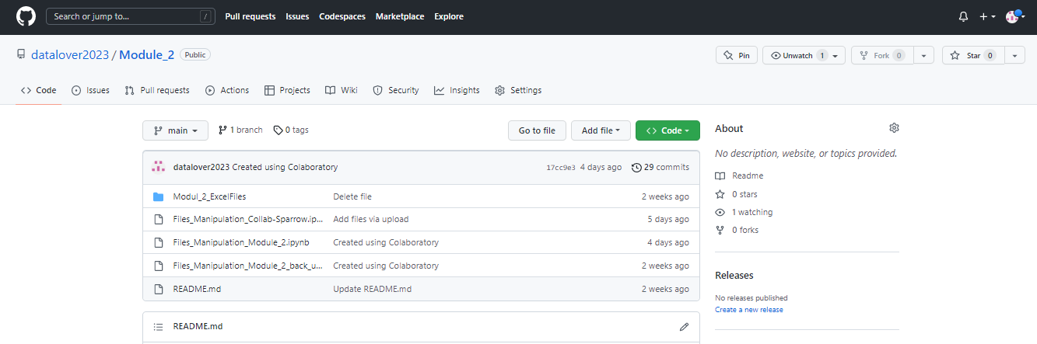

1. **Click on the green button “Code”**



1. **Then click on Download ZIP**

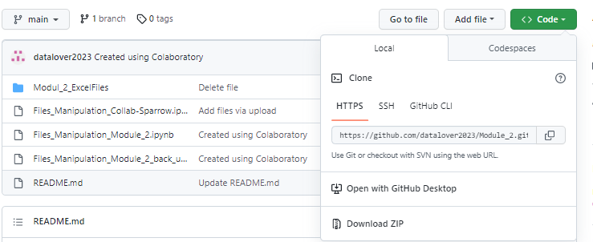

1. **In your downloads folder UNZIP the folder….**

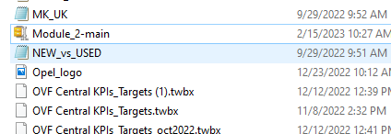

**Upload in Google Colab**

1. **Go to your Google Colab**

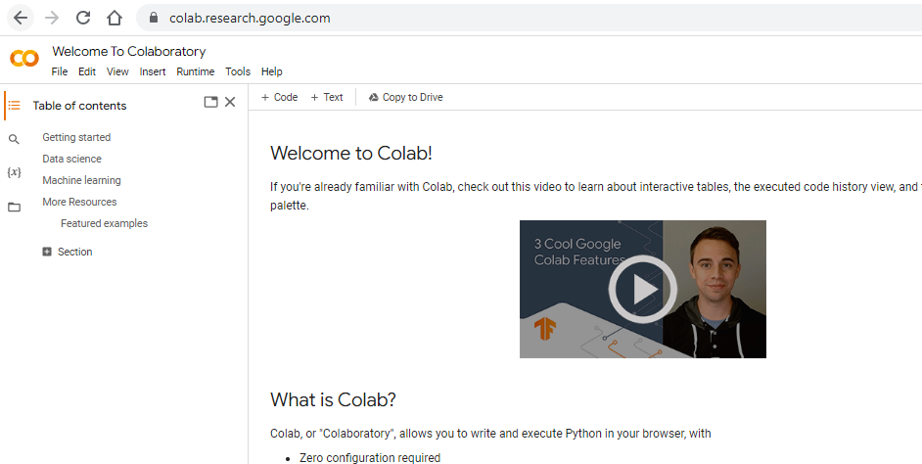

1. **Click on File and then on Upload Notebook**

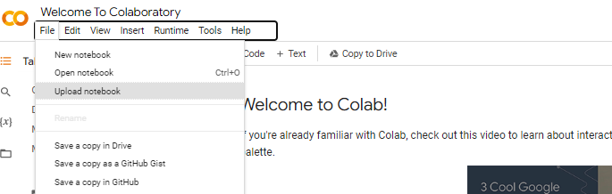

1. **In the pop up, click on Choose File and from you UNZIPPED folder select the notebook you want to upload**

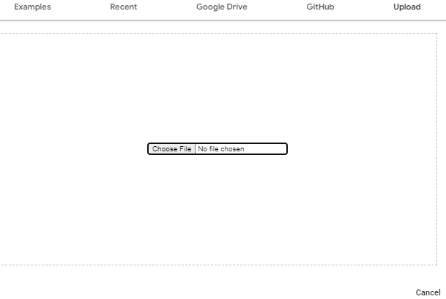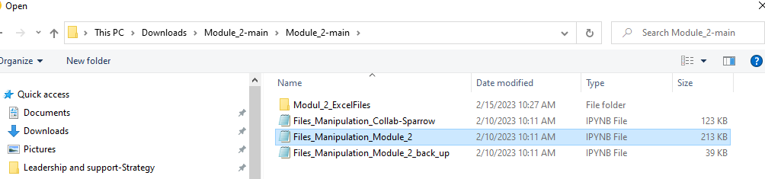

1. **Once the notebook uploaded click on Connect**

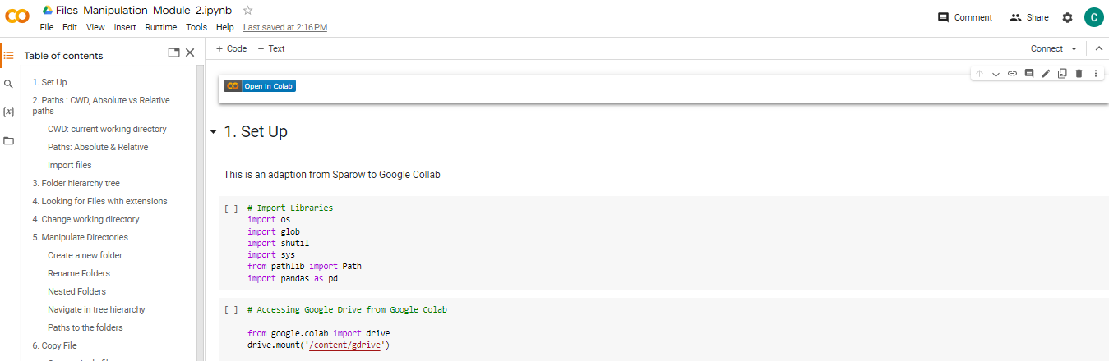

1. **Rename it (for ex. By adding _Practice at the end of the title)**

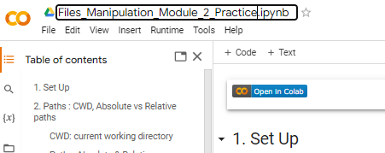

1. **Save it in Google Drive by clicking Save**

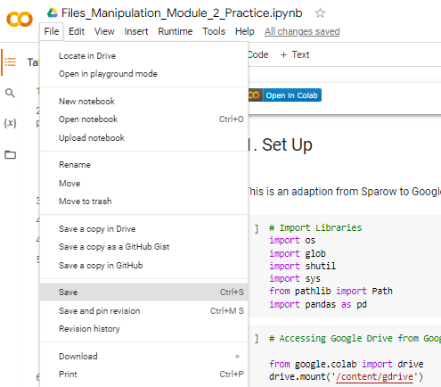

1. **Create a folder for the Module in the GitHub (open in a new tab the github) and click on “New”**

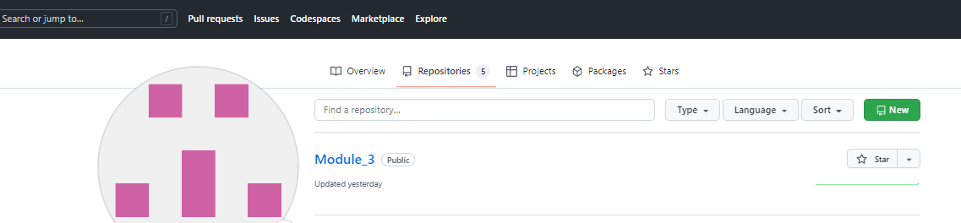

1. **Give the name of the folder (ex. Module_2) in Repository name**

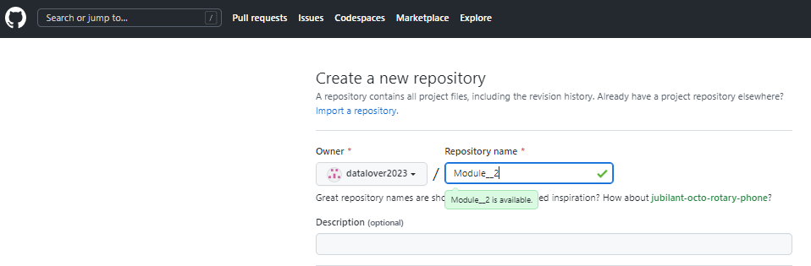

1. **Scroll down to Add a README file box and tick it**

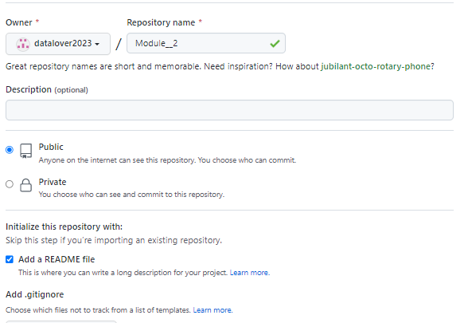

1. **Scroll down and click on Create Repository button**

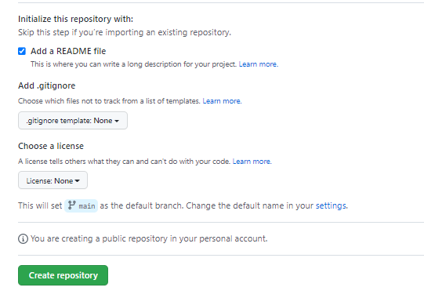

1. **It will redirect you to the created repository**

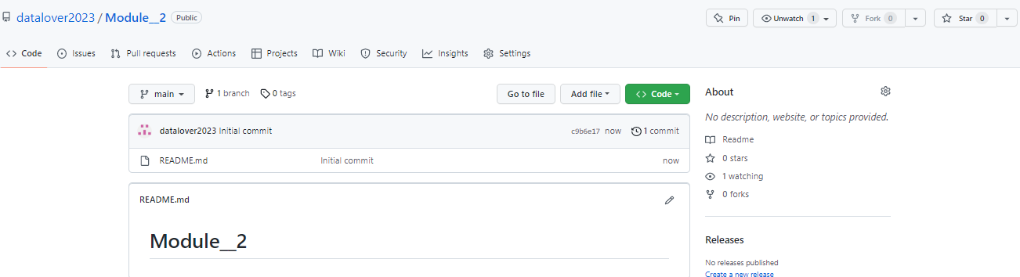

1. **Create the connection between Google Colab notebook and your github in the repository you just created**

**Go to your notebook in Google Colab, click on File and then on Save a copy in GitHub**

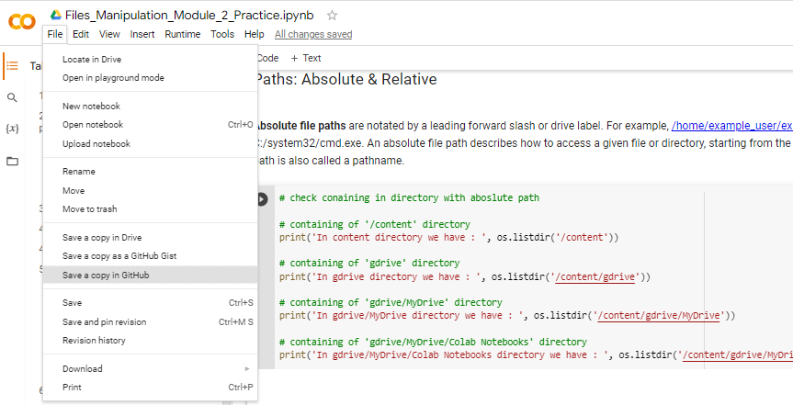

1. **Make sure you select the right repository and the box ‘Include a link in Colaboratory is ticked. Click ok**

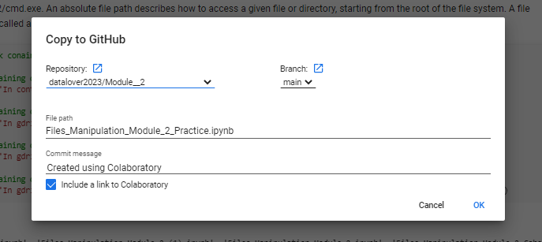

1. **It will redirect you to the GitHub repository where you can see the button “Open in Colab”**

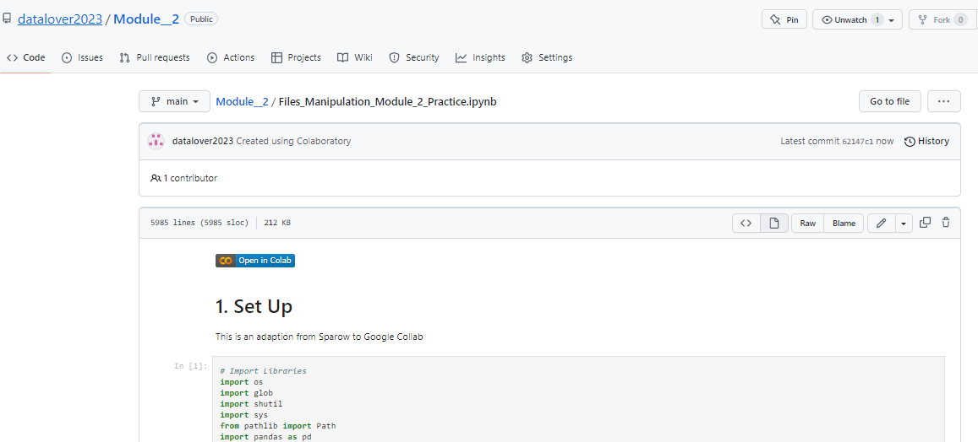

1. **If you click on repository, you’ll see that your repository contains your notebook**

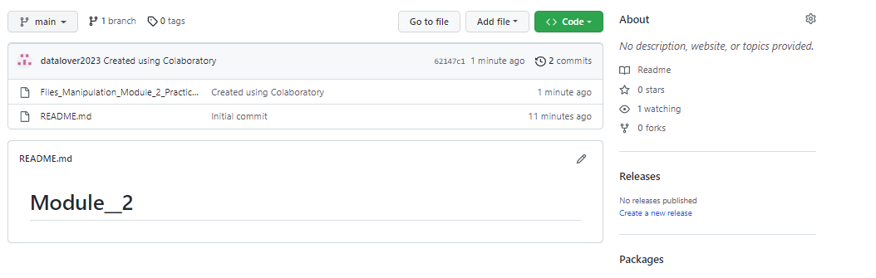

1. **If you click on ‘Open in Colab” when you in the repository**

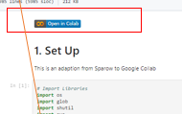

It will redirect you to Google Colab in this notebook and you can see that now you have the icon of the GitHub