For our workshop, you’ll need to use some platforms, and therefore you need to create respective accounts/ environments required for the Python Excel Automation sessions

Also, during the session it would be helpful for you (but not mandatory) to have a second device, a 2nd screen, so you can follow my screen that I’ll be sharing and another one (like personal computer) so you can be able to apply what I am showing you.

**Set Up Steps Python Excel Automation**

**Accounts required**

1. **Google** (an existing one you’re happy with or create new one, that you’ll use only for the training purpose)
2. **GitHub** : [*GitHub: Where the world builds software · GitHub*](https://github.com/)
3. **Google Colab** : [*Welcome To Colaboratory - Colaboratory (google.com)*](https://colab.research.google.com/notebooks/intro.ipynb)

**Personally Identifiable data warning**

*As part of the training we are using a public Cloud. It is forbidden to use any OVF data during this exercise.*

**GitHub Account** 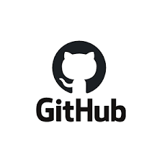

GitHub is a code hosting platform for version control and Collaboration. It lets you and others work together on projects from anywhere. Thus allowing seamless collaboration without compromising the integrity of the original project.

**2. Create a GitHub Account and connect it to your google account from Step 1**

a. Open a new tab in the browser

1. Navigate to this link <https://github.com>

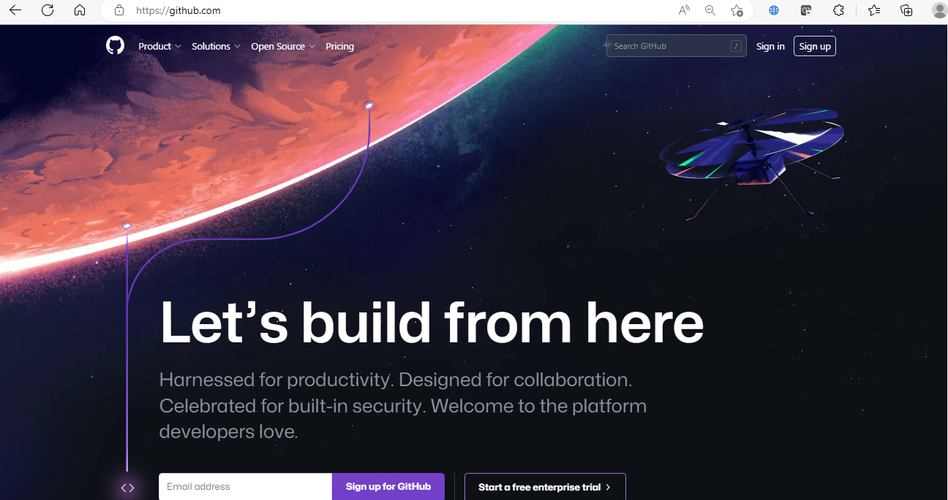

1. Click on “Sign Up” at top right of the screen.
2. Enter the gmail you created on step 1



1. Create a password/username/answer promotional question

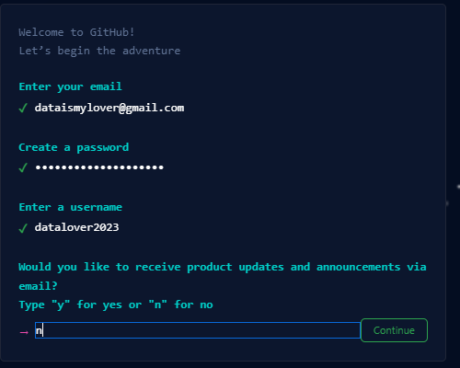

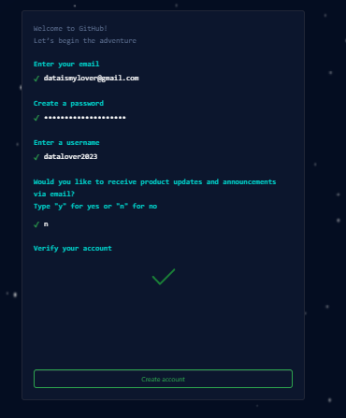

1. An email to verify your account will be sent to your gmail address (the one you are using for the training). As gmail is forbidden on working computers, you should check it form another device
2. Verify your account
3. You can skip the demographic questions by scrolling down on the page (or not) and finally get here

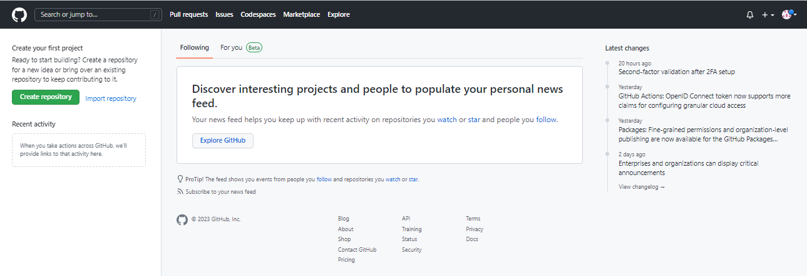

1. Click on “Create repository” at left top of screen



1. Name the repository as “Python_Excel_Automation”

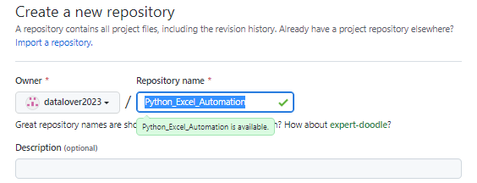

1. Select “Public”

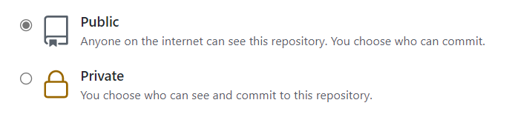

1. Select “Add a README file”

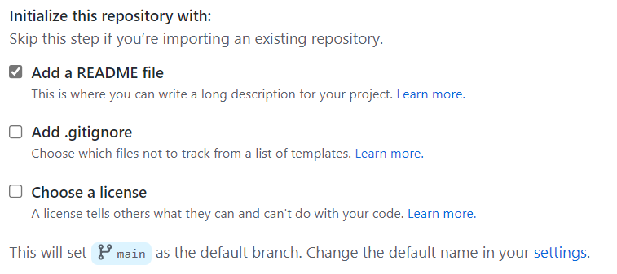

1. 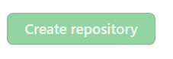 Click on Create Repository
2. Go to Google Colab, as explained in the other instruction