For our workshop, you’ll need to use some technical environment, and therefore you need to create respective accounts/ environments required for the Python Excel Automation sessions

Also, during the session it would be helpful for you (but not mandatory) to have a second device, as a 2nd screen, so you can follow my screen that I’ll be sharing and another one (like personal computer) so you can be able to apply what I am showing you during the session.

**Set Up Steps Python Excel Automation**

**Accounts required**

1. **Google** (an existing one you’re happy with or create new one, that you’ll use only for the training purpose)
2. **GitHub** : [*GitHub: Where the world builds software · GitHub*](https://github.com/)
3. **Google Colab** : [*Welcome To Colaboratory - Colaboratory (google.com)*](https://colab.research.google.com/notebooks/intro.ipynb)

**Personally Identifiable data warning**

*As part of the training we are using a public Cloud. It is forbidden to use any OVF data during this exercise.*

**Google Colab Account**



Google Colab, or Colab for short, is a product from Google Research. It allows anybody to write and execute arbitrary python code through the browser, and is especially well suited to machine learning, data analysis and education.

**Sign in to Google Account using the account from step 1 (if you’re not logged in)**

* 1. Open a new tab on the browser (in Chrome)
  2. Navigate to colab.research.google.com

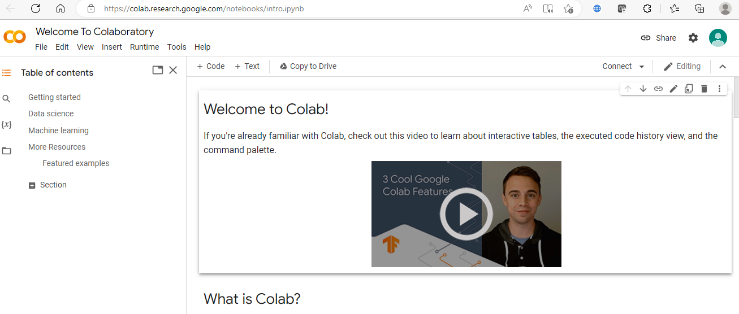

* 1. If prompted use the google account created at step 1, otherwise click Sign In on the top right of the screen and use the account created at step 1.
  2. Click on File on the left top (under Welcome to Colaboratory) and Select “New Notebook”

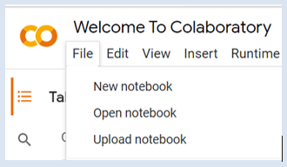

* 1. You should see the following on the top left of the screen

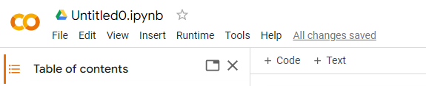

* 1. If you click right on the text “Untitled0.ipynb” you can rename the notebook name

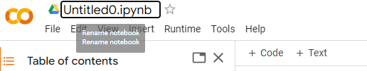

* 1. You may need to connect , by clicking on top right

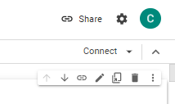

* 1. Parts of Colab: Title, Table of contents, +Code, +Text, Run Button, Cell

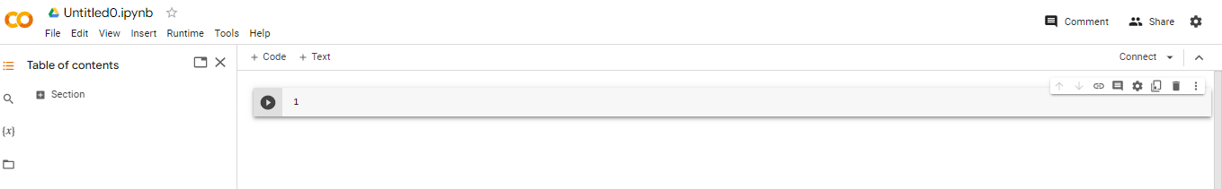

* Table of Contents will be like the summary of your notebook
* Cell is the space where you’ll right your code
* +Code allows you to add a new cell
* +Text allows to add a cell for text
* Run Button execute the code of the cell
  1. Rename the notebook as “Test

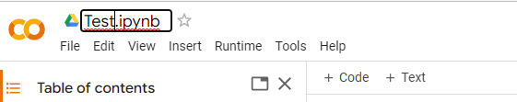

* 1. In the cell, write a dummy code and click on Run Button :
     + White 2+ 3 and then Shift+ Enter (it will run the script and change code line)
     + Write 2*3 and then Ctrl + Enter (it will run the code but it will remain in the same cell)
     + Write on 2+10 and just click on “run” button 

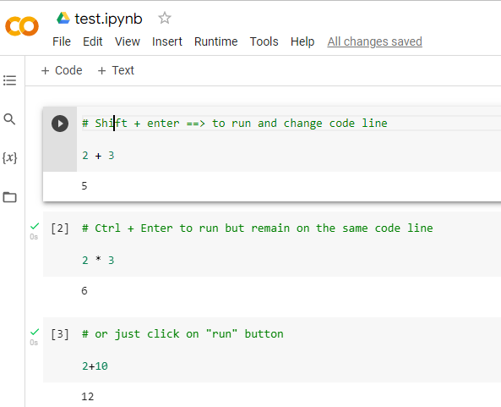

* 1. Click “File”
  2. Then “Save”

