**Change language for Google Colab**

It’s preferable to use Chrome browser…. 

If you’d like to change the language displayed in Google Colab (for ex. French to English..), then 🡺

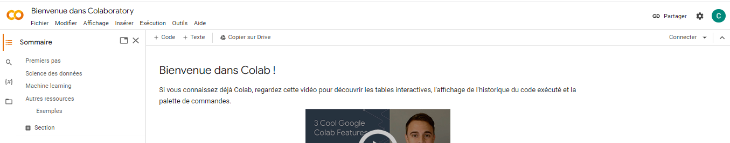

Just in case, clear your browser in Chrome:

<https://support.google.com/accounts/answer/32050>

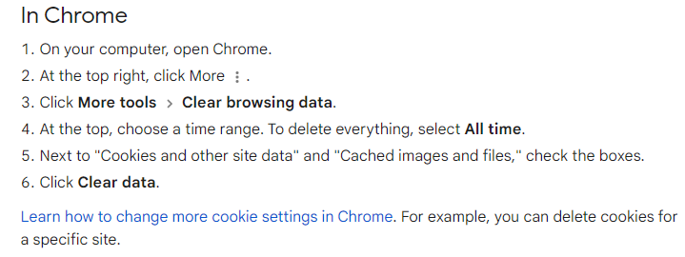

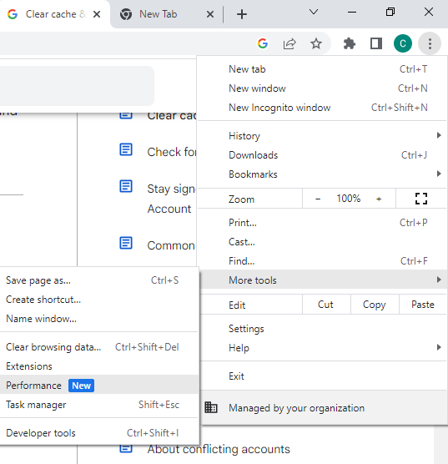

Then, again, when clicking on, top right for more, go to Parametters (Settings)

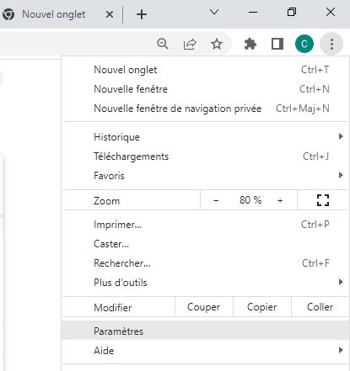

When you get to Settings page, click on languages

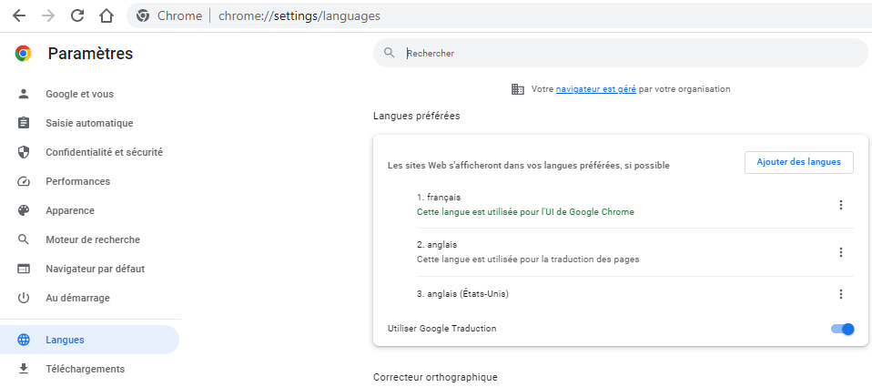

And pay attention to the right here….

At the language you want to swith to (Engilsh), click on the dots…

Tick the box : Display Google Chrome in this language

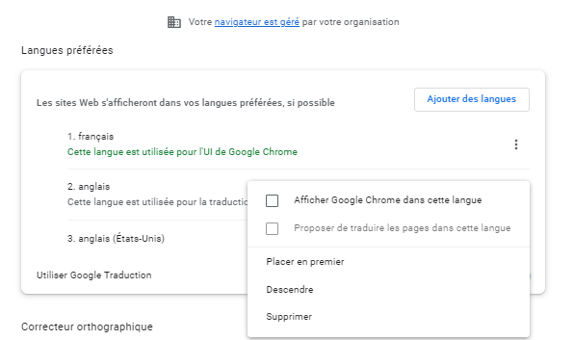

And now, your Chrome will use English by default, and when you’ll open Google Colab, from now on it will be in English

