For our workshop, you’ll need to use some platforms, and therefore you need to create respective accounts/ environments required for the Python Excel Automation sessions

Also, during the session it would be helpful for you (but not mandatory) to have a second device, a 2nd screen, so you can follow my screen that I’ll be sharing and another one (like personal computer) so you can be able to apply what I am showing you.

**Set Up Steps Python Excel Automation**

**Accounts required**

1. **Google** (an existing one you’re happy with or create new one, that you’ll use only for the training purpose)
2. **GitHub** : [*GitHub: Where the world builds software · GitHub*](https://github.com/)
3. **Google Colab** : [*Welcome To Colaboratory - Colaboratory (google.com)*](https://colab.research.google.com/notebooks/intro.ipynb)

**Personally Identifiable data warning**

*As part of the training we are using a public Cloud. It is forbidden to use any OVF data during this exercise.*

**Google Gmail Account**

1. **Create a google account if you don’t have one already or want to use a new one for the training**
   1. In Chrome, open a new Tab with google

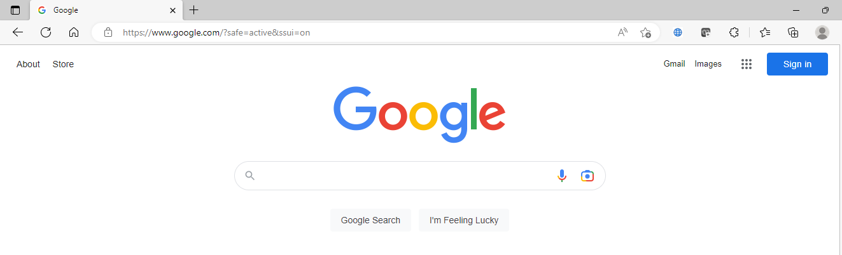

* 1. Click on “Sign In” at top right of the screen



* 1. Log in to your google account or create a new one (with << Use another account>>)

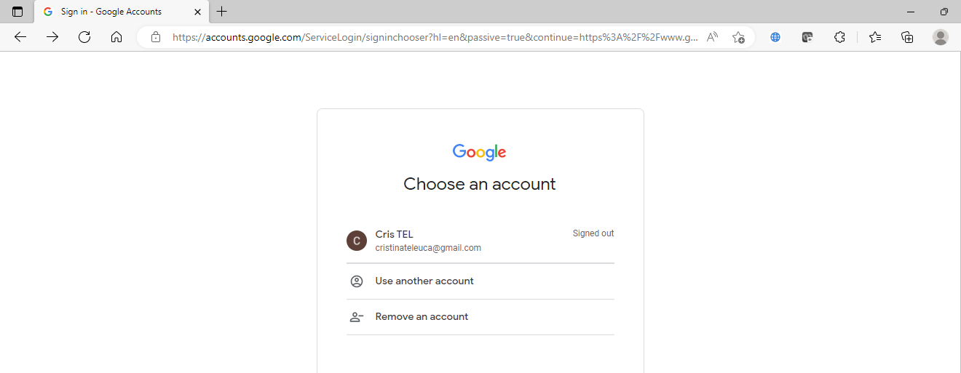

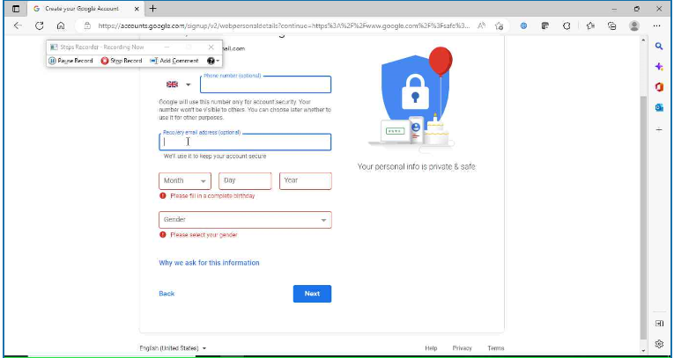

* 1. After creating the account and you are logged in you should be able to see a letter on top right of screen



* 1. You may not be able to log in on Gmail when Click on “Gmail” but you’re logged for Google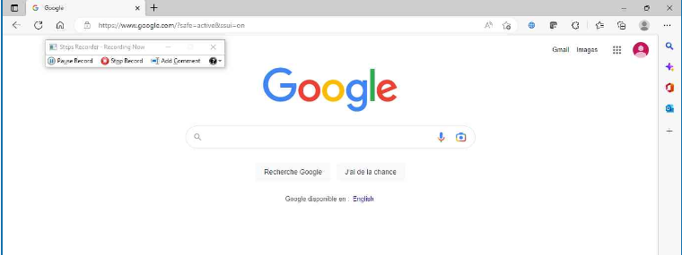
  2. Then you’ll need to create a GitHub account, explained in the other instructions