**Set Up Steps Python Excel Automation - Detailed Process**

**Background**

* Step by Step guide to create the environments required for the Python Excel Automation sessions

**Accounts required**

1. Google (gmail – new or existing one)
2. GitHub : [*GitHub: Where the world builds software · GitHub*](https://github.com/)
3. Colab : [*Welcome To Colaboratory - Colaboratory (google.com)*](https://colab.research.google.com/notebooks/intro.ipynb)

**Personally Identifiable data warning**

*As part of the training we are using a public Cloud. It is forbidden to use any OVF data during this exercise.*

**Process**

**Google Gmail Account**

1. **Create a google account if you don’t have one already**
   1. Open Mircorsoft Edge and navigate to “Google.com”

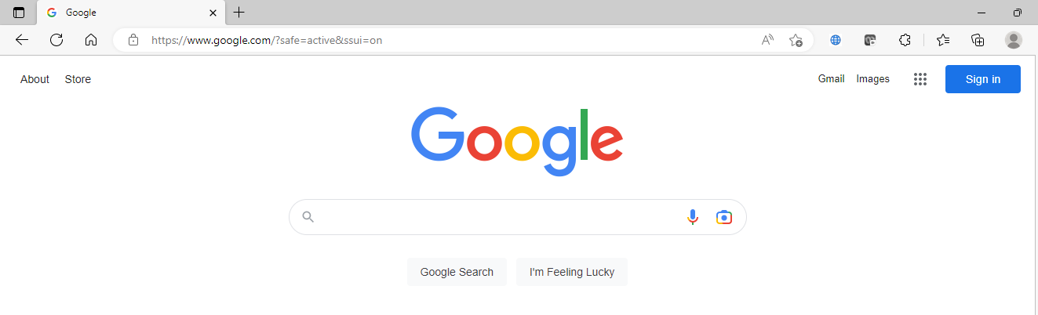

* 1. Click on “Sign In” at top right of the screen



* 1. Log in to your google account or create a new one (with << Use another account>>)

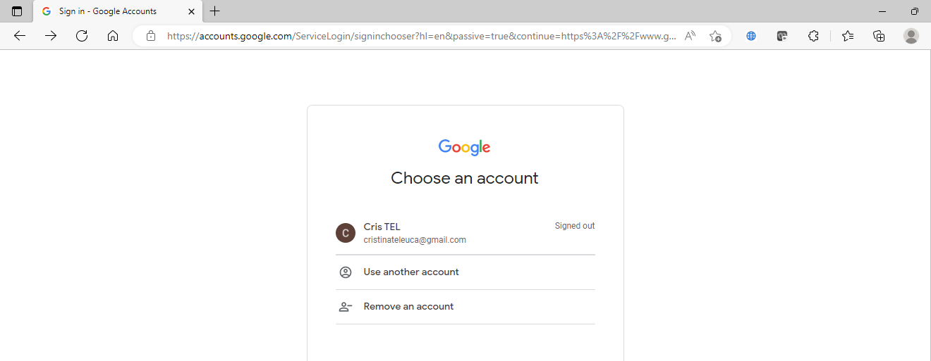

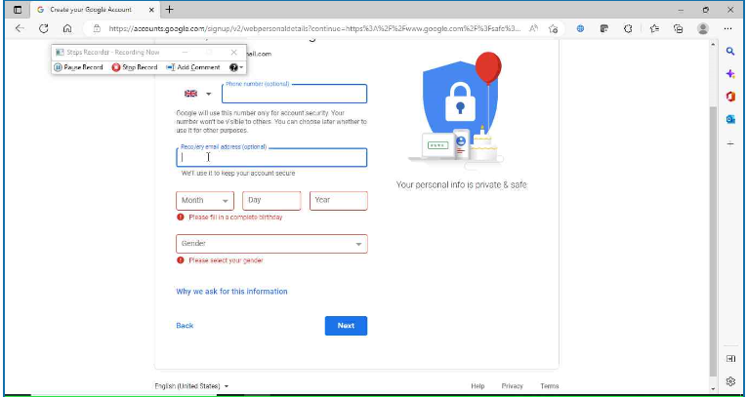

* 1. After creating the account and you are logged in you should be able to see a letter on top right of screen



* 1. You may not be able to log in on Gmail when Click on “Gmail” but you’re logged for Google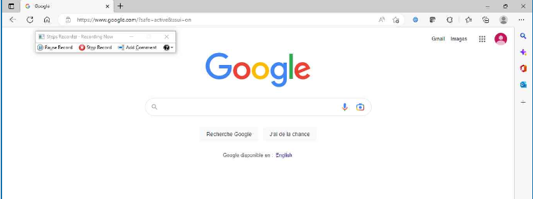
  2. Move to step 2

**GitHub Account**



GitHub is a code hosting platform for version control and Collaboration. It lets you and others work together on projects from anywhere. Thus allowing seamless collaboration without compromising the integrity of the original project.

**2. Create a GitHub Account and connect it to your google account from Step 1**

a. Open a new tab in the browser

1. Navigate to [*GitHub: Where the world builds software · GitHub*](https://github.com/)

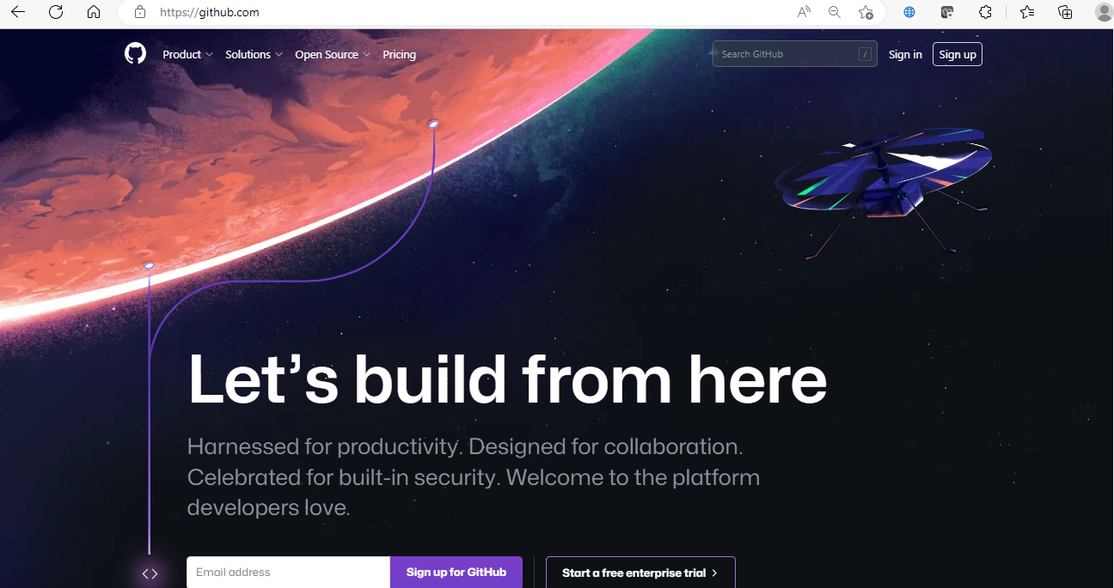

1. Click on “Sign Up” at top right of the screen.
2. Enter the gmail you created on step 1



1. Create a password/username/answer promotional question

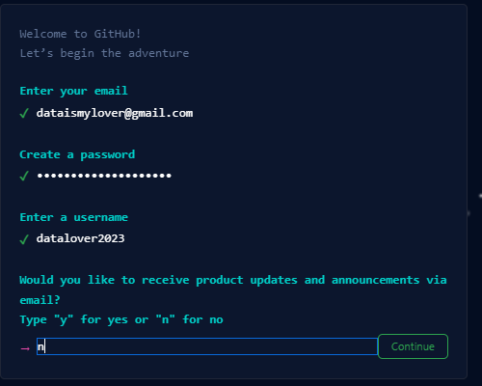

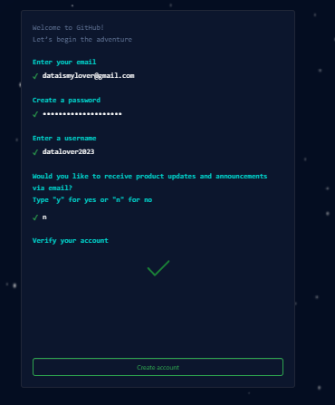

1. An email to verify your account will be sent to your gmail address
2. Verify your account
3. You can skip the demographic questions by scrolling down on the page (or not) and finally get here

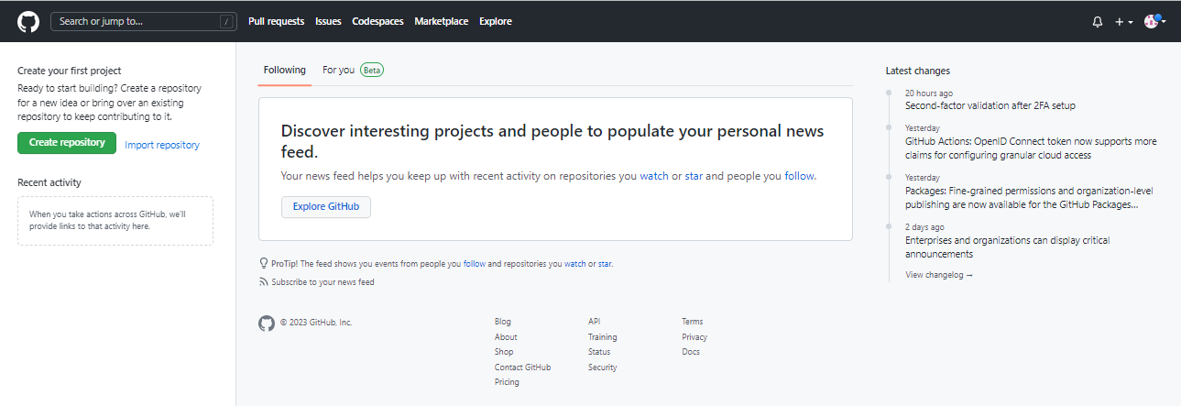

1. Click on “Create repository” at left top of screen



1. Name the repository as “Python_Excel_Automation”

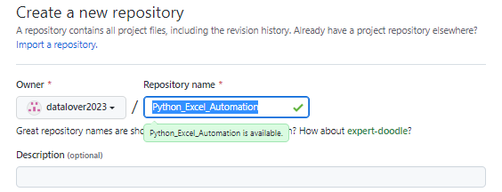

1. Select “Public”

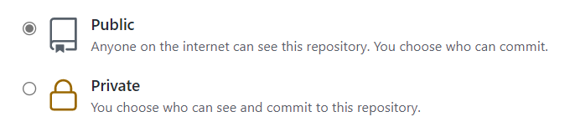

1. Select “Add a README file”

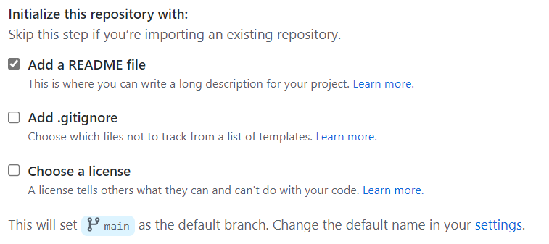

1. 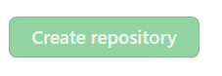 Click on Create Repository
2. Move to step 3

**Google Colab Account**



Google Colab, or Colab for short, is a product from Google Research. It allows anybody to write and execute arbitrary python code through the browser, and is especially well suited to machine learning, data analysis and education.

**Sign in to Colab Account using the account from step 1**

* 1. Open a new tab on the browser
  2. Navigate to [*Welcome To Colaboratory - Colaboratory (google.com)*](https://colab.research.google.com/notebooks/intro.ipynb)

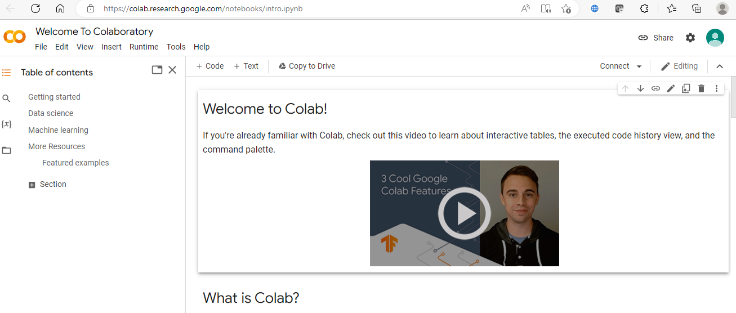

* 1. If prompted use the google account created at step 1, otherwise click Sign In on the top right of the screen and use the account created at step 1.
  2. Click on File on the left top (under Welcome to Colaboratory) and Select “New Notebook”

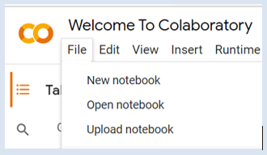

* 1. You should see the following on the top left of the screen

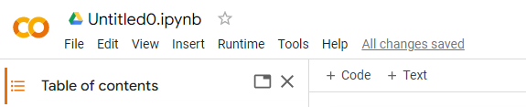

* 1. If you click right on the text “Untitled0.ipynb” you can rename the notebook name

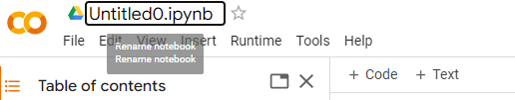

* 1. Rename the notebook as “Test

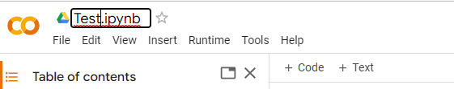

* 1. Write a dummy script in the cell next to the  sign and click:
     + White 2+ 3 and then Shift+ Enter (it will run the script and change code line)
     + Write 2*3 and then Ctrl + Enter (it will run the code but it will remain in the same cell)
     + Write on 2+10 and just click on “run” button 

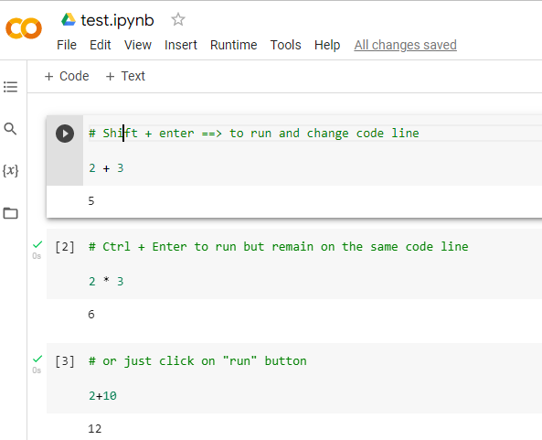

* 1. Click “File”
  2. Then “Save a copy in GitHub”

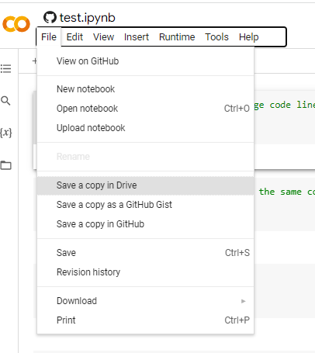

* 1. It may ask you an authorization..

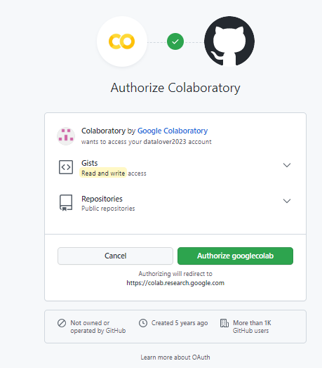

* 1. Under the Repository option select the repository we created during step 2
  2. Click “ok”

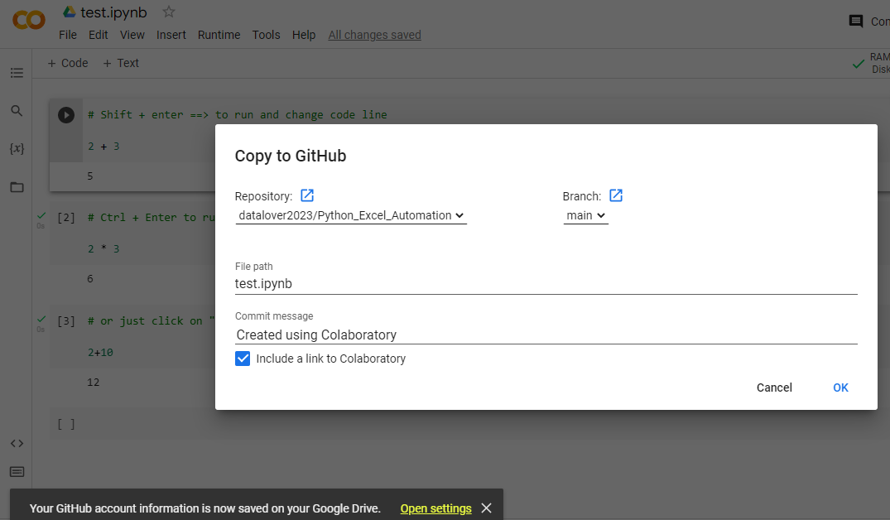

* 1. A new tab will automatically open in GitHub showing your repository and the code. 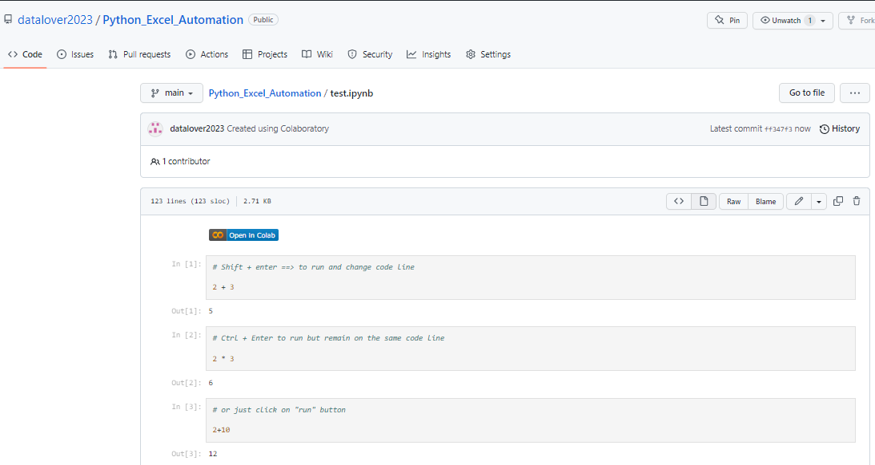
  2. If you close all Google Colab tabs in your browser and click in Github on button, it will redirect you back to the same notebook in the Google Colab. 
  3. In colab on the top you should be able to see that the sign next to the file name has change to the GitHub figurine:

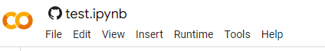

* 1. Also when you copied the notebook to GitHub, a notification informs you that the notebook has been saved to Google Drive as well.



* 1. Then “Save a copy in Drive” . So you can copy the notebook on your Drive.



**Change language of Colab**

If you’d like to change the language (for ex. French to English..)

In a new tab, open <https://myaccount.google.com/>

It’s preferable to use Chrome browser….

Suppose the Google Colab is in French :

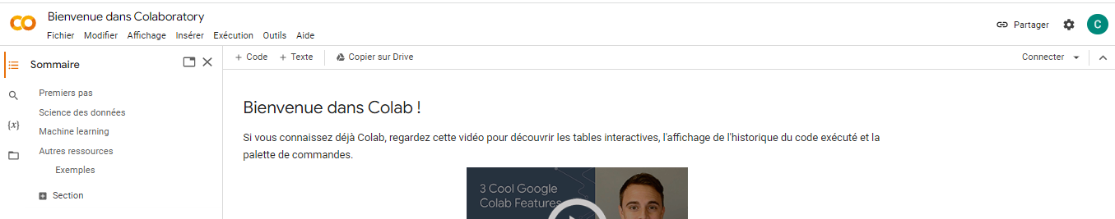

Just in case clear your browser in Chrome:

<https://support.google.com/accounts/answer/32050>

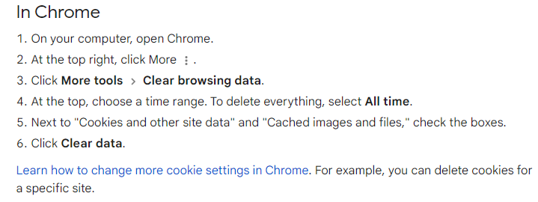

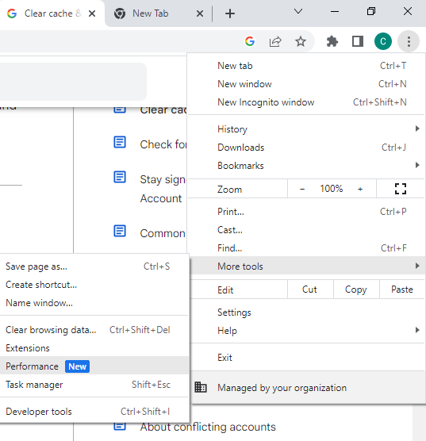

Then, again, when clicking on , top right for more, go to Parametters (Settings)

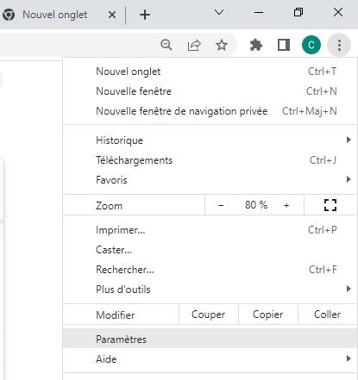

When you get to Settings page…, click on languages

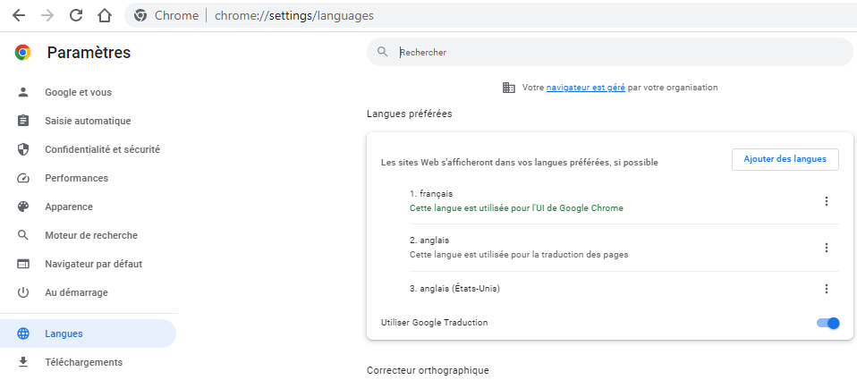

And pay attention to the right here….

At the language to swith to (Engilsh), click on the dots…

Tick the box : Display Google Chrome in this language

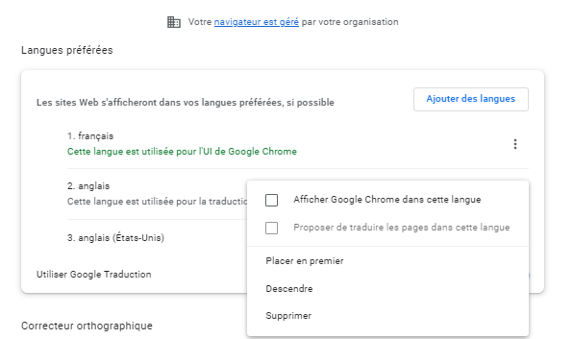

And now, your Chrome will use English by default, and when you’ll open Google Colab, from now on it will be in Englisg

