# Question 1

## (a)

y = 131  
n = 327  
dx <- 1/1000  
pi.grid <- seq(0, 1, dx)  
flat.prior <- dunif(pi.grid,0,1)  
post.unscaled <- flat.prior * dbinom(y,n,pi.grid)  
posterior <- post.unscaled / sum(post.unscaled * dx)  
plot(pi.grid, posterior, type="l",  
 xlab=expression(pi), main="Posterior Density : Flat Prior")

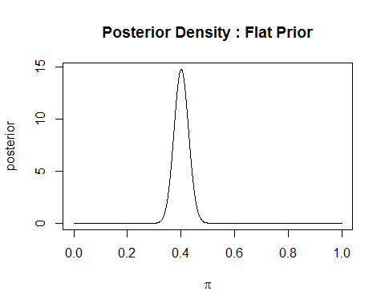

## (c)

qbeta(c(0.025, 0.975), 132, 197)

## [1] 0.3489381 0.4546312

**Answer**: The 95% equal-tailed credible interval is (0.3489381, 0.4546312)

## (d)

pbeta(0.5, 132, 197)

## [1] 0.9998409

1 - pbeta(0.5, 132, 197)

## [1] 0.0001590998

**Answer**: The posterior probablity of null hypothesis is 1.590997910^{-4} and that of alternative hypothesis is 0.9998409.

# Question 2

## (c)

qbeta(c(0.025, 0.975), 231, 296)

## [1] 0.3962467 0.4808571

**Answer**: The 95% equal-tailed credible interval is (0.3962467, 0.4808571)

## (d)

pbeta(0.5, 231, 296)

## [1] 0.9977252

1 - pbeta(0.5, 231, 296)

## [1] 0.002274776

**Answer**: The posterior probablity of null hypothesis is 0.0022748 and that of alternative hypothesis is 0.9977252.