DataNucleus AccessPlatform  Why spend significant development time designing the data access layer of your application when you can utilise the most standards compliant open source Java persistence implementation around? DataNucleus AccessPlatform supports all major O/R mapping designs allowing specification of your persistence needs using XML or Java5 annotations meaning that your development team can spend their valuable time providing value-added business logic rather than the routine task of storing /retrieving your objects  Standards Driven  DataNucleus Access Platform fully supports the Java Data Objects (JDO) specification standards (JDO1, JDO2, JDO3) and the Java Persistence specification standards (JPA1, JPA2). DataNucleus Spatial plugin fully supports the OGC Simple Feature Specification. By choosing DataNucleus Access Platform you are safeguarding the portability of your data persistence process to accepted industry standards.  Performance  DataNucleus provides a high performance persistence mechanism by utilising byte-code enhancement to provide rapid detection of changes to persisted objects, allowing optimisation not available using reflection based tools.  Extensible  DataNucleus Access Platform is architected to provide an extensible persistence framework for heterogeneous datastores. Out-of-the-box DataNucleus Access Platform provides support for all major RDBMS on the market, together with DB4O, LDAP and even Excel documents! All DataNucleus jars are OSGi bundles allowing deployment in J2SE environments, J2EE environments and OSGi environments. DataNucleus provides a host of extension points allowing you to utilise the DataNucleus persistence mechanism with your own corporate components, defining customised persistence of your own Java types, and generally not be limited in your development.  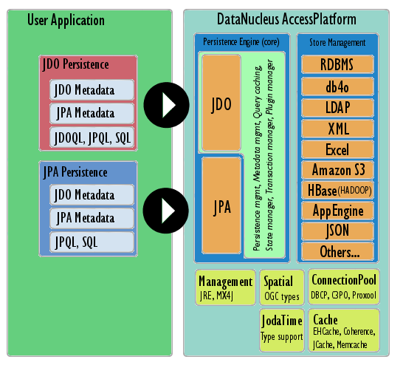 |   The most standards compliant open source Java persistence implementation available  Features at a glance  - Open Source with an Apache2 license  - JDO1, JDO2, JDO3, JPA1, JPA2 compliant  - Supports persistence to all major RDBMS datastores  - Supports persistence to ODBMS  - Supports persistence to LDAP  - Supports persistence to Documents (Excel, ODF, OOXML)  - Supports persistence to Web and Map datastores (JSON, AmazonS3, GoogleStorage, BigTable, HBase, Cassandra)  - Uses byte-code enhancement providing rapid dirty detection  - All common O/R mapping types supported  - Identity generation  - Widest range of Java type support  - Persistence specification in XML or using Annotations  - Runs on all JDKs 1.3 and up  - Usable in J2SE, J2EE, and OSGi applications  - Usable on Windows, Linux, Unix, OS X and others.  - Querying using JDOQL, JPQL or SQL  - Supports existing schemas, and schema generation  - Most complete schema control available  - High performance persistence  - Usable with all major caching products  - Extensible using OSGi technology  - Support Forum  Contact:  Web : http://www.datanucleus.com  Community : http://www.datanucleus.org  Forum : http://forum.datanucleus.org

