Music Industry Crisis Recovery Report 2020

Daniel Antal

2020-04-29

Table of Contents

Introduction 3

Creative Industries: Lessons from the Last Crisis 4

Economic Impact Assessment 4

Crisis in the Music Industry 5

Crisis Effects on Artist and Technician Earnings 5

Country Differences 5

Live Music 6

Disappearing Small Venues 6

Festivals 6

International Touring 6

Towards A Healthier Live Music Sector 6

Recorded Music 7

Public Performance 7

Mechanical and Private Copying 7

Streaming 8

Competitiveness in Europe 8

Resilience and Vulnerability in EU Member States 8

Conclusions 10

Fact-based business strategies and policies 10

European Music Observatory 10

Business strategy proposals for the live music industry 10

Business strategy proposals for the recorded music industry 10

Policy proposals to support the music industry 10

Policy proposals and Cooperation Proposals with Other Creative Industries 10

Apendix 11

Initial Partners 11

CEEMID 11

National Partners 11

Industry Partners 11

Scientific Partners 11

# Introduction

We are looking for partners to open an CEEMID to a Pilot Music Observatory and to start building evidence-based music industry strategies and policies with national, pan-European industry and academic partners.

CEEMID is Europe’s largest data source of music and creative industry data. In January 2020 Consolidated Independent teamed up with CEEMID to showcase how this resource can be used to create multi-country, evidence-based policy reports and business strategies. Our [CEE Music Industry Report](https://danielantal.eu/publication/ceereport_2020/) was introduced to the creative industry stakeholders and policymakers from many countries on the [CCS Ecosystems: FLIPPING THE ODDS Conference](https://danielantal.eu/post/2020-01-30-ceereport/) – a two-day high-level stakeholder event jointly organized by Geothe-Institute and the DG Education and Culture of the European Commission with the Creative FLIP project.

We would like to take this cooperation a step further: we would like to create sensible, fact-based proposals for the recovery of the music industry, in cooperation with similar-fated European creative industries utilizing our unrivalled data sources, industry experience and analytics capacities by opening up many high-quality pan-European indicators to a Pilot European Music Observatory.

We are inviting our **national partners** to contribute to this report with their local data, data-access and expertise with two aims: to bring national examples and problems as case studies to the European policy forums, and to create a locally relevant version of this report, which we are happy to produce in the national language of our partners.

We are inviting **industry associations** and **pan-European stakeholders** to bring their problems, data assets into this work, and seek fact-driven answers to various crisis recovery scenarios in combination with CEEMID’s more than 2000 statistical indicators, and proprietary royalty valuation and economic impact assessment models. We are open to make this statistical and econometric models open in the form of interactive web-based application, supported with real data.

We are also inviting **scientific partners**, researchers and research institutes, to contribute to this report with scientific insights, rigorous testing of our models, and a critical attitude to our findings. We are willing to give never published, valuable datasets to researchers and publication opportunities.

The **Music Industry Crisis Recovery Report 2020** will be created in two phases. We will comply all available evidence from more than 2000 music indicators to an initial document by **31 May 2020** for a pan-European discussion. In the second phase, based on the feedback from the stakeholders and further questions, we will start new data collection with our partners and dig deeper during the summer and early autumn of 2020.

# Creative Industries: Lessons from the Last Crisis

The last economic crisis has shown that the creative and cultural industries are usually weathering the storm better than most industries. Because the CCIs are made up by networks of many small enterprises, and creative workers are used to work in flexible work arrangements, the risk of job loss is lower. Europe offers high living standards compared to most of the world, therefore policymakers must prioritize household earnings. The CCIs have an especially big labor input and pay out most of their revenues domestically for creative workers. Despite these advantages, many EU member states created economic polices that were favoring large volume, but mainly automated industries with low value added and low labor components. In some member states, for example, in Hungary, Slovakia and Croatia, this lowered the development path of the creative industries even during the economic expansion of the last decade.

## Economic Impact Assessment

Using CEEMID’s [iotables](http://iotables.ceemid.eu/), originally developed for the economic impact assessment of the Hungarian film tax shelter, the policy proposals of the [Slovak Music Industry Report](https://danielantal.eu/publication/slovak_music_industry_2019/) we will demonstrate

* how creative industries, including the music industry, rank in the ability to restore the GDP or employment;
* which EU countries are most likely to gain/lose from music industry interventions.

Generally, the music industry and creative industries are producing excellent results.

# Crisis in the Music Industry

Using our data from the CE Report, we will give a fact-based, but not modelled likely assessment of the economic mechanism of the crisis in the European music industry.

## Crisis Effects on Artist and Technician Earnings

We will demonstrate which parts of the income stream are under threat , and what regional / occupational differences are likely.

## Country Differences

We will show an analyisis of the differences in demand drivers across Europe. This is important to pinpoint strenght and weaknesses, and to highlight which countries / regions are particularly hard hit.

# Live Music

Live music revenues are the most threatened revenues in the coronavirus crisis.

## Disappearing Small Venues

## Festivals

## International Touring

## Towards A Healthier Live Music Sector

Royalties

# Recorded Music

Compared to live music, where the effects of the coronavirus crisis are similar in the EU countries, the effect on royalty income will be very different. Some elements of the royalty streams, for example, income from streaming, is booming, because people spend more time at home and with home entertainment. Other elements, like public performance, is down to a historic low. Because European countries built different copyright jurisdictions, and the administration possibilities of various rights differ dramatically across EU countries, the recorded music industry in some countries may even gain from the countries, while in others it will suffer huge losses.

## Public Performance

We start with public performance, because the effects are the most direct here: restaurants, hotels are closed, and advertising revenue in the media markets is down. This will cause an enormous loss of public performance revenue, and put the whole collective management system under enormous pressure.

## Mechanical and Private Copying

Mechanical royalties from the sale of CDs and music DVDs are already very low, although vinyl products made a spectacular comeback in many markets, and became a high-value, prestige product. The reason for low mechanical royalties is threefold: in some markets, many households subscribe to streaming services; private copying is still a lucrative alternative to buying; and at last there is a significant illegal segment of the market in the form of torrents.

The physical sales do suffer from the lack of concerts, as physical products are often souvenirs from concerts. For many acts, the only viable sales point of physical products is the live performance.

There are wide differences within Europe if people are willing to consider paid alternatives, such as music subscriptions and physical or digital download purchases when private copying or torrenting is a viable alternative. In some markets, for example, in Sweden, people had been increasingly turning to paid alternatives over the years. But this is not the general picture. The EU average willingness to pay for content had been declining during the economic expansion phase of the 2010s.

Several stakeholders, like Artisjus in Hungary and SOZA in Slovakia made continued efforts to compensate this effect by increasing private copying remuneration. They will weather the storm relatively easily, because in the initial phase of the corona crisis, the sale of entertainment devices and carriers was record high – and so were the private copying levies. Others, like Croatia (Antal 2019a) and Slovenia made steps to follow them, but they may have been late. The Baltic countries, Romania or Bulgaria will be in great trouble, because their private copying revenues have never followed the growth in private copying value, and their levy collection is negligible. It is also highly questionable if the government-sponsored compensation schemes of Spain and Finland will provide large enough resources to the creators of music (and audiovisual content, and books.)

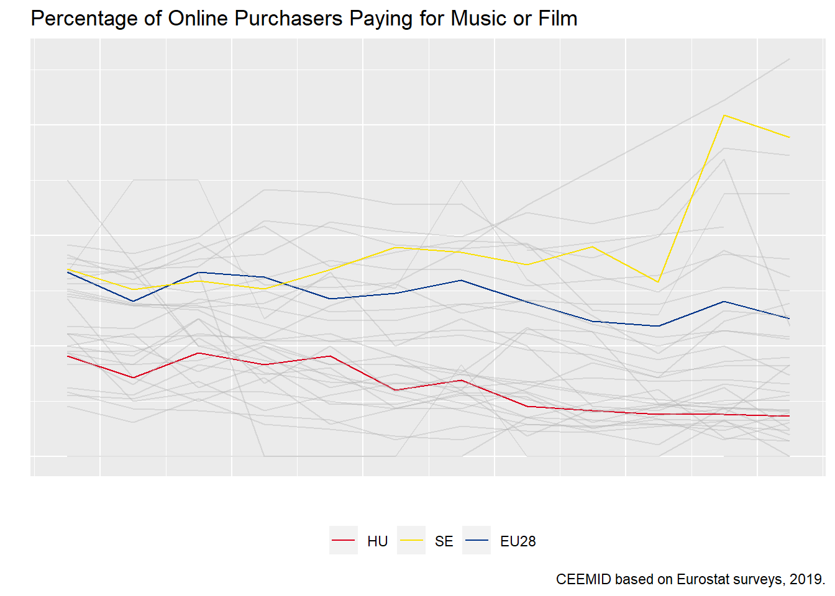

## Streaming

Streaming is generally very positively affected by the lockdown, but streaming is a globally competitive market. Only those acts will benefit who are data-savvy and understand the global market dynamics very well.

## Competitiveness in Europe

During the economic expansion, the streaming markets kept growing, and it seems that this growth will not halt in the coronacrisis, at least, if it is not so prolonged that households will not be able to pay subscription fees. The positive effects of this growth were uneven in the world, because some repertoires were more competitive in export markets. Some smaller European markets came under a lot of pressure.

## Resilience and Vulnerability in EU Member States

Depending on which organizations allow access to their data, we will show which countries are more and less resilient. The important element of this subchapter is to demonstrate that there had been serious problems during the economic expansion period in the last decade, and

# Conclusions

## Fact-based business strategies and policies

### European Music Observatory

We are planning to release a large number of statistical indicators that are conforming the terminology and policy relevance guidelines of Eurostat, in partnership with the industry (Eurostat 2014, 2017; Kotzeva et al. 2017).

## Business strategy proposals for the live music industry

## Business strategy proposals for the recorded music industry

## Policy proposals to support the music industry

## Policy proposals and Cooperation Proposals with Other Creative Industries

# Apendix

## Initial Partners

### CEEMID

CEEMID is a data integration system that could provide to be a model and starting point of building a European Music Observatory based on [open data](https://documentation.ceemid.eu/index.php?title=Open_data), [open-source software](https://documentation.ceemid.eu/index.php?title=Open-source_software) using [open collaboration](https://documentation.ceemid.eu/index.php?title=Open_collaboration) with the music industry, statisticans and academia, using best statistics, data science and AI practices. CEEMID has created thousands of high-value, hard music industry indicators using open data sources, industry data sources, surveys and various APIs to relevant other [data sources](https://documentation.ceemid.eu/index.php?title=Main_Page#Data_sources).

CEEMID is aiming to transfer thousands of indicators and a verifiable, open-source software that creates them to the [European Music Observatory](https://documentation.ceemid.eu/index.php?title=European_Music_Observatory) to give Europe-wide acces timely, reliable, actionable statistics and indicators for the music industry, policymakers and music professionals on the [Music Economy of Europe](https://documentation.ceemid.eu/index.php?title=Music_Economy_of_Europe), [Music Diversity and Circulation](https://documentation.ceemid.eu/index.php?title=Music_Diversity_and_Circulation) and on [Music, Society & Citizenship](https://documentation.ceemid.eu/index.php?title=Music,_Society_and_Citizenship).(Read more about our [data coverage](https://documentation.ceemid.eu/index.php?title=Main_Page#Data_Coverage) and [geographical coverage](https://documentation.ceemid.eu/index.php?title=Main_Page#Geographical_coverage)).

In 2014 three collective management societies, Artisjus, HDS and SOZA, realized the need to make further efforts to modernize the way they measure their own economic impact and the economic value of their licenses in order to remain competitive in advocating their interests vis-à-vis domestic governments, international organizations like CISAC and GESAC and the European Union. They signed a Memorandum of Understanding Measuring and Reporting Regional Economic Value Added, National Income and Employment by the Music Industry in a Creative Industries Perspective with their consultant to set up the CEEMID databases and to harmonize their efforts.[1]

## National Partners

## Industry Partners

## Scientific Partners

Antal, Daniel. 2019a. “Private Copying in Croatia.” <https://www.zamp.hr/uploads/documents/Studija_privatno_kopiranje_u_Hrvatskoj_DA_CEEMID.pdf>.

———. 2019b. “Správa o slovenskom hudobnom priemysle.” <https://doi.org/10.17605/OSF.IO/V3BE9>.

Artisjus, HDS, SOZA, and Candole Partners. 2014. “Measuring and Reporting Regional Economic Value Added, National Income and Employment by the Music Industry in a Creative Industries Perspective. Memorandum of Understanding to Create a Regional Music Database to Support Professional National Reporting, Economic Valuation and a Regional Music Study.”

Eurostat. 2014. *Towards a Harmonised Methodology for Statistical Indicators — Part 1: Indicator Typologies and Terminologies*. 2014th ed. Vol. 1. Towards a Harmonised Methodology for Statistical Indicators 1. Luxembourg: Publications Office of the European Union. <https://ec.europa.eu/eurostat/web/products-manuals-and-guidelines/-/KS-GQ-14-011>.

———. 2017. *Towards a Harmonised Methodology for Statistical Indicators — Part 3: Relevance for Policy Making*. 2017th ed. Vol. 3. Towards a Harmonised Methodology for Statistical Indicators 1. Luxembourg: Publications Office of the European Union. <https://ec.europa.eu/eurostat/web/products-manuals-and-guidelines/-/KS-GQ-17-007>.

Kotzeva, Mariana, Anton Steurer, Nicola Massarelli, and Mariana Popova, eds. 2017. *Towards a Harmonised Methodology for Statistical Indicators — Part 2: Communicating Through Indicators*. 2017th ed. Vol. 2. Towards a Harmonised Methodology for Statistical Indicators 1. Luxembourg: Publications Office of the European Union. <https://ec.europa.eu/eurostat/web/products-manuals-and-guidelines/-/KS-GQ-17-001>.

1. In the bibliography: Artisjus et al. (2014)