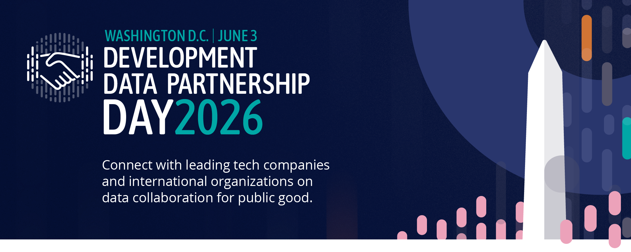

DEVELOPMENT DATA PARTNERSHIP DAY

Time | Topic | Lead
8:30 | Registration
9:00 | Opening Remarks | Haishan Fu, Chief Statistician and Director, World Bank Group
9:05 | Keynote Address | Dr. Aisha Walcott-Bryant, Head of Google Research Africa
9:25 | State of the Partnership | Holly Krambeck, Program Manager, World Bank
9:35 | How AI is Reshaping Labor Markets: Findings from International Organizations Working with LinkedIn Data  Economists from the OECD, IMF, World Bank, and CAF share what LinkedIn's global data is revealing about how AI is reshaping skills, hiring, and labor markets — moderated by LinkedIn | Rosie Hood, Lead Data Scientist, LinkedIn (Moderator)  El Iza Mohamedou, Head of the OECD Centre for Skills, OECD  Dhushyanth Raju, Lead Economist, World Bank Group  Cheryl Li, Research Analyst, IMF
10:25 | Impact Stories  Fast-paced relay-style presentations, jointly given by the tech company and the international organization staff who worked together to create impact. | Viviana Canon, Program Coordinator, UNICEF  - Katherine Macdonald, Senior Director, Ookla for Good & Strategic Initiatives, Ookla  - From Data to Deployment: Bridging Guatemala’s Connectivity Divide  Enrique Iglesias Rodriguez, Telecomunication Sector Specialist, Inter-American Development Bank  - Digital Connectivity Mapping for East Africa: Identifying Access Gaps to Guide Digital Infrastructure Investments  Mohamed Ali Hadj Taieb, Senior Data Scientist, African Development Bank  - South Asia's White-Collar Workforce: New Evidence from Alternative Data  Cynthia Lo, Program Manager, GitHub  Sahiti Sarva, Data Scientist, World Bank Group
11:00 | Break
11:15 | AI's Impact on Work and the Economy: Research from the Companies Building the Technology  Researchers from Anthropic, OpenAI, Microsoft, and Google share what their in-housework is revealing about AI's effects on jobs, productivity, and economic opportunity — in conversation with the World Bank Group Chief Economist | Indermit Gill, Chief Economist, World Bank Group (Moderator)  Ruth Appel, Economics Program Manager, Anthropic  Rachel Brown, Data Scientist, OpenAI  Seth Spielman, Director, Microsoft AI
12:15 | Impact Stories  Fast-paced relay-style presentations, jointly given by the tech company and the international organization staff who worked together to create impact. | Swati Dawra, Swati Dawra, Head of Strategic Resources and Data, Technology & AI Enablement, UNDP  - Prosperity at Risk: Flood Exposure and Wealth in Asia and the Pacific  John Bevington, Director, JBA Global Resilience  Takaaki Masaki, Senior Economist, Asian Development Bank  - Advancing Low Emission Zones in Southeast Asia  Sebastian Muller, Technical Lead, Data & AI, Asian Development Bank  - Bali Reimagined  Laura McGorman, Director, AI for Good at Meta  Sol Tadeo, Data Scientist, World Bank Group
12:50 | Closing Remarks | Jean-Michel Baudoin, CIO and General Manager, Inter-American Development Bank
1:00 | Close

