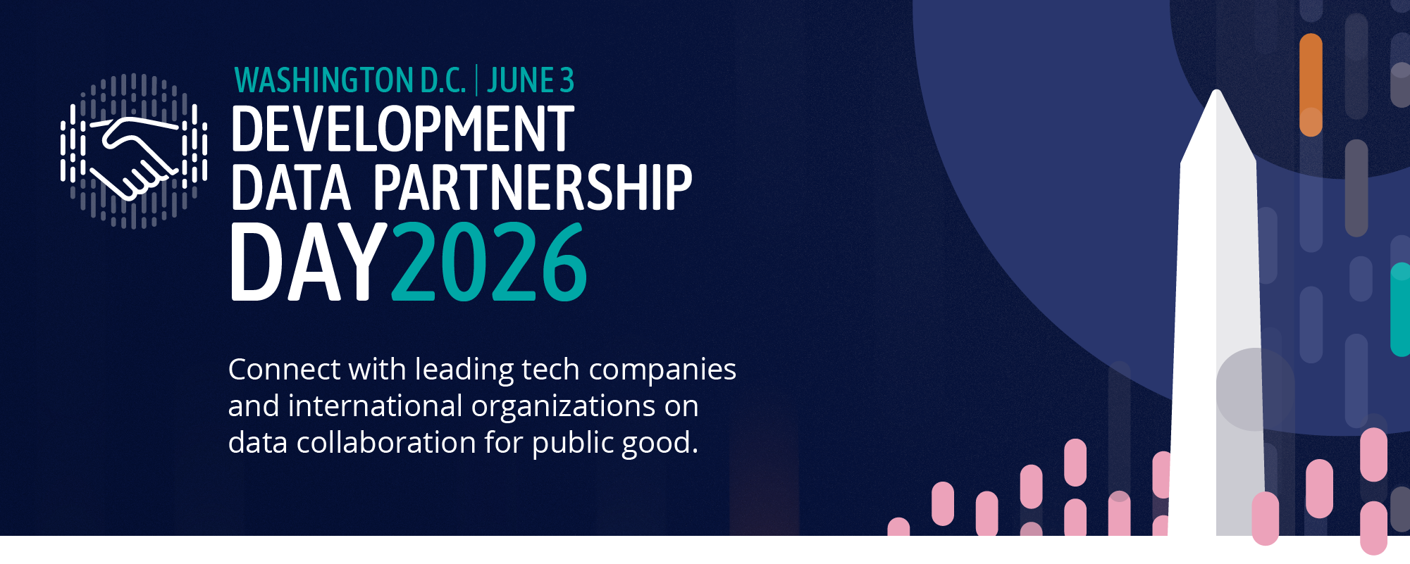

DEVELOPMENT DATA PARTNERSHIP DAY

DRAFT AGENDA

Time | Topic | Lead
8:30 | Registration
9:00 | Opening Remarks
9:05 | Keynote Address | Dr. Aisha Walcott-Bryant, Head of Google Research Africa
9:25 | State of the Partnership | Holly Krambeck, Program Manager, World Bank
9:35 | How AI is Reshaping Labor Markets: Findings from International Organizations Working with LinkedIn Data  Economists from the OECD, IMF, World Bank, and CAF share what LinkedIn's global data is revealing about how AI is reshaping skills, hiring, and labor markets — moderated by LinkedIn | Rosie Hood, Lead Data Scientist, LinkedIn (Moderator)  ---  El Iza Mohamedou, Head of the OECD Centre for Skills, OECD  Dhushyanth Raju, Lead Economist, World Bank Group  Cheryl Li, Research Analyst, IMF
10:25 | Impact Stories  Fast-paced relay-style presentations, jointly given by the tech company and the international organization staff who worked together to create impact. | Connecting Guatemala's Schools to the Internet  Katherine Macdonald, Senior Director, Ookla for Good & Strategic Initiatives, Ookla  Enrique Iglesias Rodriguez, Telecomunication Sector Specialist, Inter-American Development Bank  Advancing Low Emission Zones in Southeast Asia  Sebastian Muller, Technical Lead, Data & AI  Asian Development Bank
11:00 | Break
11:15 | AI's Impact on Work and the Economy: Research from the Companies Building the Technology  Researchers from Anthropic, OpenAI, Microsoft, and Google share what their in-housework is revealing about AI's effects on jobs, productivity, and economic opportunity — in conversation with the World Bank Group Chief Economist | Indermit Gill, Chief Economist, World Bank Group World Bank (Moderator)  ---  Ruth Appel, Economics Program Manager, Anthropic  Rachel Brown, Data Scientist, OpenAI  Seth Spielman, Director, Microsoft AI  Michael Pisa, Economic Opportunity Lead, Google
12:15 | Impact Stories  Fast-paced relay-style presentations, jointly given by the tech company and the international organization staff who worked together to create impact. | Integrating Flood Risk with High-resolution Wealth Mapping in Asia and the Pacific  John Bevington, Director, JBA Global Resilience  Takaaki Masaki, Senior Economist, Asian Development Bank  Mapping Human Displacement in Sub-Saharan Africa Using Nighttime Lights and Meta’s High Resolution Population Data  Mohamed Ali Hadj Taieb, Senior Data Scientist, African Development Bank  Bali Reimagined  Laura McGorman, Director, AI for Good at Meta  Sol Tadeo, Data Scientist, World Bank Group
12:50 | Closing Remarks | Jean-Michel Baudoin, CIO and General Manager of Technology and Transformation Department, Inter-American Development Bank
1:00 | Close

