VS.NET Components Tutorial
This tutorial demonstrates key concepts of VS.NET data-aware components.

Introduction
Find out what is in this chapter.
In this chapter we create a simple database application using the Dataphor data-aware components in Visual Studio.NET. The application is a simple browse to edit interface to add, edit, and delete data in the Stars table of the movie sample database that ships with Dataphor.

What You Should Know
Basic knowledge of the following is expected.
- Programming in VB.NET, C#, or any .NET supported language.
- Visual Studio Forms Designer.

What You Will Learn
Understanding the Data-binding Model
Setting Up the Development Environment
- Installing Data-aware Components
- Verifying the DAE Service
Building the Application
- Creating the Data Model
- Creating a New Application
- Building the Browse Form
- Connecting to the DAE Service
- Building the Edit Form
- Putting It All Together
Conclusion

Requirements
Active DAE Service

Understanding the Data-binding Model
Learn more about the Dataphor data-binding model.
Before building the application a brief introduction to key components will help. The following components are used to bind controls to a data source.
- The DataSession component provides a connection to the Dataphor Data Access Engine (DAE). It encapsulates session specific information such as user name and password. Once a client opens a session it can retrieve and manipulate data in the Dataphor DAE.
- The DataView component, given an expression provides access to the result set. Basically the DataView encapsulates a cursor against a result set defined by the Expression property. Access to the data is provided through a collection of DataFields. The First, Next, Prior, and Last methods navigate the cursor.
- The DataSource component provides a level of indirection between data-aware controls and a DataView.
The overall connection hierarchy top down is, DAE Service, DataSession(s), DataView(s), DataSource(s), Data-aware control(s). The DataView uses a DataSession to communicate with the DAE. The DataSource uses a DataView to link data-aware controls to a result set.

Setting Up the Development Environment
Learn how to setup the development environment in Visual Studio.NET.
Before beginning to create the application we need to do a few things to setup the development environment. First we demonstrate the installation of VS.NET components into the Toolbox. Finally we verify that there is an active DAE Service running.

Installing Data-aware Components
Learn how to install VS.NET components into the Toolbox.
To install the VS.NET data-aware components into the Toolbox do the following.
- Open Visual Studio.NET.
- Select Tools|Customize ToolBox…
- Select the .NET Framework Components tab.
- Sort the component list by namespace by clicking the column title Namespace.
- Select the component in the Alphora.Dataphor.DAE namespace.
- Select all the components in the Alphora.Dataphor.Client namespace.
- Select all the components in the Alphora.Dataphor.DAE.Client.Controls namespace.
- Select the OK button.
- If the Toolbox is not visible in Visual Studio then select View||Toolbox and locate the data-aware components.

Verifying the DAE Service
Learn how to verify the status of the DAE Service.
The application must communicate with an active DAE instance. The Dataphor installation installs the DAE Service which houses the default DAE instance. To verify that the DAE Service is running do one of the following.
- Open the Dataphor DAE Service Configuration Utility.
- Open the Windows Services Manager and look for the Alphora Dataphor Data Access Engine Server.
For help starting the service see <see cref=”DUGDAEService” name=”DAE Service”/>.

Building the Application
Learn how to use the VS.NET data-aware components to build an application.
The first step in building any application is to define the data model. Having a good data model is the key to having a good application. With that data model we can then build the interface. The interface is a simple windows forms application with two forms, one to browse data in the Stars table, another to edit data in the Stars table. Finally we bring it all together.

Creating the Data Model
Learn how to load a sample data model.
The Stars table schema is in the sample “Movie DB.D4” script that ships with Dataphor.
Follow the steps below to create the Stars table.
- Start Dataphoria.
- Open up a Query Script window.
  - Right-click on Servers and select Add Connection…
  - Change the Uri property to “tcp://localhost:8061/dataphor” for the default installation, or to the appropriate connection information for your configuration.
  - Right-click on the server and select Query (Script).
- Open the “Movie DB.D4” script by selecting File|Open from the menu.
- Execute the script by selecting Script|Execute from the menu or pressing (Ctrl-E)

Creating a New Application
Learn how to create a new Windows application.
We will be creating a simple Windows Forms application that consumes data using the VS.NET data-aware components. Do the following to create a new application.
- Open Visual Studio.NET.
- Select “File|New Project…” select the Windows Application template and change the application name to Stars.
- Select OK
- Open Form1 in the designer. Right-click Form1 in the Solution Explorer and select “View Designer”.

Building the Browse Form
Learn how to build a simple browse form.
The browse is a simple form with a Grid, Search, and three buttons Add, Edit and Delete. The grid provides an intuitive view of the data and allows the consumer to navigate the result set. The Add button inserts a Star, the Edit button updates a Star, and the Delete button deletes a Star. The search box provides an incremental search interface to the user. Do the following to build the form.
- Setup the development environment as described above.
- Make sure the Dataphor VS.NET data-aware components have been installed into the Toolbox as described above.
- Change the Text property of the form to “Stars Browse” by clicking on the form and editing the Text property in the properties window.
- Find the DataSource component and place one in the designer. Change the Name property to dsStars. The View property will be set later.
- Find the DBGrid control in the Toolbox and place one in the designer. Set the Source property of the grid to dsStars.
- Find the IncrementalSearch control in the Toolbox and place one above the grid in the designer.
  - Set the Text property to “Search”.
  - Set the Source property to dsStars.
- Add three buttons to the form. Set the Name property of each to “btnAdd”, “btnEdit”, and “btnDelete”, respectively. Set their Text properties to “&Add”, “&Edit”, and “&Delete”.
At this point the form should look something like this:
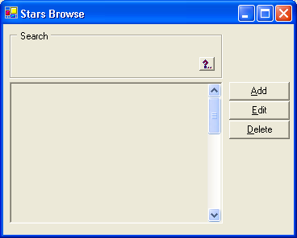

Connecting to the DAE Service.
Learn how to connect to the DAE Service using VS.NET data-aware components.
To show data in the form we need to connect to the DAE Service and create a data view.
- Find the DataSession component in the ToolBox and place one in the designer.
  - Set the ServerUri property to “tcp://localhost:8061/dataphor” for the default installation, or to the connection information for your configuration.
  - Expand the SessionInfo section.
  - Set the UserID to a valid user id or admin for default.
  - Leave the Password blank if you are using the default user id otherwise set it to the valid password.
  - Toggle the Active property to true. If you cannot activate the session check the UserID, Password and ServerUri properties. Once the session is active we have a connection with the DAE service.
- Find the DataView component in the Toolbox and place one in the designer.
  - Change its name to “Stars View”.
  - Set the Expression property to “Stars”. “Stars” is the D4 expression, the equivalent SQL expression is “select * from Stars”.
  - Set the OrderString property to “order {ID asc}. This describes the order of the result. This property is not required and could be set in the expression as a D4 statement like “Stars order by {ID asc}” or SQL statement “select * from Stars order by ID asc”.
  - Set the Session property to the session created above. The DataView can only consume data when it has access to an active DataSession.
  - Set the Active property to true. Setting the active property to true evaluates the expression against the DAE. Once the view is active we have a valid result.
  - Set the UseApplicationTransactions property to false. In this tutorial application transactions are not needed. To learn more about using application transactions and views see the Application Transactions topic in the Dataphor Developer’s Guide.
- Now that we have a view we need to link the DataSource to it. To link the DataSource, click on the dsStars component in the designer and set the View property to the StarsView created above.
- The form should look something like:
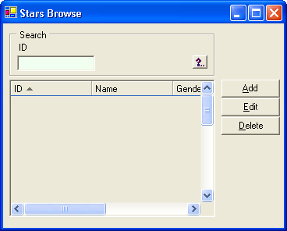
- Save the form by pressing (Ctrl-S).

Building the Edit Form
Learn how to build a simple edit form.
The edit form is a simple form with three edit boxes and two buttons. The form simply allows editing of the ID, Name, and Gender columns.
- Add a new form to the project.
  - Right-click the project and select Add|Add New Item…
  - Select Windows Form and set the name to StarsEdit.cs
  - Select “Open”.
  - Set the Text property of the form to “Stars Edit”.
- Add a ToolBar control to the form.
  - Add a ToolBarButton to the ToolBar on the form.
  - Set the Text property of the first button to “&Save”.
  - Set the DialogResult property to OK.
  - Add another ToolBarButton to the ToolBar on the form.
  - Set the Text property of the second button to “&Close”.
  - Set the DialogResult property to Cancel.
- Set the Save button as the AcceptButton of the form.
  - Select the StarsEdit form in the designer and set the AcceptButton property to the save button in the ToolBar.
- Set the Cancel button as the CancelButton of the form.
  - Select the StarsEdit form in the designer and set the CancelButton property to the cancel button in the ToolBar.
- Add a DataSource component to the form. Each edit box uses this DataSource to link to the result set.
  - Change its name to “dsEdit”.
  - Set the Modifiers property to public to allow the browse form to gain access to the View property later on.
- Add three DBTextBox controls to the form, one for each column represented.
  - Set each of their Source properties to dsEdit.
  - Set each ColumnName property to “ID”, “Name”, and “Gender” respectively.
  - Because the ID column has a key generator (operator) assigned to it, the key generator provides a default value for this column. Set the ReadOnly property to true on the DBTextBox that represents the ID column to prevent users from changing the value for this column.
- Add three labels to the form, one for each column represented.
  - Set the Text of label1 to “ID”.
  - Set the Text of label2 to “Name”.
  - Set the Text of label3 to “Gender”.
- Arrange the controls on the form to look something like this…
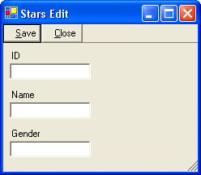
- Save the form by pressing (Ctrl-S).

Putting It All Together
Learn how to complete the browse to edit interface.
Now that we have both the browse and edit forms created we can define the interaction between the two. The browse will instantiate the edit form whenever the Add or Edit buttons are pressed. In this tutorial we are using C# but you can use VB.NET or any .NET supported language.
- Design the Stars Browse form and double click the Add button. The implementation for adding a Star consists of three things. First put the view in an insert state by invoking the Insert method of the view. Second, show the edit form. Third Post or Cancel changes when the form closes. The click event of the Add button looks like
using (StarsEdit LEditForm = new StarsEdit())
{
LEditForm.dsEdit.View = StarsView;
StarsView.Insert();
LEditForm.ShowDialog(this);
if (LEditForm.DialogResult == DialogResult.OK)
StarsView.Post();
else
StarsView.Cancel();
}
- Design the Stars BrowseForm and double click the Edit button. The implementation for editing a Star is similar to adding one. The only difference is in step one. Instead of putting the view in insert state, put it into the edit state by invoking the Edit method of the view. The click event of the Edit button looks like
using (StarsEdit LEditForm = new StarsEdit())
{
LEditForm.dsEdit.View = StarsView;
StarsView.Edit();
LEditForm.ShowDialog(this);
if (LEditForm.DialogResult == DialogResult.OK)
StarsView.Post();
else
StarsView.Cancel();
}
- Design the Stars BrowseForm and double click the Delete button.
- The Delete method of the view deletes the current row. To delete a Star all we need to do is invoke the Delete method of the view. The click event of the Delete button looks like
StarsView.Delete();
- Save your changes by pressing (Ctrl-S).
- Run the application and try the Add, Edit, Delete, and Search.
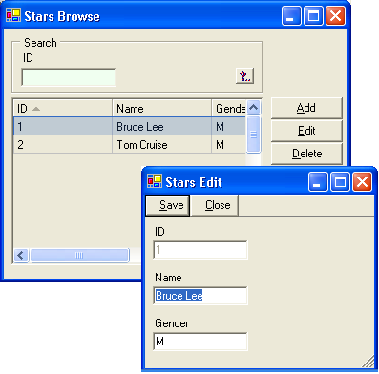

Conclusion
Closing remarks...
In the tutorial we demonstrated key points of the Dataphor Data Access Components by creating a simple database application. We introduced the components that make the data-binding model work; however, this was a brief introduction to the many capabilities of these components. These components are not only used in Rapid Application Development (RAD) but are also used for Automated Application Development (AAD). Try taking it to the next level with AAD.

