Below are the Prerequisites steps should follow to configure for the cortex framework once the Google Cloud Platform is established

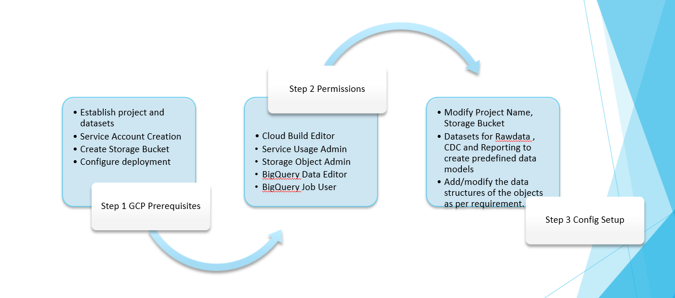

**Project and Storage Bucket creation:**

Create Project and corresponding storage bucket and provide appropriate permissions/access to the user.

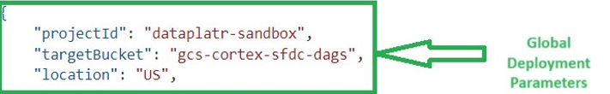

**Dataset Creation in BQ:**

Create the required datasets in BigQuery under the given project for rawdata, Ods layer and Reporting Layer.

Ex : CortexOdsStage. CortexOds, CortexEdw

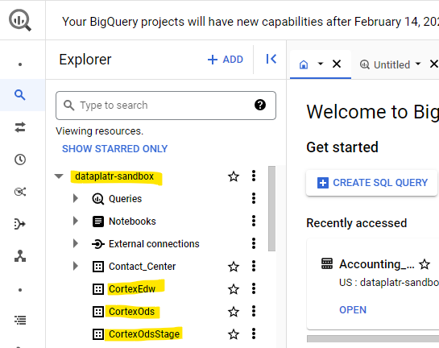

**config.json :** The behavior of the deployment is controlled by this configuration file. The file contains global configuration and configuration specific to oracle workload.

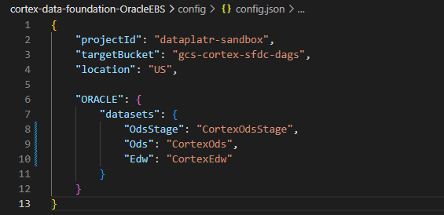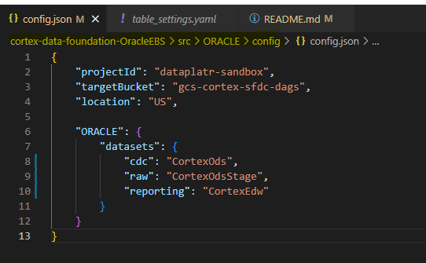

**table_settings.yaml :** This file is utilized for creating corresponding objects within specified datasets as configured in the 'config.json' file. All the names of raw objects and reporting objects can be configured here.

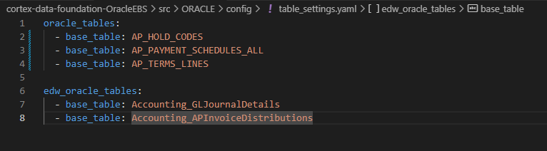

**Schema settings:** Add/modify the data structures of the objects as per requirement in raw_schema (CortexOdsStage), ods_schema (CortexOds) and edw_schema (CortexEdw) folder. Example

