Infobip Guide for Hackers

About Infobip
Infobip is a global leader in omnichannel engagement, providing messaging channels, tools and solutions for customer engagement, authentication and security. We help clients and partners simplify consumer communications, grow their businesses and enhance customer experience—securely, reliably and at scale.

The platform
Infobip AgentOS is a fully AI-enabled orchestration layer that unifies customer engagement across WhatsApp, RCS, SMS, voice, push and other OTT channels, while automating customer journeys and connecting enterprise ecosystems and third-party applications.
It enables teams to build conversational experiences with configurable AI agents and Knowledge Agents, empowered by tools, MCP-enabled services and specialized subagents, with support for agent-to-agent collaboration - all on an LLM-agnostic AI infrastructure.
When human support is needed, AgentOS can hand conversations over, with context, to an AI-powered cloud contact center.

Infobip’s scope: Infobip will support Track 4 only and mentor only teams selecting this track, with a focus on the two use-case proposals below.

Track 4 — proposed challenge directions

1. Digital onboarding and activation
Market scenario
Czech banks have built some of the best digital banking in Europe, and 85% of Czechs bank online, against an EU average of 70%. But most customers use only a small part of what their app can do:
- Mostly balance checks and transfers. People open their banking app about 150 times a year, yet the most common weekly actions are checking their balance (45%) and sending money (31%).
- Personal tools go unused. 72% of customers say personalization affects which bank they choose, but only 3% use the personalized tools their bank already offers.
- Basic facts go unchecked. 53% don’t know the interest rate on their own savings, even though it’s one tap away.
Banks keep shipping new features: spending insights, card controls, savings goals, Bank iD services, new products. Most customers never find them. Every feature that goes undiscovered is investment with no return.
Waiting for customers to open the app and explore isn’t working. To build awareness and get customers onboard, whether to the app itself, a new feature or an existing one they’ve never tried, banks need to meet them where they already spend their time: in chat apps such as WhatsApp, Viber and RCS. There, a short, relevant conversation can explain a feature, answer questions and guide the customer back into the app at exactly the right step.

Use-case proposal
How AI-powered conversational solutions help – by letting the bank run these conversations across every channel from one place. A message that goes unopened in one channel can automatically follow up in another, and AI agents answer customers’ questions using the bank’s approved content.

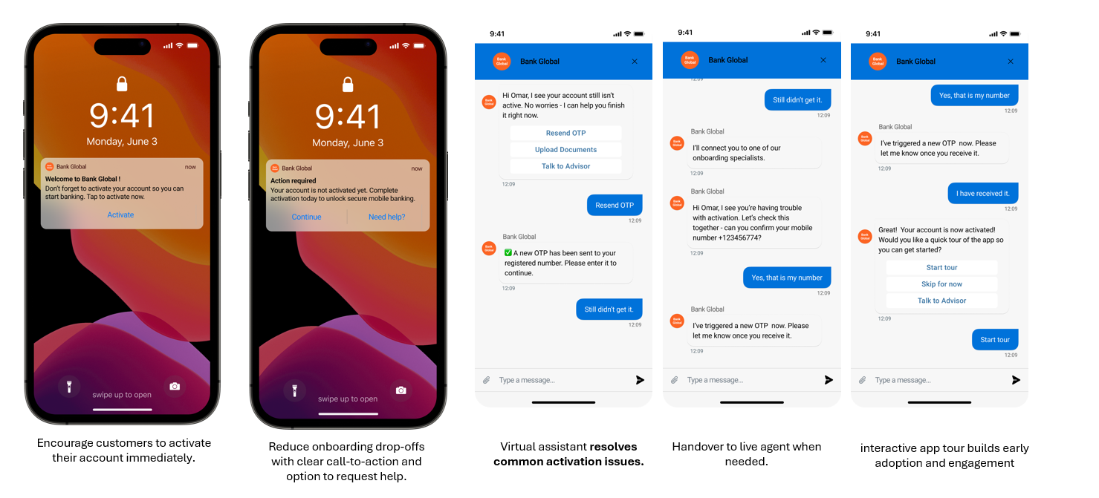
High-level example of a conversational onboarding use case

2. Customer-focused fraud prevention

Market scenario
Banks invest billions in systems that detect suspicious transactions, yet fraud losses keep climbing. Detection alone isn’t enough:
- Detection works, losses still grow. Czech banks blocked a record CZK 12.2bn of attempted fraud in 2025, over 85% of attempts. Yet client losses still rose by more than CZK 700m to CZK 2.13bn, then jumped another 79% in January–July 2026.
- Fraud hits one in four Europeans, and most stay silent. The European Banking Authority names payment fraud the most significant issue for EU consumers. An EU-wide survey of 26,000 people (November 2025) found that 24% have been tricked through messages or emails into transferring money, paying for fake goods or giving away personal data. More than half (56%) never reported it to anyone. If the bank doesn’t reach out first, it may never hear about the fraud until the money is gone.
The risk is highest when stolen card details are used at merchants outside the EU, where the strict EU rules on strong customer authentication don’t fully apply. Fraud systems can flag a suspicious payment in milliseconds, but that’s only half the job. If the bank can’t reach the real customer within seconds and get a clear “yes, that was me” or “no, block it”, the money is gone. And under the upcoming PSD3/PSR rules, banks in the EU will carry more of that loss themselves.

Use-case proposal
How AI-powered conversational solutions help - by connecting the fraud engine to the customer in real time. Sending an instant alert on the channel they actually read, with an automatic SMS backup, and letting them confirm or block the transaction with one tap. When a customer is distressed, it hands them straight to a human specialist who already has the full case.

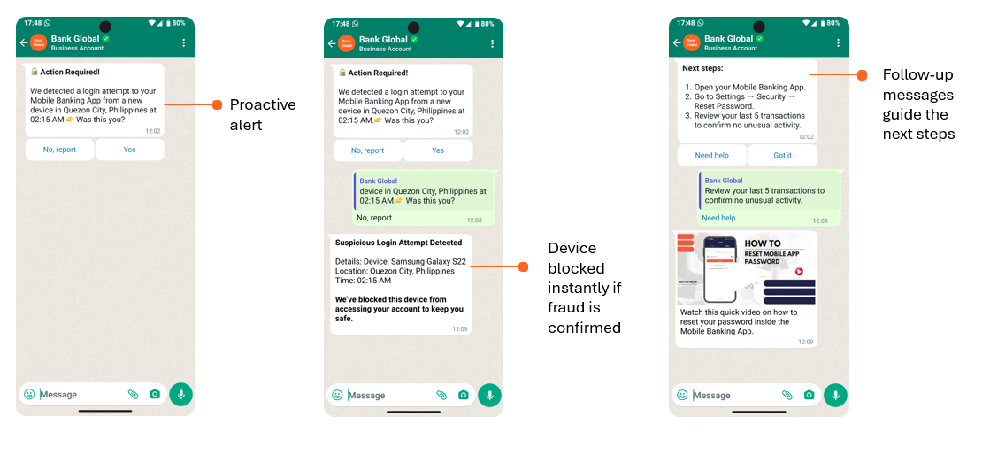
High-level example of conversational fraud prevention use case

Platform access and team credits
Sign in: Infobip platform portal
- Each team will receive access to one dedicated Infobip platform account
- Each account will have one single user, identified by username and password, which will be provided and verified by 2FA at the beginning of the Hackathon.
- Additional users can be quickly created upon request during the Hackathon, providing phone number and email address that will have to be verified via 2FA.

Per-team provision | Allowance / access
AI usage | 400 AI credits per team account
Messaging | 200 free-trial messages per channel used: SMS, WhatsApp, RCS
AgentOS | Full access to all capabilities (Journey, Agents, Automation Studio, Inbox with one human-agent operator license per team)
AI credits and free-trial message allowances can be increased on request.

Sandbox reminder: Use only the provided sandbox and synthetic data. Do not connect to production systems or use real customer personal data.

Infobip mentoring
- Infobip will support Track 4 only. Mentoring is available exclusively to teams registered on Track 4, with a focus on the two use-case proposals in this guide.
- Infobip mentor: Francesco Tonelli - Principal Solution Engineer
- Office hours: Monday 17:00–19:00 and Tuesday 10:00–12:00.

