analysis.rx.R

xing

Wed Mar 2 16:02:48 2016

filename = "201603021202_2hft_novma.csv"  
description =   
"  
Servers:two low latency server,  
Program:xing's send and recv 20160302,  
Features:  
 no libvma;  
 direct connect servers on ethernet;  
 send packet as fast as possible,  
"  
data = as.matrix(read.csv(filename, header = FALSE))  
sample.len = nrow(data)  
data.delta = data[2:sample.len,]-data[1:sample.len-1,]  
  
timeval.rx.send = data.delta[,1]*1e09+data.delta[,2]  
timeval.rx.hardware = data.delta[,3]*1e09+data.delta[,4]  
timeval.rx.user = data.delta[,5]*1e09+data.delta[,6]  
  
timeval.rx = timeval.rx.user - timeval.rx.hardware  
timeval.client = timeval.rx.hardware - timeval.rx.send  
  
"The latency shift from sender software to receiver NIC"

## [1] "The latency shift from sender software to receiver NIC"

summary(timeval.client)

## Min. 1st Qu. Median Mean 3rd Qu. Max.   
## -13380.000 -106.000 -3.000 0.242 98.000 13200.000

sd(timeval.client)

## [1] 174.7352

hist(timeval.client, breaks=200, probability = T, main = "latency shift\n sending software to receiving NIC hardware", xlab = "latency shift (ns)")

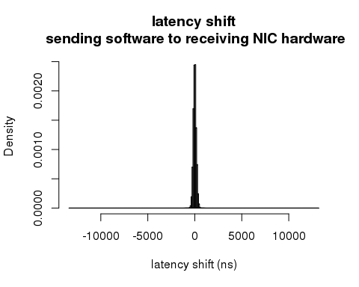

"The latency shift from receiver NIC to receiver software"

## [1] "The latency shift from receiver NIC to receiver software"

summary(timeval.rx)

## Min. 1st Qu. Median Mean 3rd Qu. Max.   
## -125100.00 -876.00 43.00 15.07 1063.00 125700.00

sd(timeval.rx)

## [1] 1107.666

hist(timeval.rx[timeval.rx<5000 & timeval.rx>-5000], breaks=200, probability = T, main = "latency shift\n in receiving server", xlab = "latency shift (ns)")

