latency_on_LL_20160627.R

xing

Tue Jun 28 13:46:48 2016

library("knitr")  
filenames = c("20160627_LL_SF_64b.csv",  
 "20160627_LL_SF_128b.csv",  
 "20160627_LL_SF_256b.csv",  
 "20160627_LL_SF_512b.csv",  
 "20160627_LL_MLNX_64b.csv",  
 "20160627_LL_MLNX_128b.csv",  
 "20160627_LL_MLNX_256b.csv",  
 "20160627_LL_MLNX_512b.csv"  
 )  
system.name = "LL"  
sep = "##############################\n"  
for(filename in filenames){  
 data.ll = read.csv(filename, header = TRUE, colClasses=c("NULL", "integer", "integer"))  
 data.ll.length = length(data.ll$inner)  
 data.ll$inner[1] = as.integer(mean(data.ll$inner[2:data.ll.length]))  
 latency.ll.in = data.ll$inner  
 latency.ll.net = data.ll$net  
 latency.ll.net.total = sum(data.ll$net)/1000  
 latency.ll.in.total = sum(data.ll$inner)/1000  
 ranges = rbind(c(0,60,1),  
 c(60,200,10),  
 c(200,500,50),  
 c(500,4000,500)  
 )  
   
 hist.table = data.frame(start=integer(), end=integer(), count=integer())  
   
 for(c in 1:nrow(ranges)){  
 range.start = ranges[c,1]  
 range.end = ranges[c,2]  
 range.step = ranges[c,3]  
 b = seq(range.start, range.end, range.step)  
 range.target = (latency.ll.in > range.start & latency.ll.in <= range.end)  
 range.count = sum(range.target)  
 range.count.ratio = range.count/(data.ll.length-1)  
 range.latency = sum(latency.ll.in[range.target])  
 range.latency.ratio = range.latency/latency.ll.in.total/1000  
 text.capital = sprintf("Internal Latency on %s(%d ns ~ %d ns)", system.name, range.start, range.end)  
 text.comment = sprintf("Count in Range:%d, %.4f%% total sample", range.count, range.count.ratio*100)  
   
 cat(sprintf(sep))  
 cat(sprintf("DATA:%s on %s\n", filename, system.name))  
 cat(sprintf("RANGE:%d ns - %d ns\n", range.start, range.end))  
 cat(sprintf("Sample Number:%d, %.4f%% of total %d samples\n", range.count, range.count.ratio*100, data.ll.length))  
   
 h.data = hist(latency.ll.in[range.target], breaks = b,right = TRUE,   
 main = text.capital, sub = text.comment, xlab = "Time(ns)", ylab = "Count",   
 las = 1  
 )  
 hist.table = rbind(hist.table, cbind(h.data$breaks[1:length(h.data$breaks)-1],   
 h.data$breaks[1:length(h.data$breaks)-1]+range.step,  
 h.data$counts))  
 }  
 cat(sprintf(sep))  
 cat(sprintf("DATA:%s on %s\n", filename, system.name))  
 cat(sprintf("Sample number:%d\n", data.ll.length))  
 cat(sprintf("latency avg=%.1f ns, sd=%.1f ns\n", mean(latency.ll.in), sd(latency.ll.in)))  
 print(summary(latency.ll.in))  
 print(kable(hist.table, col.names = c("Start", "End", "Count")))  
}

## Warning in sum(data.ll$net): integer overflow - use sum(as.numeric(.))

## ##############################  
## DATA:20160627_LL_SF_64b.csv on LL  
## RANGE:0 ns - 60 ns  
## Sample Number:16655948, 99.6841% of total 16708728 samples

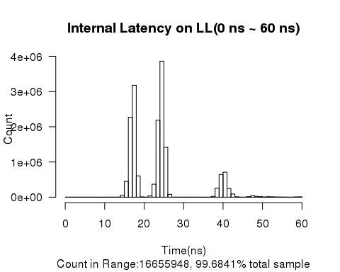

## ##############################  
## DATA:20160627_LL_SF_64b.csv on LL  
## RANGE:60 ns - 200 ns  
## Sample Number:50334, 0.3012% of total 16708728 samples

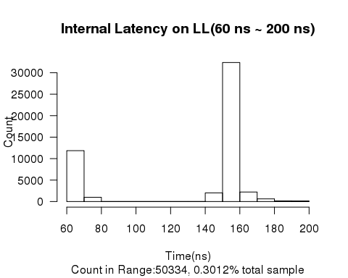

## ##############################  
## DATA:20160627_LL_SF_64b.csv on LL  
## RANGE:200 ns - 500 ns  
## Sample Number:2442, 0.0146% of total 16708728 samples

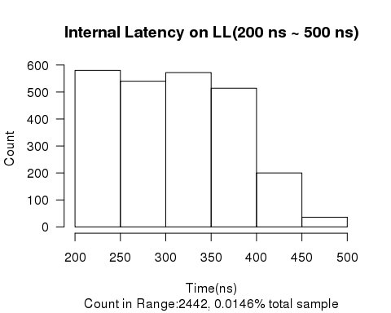

## ##############################  
## DATA:20160627_LL_SF_64b.csv on LL  
## RANGE:500 ns - 4000 ns  
## Sample Number:4, 0.0000% of total 16708728 samples

## ##############################  
## DATA:20160627_LL_SF_64b.csv on LL  
## Sample number:16708728  
## latency avg=24.4 ns, sd=10.4 ns  
## Min. 1st Qu. Median Mean 3rd Qu. Max.   
## 13.00 18.00 24.00 24.44 25.00 587.00   
##   
##   
## Start End Count  
## ------ ----- --------  
## 0 1 0  
## 1 2 0  
## 2 3 0  
## 3 4 0  
## 4 5 0  
## 5 6 0  
## 6 7 0  
## 7 8 0  
## 8 9 0  
## 9 10 0  
## 10 11 0  
## 11 12 0  
## 12 13 13  
## 13 14 2404  
## 14 15 56169  
## 15 16 448634  
## 16 17 2271131  
## 17 18 3177102  
## 18 19 605949  
## 19 20 7756  
## 20 21 1139  
## 21 22 36529  
## 22 23 368781  
## 23 24 2187722  
## 24 25 3861356  
## 25 26 1415686  
## 26 27 81536  
## 27 28 57  
## 28 29 4  
## 29 30 65  
## 30 31 706  
## 31 32 2  
## 32 33 5  
## 33 34 5  
## 34 35 6  
## 35 36 20  
## 36 37 1070  
## 37 38 24123  
## 38 39 257396  
## 39 40 645021  
## 40 41 710375  
## 41 42 245700  
## 42 43 91150  
## 43 44 10537  
## 44 45 633  
## 45 46 113  
## 46 47 14409  
## 47 48 44116  
## 48 49 22784  
## 49 50 13713  
## 50 51 4352  
## 51 52 11133  
## 52 53 9300  
## 53 54 4860  
## 54 55 3033  
## 55 56 2419  
## 56 57 1213  
## 57 58 1206  
## 58 59 5915  
## 59 60 8600  
## 60 70 11855  
## 70 80 993  
## 80 90 5  
## 90 100 0  
## 100 110 4  
## 110 120 0  
## 120 130 0  
## 130 140 0  
## 140 150 2014  
## 150 160 32367  
## 160 170 2223  
## 170 180 620  
## 180 190 138  
## 190 200 115  
## 200 250 580  
## 250 300 540  
## 300 350 572  
## 350 400 514  
## 400 450 200  
## 450 500 36  
## 500 1000 4  
## 1000 1500 0  
## 1500 2000 0  
## 2000 2500 0  
## 2500 3000 0  
## 3000 3500 0  
## 3500 4000 0

## Warning in sum(data.ll$net): integer overflow - use sum(as.numeric(.))

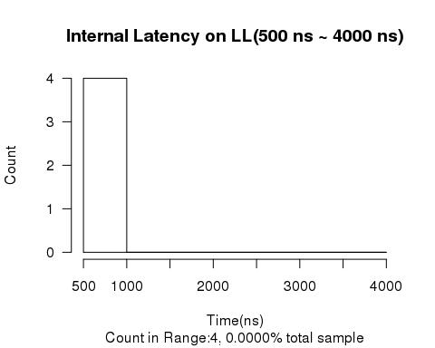

## ##############################  
## DATA:20160627_LL_SF_128b.csv on LL  
## RANGE:0 ns - 60 ns  
## Sample Number:15962160, 99.7740% of total 15998318 samples

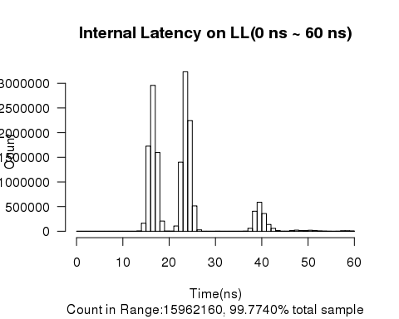

## ##############################  
## DATA:20160627_LL_SF_128b.csv on LL  
## RANGE:60 ns - 200 ns  
## Sample Number:34166, 0.2136% of total 15998318 samples

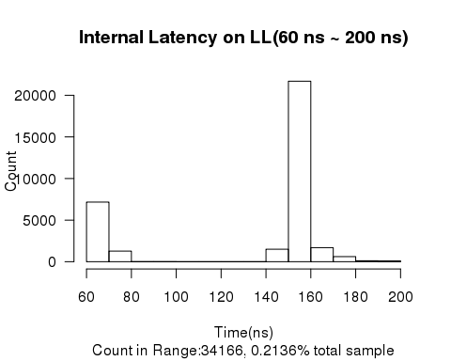

## ##############################  
## DATA:20160627_LL_SF_128b.csv on LL  
## RANGE:200 ns - 500 ns  
## Sample Number:1991, 0.0124% of total 15998318 samples

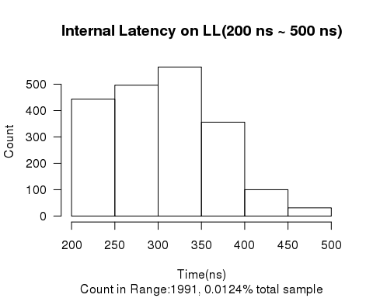

## ##############################  
## DATA:20160627_LL_SF_128b.csv on LL  
## RANGE:500 ns - 4000 ns  
## Sample Number:1, 0.0000% of total 15998318 samples

## ##############################  
## DATA:20160627_LL_SF_128b.csv on LL  
## Sample number:15998318  
## latency avg=23.4 ns, sd=9.7 ns  
## Min. 1st Qu. Median Mean 3rd Qu. Max.   
## 13.00 17.00 23.00 23.35 25.00 596.00   
##   
##   
## Start End Count  
## ------ ----- --------  
## 0 1 0  
## 1 2 0  
## 2 3 0  
## 3 4 0  
## 4 5 0  
## 5 6 0  
## 6 7 0  
## 7 8 0  
## 8 9 0  
## 9 10 0  
## 10 11 0  
## 11 12 0  
## 12 13 18  
## 13 14 5692  
## 14 15 163762  
## 15 16 1726069  
## 16 17 2956884  
## 17 18 1596650  
## 18 19 207448  
## 19 20 3894  
## 20 21 3066  
## 21 22 106876  
## 22 23 1401565  
## 23 24 3232501  
## 24 25 2242277  
## 25 26 513590  
## 26 27 28192  
## 27 28 1044  
## 28 29 421  
## 29 30 269  
## 30 31 1901  
## 31 32 4  
## 32 33 0  
## 33 34 5  
## 34 35 8  
## 35 36 38  
## 36 37 3009  
## 37 38 60513  
## 38 39 406168  
## 39 40 588810  
## 40 41 359842  
## 41 42 137651  
## 42 43 58918  
## 43 44 13079  
## 44 45 2000  
## 45 46 1463  
## 46 47 14251  
## 47 48 22960  
## 48 49 13742  
## 49 50 12592  
## 50 51 20617  
## 51 52 14049  
## 52 53 6834  
## 53 54 4205  
## 54 55 1534  
## 55 56 839  
## 56 57 2132  
## 57 58 9085  
## 58 59 9585  
## 59 60 6108  
## 60 70 7165  
## 70 80 1276  
## 80 90 10  
## 90 100 8  
## 100 110 4  
## 110 120 0  
## 120 130 0  
## 130 140 1  
## 140 150 1506  
## 150 160 21692  
## 160 170 1687  
## 170 180 614  
## 180 190 115  
## 190 200 88  
## 200 250 443  
## 250 300 496  
## 300 350 565  
## 350 400 356  
## 400 450 100  
## 450 500 31  
## 500 1000 1  
## 1000 1500 0  
## 1500 2000 0  
## 2000 2500 0  
## 2500 3000 0  
## 3000 3500 0  
## 3500 4000 0

## Warning in sum(data.ll$net): integer overflow - use sum(as.numeric(.))

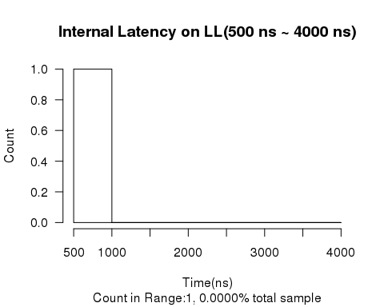

## ##############################  
## DATA:20160627_LL_SF_256b.csv on LL  
## RANGE:0 ns - 60 ns  
## Sample Number:14757656, 99.6642% of total 14807375 samples

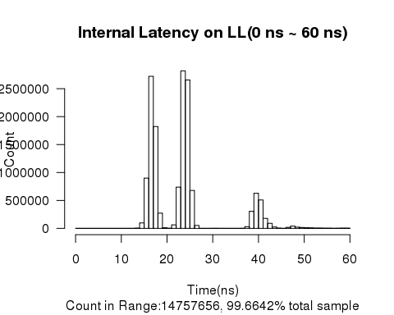

## ##############################  
## DATA:20160627_LL_SF_256b.csv on LL  
## RANGE:60 ns - 200 ns  
## Sample Number:47848, 0.3231% of total 14807375 samples

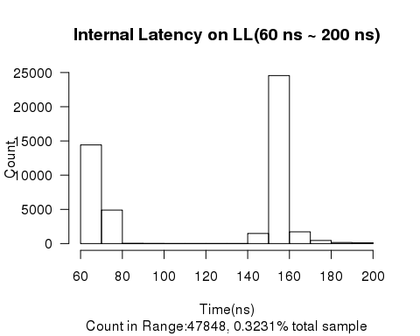

## ##############################  
## DATA:20160627_LL_SF_256b.csv on LL  
## RANGE:200 ns - 500 ns  
## Sample Number:1871, 0.0126% of total 14807375 samples

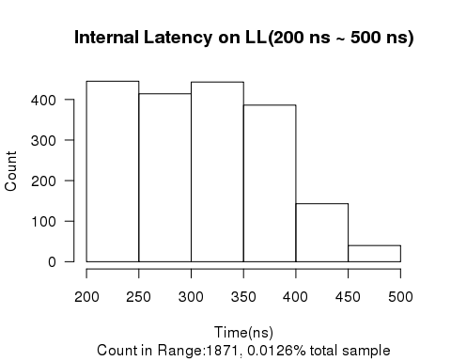

## ##############################  
## DATA:20160627_LL_SF_256b.csv on LL  
## RANGE:500 ns - 4000 ns  
## Sample Number:0, 0.0000% of total 14807375 samples

## ##############################  
## DATA:20160627_LL_SF_256b.csv on LL  
## Sample number:14807375  
## latency avg=24.1 ns, sd=10.3 ns  
## Min. 1st Qu. Median Mean 3rd Qu. Max.   
## 13.00 17.00 24.00 24.13 25.00 494.00   
##   
##   
## Start End Count  
## ------ ----- --------  
## 0 1 0  
## 1 2 0  
## 2 3 0  
## 3 4 0  
## 4 5 0  
## 5 6 0  
## 6 7 0  
## 7 8 0  
## 8 9 0  
## 9 10 0  
## 10 11 0  
## 11 12 0  
## 12 13 39  
## 13 14 4227  
## 14 15 97643  
## 15 16 899801  
## 16 17 2721108  
## 17 18 1823020  
## 18 19 272186  
## 19 20 9730  
## 20 21 2139  
## 21 22 63110  
## 22 23 738521  
## 23 24 2818616  
## 24 25 2655599  
## 25 26 678566  
## 26 27 52089  
## 27 28 548  
## 28 29 142  
## 29 30 520  
## 30 31 1737  
## 31 32 419  
## 32 33 246  
## 33 34 68  
## 34 35 13  
## 35 36 17  
## 36 37 1621  
## 37 38 31106  
## 38 39 305236  
## 39 40 628162  
## 40 41 508179  
## 41 42 178517  
## 42 43 90339  
## 43 44 24849  
## 44 45 3976  
## 45 46 630  
## 46 47 18215  
## 47 48 40025  
## 48 49 21600  
## 49 50 16120  
## 50 51 10501  
## 51 52 8225  
## 52 53 5248  
## 53 54 5406  
## 54 55 3279  
## 55 56 2914  
## 56 57 1775  
## 57 58 2786  
## 58 59 4738  
## 59 60 4105  
## 60 70 14417  
## 70 80 4901  
## 80 90 33  
## 90 100 9  
## 100 110 7  
## 110 120 1  
## 120 130 8  
## 130 140 0  
## 140 150 1481  
## 150 160 24550  
## 160 170 1717  
## 170 180 455  
## 180 190 154  
## 190 200 115  
## 200 250 445  
## 250 300 414  
## 300 350 443  
## 350 400 386  
## 400 450 143  
## 450 500 40  
## 500 1000 0  
## 1000 1500 0  
## 1500 2000 0  
## 2000 2500 0  
## 2500 3000 0  
## 3000 3500 0  
## 3500 4000 0

## Warning in sum(data.ll$net): integer overflow - use sum(as.numeric(.))

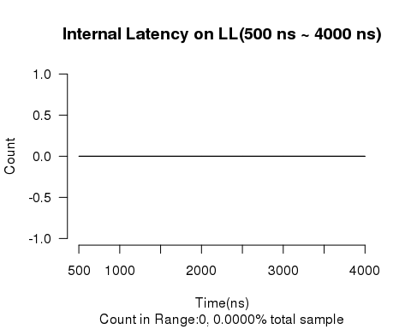

## ##############################  
## DATA:20160627_LL_SF_512b.csv on LL  
## RANGE:0 ns - 60 ns  
## Sample Number:13955389, 99.7605% of total 13988898 samples

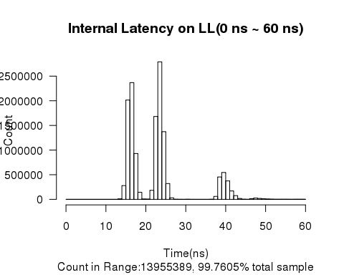

## ##############################  
## DATA:20160627_LL_SF_512b.csv on LL  
## RANGE:60 ns - 200 ns  
## Sample Number:32067, 0.2292% of total 13988898 samples

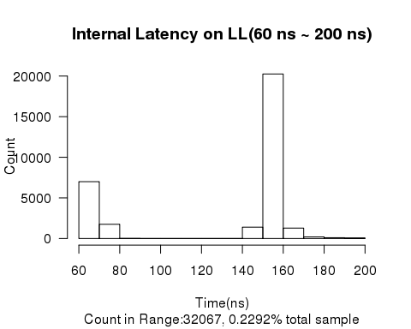

## ##############################  
## DATA:20160627_LL_SF_512b.csv on LL  
## RANGE:200 ns - 500 ns  
## Sample Number:1442, 0.0103% of total 13988898 samples

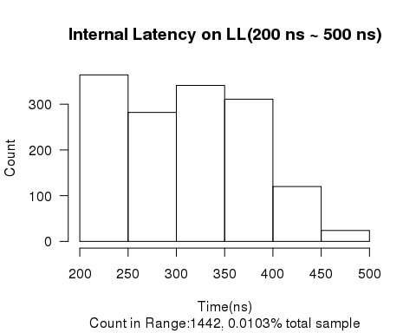

## ##############################  
## DATA:20160627_LL_SF_512b.csv on LL  
## RANGE:500 ns - 4000 ns  
## Sample Number:0, 0.0000% of total 13988898 samples

## ##############################  
## DATA:20160627_LL_SF_512b.csv on LL  
## Sample number:13988898  
## latency avg=23.5 ns, sd=9.9 ns  
## Min. 1st Qu. Median Mean 3rd Qu. Max.   
## 12.00 17.00 23.00 23.48 25.00 483.00   
##   
##   
## Start End Count  
## ------ ----- --------  
## 0 1 0  
## 1 2 0  
## 2 3 0  
## 3 4 0  
## 4 5 0  
## 5 6 0  
## 6 7 0  
## 7 8 0  
## 8 9 0  
## 9 10 0  
## 10 11 0  
## 11 12 1  
## 12 13 93  
## 13 14 9431  
## 14 15 279321  
## 15 16 2015080  
## 16 17 2367935  
## 17 18 930028  
## 18 19 144590  
## 19 20 7651  
## 20 21 5369  
## 21 22 183041  
## 22 23 1681388  
## 23 24 2789143  
## 24 25 1373438  
## 25 26 320758  
## 26 27 31776  
## 27 28 2389  
## 28 29 1294  
## 29 30 855  
## 30 31 2251  
## 31 32 109  
## 32 33 41  
## 33 34 12  
## 34 35 5  
## 35 36 18  
## 36 37 2271  
## 37 38 60107  
## 38 39 455083  
## 39 40 546071  
## 40 41 374537  
## 41 42 170642  
## 42 43 75613  
## 43 44 17437  
## 44 45 3290  
## 45 46 1302  
## 46 47 15451  
## 47 48 26486  
## 48 49 19020  
## 49 50 13089  
## 50 51 7080  
## 51 52 4196  
## 52 53 2714  
## 53 54 2224  
## 54 55 2131  
## 55 56 2335  
## 56 57 1778  
## 57 58 2120  
## 58 59 2366  
## 59 60 2029  
## 60 70 7003  
## 70 80 1751  
## 80 90 14  
## 90 100 2  
## 100 110 2  
## 110 120 0  
## 120 130 0  
## 130 140 0  
## 140 150 1398  
## 150 160 20251  
## 160 170 1280  
## 170 180 197  
## 180 190 105  
## 190 200 64  
## 200 250 364  
## 250 300 282  
## 300 350 341  
## 350 400 311  
## 400 450 120  
## 450 500 24  
## 500 1000 0  
## 1000 1500 0  
## 1500 2000 0  
## 2000 2500 0  
## 2500 3000 0  
## 3000 3500 0  
## 3500 4000 0

## Warning in sum(data.ll$net): integer overflow - use sum(as.numeric(.))



## ##############################  
## DATA:20160627_LL_MLNX_64b.csv on LL  
## RANGE:0 ns - 60 ns  
## Sample Number:25630757, 99.9184% of total 25651696 samples

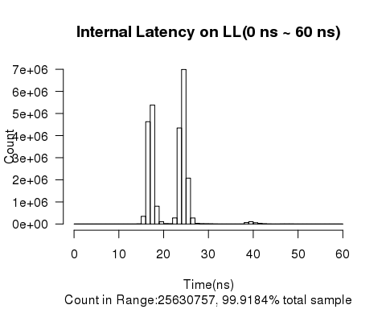

## ##############################  
## DATA:20160627_LL_MLNX_64b.csv on LL  
## RANGE:60 ns - 200 ns  
## Sample Number:18603, 0.0725% of total 25651696 samples

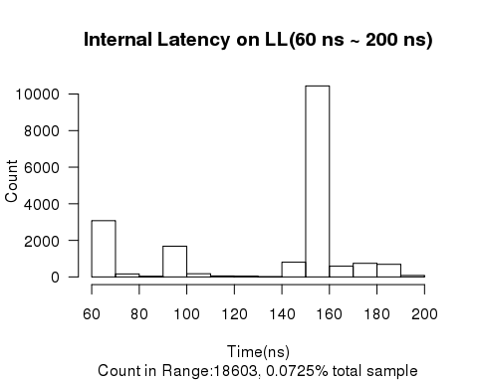

## ##############################  
## DATA:20160627_LL_MLNX_64b.csv on LL  
## RANGE:200 ns - 500 ns  
## Sample Number:2332, 0.0091% of total 25651696 samples

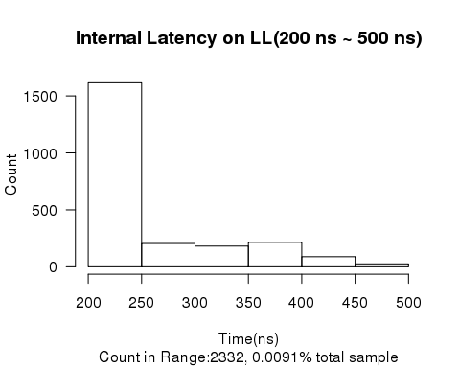

## ##############################  
## DATA:20160627_LL_MLNX_64b.csv on LL  
## RANGE:500 ns - 4000 ns  
## Sample Number:2, 0.0000% of total 25651696 samples

## ##############################  
## DATA:20160627_LL_MLNX_64b.csv on LL  
## Sample number:25651696  
## latency avg=22.0 ns, sd=6.3 ns  
## Min. 1st Qu. Median Mean 3rd Qu. Max.   
## 14.00 18.00 24.00 21.96 25.00 8833.00   
##   
##   
## Start End Count  
## ------ ----- --------  
## 0 1 0  
## 1 2 0  
## 2 3 0  
## 3 4 0  
## 4 5 0  
## 5 6 0  
## 6 7 0  
## 7 8 0  
## 8 9 0  
## 9 10 0  
## 10 11 0  
## 11 12 0  
## 12 13 0  
## 13 14 58  
## 14 15 5694  
## 15 16 349323  
## 16 17 4629573  
## 17 18 5379149  
## 18 19 806748  
## 19 20 103631  
## 20 21 15563  
## 21 22 10064  
## 22 23 275898  
## 23 24 4345653  
## 24 25 6990146  
## 25 26 2076115  
## 26 27 273149  
## 27 28 32843  
## 28 29 14427  
## 29 30 11033  
## 30 31 7900  
## 31 32 3849  
## 32 33 1483  
## 33 34 847  
## 34 35 447  
## 35 36 170  
## 36 37 63  
## 37 38 1637  
## 38 39 67724  
## 39 40 105061  
## 40 41 60017  
## 41 42 29563  
## 42 43 10567  
## 43 44 3067  
## 44 45 1176  
## 45 46 497  
## 46 47 3168  
## 47 48 4431  
## 48 49 3484  
## 49 50 1999  
## 50 51 875  
## 51 52 437  
## 52 53 209  
## 53 54 178  
## 54 55 179  
## 55 56 285  
## 56 57 906  
## 57 58 958  
## 58 59 369  
## 59 60 144  
## 60 70 3077  
## 70 80 165  
## 80 90 35  
## 90 100 1679  
## 100 110 177  
## 110 120 57  
## 120 130 44  
## 130 140 13  
## 140 150 806  
## 150 160 10440  
## 160 170 589  
## 170 180 746  
## 180 190 692  
## 190 200 83  
## 200 250 1615  
## 250 300 205  
## 300 350 182  
## 350 400 215  
## 400 450 89  
## 450 500 26  
## 500 1000 2  
## 1000 1500 0  
## 1500 2000 0  
## 2000 2500 0  
## 2500 3000 0  
## 3000 3500 0  
## 3500 4000 0

## Warning in sum(data.ll$net): integer overflow - use sum(as.numeric(.))

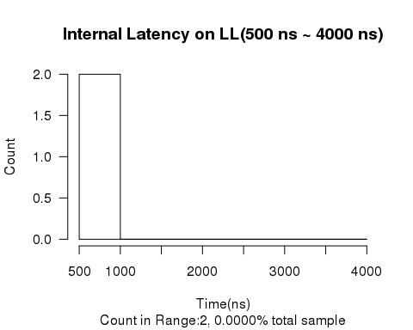

## ##############################  
## DATA:20160627_LL_MLNX_128b.csv on LL  
## RANGE:0 ns - 60 ns  
## Sample Number:23984858, 99.7614% of total 24042230 samples

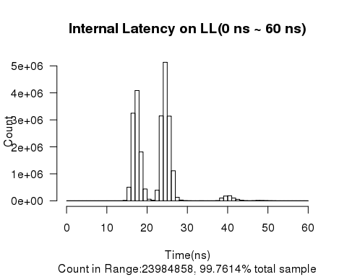

## ##############################  
## DATA:20160627_LL_MLNX_128b.csv on LL  
## RANGE:60 ns - 200 ns  
## Sample Number:51932, 0.2160% of total 24042230 samples

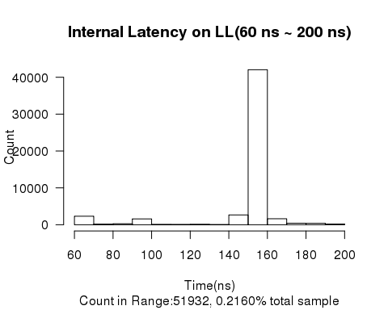

## ##############################  
## DATA:20160627_LL_MLNX_128b.csv on LL  
## RANGE:200 ns - 500 ns  
## Sample Number:5434, 0.0226% of total 24042230 samples

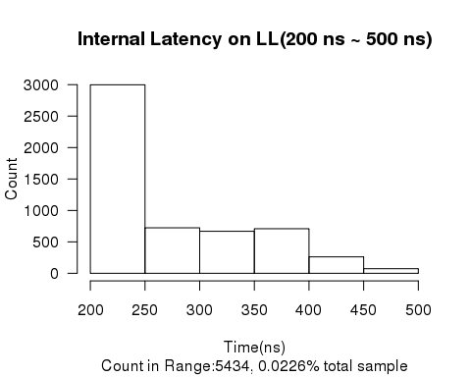

## ##############################  
## DATA:20160627_LL_MLNX_128b.csv on LL  
## RANGE:500 ns - 4000 ns  
## Sample Number:3, 0.0000% of total 24042230 samples

## ##############################  
## DATA:20160627_LL_MLNX_128b.csv on LL  
## Sample number:24042230  
## latency avg=22.9 ns, sd=9.2 ns  
## Min. 1st Qu. Median Mean 3rd Qu. Max.   
## 13.00 18.00 24.00 22.88 25.00 8609.00   
##   
##   
## Start End Count  
## ------ ----- --------  
## 0 1 0  
## 1 2 0  
## 2 3 0  
## 3 4 0  
## 4 5 0  
## 5 6 0  
## 6 7 0  
## 7 8 0  
## 8 9 0  
## 9 10 0  
## 10 11 0  
## 11 12 0  
## 12 13 1  
## 13 14 141  
## 14 15 12954  
## 15 16 502495  
## 16 17 3246971  
## 17 18 4086020  
## 18 19 1810558  
## 19 20 438424  
## 20 21 59587  
## 21 22 19453  
## 22 23 393235  
## 23 24 3145892  
## 24 25 5131126  
## 25 26 3138022  
## 26 27 1111990  
## 27 28 131086  
## 28 29 27988  
## 29 30 6919  
## 30 31 1883  
## 31 32 769  
## 32 33 1339  
## 33 34 1775  
## 34 35 1439  
## 35 36 790  
## 36 37 394  
## 37 38 5940  
## 38 39 103441  
## 39 40 177283  
## 40 41 188393  
## 41 42 104085  
## 42 43 53483  
## 43 44 20068  
## 44 45 6151  
## 45 46 2089  
## 46 47 5611  
## 47 48 13502  
## 48 49 11386  
## 49 50 8558  
## 50 51 4987  
## 51 52 2462  
## 52 53 1333  
## 53 54 739  
## 54 55 524  
## 55 56 591  
## 56 57 815  
## 57 58 859  
## 58 59 701  
## 59 60 606  
## 60 70 2317  
## 70 80 157  
## 80 90 266  
## 90 100 1590  
## 100 110 74  
## 110 120 61  
## 120 130 109  
## 130 140 31  
## 140 150 2665  
## 150 160 42036  
## 160 170 1620  
## 170 180 417  
## 180 190 387  
## 190 200 202  
## 200 250 2997  
## 250 300 724  
## 300 350 669  
## 350 400 709  
## 400 450 262  
## 450 500 73  
## 500 1000 3  
## 1000 1500 0  
## 1500 2000 0  
## 2000 2500 0  
## 2500 3000 0  
## 3000 3500 0  
## 3500 4000 0

## Warning in sum(data.ll$net): integer overflow - use sum(as.numeric(.))

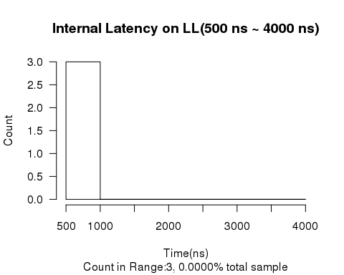

## ##############################  
## DATA:20160627_LL_MLNX_256b.csv on LL  
## RANGE:0 ns - 60 ns  
## Sample Number:18421354, 99.8636% of total 18446509 samples

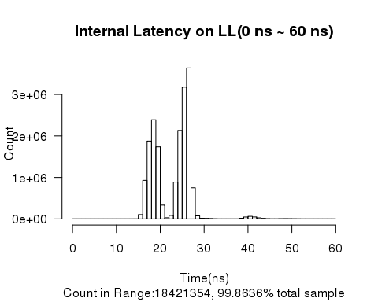

## ##############################  
## DATA:20160627_LL_MLNX_256b.csv on LL  
## RANGE:60 ns - 200 ns  
## Sample Number:20591, 0.1116% of total 18446509 samples

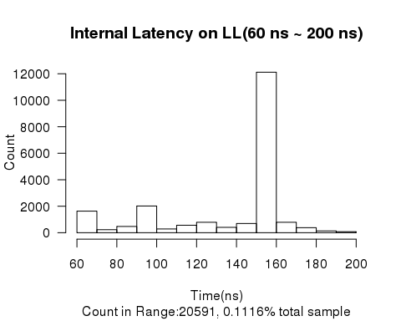

## ##############################  
## DATA:20160627_LL_MLNX_256b.csv on LL  
## RANGE:200 ns - 500 ns  
## Sample Number:4562, 0.0247% of total 18446509 samples

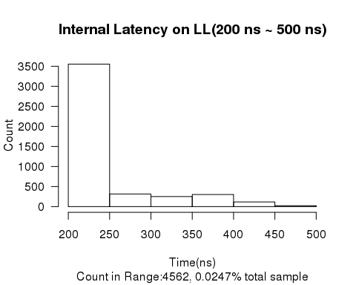

## ##############################  
## DATA:20160627_LL_MLNX_256b.csv on LL  
## RANGE:500 ns - 4000 ns  
## Sample Number:2, 0.0000% of total 18446509 samples

## ##############################  
## DATA:20160627_LL_MLNX_256b.csv on LL  
## Sample number:18446509  
## latency avg=23.6 ns, sd=6.9 ns  
## Min. 1st Qu. Median Mean 3rd Qu. Max.   
## 14.00 19.00 25.00 23.57 27.00 526.00   
##   
##   
## Start End Count  
## ------ ----- --------  
## 0 1 0  
## 1 2 0  
## 2 3 0  
## 3 4 0  
## 4 5 0  
## 5 6 0  
## 6 7 0  
## 7 8 0  
## 8 9 0  
## 9 10 0  
## 10 11 0  
## 11 12 0  
## 12 13 0  
## 13 14 5  
## 14 15 495  
## 15 16 104687  
## 16 17 928522  
## 17 18 1875581  
## 18 19 2390623  
## 19 20 1737652  
## 20 21 332547  
## 21 22 28491  
## 22 23 85550  
## 23 24 887302  
## 24 25 2132349  
## 25 26 3175694  
## 26 27 3637184  
## 27 28 750244  
## 28 29 73330  
## 29 30 14152  
## 30 31 11404  
## 31 32 8343  
## 32 33 3611  
## 33 34 805  
## 34 35 261  
## 35 36 98  
## 36 37 46  
## 37 38 301  
## 38 39 17395  
## 39 40 46235  
## 40 41 62154  
## 41 42 47733  
## 42 43 26246  
## 43 44 11597  
## 44 45 4220  
## 45 46 1484  
## 46 47 1921  
## 47 48 4610  
## 48 49 5326  
## 49 50 4270  
## 50 51 2945  
## 51 52 1717  
## 52 53 879  
## 53 54 557  
## 54 55 360  
## 55 56 308  
## 56 57 428  
## 57 58 607  
## 58 59 594  
## 59 60 491  
## 60 70 1632  
## 70 80 228  
## 80 90 475  
## 90 100 2017  
## 100 110 284  
## 110 120 565  
## 120 130 788  
## 130 140 405  
## 140 150 696  
## 150 160 12116  
## 160 170 788  
## 170 180 381  
## 180 190 137  
## 190 200 79  
## 200 250 3554  
## 250 300 315  
## 300 350 251  
## 350 400 302  
## 400 450 117  
## 450 500 23  
## 500 1000 2  
## 1000 1500 0  
## 1500 2000 0  
## 2000 2500 0  
## 2500 3000 0  
## 3000 3500 0  
## 3500 4000 0

## Warning in sum(data.ll$net): integer overflow - use sum(as.numeric(.))



## ##############################  
## DATA:20160627_LL_MLNX_512b.csv on LL  
## RANGE:0 ns - 60 ns  
## Sample Number:16130417, 99.1091% of total 16275414 samples

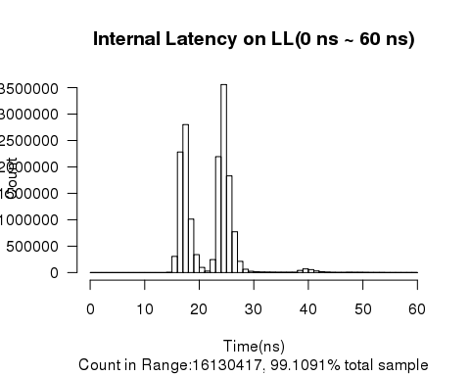

## ##############################  
## DATA:20160627_LL_MLNX_512b.csv on LL  
## RANGE:60 ns - 200 ns  
## Sample Number:134980, 0.8293% of total 16275414 samples

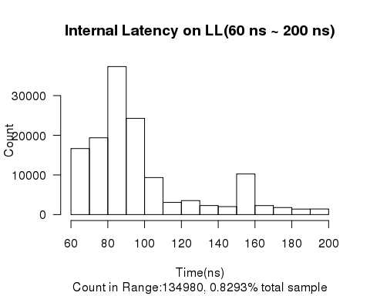

## ##############################  
## DATA:20160627_LL_MLNX_512b.csv on LL  
## RANGE:200 ns - 500 ns  
## Sample Number:10009, 0.0615% of total 16275414 samples

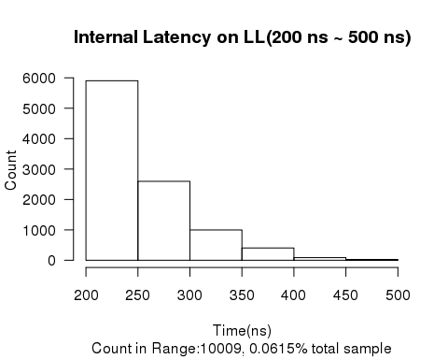

## ##############################  
## DATA:20160627_LL_MLNX_512b.csv on LL  
## RANGE:500 ns - 4000 ns  
## Sample Number:7, 0.0000% of total 16275414 samples

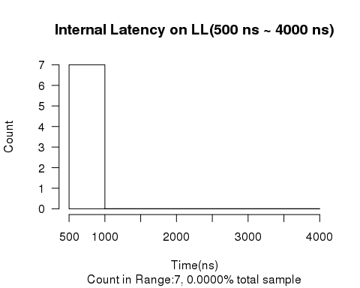

## ##############################  
## DATA:20160627_LL_MLNX_512b.csv on LL  
## Sample number:16275414  
## latency avg=23.2 ns, sd=11.0 ns  
## Min. 1st Qu. Median Mean 3rd Qu. Max.   
## 14.00 18.00 24.00 23.19 25.00 12150.00   
##   
##   
## Start End Count  
## ------ ----- --------  
## 0 1 0  
## 1 2 0  
## 2 3 0  
## 3 4 0  
## 4 5 0  
## 5 6 0  
## 6 7 0  
## 7 8 0  
## 8 9 0  
## 9 10 0  
## 10 11 0  
## 11 12 0  
## 12 13 0  
## 13 14 42  
## 14 15 5946  
## 15 16 306947  
## 16 17 2281888  
## 17 18 2800832  
## 18 19 1012454  
## 19 20 339794  
## 20 21 97707  
## 21 22 29440  
## 22 23 246585  
## 23 24 2194168  
## 24 25 3557663  
## 25 26 1829785  
## 26 27 772562  
## 27 28 212625  
## 28 29 63192  
## 29 30 24960  
## 30 31 14674  
## 31 32 10758  
## 32 33 9540  
## 33 34 7984  
## 34 35 7166  
## 35 36 6799  
## 36 37 6402  
## 37 38 6992  
## 38 39 41836  
## 39 40 70120  
## 40 41 55690  
## 41 42 31066  
## 42 43 17368  
## 43 44 9194  
## 44 45 5678  
## 45 46 3906  
## 46 47 4792  
## 47 48 6639  
## 48 49 5834  
## 49 50 5018  
## 50 51 4129  
## 51 52 3510  
## 52 53 2767  
## 53 54 2510  
## 54 55 2257  
## 55 56 2234  
## 56 57 2263  
## 57 58 2348  
## 58 59 2214  
## 59 60 2139  
## 60 70 16657  
## 70 80 19373  
## 80 90 37321  
## 90 100 24268  
## 100 110 9332  
## 110 120 3077  
## 120 130 3535  
## 130 140 2283  
## 140 150 2017  
## 150 160 10241  
## 160 170 2278  
## 170 180 1784  
## 180 190 1395  
## 190 200 1419  
## 200 250 5902  
## 250 300 2595  
## 300 350 996  
## 350 400 405  
## 400 450 88  
## 450 500 23  
## 500 1000 7  
## 1000 1500 0  
## 1500 2000 0  
## 2000 2500 0  
## 2500 3000 0  
## 3000 3500 0  
## 3500 4000 0