The unlinking of population mental ill-health and the suicide rate

N Glozier & RW Morris

Affiliation: The University of Sydney, School of Medicine, NSW, Australia

For submission to [MJA](https://www.mja.com.au/journal/mja-instructions-authors-types-articles-published-mja#Perspectives)

Date rendered: 2020-10-31

Abstract (100 words)

This is a one hundred word abstract. Note this is not for publication but may be used in correspondence with reviewers.

### Perspective

###### Australia’s unique counterfactual study and the implications for the health response

There is much debate around the potential impact of the Coronavirus Pandemic (COVID-19) on mental ill-health and suicide mortality in Australia, with the prevailing view being that both will rise dramatically. Two widely publicised models have suggested a median yearly increase in suicide rates of 9-25% (Bailey 2020; Brain and Mind Centre 2020) – actual increases of 276-750 suicide deaths per year. To put this into context the excess suicide deaths in the over 15s in 2009 the year after the financial crisis and subsequent recession in 59 countries with a population of over a billion people was 4884 (95% CI 3907 to 5860); Australia has 20 million adults, less than 1/50th of that population. Australia is not alone as other international modelling has produced a wide range of results and many high estimates (Tang et al. 2020); a key factor in these models being the use of population-estimates of psychological distress act as a final mediator of the effects of socio-economic factors on suicide rates.

Historically the suicide rate and population mental health has changed over time with economic and environmental factors. Australia’s age standardized suicide rate in 2018 was 12.1/100,000, with, contrary to media attention, middle aged men continuing to have the highest rates (28.1/100,000). The peak annual age-standardised rate for males in the last century occurred in 1930 (29.8 deaths per 100,000 population), during the Great Depression—a period of high unemployment, particularly among males, but fell to 12/100,000 in 1944. The female rate remained remarkably constant at 4.5-6/100,000 until the temporary rise in both male and female suicide rates in the 1960s attributed, in part, to the availability, and then restriction of barbiturate sedatives (Oliver and Hetzel 1973; Whitlock 1975; Harrison and Henley 2014). Likewise, rates of suicide by use of firearms declined steeply for both males and females from 1987 after the introduction of gun control restrictions in some states of Australia. The more limited data for the mental health of the population also show temporal changes correlating with the unemployment rate although changing measures preclude accurate comparisons.

However in Australia’s long period of economic stability since 2000 these temporal correlations between economic factors and mental health/suicide appear to be become unlinked. Suicide rates have remained historically low and stable, oscillating between 16.2-19.7/100,000 for men and 5-6.3/100,000 in women, with few difference seen in any particular demographic. Although there might some increase may be apparent in the 18-24 age group, however the numbers in this subgroup represent approximately a tenth of the total (n = 358), making reliable inference more difficult. Conversely there have been obvious recent rises in mental ill-health, usually measured as psychological distress in Australia. The Australian Bureau of Statistics (ABS) estimates the proportion of the population with “low”, “moderate”, “high” or “very high” levels of psychological distress from the National Health Survey. Here we describe the proportion of people reporting some level of distress (i.e., greater than “low”) by calculating the complement of the proportion reporting “low” levels of distress (*P*distressed = 1 — *P*low). This has the benefit of using the largest proportion with the smallest associated error. In 2012 (the first year for which data is readily available online), the proportion of distressed people, i.e., those reporting some level of distress greater than “low”, was 29.9 (±0.8) percent, increasing by 9.3% to 39.2 (±1.1) percent by 2018. The proportion of distressed young people has increased by 12.8% from 38.1 (±2.6) percent in 2012 to 50.9 (±3.8) percent in 2018. This is mirrored in the prevalence of the population reporting mental health conditions. In 2017-18, 20.1% Australians had a mental or behavioural condition, an increase from 17.5% in 2014-15. The rises are particularly dramatic in young people with increases in anxiety disorders of over 50%. With no economic temporal changes this really leaves only one obvious societal change as the likely culprit of such population mental health decline.

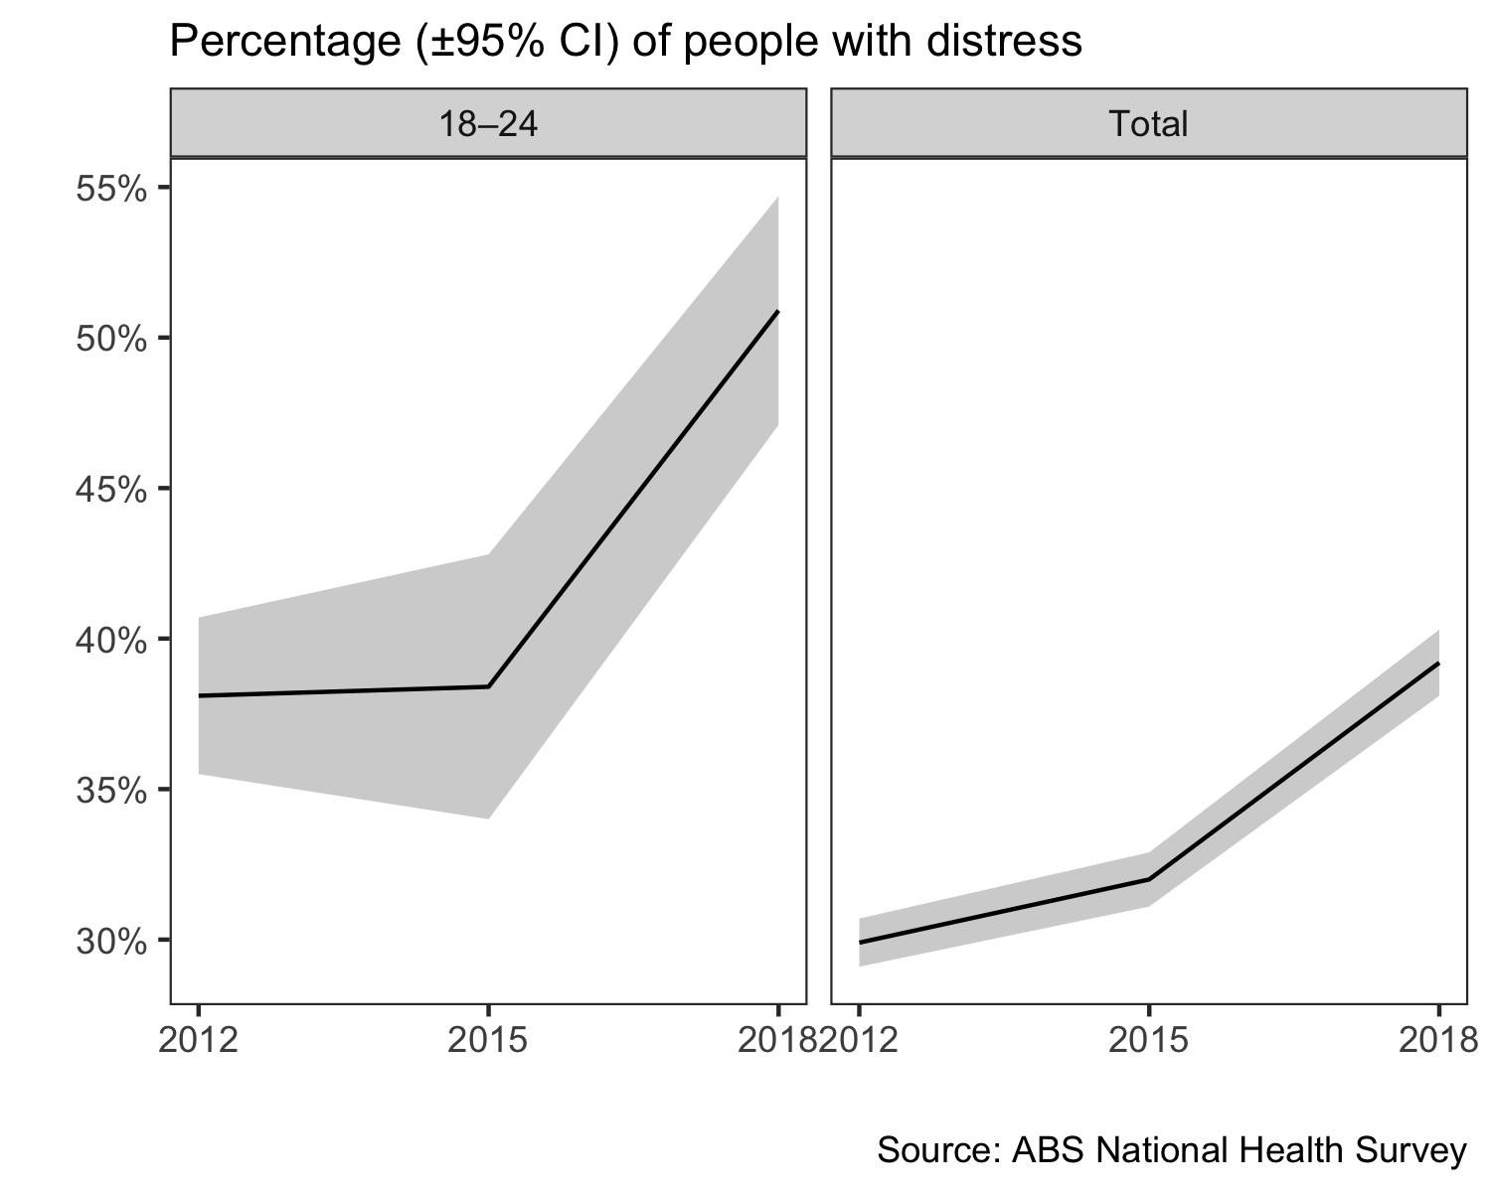

Has this unlinking between suicide rates and population mental health continued during COVID, or as suggested by the modeler’s have they merged again. Australia provides a unique counterfactual case study for this. Victoria, along with the rest of Australia, successfully reduced COVID-19 cases to negligible levels by early June (www.covid19live.com.au). However a second wave forced the State government to shut borders and reintroduce severe lockdown restrictions across Melbourne and surrounding regions in early July, followed by the declarion of a state-of-disaster on August 2nd with increased restrictions for at least six weeks. This makes Victoria a good case-study to examine the early impact of lockdown on community distress levels and suicide, relative to its historic trend or contemporaneous trends in other states (QLD data may be available in a week).

#### Method

*Victoria’s mental health over 2020*

In partnership with University of Maryland (and Carnegie Mellon University), global Facebook users, including Australian users, were invited to take off-platform surveys to self-report COVID-19-related symptoms, and the data were made available as part of the The COVID-19 Symptom Data Challenge (Kreuter et al. 2020). Every day, a new representative sample of Facebook users over 18 years old was invited to consent and participate. Sampled users received the invitation at the top of their News Feed and the surveys were conducted off the Facebook app by the academic partner. Participants reported on COVID-19 symptoms, social distancing behavior, and financial constraints. Psychological distress was measured with questions adapted from the K10 (Kessler et al. 2003), with the main outcome being the percentage of people experiencing any depression. The survey data is provided in granular but aggregate form (i.e., no response-level or person-specific data). Facebook provided regionally-specific weights to reduce nonresponse and coverage bias in age and gender. The total number of responses in the sample used here was *N* = 70,607 from Victoria, Australia (*N* = 242,618 Australia-wide), with the date range from May 1st 2020 to September 11th 2020.

Survey questions:

1. During the last 7 days, how often did you feel so nervous that nothing could calm you down?
2. During the last 7 days, how often did you feel so depressed that nothing could cheer you up?
3. How worried are you that you or someone in your immediate family might become seriously ill from coronavirus (COVID-19)?

(None, a little, some, most, or all of the time)

Note: the analysis reported here uses the results from question 2 only.

*Victorian Suicide Data for 2020*

Monthly suicide data was provided by the Victorian Coroner’s Court Monthly Suicide data report summarising the number of suicides per month between January to September 2020, published on October 5th.

#### Results

Victoria’s mental health displayed a dramatic decline from May to September with the proportion of the population reporting any depression increasing by 10.3% from 43.2% in June to 53.6% in September (a 23.9% relative increase). On all other states over the same period mental health changed by less than one percent (0.4%, or a 1.1% relative increase) indicating little change in population mental health i.e. the mental health of Victorians had plummeted relative to the rest of Australia after the announcement of the lockdown in July.

Conversely the monthly tally of suicides in Victoria shows the typical slightly declining trend over 2020, from *n* = 63 in January to *n* = 49 in September. Importantly there has also been little indication of any year on year increase in the total numbers of suicides with the aggregate number by September 2020 being *n* = 530, which is within one standard deviation of the rolling average to September over 2016-2019 of 511±19.9 (M±SD).

*(Nb. the above comparison of raw numbers may be flawed since the Victorian population has increased since 2016, so one would expect raw numbers to increase relative to past years anyway)*

The unlinked trends of suicide and mental health are shown below.

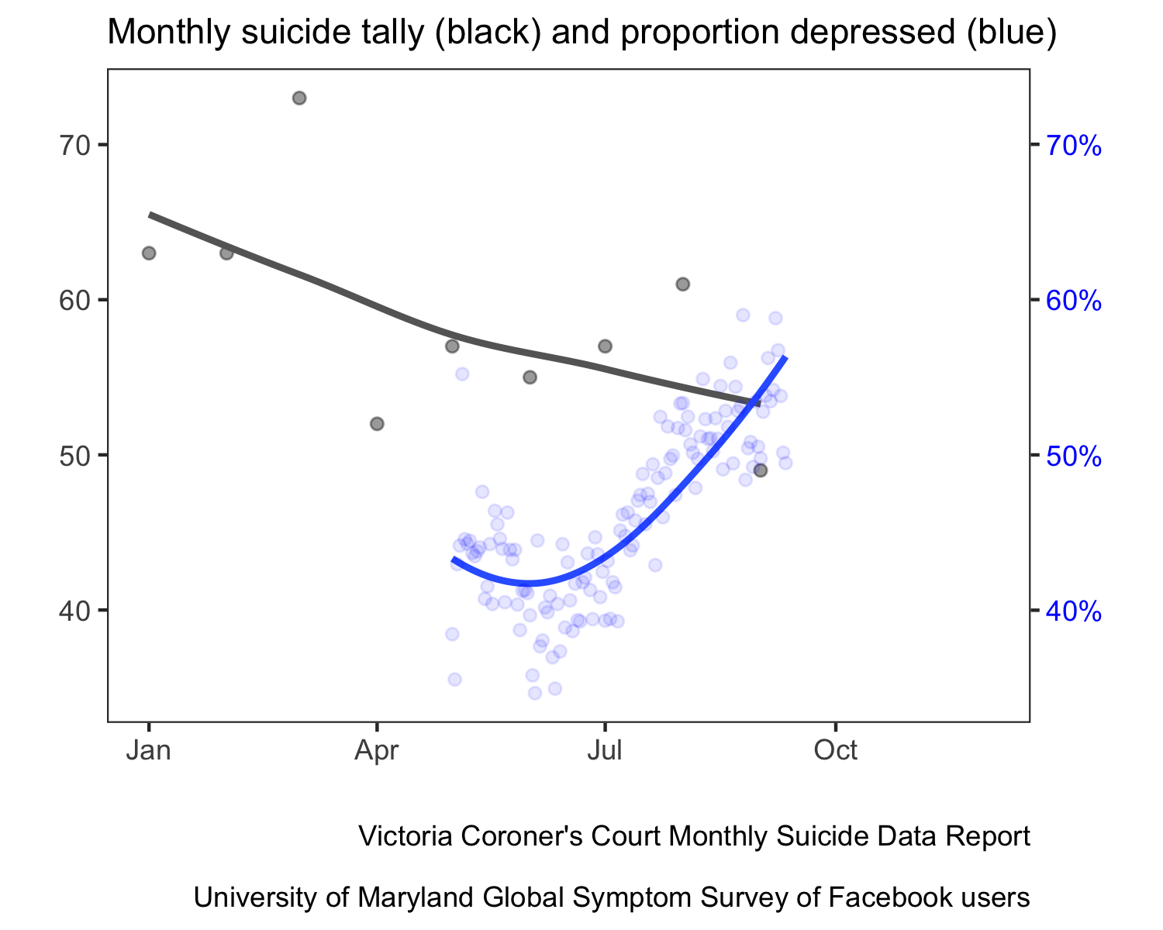

#### Conclusions

The dissonance between the decline in mental health and the stable incidence of suicide, has several possible, and not necessarily mutually exclusive, explanations and inferences:

1. Suicide rates have become a poor indicator of the community’s mental health this century, an inference supported by the observation that rising rates of mental distress in young people in Australia over the past few years have not been matched by increases in the suicide rate.
2. Suicides result from a complex interplay of personal and enivormentla factors with many very proximal factors including access to means and substance use being strongly implicated in temporal changes. Counterintuitively the lockdown in Victoria may have reduced access to these and we may see a post lockdown increase in the suicide rate.
3. The huge uncertainty in predicting rare events has not been reflected in the modelling, most of which assumes (1) concordance between temporal changes in population mental illhealth and suicide, and (2) that mental health is the mediating pathway by which socio-economic factors influence suicide, resulting in high predictions for the near future. The recent unlinking of these two factors, which continues to be observed in Australia’s natural experiment, has major implications for how strongly we take the output from such models and allocate (increasingly scarce) health care resources accordingly.

#### Appendix (do not include)

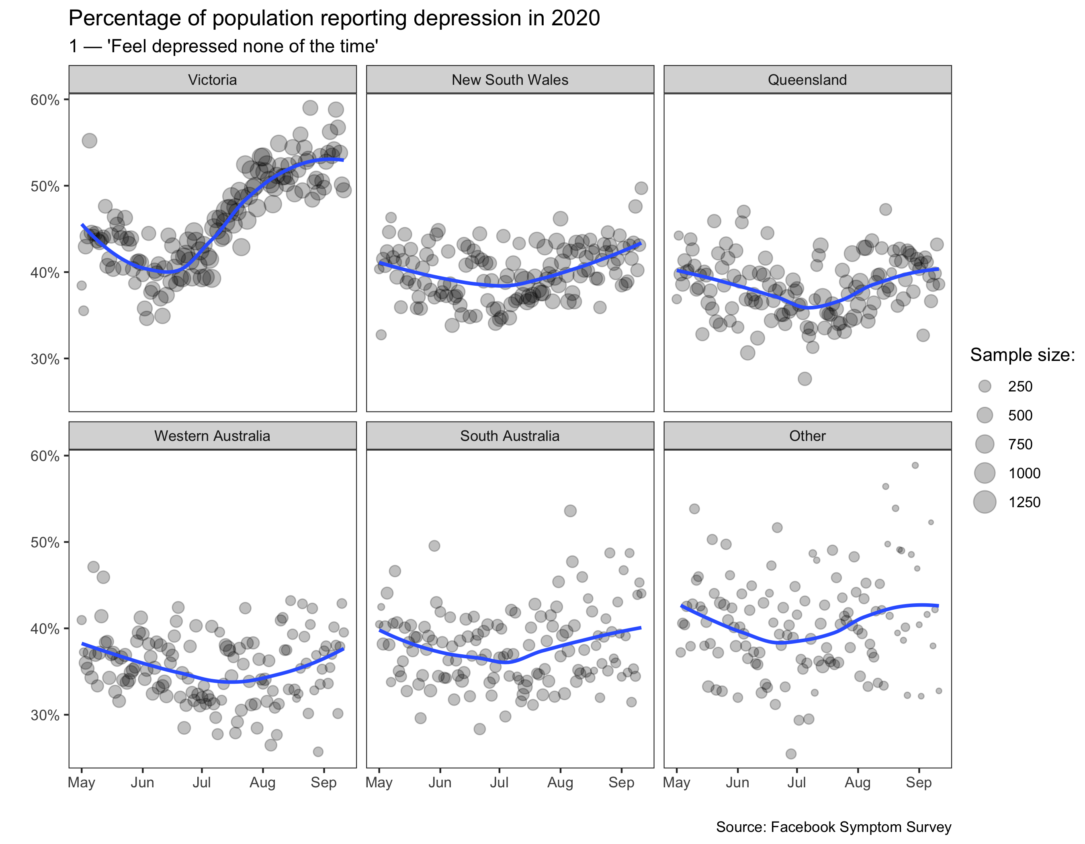

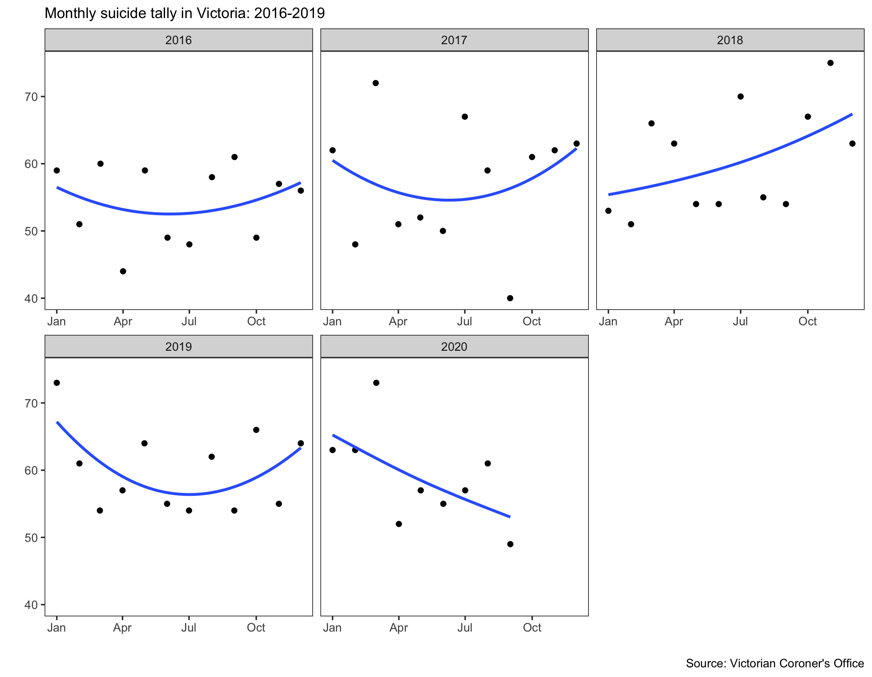

#### References (max 10)

Bailey N. The calculus of death shows the covid lock-down is clearly worth the cost [Internet]. The Conversation Media Group Ltd; 2020. Available from: <https://theconversation.com/the-calculus-of-death-shows-the-covid-lock-down-is-clearly-worth-the-cost-137716>

Brain and Mind Centre. Sounding the alarm [Internet]. The University of Sydney; 2020. Available from: <https://www.sydney.edu.au/content/dam/corporate/documents/brain-and-mind-centre/mental-wealth/sounding_the_alarm_usyd_ncphn.pdf>

Harrison J, Henley G. Suicide and hospitalised self-harm in australia: Trends and analysis. Cat no INJCAT. 2014;169.

Kessler RC, Barker PR, Colpe LJ, Epstein JF, Gfroerer JC, Hiripi E, et al. Screening for serious mental illness in the general population. Archives of general psychiatry. 2003;60(2):184–9.

Kreuter F, Barkay N, Bilinski A, Bradford A, Chiu S, Eliat R, et al. Partnering with a global platform to inform research and public policy making. In: Survey research methods. 2020. pp. 159–63.

Oliver RG, Hetzel BS. An analysis of recent trends in suicide rates in australia. International Journal of Epidemiology. 1973;2(1):91–101.

Tang S, Deady M, Yip D, Christensen H. COVID-19 and suicide: Variation and response [Internet]. Insight, MJA; 2020. Available from: <https://insightplus.mja.com.au/2020/29/covid-19-and-suicide-variation-and-response/>

Whitlock F. Suicide in brisbane, 1956 to 1973: The drug-death epidemic. Medical Journal of Australia. 1975;1(24):737–7.