The increasing cost of happiness

R.W. Morris1,2, N. Kettlewell2,3,4 & N.Glozier1,5

1. Central Clinical School, Faculty of Medicine and Health, University of Sydney, NSW, Australia
2. ARC Centre of Excellence for Children and Families over the Life Course, University of Queensland, QLD, Australia
3. School of Economics, University of Technology, NSW, Australia
4. Institute of Labor Economics (IZA), Bonn, Germany
5. Brain and Mind Centre, University of Sydney, NSW, Australia

**Corresponding author:**

Professor Nick Glozier   
Faculty of Medicine and Health,   
University of Sydney,   
NSW 2050,   
Australia   
email: nick.glozier@sydney.edu.au

Draft: 14 November, 2020  
Word count: 3760 (max 4000)  
Tables: 1  
Figures: 5

**keywords:** Subjective wellbeing, household wealth, HILDA

## Abstract

A fundamental question for governments and people is how much happiness does a dollar buy? The accepted view among economists and psychologists is that money and happiness increase together up to a point, after which there is little further gain from increasing wealth. While the location of this change point has been determined, and the cost of happiness reportedly ranges between USD$60-95K, there has been no investigation as to whether the cost of happiness has increased or decreased over time. We tested the relationship between money and both happiness and life satisfaction using household economic data from Australia between 2002-2016. We discovered the cost of happiness has increased over those 16 years faster than inflation (i.e., cost of living). This result shows that inequalities in wealth may be driving inequities in happiness and wellbeing, with implications for health and government policy-goals to improve wellbeing by increasing wealth.

## Background

A fundamental question for psychology and economics is just how much wellbeing does a dollar buy? Increasing wealth is commonly associated with increasing wellbeing, however a point at which wealth no longer increases subjective wellbeing has also been widely observed (Clark et al., 2008; Dolan et al., 2008; Easterlin, 1974). Given that a central goal of nations and governments is to improve wealth under the assumption that wealth always increases wellbeing, challenges to this notion have far reaching consequences (Frijters et al., 2020).

Subjective wellbeing is not a unitary entity (Diener et al., 2017); studies typically distinguish between life satisfaction, the cognitive appraisal of one’s own accomplishments, and happiness, one’s prevailing affective state or emotional mood. Money can have different effects on each. For instance, we have recently reported that positive life events, such as a major financial windfall, have a greater impact on an individual’s satisfaction than their happiness (Kettlewell et al., 2020). While the distinct effect of wealth on satisfaction and happiness was observed within individuals, the distinct effects of wealth have also been observed across individuals. For instance, Kahneman & Deaton (2010) showed that self-reported levels of happiness increased with household wealth up to a point ($75,000). But after that, increasing amounts of money had no further effect on happiness. They also reported that life satisfaction continued to increase with wealth beyond $75,000. Indeed, the difference between the two questions: “How satisfied are you with your life?” and “How happy are you these days?” has been identified as a crucial mediating factor in a meta-analysis of 111 studies on wealth and wellbeing (Howell and Howell, 2008; also Veenhoven and Hagerty, 2006). Results such as these have provided a more nuanced view among psychologists and (some!) economists about the relationship between wealth and wellbeing; namely that wealth is more strongly related to satisfaction than to happiness.

The distinction between satisfaction and happiness are increasingly relevant to governments and policy-makers due to the growing recognition that increasing wealth does not necessarily lead to improvements in wellbeing (Clark, 2018; Frijters et al., 2020). If wealth no longer improves wellbeing, then the maximization of wealth may no longer be a legitimate goal of government. Fundamentally, the existence of a change point between wealth and happiness reveals an unacknowledged inequality in the distribution of wellbeing in the economy. Of concern is the point at which wealth produces no further increases in happiness – that is, the change point, or cost of happiness. The cost of happiness represents the point at which material wealth stops driving inequalities in the distribution of happiness in the economy, where lower cost-points represent more equitable distributions of happiness. For instance, Kahneman estimated the cost of happiness among US survey respondents in 2008 to be approximately USD75,000 per year, substantially more than the US median income (USD52,000) in that year. Research since then has revealed variations in the cost of happiness due to world region, gender, and education (Jebb et al., 2018), consistent with financial inequality driving inequities in wellbeing and happiness. However, to date there has been no investigation of whether the cost of happiness has changed over time. In particular has the cost, and therefore the distribution, of happiness become more or less equitable in the last few decades?

We used household economic panel data from Australia (HILDA) to provide the first investigation of whether changes in wealth and wellbeing have changed the cost of happiness over the last 16 years (2002-2018). HILDA provides a representative sample of households in Australia with detailed measurements of wealth and subjective wellbeing in the same sample, which makes it an excellent data source to investigate the present question. We distinguished between satisfaction and happiness as different components of subjective wellbeing, and evaluated how each varies with household wealth. After adjusting for age, gender, and education level, we confirmed that happiness and satisfaction have distinct relationships with increasing wealth, but the cost of happiness has increased in real dollar terms since 2002.

## Methods

#### Wealth

Our indicator of wealth and economic security was household after-tax income. Household income better represents economic security, since members of the same household share expenses as well as risks; i.e., they can provide a direct and immediate support network when financial shocks occur. The other major studies also used household after-tax income as the indicator of wealth and economic security (e..g, Kahneman and Deaton, 2010; Jebb et al., 2018), and so we follow the same standard here as well. Household financial year disposable regular income [(hifdip)](https://www.online.fbe.unimelb.edu.au/HILDAodd/KWCrossWaveCategoryDetails.aspx?varnt=hifdip) from the annual HILDA survey in 2002, 2006, 2010, 2014,and 2018 was selected. This variable in HILDA represents the sum across all household members of financial year gross regular income less taxes on financial year gross regular income.

Household income was provided by the University of Melbourne as imputed, and with weighted topcodes to preserve anonymity. We removed individuals with values above the threshold indicated for top-coding. Household wealth was adjusted for the number of people in each household by dividing by the square root of household size (Headey and Wooden, 2004; Jebb et al., 2018; Kahneman and Deaton, 2010). We converted dollar values to the base year (2002) according to CPI from the RBA, in order to adjust for inflation (<https://www.rba.gov.au/calculator/annualDecimal.html>).

#### Subjective Wellbeing

There are a variety of variables related to subjective well-being collected annually in HILDA, but the two we used here matched the variables we used in our previous paper (Kettlewell et al., 2020), namely, life satisfaction as a measure of cognitive wellbeing, and the SF-36 as a measure of affective wellbeing or happiness. Life satisfaction [(losat)](https://www.online.fbe.unimelb.edu.au/HILDAodd/KWCrossWaveCategoryDetails.aspx?varnt=losat) was assessed by a single item question asked each survey: “How satisfied are you with your life (0 to 10)”. Happiness was determined by item 9 in the SF-36 [(gh9a to gh9i)](https://www.online.fbe.unimelb.edu.au/HILDAodd/KWCrossWaveCategoryDetails.aspx?varnt=gh9a). The SF-36 is a widely used self-completion measure of various aspects of physical, emotional and mental health (Ware Jr, 2000). Item 9 consists of nine questions relating to mental health and vitality, where five questions deal with positive and negative aspects of mental health (e.g., “Felt so down in the dumps nothing could cheer me up”, “Been happy”), and four questions deal with positive and negative aspects of vitality (e.g., “feel full of life”, “felt worn out”). Each question referred to the past four weeks and agreement was indicated on a six-point scale. We reverse scored the relevant responses and calculated the sum of the nine questions so that higher scores represented better wellbeing.

#### Modelling

We modelled the relationship between wealth and each wellbeing variable (happiness and satisfaction) using a simple **linear model** and a **piecewise model** (broken-stick). The linear model was the simplest relationship while the piecewise model was chosen as the simplest extension of a linear model which can identify a change point (inflection) between wellbeing and wealth. The location of the change point was a free parameter which revealed where wellbeing no longer increased linearly with wealth. We then compared the linear model against the piecewise model to determine if a change point existed in each or any year between wealth and each wellbeing variable (see model selection). Finally, where a change point existed, we determined the location of the change point for that year (see change point estimation).

*Model estimation*  
We adopted a Bayesian approach for estimating the linear and piecewise model in the software Stan (Bürkner, 2017; Stan Development Team, 2019). In each case,

Let $y_{i}∼N(μ_{i},σ_{y}^{2})$

The linear model was estimated as:

$$μ_{i}=β_{0}+β_{1}X_{i}$$

Where $X_{i}$ was an individual’s household wealth ($) as well as other covariates (age, age2, gender, education), and $y_{i}$ was an individual’s wellbeing.

The piecewise model was a simple extension of this to include a free parameter to represent the changepoint in wealth ($ω$) as well as the slope after the change point ($β_{2}$):

$$μ_{i}=β_{0}+β_{1}(x_{i}-ω_{t})(x_{i}≤ω_{t})+β_{2}(x_{i}-ω_{t})(x_{i}>ω_{t})$$

The above models estimated population-level (fixed) effects for each year in the data (*t* = 2002, 2006, 2010, 2014 and 2018). Because we were interested in the location of the change point between wealth and wellbeing that existed across individuals within each year, we ignored the panel design of HILDA because the dependency between observations of the same person across years was orthogonal to our effects of interest. We assumed an unstructured variance-covariance matrix between years, and specified weakly informed priors for each *β*, and a uniform prior over the restricted range of wealth values for *ω*.

*Model selection*  
To determine whether wellbeing was a linear or non-linear (e.g., piecewise) function of wealth, we compared the linear and piecewise model posterior probabilities using the [Widely Applicable Information Criterion (WAIC)](https://bookdown.org/ajkurz/Statistical_Rethinking_recoded/overfitting-regularization-and-information-criteria.html#the-problem-with-parameters). The WAIC is the log-posterior predictive density plus a penalty proportional to the variance in the posterior distribution. Thus it provides an approximation of the out-of-sample deviance that converges to the cross-validation approximation in a large sample, with a penalty for the effective number of parameters (degrees of freedom). For this reason is it useful to compare two models of varying complexity, such as our linear and piecewise model.

WAIC was defined as: WAIC = -2(lppd - *p*WAIC)

Where lppd (log pointwise predictive density) is the total across observations of the log of the average likelihood of each observation, and *p*WAIC is the effective number of free parameters determined by the sum of the variance in log-likelihood for each observation (*i*).

*Parameter estimation*  
To determine the location of the change point (*ω*) between wellbeing and wealth, we modelled the relationship between wealth and wellbeing across individuals using the piecewise model described above, and sampled the posterior probability of *ω* over 4000 interations. The complete posterior distribution of *ω* for each year is presented along with the expected value (mean).

*Covariates*

Age (and age2), gender, and education were included as covariates, and fulltime students were removed. Gender was included as a binary variable, and education was coded from the highest level of education achieved (“less than highschool”, “highschool”, “university graduate”, “postgraduate”).

## Results

For visualization purposes only, due to the large number of individual data points in each year, we grouped individuals into 10 equal-sized subgroups according to their wealth decile ($). Thus in each plot, the mean wealth and mean wellbeing score for each decile is presented, rather than each individual data point. Note that the line-of-best-fit and 95% confidence intervals from each regression model *of all individuals* is shown in overlay.

##### Figure 1. Household wealth and satisfaction (blue) and happiness (red)

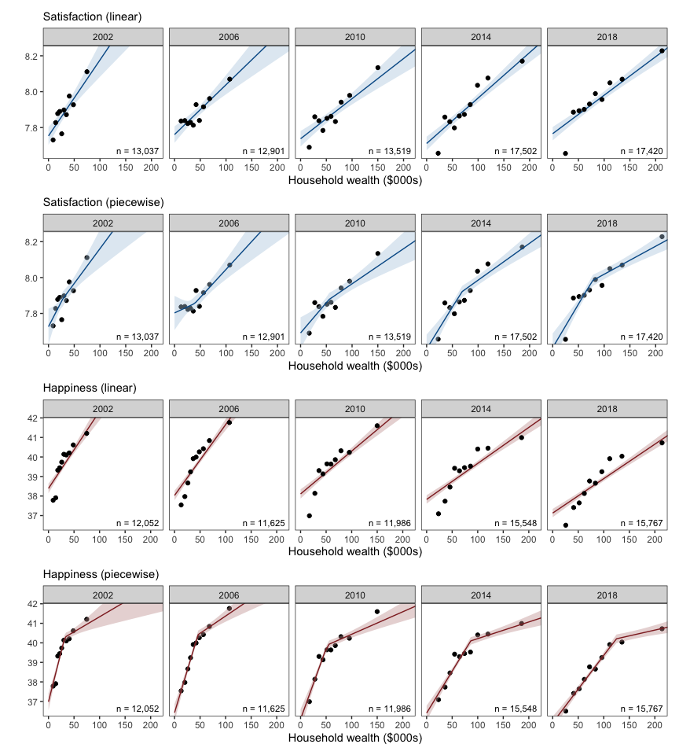

Figure 1 legend:_ Line-of-best-fit and 95% confidence interval (shaded) from regressions of wellbeing on household wealth, with age, gender and education included as covariates. Wellbeing was measured as life satisfaction (blue) or happiness (red). The total number of individuals in each model are shown (*n*). Points represent the mean value of each wealth decile.

Figure 1 shows the relationship between household wealth and satisfaction appeared relatively linear, as the results of the piecewise regression indicated the inflection of the change point could be increasing (e.g., 2002, 2006) as well as decreasing (e.g., 2010, 2014, 2018). By contrast, a decreasing change point was evident in each year of happiness on wealth. The results of a formal comparison between linear and piecewise models is provided in Model Selection below. However note that the change point between wealth and happiness appeared to shift rightwards over time (bottom row). (We can also see the linear relationship between household wealth and each wellbeing variable became slightly weaker over time, i.e., less steep)

#### Model Selection

We compared the posterior evidence for a linear relationship between wellbeing and wealth with the posterior evidence of a nonlinear (piecewise) relationship (WAIClinear — WAICpiecewise). Thus a WAIC difference greater than zero indicated evidence for a linear relationship. A WAIC difference less than zero indicated evidence for a nonlinear (piecewise) relationship.

##### Figure 2. Model evidence for satisfaction (blue) and happiness (red)

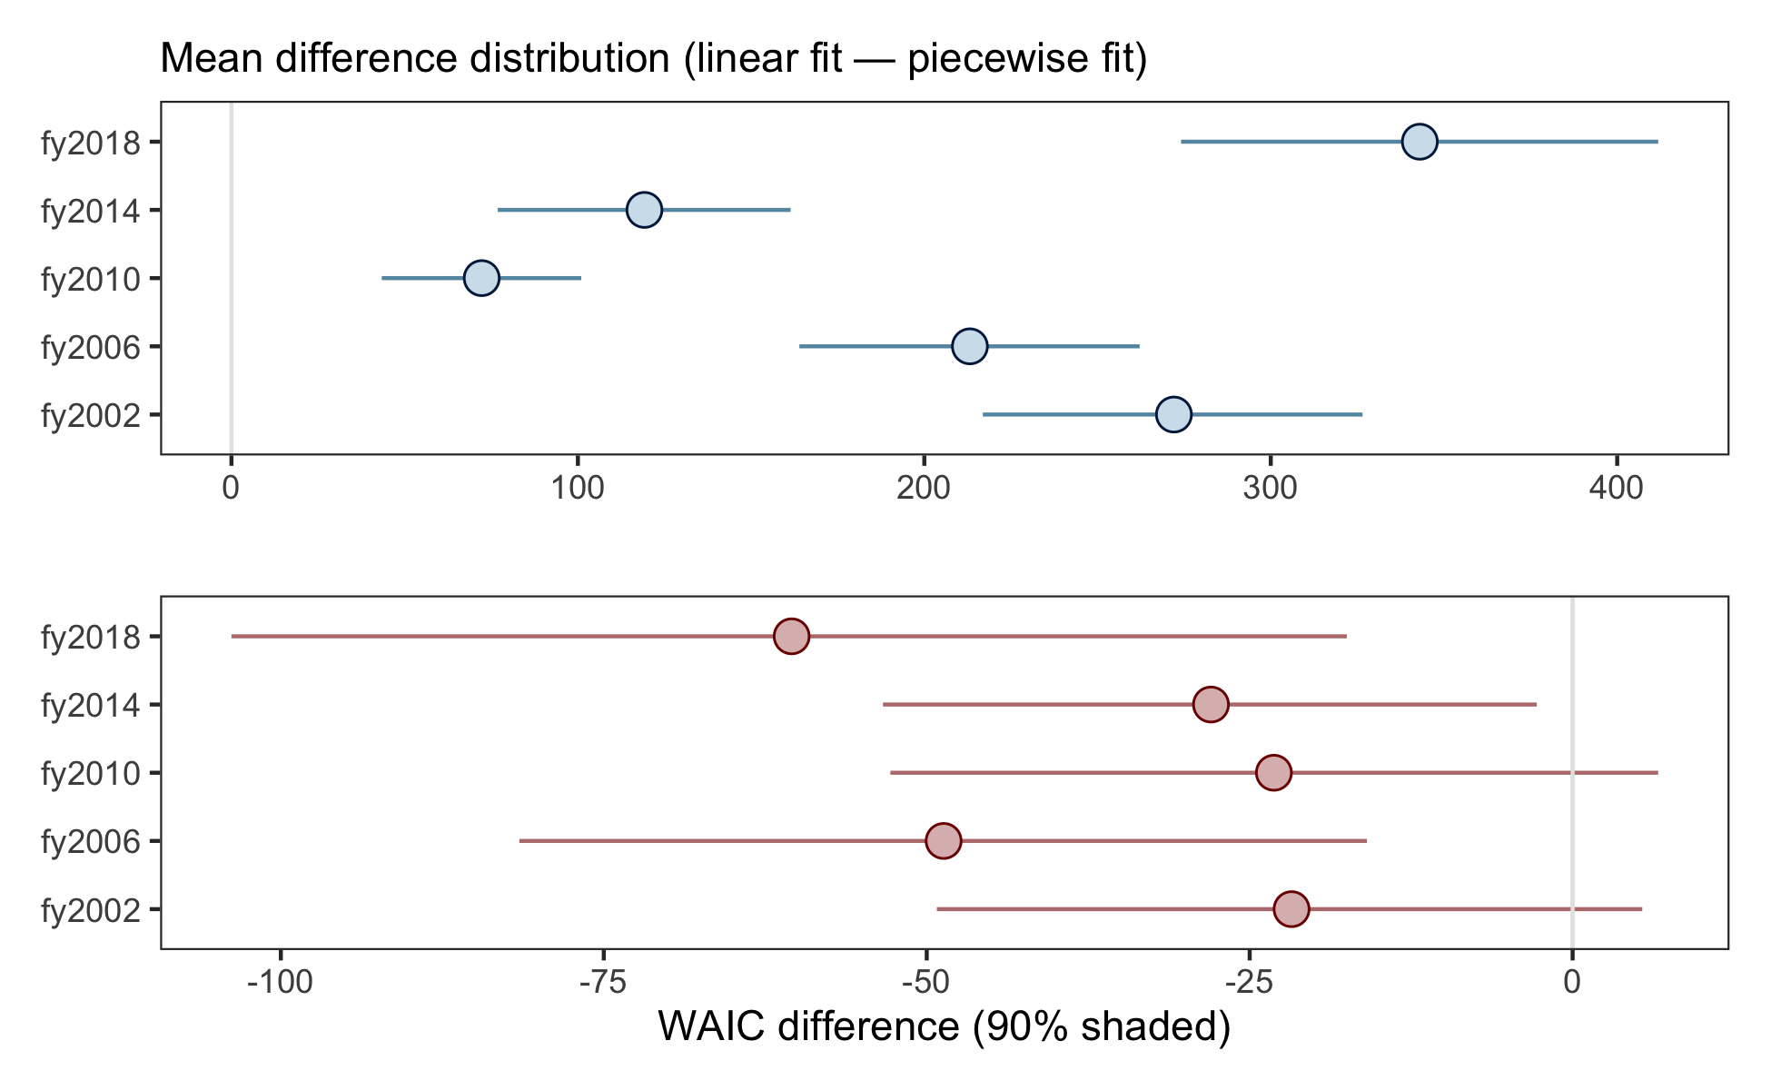

Figure 2 legend:_ Differences in posterior evidence for a linear fit over a piecewise fit (WAIC) for satisfaction (blue) and happiness (red). The filled circle indicates the mean of the distribution and the horizontal bars represents the 90% credible interval. A difference greater than zero is support for the linear model and below zero is support for the piecewise model.

Model selection revealed the posterior evidence for the linear fit of satisfaction on wealth was credibly superior to the nonlinear (piecewise) fit - Figure 2 shows the 90% credible interval of the fit for each year of satisfaction was above zero with no overlap. By contrast, a nonlinear fit of happiness on wealth was generally superior, and the nonlinear fit was credibly superior at 90% for each of three years (2006, 2014, 2018). Thus, the posterior evidence indicates happiness and satisfaction have distinct relationships with household wealth; satisfaction tends to increase linearly with wealth, while a change point exists in the relationship between happiness wealth.

#### Parameter Estimation

We present the complete posterior distribution of ω over 4000 samples for each year, representing the location of the change point between happiness and wealth. Shaded areas to the right of the vertical grey dotted line are credibly (90%) larger than the base year (2002).

##### Figure 3. Bayesian change point results

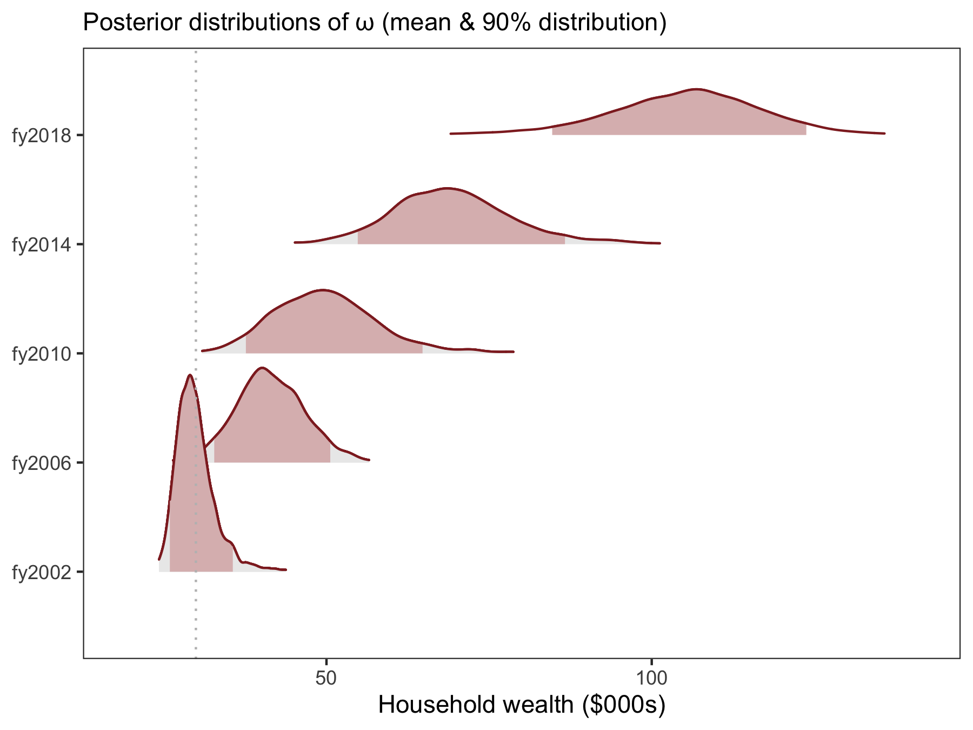

Figure 3 legend: Posterior distribution of the parameter &omega; representing the change point location in household wealth (\$) for each year. Shaded area represents the 90% credible region.

Figure 3 shows the change point between happiness and household wealth (the *cost of happiness*) credibly increased between 2002 and 2018. Table 2 below compares the change in median and mean wealth for each year with the cost of happiness. It also present the percentage of people in each year whose household wealth exceeded the cost point.

Table 1. Household wealth, change points and percentile

| year | median ($000s) | mean ($000s) | change point ($000s) | % |
| --- | --- | --- | --- | --- |
| fy2002 | 26.86 | 30.93 | 29.41 | 43.7 |
| fy2006 | 38.07 | 43.77 | 41.13 | 44.0 |
| fy2010 | 53.72 | 61.24 | 49.43 | 55.8 |
| fy2014 | 66.62 | 76.81 | 68.85 | 47.7 |
| fy2018 | 74.54 | 86.99 | 105.85 | 26.0 |

Table 1 shows the cost of happiness increased faster than median household wealth. As a result, a smaller percentage of people achieved a level of wealth at which happiness no longer increased in 2018 than in 2002.

## Conclusions

We found the relationship between subjective wellbeing and wealth was positive, but happiness and satisfaction had different (positive) relationships: Satisfaction increased linearly with wealth, while happiness increased rapidly up to a point after which further increments in wealth produced less change – this confirms the distinct effects of wealth in previous research (e.g., Howell and Howell, 2008; Kahneman and Deaton, 2010), and contributes rare evidence from the same sample. Furthermore, we report here for the first time that the change point between wealth and happiness increased over time between 2002 and 2018, faster than inflation or the median household income.

We refer to the change point after which increases in wealth no longer produce similar increases in happiness as the cost of happiness. So household wealth, and the economic security it represents, buys happiness up to a point after which happiness and wealth are rarely related. Satisfaction on the other hand always increased with household wealth. The difference likely reflects the importance of a numerical dollar value (e.g., bank balance) when cognitively appraising one’s life achievements, versus the relevance of that number to our everyday experience of joy and prevailing mood. However an implication of the increasing cost of happiness over the last sixteen years is that wealth inequality is driving increasing *inequities* in wellbeing. In 2002, the cost point of happiness represented a 9% increase over median wealth, while in 2018 it represented a 42% increase over median wealth. This also represents a reduction from 44% to 26% in the proportion of people who have achieved a level of household wealth beyond which their happiness no longer depends. Thus over time the happiness of more people, i.e., their everyday experience of joy and their prevailing mood, has depended on their material wealth.

Australia has low levels of wealth disparity relative to other OECD countries, and the Gini coefficient has not changed a great deal between 2002 and 2018 in the HILDA dataset (Commission and others, 2018). A stable Gini coefficient shows income inequality has remained steady over the time period, and our results do not conflict with this conclusion. Rather what we are revealing is the effect of income inequality on happiness has increased over the same time period. So while income inequality has remained steady, it’s impact on wellbeing inequity has increased. We think this highlights the issue that while traditional measures of wealth and income inequality may not change, their impact on wellbeing and health can still vary. As focus shifts from traditional wealth indicators towards wellbeing measures, findings such as this may become more prevalent.

Some recent studies have challenged either the notion that the positive effect of money plateaus, or that the effect on happiness and satisfaction are distinct. In a nationally representative sample of 44,000 adult Americans in the General Social Survey (GSS), happiness continued to increase with household wealth, implying no change point existed between money and happiness (Twenge and Cooper, 2020). The GSS asks a single item on happiness: “Taken all together, how would you say things are these days – would you say that you are very happy, pretty happy, or not too happy?” The form of this question is quite similar to the single item “life satisfaction” question in HILDA, as both request the respondent to cognitively evaluate their circumstances. By contrast, the nine items we selected to measure happiness covered a range of affect and focused on current feelings: e.g., “How much of the time during the past 4 weeks have you been a happy person?” Critical differences in the operational definition of happiness seem likely to explain the results observed here.

A second recent report from a survey of 1.7 million people representing 164 countries in the Gallup World Poll reported increases in household wealth were associated with change points in happiness and satisfaction (Jebb et al., 2018), rather than distinct effects as we found. It may be that differences in the sparsity of the high income data in HILDA (for which extremely high income households are masked) explain the differences here. However including these individuals in our analysis did not change the linear effect between wealth and satisfaction observed here, and the weighted topcodes should have biased the result towards a change point. We also note a linear effect between wealth and satisfaction is consistent with the majority of earlier literature (Howell and Howell, 2008; Stevenson and Wolfers, 2013).

As governments and policy-makers begin to focus on wellbeing, it will be critical to understand how traditional economic indicators such as household wealth, income inequality, and consumption interact with wellbeing and health. According to Frijters et al. (2020), coming up with a consensus to translate income into wellbeing features high on the wider wellbeing research agenda. Establishing the links between income, household wealth, wellbeing and health, and how inequalities in one drives inequities in the other, will be a critical step in that agenda.

## References

Bürkner, P.-C., 2017. brms: An R package for Bayesian multilevel models using Stan. Journal of Statistical Software 80, 1–28. <https://doi.org/10.18637/jss.v080.i01>

Clark, A.E., 2018. Four decades of the economics of happiness: Where next? Review of Income and Wealth 64, 245–269.

Clark, A.E., Frijters, P., Shields, M.A., 2008. Relative income, happiness, and utility: An explanation for the easterlin paradox and other puzzles. Journal of Economic literature 46, 95–144.

Commission, A.G.-P., others, 2018. Rising inequality? A stocktake of the evidence. Productivity Commission Research Paper.

Diener, E., Heintzelman, S.J., Kushlev, K., Tay, L., Wirtz, D., Lutes, L.D., Oishi, S., 2017. Findings all psychologists should know from the new science on subjective well-being. Canadian Psychology/psychologie canadienne 58, 87.

Dolan, P., Peasgood, T., White, M., 2008. Do we really know what makes us happy? A review of the economic literature on the factors associated with subjective well-being. Journal of economic psychology 29, 94–122.

Easterlin, R.A., 1974. Does economic growth improve the human lot? Some empirical evidence, in: Nations and Households in Economic Growth. Elsevier, pp. 89–125.

Frijters, P., Clark, A.E., Krekel, C., Layard, R., 2020. A happy choice: Wellbeing as the goal of government. Behavioural Public Policy 4, 126–165.

Headey, B., Wooden, M., 2004. The effects of wealth and income on subjective well-being and ill-being. Economic record 80, S24–S33.

Howell, R.T., Howell, C.J., 2008. The relation of economic status to subjective well-being in developing countries: A meta-analysis. Psychological bulletin 134, 536.

Jebb, A.T., Tay, L., Diener, E., Oishi, S., 2018. Happiness, income satiation and turning points around the world. Nature Human Behaviour 2, 33–38.

Kahneman, D., Deaton, A., 2010. High income improves evaluation of life but not emotional well-being. Proceedings of the national academy of sciences 107, 16489–16493.

Kettlewell, N., Morris, R.W., Ho, N., Cobb-Clark, D.A., Cripps, S., Glozier, N., 2020. The differential impact of major life events on cognitive and affective wellbeing. SSM-population health 10, 100533.

Stan Development Team, 2019. RStan: The R interface to Stan.

Stevenson, B., Wolfers, J., 2013. Subjective well-being and income: Is there any evidence of satiation? American Economic Review 103, 598–604.

Twenge, J.M., Cooper, A.B., 2020. The expanding class divide in happiness in the united states, 1972–2016. Emotion.

Veenhoven, R., Hagerty, M., 2006. Rising happiness in nations 1946–2004: A reply to easterlin. Social indicators research 79, 421–436.

Ware Jr, J.E., 2000. SF-36 health survey update. Spine 25, 3130–3139.