The Effect of Major Life Events on Mental Health and Happiness

N. Kettlewell1, R.W. Morris2,3, N. Ho4, D.A. Cobb-Clarke1, S.Cripps2 & N.Glozier3,4

1. School of Economics, University of Sydney, NSW, Australia
2. Centre for Translational Datascience, University of Sydney, NSW, Australia
3. Central Clinical School, University of Sydney, NSW, Australia
4. Brain Mind Centre, University of Sydney, NSW, Australia

**Corresponding author:**  
Professor Nick Glozier  
Faculty of Health and Medicine,  
University of Sydney,  
NSW 2050,  
Australia  
email: [nick.glozier@sydney.edu.au](mailto:nick.glozier@sydney.edu.au)

Draft: 17 November, 2018  
Word count: 3500 (max 4000)  
Tables: 1 (max 6)  
Figures: 4 (max 6)

**keywords:** Epidemiology, population survey, subjective well-being

# Abstract

**Aims.** Major life events such as getting married, death of a loved one, retirement or job loss are widely assumed to have a substantial, albiet temporary impact on well-being and happiness. However few longitudinal studies have compared the impact of different life events on well-being; and fewer still have compared different components of well-being over the same time period. Here we describe the impact of 22 different life events on two different components of well-being in a large, longitudinal dataset. We aim to provide insight into how wellbeing changes in response to different external events in the broader population.  
**Methods.** Data from the Household Income and Labour Dynamics in Australia (HILDA) survey were used. Mental component scores from the SF-36 and a life satisfaction score was collected from 2001 to 2016. The effect of major life-events on these well-being measures was assessed over a ±3 year time-window in that 16 year period. Fixed effect regression models were used to distinguish the unique effect of life events on changes in the two well-being measures.  
**Results:** We were able to sort events according to the size of their positive and negative effects on mental health and life-satisfaction. Some events had a profound impact on the well-being measures (e.g., death of a spouse, divorce, birth of a child, marriage). Others had relativily little effect (e.g,. moving home, retirement). In general, negative events (e.g., widowed) had a larger impact on mental health while positive events (e.g,. birth of a child) had a larger impact on life satisfaction. Relatively few events had an impact on well-being beyond two years, but exceptions existed (e.g., divorce, retirement).  
**Conclusions** Different life events have substantially different effects on well-being and happiness. These effects range from positive to negative, and can last as little as 3 months to more than 3 years. The distinct components of well-being we measured here had similar but not identical time courses to external events. In most cases subjective well-being is either not substantially affected by these events for longer than our measurement interval (i.e., 3 months), or returns to baseline within three years (i.e., hedonic adaptation). These results will help clinicians, economists and policymakers understand how external events and interventions can increase or decrease wellbeing and happiness in the general population. (399/400 words)

## Introduction

The observation that major life events, such as marriage, death of a child or spouse, bankruptcy or lottery winnings have a substantial impact on our happiness and well-being is widely appreciated and self-apparent (i.e., *“shit happens”*). While such colloquial observations confirm our universal experience, they do not tell us anything about the relative impact of different events on happiness in the general population. That is, how do different events impact well-being on average? Is, for instance, death of one’s spouse worse than divorce? Alternatively, other things being equal, is starting a new job better than getting promoted? In short, how can we compare the impact of different life events?

One answer to these questions has been provided by research on subjective well-being, which has focused on hedonic adaptation (Gilbert, 2009). However the claim that specific feelings such as happiness fluctuate according to circumstances but ultimately return to a set baseline provides only an incomplete answer to the questions just raised. Early research on subjective well-being claimed that people adapt to events, both good and bad, over time (Brickman et al., 1978). However we now know that, despite adaptation, in some cases the changes in our well-being are permanent or at least last for many years. For instance, longitudinal studies which have followed individuals across time indicate the amount of adaptation varies by event, with disability (Lucas, 2007), divorce (Lucas, 2005), death of spouse (Lucas, 2005), and unemployment (Lucas et al., 2004) all having long-term negative effects. Furthermore, evidence from prospective longitudinal studies has found that events such as marriage and unemployment continue to influence both life satisfaction and well-being long after they have occurred (Luhmann et al., 2012). Other longitudinal studies have found evidence of adaption to these same events (Clark et al., 2008, Frijters et al. (2011)), consistent with earlier cross-sectional studies of hedonic adaptation. Differences in methods and samples might explain some of the inconsistent results, but what is needed are more longitudinal studies of multiple events in a single population.

Previous studies have focused on the differences in the length of the time course over which our well-being adapts in the wake of major life events, however the duration of impact only represents one feature of the timecourse of the response. For instance, prior studies do not compare the magnitude of change produced by different events. We cannot take it for granted that events which produce long term changes in happiness also produce the largest changes in magnitude. An event such as retirement could produce a longer lasting change in happiness than the birth of a child, despite producing a smaller change in magnitude before returning to baseline. It’s also possible that different components of well-being may respond differently to life events. Subjective well-being is not a single unitary entity, and consists of multiple dimensions, such as positive and negative aspects, cognitive and affective components, etc. (Diener et al., 2017). For example, a meta-analysis of subjective well-being studies distinguished between two different contributors to well-being (broader life satisfaction and specific affect) across different studies, and reported distinct temporal dynamics of each (Luhmann et al., 2012). However few longitudinal studies have compared the impact of different life events on well-being; and fewer still have compared different components of well-being over the same time period in the same sample.

We compare the impact major life events on two components of well-being (mental health and life satisfaction) in a single longitudinal study. The [**HILDA dataset**](https://melbourneinstitute.unimelb.edu.au/hilda) has collected responses from over 11,000 Australians over sixteen years, including data on 22 different life events experienced in each of the last four quarters of every year, as well as measures of subjective well-being such as overall life-satisfaction and mental health scores. This relatively unique dataset thus allows us to ask what is the impact of different life events in the general population? What is the relationship between different components of well-being in the face of major life challenges? Do changes in one necessarily accompany changes in the other? And can life satisfaction and mental health diverge in some circumstances? Other studies have examined the temporal dynamics of major life events on subjective well-being using this dataset (e.g., Frijters et al., 2011), but they have typically only used a single item measure of well-being (e.g., overall life-satisfaction based on a single-item question) over a far shorter period of time (e.g., six years)

## Methods

The analysis was performed in *R* (version 3.5.1) (R Core Team, 2013), using the tidyverse package (version 1.2.1) for data import and wrangling (Wickham, 2017) , the plm package (1.6-6) for fixed effect estimates (Croissant and Millo, 2008), along with some custom helper functions and wrappers for convenience (provided in src/).

#### Data

The Household, Income and Labour Dynamics in Australia (HILDA) survey is a longitudinal, nationally representative study of Australian households. It collects detailed information annually from over 7000 households (Wilkins, 2013). The survey covers a range of dimensions including social, demographic, health and economic conditions using a combination of face-to-face interviews with trained interviewers and a self-completion questionnaire. It began in 2001 with the survey of 13,969 persons in 7,682 households (out of a total of 15,127 eligible household members). Each year since, interviews have been conducted with all willing members of each household who are at least 15 years old at the time of the interview. The rate of retention of the initial responding sample is 74 percent, which is comparable to other national longitudinal surveys such as the British Household Panel Survey and the German Socio-Economic Panel Survey (Watson and Wooden, 2006).

Life satisfaction scores were obtained from the annual face-to-face interview using the response to the familiar question:

“All things considered, how satisfied are you with your life?”

Respondents are told to:

“Pick a number between 0 and 10 to indicate how satisfied you are” and that “the more satisfied you are, the higher the number you should pick”.

The mental component score was obtained from the SF-36, one of the most widely used self-completion measures of health status. It comprises 36 items which are used to measure eight scales covering various aspects of physical, emotional and mental health. These eight scales are: Physical Functioning; Role-Physical (interference with work or other daily activities due to physical health); Bodily Pain; General Health; Vitality; Social Functioning (interference with normal social activities); Role-Emotional (interference with work or other daily activities due to emotional problems); and Mental Health (symptoms associated with anxiety and depression and measures of positive affect). In addition, the eight scales yield two summary scales of health, relating to physical (the Physical Component Summary: PCS) and mental (the Mental Component Summary: MCS) functioning and well-being. To calculate the MCS, we followed standard procedures and transformed each of the eight SF-36 subscales to a 0–100 scale (McHorney et al., 1994, McHorney et al. (1993), Ware Jr and Sherbourne (1992)). Scoring algorithms were applied to produce the MCS, using the Australian norms (STATISTICS, 1997).The SF-36 was included as the first element in HILDA’s self-completion questionniare.

The occurrences of life events were determined by responses in a subsequent section of HILDA’s self-completion questionnaire and have been included since wave 2 (2002). This questionnaire is completed after the life satisfaction scores and SF-36 and so the respondent’s recollection of the life events will not bias their evaluation of the well-being measures.

Respondents are told:

“We now would like you to think about major events that have happened in your life over the past 12 months. For each statement cross the YES box or the NO box to indicate whether each event happened during the past 12 months. If you answer ‘YES’, then also cross one box to indicate how long ago the event happened or started.”

This information is given by quarter.

The range of life events is comprised of 22 different items, and they include both positive and negative events:

|  |  |
| --- | --- |
| Event | Description |
| widowed | death of loved one (e.g., spouse) |
| divorced | divorce or separation from partner |
| bankrupt | a financial loss (including bankruptcy) |
| jailed | detained in jail |
| attacked | victim of physical violence |
| injured | suffered a serious injury (e.g., disability) |
| reconciled | reconciled with spouse |
| fired | lost job or made redundant (including fired) |
| familyharmed | serious injury to family member |
| robbed | victim of property crime (e.g., house breaking) |
| bereaved | death of a close friend |
| relativdied | death of a close relative |
| friendjail | jail for a close friend or relative |
| homeless | home destroyed in a natural disaster (2009 to 2016 only) |
| moved | moved home |
| hired | started a new job |
| promoted | promoted at work |
| retired | retired from workforce |
| money | a financial windfall (e.g., lottery win, inheritance) |
| pregnant | you (or your partner) got pregnant |
| married | got married |
| birth | birth (or adoption) of a child |

We filter out *homeless* and *jailed* in the plots presented here, as they have a small $n$ and contribute to too much variation on the y-axis. However, they are still included in the modelling as covariates.

#### Model Design

We are interested in how life events affect variation over time in happiness and mental health. When a respondent indicates a life event occurred that year, they also indicate how long ago in quarterly intervals (3-monthly intervals) the event occurred. This gives us a slightly better temporal resolution than the annual indicator to observe the effect of the life event in the current year. Using the quarterly and annual indicators, we will model the effect of life events on current mental health and happiness scores among individuals as a function of time since the life event. To estimate these effects, we utilise the panel nature of our data and estimate a series of linear fixed effects regression models.

Under this approach we have a linear model with $N$ observations and $T$ time points:

$$y_{it}=βX_{it}+α_{i}+ϵ_{it} for t=1...T and i=1...N$$

Where $X_{it}$ is a vector of control variables. In our application, this is a set of dummy variables representing lags and leads on the life event. For example, we have a *pre36* = 1 if the life event occurs in the next 3 years, a *pre24* = 1 if the event occurs in the next 2 years, … , a *post24* = 1 if the event occurred 2 years ago, and a *post36* = 1 if the event occurred 3 years ago. In total, we have seven dummy variables indicating the outcome variable $y_{it}$ was obtained after the life event (*post00*, *post03*, *post06*, *post09*, *post12*, *post24*, *post36*), as well as three variables indicating $y_{it}$ was obtained before the event (*pre12*, *pre24*, *pre36*). $X_{it}$ can also include other time varying controls (e.g. education).

$α_{i}$ is the time-invariant subject-specific effect, which may be correlated with the error-term $ϵ$, for example, if innately unhappy people are more likely to divorce. $α_{i}$ is unobserved by the researcher but it is a constant (i.e., time-invarying) and so can be removed from the model by demeaning, i.e., $α—{\overline{α}}_{i}=0$. We can demean each of the terms, including $y_{it}$ and $X_{it}$ variables, and so remove the time-invarying effects from the model. Letting $Δ$ indicate that the variable has been demeaned in this way, our model becomes:

$$y_{it}^{Δ}=βX_{it}^{Δ}+ϵ_{it}$$

A general issue in large, longitudinal studies is how to treat missing data. In our particular case, missing data can occur for three reasons. First, the number of available predictors will vary at the endpoints of our dataset (i.e., left censoring). For instance, at the beginning of our dataset there is no life event data prior to 2002 to account for changes in our outcome measure in the years 2002, 2003 and 2004. At the other end of our dataset, e.g., 2016, we do not know if a life event will occur in 2017, so we will have people in the dataset who should be contributing to the estimation of anticipation effects but are not (right censoring). Misclassification in this case would tend to attenuate our estimates towards zero. A second source of missing data is some people do not answer the life event questions in some years. This varies slightly between events, but is generally modest in the HILDA dataset (previously reported at around 11 percent (Luhmann et al., 2012)). Misclassification in this case would tend to increase the unexplained variance in our outcome variable and so contribute to our error term. Third, some people are missing in some years from HILDA altogether. In these cases, we cannot be sure if they experienced an event during that period. This is a similar issue to the endpoints issue. Our initial approach is to assume that no life event occurred in these years. In follow-up analysis, we exclude from the sample any observations within 3 years of missing life event data (and means we only estimate effects for the years 2005-2012).

Another concern is the covariance structure among events. We can expect there will be correlations between the occurrence of life events. For instance, getting pregnant and giving birth can be expected to often co-occur, sometimes in the same year. If individuals who experience one type of life event are likely to experience several others, then this may introduce selection effects into our model which would need to be addressed. In our follow-up analyses, we include every other event as a covariate, as well as certain time-varying covariates of no interest (e.g., year effects, changes in education or socioeconomic status). By including these time-varying covariates, we hope to isolate the unique effect of each event on well-being.

A final wrinkle to consider in this analysis is the issue of balanced data. It is possible for an individual event to contribute to timepoints after the outcome and none before the outcome (or *vice versa*). This may happen if an individual was not measured before they reported the event (or they dropped out after reporting the event).

## Results

**Missing data**. The response rate for life events in the HILDA dataset is not perfect. Potentially there is bias - people might be more likely to report positive life events (birth, marriage etc) than negative life events (bankruptcy, job loss). However, the percentage of missing responses is about 11-12 percent for each event (see Table 1. Supplementary material). In addition, people might be more likely to miss the HILDA interview if they have recently experienced certain life events (e.g., moved home). If we count the number of missing people in each wave, the percentage of missing data is much higher, but it remains very similar at 34-35 percent for each event (see Table 2. Supplementary material).

**Correlations amongst variables**. One of our aims is to observe differences in life satisfaction and mental health in response to life events. One concern is that life satisfaction and mental health scores might be tightly correlated, in which case we are unlikely to observe differences between them. We can also expect there will be correlations between the occurrence of life events. For instance, getting pregnant and giving birth can be expected to co-occur. If individuals who experience one type of life event are likely to experience several others, then this may introduce selection effects into our model which would need to be addressed. We present the correlations between life events in Table 1 below.

## Warning: Column `xwaveid` joining character vector and factor, coercing  
## into character vector

## Warning: Column `wave` joining character vector and factor, coercing into  
## character vector

The well-being measures are only moderately associated with each other, $r^{2}$ = 0.22. Among life events, the correlations are moderate with the largest correlation between *birth* and *pregnant*, where $r$ = 0.38. Other notable correlations occur between divorce and reconciliation, losing a job (*fired*) and starting a new job (*hired*), as well as moving (*moved*) and starting a new job (*hired*). The correlations between all other events are smaller.

Figure 1 below shows the full effect of each life event on life satisfaction and mental health, ignoring any other life events (or any other covariates apart from year). Thus, each life event is included in its own separate model, and any influence of the other events on changes is deliberately ignored (and so is a potential channel).

For each life event, the coefficients are visualized in a line plot with time of event (e.g., bankruptcy) relative to the outcome measurement on the x-axis, and the amount of change in the outcome score (e.g., mental health) produced by the event on the y-axis. Differences from zero (on the y-axis) represent the marginal effect of the life event on the outcome variable.

Sometimes the effect of a life event seems to precede the time of the event (+0 on the x-axis). These anticipatory effects suggest the life events are not unexpected or surprising. We can also see that some events are clearly worse than others. For instance, on average the death of one’s partner (widowed) has a larger negative impact on mental health than a major financial loss (bankrupt), but they have similar negative impacts on life satisfaction. In turn, a major financial loss (bankrupt) is worse than a serious personal injury (injured). Conversely, reconciling with one’s partner after separation or divorce is relatively better than divorce. More generally, bad events have larger impacts on mental health than life satisfaction (e.g., widowed, divorced, injured, reconciled, familyharmed), while good events have a larger impact on life satisfaction than mental health (e.g., married, bith, pregnant, money).

Sometimes the effect of a life event might mediate the effect of other life events (i.e., indirect effects). For instance, losing one’s job may co-occur with moving home, divorce or even a change in socioeconomic status, any of which may be the primary driver of changes in well-being. In an effort to ameliorate the influence of indirect effects (and so expose the unique effect of life events) we examined a model which included other covariates in the model. The relevant covariates in this context are features which change across time along with the changes in well-being we wish to model, i.e., variables that change with time. Thus, apart from each of the other life events, we also include year, age, changes in education, and changes in SEIFA status as potential covariates. There may be other relevant (better) variables in the HILDA dataset which can be included in future iterations of this document.

Figure 2 shows the results of a model which includes all other life events as covariates, as well as year, age, changes in education, and changes in SEIFA status. For this reason, the model shows the unique effect of each event on well-being

Plotting the unique effects of life events has not changed the general impressions we described previously (with regard to Figure 1).

Up until this point, we have been assuming that unlabelled time points do not contain life events. I.e., our implicit imputation is that missing = zero. This might not be true, and unreported life events may be producing changes we are not modelling. We can omit waves in which there is missing life event data within the time window we are studying (+/- 3 years). This will result in less data but the remaining observations should be uncontaminated by unobserved events, as shown below in Figure 3.

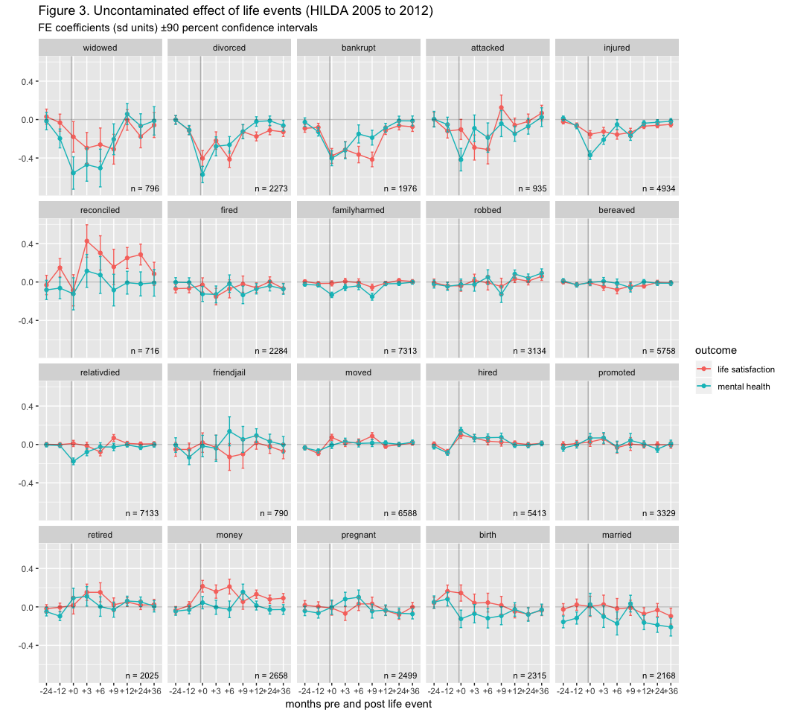

Comparing the uncontaminated effect of the same events to our earlier figures, we can see the baseline of some events has shifted to a level below zero (e.g., divorced), while the impact of other events have shifted the baseline to a slightly superior level (e.g., hired).

Finally, in Figure 4 we can examine a model which only includes individuals with observations before and after the event (i.e., a balanced model). This obviously further restricts the $n$ contributing to each plot.

In this restricted data, many of the observations we made earlier cannot be generalized. The increase in error has even reduced our ability to see clear differences in the size of the effect between different events.

#### To do

* fill out details of results (df, etc)
* correct notation for equations
* figure captions
* black & white figures

## Conclusions

In this population level survey, we can see in general that different life events have larger impacts than others on well-being. For instance, death of a spouse or partner is generally one of the worst things that can happen here. Conversely, birth (or adoption) of a new child, along with marrige, is one of the best events.

Each life event tends to impact life satisfaction and mental health similarly, however bad events tend to have a larger effect on mental health while good events have a larger effect on life satisfaction. There are exceptions when one moves without the other or they even move in opposite directions. For instance, a major financial windfall (“money”) or birth has a positive effect on happiness and little systematic effect on mental health in the first year or two. The distinct response to a single event among these measures seems to strongly support the view that well-being has multiple components.

The implications of this for government policy, economic cost models, etc remain to be spelled out.

#### Acknowledgements

This paper uses unit record data from the Household, Income and Labour Dynamics in Australia (HILDA) survey. The HILDA project was initiated and is funded by the Australian Government Department of Social Services (DSS) and is managed by the Melbourne Institute of Applied Economic and Social Research Melbourne Institute. The findings and views reported in this paper, however, are those of the author and should not be attributed to either DSS or the Melbourne Institute.

#### Financial Support

This research received no specific grant from any funding agency, commercial or not-for-profit sectors.

#### Conflict of Interest

*None*.

#### Availability of Data and Materials

Data are available on application to the Australian Government Department of Social Services. All code used to produce this report is available on GitHub: <https://github.com/datarichard/shit-happens>. ***

# References

Brickman, P., Coates, D., Janoff-Bulman, R., 1978. Lottery winners and accident victims: Is happiness relative? Journal of personality and social psychology 36, 917.

Clark, A.E., Diener, E., Georgellis, Y., Lucas, R.E., 2008. Lags and leads in life satisfaction: A test of the baseline hypothesis. The Economic Journal 118, F222–F243.

Croissant, Y., Millo, G., 2008. Panel data econometrics with r. Journal of Statistical Software 27, 1–43.

Diener, E., Heintzelman, S.J., Kushlev, K., Tay, L., Wirtz, D., Lutes, L.D., Oishi, S., 2017. Findings all psychologists should know from the new science on subjective well-being. Canadian Psychology/psychologie canadienne 58, 87.

Frijters, P., Johnston, D.W., Shields, M.A., 2011. Life satisfaction dynamics with quarterly life event data. Scandinavian Journal of Economics 113, 190–211.

Gilbert, D., 2009. Stumbling on happiness. Vintage Canada.

Lucas, R.E., 2005. Time does not heal all wounds: A longitudinal study of reaction and adaptation to divorce. Psychological science 16, 945–950.

Lucas, R.E., 2007. Long-term disability is associated with lasting changes in subjective well-being: Evidence from two nationally representative longitudinal studies. Journal of personality and social psychology 92, 717.

Lucas, R.E., Clark, A.E., Georgellis, Y., Diener, E., 2004. Unemployment alters the set point for life satisfaction. Psychological science 15, 8–13.

Luhmann, M., Hofmann, W., Eid, M., Lucas, R.E., 2012. Subjective well-being and adaptation to life events: A meta-analysis. Journal of personality and social psychology 102, 592.

McHorney, C.A., Ware Jr, J.E., Lu, J.R., Sherbourne, C.D., 1994. The mos 36-item short-form health survey (sf-36): III. tests of data quality, scaling assumptions, and reliability across diverse patient groups. Medical care 40–66.

McHorney, C.A., Ware Jr, J.E., Raczek, A.E., 1993. The mos 36-item short-form health survey (sf-36): II. psychometric and clinical tests of validity in measuring physical and mental health constructs. Medical care 247–263.

R Core Team, 2013. R: A language and environment for statistical computing. R Foundation for Statistical Computing, Vienna, Austria.

STATISTICS, A.B.O., 1997. National health survey sf-36 population norms australia. Australia, Australian Bureau of Statistics.

Ware Jr, J.E., Sherbourne, C.D., 1992. The mos 36-item short-form health survey (sf-36): I. conceptual framework and item selection. Medical care 473–483.

Watson, N., Wooden, M., 2006. Modelling longitudinal survey response: The experience of the hilda survey, in: ACSPRI Social Science Methodology Conference. pp. 10–13.

Wickham, H., 2017. Tidyverse: Easily install and load the ’tidyverse’.