The Effect of Major Life Events on Mental Health and Happiness

N. Kettlewell1, R.W. Morris2,3, N. Ho4, D.A. Cobb-Clarke1, S.Cripps2 & N.Glozier3,4

1. School of Economics, University of Sydney, NSW, Australia
2. Centre for Translational Datascience, University of Sydney, NSW, Australia
3. Central Clinical School, University of Sydney, NSW, Australia
4. Brain Mind Centre, University of Sydney, NSW, Australia

**Corresponding author:**  
Professor Nick Glozier  
Faculty of Health and Medicine,  
University of Sydney,  
NSW 2050,  
Australia  
email: [nick.glozier@sydney.edu.au](mailto:nick.glozier@sydney.edu.au)

Draft: 30 September, 2018  
Word count: (max 4000)  
Tables: (max 6)  
Figures: (max 6)

**keywords:** Epidemiology, population survey, subjective well-being

## Abstract

**Aims.** Major life events such as getting married, death of a loved one, retirement or job loss are widely assumed to have a substantial, albiet temporary impact on well-being and happiness. However few longitudinal studies have compared the impact of different life events on well-being; and fewer still have compared different components of well-being over the same time period. Here we describe the impact of 22 different life events on two different components of well-being in a large, longitudinal dataset. We aim to provide insight into how wellbeing changes in response to different external events in the broader population.  
**Methods.** Data from the Household Income and Labour Dynamics in Australia (HILDA) survey were used. Mental component scores from the SF-36 and a life satisfaction score was collected from 2001 to 2016. The effect of major life-events on these well-being measures was assessed over a ±3 year time-window in that 16 year period. Fixed effect regression models were used to distinguish the unique effect of life events on changes in the two well-being measures.  
**Results:** We were able to sort events according to the size of their positive and negative effects on mental health and life-satisfaction. Some events had a profound impact on the well-being measures (e.g., death of a spouse, divorce, birth of a child, marriage). Others had relativily little effect (e.g,. moving home, retirement). In general, negative events (e.g., widowed) had a larger impact on mental health while positive events (e.g,. birth of a child) had a larger impact on life satisfaction. Relatively few events had an impact on well-being beyond two years, but exceptions existed (e.g., divorce, retirement).  
**Conclusions** Different life events have substantially different effects on well-being and happiness. These effects range from positive to negative, and can last as little as 3 months to more than 3 years. The distinct components of well-being we measured here had similar but not identical time courses to external events. In most cases subjective well-being is either not substantially affected by these events for longer than our measurement interval (i.e., 3 months), or returns to baseline within three years (i.e., hedonic adaptation). These results will help clinicians, economists and policymakers understand how external events and interventions can increase or decrease wellbeing and happiness in the general population. (399/400 words)

## Introduction

The observation that major life events, such as marriage, death of a child or spouse, bankruptcy or lottery winnings have a substantial impact on our happiness and well-being is widely appreciated and self-apparent (i.e., *“shit happens”*). While such colloquial observations confirm our universal experience, they do not tell us anything about the relative impact of different events on happiness in the general population. That is, how do different events impact well-being on average? Is, for instance, death of one’s spouse worse than divorce? Alternatively, other things being equal, is starting a new job better than getting promoted? In short, how can we compare the impact of different life events?

One answer to these questions has been provided by research on subjective well-being, which has focused on hedonic adaptation (Gilbert 2009). However the claim that specific feelings such as happiness fluctuate according to circumstances but ultimately return to a set baseline provides only an incomplete answer to the questions just raised. Early research on subjective well-being claimed that people adapt to events, both good and bad, over time (Brickman, Coates, and Janoff-Bulman 1978). However we now know that, despite adaptation, in some cases the changes in our well-being are permanent or at least last for many years. For instance, longitudinal studies which have followed individuals across time indicate the amount of adaptation varies by event, with disability (Richard E. Lucas 2007), divorce (Richard E Lucas 2005), death of spouse (Richard E Lucas 2005), and unemployment (Richard E Lucas et al. 2004) all having long-term negative effects. Furthermore, evidence from prospective longitudinal studies has found that events such as marriage and unemployment continue to influence both life satisfaction and well-being long after they have occurred (Luhmann et al. 2012). Other longitudinal studies have found evidence of adaption to these same events (Clark et al. 2008, Frijters, Johnston, and Shields (2011)).

However while such studies tell us about differences in the length of the time course over which our well-being adapts in the wake of major life events, they do not always allow us to compare the amount of change in that time course. For instance, we cannot take it for granted that events which produce long term changes in happiness also produce the largest changes in magnitude. An event such as retirement could produce a smaller increase in happiness than the birth of a child, despite lasting longer before returning to baseline. It’s also possible that different components of well-being may respond differently to life events. Subjective well-being is not a single unitary entity, and may consist of multiple dimensions, such as positive and negative aspects, cognitive and affective components, etc. (Diener et al. 2017). For example, a meta-analysis of subjective well-being studies distinguished between two different contributors to well-being (broader life satisfaction and specific affect) across different studies, and reported distinct temporal dynamics of each [luhmann2012subjective]. However few longitudinal studies have compared the impact of different life events on well-being; and fewer still have compared different components of well-being over the same time period.

We compare the impact major life events on two components of well-being (mental health and life satisfaction) in a single longitudinal study. The [**HILDA dataset**](https://melbourneinstitute.unimelb.edu.au/hilda) has collected responses from over 11,000 Australians over sixteen years, including data on 22 different life events experienced in each of the last four quarters of every year, as well as measures of subjective well-being such as overall life-satisfaction and mental health scores. This relatively unique dataset thus allows us to ask what is the impact of different life events in the general population? What is the relationship between different components of well-being in the face of major life challenges? Do changes in one necessarily accompany changes in the other? And can life satisfaction and mental health diverge in some circumstances? Other studies have examined the temporal dynamics of major life events on subjective well-being using this dataset (e.g., Frijters, Johnston, and Shields 2011), but they have typically only used a single item measure of well-being (e.g., overall life-satisfaction based on a single-item question) over a far shorter period of time (e.g., six years)

## Methods

The analysis was performed in *R* (version 3.5.1) (R Core Team 2013), using the tidyverse package (version 1.2.1) for data import and wrangling (Wickham 2017) , the plm package (1.6-6) for fixed effect estimates (Croissant and Millo 2008), along with some custom helper functions and wrappers for convenience (provided in src/).

#### Data

The Household, Income and Labour Dynamics in Australia (HILDA) survey is a longitudinal, nationally representative study of Australian households. It collects detailed information annually from over 7000 households (Wilkins, 2013). The survey covers a range of dimensions including social, demographic, health and economic conditions using a combination of face-to-face interviews with trained interviewers and a self-completion questionnaire. It began in 2001 with the survey of 13,969 persons in 7,682 households (out of a total of 15,127 eligible household members). Each year since, interviews have been conducted with all willing members of each household who are at least 15 years old at the time of the interview. The rate of retention of the initial responding sample is 74 percent, which is comparable to other national longitudinal surveys such as the British Household Panel Survey and the German Socio-Economic Panel Survey (Watson and Wooden 2006).

Life satisfaction scores were obtained from the annual face-to-face interview using the response to the familiar question:

“All things considered, how satisfied are you with your life?”

Respondents are told to:

“Pick a number between 0 and 10 to indicate how satisfied you are” and that “the more satisfied you are, the higher the number you should pick”.

The mental component score was obtained from the SF-36, one of the most widely used self-completion measures of health status. It comprises 36 items which are used to measure eight scales covering various aspects of physical, emotional and mental health. These eight scales are: Physical Functioning; Role-Physical (interference with work or other daily activities due to physical health); Bodily Pain; General Health; Vitality; Social Functioning (interference with normal social activities); Role-Emotional (interference with work or other daily activities due to emotional problems); and Mental Health (symptoms associated with anxiety and depression and measures of positive affect). In addition, the eight scales yield two summary scales of health, relating to physical (the Physical Component Summary: PCS) and mental (the Mental Component Summary: MCS) functioning and well-being. To calculate the MCS, we followed standard procedures and transformed each of the eight SF-36 subscales to a 0–100 scale (McHorney et al. 1994, McHorney, Ware Jr, and Raczek (1993), Ware Jr and Sherbourne (1992)). Scoring algorithms were applied to produce the MCS, using the Australian norms (STATISTICS 1997).The SF-36 was included as the first element in HILDA’s self-completion questionniare.

The occurrences of life events were determined by responses in a subsequent section of HILDA’s self-completion questionnaire and have been included since wave 2 (2002). This questionnaire is completed after the life satisfaction scores and SF-36 and so the respondent’s recollection of the life events will not bias their evaluation of the well-being measures.

Respondents are told:

“We now would like you to think about major events that have happened in your life over the past 12 months. For each statement cross the YES box or the NO box to indicate whether each event happened during the past 12 months. If you answer ‘YES’, then also cross one box to indicate how long ago the event happened or started.”

This information is given by quarter.

The range of life events is comprised of 22 different items, and they include both positive and negative events:

1. lefnw financial loss (e.g., bankruptcy)
2. lefni financial windfall (e.g., lottery win, inheritance)
3. lefrd lost job (e.g., fired)
4. lejob started a new job
5. leprm promoted at work
6. lertr retired from workforce
7. lemar got married
8. lemar you (or partner) got pregnant
9. lebth birth (or adoption) of a child
10. ledsc death of loved one (e.g., child or spouse)
11. lesep divorce or separation
12. lemvd moved home
13. leins suffered a serious injury (e.g., disability)
14. lepcm victim of property crime (e.g., house breaking)
15. lejls detained in jail
16. lejlf jail for a close friend or relative
17. ledfr death of a close friend
18. ledhm home destroyed in a natural disaster (2009 to 2016 only)
19. ledrl death of a close relative
20. leinf serious injury to family member
21. lercl reconciled with spouse
22. levio victim of physical violence

#### Model Design

We are interested in how life events affect variation over time in happiness and mental health. When a respondent indicates a life event occurred that year, they also indicate how long ago in quarterly intervals (3-monthly intervals) the event occurred. This gives us a slightly better temporal resolution than the annual indicator to observe the effect of the life event in the current year. Using the quarterly and annual indicators, we will model the effect of life events on current mental health and happiness scores among individuals as a function of time since the life event. To estimate these effects, we utilise the panel nature of our data and estimate a series of linear fixed effects regression models.

Under this approach we have a linear model with $N$ observations and $T$ time points:

$$y_{it}=βX_{it}+α_{i}+ϵ_{it} for t=1...T and i=1...N$$

Where $X_{it}$ is a vector of control variables. In our application, this is a set of dummy variables representing lags and leads on the life event. For example, we have a **pre36** = 1 if the life event occurs in the next 3 years, a **pre24** = 1 if a life event occurs in the next 2 years, … , and a **post36** = 1 if a life event occurred 3 years ago. In total, we have seven dummy variables indicating the $y_{it}$ occurred up to 36 months after the life event (**post00**, **post03**, **post06**, **post09**, **post12**, **post24**, **post36**), as well as three variables indicating $y_{it}$ was measured up to 36 months before the life event (**pre12**, **pre24**, **pre36**). $X_{it}$ can also include other time varying controls (e.g. education).

$α_{i}$ is the time-invariant subject-specific effect, which may be correlated with the erorr-term $ϵ$, for example, if innately unhappy people are more likely to divorce. $α_{i}$ is unobserved by the researcher but it is a constant (i.e., time-invarying)and so can be removed from the model by demeaning, i.e., $α—{\overline{α}}_{i}=0$. We can demean each of the terms, including $y_{it}$ and $X_{it}$ variables, and so remove the time-invarying effects from the model. Letting $Δ$ indicate that the variable has been demeaned in this way, our model becomes:

$$y_{it}^{Δ}=βX_{it}^{Δ}+ϵ_{it}$$

One issue we have is **missing data**. This can occur for three reasons. First, the number of available predictors will vary at the endpoints of our dataset. For instance, at the beginning of our dataset there is no life event data prior to 2002 to account for changes in our outcome measure in the years 2002, 2003 and 2004. At the end of our dataset, e.g., 2016, we do not know if a life event will occur in 2017, so we will have people in the dataset who should be contributing to the estimation of anticipation effects but are not. Misclassification in this case would tend to attenuate our estimates towards zero. A second source of missing data is some people do not answer the life event questions in some years. This varies across events, but is generally modest (around **X percent**). Misclassification in this case would tend to increase the unexplained variance in our outcome variable and so contribute to our error term. Third, some people are missing in some years from HILDA altogether. In these cases, we cannot be sure if they experienced an event during that period. This is a similar issue to the endpoints issue. Our initial approach is to assume that no life event occurred in these years. In follow-up analysis, we exclude from the sample any observations within 3 years of missing life event data (and means we only estimate effects for the years 2005-2012).

Another wrinkle to consider in this analysis is the problem of multiple events of the same type occurring within the time window of our model (±3 years). When multiple events occur within the time window, the influence of each occurrence on the outcome is ambiguous. For instance, when the same life event such as a new job occurs in 2008 and 2009, any happiness score from a wave that occurs within three years of both events (2006 to 2011) would be predicted by both events, however the relative contribution of each event to the happiness score would be ambiguous. Rather than exclude the ambiguous scores, **we assume that the most recent event (proximate cause assumption) exerts the strongest influence and so only label the most proximate event preceding the outcome**. This will ignore the influence of some events of the same type that occur frequently (e.g., new job, promotion etc) but are more distal to the outcome of interest.

## Results

**Figure 1** below shows the estimate of effect for each life event on life satisfaction and mental health without controlling for other life events (or covariates such as age). Thus, each life event is included in its own separate model, and any influence of the other events on changes is deliberately ignored (and so is a potential channel).

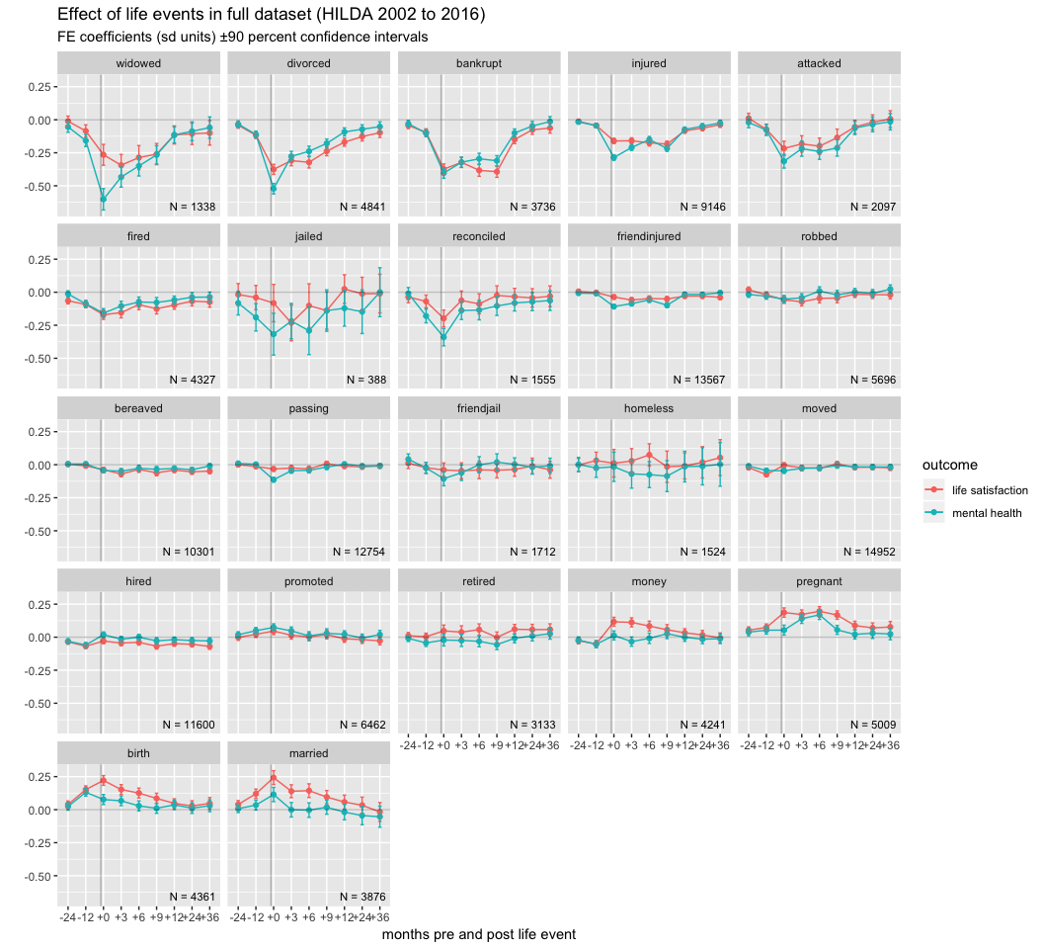

For each life event, the coefficients are visualized in a line plot with time of event (e.g., bankruptcy) relative to the outcome measurement on the x-axis, and the amount of change in the outcome score (e.g., mental health) produced by the event on the y-axis. Differences from zero (on the y-axis) represent the marginal effect of the life event on the outcome variable.

Sometimes the effect of a life event seems to precede the time of the event (+0 on the x-axis).

Sometimes the effect of a life event might mediate the effect of other life events (i.e., indirect effects). For instance, losing one’s job may co-occur with moving home, divorce or even a change in socioeconomic status, any of which may be the primary driver of changes in well-being. In an effort to ameliorate the influence of indirect effects (and so expose the direct effect of life events) we examined a model which included other covariates in the model. The relevant covariates in this context are features which change across time along with the changes in well-being we wish to model, i.e., variables that change with time. Thus, apart from each of the other life events, we also include year, age, changes in education, and changes in SEIFA status as potential covariates. There may be other relevant (better) variables in the HILDA dataset which can be included in future iterations of this document.

**Figure 2** below shows the results of a model which includes all other life events as covariates, as well as year, age, changes in education, and changes in SEIFA status. For this reason, the model shows the unique effect of each event on well-being

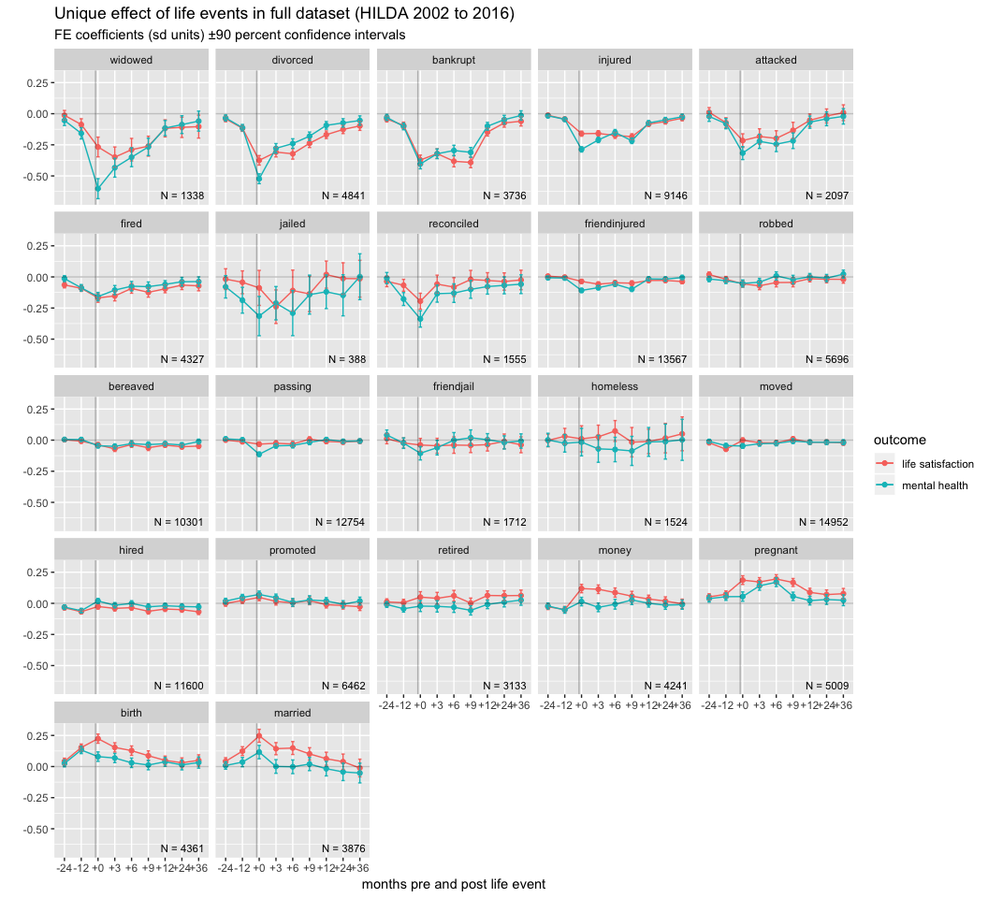

Up until this point, we have been assuming that unlabelled time points do not contain life events. I.e., our implicit imputation is that missing = zero. This might not be true, and unreported life events may be producing changes we are not modelling. We can omit waves in which there is missing life event data within the time window we are studying (+/- 3 years). This will result in less data but the remaining observations should be uncontaminated by unobserved events, as shown below in **Figure 3**.

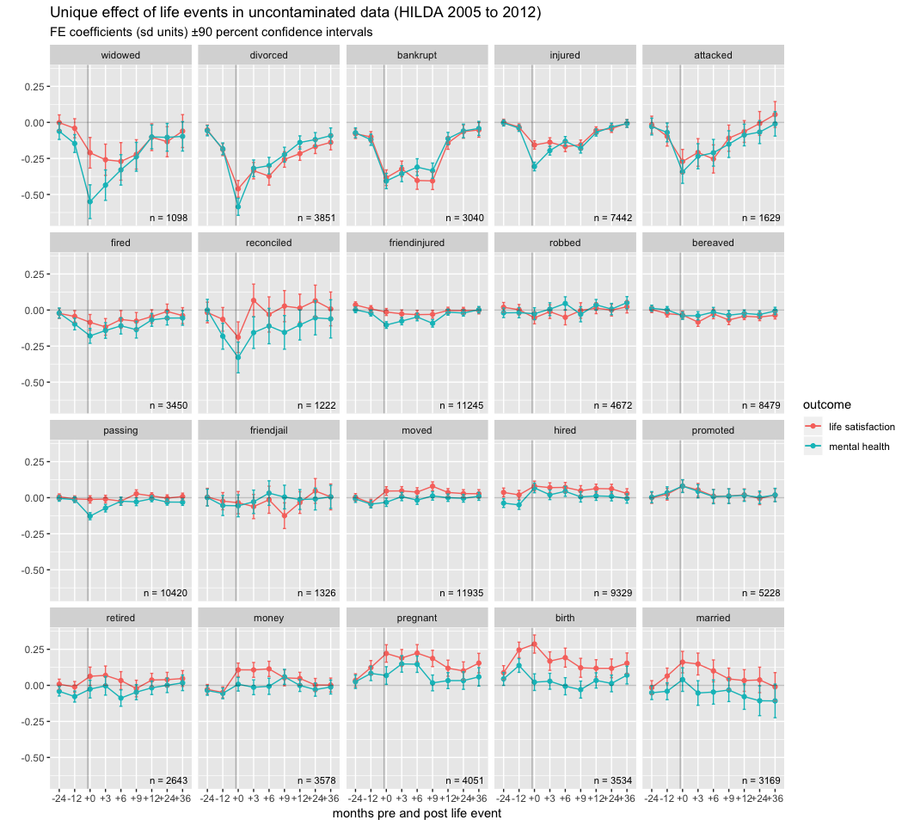

Finally, in **Figure 4** we can examine a model which only includes individuals with an equal number of observations before and after the event (i.e., a balanced model).

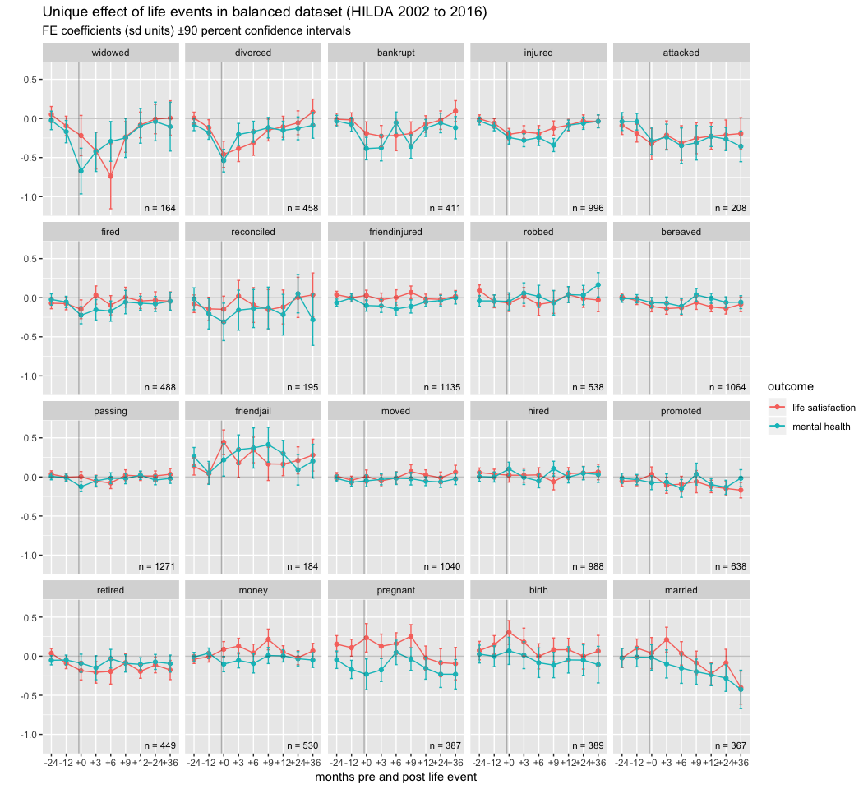

#### To do

* fill out details of results (df, etc)

## Conclusions

In general, happiness moves in line with mental health scores, however there are exceptions when one moves without the other or they even move in opposite directions. For instance, a major financial windfall (e.g., winning the lottery) or birth has a positive effect on happiness and little systematic effect on mental health in the first year or two. The implications of this for government policy, economic cost models, etc remain to be spelled out.

#### Acknowledgements

This paper uses unit record data from the Household, Income and Labour Dynamics in Australia (HILDA) survey. The HILDA project was initiated and is funded by the Australian Government Department of Social Services (DSS) and is managed by the Melbourne Institute of Applied Economic and Social Research Melbourne Institute. The findings and views reported in this paper, however, are those of the author and should not be attributed to either DSS or the Melbourne Institute.

#### Financial Support

This research received no specific grant from any funding agency, commercial or not-for-profit sectors.

#### Conflict of Interest

*None*.

#### Availability of Data and Materials

Data are available on application to the Australian Government Department of Social Services. All code used to produce this report is available on GitHub: <https://github.com/datarichard/shit-happens>.

## References

Brickman, Philip, Dan Coates, and Ronnie Janoff-Bulman. 1978. “Lottery Winners and Accident Victims: Is Happiness Relative?” *Journal of Personality and Social Psychology* 36 (8): 917. <https://www.ncbi.nlm.nih.gov/pubmed/690806>.

Clark, Andrew E, Ed Diener, Yannis Georgellis, and Richard E Lucas. 2008. “Lags and Leads in Life Satisfaction: A Test of the Baseline Hypothesis.” *The Economic Journal* 118 (529): F222–F243. <https://onlinelibrary.wiley.com/doi/10.1111/j.1468-0297.2008.02150.x>.

Croissant, Yves, and Giovanni Millo. 2008. “Panel Data Econometrics with R.” *Journal of Statistical Software* 27 (2): 1–43. <https://CRAN.R-project.org/package=plm>.

Diener, Ed, Samantha J Heintzelman, Kostadin Kushlev, Louis Tay, Derrick Wirtz, Lesley D Lutes, and Shigehiro Oishi. 2017. “Findings All Psychologists Should Know from the New Science on Subjective Well-Being.” *Canadian Psychology/Psychologie Canadienne* 58 (2): 87. <http://psycnet.apa.org/record/2016-48141-001>.

Frijters, Paul, David W Johnston, and Michael A Shields. 2011. “Life Satisfaction Dynamics with Quarterly Life Event Data.” *Scandinavian Journal of Economics* 113 (1): 190–211. <https://onlinelibrary.wiley.com/doi/full/10.1111/j.1467-9442.2010.01638.x>.

Gilbert, Daniel. 2009. *Stumbling on Happiness*. Vintage Canada.

Lucas, Richard E. 2005. “Time Does Not Heal All Wounds: A Longitudinal Study of Reaction and Adaptation to Divorce.” *Psychological Science* 16 (12): 945–50. <https://www.ncbi.nlm.nih.gov/pubmed/16313658>.

Lucas, Richard E, Andrew E Clark, Yannis Georgellis, and Ed Diener. 2004. “Unemployment Alters the Set Point for Life Satisfaction.” *Psychological Science* 15 (1): 8–13. <https://ideas.repec.org/p/bru/bruedp/02-16.html>.

Lucas, Richard E. 2007. “Long-Term Disability Is Associated with Lasting Changes in Subjective Well-Being: Evidence from Two Nationally Representative Longitudinal Studies.” *Journal of Personality and Social Psychology* 92 (4): 717. <https://www.ncbi.nlm.nih.gov/pubmed/17469954>.

Luhmann, Maike, Wilhelm Hofmann, Michael Eid, and Richard E Lucas. 2012. “Subjective Well-Being and Adaptation to Life Events: A Meta-Analysis.” *Journal of Personality and Social Psychology* 102 (3): 592. <https://www.ncbi.nlm.nih.gov/pmc/articles/PMC3289759/>.

McHorney, Colleen A, John E Ware Jr, and Anastasia E Raczek. 1993. “The Mos 36-Item Short-Form Health Survey (Sf-36): II. Psychometric and Clinical Tests of Validity in Measuring Physical and Mental Health Constructs.” *Medical Care*, 247–63.

McHorney, Colleen A, John E Ware Jr, JF Rachel Lu, and Cathy Donald Sherbourne. 1994. “The Mos 36-Item Short-Form Health Survey (Sf-36): III. Tests of Data Quality, Scaling Assumptions, and Reliability Across Diverse Patient Groups.” *Medical Care*, 40–66.

R Core Team. 2013. *R: A Language and Environment for Statistical Computing*. Vienna, Austria: R Foundation for Statistical Computing. <http://www.R-project.org/>.

STATISTICS, AUSTRALIAN BUREAU OF. 1997. “National Health Survey Sf-36 Population Norms Australia.” *Australia, Australian Bureau of Statistics*.

Ware Jr, John E, and Cathy Donald Sherbourne. 1992. “The Mos 36-Item Short-Form Health Survey (Sf-36): I. Conceptual Framework and Item Selection.” *Medical Care*, 473–83.

Watson, Nicole, and Mark Wooden. 2006. “Modelling Longitudinal Survey Response: The Experience of the Hilda Survey.” In *ACSPRI Social Science Methodology Conference*, 10–13.

Wickham, Hadley. 2017. *Tidyverse: Easily Install and Load the ’Tidyverse’*. <https://CRAN.R-project.org/package=tidyverse>.