Unit 4 Capstone Report

I. Introduction

Twitter has maintained its status as the premier micro-blogging internet platform since being introduced a decade ago. Users of Twitter send out short messages ‘tweets’ to other users (followers) and receive tweets from other Twitter users that they follow. Tweets tend to be short messages (280 characters) that can contain images, video and url references. The messages can also contain topical hashtags (words beginning with a # symbol) and can be directed at specific users with @(username) tags.

Twitter has maintained exceptional growth and is considered an indispensable corporate social media tool. At the beginning of 2018, Twitter has over 330 million active users and over 500 million tweets are sent per day. There are many accounts that have over 10 million twitter followers.

The goal of this project is to use natural language processing tools, both supervised and unsupervised, in order to classify the identity of 10 major Twitter celebrities and corporate accounts using information from their tweets as documents. These Twitter accounts were purposely picked to exclude an over-reliance on political content. Thus current and past presidents and other high profile politicians were not included.

The included individuals were considered primarily for the variety of topics that they tweet about. The selection of accounts was a quick one time decision to include individuals with broad based popularity. There was no re-selection of accounts after test results. Most but not all of the tweets revolve around technology as their job function. The included twitter accounts are elonmusk, NASA, nytimes, espn, JamesWoods, katyperry, ScottAdams, WilliamShatner, tim_cook, and BillGates. As can be seen, there are a mix of technology executives and founders along with governmental and corporate news organizations. There are also a mix of musicians and assorted Hollywood types included. James Woods and Scott Adams arguably tweet quite often about social and political topics but are not formally political in their job function. One commonality among these twitter users is the high number of followers of their respective accounts.

Downloading the tweets was done using the Tweepy library. Tweepy has an easy to use python wrapper of the Twitter developers API. Twitter’s API only allows for a maximum download of 3200 tweets from a twitter account. The option to exclude retweets was turned on for these downloads. Note that the text of the tweets keeps the word ‘RT’ even after excluding retweet content.

II. Bag of Words Representation

The bag of words representation of text is a simple count of the n-grams in the texts. An n-gram is a continuous sequence of n tokens in a text. Commonly n is either 1, 2, or 3 (called Unigram, bigram, and trigram). As was mentioned above, tweets have various additional items that need to be filtered out in order to tokenize a clean text for analysis.

The following is a list of pre-processing steps taken to clean the tweets into a suitable text for NLP analysis.

Step 1 - Call Beautiful Soup to clean out HTML fragments in tweets.
Step 2 - Strip url's and keep only letters and numbers.
Step 3 - Strip out utf-8 tags.
Step 4 - Lower case and split to tokenize the text.

The Beautiful Soup python library is called to strip out residual html or xml tags that can exist in raw tweets. URL’s need to be stripped out and only standard letters and numbers are kept. UTF-8 special codes are also stripped out. The resulting text is lower-cased and split into tokens for analysis.

A (75%/25%) Train/Test split was done and the following analysis is conducted entirely by using 10-fold cross validation on the training data. The average of the folds classification accuracy is used to rank supervised learning methods.

The following sklearn models results use standard unigram bag of word representations fit on the training data using the mean of 10-fold CV. No stopword lists were used. Preliminary experiments led me to abandon the use of stop word lists for bag of words. Tweets contain a relatively impoverished vocabulary that is cut down too much by removing stop words.

Random Forest – 47.3%
SVC – 12.2%
SVC(‘linear’) - 62.9%
Gradient Boosting – 55.4%
Logistic Regression – 68.98%
Grid search of L2 and L1 regularization of Logistic Regression resulted in worse results than default Logistic Regression.

Best results came from default logistic regression.

After this experiments on including bigrams + unigram bag of words was conducted. The results follows:

Logistic Regression – 69.1%
Grid search of L2 and L1 regularization of Logistic Regression resulted in worse results than plain Logistic Regression.
SVC(‘linear’) - 61.4%

Trigram experiments were conducted and Logistic Regression scored worse than with only bigrams. There were never any competitive machine learning models that could beat Logistic Regression. Various experiments were tried but did not prove fruitful. Somewhat surprisingly given the large number of variables in the unigram + bigram bag of words representation, regularization did not improve results over common logistic regression.

The confusion matrix for the bag of words results follows.

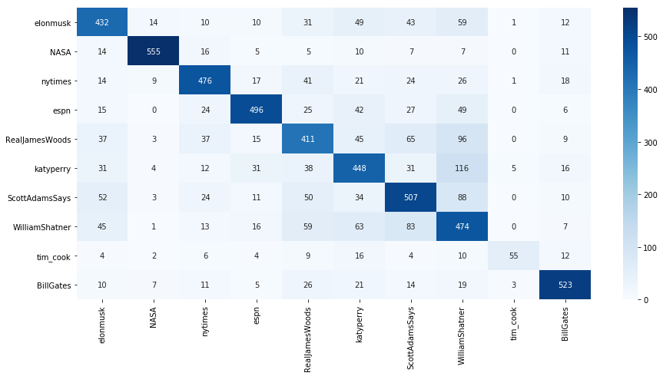

III. Tf-IDF Representation

A TF-IDF representation was tried next based on the following option setup.

norm='l2', use_idf=True, smooth_idf=False, sublinear_tf=True,
max_df=0.5, # drop words with df of greater than .5 min_df=2, # words must occur twice
stop_words='english',
lowercase=True, # lowercase everything

Results of running a battery of supervised learning models are as follows:

Random Forest – 56.2%
SVC(‘linear’) - 65.7%
Gradient Boosting – 53.3%
Logistic Regression – 66.4%
A grid search of L2 and L1 regularization of Logistic Regression was uniformly worse than LR itself.

Next an TF-IDF representation was run with stop words included for Logistic Regression. Results were better than without stop words marginally at 67.3%.

Overall, the experience running supervised learning algorithms on the tweet data shows that unigram + bigram bag of words with Logistic Regression achieves superior results.

IV. Kmeans Clustering on TF-IDF Data

A set of k-means clustering on the TF-IDF data including stop words was run. All score results for similarity were very low. Results for 4 clusters gave the best Silhouette score. The clusters were unintelligible. Adding the clusters to the TF-IDF input data did not improve classification results in a meaningful way.

V. Latent Semantic Analysis

K-means was not effective in improving classification results. I experimented next with taking various dimensions of a truncated SVD on the TF-IDF data. The dimension reduction was the subject of experiment. Good results appears to be with a dimension of 250 for the LSA vectors. This data was added to the Bag of Words bigram dataset and the highest 10-fold CV score was gained: 69.24%. Once again, regularization of the Logistic Regression did not help. Let’s look at the first 10 LSA directions.

The first component is composed of long coherent sentences.
The second component is composed of sentences that talk about action to 'you' or 'yourself'.
The third component is composed of ‘yes’ responses.
The fourth component is composed of short sentences with 'it is' in them.
The fifth component is composed of short sentences with 'this is' in them.
The sixth component says “morning briefing: here’s what you need to start your day.
The seventh component says “evening briefing: here’s what you need to start your day.
The eighth component is of the form “that’s [blank]” . Generally a short sentence.
The ninth component just says “no”
The tenth component says short idiomatic expressions like “idiot for idioms”, “justice for everybody”, and “braces for comments”.

VI. Conclusions

Best results were from bag of words including both unigram and bigram. Logistic regression is the modeling method of choice. K-means is not useful in clustering these tweets. LSA helps the classification marginally and gives component summaries that are intelligible but not necessarily useful. Further experiments with hyperparameter estimation of nonlinear models does not appear to be extremely useful. TF-IDF was disappointing for classification in general. Since tweets appear to be composed of a small vocabulary, it seems to be better to keep stop words in the bag of words.

