**DBMS LAB PROJECT** **MOVENTUR:**

**Conceptual Schema**

**Key Milestone # 0****1**

**Spring 2025**

**CSE-403L**

**Database Management System Lab**

Submitted by:

**Muhammad Musa (22PWCSE2157)**

**Muhammad Jasim (22PWCSE2102)**

Class Section: **‘C’**

“We affirm that we have completed this work with integrity”

Submitted to:

**Engr. Sumayyea Salahuddin**

Sunday, May 25, 2025

Department of Computer Systems Engineering

University of Engineering and Technology, Peshawar

**DBMS Lab Project Moventure: Conceptual Schema**

**1. Entity Description**

| Entity | Description | Attributes |
| --- | --- | --- |
| **CANDIDATES** | Represents individuals who are running for a specific elected position. | id (Primary Key), position_id (Foreign Key), firstname, lastname, photo, platform |
| **POSITIONS** | Represents the various elected positions available in the voting system. | id (Primary Key), description, max_vote (maximum number of votes allowed for this position), priority |
| **ADMIN** | Represents the administrators who manage and oversee the voting system. | id (Primary Key), username, password, voters (likely a count or summary of total voters), votes (likely a count or summary of total votes) |
| **VOTERS** | Represents registered individuals eligible to cast votes in the system. | id (Primary Key), voters_id (unique identifier for voting), password, firstname, lastname, photo |
| **VOTES** | Represents a record of a single vote cast by a voter for a candidate. | id (Primary Key), voter (Foreign Key to VOTERS.id), candidate_id (Foreign Key to CANDIDATES.id), position_id (Foreign Key to POSITIONS.id) |

**2. Detailed Business Rules**

Here are the detailed business rules derived from the provided ERD for the online voting system:

1. **Candidates and Positions:**
   * A Candidate can run for exactly one Position.
   * A Position can have one or more Candidates.
   * Each Candidate has a unique ID, first name, last name, photo, and platform.
   * Each Position has a unique ID, description, a maximum number of votes allowed for that position (max_vote), and a priority.
2. **Voters and Votes:**
   * A Voter can cast votes for multiple positions.
   * A Voter can cast at most one vote for a given Position.
   * A Vote is cast by exactly one Voter.
   * Each Voter has a unique ID, a voters_id (likely a unique identifier for voting purposes), a password, first name, last name, and photo.
3. **Votes and Candidates/Positions:**
   * A Vote is cast for exactly one Candidate.
   * A Vote is associated with exactly one Position.
   * A Candidate can receive zero, one, or many Votes.
   * A Position can receive zero, one, or many Votes.
   * Each Vote has a unique ID, identifies the voter who cast it, the candidate_id for whom the vote was cast, and the position_id for which the vote was cast.
4. **Admin and System Management:**
   * An Admin can manage system parameters related to Voters and Votes.
   * An Admin can view details of Voters and Votes.
   * Each Admin has a unique ID, a username, and a password.
   * The Admin entity seems to hold summary information like voters (total number) and votes (total number), indicating a management or reporting role.
5. **Relationship between Entities:**
   * CANDIDATES and POSITIONS have a Many-to-One relationship (Many Candidates to One Position).
   * VOTERS and VOTES have a One-to-Many relationship (One Voter can make Many Votes).
   * VOTES is a linking table (or junction entity) connecting VOTERS, CANDIDATES, and POSITIONS to record specific vote instances. This implies a many-to-many relationship between VOTERS and CANDIDATES (a voter can vote for many candidates, and a candidate can be voted for by many voters) through the VOTES table, and similarly for VOTERS and POSITIONS, and CANDIDATES and POSITIONS in the context of votes.
   * ADMIN appears to have a supervisory or management role over VOTERS and VOTES, indicated by the relationships to these entities, likely for system administration and reporting.

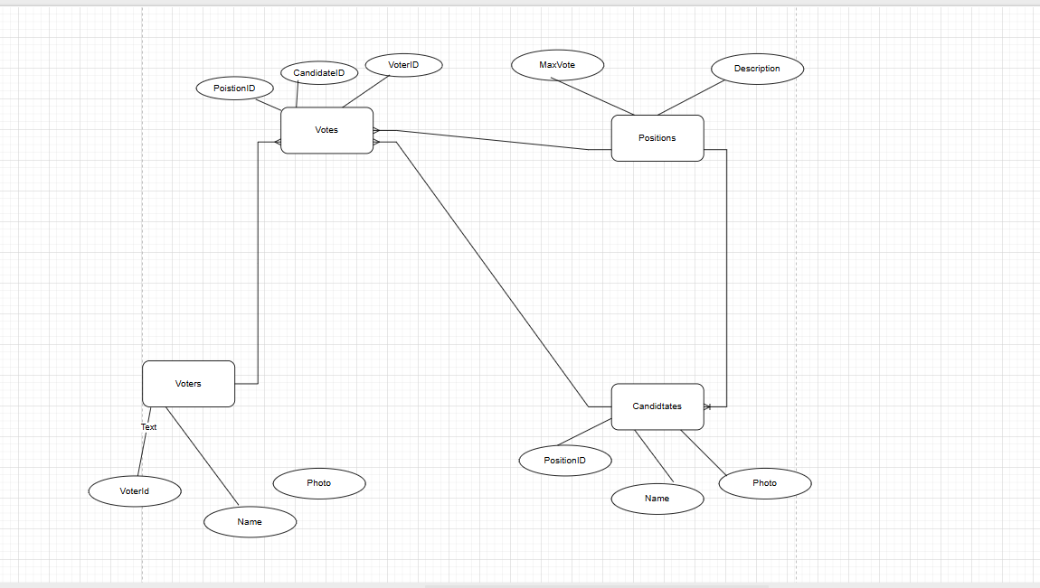

**References**

* <https://grok.com/chat/27983633-f475-4d84-a581-e50639a1456d>
* <https://www.geeksforgeeks.org/how-to-draw-entity-relationship-diagrams>