About the data: retail order management dataset from a bike store
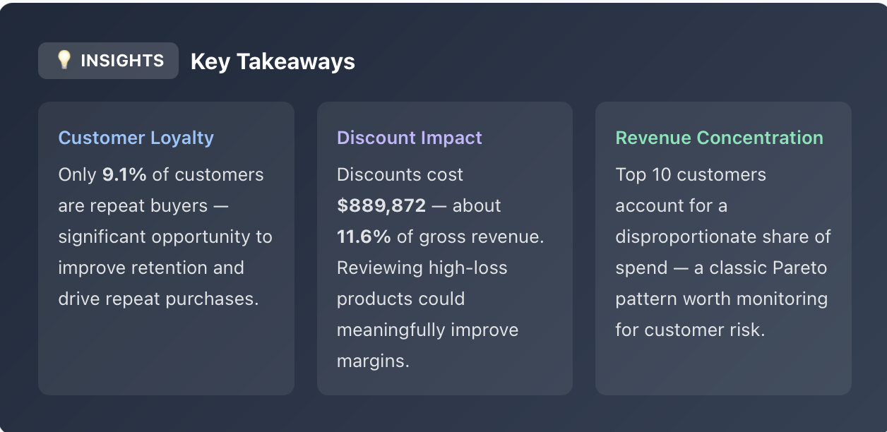
👤 Customer Insights:
- Who are our top 10 customers by total spend?
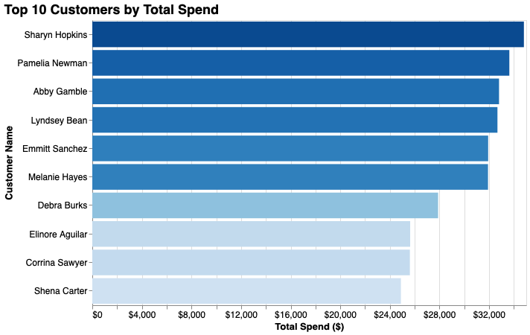

- How many customers have placed more than one order (repeat customers vs. one-time buyers)?
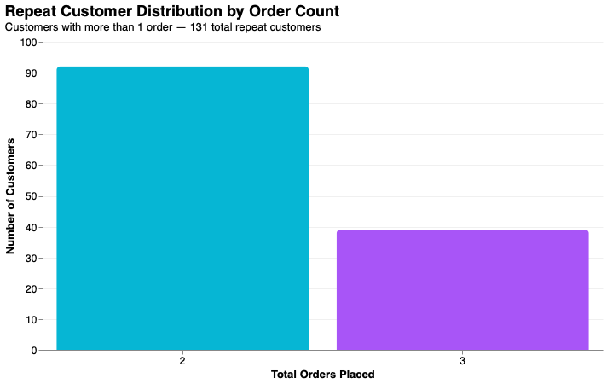

- Which states or cities have the highest concentration of customers and orders?
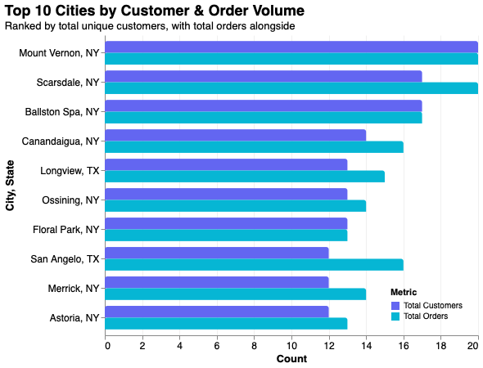
- What percentage of customers have never placed an order?
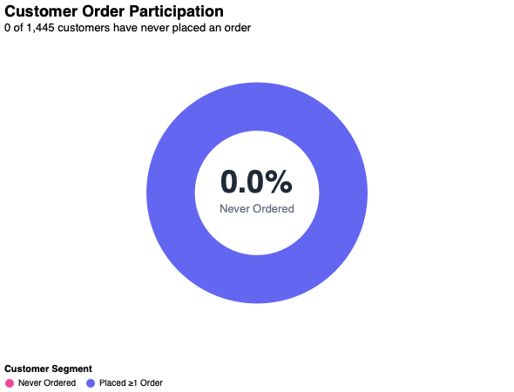
💰 Revenue & Sales:
- What is the total revenue generated, and how has it trended month-over-month?

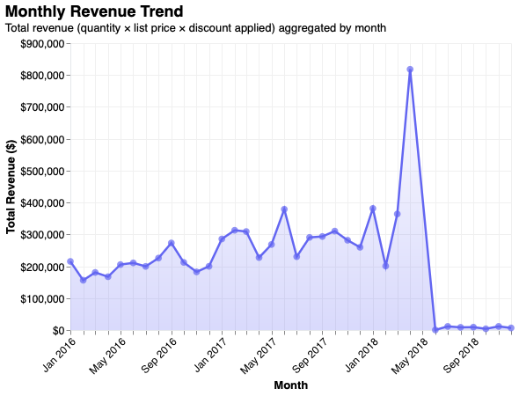
- Which products (by product_id) generate the most revenue?
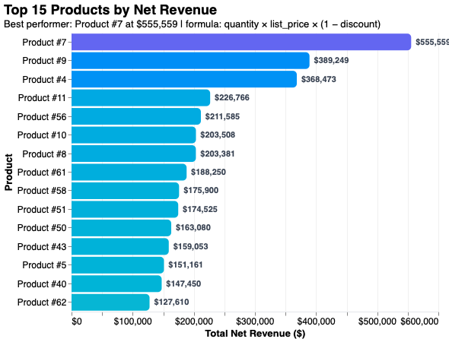
- How much revenue is lost due to discounts, and which products have the highest discount rates?
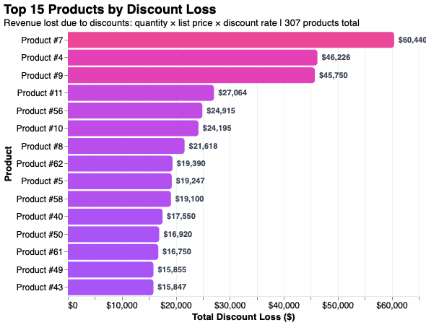
🛒 Product & Basket Analysis:
- What is the average number of items per order?
