Group 02 - Skin Cancer

Leonie Thomas, Isabel Potthof, Elif Tosun and Marlene Khin

21.07.2019

# **Preparations**

## 1.Loading following packages

library(ggplot2)  
library(relaimpo)  
library(factoextra)  
library(gridExtra)  
library(reshape2)  
library(data.table)  
library(cluster)  
library(rstudioapi)  
library(pheatmap)  
library(caret)  
library(tidyverse)  
library(dendextend)  
library(factoextra)  
library(devtools)  
library(ggfortify)  
library(rstudioapi)   
library(data.table)   
library(ggplot2)   
library(scales)   
library(stats)  
library(caTools)

## 2. Setting the sys-path and loading the data

The sys-path was used in R, but markdown could not knit it so the data was loaded as explained in step 3.

root.dir = dirname(rstudioapi::getSourceEditorContext()$path)  
data = readRDS(paste0(root.dir, "/DepMap19Q1_allData.RDS"))

## 3. Loading the data set

data = readRDS("C:/Users/LeoTh/Documents/GitHub/project-01-group-02/DepMap19Q1_allData.RDS")  
data$expression[1:10,1:5]

## ACH-000004 ACH-000005 ACH-000007 ACH-000009 ACH-000011  
## TSPAN6 2.6158871 3.0669502 4.06608919 6.50795317 4.5777309  
## TNMD 0.0000000 0.0000000 0.00000000 0.09761080 0.0000000  
## DPM1 5.3233701 5.7626146 5.88996020 7.98162436 5.5357419  
## SCYL3 2.4059924 2.9927684 3.04963077 2.24792751 2.0874628  
## C1orf112 3.9020736 5.3596617 3.76022095 4.49121176 2.6461627  
## FGR 0.9259994 0.2387869 0.02856915 0.00000000 0.0000000  
## CFH 4.8889867 5.7001623 0.01435529 0.02856915 0.3561438  
## FUCA2 3.8962718 4.1432301 5.56193706 7.08852326 5.5251293  
## GCLC 4.8359241 5.3805909 4.97407037 5.72737594 4.3540289  
## NFYA 4.9868660 5.3391374 3.99004722 4.63343121 3.1554254

data$copynumber[1:10,1:5]

## ACH-000004 ACH-000005 ACH-000007 ACH-000009 ACH-000011  
## A1BG 0.4322 0.265953 -0.041971 -0.0352 0.131139  
## NAT2 0.1197 0.215723 -0.043539 -0.0768 -0.332231  
## ADA -0.3483 -0.389113 -0.031292 1.0902 0.185270  
## CDH2 0.1071 0.100735 -0.064250 -0.8614 -0.322219  
## AKT3 0.1191 0.163029 0.541094 0.0862 0.284791  
## GAGE12F 0.0375 -1.197690 -29.958527 0.4590 -0.299359  
## ZBTB11-AS1 0.1022 0.164588 -0.036427 -0.0351 -0.360381  
## MED6 -0.3972 -0.381579 -0.069094 -0.3454 -0.350737  
## NR2E3 0.1294 0.228166 -0.050321 -0.3594 0.196947  
## NAALAD2 0.1385 0.194863 -0.051092 0.9784 -0.375141

data$kd.ceres[1:10,1:5]

## ACH-000004 ACH-000005 ACH-000007 ACH-000009 ACH-000011  
## A1BG 0.13464536 -0.21244506 0.043317923 0.070512000 0.1909349984  
## A1CF 0.07553627 0.23312358 0.066837574 0.008429764 0.0839524066  
## A2M -0.14020860 0.04436493 -0.036196515 0.027114196 -0.0007407878  
## A2ML1 0.01392843 0.17383724 0.134781001 0.055926773 0.3533751560  
## A3GALT2 0.02913103 -0.12438932 0.082995584 0.046325389 -0.0370438478  
## A4GALT -0.14728384 -0.29884901 0.119084008 0.015968267 -0.2058028668  
## A4GNT 0.27582919 0.12025981 0.057116006 0.053502301 0.0712754121  
## AAAS -0.36363296 -0.33992528 -0.352541473 -0.498860059 -0.3173102098  
## AACS 0.25016463 -0.01130946 -0.005799644 0.110794285 0.0998241033  
## AADAC 0.12974343 0.01565951 0.241488251 0.066921220 0.1055390534

data$kd.prob[1:10,1:5]

## ACH-000004 ACH-000005 ACH-000007 ACH-000009 ACH-000011  
## A1BG 0.0024724805 0.106866767 0.0080037212 0.005476636 1.425907e-03  
## A1CF 0.0061129164 0.002192881 0.0057571355 0.013869531 6.869958e-03  
## A2M 0.0808199476 0.013620180 0.0225154331 0.010608210 2.070112e-02  
## A2ML1 0.0143307481 0.003971270 0.0020673543 0.006886869 9.601914e-05  
## A3GALT2 0.0117268791 0.057068492 0.0045482949 0.007972490 3.171446e-02  
## A4GALT 0.0863246673 0.181176460 0.0026466956 0.012466221 1.576283e-01  
## A4GNT 0.0001951991 0.006674315 0.0066110831 0.007143158 8.184101e-03  
## AAAS 0.3857305749 0.226019789 0.3509659628 0.654158459 3.256387e-01  
## AACS 0.0003231688 0.022459532 0.0154067787 0.002847221 5.510092e-03  
## AADAC 0.0026802343 0.017681919 0.0003347122 0.005807022 5.072046e-03

data$annotation[1:10,1:5]

## DepMap_ID CCLE_Name  
## 4 ACH-000004 HEL_HAEMATOPOIETIC_AND_LYMPHOID_TISSUE  
## 5 ACH-000005 HEL9217_HAEMATOPOIETIC_AND_LYMPHOID_TISSUE  
## 7 ACH-000007 LS513_LARGE_INTESTINE  
## 8 ACH-000009 C2BBE1_LARGE_INTESTINE  
## 10 ACH-000011 253J_URINARY_TRACT  
## 11 ACH-000012 HCC827_LUNG  
## 12 ACH-000013 ONCODG1_OVARY  
## 13 ACH-000014 HS294T_SKIN  
## 14 ACH-000015 NCIH1581_LUNG  
## 16 ACH-000017 SKBR3_BREAST  
## Aliases Primary.Disease  
## 4 HEL Leukemia  
## 5 HEL 92.1.7 Leukemia  
## 7 LS513 Colon/Colorectal Cancer  
## 8 C2BBe1 Colon/Colorectal Cancer  
## 10 253J Bladder Cancer  
## 11 HCC827 Lung Cancer  
## 12 ONCO-DG-1 Ovarian Cancer  
## 13 Hs 294T;A101D;Hs 294.T Skin Cancer  
## 14 NCI-H1581;NCI-H2077 Lung Cancer  
## 16 SK-BR-3 Breast Cancer  
## Subtype.Disease  
## 4 Acute Myelogenous Leukemia (AML), M6 (Erythroleukemia)  
## 5 Acute Myelogenous Leukemia (AML), M6 (Erythroleukemia)  
## 7 Colon Carcinoma  
## 8 Colon Adenocarcinoma  
## 10 Carcinoma  
## 11 Non-Small Cell Lung Cancer (NSCLC), Adenocarcinoma  
## 12 Adenocarcinoma  
## 13 Melanoma  
## 14 Non-Small Cell Lung Cancer (NSCLC), Large Cell Carcinoma  
## 16 Carcinoma

data$mutation$`ACH-000004`[1:10,1:5]

## V1 Hugo_Symbol Entrez_Gene_Id NCBI_Build Chromosome  
## 1: 698 RNF207 388591 37 1  
## 2: 699 PLEKHG5 57449 37 1  
## 3: 700 PDPN 10630 37 1  
## 4: 701 CASP9 842 37 1  
## 5: 702 RAP1GAP 5909 37 1  
## 6: 703 C1QC 714 37 1  
## 7: 704 CNKSR1 10256 37 1  
## 8: 705 AHDC1 27245 37 1  
## 9: 706 COL16A1 1307 37 1  
## 10: 707 CSMD2 114784 37 1

# **Part 1: Data cleanup**

## **1.1 Extracting and splitting our data**

Defining a new matrix only containing the mutation data which is structured differently from the other matrices.

mut <- data$mutation

Additionally, to the mutation matrix another matrix is needed containing all matrices except the mutation data.

'%!in%' <- function(x,y)!('%in%'(x,y)) # defining an operator that will only pick the data that is NOT defined in the list; so the data that needs to be excluded  
dt_new <- lapply(which(names(data) %!in% "mutation"), function(a) data[[a]]) # extracting the non-mutation data   
names(dt_new) <- names(data)[which(names(data) %!in% "mutation")] # renaming the data with the original names  
#our data now consists out of 2 lists   
names(dt_new)

## [1] "expression" "copynumber" "kd.ceres" "kd.prob" "annotation"

head(mut[[1]])#just picking one cell line as an example

## V1 Hugo_Symbol Entrez_Gene_Id NCBI_Build Chromosome Start_position  
## 1: 698 RNF207 388591 37 1 6279339  
## 2: 699 PLEKHG5 57449 37 1 6533165  
## 3: 700 PDPN 10630 37 1 13940848  
## 4: 701 CASP9 842 37 1 15819484  
## 5: 702 RAP1GAP 5909 37 1 21924552  
## 6: 703 C1QC 714 37 1 22974054  
## End_position Strand Variant_Classification Variant_Type  
## 1: 6279339 + Missense_Mutation SNP  
## 2: 6533165 + Missense_Mutation SNP  
## 3: 13940848 + Missense_Mutation SNP  
## 4: 15819484 + Missense_Mutation SNP  
## 5: 21924552 + Missense_Mutation SNP  
## 6: 22974054 + Silent SNP  
## Reference_Allele Tumor_Seq_Allele1 dbSNP_RS dbSNP_Val_Status  
## 1: G C   
## 2: G A rs373198302   
## 3: A G   
## 4: C G   
## 5: A T <NA> <NA>  
## 6: G C rs369658525   
## Genome_Change Annotation_Transcript Tumor_Sample_Barcode  
## 1: g.chr1:6279339G>C ENST00000377939.4 ACH-000004  
## 2: g.chr1:6533165G>A ENST00000400915.3 ACH-000004  
## 3: g.chr1:13940848A>G ENST00000509009.1 ACH-000004  
## 4: g.chr1:15819484C>G ENST00000333868.5 ACH-000004  
## 5: g.chr1:21924552A>T ENST00000374765.4 ACH-000004  
## 6: g.chr1:22974054G>C ENST00000374639.3 ACH-000004  
## cDNA_Change Codon_Change Protein_Change isDeleterious  
## 1: c.1777G>C c.(1777-1779)Gag>Cag p.E593Q FALSE  
## 2: c.1033C>T c.(1033-1035)Ccc>Tcc p.P345S FALSE  
## 3: c.409A>G c.(409-411)Atc>Gtc p.I137V FALSE  
## 4: c.1205G>C c.(1204-1206)gGt>gCt p.G402A FALSE  
## 5: c.1885T>A c.(1885-1887)Tct>Act p.S629T FALSE  
## 6: c.516G>C c.(514-516)gcG>gcC p.A172A FALSE  
## isTCGAhotspot TCGAhsCnt isCOSMIChotspot COSMIChsCnt ExAC_AF VA_WES_AC  
## 1: FALSE 0 FALSE 0 NA <NA>  
## 2: FALSE 0 FALSE 0 4.942e-05 <NA>  
## 3: FALSE 0 FALSE 0 NA <NA>  
## 4: FALSE 0 FALSE 0 NA <NA>  
## 5: FALSE 0 FALSE 0 NA <NA>  
## 6: FALSE 0 FALSE 0 4.118e-05 <NA>  
## CGA_WES_AC SangerWES_AC SangerRecalibWES_AC RNAseq_AC HC_AC RD_AC  
## 1: <NA> <NA> 72:69 <NA> <NA> <NA>  
## 2: <NA> <NA> 43:41 <NA> <NA> <NA>  
## 3: <NA> <NA> 52:64 <NA> <NA> <NA>  
## 4: <NA> <NA> 32:162 27:58 26:121 <NA>  
## 5: <NA> <NA> 7:8 22:13 <NA> <NA>  
## 6: <NA> <NA> 49:58 <NA> <NA> <NA>  
## WGS_AC Variant_annotation DepMap_ID  
## 1: <NA> other non-conserving ACH-000004  
## 2: <NA> other non-conserving ACH-000004  
## 3: <NA> other non-conserving ACH-000004  
## 4: <NA> other non-conserving ACH-000004  
## 5: <NA> other non-conserving ACH-000004  
## 6: <NA> silent ACH-000004

The next step is to extract the cell lines of the skin cancer. For that we need to get to know the names of the cell lines from the skin cancer, this information we can get out of the annotation dataframe. Then we can create a new dataframe which only contains the data we will work with.

Defining which samples will be taken out of the original dataset.

sample_case = c("Skin Cancer")

Looking at the annotation matrix and searching only for the primary diseases matching the previous defined sample_case. A vector containing all the cell lines with skin cancer as the primary disease is obtained.

samples = data$annotation$DepMap_ID[which(data$annotation$Primary.Disease == sample_case)]

34 cell lines have the primary disease skin cancer.

Extracting all cell lines defined in the previous step out of the data (except the mutation matrix).

processed_data <- lapply(1:length(dt_new), function(a) { # picking the data for our sample   
 dat_picker <- dt_new[[a]] # picking one file at each iteration   
 if(names(dt_new[a])== "annotation"){ # treating the annotations differnetly because the cell line names are in a colum and are not the columnames like in the other matrices  
 output <- dat_picker[which(dat_picker[,1] %in% samples),]  
 } else {  
 output <- dat_picker[,which(colnames(dat_picker) %in% samples)]# only taking the skin cancer cell lines   
 output <- output[complete.cases(output),] # only taking rows without NAs   
 output <- output[order(rownames(output)),] # reordering the genes according to their name  
 }  
 return(output)  
})  
names(processed_data) <- names(dt_new) # renameing the objects according to the original data  
rm(dt_new,sample_case) # removing objects which are not need anymore  
#taking a look at the data:   
processed_data$expression[1:10,1:5]

## ACH-000014 ACH-000274 ACH-000304 ACH-000322 ACH-000348  
## 7SK 0.32996228 0.12548079 0.00000000 0.00000000 0.61939343  
## A1BG 6.08661395 0.79908731 5.21179100 5.24716800 5.67694436  
## A1BG-AS1 4.33771109 0.34482850 3.82273000 3.76234882 3.92979100  
## A1CF 0.05658353 0.08406426 0.01435529 0.04264434 0.00000000  
## A2M 6.14425036 7.95006009 6.83605000 6.00360224 4.62993941  
## A2M-AS1 0.50589093 1.12432814 0.46466830 0.46466827 0.28688115  
## A2ML1 0.23878686 0.01435529 0.00000000 0.00000000 0.01435529  
## A2ML1-AS1 0.00000000 0.00000000 0.00000000 0.00000000 0.00000000  
## A2ML1-AS2 0.00000000 0.00000000 0.00000000 0.00000000 0.00000000  
## A2MP1 0.04264434 0.01435529 0.00000000 0.01435529 0.00000000

processed_data$copynumber[1:10,1:5]

## ACH-000014 ACH-000274 ACH-000304 ACH-000322 ACH-000348  
## A1BG 0.0989 -0.097469 0.0184 0.0536 0.2243  
## A1BG-AS1 0.0989 -0.097469 0.0184 0.0536 0.2243  
## A1CF -0.3120 0.005770 -0.9286 -0.3620 -0.2004  
## A2M 0.1110 0.014809 0.0080 0.0876 -0.1028  
## A2M-AS1 0.1110 0.014809 0.0080 0.1893 -0.1028  
## A2ML1 0.1110 0.014809 0.0080 0.1893 -0.1028  
## A2MP1 0.1110 0.014809 0.0080 0.0876 -0.1028  
## A4GALT 0.0580 -0.011931 0.0359 0.2368 -0.1255  
## A4GNT 0.0961 -0.001092 0.0207 0.4689 0.2784  
## AA06 0.0823 0.017090 0.0315 0.1839 -0.1232

processed_data$kd.ceres[1:10,1:5]

## ACH-000014 ACH-000274 ACH-000304 ACH-000322 ACH-000348  
## A1BG 0.112978995 0.09000078 0.123999117 0.17552003 0.05979116  
## A1CF -0.035332501 0.13896177 0.274438862 0.08205882 0.07506780  
## A2M 0.028806113 -0.07116082 -0.201401893 0.01866713 -0.05790399  
## A2ML1 0.169333904 0.10695957 0.291635816 0.20971252 0.09614451  
## A3GALT2 -0.003591934 -0.09866711 -0.056745475 -0.37374191 -0.07849708  
## A4GALT -0.084698165 -0.11183837 -0.164706825 0.07185597 -0.05414073  
## A4GNT -0.117547293 0.03983944 -0.005448509 -0.01545300 0.07601372  
## AAAS -0.371033490 -0.41828686 -0.195925758 -0.28411957 -0.32252314  
## AACS -0.045406257 0.02847436 -0.097559375 -0.08118755 -0.01892812  
## AADAC 0.138287975 0.16723110 0.147066204 0.38636762 0.04059718

processed_data$kd.prob[1:10,1:5]

## ACH-000014 ACH-000274 ACH-000304 ACH-000322 ACH-000348  
## A1BG 0.002774072 0.004409101 0.002713543 9.701586e-04 0.006625887  
## A1CF 0.023529328 0.002004631 0.000372957 4.262132e-03 0.005132902  
## A2M 0.009873198 0.039221771 0.103075053 1.047207e-02 0.037397252  
## A2ML1 0.001095265 0.003375634 0.000306326 5.420935e-04 0.003550176  
## A3GALT2 0.015498205 0.053319884 0.025767742 3.809270e-01 0.048325382  
## A4GALT 0.042860321 0.061256566 0.075245128 4.955556e-03 0.035654746  
## A4GNT 0.061754873 0.009330674 0.014367402 1.639439e-02 0.005049978  
## AAAS 0.417853626 0.491584887 0.098458357 2.246814e-01 0.386247431  
## AACS 0.026723760 0.010955990 0.039643561 3.609931e-02 0.022159161  
## AADAC 0.001837255 0.001242681 0.001980259 1.917526e-05 0.009061951

processed_data$annotation[1:10,1:5]

## DepMap_ID CCLE_Name Aliases Primary.Disease  
## 13 ACH-000014 HS294T_SKIN Hs 294T;A101D;Hs 294.T Skin Cancer  
## 269 ACH-000274 HS852T_SKIN Hs 852.T Skin Cancer  
## 299 ACH-000304 WM115_SKIN WM-115 Skin Cancer  
## 317 ACH-000322 HT144_SKIN HT-144 Skin Cancer  
## 343 ACH-000348 RPMI7951_SKIN RPMI-7951 Skin Cancer  
## 393 ACH-000401 COLO800_SKIN COLO-800 Skin Cancer  
## 396 ACH-000404 K029AX_SKIN K029AX Skin Cancer  
## 418 ACH-000425 UACC62_SKIN UACC-62 Skin Cancer  
## 443 ACH-000450 MELHO_SKIN MEL-HO Skin Cancer  
## 451 ACH-000458 CJM_SKIN CJM Skin Cancer  
## Subtype.Disease  
## 13 Melanoma  
## 269 Melanoma  
## 299 Melanoma  
## 317 Melanoma  
## 343 Melanoma  
## 393 Melanoma  
## 396 Melanoma  
## 418 Melanoma  
## 443 Melanoma  
## 451 Melanoma

processed_data$mutation$`ACH-000004`[1:10,1:5]

## NULL

Extracting the previously defined cell lines from the mutation data.

ids = which(names(mut) %in% samples)   
allDepMap_mutation_SkinCancer = lapply(ids, function(a) {  
 mut[[a]]})  
rm(mut, ids, data) #tidying

Losing the mutations which are not deleterious meaning not interesting to us.

allDepMap_mutation_SkinCancer = lapply(1:34, function(a) {  
 allDepMap_mutation_SkinCancer[[a]][which(allDepMap_mutation_SkinCancer[[a]][,"isDeleterious"]== TRUE), ]  
 })  
names(allDepMap_mutation_SkinCancer) <- samples

Losing all genes which are not in every data frame. First, all gene names have to be picked out of the data.

Genenames <- unique(c(rownames(processed_data[[1]]),rownames(processed_data[[2]]),rownames(processed_data[[3]]),rownames(processed_data[[4]])))

Then picking these genes which are in all 4 data frames which are needed for further analysis.

i <- 1  
out <- vector("character", length(seq_along(1:16970)))# length of the matrix depending on how many Genes we have which are in every data frame  
for (x in seq_along(Genenames)) {  
 if(Genenames[x] %in% rownames(processed_data$expression) & Genenames[x] %in% rownames(processed_data$copynumber) & Genenames[x] %in% rownames(processed_data$kd.ceres) & Genenames[x] %in% rownames(processed_data$kd.prob))  
 {out[i] <- Genenames[x]  
 i <- i+1  
 }   
}  
  
allDepMap_annotation_SkinCancer <- processed_data$annotation # saving the annotation object in a seperate dataframe  
# because it doesnt contain any information about the genes   
  
processed_data <- lapply(processed_data[1:4], function(a) {  
 a <- a[which(rownames(a) %in% out),]  
 return(a)  
})  
  
processed_data$mutation <- allDepMap_mutation_SkinCancer  
processed_data$annotation <- allDepMap_annotation_SkinCancer  
rm(i,out, Genenames,x, allDepMap_annotation_SkinCancer, samples, allDepMap_mutation_SkinCancer)

Looking at the processed data.

processed_data$expression[1:10,1:5]

## ACH-000014 ACH-000274 ACH-000304 ACH-000322 ACH-000348  
## A1BG 6.08661395 0.79908731 5.21179100 5.24716800 5.67694436  
## A1CF 0.05658353 0.08406426 0.01435529 0.04264434 0.00000000  
## A2M 6.14425036 7.95006009 6.83605000 6.00360224 4.62993941  
## A2ML1 0.23878686 0.01435529 0.00000000 0.00000000 0.01435529  
## A4GALT 0.97819563 0.02856915 0.12432810 0.98550043 3.09592442  
## A4GNT 0.07038933 0.11103131 0.00000000 0.04264434 0.09761080  
## AAAS 5.97613447 5.61087720 5.55642900 5.72737594 5.85424505  
## AACS 5.13463167 5.08788710 4.21645500 4.14241344 4.17552460  
## AADAC 0.01435529 0.21412481 0.05658353 0.07038933 0.33342373  
## AADACL2 0.02856915 0.00000000 0.00000000 0.00000000 0.02856915

processed_data$copynumber[1:10,1:5]

## ACH-000014 ACH-000274 ACH-000304 ACH-000322 ACH-000348  
## A1BG 0.0989 -0.097469 0.0184 0.0536 0.2243  
## A1CF -0.3120 0.005770 -0.9286 -0.3620 -0.2004  
## A2M 0.1110 0.014809 0.0080 0.0876 -0.1028  
## A2ML1 0.1110 0.014809 0.0080 0.1893 -0.1028  
## A4GALT 0.0580 -0.011931 0.0359 0.2368 -0.1255  
## A4GNT 0.0961 -0.001092 0.0207 0.4689 0.2784  
## AAAS 0.1107 0.014809 0.0115 -0.0250 -0.1559  
## AACS 0.1120 0.014809 0.0340 0.0906 -0.1817  
## AADAC 0.0768 0.015465 0.0304 0.4689 0.2784  
## AADACL2 0.0768 0.015465 0.0304 0.4689 0.2784

processed_data$kd.ceres[1:10,1:5]

## ACH-000014 ACH-000274 ACH-000304 ACH-000322 ACH-000348  
## A1BG 0.11297899 0.09000078 0.123999117 0.17552003 0.05979116  
## A1CF -0.03533250 0.13896177 0.274438862 0.08205882 0.07506780  
## A2M 0.02880611 -0.07116082 -0.201401893 0.01866713 -0.05790399  
## A2ML1 0.16933390 0.10695957 0.291635816 0.20971252 0.09614451  
## A4GALT -0.08469817 -0.11183837 -0.164706825 0.07185597 -0.05414073  
## A4GNT -0.11754729 0.03983944 -0.005448509 -0.01545300 0.07601372  
## AAAS -0.37103349 -0.41828686 -0.195925758 -0.28411957 -0.32252314  
## AACS -0.04540626 0.02847436 -0.097559375 -0.08118755 -0.01892812  
## AADAC 0.13828797 0.16723110 0.147066204 0.38636762 0.04059718  
## AADACL2 0.07158946 0.08736997 0.084883216 0.23972258 0.09690599

processed_data$kd.prob[1:10,1:5]

## ACH-000014 ACH-000274 ACH-000304 ACH-000322 ACH-000348  
## A1BG 0.002774072 0.004409101 0.002713543 9.701586e-04 0.006625887  
## A1CF 0.023529328 0.002004631 0.000372957 4.262132e-03 0.005132902  
## A2M 0.009873198 0.039221771 0.103075053 1.047207e-02 0.037397252  
## A2ML1 0.001095265 0.003375634 0.000306326 5.420935e-04 0.003550176  
## A4GALT 0.042860321 0.061256566 0.075245128 4.955556e-03 0.035654746  
## A4GNT 0.061754873 0.009330674 0.014367402 1.639439e-02 0.005049978  
## AAAS 0.417853626 0.491584887 0.098458357 2.246814e-01 0.386247431  
## AACS 0.026723760 0.010955990 0.039643561 3.609931e-02 0.022159161  
## AADAC 0.001837255 0.001242681 0.001980259 1.917526e-05 0.009061951  
## AADACL2 0.005275945 0.004588671 0.004600816 3.200669e-04 0.003501290

processed_data$annotation[1:10,1:5]

## DepMap_ID CCLE_Name Aliases Primary.Disease  
## 13 ACH-000014 HS294T_SKIN Hs 294T;A101D;Hs 294.T Skin Cancer  
## 269 ACH-000274 HS852T_SKIN Hs 852.T Skin Cancer  
## 299 ACH-000304 WM115_SKIN WM-115 Skin Cancer  
## 317 ACH-000322 HT144_SKIN HT-144 Skin Cancer  
## 343 ACH-000348 RPMI7951_SKIN RPMI-7951 Skin Cancer  
## 393 ACH-000401 COLO800_SKIN COLO-800 Skin Cancer  
## 396 ACH-000404 K029AX_SKIN K029AX Skin Cancer  
## 418 ACH-000425 UACC62_SKIN UACC-62 Skin Cancer  
## 443 ACH-000450 MELHO_SKIN MEL-HO Skin Cancer  
## 451 ACH-000458 CJM_SKIN CJM Skin Cancer  
## Subtype.Disease  
## 13 Melanoma  
## 269 Melanoma  
## 299 Melanoma  
## 317 Melanoma  
## 343 Melanoma  
## 393 Melanoma  
## 396 Melanoma  
## 418 Melanoma  
## 443 Melanoma  
## 451 Melanoma

processed_data$mutation$`ACH-000004`[1:10,1:5]

## NULL

# **Part 2: Data visualisation**

## **2.1 Preparing our data for plotting**

### **2.1.1 Extracting our data for plotting**

Not all the data is needed for plotting so the data is prepared for the following plots.

generalPlottingData <- lapply(1:(length(processed_data)-2), function(a) { # the annotation matrix is not needed  
 dtPicker <- processed_data[[a]]  
 out <- melt(dtPicker) # binding the data togehter that it has samples and values as columns  
 out$Gene <- rep(rownames(dtPicker), ncol(dtPicker)) # adding the genes; probably this might be useful in a later stage  
 out$Case <- names(processed_data)[1:(length(processed_data)-1)][a]# adding a labelling column  
 colnames(out) <- c("Sample", "Value", "Gene", "Case") # renameing the columns  
 return(out)  
})

## No id variables; using all as measure variables  
## No id variables; using all as measure variables  
## No id variables; using all as measure variables  
## No id variables; using all as measure variables

names(generalPlottingData) <- names(processed_data)[1:(length(processed_data)-2)] # renameing the data

### **2.1.2 Plotting Data - Driver Mutations**

Producing a vector encompasing every gene which at least mutated once.

singleGenes <- as.vector(unique(as.data.frame(rbindlist(lapply(seq_along(processed_data$mutation), function(a) {  
 out <- as.data.frame(as.vector(unique(processed_data$mutation[[a]]$Hugo_Symbol)))}))))[,1])

Creating a data frame containing the mutation rate of every gene.

geneCounts <- sapply(seq_along(singleGenes), function(a) {  
 genePicker <- singleGenes[a] # picking one gene  
 sumGene <- lapply(seq_along(processed_data$mutation), function(b) {  
 mutPicker <- processed_data$mutation[[b]] # picking one of the 34 mutation lists  
 out <- as.data.frame(length(which(mutPicker$Hugo_Symbol == genePicker))) # looking how often an entry is in the mutation list  
 return(out)  
 })  
 geneCount <- colSums(as.data.frame(rbindlist(sumGene))) # summing it up to get the total count for each gene  
 return(geneCount)  
})  
names(geneCounts) <- singleGenes # renameing   
geneCounts <- as.data.frame(geneCounts) # creating a nice data frame  
colnames(geneCounts) <- c("Value")  
geneCounts <- geneCounts[order(-geneCounts$Value), , drop = FALSE] # sorting the data frame  
head(geneCounts)

## Value  
## TTN 13  
## TP53 9  
## HMCN1 8  
## TMTC2 7  
## RYR2 7  
## CACNA1I 7

Extacting the data for the top 10 which will be our driver mutations in the further investigation.

dataTopDriverGenes <- lapply(1:(length(processed_data)-2), function(a) { # picking the data for our sample   
 dat_picker <- processed_data[[a]] # picking one file at each iteration   
 output <- dat_picker[which(rownames(dat_picker) %in% rownames(geneCounts)[1:10]),] # comparing the rownames of the picked data with the names of the 10 most mutated genes  
 return(output)  
})  
names(dataTopDriverGenes) <- names(processed_data)[1:4]  
  
rm(singleGenes)

### **2.1.3 Extracting the drivermutations for every cell line**

Putting all mutation data in one matrix.

oneMatrix <- data.frame()  
for (i in c(1:34)) { # 34 is the number of cell lines of interest  
 oneMatrix <- rbind(oneMatrix,processed_data$mutation[[i]][,Hugo_Symbol:DepMap_ID])  
}

Extracting just the column of the gene name and the cell line.

celllinesMutations <- oneMatrix[which(oneMatrix$Hugo_Symbol %in% rownames(geneCounts)[1:10] ),]  
celllinesMutations <- cbind(celllinesMutations$Hugo_Symbol, celllinesMutations$DepMap_ID)  
View(celllinesMutations)

Extracting the drivermuations for every cell line out of the data frame and putting it into another data frame so it can be used for plotting.

Genes <- c("COL11A1,TMTC2,TTN", " HMCN1", "COL11A1,HMCN1,SLC510", "HMCN1,TMTC2", "COL11A1,TP53,TTN","none","ZNF292","RYR2","HMCN" ,"none2","none3", "TP53, TTN","HMCN1", "TTN,ZNF292","TMTC2,TP53,NEB","TP53", "TMTC2,NEB","none4","TMTC2,TTN,ZNF292", "none5","CACNA1I","HMCN1,TP53,ZNF292","none6","none7","HMCN1,TMTC2,ZNF292","RYR2,TMTC2,NEB","RYR2,NEB,TTN,CACNA1I","HMCM1,TP53","TTN","COL11A1,SLC5A10","COL11A1,CACNA1I","TTN,CACNA1I","RYR2,CACNA1I,ZNF292","TP53,TTN,CACNA1I" )  
celllines <- c(colnames(processed_data$expression))  
cellinesMutations <- as.data.frame(cbind(celllines, Genes))  
  
rm(oneMatrix, Genes,celllines,i)

The explanation for the previous extraction will be outlined in the following visualization part.

## **2.2 Visualizing our data**

### **2.2.1 Heatmap with the knock down data**

Starting with a heatmap of the knock down data (the kd.ceres matrix). This matrix consists of gene knockdown scores. The impact of the knocked out gene on the cell survival is reflected by that score. The impact can be a reduction or an increase in proliferation. It could also mean that there is no change in cell proliferation at all. Smaller values refer to higher importance. Useing only the first 50 genes because otherwise the computer was overchallenged and could not produce the heatmap.

pheatmap(as.matrix(processed_data$kd.ceres[1:50,]), clustering_method = "ward.D2",border_color = "white", fontsize = 8,   
 main = paste0("kdCERES for potential 2nd site targets"),  
 show_rownames = F, show_colnames = T,  
 cutree_rows = 4,  
 cutree_cols = 2,   
 fontsize_row=8)

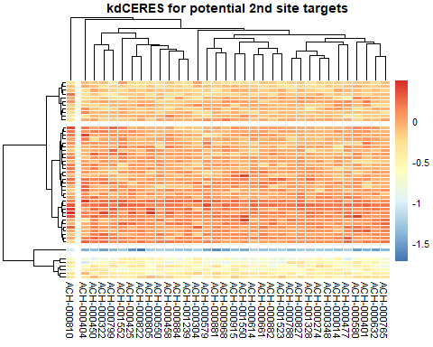

* *There are clear differences between the knockdown data depending on the knocked out gene in a specific cell line.*
* *The cell lines behave differently when the same gene is knocked out.*
* *This means there are genes that are important for cell proliferation and could play a role in cancer development.*

### **2.2.2 Distribution of the expression values between the different cell lines**

Creating a boxplot with the expression matrix to see how the expression of the genes is distributed over the different cell lines.

data <- generalPlottingData$expression  
  
ggplot(data, aes(x=Sample, y= Value)) +  
 geom_boxplot(aes(fill = Sample), outlier.size = 0.1, outlier.alpha = 0.2) + # reconstructing the outliers a bit (reduce them in size; because we are interested in the boxplots and not the outliers)  
 theme_bw(base_size = 7) + # formating the size of the theme nicely  
 theme(legend.position= "none", # defining the legend position (here no leghend will be needed)  
 legend.direction="horizontal", #define the legend direction if one is there  
 plot.title = element_text(hjust = 0.5), # making the title of the plot into the middle  
 axis.text.x = element_text(angle = 90, vjust = 0.5, hjust=1), # defining the orientation of the text on the x-axis  
 legend.title= element_blank(), # no title of the legend should be plotted  
 axis.title.x = element_blank(), # no title of the x-axis is relevant; because that would be samples and that is cleare due to the naming  
 strip.text.y = element_text(angle = 90)) # defining the orientation of the text of the y-axis

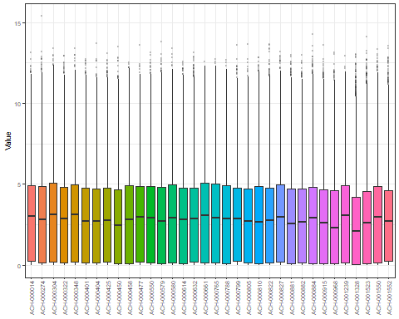

* *Many genes are distributed between the 25 and 75 quantile. But there are also some outliers which are of special interest in the following data analysis.*
* *For now we can say that the data is differnetly distributed between the celllines based on different mutations in the different cell lines.*

### **2.2.3 Top 10 mutated genes**

In the Data extraction part we extracted the genecounts for every mutation. Firstly we want to take a general look at the distribution of the mutation number of every gene over all cell lines:

plotData <- geneCounts  
  
plotData$Gene <- rownames(plotData)  
  
ggplot(data = plotData) +  
 (geom_bar(mapping = aes(x = Gene, y = Value), stat = "identity")) +  
 theme_bw(base_size = 7) + # formating the size of the theme nicely  
 theme(legend.position= "none", # defining the legend position (here no legend will be needed)  
 legend.direction="horizontal", # defining the legend direction if one is there  
 plot.title = element_text(hjust = 0.5), # making the title of the plot into the middle  
 axis.text.x = element_blank(), # defining the orientation of the text on the x-axis  
 axis.text.y = element_text(angle = 90, vjust = 0.5, hjust=1, size = 10), # defining the orientation of the text on the x-axis  
 legend.title= element_blank(), # no title of the legend should be plotted  
 axis.title.x = element_blank(), # no title of the x-axis is relevant; because that would be samples and that is cleare due to the naming  
 strip.text.y = element_text(angle = 90)) # defining the orientation of the text of the y-axis

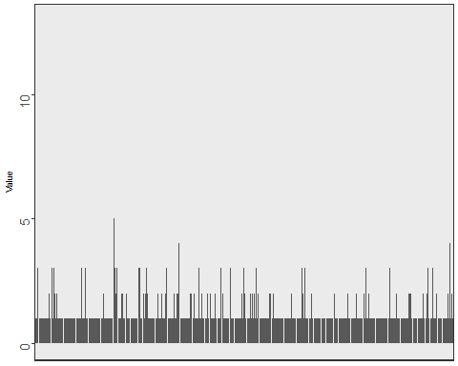

rm(plotData)

Now we want to see which mutations are the top 10 mutated genes.

plotData <- geneCounts[1:10, ,drop = FALSE]  
  
plotData$Gene <- rownames(plotData)  
  
ggplot(data = plotData) +  
 (geom_bar(mapping = aes(x = Gene, y = Value), stat = "identity")) +  
 theme_bw(base_size = 7) + # formating the size of the theme nicely  
 theme(legend.position= "none", # defining the legend position (here no legend will be needed)  
 legend.direction="horizontal", # defining the legend direction if one is there  
 plot.title = element_text(hjust = 0.5), # making the title of the plot into the middle  
 axis.text.x = element_text(angle = 90, vjust = 0.5, hjust=1, size = 10), # defining the orientation of the text on the x-axis  
 axis.text.y = element_text(angle = 90, vjust = 0.5, hjust=1, size = 10), # defining the orientation of the text on the x-axis  
 legend.title= element_blank(), # no title of the legend should be plotted  
 axis.title.x = element_blank(), # no title of the x-axis is relevant; because that would be samples and that is cleare due to the naming  
 strip.text.y = element_text(angle = 90)) # defining the orientation of the text of the y-axis

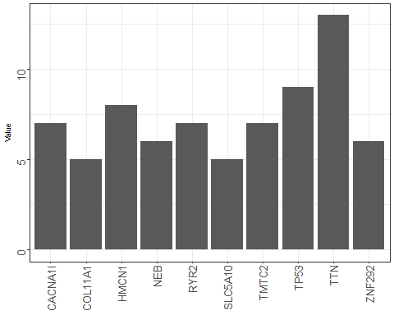

rm(plotData)

* *The expected driver mutations are BRAF, RAS, NF1 and Triple-WT, because they are specific for cutaneous melanoma (1).*
* *The barplot does not mention any of the expected ones, so in the end an analysis of the biological background is needed.*

# **3. Dimensionality reduction**

General questions:

* Can we group the different driver mutations together so that we can see in which other genes the cell lines with a specific driver mutation differentiate?
* With Dimnsionality reduction we could gain insight which other genes are our secound targets.

## **3.1 Hierachical clustering**

Creating a hierachical cluster with our driver mutations.

drivergene <- 3   
# determines which of the driver mutations will be seen in the cluster at the x axis  
dataset <- processed_data$expression # determines which dataset we use  
  
colnames(dataset)[which(colnames(dataset) %in% unique(celllinesMutations[which(celllinesMutations[,1] == rownames(geneCounts)[drivergene]),2]))] <- rownames(geneCounts)[drivergene]   
# setting the colnames of the cell lines which have the drivermutation entered in the dirvermutation variable , to this drivermutation so we can see if these cell lines cluster together  
# drivermutation 3 is just an example can set every drivergene of interest  
  
  
cor.mat = cor(dataset, method = "spearman")  
cor.dist = as.dist(1 - cor.mat)  
cor.hc = hclust(cor.dist, method = "ward.D2")  
cor.hc = as.dendrogram(cor.hc)  
plot(cor.hc, las = 2, cex.lab = 1, main = "Clustering of the expression values of all cell lines")

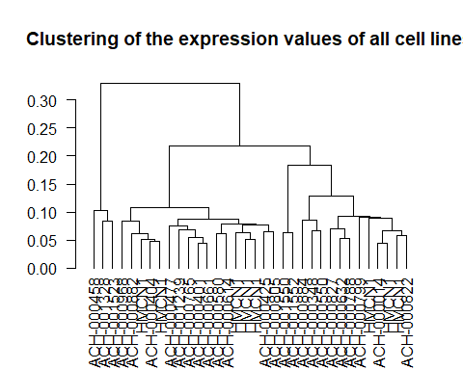

rm(drivergene, realcelllinenames, dataset, cor.hc, cor.mat, cor.dist)

## Warning in rm(drivergene, realcelllinenames, dataset, cor.hc, cor.mat,  
## cor.dist): Objekt 'realcelllinenames' nicht gefunden

## **3.2 K-means**

Performing a k-means to identify the structure of our clusters.

dataset <- t(processed_data$expression[-which(rownames(processed_data$expression) %in% rownames(geneCounts)[1:10]),])   
# determining which dataset we use  
# trying to cluster the cell lines with the same driver mutations in the same cluster according to the   
# expression data without the expression of the driver mutations  
# Searching for the cause of the diffences between the cell lines besides the expression of the driver mutations   
  
rownames(dataset) <- cellinesMutations$Genes  
  
dataset <- dataset[,-which(apply(dataset, 2, function(x) {  
 var(x)  
}) == 0)]

For choosing the best number centers for the clusters the kink method was used.

wss = sapply(1:9, function(k) {  
 kmeans(x = dataset, centers = k)$tot.withinss  
})  
plot(1:9, wss, type = "b", pch = 19, xlab = "Number of clusters K", ylab = "Total within-clusters sum of squares")

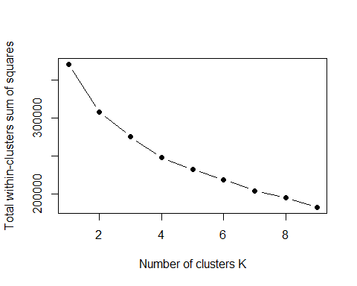

* *But theres no kink in this curve so we need to use other methods to tell us how much centers would be best to choose.*

Now we try the silouette method.

fviz_nbclust(dataset, kmeans, method = "silhouette")

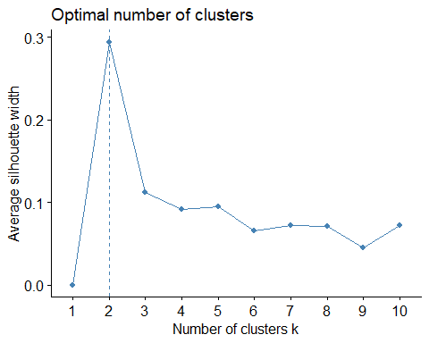

# according to the silhouette method the clustering with two centers seems to be the best one  
  
# taking a look at the clustering with different centers (2, 4, 5, 10)   
km = kmeans(x =dataset, centers = 2, nstart = 100)  
plot(silhouette(km$cluster,dist(dataset)), main = "Silhouette Values for 2 clusters", cex=0.5)

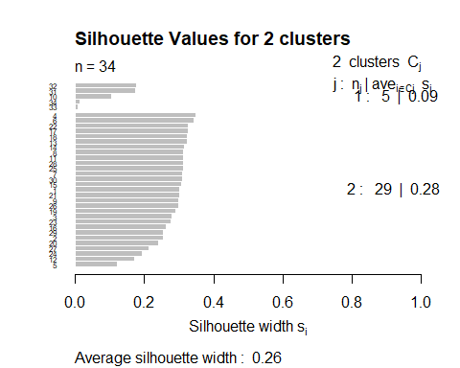

km2 <- kmeans(dataset, centers = 2, nstart = 100)  
km3 <- kmeans(dataset, centers = 5, nstart = 100)  
km4 <- kmeans(dataset, centers = 4, nstart = 100)  
km5 <- kmeans(dataset, centers = 10, nstart = 100)  
  
  
  
p1 <- fviz_cluster(km2,geom = "point", data = dataset) + ggtitle("k = 2")  
p2 <- fviz_cluster(km3, geom = "point", data = dataset) + ggtitle("k = 5")  
p3 <- fviz_cluster(km4, geom = "point", data = dataset) + ggtitle("k = 4")  
p4 <- fviz_cluster(km5, geom = "point", data = dataset) + ggtitle("k = 10")  
  
grid.arrange(p1, p2, p3, p4, nrow = 2)

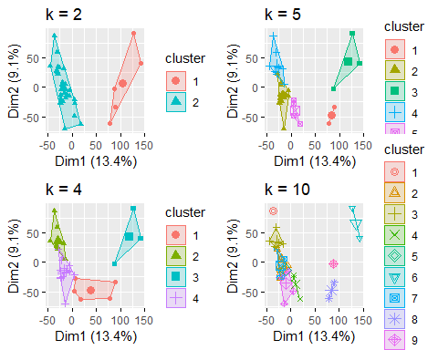

p4 <- fviz_cluster(km5, geom = "text", labelsize = 9, data = dataset) + ggtitle("k = 10")  
plot(p4) # clustering with 10 centers does not conclude in clusters with the same driver mutations

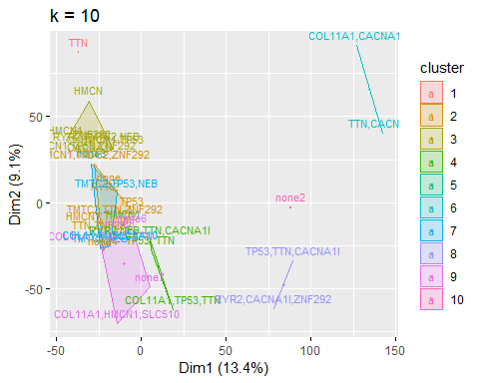

# having more than one driver mutation in most cell lines may cause this  
p1 <- fviz_cluster(km2,geom = "text", labelsize = 9, data = dataset) + ggtitle("k = 2")  
plot(p1)

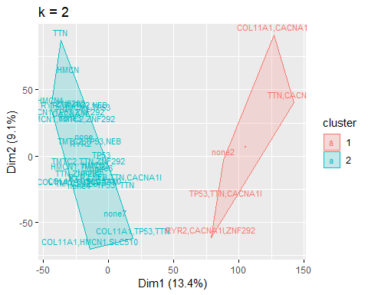

rm(km,km2,km3,km4,km5,p1,p2,p3,p4, dataset,wss)

* *The clustering with two centers seems to be the best one.*
* *Our next step in the pca will be to see which of the genes drive the differentation of the celllines in this plot because they will be the most variable and thus most interesting ones.*

# **3.3 PCA**

Investigating with a principal component analysis why the data clusters together the way it does. Looking at the first two principal components because they are the most interesting.

dataset <- processed_data$expression # determining which dataset will be used  
  
colnames(dataset)<- cellinesMutations$Genes  
  
pca = prcomp(t(dataset), center = F, scale. = F)  
summary(pca)

## Importance of components:  
## PC1 PC2 PC3 PC4 PC5  
## Standard deviation 495.3869 46.27533 35.11722 26.07913 24.64502  
## Proportion of Variance 0.9573 0.00835 0.00481 0.00265 0.00237  
## Cumulative Proportion 0.9573 0.96567 0.97048 0.97313 0.97550  
## PC6 PC7 PC8 PC9 PC10  
## Standard deviation 21.01126 20.73196 19.77350 19.31929 17.76823  
## Proportion of Variance 0.00172 0.00168 0.00153 0.00146 0.00123  
## Cumulative Proportion 0.97723 0.97890 0.98043 0.98188 0.98312  
## PC11 PC12 PC13 PC14 PC15  
## Standard deviation 17.71421 16.8245 16.18356 15.71160 15.43367  
## Proportion of Variance 0.00122 0.0011 0.00102 0.00096 0.00093  
## Cumulative Proportion 0.98434 0.9854 0.98647 0.98743 0.98836  
## PC16 PC17 PC18 PC19 PC20  
## Standard deviation 15.26658 14.96113 14.46341 13.90066 13.62804  
## Proportion of Variance 0.00091 0.00087 0.00082 0.00075 0.00072  
## Cumulative Proportion 0.98927 0.99014 0.99096 0.99171 0.99243  
## PC21 PC22 PC23 PC24 PC25  
## Standard deviation 13.48726 13.20117 13.08648 12.66417 12.34321  
## Proportion of Variance 0.00071 0.00068 0.00067 0.00063 0.00059  
## Cumulative Proportion 0.99314 0.99382 0.99449 0.99512 0.99571  
## PC26 PC27 PC28 PC29 PC30  
## Standard deviation 11.96792 11.74491 11.66818 11.40272 11.21416  
## Proportion of Variance 0.00056 0.00054 0.00053 0.00051 0.00049  
## Cumulative Proportion 0.99627 0.99681 0.99734 0.99785 0.99834  
## PC31 PC32 PC33 PC34  
## Standard deviation 10.83176 10.65546 10.26134 9.49512  
## Proportion of Variance 0.00046 0.00044 0.00041 0.00035  
## Cumulative Proportion 0.99879 0.99924 0.99965 1.00000

# showing labels (cell lines)  
  
  
fviz_eig(pca)

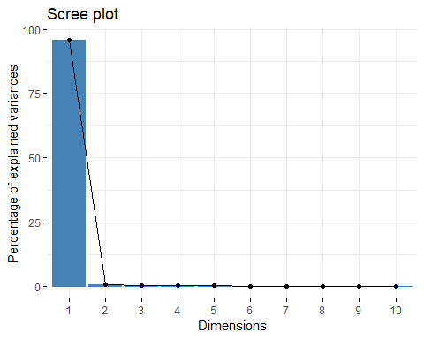

str(pca)

## List of 5  
## $ sdev : num [1:34] 495.4 46.3 35.1 26.1 24.6 ...  
## $ rotation: num [1:16970, 1:34] -9.20e-03 -3.19e-05 -7.79e-03 -1.45e-04 -2.30e-03 ...  
## ..- attr(*, "dimnames")=List of 2  
## .. ..$ : chr [1:16970] "A1BG" "A1CF" "A2M" "A2ML1" ...  
## .. ..$ : chr [1:34] "PC1" "PC2" "PC3" "PC4" ...  
## $ center : logi FALSE  
## $ scale : logi FALSE  
## $ x : num [1:34, 1:34] -502 -494 -511 -500 -504 ...  
## ..- attr(*, "dimnames")=List of 2  
## .. ..$ : chr [1:34] "COL11A1,TMTC2,TTN" " HMCN1" "COL11A1,HMCN1,SLC510" "HMCN1,TMTC2" ...  
## .. ..$ : chr [1:34] "PC1" "PC2" "PC3" "PC4" ...  
## - attr(*, "class")= chr "prcomp"

autoplot(pca, colour = 'blue')

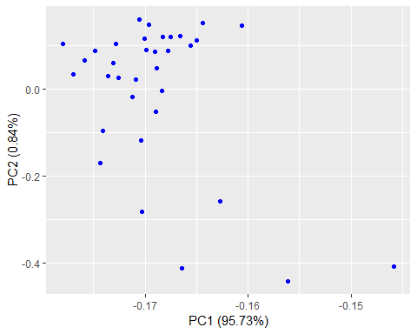

fviz_pca_ind(pca,  
 col.ind = "cos2", # color by the quality of representation  
 gradient.cols = c("#00AFBB", "#E7B800", "#FC4E07"),  
 repel = TRUE, # Avoid text overlapping  
)

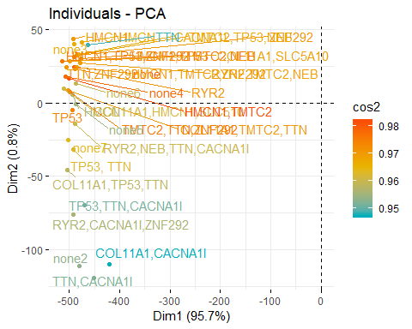

* *Again, there are two clusters.*
* *The first principal component contains the most information about the data.*

var_coord_func <- function(loadings, comp.sdev){  
 loadings*comp.sdev  
}  
  
loadings <- pca$rotation  
sdev <- pca$sdev  
var.coord <- t(apply(loadings, 1, var_coord_func, sdev))   
  
var.cos2 <- var.coord^2  
comp.cos2 <- apply(var.cos2, 2, sum)  
contrib <- function(var.cos2, comp.cos2){var.cos2*100/comp.cos2}  
  
var.contrib <- t(apply(var.cos2,1, contrib, comp.cos2))  
head(var.contrib[, 1:4])

## PC1 PC2 PC3 PC4  
## A1BG 8.458140e-03 4.042140e-02 2.820464e-03 1.626858e-03  
## A1CF 1.017925e-07 9.118405e-08 6.046034e-06 1.241073e-05  
## A2M 6.063349e-03 4.405875e-02 8.758703e-02 1.918378e-02  
## A2ML1 2.113426e-06 8.293155e-04 5.108695e-04 6.804066e-04  
## A4GALT 5.277506e-04 5.244157e-02 2.770271e-03 6.278979e-03  
## A4GNT 3.632784e-06 1.020123e-08 5.599425e-05 1.554282e-05

top100var.contrib <- var.contrib[,1]  
top100var.contrib <- as.data.frame(top100var.contrib[order(-top100var.contrib)])  
top100var.contrib$Genes <- rownames(top100var.contrib)  
top100var.contrib <- top100var.contrib[1:100,]  
colnames(top100var.contrib)[1] <- "Contribution"  
  
  
ggplot(data = top100var.contrib) +  
 (geom_bar(mapping = aes(x = Genes, y = Contribution), stat = "identity")) +  
 theme_bw(base_size = 7) + # formating the size of the theme nicely  
 theme(legend.position= "none", # defining the legend position (here no leghend will be needed)  
 legend.direction="horizontal", # defining the legend direction if one is there  
 plot.title = element_text(hjust = 0.5), # making the title of the plot into the middle  
 axis.text.x = element_text(angle = 90, vjust = 0.5, hjust=1, size = 5), # defining the orientation of the text on the x-axis  
 axis.text.y = element_text(angle = 90, vjust = 0.5, hjust=1, size = 10), # defining the orientation of the text on the y-axis  
 legend.title= element_blank(), # no title of the legend should be plotted  
 axis.title.x = element_blank(), # no title of the x-axis is relevant; because that would be samples and that is cleare due to the naming  
 strip.text.y = element_text(angle = 90)) # defining the orientation of the text of the y-axis

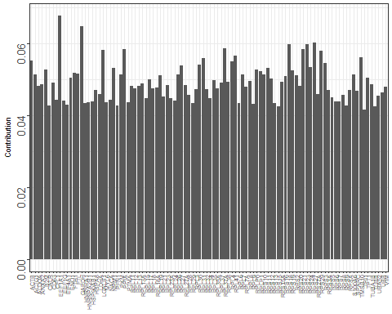

* *These are the components which are contributing the most to our variation in the data. Maybe we will find some of these in our result of the p-test.*

rm(drivergene, realcelllinenames, dataset, loadings, pca, realcelllinenames, var.contrib, var.coord, var.cos2, comp.cos2, sdev)

## Warning in rm(drivergene, realcelllinenames, dataset, loadings, pca,  
## realcelllinenames, : Objekt 'drivergene' nicht gefunden

## Warning in rm(drivergene, realcelllinenames, dataset, loadings, pca,  
## realcelllinenames, : Objekt 'realcelllinenames' nicht gefunden  
  
## Warning in rm(drivergene, realcelllinenames, dataset, loadings, pca,  
## realcelllinenames, : Objekt 'realcelllinenames' nicht gefunden

# **4. Statistical test**

We want to perform a p-test and compare the p-values.

driverGenes <- rownames(geneCounts)[1:10] # only using the TOP 10 driver genes  
ttestgenes <- rownames(processed_data$kd.ceres)  
  
potSecondSites <- lapply(seq_along(driverGenes), function(a) {  
 genePicker <- driverGenes[a] # picking one driver gene  
 print(paste0("I am doing driver mut: ", a))  
 output <- sapply(seq_along(rownames(processed_data$kd.ceres)), function(b) { #the kdCERES matrix is of interest take its' rownames as refrence  
 secondSitePicker <- rownames(processed_data$kd.ceres)[b] # picking a potetnial 2nd site target  
 if (secondSitePicker != genePicker) {  
 drMUT <- processed_data$kd.ceres[which(rownames(processed_data$kd.ceres) == genePicker),] # picking the driver mut data  
 sndMUT <- as.vector(processed_data$kd.ceres[which(rownames(processed_data$kd.ceres) == secondSitePicker),]) # picking the 2nd site data  
 cor.val <- cor.test(unlist(drMUT, use.names=FALSE) , unlist(sndMUT, use.names=FALSE), method = "spearman") # making a spearman correlation  
 return(cor.val$p.value) # returning the p-values  
 } else {  
 return(1)  
 }  
 })  
 names(output) <- rownames(processed_data$kd.ceres) # renaming all  
 output <- as.data.frame(output) # getting a nice data frame  
 return(output)  
})

## [1] "I am doing driver mut: 1"  
## [1] "I am doing driver mut: 2"  
## [1] "I am doing driver mut: 3"  
## [1] "I am doing driver mut: 4"  
## [1] "I am doing driver mut: 5"  
## [1] "I am doing driver mut: 6"  
## [1] "I am doing driver mut: 7"  
## [1] "I am doing driver mut: 8"  
## [1] "I am doing driver mut: 9"  
## [1] "I am doing driver mut: 10"

names(potSecondSites) <- driverGenes # renaming the list of lists  
lapply(potSecondSites, head) # looking at the nice data

## $TTN  
## output  
## A1BG 0.70023480  
## A1CF 0.39115670  
## A2M 0.34286907  
## A2ML1 0.11397865  
## A4GALT 0.19132453  
## A4GNT 0.01504808  
##   
## $TP53  
## output  
## A1BG 0.28160340  
## A1CF 0.70023480  
## A2M 0.39697321  
## A2ML1 0.64097590  
## A4GALT 0.09015868  
## A4GNT 0.60183071  
##   
## $HMCN1  
## output  
## A1BG 0.4227534  
## A1CF 0.8657359  
## A2M 0.6534159  
## A2ML1 0.7917565  
## A4GALT 0.8725280  
## A4GNT 0.3437615  
##   
## $TMTC2  
## output  
## A1BG 0.45154526  
## A1CF 0.43701759  
## A2M 0.95872743  
## A2ML1 0.75867863  
## A4GALT 0.01716129  
## A4GNT 0.62127398  
##   
## $RYR2  
## output  
## A1BG 0.879329218  
## A1CF 0.669727445  
## A2M 0.002884766  
## A2ML1 0.213302043  
## A4GALT 0.088108676  
## A4GNT 0.304196025  
##   
## $CACNA1I  
## output  
## A1BG 0.93400823  
## A1CF 0.09259686  
## A2M 0.14278128  
## A2ML1 0.61030460  
## A4GALT 0.10401228  
## A4GNT 0.53711418  
##   
## $ZNF292  
## output  
## A1BG 0.27458108  
## A1CF 0.75736391  
## A2M 0.57435603  
## A2ML1 0.07565286  
## A4GALT 0.38922902  
## A4GNT 0.08058396  
##   
## $NEB  
## output  
## A1BG 0.42275339  
## A1CF 0.07595393  
## A2M 0.36190890  
## A2ML1 0.33314716  
## A4GALT 0.04869324  
## A4GNT 0.05084604  
##   
## $COL11A1  
## output  
## A1BG 0.07535272  
## A1CF 0.49777121  
## A2M 0.80910520  
## A2ML1 0.26539892  
## A4GALT 0.18653536  
## A4GNT 0.68237842  
##   
## $SLC5A10  
## output  
## A1BG 0.991742072  
## A1CF 0.467398656  
## A2M 0.834622511  
## A2ML1 0.453641927  
## A4GALT 0.916192275  
## A4GNT 0.007613915

Now that we got all those p-values we want to order the data according to their p-values. So we can see the smallest ones which are the most important ones.

potSecondSites <- lapply(potSecondSites, function(a){  
 a <- as.data.frame(cbind(a$output, rownames(a)))  
 a <- a[order(a[1]), ]  
})

Selecting the 20 genes out of every DriverGene List with the lowest p score.

potSecondSitestop20 <- lapply(seq_along(potSecondSites), function (a){  
 output <- potSecondSites[[a]][1:20,]  
 return(output)  
})  
names(potSecondSitestop20) <- driverGenes  
  
ggplot(data = potSecondSitestop20$TTN) +  
 (geom_bar(mapping = aes(x = V2, y = V1), stat = "identity")) +  
 theme_bw(base_size = 7) + # formating the size of the theme nicely  
 theme(legend.position= "none", # defining the legend position (here no legend will be needed)  
 legend.direction="horizontal", # defining the legend direction if one is there  
 plot.title = element_text(hjust = 0.5), # making the title of the plot into the middle  
 axis.text.x = element_text(angle = 90, vjust = 0.5, hjust=1, size = 10), # defining the orientation of the text on the x-axis  
 axis.text.y = element_text(angle = 90, vjust = 0.5, hjust=1, size = 8), # defining the orientation of the text on the y-axis  
 legend.title= element_blank(), # no title of the legend should be plotted  
 axis.title.x = element_blank(), # no title of the x-axis is relevant; because that would be samples and that is cleare due to the naming  
 strip.text.y = element_text(angle = 90)) # defining the orientation of the text of the y-axis

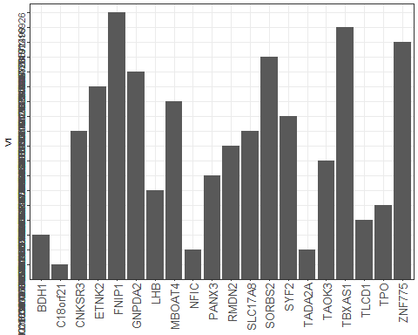

rm(potSecondSites, ttestgenes)

# **5. Multiple linear regression analysis**

## **5.1 Predicting the expression of our driver genes with all the data**

Creating a data frame for the multiple linear regression. In this data frame all the columns are the data frames and the rows represent the genes in every cell line.

With this data frame the linear regression is performed. After that the predicted values are compared with the real values of the data_set by a spearman correlation. Performing this with every driver gene.

# Building the dataframe for the linear Regression  
a <- generalPlottingData$expression[,1:3]  
a <-a[,c(1,3,2)]  
copynumber <- generalPlottingData$copynumber[,2]  
kd.ceres <- generalPlottingData$kd.ceres[,2]  
kd.prob <- generalPlottingData$kd.prob[,2]  
  
RegData <- cbind(a,copynumber,kd.ceres,kd.prob)  
  
# doing the multiple linear regression   
# comparing the predicted values of our model with the real values of the test_data by spearman correlaton  
# doing this for every driver gene  
  
Regressionanalysis <-lapply(1:10, function(x){  
 RegData <- cbind(a,copynumber,kd.ceres,kd.prob)  
 Driverexpression <- c()  
 for (i in 1:34) { # 34 = te skin cancer cell lines  
 a <- 16970*i # 16970 = number of genes  
 c <- (16970* (i-1))+1  
 b <- colnames(processed_data$expression)[i]  
 Driverexpression[c:a] <- processed_data$expression[rownames(geneCounts)[x],b]  
 }  
 print(paste0("I am doing driver mut: ", rownames(geneCounts)[x]))  
 RegData <- cbind(RegData,Driverexpression)  
 RegData <-as.data.frame(RegData)  
 colnames(RegData) <- as.vector(colnames(RegData))  
 set.seed(123) # initializing the random numbers  
 split = sample.split(RegData, SplitRatio = 0.8) # splitting the dataset into 4/5 Training and 1/5 Testing dataset  
 training_set = subset(RegData, split == TRUE) # using the labels to get the training data  
 test_set = subset(RegData, split == FALSE)   
 rm(RegData)  
 # fitting the multiple linear regression to the Training set  
 regressor = lm(Driverexpression ~ Value + copynumber + kd.ceres + kd.prob , data = training_set) # predicting profit based on ALL (=.) the input variables for one company   
 # predicting the test set results  
 y_pred = predict(regressor, newdata = test_set, se.fit = TRUE) # predicting the expression based on the testing data   
 test_set$Prediction = y_pred$fit # adding the predictions to the dataset  
 # comparing the predictions (last column) with the real values of the startups (2nd last column)  
 Results <- cor.test(test_set$Driverexpression, test_set$Prediction, method = "spearman", exact=FALSE)  
 return(Results)  
})

## [1] "I am doing driver mut: TTN"  
## [1] "I am doing driver mut: TP53"  
## [1] "I am doing driver mut: HMCN1"  
## [1] "I am doing driver mut: TMTC2"  
## [1] "I am doing driver mut: RYR2"  
## [1] "I am doing driver mut: CACNA1I"  
## [1] "I am doing driver mut: ZNF292"  
## [1] "I am doing driver mut: NEB"  
## [1] "I am doing driver mut: COL11A1"  
## [1] "I am doing driver mut: SLC5A10"

names(Regressionanalysis) <- rownames(geneCounts)[1:10]  
Regressionanalysis <- as.vector(Regressionanalysis)  
rm(RegData,kd.ceres,kd.prob,copynumber,a)  
  
  
ResultsRegression <- melt(lapply(1:length(Regressionanalysis), function(x){  
 return(Regressionanalysis[[x]][3])  
}))  
ResultsRegression <- cbind(ResultsRegression,melt(lapply(1:length(Regressionanalysis), function(x){  
 return(Regressionanalysis[[x]][1])  
})))  
  
ResultsRegression$L2 <- rownames(geneCounts)[1:10]  
ResultsRegression <- ResultsRegression [,c(2,1,4)]  
colnames(ResultsRegression) <- c("DriverGene", "pvalue", "Svalue" )  
  
print(ResultsRegression)

## DriverGene pvalue Svalue  
## 1 TTN 5.509211e-16 7.317806e+14  
## 2 TP53 4.997652e-09 7.359220e+14  
## 3 HMCN1 5.739113e-37 7.233205e+14  
## 4 TMTC2 1.486016e-36 7.234577e+14  
## 5 RYR2 1.671884e-30 7.255677e+14  
## 6 CACNA1I 7.949257e-20 7.299161e+14  
## 7 ZNF292 9.481412e-12 7.341441e+14  
## 8 NEB 5.286592e-14 7.328378e+14  
## 9 COL11A1 1.548789e-77 7.124150e+14  
## 10 SLC5A10 4.727922e-25 7.276653e+14

* *With these low p-values we can say with confidence that our Model is able to reproduce and predict the expression values of our driver genes.*
* *Using just our top 20 out of the statistical testing we hoped to see that the p values would not increase that much. This would verify our these that these genes are the essential components which drive the different expression of the Driver Gene.*
  + As you can see below this ist not the case and the p values are very much increased.*

Regressionanalysistop20 <-lapply(1:10, function(x){  
 a <- generalPlottingData$expression[which(generalPlottingData$expression[,3] %in% as.character(potSecondSitestop20[[x]][,2])),1:3]  
 a <-a[,c(1,3,2)]  
 copynumber <- generalPlottingData$copynumber[which(generalPlottingData$copynumber[,3] %in% as.character(potSecondSitestop20[[x]][,2])),2]  
 kd.ceres <- generalPlottingData$kd.ceres[which(generalPlottingData$kd.ceres[,3] %in% as.character(potSecondSitestop20[[x]][,2])),2]  
 kd.prob <- generalPlottingData$kd.prob[which(generalPlottingData$kd.prob[,3] %in% as.character(potSecondSitestop20[[x]][,2])),2]  
 RegData <- cbind(a,copynumber,kd.ceres,kd.prob)  
 h <- length(generalPlottingData$expression[which(generalPlottingData$copynumber[,3] %in% as.character(potSecondSitestop20[[x]][,2])),2])  
 Driverexpression <- c()  
 for (i in 1:34) {  
 a <- h*i  
 c <- (h* (i-1))+1  
 b <- colnames(processed_data$expression)[i]  
 Driverexpression[c:a] <- processed_data$expression[rownames(geneCounts)[x],b]  
 }  
 print(paste0("I am doing driver mut: ", rownames(geneCounts)[x]))  
 RegData <- cbind(RegData,Driverexpression)  
 RegData <-as.data.frame(RegData)  
 colnames(RegData) <- as.vector(colnames(RegData))  
 set.seed(123) #initialize the random numbers  
 split = sample.split(RegData, SplitRatio = 0.8) #split the dataset into 4/5 Training and 1/5 Testing dataset  
 training_set = subset(RegData, split == TRUE) #use the labels to get the training data  
 test_set = subset(RegData, split == FALSE)   
 rm(RegData)  
 # Fitting Multiple Linear Regression to the Training set  
 regressor = lm(Driverexpression ~ Value + copynumber + kd.ceres + kd.prob , data = training_set) #predict profit based on ALL (=.) the input variables for one company   
 # Predicting the Test set results  
 y_pred = predict(regressor, newdata = test_set, se.fit = TRUE) #predict the expression based on your testing data   
 test_set$Prediction = y_pred$fit #add your predictions to the dataset  
 #Now compare the Predictions (last column) with the real values of the startups (2nd last column)  
 Results <- cor.test(test_set$Driverexpression, test_set$Prediction, method = "spearman", exact=FALSE)  
 return(Results)  
})

## [1] "I am doing driver mut: TTN"

## Warning in data.frame(..., check.names = FALSE): row names were found from  
## a short variable and have been discarded

## [1] "I am doing driver mut: TP53"

## Warning in data.frame(..., check.names = FALSE): row names were found from  
## a short variable and have been discarded

## [1] "I am doing driver mut: HMCN1"

## Warning in data.frame(..., check.names = FALSE): row names were found from  
## a short variable and have been discarded

## [1] "I am doing driver mut: TMTC2"

## Warning in data.frame(..., check.names = FALSE): row names were found from  
## a short variable and have been discarded

## [1] "I am doing driver mut: RYR2"

## Warning in data.frame(..., check.names = FALSE): row names were found from  
## a short variable and have been discarded

## [1] "I am doing driver mut: CACNA1I"

## Warning in data.frame(..., check.names = FALSE): row names were found from  
## a short variable and have been discarded

## [1] "I am doing driver mut: ZNF292"

## Warning in data.frame(..., check.names = FALSE): row names were found from  
## a short variable and have been discarded

## [1] "I am doing driver mut: NEB"

## Warning in data.frame(..., check.names = FALSE): row names were found from  
## a short variable and have been discarded

## [1] "I am doing driver mut: COL11A1"

## Warning in data.frame(..., check.names = FALSE): row names were found from  
## a short variable and have been discarded

## [1] "I am doing driver mut: SLC5A10"

## Warning in data.frame(..., check.names = FALSE): row names were found from  
## a short variable and have been discarded

names(Regressionanalysistop20) <- rownames(geneCounts)[1:10]  
Regressionanalysistop20 <- as.vector(Regressionanalysistop20)  
  
ResultsRegressiontop20 <- melt(lapply(1:length(Regressionanalysistop20), function(x){  
 return(Regressionanalysistop20[[x]][3])  
}))  
ResultsRegressiontop20 <- cbind(ResultsRegressiontop20,melt(lapply(1:length(Regressionanalysistop20), function(x){  
 return(Regressionanalysistop20[[x]][1])  
})))  
  
ResultsRegressiontop20$L2 <- rownames(geneCounts)[1:10]  
ResultsRegressiontop20 <- ResultsRegressiontop20 [,c(2,1,4)]  
colnames(ResultsRegressiontop20) <- c("DriverGene", "pvalue", "Svalue" )  
  
print(ResultsRegressiontop20)

## DriverGene pvalue Svalue  
## 1 TTN 0.09746992 49026556057  
## 2 TP53 0.04382470 49238451647  
## 3 HMCN1 0.88944564 48128985972  
## 4 TMTC2 0.12381370 48956640123  
## 5 RYR2 0.10252586 49012065541  
## 6 CACNA1I 0.42022190 48523361801  
## 7 ZNF292 0.07410218 49102647128  
## 8 NEB 0.79788512 48198209845  
## 9 COL11A1 0.80113984 48195718948  
## 10 SLC5A10 0.20397571 48797830898

* + With this result we can not define confidently the second targets.*

# **6.Results**

Resultspresentation <- lapply(1:length(potSecondSitestop20), function(x){  
 return(potSecondSitestop20[[x]][2])  
})  
  
names(Resultspresentation) <- rownames(geneCounts)[1:10]  
print(Resultspresentation)

## $TTN  
## V2  
## 1619 C18orf21  
## 9311 NFIC  
## 14283 TADA2A  
## 1308 BDH1  
## 14708 TLCD1  
## 15183 TPO  
## 7750 LHB  
## 10332 PANX3  
## 14321 TAOK3  
## 12208 RMDN2  
## 2967 CNKSR3  
## 13171 SLC17A8  
## 14213 SYF2  
## 8296 MBOAT4  
## 4571 ETNK2  
## 5693 GNPDA2  
## 13698 SORBS2  
## 16853 ZNF775  
## 14435 TBXAS1  
## 5161 FNIP1  
##   
## $TP53  
## V2  
## 2499 CDKN1A  
## 11816 RAD50  
## 14298 TAF4  
## 14764 TMCC1  
## 4371 ELP5  
## 2900 CLNS1A  
## 3317 CSNK1E  
## 15153 TP53BP1  
## 1038 ATE1  
## 5012 FEM1B  
## 10303 PAGR1  
## 12378 RPL23  
## 16904 ZNF862  
## 11548 PSME3  
## 11231 PPP1R42  
## 4149 DYNLT1  
## 11199 PPP1R12A  
## 9363 NIPBL  
## 16084 WDR83  
## 14889 TMEM207  
##   
## $HMCN1  
## V2  
## 3855 DLEC1  
## 7868 LPA  
## 14241 SYT1  
## 2696 CHI3L2  
## 1086 ATP13A4  
## 15195 TPRX1  
## 3970 DNM1  
## 997 ASGR1  
## 5454 GCKR  
## 321 ADO  
## 2893 CLMN  
## 564 AMTN  
## 12134 RHBDD2  
## 14043 STBD1  
## 5219 FPGT  
## 8695 MRGPRX1  
## 289 ADCY2  
## 11622 PTPN13  
## 16185 XPO4  
## 6637 IFNW1  
##   
## $TMTC2  
## V2  
## 6823 INPP1  
## 6415 HPCAL4  
## 6838 INSL4  
## 10807 PIM1  
## 1630 C19orf44  
## 13439 SLC6A5  
## 12357 RPF2  
## 13018 SHBG  
## 14524 TENM4  
## 9418 NME1  
## 12112 RGS13  
## 11239 PPP2R2A  
## 13478 SLCO2A1  
## 12557 RWDD3  
## 4841 FAM78A  
## 15160 TP53RK  
## 7610 LAMC1  
## 14552 TEX33  
## 5893 GRIK4  
## 16316 ZC3H7A  
##   
## $RYR2  
## V2  
## 5170 FOS  
## 10974 PLSCR1  
## 4126 DUSP7  
## 13270 SLC26A8  
## 4693 FAM118B  
## 13662 SNX21  
## 12493 RRP8  
## 6148 HERC4  
## 2600 CEP57L1  
## 15432 TSPO  
## 13161 SLC16A7  
## 6609 IFITM2  
## 10984 PLXNA2  
## 4233 EFCAB14  
## 8288 MBIP  
## 16664 ZNF501  
## 12256 RNF14  
## 13123 SLC10A1  
## 4750 FAM177A1  
## 173 ACSF3  
##   
## $CACNA1I  
## V2  
## 13544 SMDT1  
## 8832 MSX2  
## 7726 LGALS12  
## 9657 NUCB1  
## 7536 KRTAP21-3  
## 4033 DPRX  
## 3564 DAOA  
## 10200 OSBPL3  
## 10618 PENK  
## 4608 EXOC3L4  
## 11025 PNPLA5  
## 12802 SEH1L  
## 760 APOBEC3F  
## 9013 MYO1H  
## 15604 UBA52  
## 12857 SERHL2  
## 1598 C16orf97  
## 3660 DDR1  
## 39 ABCA7  
## 15108 TNRC6B  
##   
## $ZNF292  
## V2  
## 7630 LARP4B  
## 10984 PLXNA2  
## 13213 SLC24A1  
## 13373 SLC39A9  
## 10203 OSBPL7  
## 15231 TRAPPC10  
## 12266 RNF152  
## 1824 C6orf99  
## 5586 GLB1  
## 8021 LSM5  
## 10214 OSMR  
## 14875 TMEM190  
## 15768 UNC93A  
## 10717 PHF5A  
## 3094 COPA  
## 11354 PRKCSH  
## 16138 WNT5A  
## 8275 MAX  
## 2703 CHL1  
## 4649 F2RL2  
##   
## $NEB  
## V2  
## 3318 CSNK1G1  
## 3931 DNAJC10  
## 7082 KCNAB3  
## 12359 RPGRIP1L  
## 2675 CHCHD5  
## 15311 TRIM61  
## 9390 NKX6-1  
## 11828 RAD9B  
## 16674 ZNF514  
## 3429 CWC25  
## 2332 CD22  
## 13376 SLC40A1  
## 8895 MTRNR2L2  
## 4583 EVA1A  
## 5809 GPR183  
## 14900 TMEM219  
## 1213 BAALC  
## 11643 PTPRH  
## 15120 TOM1L2  
## 8621 MOCOS  
##   
## $COL11A1  
## V2  
## 3713 DEFB108B  
## 5233 FRK  
## 10256 OXT  
## 16705 ZNF560  
## 2882 CLIC6  
## 9029 MYOM1  
## 14943 TMEM37  
## 930 ARMS2  
## 11982 RBP1  
## 1922 CACNG7  
## 7372 KLHL36  
## 4932 FBXO11  
## 15437 TSPYL6  
## 1078 ATP10D  
## 8008 LRTOMT  
## 14339 TAS2R13  
## 1898 CACHD1  
## 5332 GABBR2  
## 15616 UBASH3B  
## 11202 PPP1R13B  
##   
## $SLC5A10  
## V2  
## 8177 MAP2K4  
## 13850 SPNS2  
## 16525 ZNF256  
## 6648 IFT52  
## 13815 SPEM1  
## 7249 KIAA1324L  
## 4226 EEF2K  
## 8987 MYL4  
## 10888 PLAC8L1  
## 14539 TEX10  
## 16738 ZNF593  
## 15072 TNFSF12  
## 13018 SHBG  
## 3795 DHRS11  
## 11358 PRKD3  
## 11415 PRPSAP2  
## 10410 PCBP4  
## 13153 SLC16A11  
## 14303 TAF6L  
## 4107 DUSP10

print(top100var.contrib[1:20,2])

## [1] "EEF1A1" "GAPDH" "RPS27" "RPS23" "RPS18" "RPL37A" "PPIA"   
## [8] "RPS21" "LGALS1" "RPS29" "RPL41" "TMSB10" "RPL31" "ACTB"   
## [15] "RPL4" "RPS3" "RPL30" "RPL27" "RPS24" "RPS11"

which(top100var.contrib[1:20,2] %in% as.character(melt(Resultspresentation)[,1]))

## Using V2 as id variables  
## Using V2 as id variables  
## Using V2 as id variables  
## Using V2 as id variables  
## Using V2 as id variables  
## Using V2 as id variables  
## Using V2 as id variables  
## Using V2 as id variables  
## Using V2 as id variables  
## Using V2 as id variables

## integer(0)

* *Our top 10 driver mutations are : TTN, TP53, HMCN1, TMTC2, RYR2, CACNA1I, ZNF292, NEB, COL11A1, SLC5A10. We defined them with a barplot at the beginning.*
* *Our goal was to find possible second side targets interacting with these driver mutations more often than other mutations and which are of a greater importance than other interactin genes.*
* *We tried to define these targets with a PCA and a p-test.But the 2nd targets from the pca and the regression are not overlapping. This could be due to the data or mistakes we made in the skript. Also the kmeans and the PCA do not reproduce the same second side targets.*
* *However we decided to present the targets we defined with the p-test. As shown above we have listed the top 20 second side targets from the p-test for each gene.*
* *The regression model shows a really low p-value at which leads us to the conclucion that the above listed genes could be taken in account as targets for drug development in skin cancer.*

# **7. Biological background**

Firstly, the literature identifies BRAF, RAS, NFI and Triple WT as the leading mutations for skin cancer (1). Unfortunatly, mutations of these genes are not emphasized as our top 10 driver mutations.

However, we will now take a look at our results. Could the driver mutation extracted from our data be related to skin cancer? And are there biological interactions between the driver mutations and the second targets?

In the following, we will be investigating our top mutated genes TTN, TP53 and their second targets and their relevence in skin cancer therapy.

TTN, which is our top mutated gene, encodes for the largest protein in the human genome and is a part of the sacromere in the steriated muscle (2). Its complex structure and size, which leads to the sacromeric organization during a contraction, is due to its composition of 364 exons (2). That creats a protein, which is approximatly composed of 38,000 amino acid residues(2). The mentioned sacromere gene is stated to be a major human disease gene, for instance, truncating types of TTN are reprotedly the main reason for dilated cardiomyopathy, which is a common cause of heart failure and cardiac death (2).

Tissue expression of TTN in heart muscle and skeletal muscle (3):

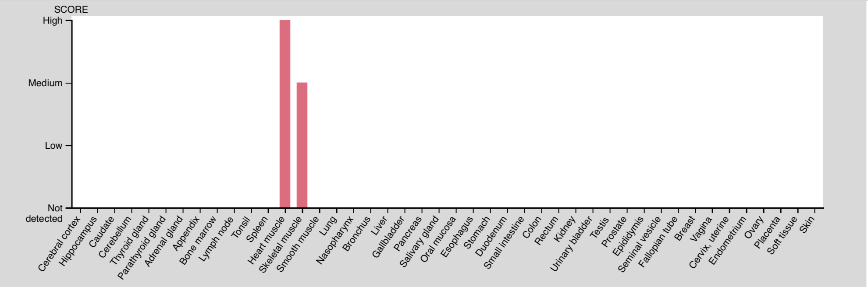

It is possible to see in the chart, that TTN is not detected in skin tissue, consequently, it will not play a leading role in the developement of skin cancer. Nevertheless, in the following we will investigate in how well our analysis was able to predict possible second targets.

In that matter we used a website called GeneMANIA, which is a server for biological network integration and predicting gene functions (4). The website enables us to visually see how genes are connected and to what extend physical interactions, co-expression, co-localiation, pathway, genetic interactions and shared protein domains can be found (4). It is possible to download a full report to gain fruther inside, for instance, which pathway in particular is connecting these genes (4). In our results the three major second targets for TTN are C18orf21, NFIC, TADA2A. Our driver mutation and the calculated second targets are indicated with stripes.

Network of TTN and second targets:

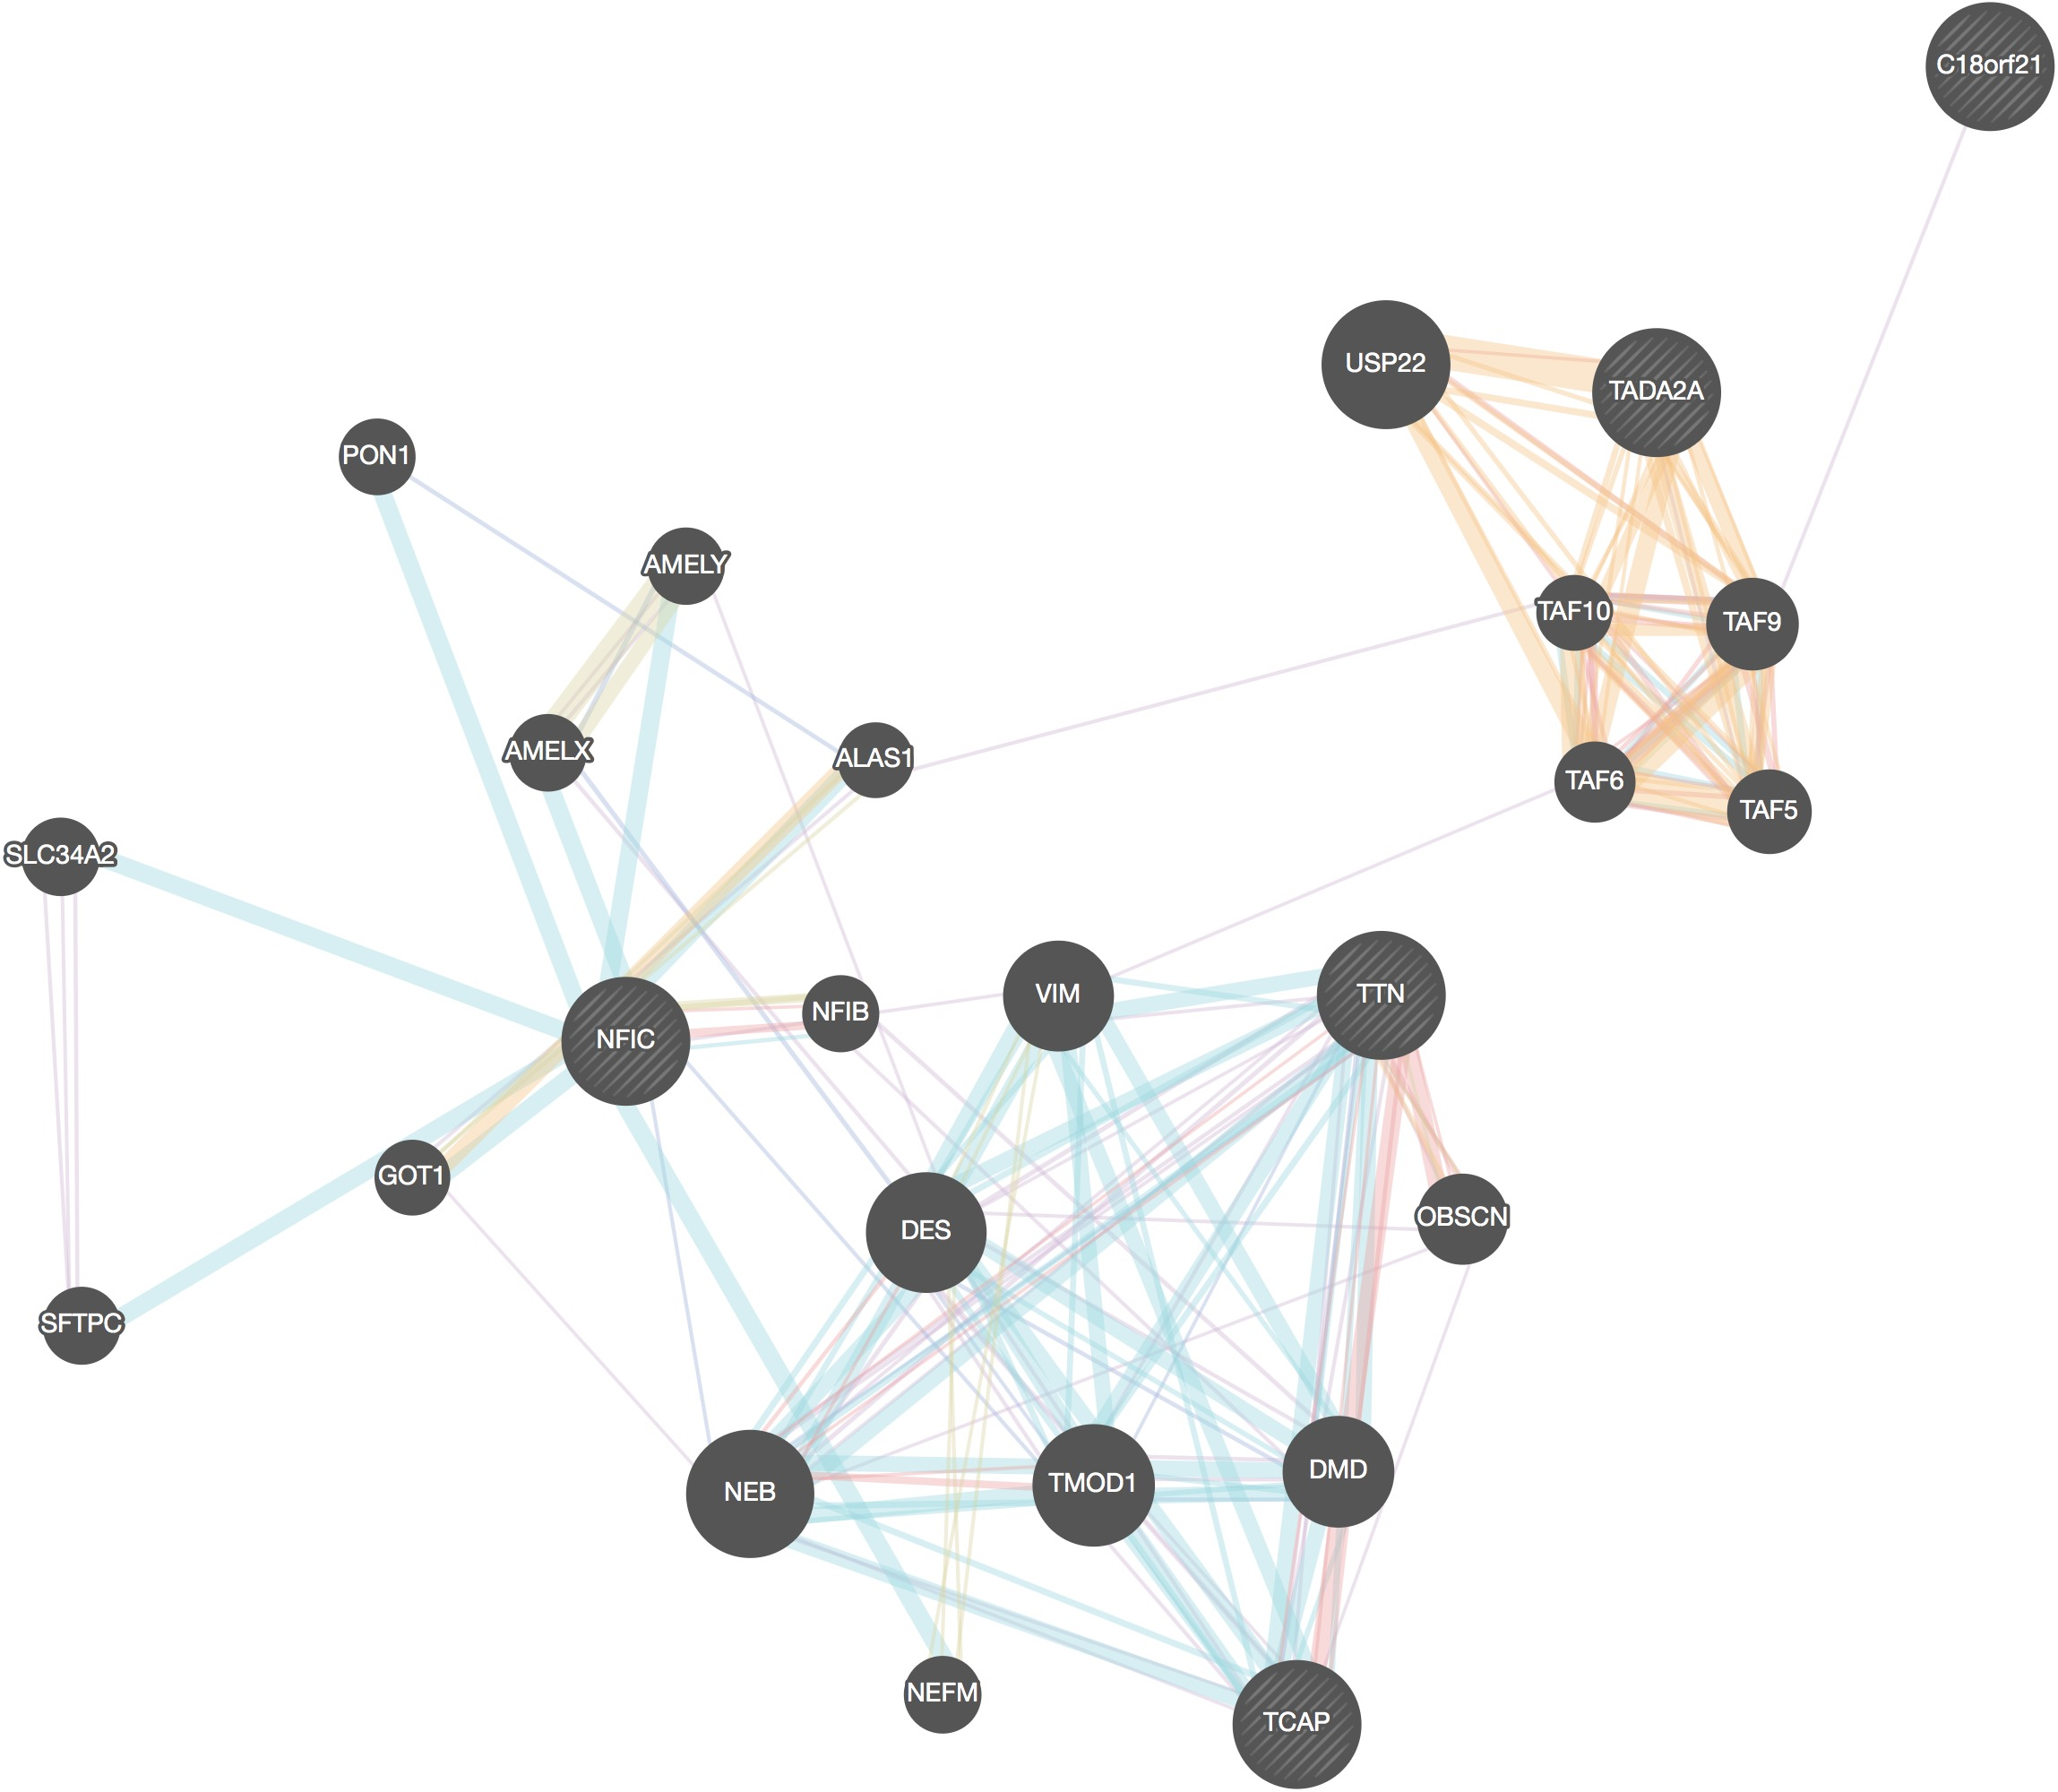

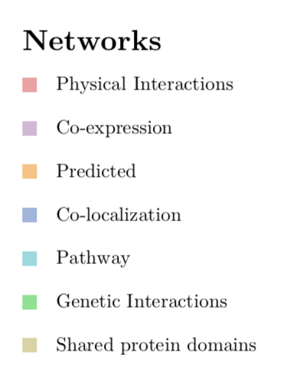

In the report it is stated that 67,64% of physical interaction and 13,5% of co-expression can be found, whereas, the probabilty for shared pathways and genetic interactions are significantyl low (4). Physical interaction indicates that these proteins are likely to form bonds between complexes and interact with each other (5). TTN is not directly connected with any second target, however, a link is to be found between TTN and NFIC which are co-expressed with NEB (nebulin),which is giant protein component of the cytoskeletal matrix that coexists with the thick and thin filaments within the sarcomeres of skeletal muscle (6).

As we mentioned in our results, because of our regression analysis it is not possible to state C18orf21, NFIC, TADA2A confidently as second targets, thus, the computed network propably does not match the underlying interactions in our data set.

In the following we will take a look at TP53, which is our second most mutated gene, and its second targets. This gene is a tumor suppressor protein containing transcriptional activation, DNA binding, and oligomerization domains, additionally, it plays a major role in the induction of cell cycle arrest, apoptosis, senescence, DNA repair, and changes in metabolism (7). A loss of function in TP53 through a mutation can lead to multiple types of human cancer (7). UV irridation appears to play a significant role in the mutation of TP53, according to the article " p53 and the Pathogenesis of Skin Cancer" a significant number of TP53 mutants are to be found on sun-exposed skin (8). As a result, our second targets for TP53 could be a lead for possible new drug targets in skin cancer therapy.

The top three second targets for TP53 ,which were extracted from our data base, are CDKN1A, RAD50, TAF4. We perform an anlysis with GeneMANIA to detect possible interactions (4). On the left side is our driver mutation and second targets and on the right side are all possible interaction partners are listed.

Network of TP53 and its second targets:

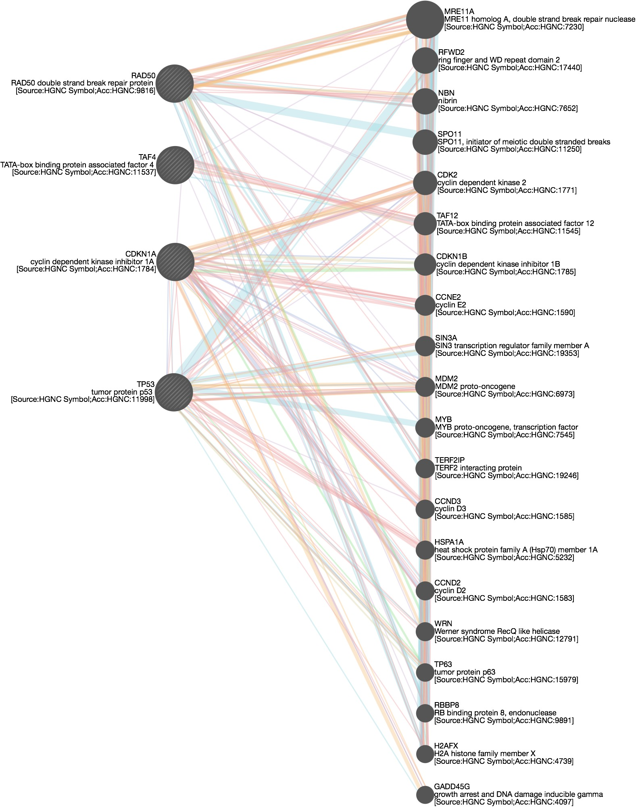

In this case its is noticeable that the correlation between the pathways of TP53 and the second targets is significantly high with 4.35% , which is illustrated below.

Network of pathways: TP53 and second targets:

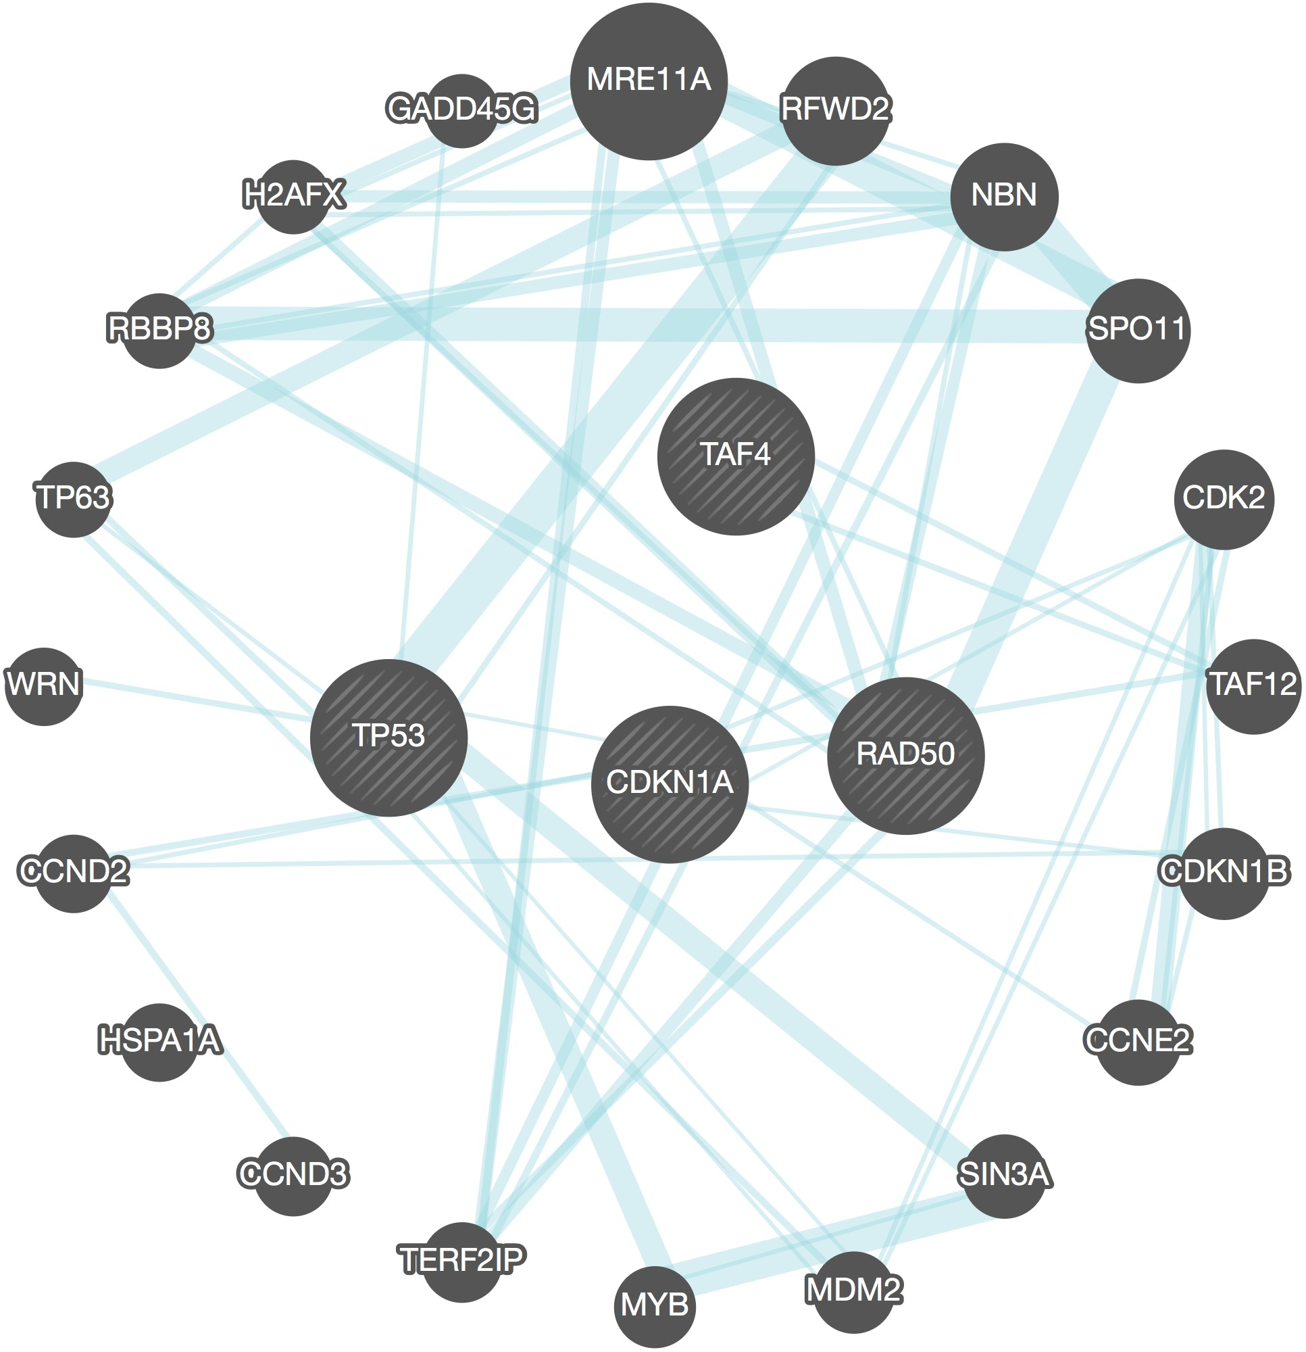

According to our analysis, CDKN1A is predicted most likely to be a second target for TP53. Due to the correlation of driver mutation and the second targets pathways ,we will take a fruther look into a possible link between CDKN1A and TP53. CDKN1A is a cyclin dependent kinase inhibitor and expresses proteins which function as regulators of cell cycle progression at G1 (7). The expression of CDKN1A is controlled by TP53, which means that CDKN1A has a key role in the p53-dependent cell cycle G1 phase arrest caused by stress stimuli (7). It is reported that this second target can interact with proliferating cell nuclear antigen and has a regulatory role in S phase DNA repilcation and DNA damage repair (7). G1/S checkpoint defects are mentioned to be significant factors in melanoma tumorgenesis, although, the results implicate that cyclindependent kinases and TP53 are not major drivers, but can be taken into consideration (9).

To sum it up, in spite of the fact that the driver mutation from the literature and the calculated driver mutation from our data set do not match up, we were able to detect possible second targets for our driver mutations. In the case of TP53, CDKN1A gene has clearly biological interactions with TP53 and our mathematical model was able to predict this interaction.

# **8. References**

1. Akbani et al. (2015), Genomic Classification of Cutaneous Melanoma. Cell 161, 1681-1696
2. Gigli M, Begay RL, Morea G, et al. A Review of the Giant Protein Titin in Clinical Molecular Diagnostics of Cardiomyopathies. Front Cardiovasc Med. 2016;3:21. Published 2016 Jul 21. <doi:10.3389/fcvm.2016.00021>
3. Uhlén M et al, 2015. Tissue-based map of the human proteome. Science PubMed: 25613900 DOI: 10.1126/science.1260419, Human Protein Atlas
4. Warde-Farley D, Donaldson SL, Comes O, Zuberi K, Badrawi R, Chao P, Franz M, Grouios C, Kazi F, Lopes CT, Maitland A, Mostafavi S, Montojo J, Shao Q, Wright G, Bader GD, Morris Q Nucleic Acids Res. 2010 Jul 1;38 Suppl:W214-20 PubMed Abstract
5. Clancy T, Rødland EA, Nygard S, Hovig E. Predicting physical interactions between protein complexes. Mol Cell Proteomics. 2013;12(6):1723-1734. <doi:10.1074/> mcp.O112.019828
6. Pruitt KD, Tatusova T, Brown GR, Maglott DR. NCBI Reference Sequences (RefSeq): current status, new features and genome annotation policy. Nucleic Acids Res. 2012;40(Database issue):D130-D135. <doi:10.1093/nar/gkr1079>
7. O’Leary NA, Wright MW, Brister JR, Ciufo S, Haddad D, McVeigh R, Rajput B, Robbertse B, Smith-White B, Ako-Adjei D, Astashyn A, Badretdin A, Bao Y, Blinkova O, Brover V, Chetvernin V, Choi J, Cox E, Ermolaeva O, Farrell CM, Goldfarb T, Gupta T, Haft D, Hatcher E, Hlavina W, Joardar VS, Kodali VK, Li W, Maglott D, Masterson P, McGarvey KM, Murphy MR, O’Neill K, Pujar S, Rangwala SH, Rausch D, Riddick LD, Schoch C, Shkeda A, Storz SS, Sun H, Thibaud-Nissen F, Tolstoy I, Tully RE, Vatsan AR, Wallin C, Webb D, Wu W, Landrum MJ, Kimchi A, Tatusova T, DiCuccio M, Kitts P, Murphy TD, Pruitt KD. Reference sequence (RefSeq) database at NCBI: current status, taxonomic expansion, and functional annotation. Nucleic Acids Res. 2016 Jan 4;44(D1):D733-45 PubMed Tatusova T, DiCuccio M, Badretdin A, Chetvernin V, Nawrocki EP, Zaslavsky L, Lomsadze A, Pruitt KD, Borodovsky M, Ostell J. NCBI prokaryotic genome annotation pipeline. Nucleic Acids Res. 2016 Aug 19;44(14):6614-24 PubMed Brister JR, Ako-Adjei D, Bao Y, Blinkova O. NCBI viral genomes resource. Nucleic Acids Res. 2015 Jan;43(Database issue):D571-7 PubMed
8. Benjamin CL, Ananthaswamy HN. p53 and the pathogenesis of skin cancer. Toxicol Appl Pharmacol. 2007;224(3):241-248. <doi:10.1016/j.taap.2006.12.006>
9. Soto JL, Cabrera CM, Serrano S, López-Nevot MA. Mutation analysis of genes that control the G1/S cell cycle in melanoma: TP53, CDKN1A, CDKN2A, and CDKN2B. BMC Cancer. 2005;5:36. Published 2005 Apr 8. <doi:10.1186/1471-2407-5-36>

# **finally done :)**