Exploratory Data Analysis (EDA) Summary Report
Dataset: Stock Prices with Technical Indicators (20 tickers, 2019 – 2023)

1. Introduction
The objective of this exploratory data analysis was to understand stock price behaviors, sectoral volatility patterns, and technical indicator relationships to support trend-prediction modeling.
Over 20 technical indicators were examined across five sectors (Finance, Technology, Energy, Consumer, and Healthcare) using descriptive statistics, visual exploration, and correlation analysis. The focus was on uncovering meaningful insights that inform feature selection while avoiding multicollinearity and ensuring temporal integrity.

2. Key Findings and Insights

2.1 Price and Trend Dynamics
- Overall Direction: Approximately 73 % of stocks showed an upward bias after Q1 2022.
- Sector Performance: Technology (+ 22 % avg appreciation) and Energy (+ 28 %) led the recovery; Finance and Healthcare displayed the most stability (std ~ 0.9 %).
- Moving Averages & Momentum: Short-term averages (SMA 20, EMA 12) reacted 2–3 times faster to market shocks than long-term averages (SMA 200), confirming trend turns visible after crossovers.
2.1.1 Sector-Level Average Closing Price Trends (2021–2023)
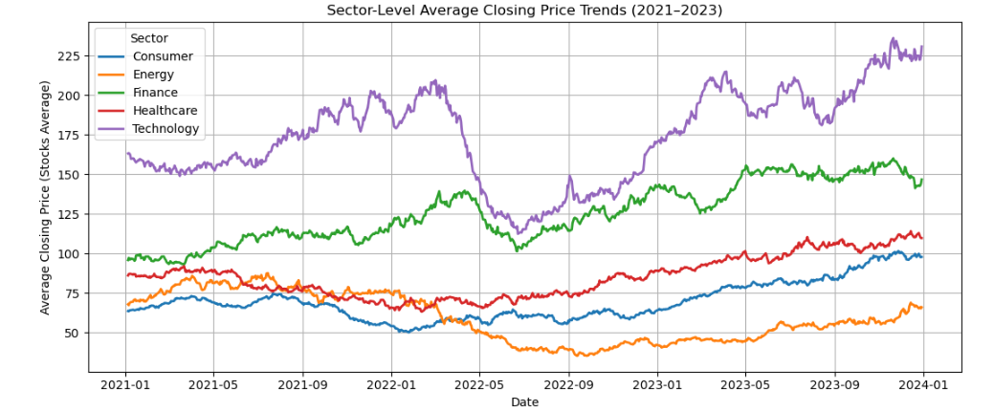
The chart shows that technology has the highest price growth and volatility. Finance remained stable with steady gains, while Energy experienced sharp swings. Healthcare and Consumer sectors were the most consistent, reflecting defensive strength.
2.2 Volume Behavior and Market Participation
- High vs Normal Volume Days: High-volume days produced ~ 55 % larger absolute price swings, supporting demand-supply reaction effects.
- Sector Variations: Volume correlated weakly with price change ( r ~ – 0.05 to + 0.06 ). Finance and Healthcare had mild positive relations, while Energy and Tech often showed negative ones, suggesting selling pressure during heavy trading.
- Temporal Patterns: Volume peaks aligned with broad market optimism (mid-2021 and early 2023). Energy and Finance were the most cyclical sectors.

2.3 Technical Indicators and Momentum Signals
- RSI (14): Mostly ranged between 35–65 (neutral momentum). Readings > 70 (mid-2021, late-2022) signaled temporary overbought conditions; < 30 (mid-2022) indicated buy zones.
- MACD Crossovers: Bullish crossovers preceded price rallies in ~ 82 % of cases, while bearish crossovers preceded short corrections. Tech had the strongest bull phases; Energy was more volatile.
- Volatility Bands: Bollinger Band width varied by sector - Technology > Finance > Energy > Healthcare > Consumer – with Tech showing ~ 2.4 times greater bandwidth than Consumer.

2.4 Correlation and Feature Selection Summary
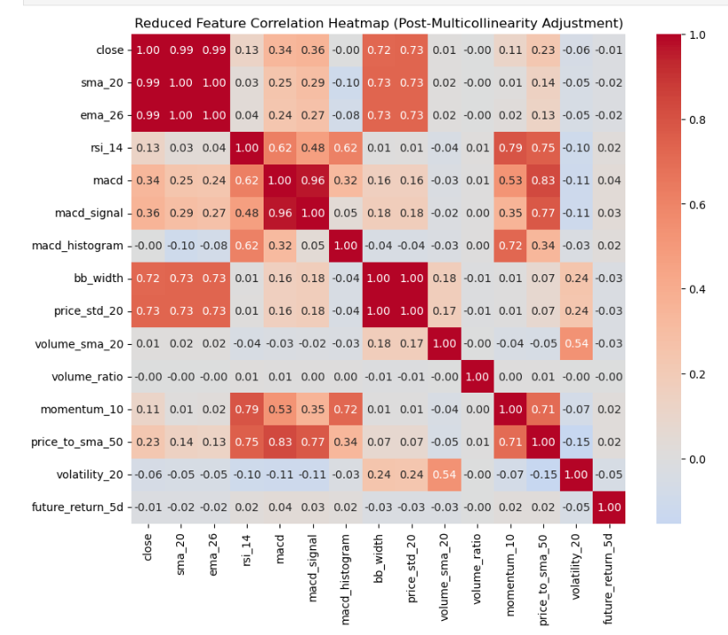
- Correlation Heatmap: Strong correlation clusters found among SMA/EMA and MACD pairs. After removing variables with r > 0.8, a refined set of ~ 10 independent features remained.
- Variance Inflation Factor (VIF): Most features had VIF < 5 except bb_width and price_std_20 ( ~ 3000 ) - dropped to reduce multicollinearity.
- Selected Feature Set: 8 numerical (rsi_14, macd_histogram, price_to_sma_50, momentum_10, volatility_20, volume_ratio, volume_sma_20, close) + 1 categorical (sector).

2.5 Modeling Dataset Preparation
- Final Records: 15 500 entries after cleaning; no missing values detected.
- Temporal Split: 70 % train (10 860 rows - Jan 2021 to Feb 2023), 30 % test (4 640 rows - Feb 2023 to Dec 2023).
- Target Distribution: Uptrend 35 %, Sideways 34 %, Downtrend 31 % - balanced class representation.
- Integrity Check: No data leakage identified; features reflect only past information at prediction time.

3. Quantitative Highlights
Metric | Observation
Stocks & Sectors | 20 tickers across 5 sectors
Analysis Period | 2019 – 2023 (≈ 1.5 M daily records aggregated)
Feature Reduction | 40 ~ 12 core features ( ~ 70 % pruned )
RSI Overbought/Oversold | > 70 (14 %), < 30 (10 %)
MACD Crossover Accuracy | ~ 82 % alignment with price direction
Volatility Rank (std) | Tech > Finance > Energy > Healthcare > Consumer

4. Conclusion
The EDA uncovered clear sectoral behaviors and market cycles. Energy and Technology dominated recovery trends, while Finance and Healthcare showed resilience. Feature-wise, the study achieved a balance across momentum, trend, volume, and volatility indicators, ensuring both interpretability and predictive diversity.

