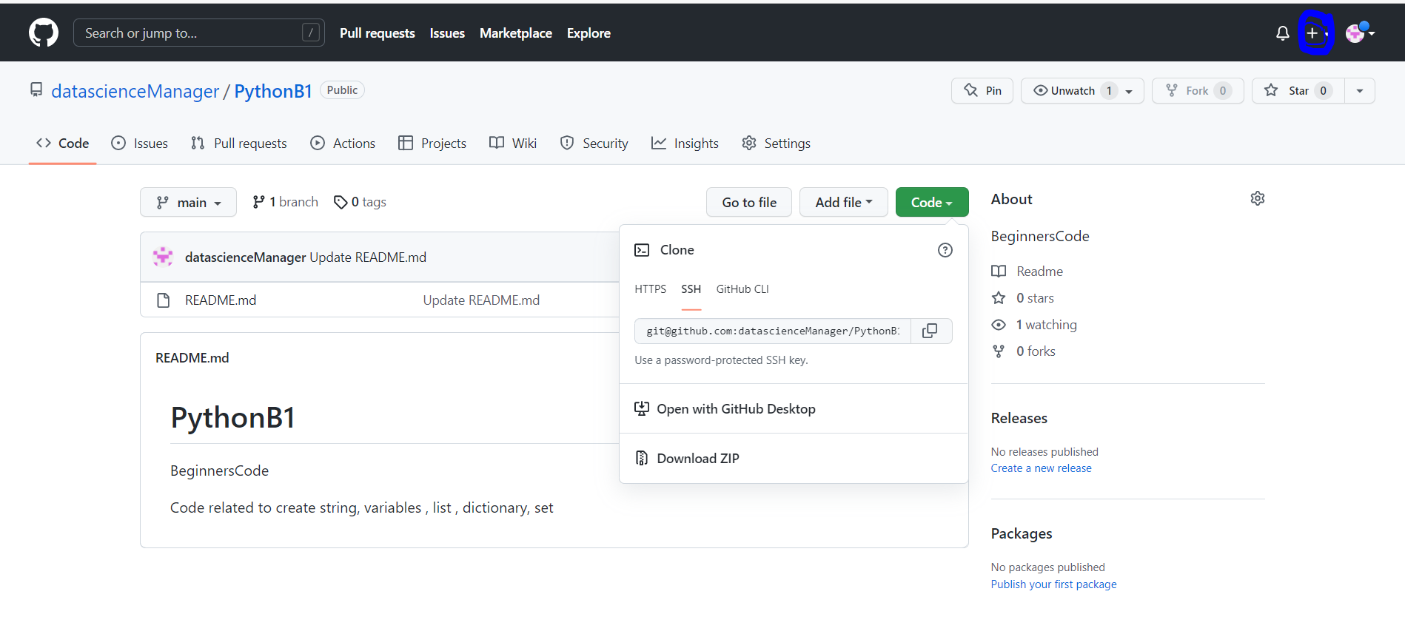

Then from code copy the SSH

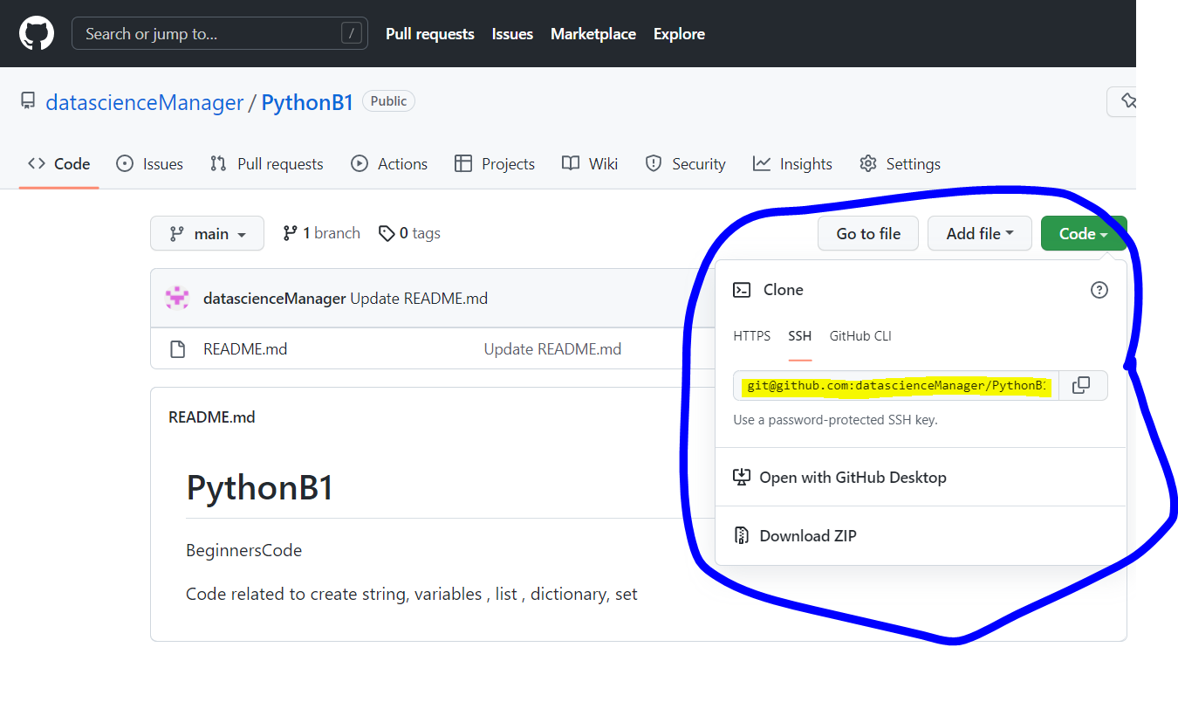

In visual studio , in respective folder

Type **git clone**

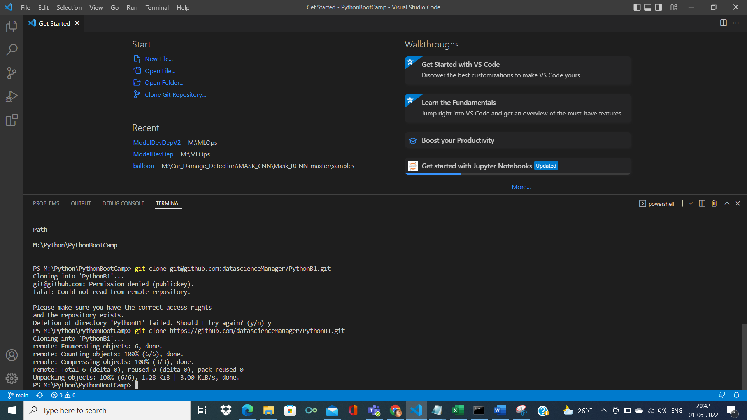

Select git bash instead of power shell

And use ls -la ( list everything under this folder)

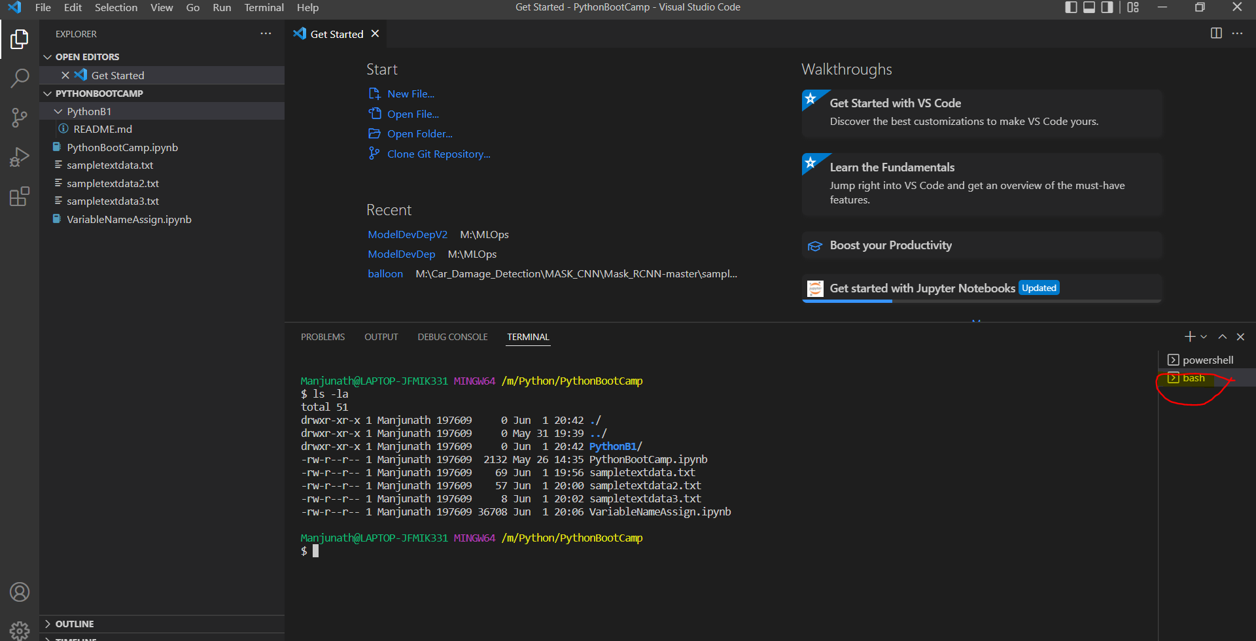

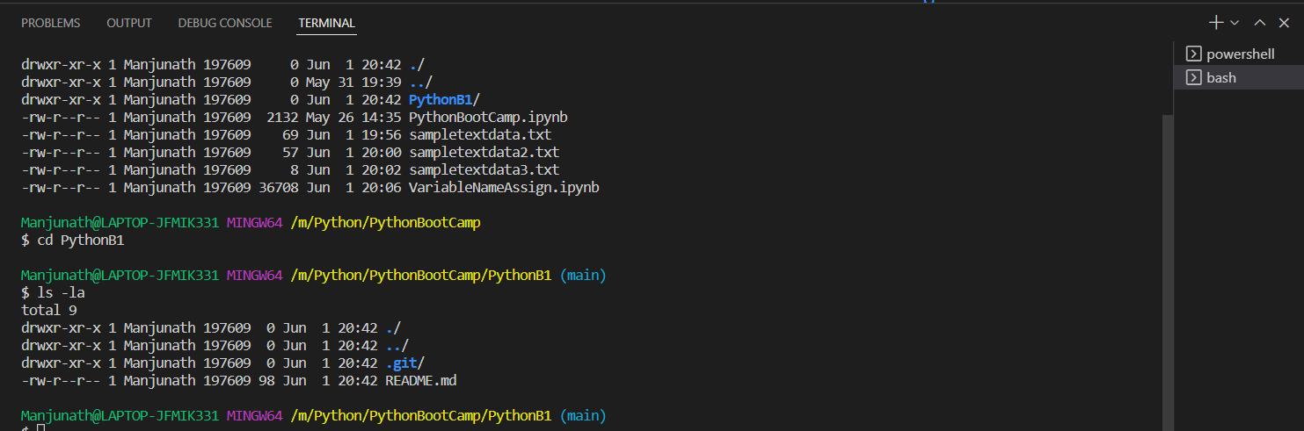

Git status

Gives me the details of the folder or files added

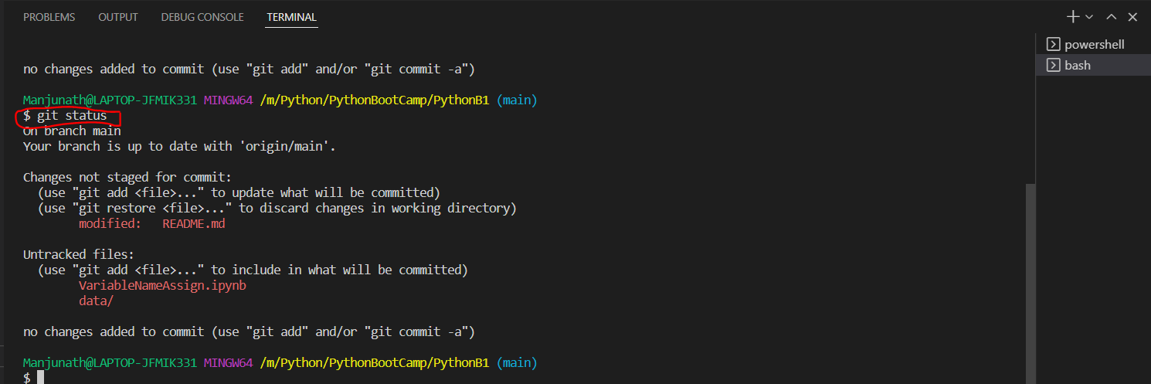

Git add .

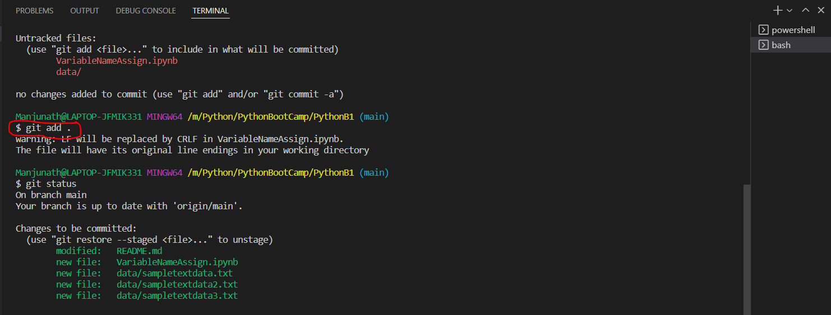

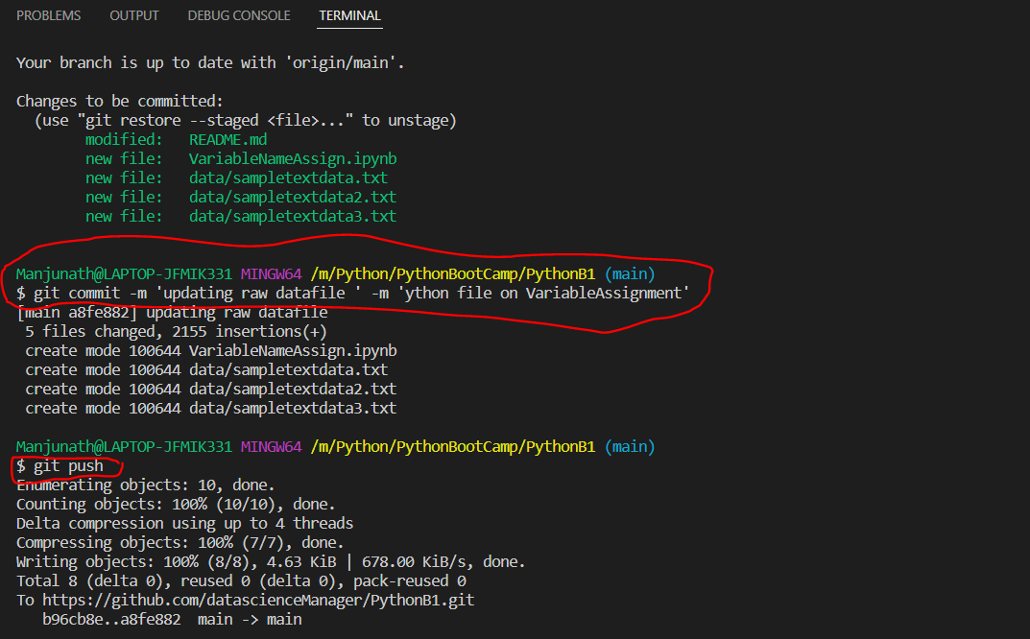

Manjunath@LAPTOP-JFMIK331 MINGW64 /m/09_R/R/R4GitHub (master)

$ git init

Reinitialized existing Git repository in M:/09_R/R/R4GitHub/.git/

Manjunath@LAPTOP-JFMIK331 MINGW64 /m/09_R/R/R4GitHub (master)

$ ls -la

total 60

drwxr-xr-x 1 Manjunath 197609 0 Aug 17 13:42 ./

drwxr-xr-x 1 Manjunath 197609 0 Aug 17 13:34 ../

drwxr-xr-x 1 Manjunath 197609 0 Aug 17 13:55 .git/

-rw-r--r-- 1 Manjunath 197609 49975 Jun 10 2018 Learning_Recently.R

drwxr-xr-x 1 Manjunath 197609 0 Aug 17 13:48 Rprogram/

Manjunath@LAPTOP-JFMIK331 MINGW64 /m/09_R/R/R4GitHub (master)

$ git status

On branch master

nothing to commit, working tree clean

Manjunath@LAPTOP-JFMIK331 MINGW64 /m/09_R/R/R4GitHub (master)

$ git clone https://github.com/datascienceManager/Rprogram.git

fatal: destination path 'Rprogram' already exists and is not an empty directory.

Manjunath@LAPTOP-JFMIK331 MINGW64 /m/09_R/R/R4GitHub

$ git init

Initialized empty Git repository in M:/09_R/R/R4GitHub/.git/

Manjunath@LAPTOP-JFMIK331 MINGW64 /m/09_R/R/R4GitHub (master)

$ ls -la

total 60

drwxr-xr-x 1 Manjunath 197609 0 Aug 17 13:56 ./

drwxr-xr-x 1 Manjunath 197609 0 Aug 17 13:34 ../

drwxr-xr-x 1 Manjunath 197609 0 Aug 17 13:56 .git/

-rw-r--r-- 1 Manjunath 197609 49975 Jun 10 2018 Learning_Recently.R

drwxr-xr-x 1 Manjunath 197609 0 Aug 17 13:48 Rprogram/

Manjunath@LAPTOP-JFMIK331 MINGW64 /m/09_R/R/R4GitHub (master)

$ git status

On branch master

No commits yet

Untracked files:

(use "git add <file>..." to include in what will be committed)

Learning_Recently.R

Rprogram/

nothing added to commit but untracked files present (use "git add" to track)

Manjunath@LAPTOP-JFMIK331 MINGW64 /m/09_R/R/R4GitHub (master)

$ git add .

Manjunath@LAPTOP-JFMIK331 MINGW64 /m/09_R/R/R4GitHub (master)

$ git status

On branch master

No commits yet

Changes to be committed:

(use "git rm --cached <file>..." to unstage)

new file: Learning_Recently.R

new file: Rprogram/Average_Matrix_Adoptive.R

Manjunath@LAPTOP-JFMIK331 MINGW64 /m/09_R/R/R4GitHub (master)

$ git commit -m 'R Learning stuff' -m 'R preprocessing learning stuff'

[master (root-commit) 0ef6e4c] R Learning stuff

2 files changed, 2885 insertions(+)

create mode 100644 Learning_Recently.R

create mode 100644 Rprogram/Average_Matrix_Adoptive.R

Manjunath@LAPTOP-JFMIK331 MINGW64 /m/09_R/R/R4GitHub (master)

$ git push

fatal: No configured push destination.

Either specify the URL from the command-line or configure a remote repository using

git remote add <name> <url>

and then push using the remote name

git push <name>

Manjunath@LAPTOP-JFMIK331 MINGW64 /m/09_R/R/R4GitHub (master)

$ git remote add origin https://github.com/datascienceManager/Rprogram.git

Manjunath@LAPTOP-JFMIK331 MINGW64 /m/09_R/R/R4GitHub (master)

$ git branch -M main

Manjunath@LAPTOP-JFMIK331 MINGW64 /m/09_R/R/R4GitHub (main)

$ git push -u origin main

Enumerating objects: 5, done.

Counting objects: 100% (5/5), done.

Delta compression using up to 4 threads

Compressing objects: 100% (5/5), done.

Writing objects: 100% (5/5), 21.35 KiB | 1.19 MiB/s, done.

Total 5 (delta 0), reused 0 (delta 0), pack-reused 0

To https://github.com/datascienceManager/Rprogram.git

* [new branch] main -> main

Branch 'main' set up to track remote branch 'main' from 'origin'.

Manjunath@LAPTOP-JFMIK331 MINGW64 /m/09_R/R/R4GitHub (main)

**While it was throwing error**

Manjunath@LAPTOP-JFMIK331 MINGW64 /m/09_R/R/R4GitHub/Rprogram (main)

$ git pull --rebase origin main

warning: no common commits

remote: Enumerating objects: 5, done.

remote: Counting objects: 100% (5/5), done.

remote: Compressing objects: 100% (5/5), done.

Uremote: Total 5 (delta 0), reused 5 (delta 0), pack-reused 0

Unpacking objects: 100% (5/5), 21.33 KiB | 91.00 KiB/s, done.

From https://github.com/datascienceManager/Rprogram

* branch main -> FETCH_HEAD

* [new branch] main -> origin/main

Successfully rebased and updated refs/heads/main.

Manjunath@LAPTOP-JFMIK331 MINGW64 /m/09_R/R/R4GitHub/Rprogram (main)

$ git push origin main

Enumerating objects: 9, done.

Counting objects: 100% (9/9), done.

Delta compression using up to 4 threads

Compressing objects: 100% (8/8), done.

Writing objects: 100% (8/8), 11.82 KiB | 1.31 MiB/s, done.

Total 8 (delta 1), reused 0 (delta 0), pack-reused 0

remote: Resolving deltas: 100% (1/1), done.

To https://github.com/datascienceManager/Rprogram.git

0ef6e4c..4d24a9f main -> main

Manjunath@LAPTOP-JFMIK331 MINGW64 /m/09_R/R/R4GitHub/Rprogram (main)

$ git status

On branch main

Changes not staged for commit:

(use "git add <file>..." to update what will be committed)

(use "git restore <file>..." to discard changes in working directory)

modified: Learning_Recently.R

no changes added to commit (use "git add" and/or "git commit -a")

Manjunath@LAPTOP-JFMIK331 MINGW64 /m/09_R/R/R4GitHub/Rprogram (main)

$ git add .

Manjunath@LAPTOP-JFMIK331 MINGW64 /m/09_R/R/R4GitHub/Rprogram (main)

$ git commit -m "Learning on R concepts"

[main a62e324] Learning on R concepts

1 file changed, 32 insertions(+)

Manjunath@LAPTOP-JFMIK331 MINGW64 /m/09_R/R/R4GitHub/Rprogram (main)

$ git remote add origin https://github.com/datascienceManager/Rprogram.git

fatal: remote origin already exists.

Manjunath@LAPTOP-JFMIK331 MINGW64 /m/09_R/R/R4GitHub/Rprogram (main)

$ git branch -M main

Manjunath@LAPTOP-JFMIK331 MINGW64 /m/09_R/R/R4GitHub/Rprogram (main)

$ git push -u origin main

Enumerating objects: 5, done.

Counting objects: 100% (5/5), done.

Delta compression using up to 4 threads

Compressing objects: 100% (3/3), done.

Writing objects: 100% (3/3), 985 bytes | 328.00 KiB/s, done.

Total 3 (delta 2), reused 0 (delta 0), pack-reused 0

remote: Resolving deltas: 100% (2/2), completed with 2 local objects.

To https://github.com/datascienceManager/Rprogram.git

4d24a9f..a62e324 main -> main

Branch 'main' set up to track remote branch 'main' from 'origin'.

Manjunath@LAPTOP-JFMIK331 MINGW64 /m/09_R/R/R4GitHub/Rprogram (main)

$