**Figure 1:** A workflow to analyse stage-specific genes : first, tumor genes are obtained, second, stage-specific genes are obtained from all tumor samples. From these, stage-specifc co-expression networks and sub-interactome networks are constructed. Finally shannon entropy and network analysis are performed to assess aggressiveness and cancer progression.

**Figure 2:** Ven diagram for the number of gene per stage (RPKM threshold ≥ 10, LFC tumor threshold ≥ 1.58 and LFC per stage ≥ 1.58).

**Figure 3:** Sub-interactome networks (RPKM threshold ≥ 10, LFC tumor threshold ≥ 1.58 and LFC per stage ≥ 1.58) for each stage are plotted using igraph. Vertex colous and size correspond to clustered community and vertex degree, respectivelly.

**Figure 4:** Summary of the network statistics of sub-interactome network per stage (RPKM threshold ≥ 10, LFC tumor threshold ≥ 1.58 and LFC per stage ≥ 1.58) for each stage were assessed on the cytoescpae.

**Table 1:** For the parametrization of the workflow, combinations of RPKM threshold, LFC tumor threshold and LFC per stage threshold are assessed. The following results are evaluated : Number of tumor genes, number of stage-specific genes (all stage-specific genes/genes without overlap to other stages), number of vertex used in the network, number of edges used in the network, and value of entropy of the resulting network (NºVERTEX/NºEDGES/ENTROPY). Values are obtained for both co-expression networks and sub-interactomes.

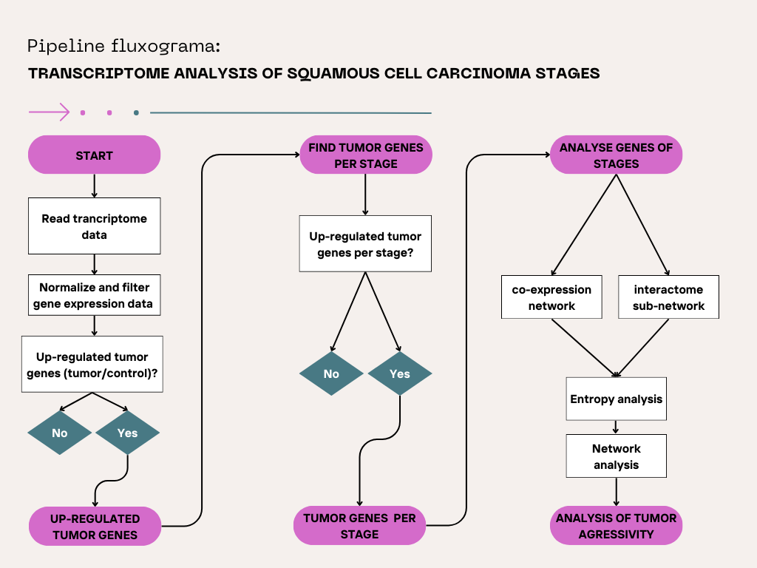Figure 1

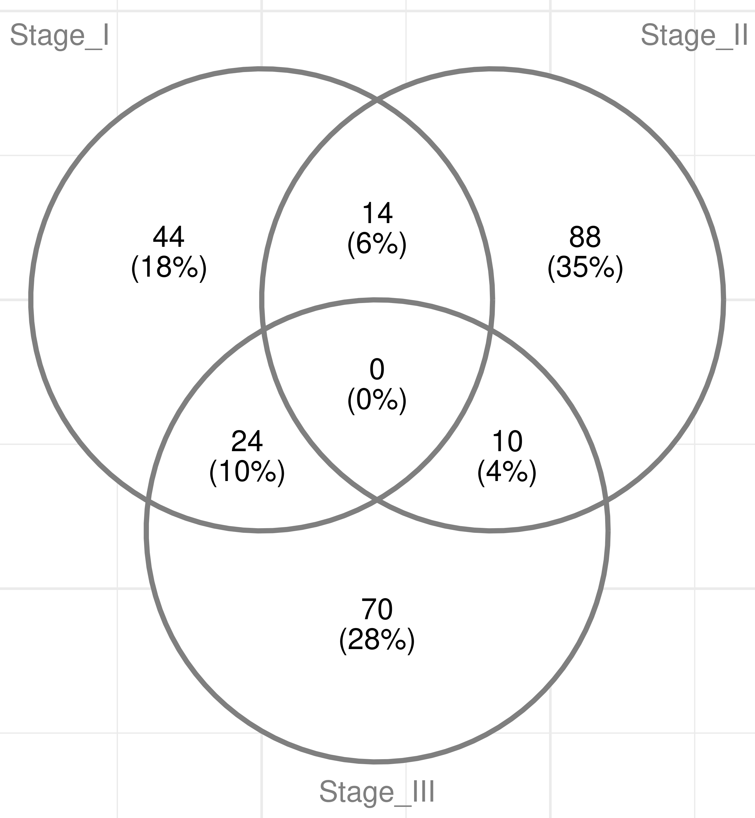Figure 2

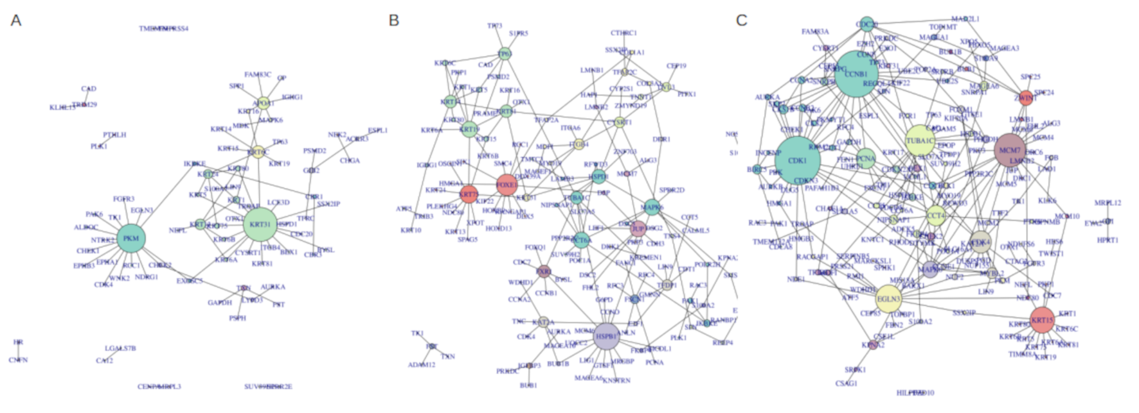Figure 3

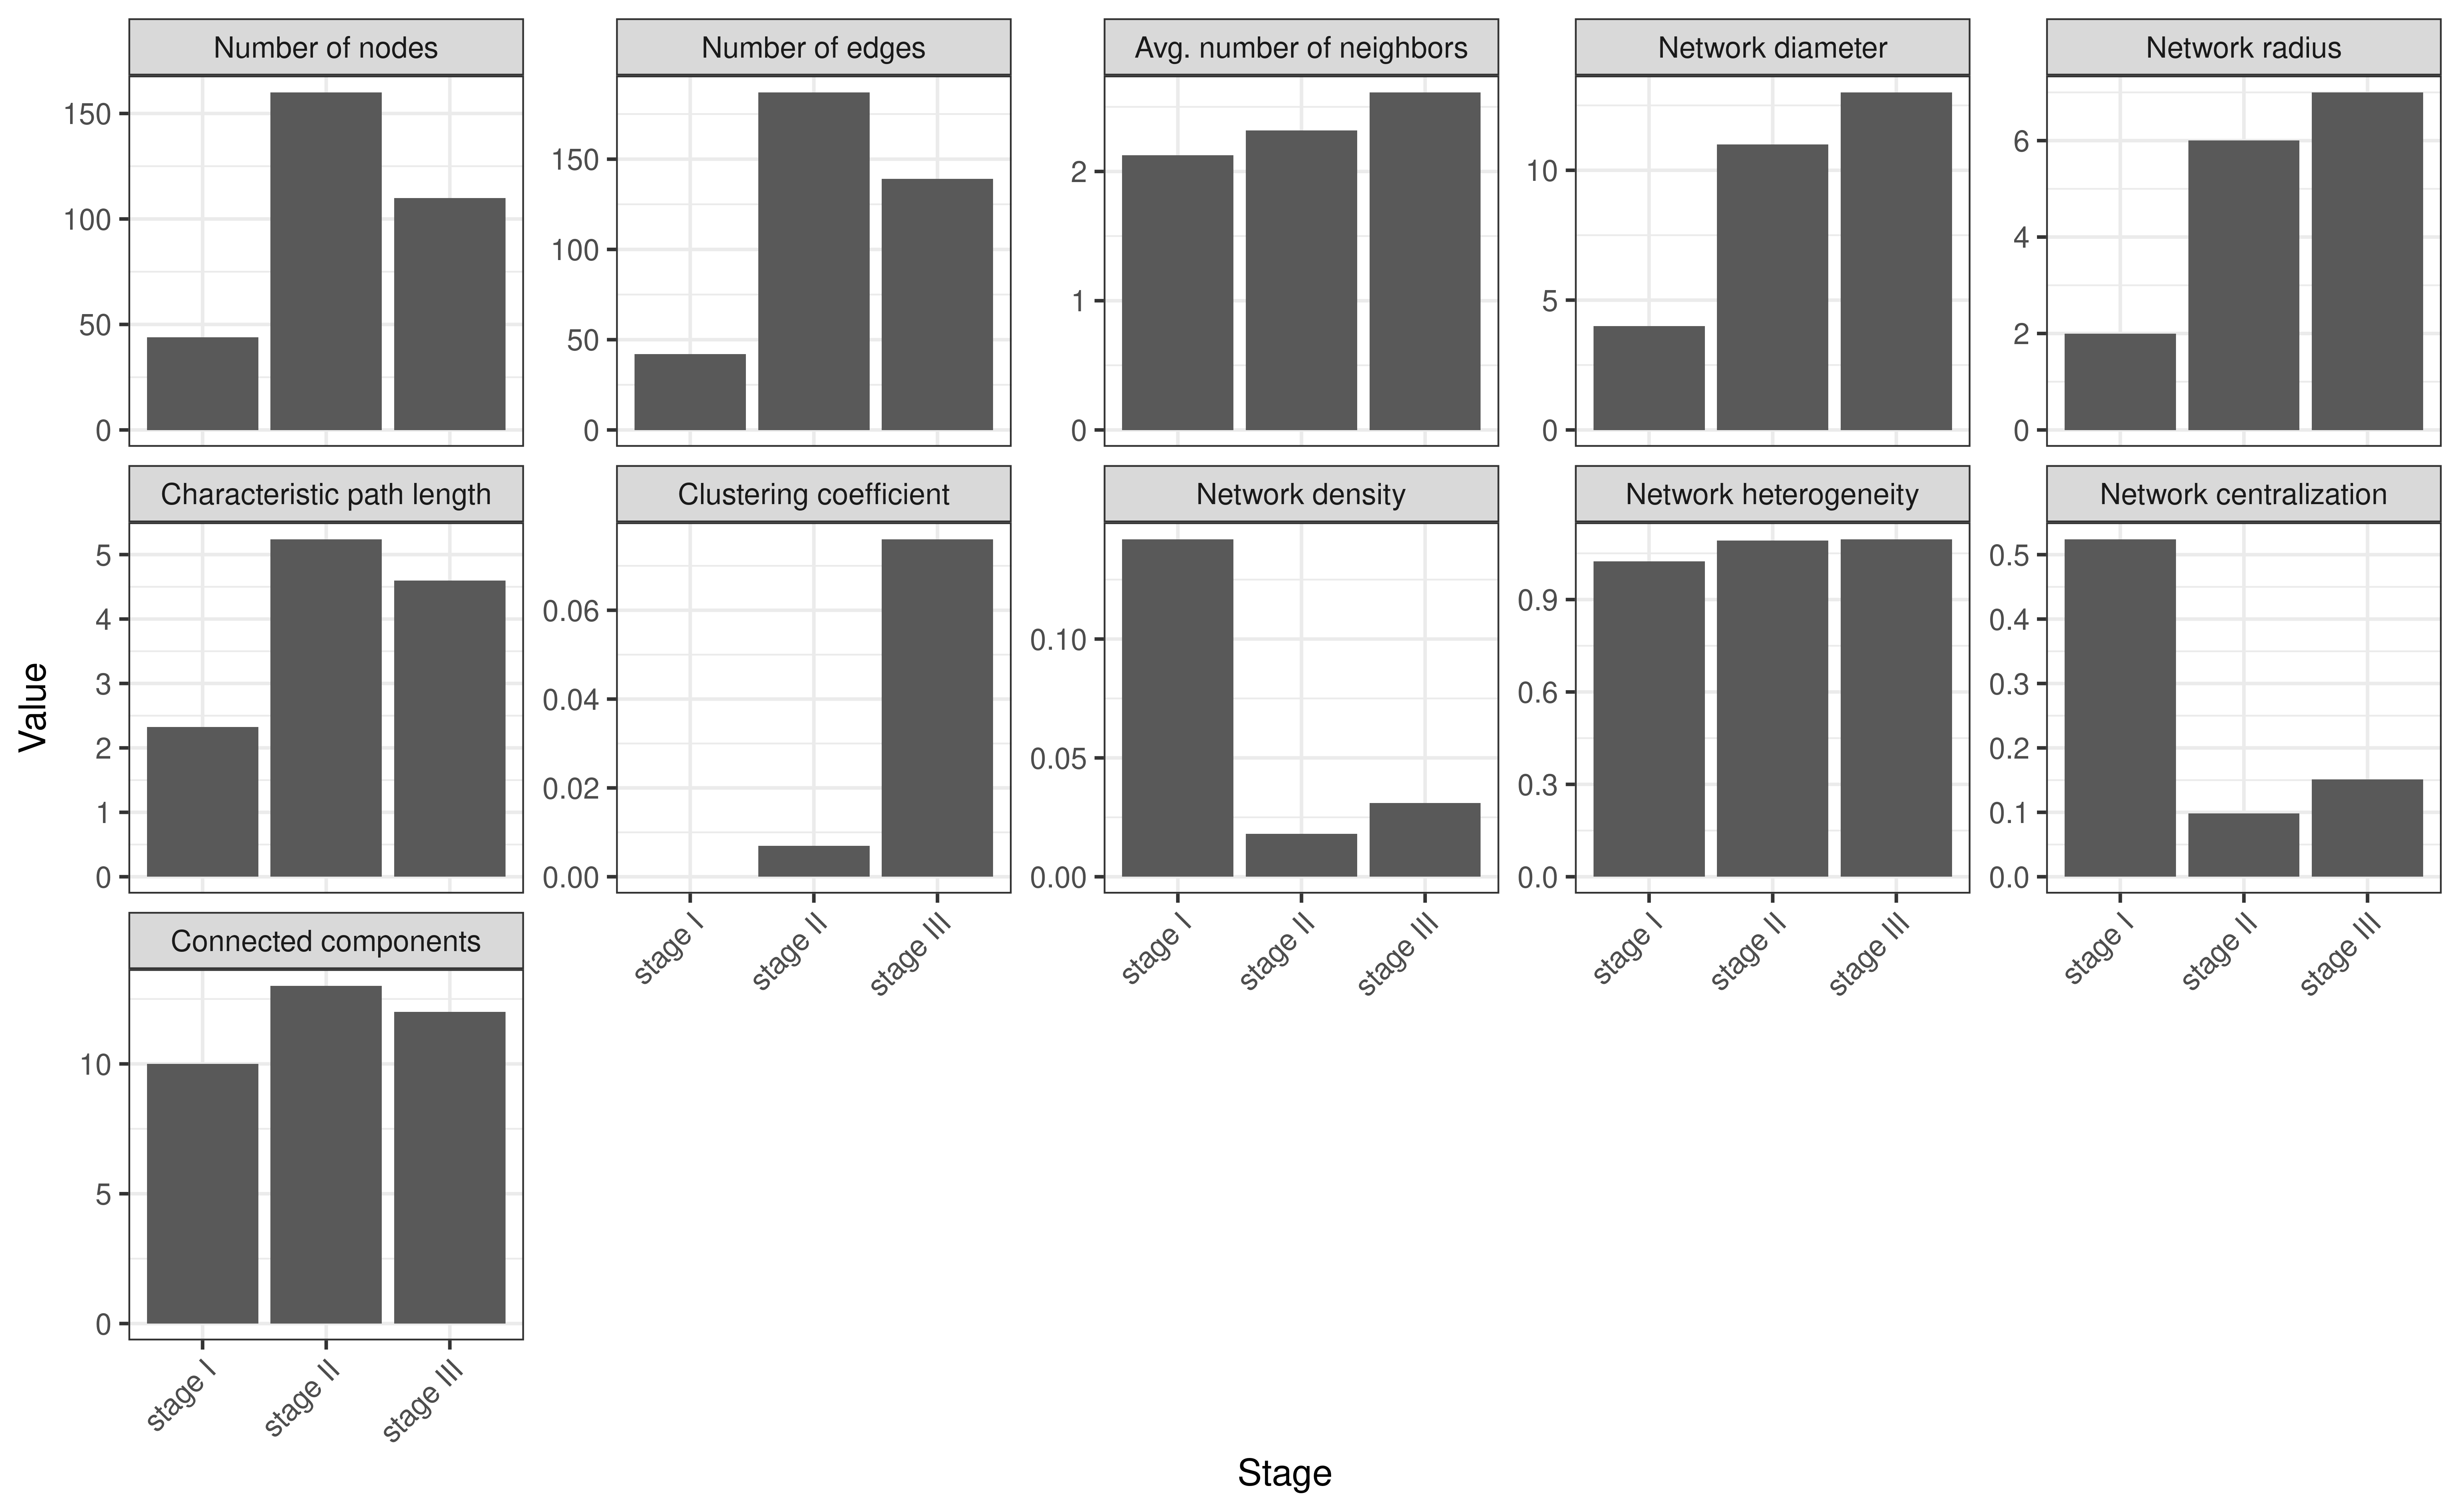Figure 4

Table 1

|  |  |  |  |  |  |  |  |  |  |  |  |  |
| --- | --- | --- | --- | --- | --- | --- | --- | --- | --- | --- | --- | --- |
| Thresholds | | |  | Number of tumor genes per stage (all/exclusive per stage) | | | co-expression netwok, after filtering (Nº of vertex/Nº of edges/Entropy) | | | sub-interactome network, extrapolated (Nº of vertex/Nº of edges/Entropy) | | |
| RPKM | LFC tumor | LFC per stage | Nº of tumor genes | **Stage I** | **Stage II** | **Stage III** | **Stage I** | **Stage II** | **Stage III** | **Stage I** | **Stage II** | **Stage III** |
| 3 | ≥1 | ≥1 | 1894 | 159/104 | 246/190 | 344/263 | 78/123/1.8509 | 142/289/2.1892 | 197/416/2.7483 | 360/434/1.8228 | 566/846/2.3299 | 747/1381/2.7499 |
| 5 | ≥1 | ≥1 | 1537 | 154/99 | 243/187 | 338/257 | 74/114/1.774 | 140/287/2.2088 | 192/401/2.74 | 317/376/1.7928 | 486/726/2.3635 | 642/1199/2.7873 |
| 10 | ≥1 | ≥1 | 1022 | 140/87 | 225/171 | 313/236 | 65/90/1.45 | 130/253/2.076 | 177/376/2.7919 | 231/256/1.7223 | 362/527/2.3367 | 462/824/2.7546 |
| 3 | ≥1.58 | ≥1 | 883 | 109/67 | 159/123 | 161/113 | 50/76/1.9375 | 92/190/2.2714 | 84/141/1.9329 | 101/108/1.6237 | 195/229/1.9478 | 233/336/2.2566 |
| 5 | ≥1.58 | ≥1 | 695 | 105/63 | 156/120 | 155/107 | 47/73/2.0019 | 90/188/2.304 | 80/130/1.9456 | 84/89/1.5565 | 157/182/1.986 | 186/273/2.3503 |
| 10 | ≥1.58 | ≥1 | 452 | 92/52 | 145/110 | 134/89 | 39/54/1.4745 | 82/164/2.1161 | 66/93/1.5724 | 57/52/1.3245 | 118/133/1.9119 | 129/175/2.2628 |
| 3 | ≥1.58 | ≥1.58 | 883 | 95/56 | 115/91 | 121/86 | 42/64/1.8642 | 68/113/1.9086 | 64/103/1.8398 | 87/89/1.5051 | 160/187/1.9229 | 195/255/2.0967 |
| 5 | ≥1.58 | ≥1.58 | 695 | 92/53 | 115/91 | 117/82 | 39/56/1.6946 | 68/113/1.9086 | 61/100/1.8995 | 72/73/1.4283 | 131/151/1.9352 | 160/213/2.1903 |
| 10 | ≥1.58 | ≥1.58 | 452 | 82/44 | 115/91 | 104/70 | 33/44/1.4186 | 67/112/1.9261 | 52/82/1.7948 | 44/42/1.3668 | 106/116/1.8114 | 110/139/2.1201 |