Transcriptome analysis of lung squamous cell carcinoma progression and staging

Felipe Leal Valentim¹, Carlyle Ribeiro Lima¹, Nicolas Carels^{1,*}
¹Laboratory of Biological Systems Modeling, Center of Technological Development in Health (CDTS), Oswaldo Cruz Foundation (Fiocruz), 21040-900, Rio de Janeiro, Brazil.
*Correspondence to nicolas.carels@fiocruz.br

Abstract
In this report, we analyzed how the profile of gene over-expression is affected by progression and staging in lung squamous cell carcinoma. We used Shannon entropy of sub-networks of up-regulated malignant genes to ascertain that transcriptome profiling was consistent with tumor staging. Degree-entropies of 3.669, 3.713, and 3.786 bits were associated with stages I, II and III, respectively, which demonstrated the RNA-seq profiling was consistent with tumor progression from stage I to III. We found 23, 62 and 169 genes that were were expression fingerprints for stages I, II and III. among which certain may serve as potential prognostic biomarkers and other may serve for theranostics. Gene distribution according to hallmarks and stage-wise expression analyses showed that the over-expression of
Keywords: LUSC, prognostic, RNA-seq, entropy, biomarkers,

1. Introduction
Lung cancer is the leading cause of cancer with an estimated 1.8 million deaths and 2.2 million new lung cancer cases worldwide in 2020 (Li et al., 2023). The main cause of lung cancer may be smoking (O’Keeffe et al., 2018), but studies on genetic predisposition have also found associations with race and gender (Wang et al., 2017). Lung cancer is heterogeneous and fatal, with non-small cell lung cancer (NSCLC) as its main pathological subtype. Lung squamous cell carcinoma (LUSC) and lung adenocarcinoma (LUAD) are the primary subtypes of NSCLC (Chen et al., 2014) LUSC accounts for 20%–30% of every type of lung cancer. The incidence of LUSC has decreased since the 1990s due to the efforts of smoking cessation programs (Barta et al., 2019). Specific treatments for LUSCs are still lacking, leaving advanced-stage patients with few treatment options (Lau et al., 2022) and clinical outcome remain unsatisfactory (Relli et al., 2019).
Quoting Lau et al. (2022): “The common driver mutations found in LUADs are rarely identified in LUSCs and efforts at identifying driver mutations in LUSC have not been fruitful. Of the few candidate pathways frequently altered in LUSCs, therapies directed to target these pathways had low efficacy in clinical trials. Drug development in LUSCs has been challenging due to complex tumor genomics, a limited mechanistic understanding of the interplay of oncogenic pathways, and a lack of representative mouse models. With such high mortality, the development of therapies specific to LUSCs is urgently needed”.
Rather than classical activating mutations, EGFR gene amplification and elevated protein expression are more common in LUSCs (Socinski et al., 2018) where sensitizing mutations are rare. Inhibition of cross-reacting pathways with wild-type EGFR receptors only resulted in modest benefits at the cost of high toxicity (Zhao et al., 2021). Poor biomarker representativeness can partially explain the lack of efficacy of ERBB-directed therapy. Amplifications in FGFR1 are associated with a worse prognosis (Tsironis et al., 2018), but the limited activity of FGFR inhibitors suggests that FGFR amplification alone may not be a biomarker as predictive as expected. Similarly, there were controversial discussions on the involvement of DDR, RAS, MEK, PI3K-AKT pathways in LUSC, however, therapies targeting these pathways were unsuccessful (see refs in Lau et al., 2022).
Biomarkers can be obtained through many technologies (Zhou et al., 2024). More recently, the over-expression of several genes: (i) FGG, C3, FGA, JUN, CST3, CPSF4, and HIST1H2BH (Wu et al., 2023) and (ii) CCL1, KLRC3, KLRC4, CCL23, and KLRC1 (Li et al., 2021) were proposed as risk and prognostic biomarkers for LUSC, while that of other ARC, CLVS2, ENPP5, FAM83D, HPRT1, HSP8, ITGA2, LCLAT1, LONRF3, MBNL2, MED12L, NACC2, SLC6A8, THBS1, and ZBTB4 proposed as markers of patient survival (Liu et al., 2022). However, critical clinical trial of these markers was not evaluated yet. Several ncRNA were also investigated as potential biomarkers (Wang et al., 2019; Liu et al., 2022), which show that the area is evolving quickly and that new developments could be available in a close future.
The grade of a tumor describes how normal or abnormal its cancer cells look under a microscope. The more normal the cells look, the less aggressive the cancer and the more slowly it grows and spreads (Rosai and Ackerman, 1979). On the other hand, the more abnormal the cells look, the more aggressive the cancer and the faster it is likely to grow and spread (Tsagkalidis and Blaszczyk, 2023). Tumor grades and stages (Amin et al., 2017) were found to be correlated (Derwinger et al., 2010), which allow to use the TNM staging system to assess the evolution of tumor aggressiveness over time and to associate analyze how time affect transcriptome profiling. Here, we propose three new biomarkers as well as a set of new potential drug targets for personalized therapy based on gene over-expression over hallmarks and tumor staging in lung whose purpose is to assess oncologist for prognosis and theranostics. In addition, we analyzed the annotated pathways over staging.

2. Materials and Methods

2.1. RNA-seq materials
RNA-seq from TCGA samples of LUSC were downloaded from the GDC portal (https://portal.gdc.cancer.gov/) accessed on 2024-04-04. Among the 486 lung samples, 45 were paired samples (45 tumor and 45 non-tumoral samples, each from a same patient), and the remaining (441) were non-paired, which means that no control from healthy lung was available for them. The clinical sheet informed that (i) for stage I, 198 LUSC samples were non-paired while 24 were paired, (ii) for stage II, 130 LUSC samples were non-paired, while 17 were paired, (iii) and for stage III, 68 LUSC samples were non-paired, while 4 were paired.

2.2. Detection of expression signatures among stages
RNA-seq counts were normalized according to the reads per kilobase per million mapped reads (RPKM) methodology as described by (Mortazavi et al., 2008). This normalization process was performed using the RPKM package from R (Robinson et al., 2010) for the 15526 human genes of the IntAct (2017 version) interactome (Orchard et al., 2013). The IntAct interactome was obtained from the intact-micluster.txt file (version updated December 2017) accessed on January 11, 2018, at ftp://ftp.ebi.ac.uk/pub/databases/intact/current/psimitab/intact-micluster.txt. Genes with an average RPK ≤ 4 were desconsidered due to the noise they may introduce.
Then, a two-phase method was used to identify stage expression signatures among LUSC genes. First, tumor genes were identified by comparing the tumor with normal samples. In this process, we identified malignant genes whose average expression significantly differed among stages by comparing 486 tumor samples by reference to the 45 normal samples, i.e, (i) for stage I, we compared 222 tumor samples with the 45 normal ones, (ii) for stage II, we compared 147 tumor samples with the 45 normal ones, and (iii) for stage III, we compared 72 tumor samples with the 45 normal ones. We identified these genes whose average expression significantly differed among stages with the abbreviation DEGS. The average expressions in normal and tumor samples were used to calculate the genes that were significantly more expressed in tumors than in normal tissues by computing the false discovery rate (FDR) of paired t-test. From the list of significantly up-regulated genes, we considered those with a log₂ fold change ≥ 1 as up-regulated. Log₂ fold change was calculated as the log₂(average expression of tumor samples of stage i /average expression of normal samples) for i ϵ {1, 2, 3}. This threshold was chosen because it is consensus in the literature and because it can be detected by RT-qPCR. Note that the average expression of a given gene in tumors of a given stage might be different from that of tumors of another stage considering the same gene. However the differences were tiny, in most cases, but the average might mask larger differential expression because of the large variance among samples.
2.3. Shannon entropy
Quoting Enneking et al. (1980), the purposes of a staging system are to “(i) incorporate the significant prognostic factors into a system that describes progressive degrees of risk of local recurrence and distant metastases to which a patient is subject, (ii) stratify the stages so they have specific implications for surgical management, and (iii) provide guidelines for adjunctive therapies”. Staging is correlated with 5-year overall survival (OS) in lung (Jeon et al., 2015). 5-year OS is, therefore, a measure of aggressiveness and it has been shown that it is correlated to Shannon entropy of up-regulated gene sub-networks (Conforte et al., 2019). Thus, we postulated that degree-entropy of sub-network of malignant up-regulated genes could be used to check the proper alignment of up-regulated gene profiling with tumor staging. Consequently, we constructed sub-interactome networks for each stage by sampling the IntAct interactome with their respective up-regulated genes and computed the degree-entropy according to formula 1 using the Entropy function of R (https://www.rdocumentation.org/packages/DescTools/versions/0.99.54/topics/Entropy, accessed on 10 May 2024):
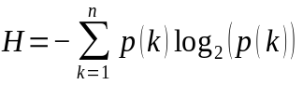 (1)
where p(k) is the probability of occurrence of a vertex with a rank order k (k edges) in the sub-network considered. The events of k edges were computed from the minimum value of one edge between two vertices to the event corresponding to the vertex with the maximal edges n and its neighbors for the sub-network under consideration. When k did not match any vertex in the network, its corresponding entropy was not computed because it would result in an undefined value (log₂(0) is undefined). The sub-networks were generated automatically from gene lists found to be up-regulated for a given stage.

2.4. Hallmarks
We investigated the proportion of up-regulated genes that compose several hallmarks as available from the MSigDB (Liberzon et al., 2015; https://www.gsea-msigdb.org/gsea/msigdb/human/genesets.jsp?collection=H) for each stage. The hallmarks that we considered here were: Androgen response, Angiogenesis, Apoptosis, DNA Repair, E2F, Oestrogen early, Oestrogen late, Fatty acid metabolism, G2M checkpoint, Glycolysis, Hedgehog, Heme metabolism, Hypoxia, IL2_STAT5, IL6_JACK_STAT3, Inflamatory response, Interferon α response, Interferon γ response, KRAS, Mitotic spindle, mTORC1, MYC V1, MYC V2, Myogenesis, Notch, Oxidative phosphorylation, P53, Peroxisome, PI3K/AKT/mTOR, Reactive oxigen, TGFβ, TNFα, Unfolded protein response, and Wnt β-Catenin.

2.5. Functional annotation analysis
ClusterProfiler (Yu et al., 2012; Wu et al., 2021) was used to annotate DEGS according to GO and KEGG. For these two databases, annotations were considered relevant when they adjusted p-value was ≤ 0.05. GeneCards version 5.2 (Stelzer et al., 2016) was queried for each ENSEMBL identifier to retrieve and extract the corresponding disease-associated, related pathways, and gene ontology annotation. CluterProfiler released annotations for 74 (GO), 84 (KEGG), and 132 (Reactome) genes considering all DEGStogether among 77 (GO), 214 (KEGG), and 834 (Reactome) statistically significant terms. Furthermore, the number of genes in each annotated GO, KEGG and Reactome significant terms were counted.

3. Results
3.1. Up-regulated genes from squamous lung cancer biomarkers
We identified 4,882 genes as up-regulated among tumors of the three stages. From these genes 1618, 1694 and 1795 were associated with stages I, II and III, respectively. The PCA (Figure 1A) shows that the first component (PC1) explained 30.46% of total variance in associated with the difference of gene expression between paired normal and tumor samples. Normal samples are arranged in a more concise group while tumor samples show more disperse pattern, both in the first and second components. Among the proteins of these genes, 1140, 1198, 1280 (vertices) formed PPI networks with 3291, 3564, and 4002 edges corresponding to entropies of 3669, 3713, and 3786 for stage I, II, and III, respectively, when compared to the IntAct interactome. Finally, the number of DEGS was 23, 62, 169 for stages I, II and III, respectively (Figure 1B).

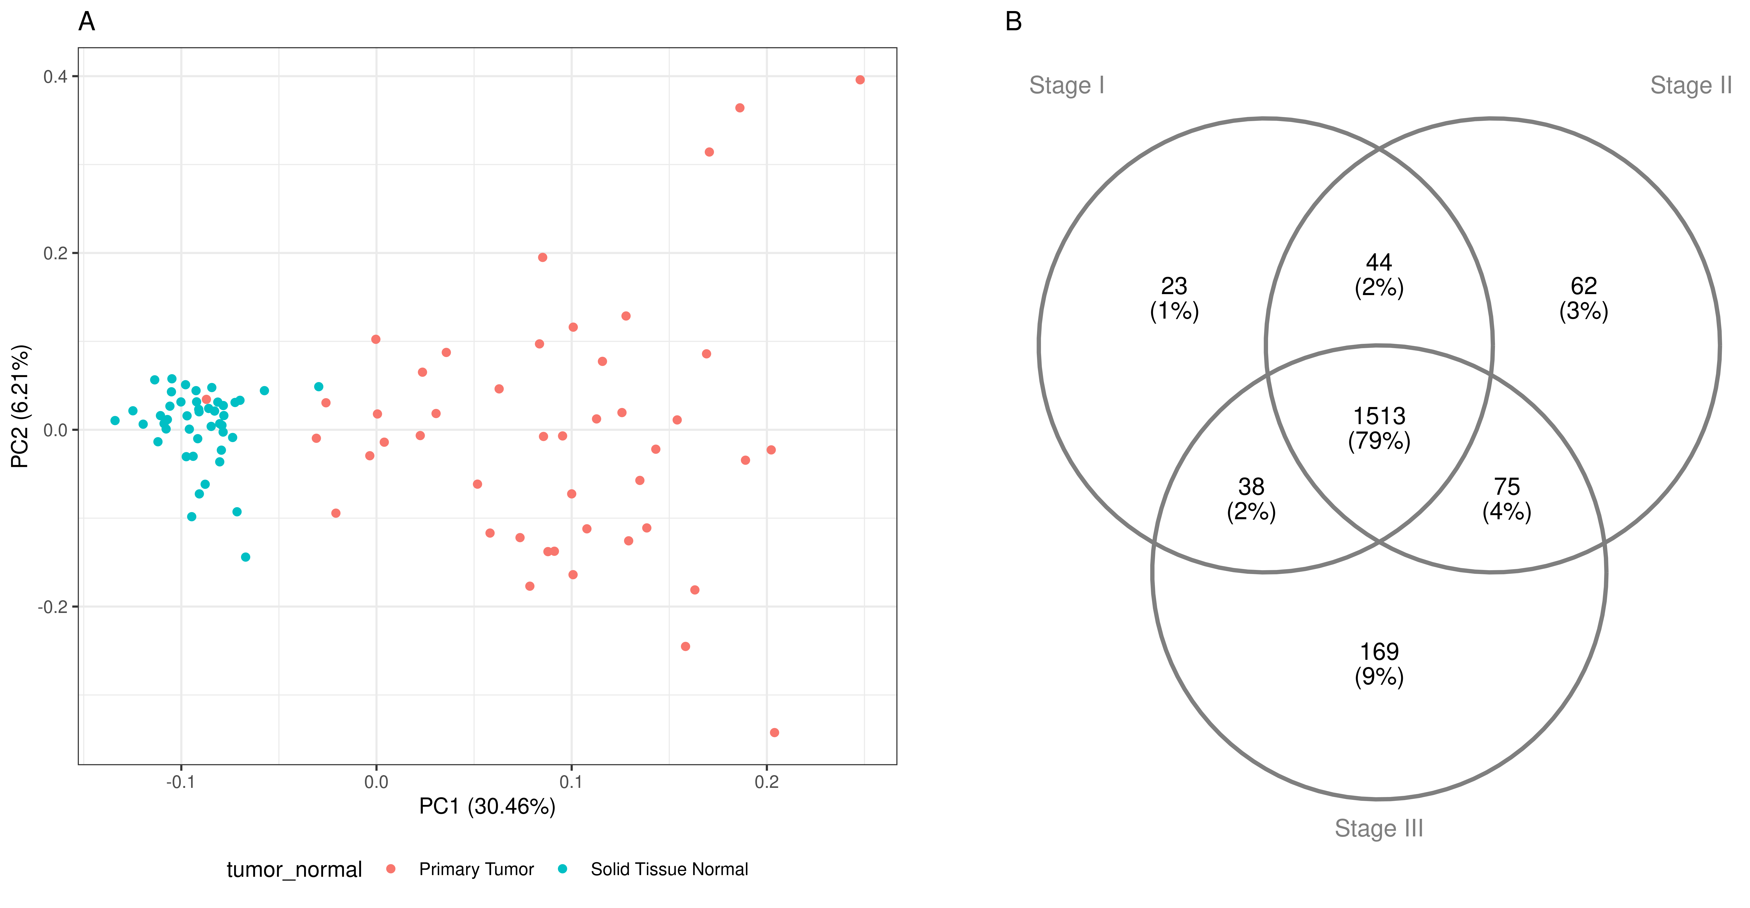
Figure 1. RNA-seq sample composition and gene expression heterogeneity. A: PCA of tumor genes contrasting paired tumor and normal samples. B: Venn diagram of malignant up-regulated genes common to every stages (center) and DEGS (periphery).
3.2. Biomarkers
Comparing DEGS with pubmed for biomarkers, we found a list of 67 genes (Yang et al., 2024; April et al., 2024; Mauricio et al., 2014; Jai et al., 2014; Pamela et al., 2017; Chuantao et al., 2021; Fangwei et al., 2022; Kaier et al., 202). Among these, 24 (36%) were present in the malignant up-regulated genes of this study. Many of these potential biomarkers show large differential expression in our analysis, e.g. ERCC1, AURKA, TPX2, BIRC5, MET, KLK10, TOP2A, PCNA, KRAS, CCNB1, CEP55, TP53, EGFR, CHEK1, CCNB2, RRM1, CDK1, MCC, UBE2C, AURKB, EXT1, PYCR1 (Figure S3).
Moreover, investigation of biomarkers in up-regulated genes found 52 genes with fold changes larger than 50 in turmor, and average RPKM ≤ 10 (Table S1). In table 1, we present the biomarkers whose fold change is ≥100 and average RPKM ≤ 2, which should warrant significant signal-to-noise ratio (Figure 2). The markers that met these criterias had average RPKM ≥ 100.
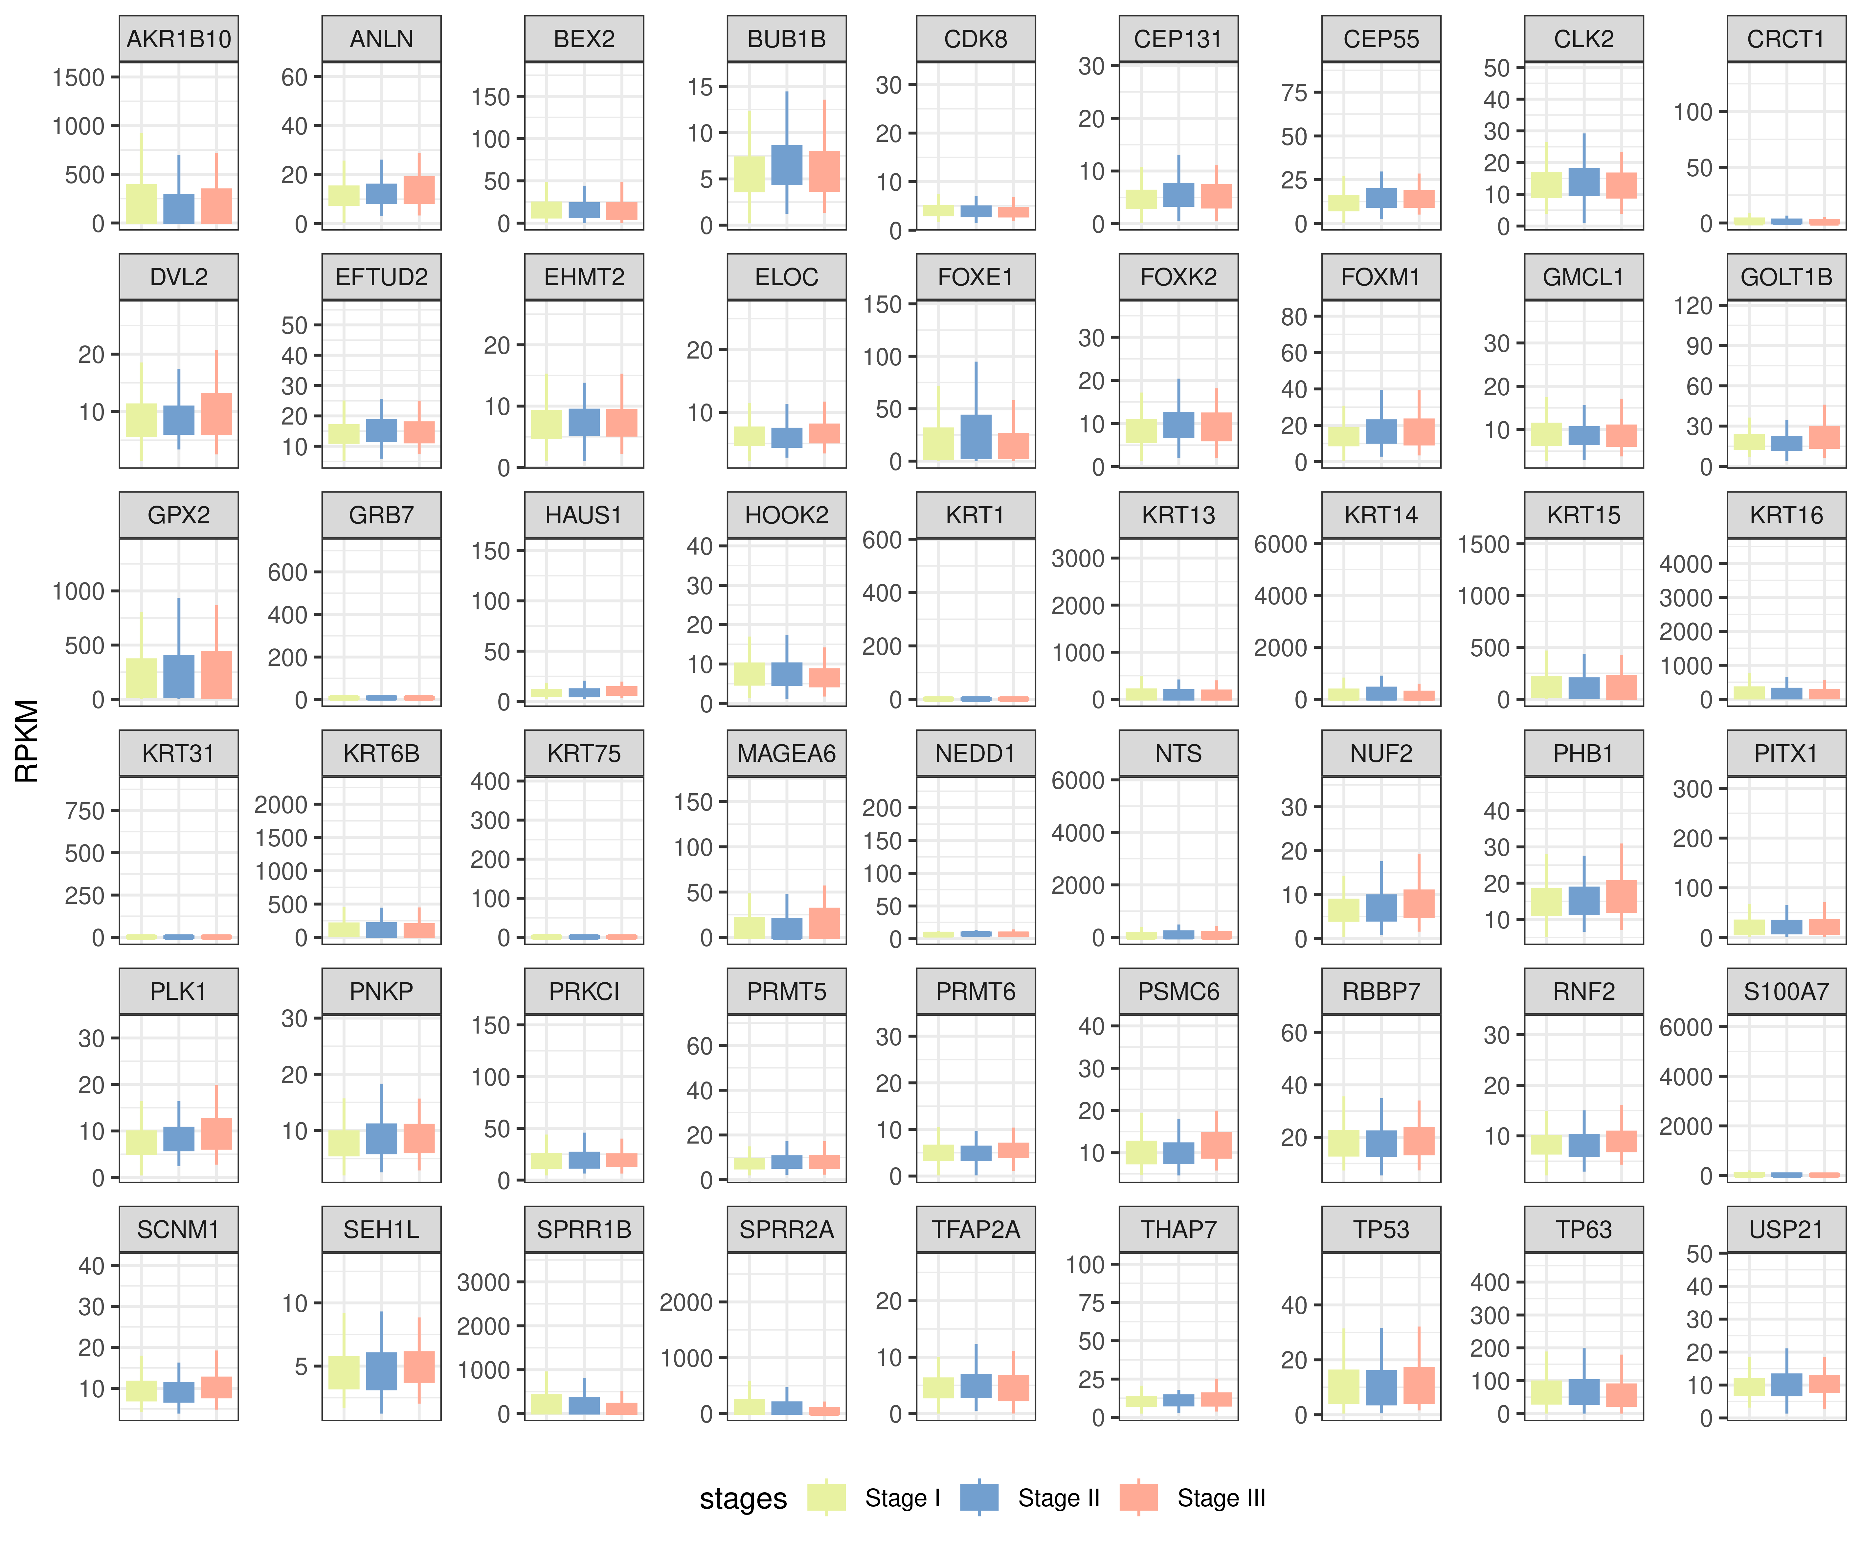
Figure 2: Figure 2. Boxplots of biomarker expression from LUSC (see Tables 1, 2, 3 e 4).

Table 1. Biomarkers whose fold change is ≥100 and average RPKM ≤ 2.
 |  | Control |  | Tumor
# | GS¹ | Avg.² | S.D.³ | Avg. | S.D. | FC⁴
1 | KRT14 | 1.09 | 1.38 | 380.23 | 917.33 | 350.13
2 | KRT16 | 1.15 | 3.02 | 294.09 | 468.97 | 255.21
3 | NTS | 2.63 | 6.24 | 291.99 | 590.41 | 111.02
4 | SPRR1B | 1.40 | 3.48 | 280.04 | 411.30 | 200.03
5 | GPX2 | 1.90 | 2.49 | 245.73 | 291.06 | 129.07
6 | SPRR1B | 1.40 | 3.48 | 242.85 | 594.81 | 173.46
7 | AKR1B10 | 0.80 | 1.83 | 233.28 | 335.42 | 289.87
8 | GPX2 | 1.90 | 2.49 | 230.58 | 272.28 | 121.12
9 | AKR1B10 | 0.80 | 1.83 | 222.94 | 346.23 | 277.02
10 | KRT13 | 0.99 | 1.20 | 199.97 | 401.88 | 202.38
11 | SPRR2A | 1.03 | 3.58 | 198.90 | 418.17 | 193.57
12 | KRT13 | 0.99 | 1.20 | 198.62 | 429.64 | 201.01
13 | AKR1B10 | 0.80 | 1.83 | 171.07 | 258.15 | 212.58
14 | KRT6B | 0.59 | 1.02 | 166.60 | 270.75 | 283.89
15 | S100A7 | 0.49 | 0.92 | 153.56 | 585.11 | 310.28
¹GS: Gene symbol. ²Avg.: Average. ³S.D.: Standard deviation. ⁴FC: Fold change.
Because of their good signal-to-noise ratio, we believe that the markers of Table 1 should be useful for diagnosis in squamous cell lung cancer. However, one can see from Table 1 that standard deviation is large for these genes. Since de distribution of expression for these genes is asymmetric (Figure 2), standard deviation is only used here as an indicator of asymmetry, which show that expression can be significantly larger than the average according to samples. This situation is typical of personalized oncology where combination of markers may indicate a given disease type or condition.

3.3. Hub targets
The other genes of this study do not present a fold change sufficient to be used as biomarkers. However, they could be interesting as targets for therapies; when a protein has interaction with other markers, or when its over-expression may affect their own regulation. Consequently, up-regulated proteins with a large rate of interaction with their neighbors turn them to be potential targets. An average two fold differential expression with the control is already significant in that sense.
Considering that the average connection score of up-regulated genes across every three stages was 30 by reference to the IntAct reactome, we chose 50 as a threshold above which to consider a protein with a higher connection score as a hub. Because therapy is intended to maximize the patient comfort we also filtered out genes whose expression was larger than ~10 in the control since targeting drugs could affect the healthy tissue in case of basal expression. When we performed this exercise with DEGS, we found the results outlined in Table 2.
Table 2. Differential expression of hubs from DEGS.
 |  | Normal |  | Stage I
# | GS¹ | Avg.² | S.D.³ | Avg. | S.D. | FC⁴ | Cnx⁵
1 | GRB7 | 5.29 | 2.01 | 13.44 | 49.63 | 2.54 | 53
 |  | Normal |  | Stage II
1 | SRC | 7.96 | 1.51 | 16.06 | 6.90 | 2.02 | 201
2 | RNPS1 | 10.02 | 1.31 | 20.33 | 6.85 | 2.03 | 163
3 | HOOK2 | 3.89 | 1.21 | 7.99 | 3.87 | 2.05 | 114
4 | EFTUD2 | 7.47 | 1.08 | 15.64 | 5.83 | 2.09 | 60
5 | PRKCI | 10.45 | 5.26 | 21.79 | 17.03 | 2.08 | 54
 |  | Normal |  | Stage III
1 | DVL2 | 4.76 | 0.82 | 9.95 | 5.28 | 2.09 | 126
2 | HAUS1 | 5.11 | 1.46 | 13.02 | 18.43 | 2.55 | 106
3 | RNF2 | 4.53 | 0.77 | 9.45 | 4.19 | 2.09 | 92
4 | PHB1 | 8.36 | 1.50 | 18.05 | 8.79 | 2.16 | 80
5 | ELOC | 3.35 | 1.25 | 6.98 | 2.72 | 2.08 | 59
6 | PSMC6 | 5.96 | 1.55 | 12.39 | 5.12 | 2.08 | 59
7 | THAP7 | 6.56 | 1.19 | 13.89 | 13.10 | 2.12 | 54
8 | SEH1L | 2.56 | 0.75 | 5.19 | 2.12 | 2.02 | 50
¹GS: Gene symbol. ²Avg.: Average. ³S.D.: Standard deviation. ⁴FC: Fold change. ⁵Cnx: Connections.
Among DEGS whose average expression was significantly different in more than one stage, i.e., those corresponding to the intersections of Venn diagram (Figure 1B) between two stages, we find the selected biomarkers (fold change ≥100, average RPKM ≤ 2) in Tables 3.
Table 3. Differential expression of hubs for DEGS of more than one stage.
 |  | Normal |  | Stages I and II
# | GS¹ | Avg.² | S.D.³ | Avg. | S.D. | FC⁴ | Cnx⁵
1 | CDK8 | 2.08 | 0.32 | 4.28 | 2.49 | 2.06 | 80
2 | KRT1 | 0.66 | 0.57 | 7.44 | 41.96 | 11.19 | 51
4 | NEDD1 | 3.94 | 1.03 | 8.66 | 12.41 | 2.20 | 86
 |  | Normal |  | Stages I and III
1 | GMCL1 | 4.62 | 1.17 | 9.31 | 4.17 | 2.02 | 64
2 | GOLT1B | 9.33 | 2.69 | 20.18 | 12.25 | 2.16 | 175
3 | BEX2 | 8.86 | 3.07 | 18.82 | 19.23 | 2.12 | 75
4 | PRMT6 | 2.69 | 0.64 | 5.50 | 3.42 | 2.05 | 82
5 | RBBP7 | 9.49 | 1.29 | 19.04 | 8.74 | 2.01 | 77
6 | SCNM1 | 4.86 | 0.86 | 10.17 | 4.86 | 2.09 | 132
7 | TP53 | 5.83 | 1.21 | 11.78 | 8.98 | 2.02 | 419
 |  | Normal |  | Stages II and III
1 | CEP131 | 2.52 | 0.89 | 5.82 | 2.98 | 2.31 | 53
2 | CLK2 | 6.86 | 1.98 | 14.34 | 6.01 | 2.09 | 76
3 | EHMT2 | 3.87 | 1.05 | 7.74 | 3.62 | 2.00 | 87
4 | FOXK2 | 4.43 | 0.56 | 10.21 | 4.11 | 2.31 | 103
5 | PNKP | 4.46 | 1.15 | 9.14 | 4.19 | 2.05 | 55
6 | PRMT5 | 3.89 | 0.61 | 8.52 | 6.32 | 2.19 | 101
7 | USP21 | 5.16 | 1.35 | 10.45 | 4.70 | 2.02 | 73
¹GS: Gene symbol. ²Avg.: Average. ³S.D.: Standard deviation. ⁴FC: Fold change. ⁵Cnx: Connections.
The intersection common to all up-regulated genes (n=1513) of the Venn diagram in Figure 1B produced 143 potential biomarkers (Table SB). In Table 4, we present 16 hubs with the largest fold changes (>19) found for stage III.

Table 4. Differential expression of hubs from stage III.
 |  | Normal |  | Stage III
# | GS¹ | Avg.² | S.D.³ | Avg. | S.D. | FC⁴ | Cnx⁵
1 | MAGEA6 | 0.01 | 0.02 | 17.14 | 25.76 | 1670.42 | 109
2 | KRT31 | 0.01 | 0.02 | 16.50 | 74.09 | 1546.28 | 368
3 | KRT75 | 0.02 | 0.07 | 10.45 | 46.81 | 487.55 | 124
4 | KRT16 | 1.15 | 3.02 | 294.09 | 468.97 | 255.21 | 69
5 | FOXE1 | 0.09 | 0.17 | 21.82 | 27.02 | 229.88 | 76
6 | CRCT1 | 0.04 | 0.08 | 4.59 | 12.49 | 122.24 | 52
7 | PITX1 | 0.26 | 0.37 | 29.73 | 36.88 | 112.37 | 62
8 | KRT15 | 1.97 | 2.35 | 163.22 | 253.37 | 82.87 | 147
9 | TP63 | 1.22 | 0.70 | 75.66 | 67.81 | 62.16 | 87
10 | TFAP2A | 0.13 | 0.10 | 5.28 | 3.46 | 42.03 | 90
11 | NUF2 | 0.31 | 0.31 | 8.73 | 5.48 | 27.74 | 66
12 | FOXM1 | 0.69 | 0.68 | 16.62 | 9.95 | 24.18 | 57
13 | ANLN | 0.64 | 0.59 | 13.21 | 7.57 | 20.55 | 138
14 | BUB1B | 0.30 | 0.32 | 6.07 | 3.09 | 20.30 | 57
15 | CEP55 | 0.75 | 0.68 | 14.46 | 7.91 | 19.25 | 93
16 | PLK1 | 0.50 | 0.46 | 9.64 | 4.45 | 19.20 | 171
¹GS: Gene symbol. ²Avg.: Average. ³S.D.: Standard deviation. ⁴FC: Fold change. ⁵Cnx: Connections.

3.4. Stage-wise functional analysis
The profile of genes that compose the hallmarks for the three stages is given in Table 5.
Table 5. Distribution of up-regulated genes per hallmark among stage in LUSC.
 | Stage I |  | Stage II |  | Stage III |  | Stage III minus I
Hallmarks | Gene, n | % | Gene, n | % | Gene, n | % | Δ
Androgen resp | 11 | 1.15 |  |  | 12 | 1.19 | 1
Angiogenesis | 10 | 1.05 |  |  | 9 | 0.89 | -1
Apoptosis | 22 | 2.30 |  |  | 19 | 1.89 | -3
DNA_repair | 31 | 3.24 |  |  | 38 | 3.78 | 7
E2F | 101 | 10.56 |  |  | 108 | 10.74 | 7
Oestrogen early | 35 | 3.66 |  |  | 36 | 3.58 | 1
Oestrogen late | 51 | 5.33 |  |  | 51 | 5.07 | 0
Fatty acid metab. | 20 | 2.09 |  |  | 21 | 2.09 | 1
G2M checkpoint | 78 | 8.16 |  |  | 82 | 8.15 | 4
Glycolysis | 58 | 6.07 |  |  | 61 | 6.06 | 3
Hedgehog | 3 | 0.31 |  |  | 3 | 0.30 | 0
Heme metab. | 15 | 1.57 |  |  | 18 | 1.79 | 3
Hypoxia | 36 | 3.77 |  |  | 36 | 3.58 | 0
IL2_STAT5 | 28 | 2.93 |  |  | 25 | 2.49 | -3
IL6_JACK_STAT3 | 8 | 0.84 |  |  | 7 | 0.70 | -1
Inflamatory resp. | 12 | 1.26 |  |  | 11 | 1.09 | -1
Interf. α resp. | 2 | 0.21 |  |  | 2 | 0.20 | 0
Interf. γ resp. | 7 | 0.73 |  |  | 8 | 0.80 | 1
KRAS | 18 | 1.88 |  |  | 18 | 1.79 | 0
Mitotic spindle | 34 | 3.56 |  |  | 33 | 3.28 | -1
mTORC1 | 68 | 7.11 |  |  | 78 | 7.75 | 10
MYC V1 | 87 | 9.10 |  |  | 99 | 9.84 | 12
MYC V2 | 30 | 3.14 |  |  | 32 | 3.18 | 2
Myogenesis | 18 | 1.88 |  |  | 19 | 1.89 | 1
Notch | 8 | 0.84 |  |  | 8 | 0.80 | 0
Oxidat. Phosphoryl. | 35 | 3.66 |  |  | 43 | 4.27 | 8
P53 | 36 | 3.77 |  |  | 35 | 3.48 | -1
Peroxisome | 11 | 1.15 |  |  | 12 | 1.19 | 1
PI3K/AKT/mTOR | 13 | 1.36 |  |  | 14 | 1.39 | 1
React. oxigen | 13 | 1.36 |  |  | 13 | 1.29 | 0
TGFβ | 2 | 0.21 |  |  | 2 | 0.20 | 0
TNFα | 17 | 1.78 |  |  | 14 | 1.39 | -3
Unf. Prot. Resp. | 28 | 2.93 |  |  | 30 | 2.98 | 2
Wnt_β-Catenin | 10 | 1.05 |  |  | 9 | 0.89 | -1
Total | 956 |  |  |  | 1006 |  | 50

Despite the small differences among stages, one can observe from Table 5 that the increase in gene number in (n=50) from stage I to stage III occurs mainly in the hallmarks of: DNA repair, E2F, G2M checkpoint, Glycolysis, mTORC1, MYC V1, and Oxidative phosphorylation.

3.5. Stage-wise functional analysis

In addition to hallmarks, ClusterProfiler was used to annotate DEGS by comparison to GO, KEGG and Reactome (see Table 1 and Table S1). We first noted KEGG pathways common to all stages: “Biosynthesis of cofactors”, “Chemical carcinogenesis - receptor activation”, “Nicotinate and nicotinamide metabolism” and “Nucleocytoplasmic transport”. From these, "Nicotinate and nicotinamide metabolism" pathway is shown to be modulated by genes related to esophageal squamous cell carcinoma (Qi et. al 2024). Moreover, study relating non-small-cell lung cancer "Chemical carcinogenesis - receptor activation" has also been found (Kaili et. at. 2024).
We selected the 3 most anbundant terms per stage, for each GO, KEGG and Reactome.We noted that the most frequent GO terms for stage I were related to “stress granule”. Functions and mechanisms of stress granules have already been studied in cancer, and OLFM4, GRB7, DHX36 are known to be associated to lung cancer through this function (Figure 3A). Moreover, the KEGG analysis revealed the participation of FABP7 to the PPAR-signaling pathway given that PARγ in myeloid cells is known to promote lung cancer progression and metastasis (Jiyun et al., 2024).
Stage II was enriched with GO terms for “axonogenesis”, “mesenchyme development”, and “regulation of nervous system development” (CTTN, EFNB1, HIF1A, EPHB6, EPHA4, NR1D1, LAMA5, PARD3, ADAM8, THY1, PRKCI, ROBO1, HNRNPAB).
Concerning stage III, we found the following enrich terms: “mitochondrial inner membrane”, “mitochondrial matrix” and “mitochondrial protein-containing complex” referring to TIMM9, NDUFS8, COX6A1, MRPL18, COX7A2L, PLA2G4A, MRPS7, SUPV3L1, MALSU1, MRPL17, MAIP1, ABCE1, NUDT2, PHB1, MRPL48, GADD45GIP1, MRPS23, MRPS16, GLRX5, MRPL40 and TIMM23. When considering the Reactome’s pathways, we found altered gene expression (DVL2, PSMB1, VTA1, AP2S1, SEH1L, PSMC6, PSMA7, PSMD7, AKT2, BCL9, CLTA, ELOC, PSMD4, PSMC2 and NELFA) for genes in the WNT pathway (Figure 3B). Recurrent WNT pathway alterations are frequent in relapsed small cell lung cancer (Cody et. al., 2021). WNT and cross-linked pathways are known to participate from the proliferative signaling (Baker et al., 2017).
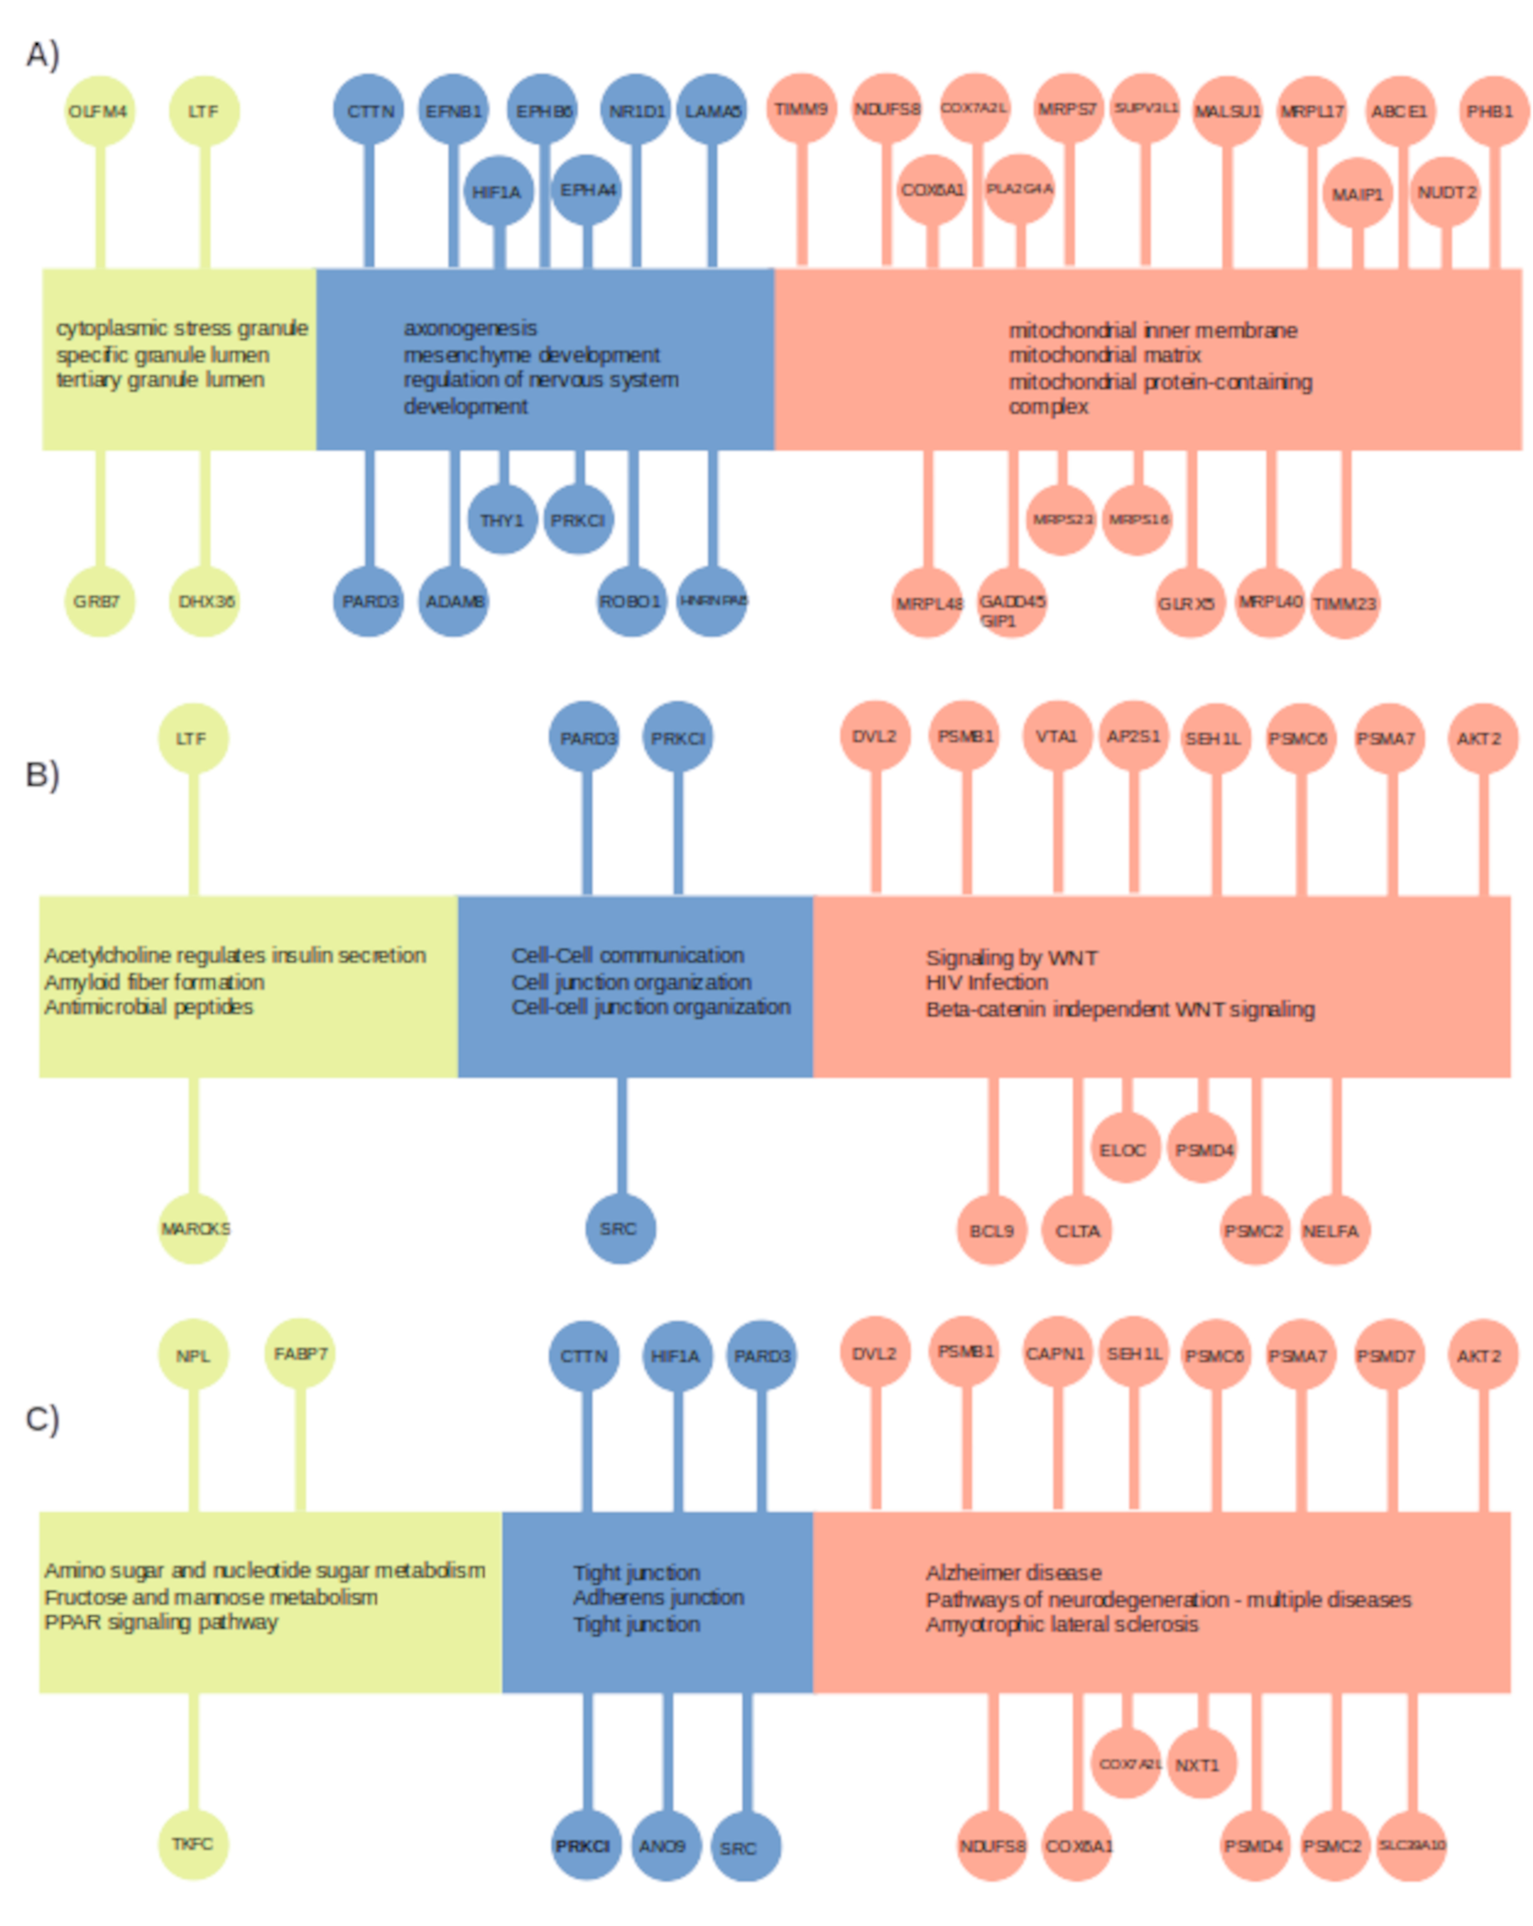Figure 3: Figure 3: Summary of funcional analysis with ClusterProfiler. Terms with greatest number of genes are visualized for A) GO, B) Reactome and C) KEGG databases.

4. Discussion
The directive of World Health Organization (WHO) is to support the development of fast methods of lead screening against cancer, and the classification of tumors for suitable therapies. By 2020, the cancer of lung (2.21 million cases) came in second place worldwide behind that of breast (2.26 million cases), but before those of colon and rectum (1.93 million cases), prostate (1.41 million cases), skin (non-melanoma, 1.20 million cases), and stomach (1.09 million cases).
A general remark of this study is that the differences of expression between stages were too small for DEGS to be considered as stage markers. Simply their demonstrated a statistically significant trend of expression according to stages for the considered gene (see Table SW). However, large variances of gene expression were observed, which means that the average of gene expression is not necessary a suitable metric in a personalized oncology approach of patient treatment. In such a particular case, a patient may show a much larger expression of a given gene compared to the control and, in that case, the referred gene could serve as a therapy target for the patient under consideration. In that sense, our study based on the comparison of averages across tumor samples with controls extracts significant tendencies that must be validated case by case. Whether differences of expression among stages are significant or not from a medical standpoint will need to be validated in further experiments.

4.1. Biomarkers

4.2. Hub targets

4.3. Hallmarks

4.4. Enrichment analysis
To compensate for the small differences of gene expression among stages, we performed enrichment analyses where we considered GO, KEGG, and Reactome annotations and made the hypothesis that those holding more genes were more relevant for the stage under consideration. The evolution of annotation class enrichment with genes roughly portrait the functional trajectory of tumors among stages. The rough figure that was obtained shows our annotations should be improved in the case of cancer.
Tumor trajectory can be viewed through the participation of an increasing gene number to functional annotation and reveal key mechanisms of cancer progression. Notably, for the stage I we found terms associated to stree granule (GO, cytoplasmic stress granule, specific granule lumen, tertiary granule lumen) and PPAR signaling pathway (KEGG, PPAR signaling pathway). For stage II, pathways related to cell junction (KEGG, Cell-Cell communication, Cell junction organization, Cell-cell junction organization, REACTOME, Tight junction, Adherens junction) are noted. For stage III we found enrichment of terms related to mitochondrial activity (GO, mitochondrial inner membrane, mitochondrial matrix, mitochondrial protein-containing complex) WNT Signaling (Reactome, Signaling by WNT, Beta-catenin independent WNT signaling).
XXXXX

5. Conclusion

Acknowledgement
Aqui, os detalhes da sua bolsa.

References
Abbarin N, Miguel SS, Holcroft J, Iwasaki K, Ganss B. The enamel protein Amelotin is a promoter of hydroxyapatite mineralization. J Bone Miner Res. 2015;30(5):775–85.
Alfredo Paredes Lario, Carlos Blanco García, Miguel Echenique Elizondo, Carmen Lobo. Expression of Proteins Associated With Multidrug Resistance to Chemotherapy in Lung Cancer. Arch Bronconeumol. 2007 Sep;43(9):479-84.
Amin MB, Greene FL, Edge SB, Compton CC, Gershenwald JE, Brookland RK, Meyer L, Gress DM, Byrd DR, Winchester DP. The Eighth Edition AJCC Cancer Staging Manual: Continuing to build a bridge from a population-based to a more "personalized" approach to cancer staging. CA Cancer J Clin. 2017 Mar;67(2):93-99. doi: 10.3322/caac.21388. Epub 2017
Bai Q, Yang X, Li Q, Chen W, Tian H, Lian R, Liu X, Wang S, Yang Y. Metastatic Tumor Cell-Specific FABP7 Promotes NSCLC Metastasis via Inhibiting β-Catenin Degradation. Cells. 2022 Feb 25;11(5):805. doi: 10.3390/cells11050805.
Baker S, Ali I, Silins I, Pyysalo S, Guo Y, Högberg J, Stenius U, Korhonen A. Cancer Hallmarks Analytics Tool (CHAT): a text mining approach to organize and evaluate scientific literature on cancer. Bioinformatics. 2017 Dec 15;33(24):3973-3981. doi: 10.1093/bioinformatics/btx454.
Barta JA, Powell CA, Wisnivesky JP. Global Epidemiology of Lung Cancer. Ann Glob Health. 2019 Jan 22;85(1):8. doi: 10.5334/aogh.2419.
Bawazir AA, Alrossais NM, BinSaleh Y, Alamodi AA, Alshammari A. A Case Report of Intrapulmonary Teratoma in the Right Upper Lung Zone in a 35-year-old Female Patient. Cureus. 2019 Jan 7;11(1):e3834. doi: 10.7759/cureus.3834.
Chen Z, Fillmore CM, Hammerman PS, Kim CF, Wong KK. Non-small-cell lung cancers: a heterogeneous set of diseases. Nat Rev Cancer (2014) 14(8):535–46. doi: 10.1038/nrc3775.
Chen C, Maimaiti A, Zhang X, Qu H, Sun Q, He Q, Yu W. Knockdown of RAI14 suppresses the progression of gastric cancer. Onco Targets Ther. 2018;11:6693–6703. doi:10.2147/ott.s175502
Chi T. Viet, Kesava R. Asam, Gary Yu, Emma C. Dyer, Sara Kochanny, Carissa M. Thomas, Nicholas F. Callahan, Anthony B. Morlandt, Allen C. Cheng, Ashish A. Patel, Dylan F. Roden, Simon Young, James Melville, Jonathan Shum, Paul C. Walker, Khanh K. Nguyen, Stephanie N. Kidd, Steve C. Lee, Gretchen S. Folk, Dan T. Viet, Anupama Grandhi, Jeremy Deisch, Yi Ye, Fatemeh Momen-Heravi, …Bradley E. Aouizerat. Artificial intelligence-based epigenomic, transcriptomic and histologic signatures of tobacco use in oral squamous cell carcinoma. npj Precision Oncology volume 8, Article number: 130 (2024)
Chuantao Zhang, Man Jiang, Na Zhou, Helei Hou, Tianjun Li, Hongsheng Yu, Yuan-De Tan, and Xiaochun Zhang. Use tumor suppressor genes as biomarkers for diagnosis of non-small cell lung cancer. Sci Rep. 2021; 11: 3596.
Cody J. Aros, Carla J. Pantoja & Brigitte N. Gomperts . Wnt signaling in lung development, regeneration, and disease progression. Communications Biology volume 4, Article number: 601 (2021).
Conforte AJ, Tuszynski JA, da Silva FAB, Carels N. Signaling Complexity Measured by Shannon Entropy and Its Application in Personalized Medicine. Front Genet. 2019 Oct 21;10:930. doi: 10.3389/fgene.2019.00930.Derwinger K, Kodeda K, Bexe-Lindskog E, Taflin H. Tumour differentiation grade is associated with TNM staging and the risk of node metastasis in colorectal cancer. Acta Oncol. 2010;49(1):57-62. doi: 10.3109/02841860903334411.
Enneking WF, Spanier SS, Goodman MA. A system for the surgical staging of musculoskeletal sarcoma. Clin Orthop Relat Res 1980;153:106–120
Fangwei Wang,Qisheng Su, and Chaoqian Li. Identidication of novel biomarkers in non-small cell lung cancer using machine learning. Sci Rep. 2022; 12: 16693.
Hanxiao Li, P. Anton van der Merwe & Shivan Sivakumar. Biomarkers of response to PD-1 pathway blockade. British Journal of Cancer volume 126, pages1663–1675 (2022)
Hou L, Zhou H, Wang Y, Liu J, Zhang D, Li Y, Xue X. Identification of FABP7 as a Potential Biomarker for Predicting Prognosis and Antiangiogenic Drug Efficacy of Glioma. Dis Markers. 2022 Jun 24;2022:2091791. doi: 10.1155/2022/2091791.
Huan Zhou, Jing Luo, Kelin Mou, Lin Peng, Xiaoyue Li, Yulin Lei, Jianmei Wang, Sheng Lin, Yuhao Luo, and Li Xi. Stress granules: functions and mechanisms in cancer. Cell Biosci. 2023; 13: 86.
J Wohlschläger, C Wittekind, D Theegarten. New TNM classification of malignant lung tumours. Pathologe. 2010 Sep;31(5):355-60. doi: 10.1007/s00292-010-1303-4.
Jai N. Patel, Jennifer L. Ersek, and Edward S. Kim. Lung cancer biomarkers, targeted therapies and clinical assays. Transl Lung Cancer Res. 2015 Oct; 4(5): 503–514.
Jeon DS, Kim HC, Kim SH, Kim TJ, Kim HK, Moon MH, Beck KS, Suh YG, Song C, Ahn JS, Lee JE, Lim JU, Jeon JH, Jung KW, Jung CY, Cho JS, Choi YD, Hwang SS, Choi CM; Korean Association for Lung Cancer; Korea Central Cancer Registry. Five-Year Overall Survival and Prognostic Factors in Patients with Lung Cancer: Results from the Korean Association of Lung Cancer Registry (KALC-R) 2015. Cancer Res Treat. 2023 Jan;55(1):103-111. doi: 10.4143/crt.2022.264.
Jiyun Zhang, Miru Tang, andJinsai Shang. PPARγ Modulators in Lung Cancer: Molecular Mechanisms, Clinical Prospects, and Challenges. Biomolecules 2024, 14(2), 190
Junmiao Wen, Wang Zheng, Liang Zeng, Boyan Wang, Donglai Chen, Yongbing Chen, Xueguan Lu, Chunlin Shao, Jiayan Chen, and Min Fan. LTF Induces Radioresistance by Promoting Autophagy and Forms an AMPK/SP2/NEAT1/miR-214-5p Feedback Loop in Lung Squamous Cell Carcinoma. Int J Biol Sci. 2023; 19(5): 1509–1527.
Kaier Cai, Zhilong Xie, Yingao Liu, Junfeng Wu, Hao Song, Wang Liu, Xinyi Wang, Yinghuan Xiong, Siyuan Gan, and Yanqin. Identification of Potential Key Genes and Prognostic Biomarkers of Lung Cancer Based on Bioinformatics. Biomed Res Int. 2023; 2023: 2152432.
Kaili Guo, Yu Jiang, Wei Qiao, Panpan Yuan, Miao Xue, Jiping Liu, Hao Wei, Bin Wang, Xingmei Zhu. Revealing the active ingredients and mechanism of P. sibiricumm in non-small-cell lung cancer based on UPLC-Q-TOF-MS/MS, network pharmacology, and molecular docking. Heliyon. 2024 Apr 3;10(7):e29166. doi: 10.1016/j.heliyon.2024.e29166. eCollection 2024 Apr 15.
Karlic, KJ.; Chang, AC.; Ayanian, JZ.; Ruff, AL. An Extremely Rare Cause of Restrictive Lung Disease: Intrapulmonary Mature Teratoma. AIM Clinical Cases 2023, 2, e230697. doi:10.7326/aimcc.2023.0697.
Lau SCM, Pan Y, Velcheti V, Wong KK. Squamous cell lung cancer: Current landscape and future therapeutic options. Cancer Cell. 2022 Nov 14;40(11):1279-1293. doi: 10.1016/j.ccell.2022.09.018.
Li C, Lei S, Ding L, Xu Y, Wu X, Wang H, Zhang Z, Gao T, Zhang Y, Li L. Global burden and trends of lung cancer incidence and mortality. Chin Med J (Engl). 2023 Jul 5;136(13):1583-1590. doi: 10.1097/CM9.0000000000002529.
Li N, Li Y, Zheng P, Zhan X. Cancer Stemness-Based Prognostic Immune-Related Gene Signatures in Lung Adenocarcinoma and Lung Squamous Cell Carcinoma. Front Endocrinol (Lausanne). 2021 Oct 21;12:755805. doi: 10.3389/fendo.2021.755805.
Liberzon A, Birger C, Thorvaldsdóttir H, Ghandi M, Mesirov JP, Tamayo P. The Molecular Signatures Database (MSigDB) hallmark gene set collection. Cell Syst. 2015 Dec 23;1(6):417-425. doi: 10.1016/j.cels.2015.12.004.
Liu H, Li T, Dong C, Lyu J. Identification of miRNA signature for predicting the prognostic biomarker of squamous cell lung carcinoma. PloS One (2022) 17(3):e0264645. doi: 10.1371/journal.pone.0264645.
Mardani, P., Naseri, R., Amirian, A.; Shahriarirad, R.; Anbardar, M.H.; Fouladi, D.; Ranjbar, K. Intrapulmonary mature cystic teratoma of the lung: case report of a rare entity. BMC Surg 20, 203 (2020). doi:10.1186/s12893-020-00864-y.
Mauricio Burotto,Anish Thomas,Deepa Subramaniam,Giuseppe Giaccone and Arun Rajan. Biomarkers in Early-Stage Non-Small Cell Lung Cancer: Current Concepts and Future Directions. J Thorac Oncol. 2014 Nov; 9(11): 1609–1617.
Mingxue Wang, Renjie Yu, Xuefeng Ling, Wa Cao, Yunyun Liu, Lei Fang, and Jianlin Tong. COPB2 promotes metastasis and inhibits apoptosis of lung adenocarcinoma cells through functioning as a target of miR-216a-3p. Transl Cancer Res. 2020 Apr; 9(4): 2648–2659. doi: 10.21037/tcr.2020.02.65
Mortazavi A, Williams BA, McCue K, Schaeffer L, Wold B (2008) Mapping and quantifying mammalian transcriptomes by RNA-Seq. Nature Methods 5: 621–628. pmid:18516045
O'Keeffe LM, Taylor G, Huxley RR, et al. Smoking as a risk factor for lung cancer in women and men: a systematic review and meta-analysis. BMJ Open 2018;8:e021611. doi:10.1136/bmjopen-2018-021611
Orchard S, Ammari M, Aranda B, Breuza L, Briganti L, Broackes-Carter F, Campbell NH, Chavali G, Chen C, del-Toro N, Duesbury M, Dumousseau M, Galeota E, Hinz U, Iannuccelli M, Jagannathan S, Jimenez R, Khadake J, Lagreid A, Licata L, Lovering RC, Meldal B, Melidoni AN, Milagros M, Peluso D, Perfetto L, Porras P, Raghunath A, Ricard-Blum S, Roechert B, Stutz A, Tognolli M, van Roey K, Cesareni G, Hermjakob H. The MIntAct project--IntAct as a common curation platform for 11 molecular interaction databases. Nucleic Acids Res. 2014 Jan;42(Database issue):D358-63. doi: 10.1093/nar/gkt1115.
Pamela Villalobos, Ignacio I. Wistuba. Lung Cancer Biomarkers. Hematol Oncol Clin North Am. 2017 Feb; 31(1): 13–29.
Peter Larsson, Daniella Pettersson, Hanna Engqvist, Elisabeth Werner Rönnerman, Eva Forssell-Aronsson, Anikó Kovács, Per Karlsson, Khalil Helou & Toshima Z. Parris. Pan-cancer analysis of genomic and transcriptomic data reveals the prognostic relevance of human proteasome genes in different cancer types. BMC Cancer volume 22, Article number: 993 (2022)
Qi Huang, Haiming Chen, Dandan Yin, Jie Wang, Shaodong Wang, Feng Yang, Jiawei Li, Teng Mu, Jilun Li, Jia Zhao, Rong Yin, Wei Li, Mantang Qiu, Erbao Zhang & Xiangnan Li. Multi-omics analysis reveals NNMT as a master metabolic regulator of metastasis in esophageal squamous cell carcinoma. npj Precision Oncology volume 8, Article number: 24 (2024) Cite this article
Rana SS, Swami N, Mehta S, Singh J, Biswal S. Intrapulmonary teratoma: an exceptional disease. Ann Thorac Surg. 2007 Mar;83(3):1194-6. doi: 10.1016/j.athoracsur.2006.07.072.
Relli V, Trerotola M, Guerra E, Alberti S. Abandoning the notion of non-small cell lung cancer. Trends Mol Med (2019) 25(7):585–94. doi: 10.1016/j.molmed.2019.04.012.
Robinson MD, McCarthy DJ, Smyth GK. edgeR: a Bioconductor package for differential expression analysis of digital gene expression data. Bioinformatics. 2010;26(1):139-40. doi: 10.1093/bioinformatics/btp616.
Rosai J, Ackerman LV. The pathology of tumors, part III: grading, staging & classification. CA Cancer J Clin. 1979 Mar-Apr;29(2):66-77. doi: 10.3322/canjclin.29.2.66.
Saini ML, Krishnamurthy S, Kumar RV. Intrapulmonary mature teratoma. Diagn Pathol. 2006 Oct 21;1:38. doi: 10.1186/1746-1596-1-38.
Scott, A.; Salgia, R. Biomarkers in lung cancer: from early detection to novel therapeutics and decision making. Biomark Med. 2008 Dec 1; 2(6): 577–586.
Shannon C. E. (1948). A mathematical theory of communication. Bell. Syst. Tech. J. 27 (July 1928), 379–423. 10.1002/j.1538-7305.1948.tb01338.x
Socinski MA, Obasaju C, Gandara D, Hirsch FR, Bonomi P, Bunn PA Jr, Kim ES, Langer CJ, Natale RB, Novello S, Paz-Ares L, Pérol M, Reck M, Ramalingam SS, Reynolds CH, Spigel DR, Wakelee H, Thatcher N. Current and Emergent Therapy Options for Advanced Squamous Cell Lung Cancer. J Thorac Oncol. 2018 Feb;13(2):165-183. doi: 10.1016/j.jtho.2017.11.111.
Stelzer G, Rosen N, Plaschkes I, Zimmerman S, Twik M, Fishilevich S, Stein TI, Nudel R, Lieder I, Mazor Y, Kaplan S, Dahary D, Warshawsky D, Guan-Golan Y, Kohn A, Rappaport N, Safran M, Lancet D. The GeneCards Suite: From Gene Data Mining to Disease Genome Sequence Analyses. Curr Protoc Bioinformatics. 2016 Jun 20;54:1.30.1-1.30.33. doi: 10.1002/cpbi.5.
Tsagkalidis V, Blaszczyk MB, In H. Interpretation of Tumor Response Grade following Preoperative Therapy for Gastric Cancer: An Overview. Cancers (Basel). 2023 Jul 18;15(14):3662. doi: 10.3390/cancers15143662.
Tsironis G, Ziogas DC, Kyriazoglou A, Lykka M, Koutsoukos K, Bamias A, Dimopoulos MA. Breakthroughs in the treatment of advanced squamous-cell NSCLC: not the neglected sibling anymore? Ann Transl Med. 2018 Apr;6(8):143. doi: 10.21037/atm.2018.02.18.
van der Flier LG, Haegebarth A, Stange DE, van de Wetering M, Clevers H. OLFM4 is a robust marker for stem cells in human intestine and marks a subset of colorectal cancer cells. Gastroenterology. 2009 Jul;137(1):15-7. doi: 10.1053/j.gastro.2009.05.035.
Wang, J., Liu, Q., Yuan, S. et al. Genetic predisposition to lung cancer: comprehensive literature integration, meta-analysis, and multiple evidence assessment of candidate-gene association studies. Sci Rep 7, 8371 (2017). https://doi.org/10.1038/s41598-017-07737-0.
Wan Zhu, Longxiang Xie, Jianye Han, and Xiangqian Guo. The Application of Deep Learning in Cancer Prognosis Prediction. Cancers (Basel). 2020 Mar; 12(3): 603.
Wang X, Su R, Guo Q, Liu J, Ruan B, Wang G. Competing endogenous RNA (ceRNA) hypothetic model based on comprehensive analysis of long non-coding RNA expression in lung adenocarcinoma. PeerJ (2019) 7:e8024. doi: 10.7717/peerj.8024.
Warren W.G, Osborn M, Yates A, O'Sullivan SE. The emerging role of fatty acid binding protein 7 (FABP7) in cancers. Drug Discov Today. 2024 May;29(5):103980. doi: 10.1016/j.drudis.2024.103980.
Wu T, Hu E, Xu S, Chen M, Guo P, Dai Z, Feng T, Zhou L, Tang W, Zhan L, Fu x, Liu S, Bo X, Yu G (2021). “clusterProfiler 4.0: A universal enrichment tool for interpreting omics data.” The Innovation, 2(3), 100141. doi:10.1016/j.xinn.2021.100141.
Wu R, Ma R, Duan X, Zhang J, Li K, Yu L, Zhang M, Liu P, Wang C. Identification of specific prognostic markers for lung squamous cell carcinoma based on tumor progression, immune infiltration, and stem index. Front Immunol. 2023 Sep 29;14:1236444. doi: 10.3389/fimmu.2023.1236444.
Xiao Y, Zhang H, Du G, Meng X, Wu T, Zhou Q, Wang Y, Tan B. RAI14 Is a Prognostic Biomarker and Correlated With Immune Cell Infiltrates in Gastric Cancer. Technol Cancer Res Treat. 2020 Jan-Dec;19:1533033820970684. doi: 10.1177/1533033820970684.
Yang Yunchu, Akihiko Miyanaga,corresponding author Kuniko Matsuda, Koichiro Kamio, and Masahiro Seike. Exploring effective biomarkers and potential immune related gene in small cell lung cancer. Sci Rep. 2024; 14: 7604.
Yu G, Wang L, Han Y, He Q (2012). “clusterProfiler: an R package for comparing biological themes among gene clusters.” OMICS: A Journal of Integrative Biology, 16(5), 284-287. doi:10.1089/omi.2011.0118.
Yuting Zhan,1 Haihua Wang,1 Yue Ning,1 Hongmei Zheng,1 Sile Liu,1 Yang Yang,1 Ming Zhou,2 and Songqing Fan. Understanding the roles of stress granule during chemotherapy for patients with malignant tumors. Am J Cancer Res. 2020; 10(8): 2226–2241.
Yuxin Cui, Zhilei Li, Junxia Cao, Jane Lane, Emily Birkin, Xuefei Dong, Lijian Zhang, and Wen G. Jiang . The G4 Resolvase DHX36 Possesses a Prognosis Significance and Exerts Tumour Suppressing Function Through Multiple Causal Regulations in Non-Small Cell Lung Cancer. Front Oncol. 2021; 11: 655757.
Yuzhen Wang, Yingchun Wang, Wen Liu, Lu Ding, Xiaodi Zhang, Bo Wang, Zheng Tong, Xuetian Yue, Chunyang Li, Liyun Xu, Zhuanchang Wu, Xiaohong Liang, Chunhong Ma & Lifen Gao. TIM-4 orchestrates mitochondrial homeostasis to promote lung cancer progression via ANXA2/PI3K/AKT/OPA1 axis. Cell Death & Disease volume 14, Article number: 141 (2023).
Zhao Y, Cheng B, Chen Z, Li J, Liang H, Chen Y, Zhu F, Li C, Xu K, Xiong S, Lu W, Chen Z, Zhong R, Zhao S, Xie Z, Liu J, Liang W, He J. Toxicity profile of epidermal growth factor receptor tyrosine kinase inhibitors for patients with lung cancer: A systematic review and network meta-analysis. Crit Rev Oncol Hematol. 2021 Apr;160:103305. doi: 10.1016/j.critrevonc.2021.103305
Zhou, Y., Tao, L., Qiu, J. et al. Tumor biomarkers for diagnosis, prognosis and targeted therapy. Sig Transduct Target Ther 9, 132 (2024). https://doi.org/10.1038/s41392-024-01823-2.

