Transcriptome and entropy analysis of lung squamous cell carcinoma progression and staging

Felipe Leal Valentim¹, Carlyle Ribeiro Lima¹, Nicolas Carels^{1,*}
¹Laboratory of Biological Systems Modeling, Center of Technological Development in Health (CDTS), Oswaldo Cruz Foundation (Fiocruz), 21040-900, Rio de Janeiro, Brazil.
*Correspondence to nicolas.carels@fiocruz.br

Abstract
Stage-specific signatures were detected followed by analysis of their respective sub-interactomes. Remarkably, 23, 62 and 169 genes were determined as potential biomarkers, respectively for stages I, II and III. From the stage-specific networks constructed from sub-interactome of biomarkers, shannon entropy was calculated to test whether there is more cancer information on expression of genes in the later stages. Entropy values of 3.669, 3.713 and 3.786 for stages I, II and III shows that perhaps cancer progression is detected at transcriptome level. Stage-wise functional analysis showed...Potential biomarkers for each stage were selected based on t-test (FDR ≤ 0.05).... This work supports the fact that transcritpome can reveal markers for cancer staging and study of cancer progression....

Keywords:

1. Introduction
Lung cancer is a disease that kills n people every year [cite]. The main cause of lung cancer may be smoking [cite]. But studies on genetic predisposition have found associations also of race and gender to the causes of lung cancer [cite]. Squamous cell lung cancer is a subtype of cancer characterized by this [cite] and that [cite], with a prevalence of xx% [cite] of all types of lung cancer.
The current understanding is that once the tumor appears, it becomes more aggressive as it progresses [cite]. Furthermore, treatment is different for tumors in the cancer stages [cite]. Therefore, methods for cancer staging, i.e., tumor classification or cancer staging, are valuable [cite].
The diagnostic procedure for determining the stage of cancer in patients in a hospital setting is XX [cite]. It was also studied and published by this [cite] and this method [cite]. This and that proposed biomarker for cancer staging [cite]. Our bioinformatics work aims to gather more evidence that transcriptome is available for the diagnosis and staging of squamous cell lung cancer [cite]. Furthermore, in establishing a method to identify stage-specific biomarkers [cite].

2. Results
Method for identification of stage-specific cancer genes
A two-phase method was developed for the identification of stage-specific squamous lung cancer genes. First, tumor genes are identified by comparing the tumor with normal samples. Second, genes are distributed across stages by matching the average expression at each stage beyond normal samples [see Figure fluxogram].
Squamous lung cancer biomarkers
4882 genes are identified to be up-regulated in tumor (RPKM ≥ 4 and paired t-test FDR ≤ 0.05) and were considered as potential biomarkers for lung cancer diagnosis. To further select candidate genes, we searched pubmed literature to look at the known biomarkers [PMC10982305, PMC2742385, PMC4254270, PMC4630522, PMC5137804, PMC7881207, PMC9537298, PMC9876670]. From the pubmed search, 67 known biomarkers genes were found. Among these, 24 were selected in both, this study and previsous work (see Figure 5).
Table 4 : Published tumor biomarkers.
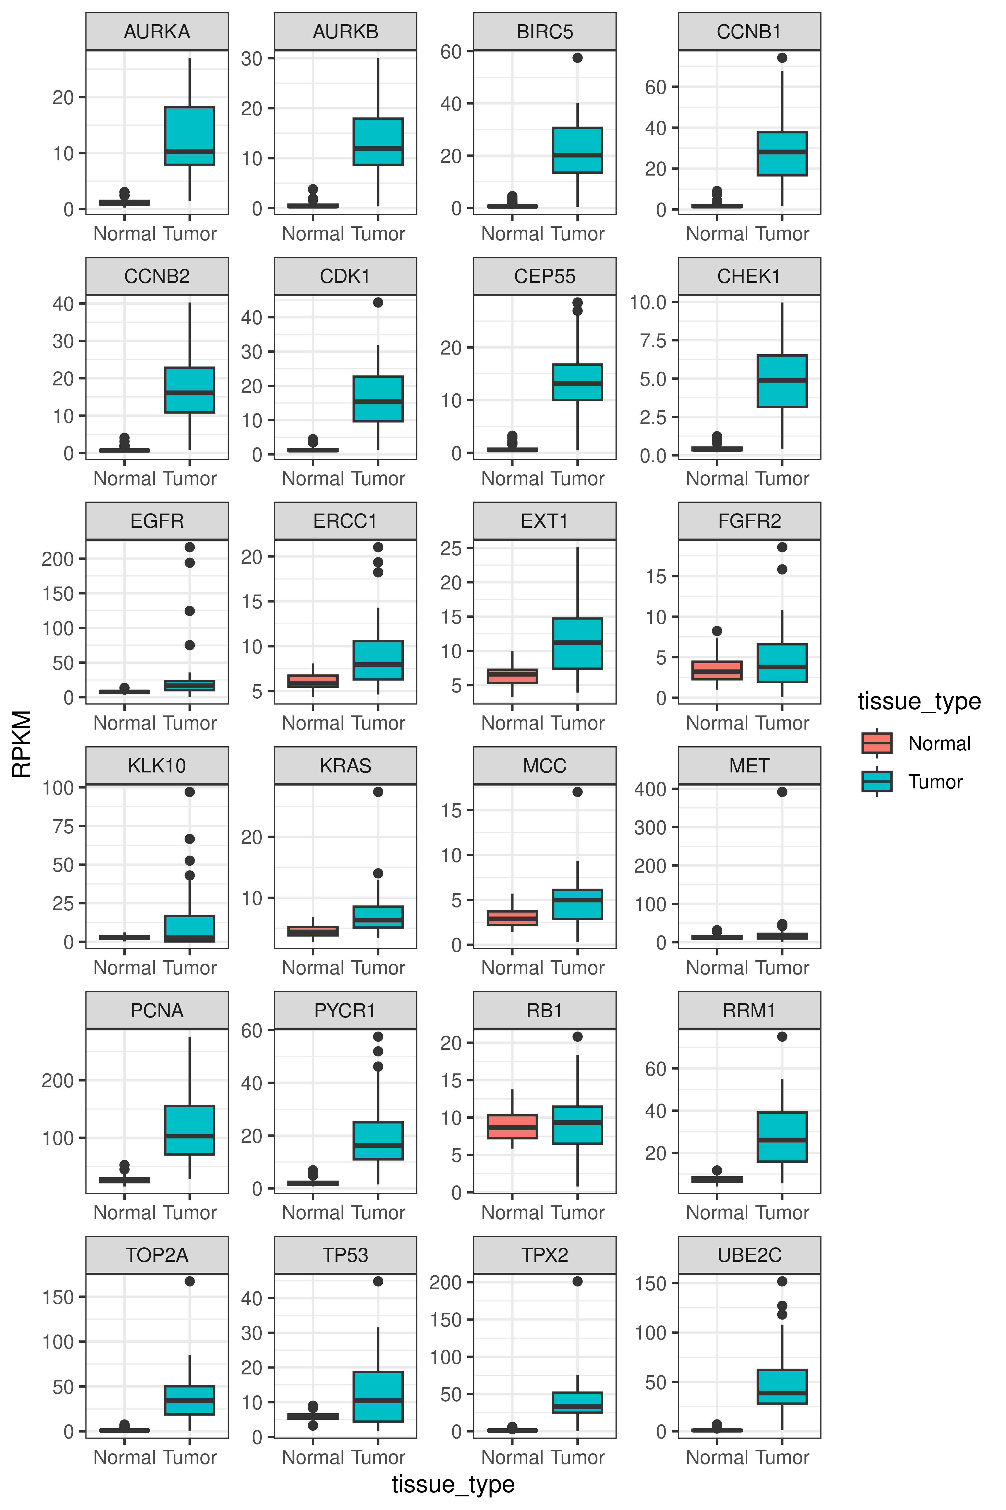
Figure 5 : Expression of known tumor biomarkers.

Stage-specific signatures for squamous cell lung cancer
From the genes identified to be up-regulated in tumor, 1618, 1694 and 1795 are distributed to stages I, II and III, respectively (RPKM ≥ 4 , log2foldchange ≥1 and unpaired t-test FDR ≤ 0.05). These genes were used to sample sub-interactomes with 1140/3291, 1198/3564, 1280/4002 vertex/edges for each stage. Then, entropy values of 3.669, 3.713 and 3.786 were obtained for sub-interactomes of stages I, II and III. Finally, the number of stage-specific genes, i.e. without overlap to other stages, is 23, 62, 169 in stages I, II and III, respectively (see Figure 1).
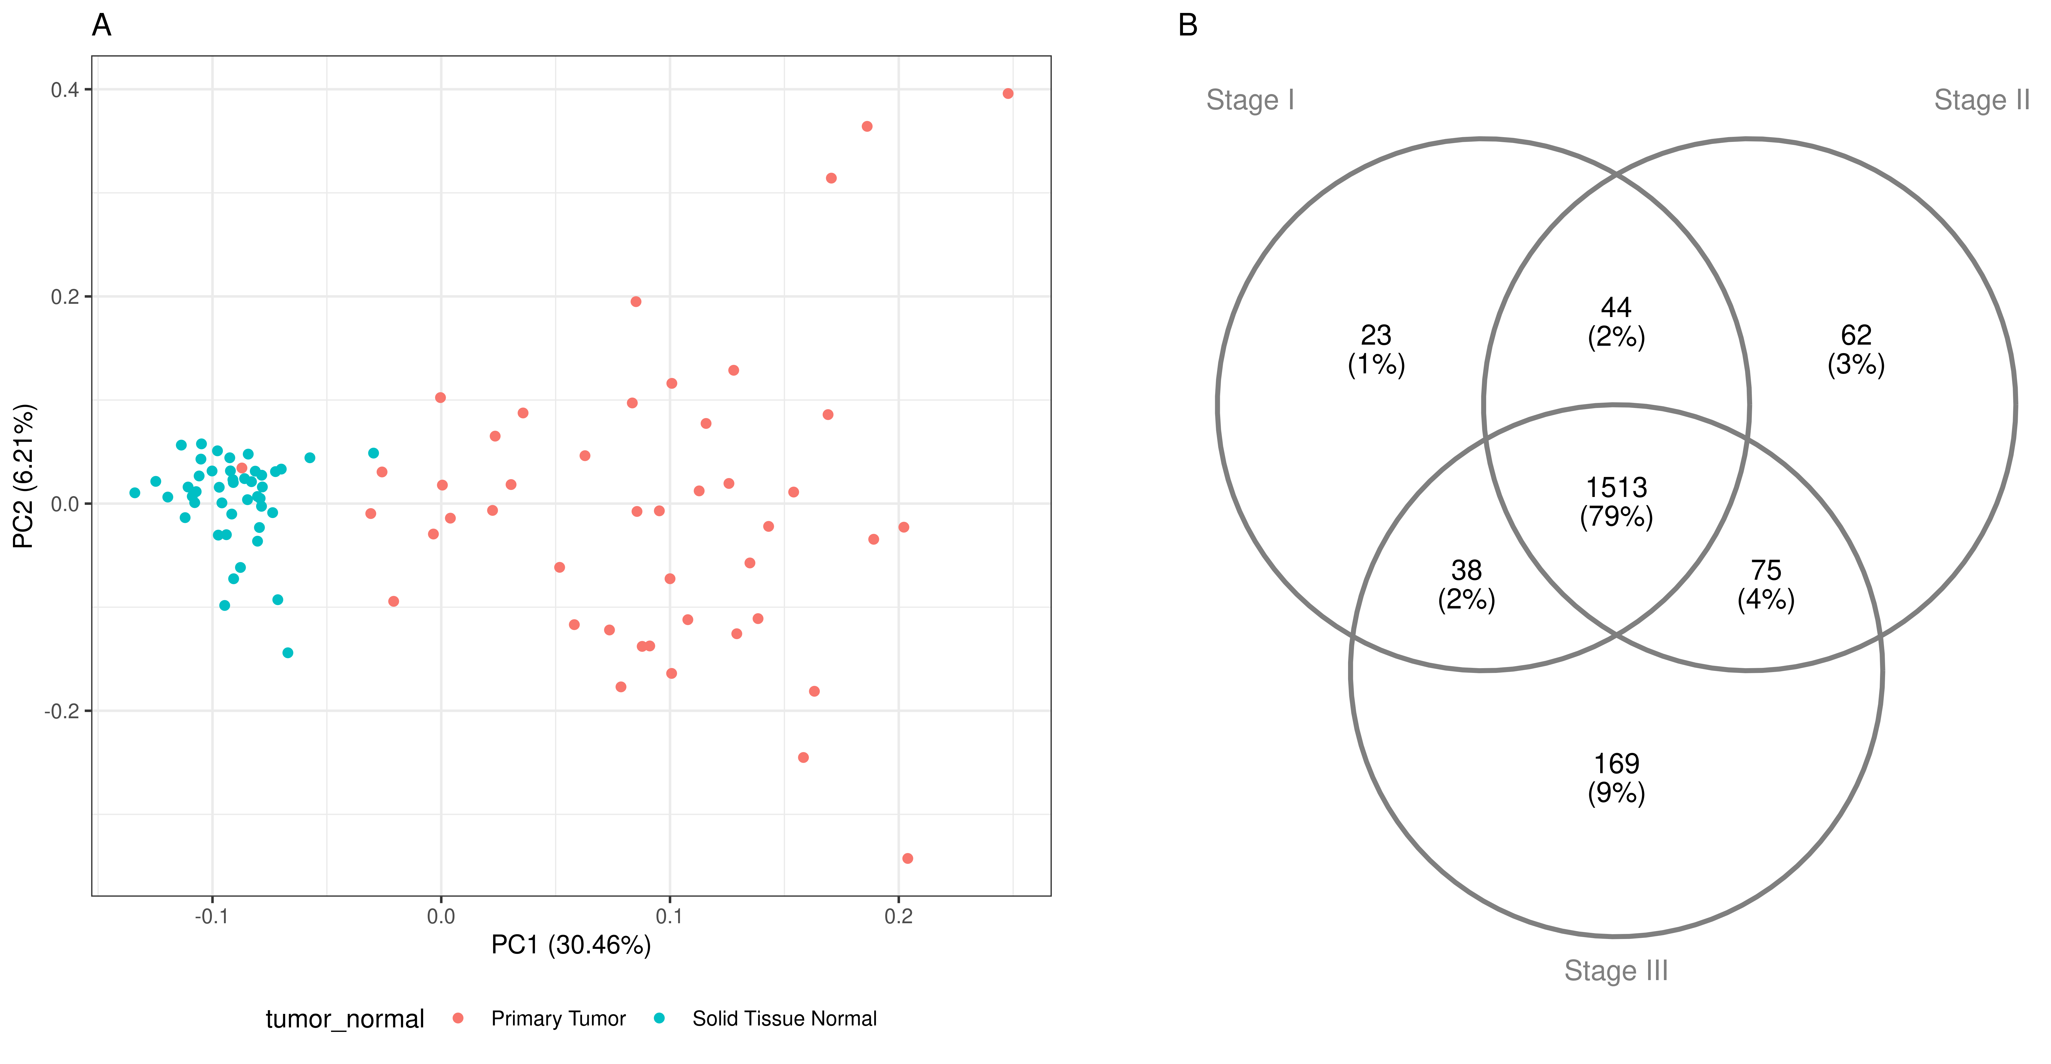
Figure 1 : A) PCA of tumor genes contrasting tumor and normal paired samples. B) Ven diagram of turmor genes and their stage-specific distribution.

Stage-wise functional analysis
ClusterProfiler [cite] was used to annotate stage-specific genes against GO , KEGG databases (p.adjust <0.05). Additionally, the Human Gene Database [cite] was queried Genecards summary was stored. Associated diseases , related pathways and gene ontology annotation were extrated from summary (see Table 1). Among the 254 selected genes, CluterProfiler annotation is available for 74 (GO), 84 (KEGG), and 132 (Reactome) genes. There are 77/214/834 (GO/KEGG/Reactome) significative (p.adjust <0.05) terms (see Table 2). From these, we selected ten top terms in number of genes and combined them for further investigation (see Figures 6, 7 and 8). KEGG pathways common to all stages are “Biosynthesis of cofactors”, “Chemical carcinogenesis - receptor activation”, “Nicotinate and nicotinamide metabolism and Nucleocytoplasmic transport”. Noteworthy, genes NADK2, KPNA4, NADSYN1, SRC, RNPS1, SPR, AKT2, PTGES3, RPS6KB2 and NT5C are annotated to these pathways that present in all three stages.
Progression of lung cancer accross stages can be speculated by analysing GO functional annotation of tree top terms in number of genes. In stage I, terms relatd to granule are observed (cytoplasmic stress granule, specific granule lumen and tertiary granule lumen). For stage II, axonogenesis, mesenchyme development and regulation of nervous system development are noted. While for stage III, GO terms pointing to mitochondrial activity are listed (mitochondrial inner membrane, mitochondrial matrix, mitochondrial protein-containing complex).
Table 1 : Annotation interpretation via GeneCards and ClusterProfiler.
Table 2 : Ten most abundant terms in number of genes per stage.
Figure 6 : Network of functional analysis with GO terms.

Figure 7 : Network of functional analysis with KEGG pathways.

Figure 8 : Network of functional analysis with Reactome pathways.
Table 3 : Statistics of stage-specific gene
Biomarkers selection for squamous cell lung cancer staging
Boxplots of the stage-specific genes (Figure S1) were inspected to filter biomarkers for staging squamous cell lung cancer tumors. Genes was futrher selected when average expression in a specific stage was greater than in at least one of the other two stages, i.e. Stage A > Stage B (p-value<0.05) or Stage A > Stage B (p-value<0.05).
Figure S1 : Comparisson of stage-specific gene expression of genes accross stages.
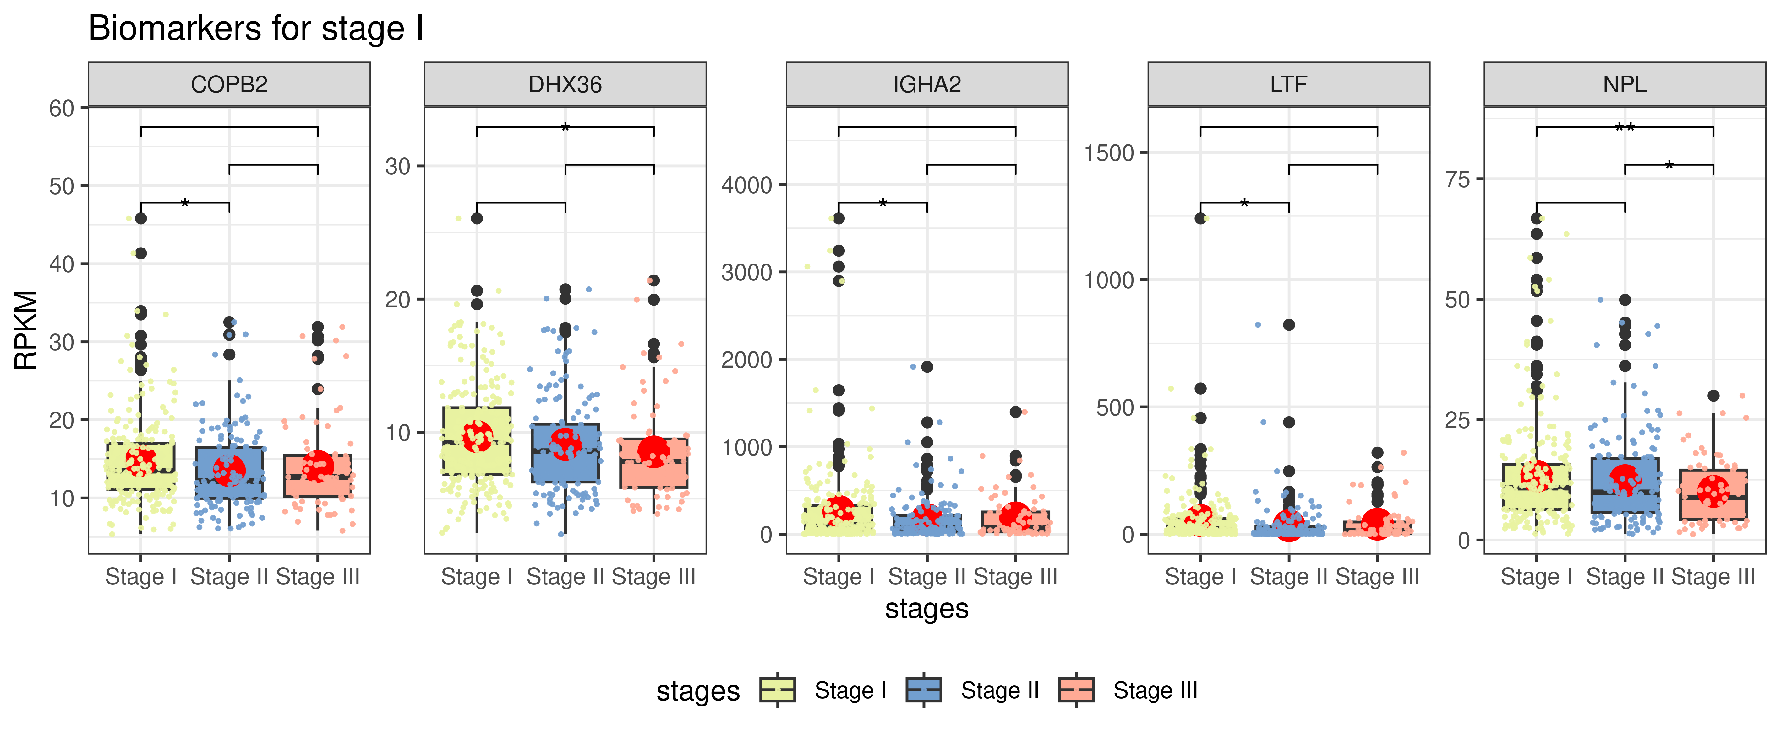
Figure 9: Selected biomarkers for staging squamous cell lung cancer, stage I.

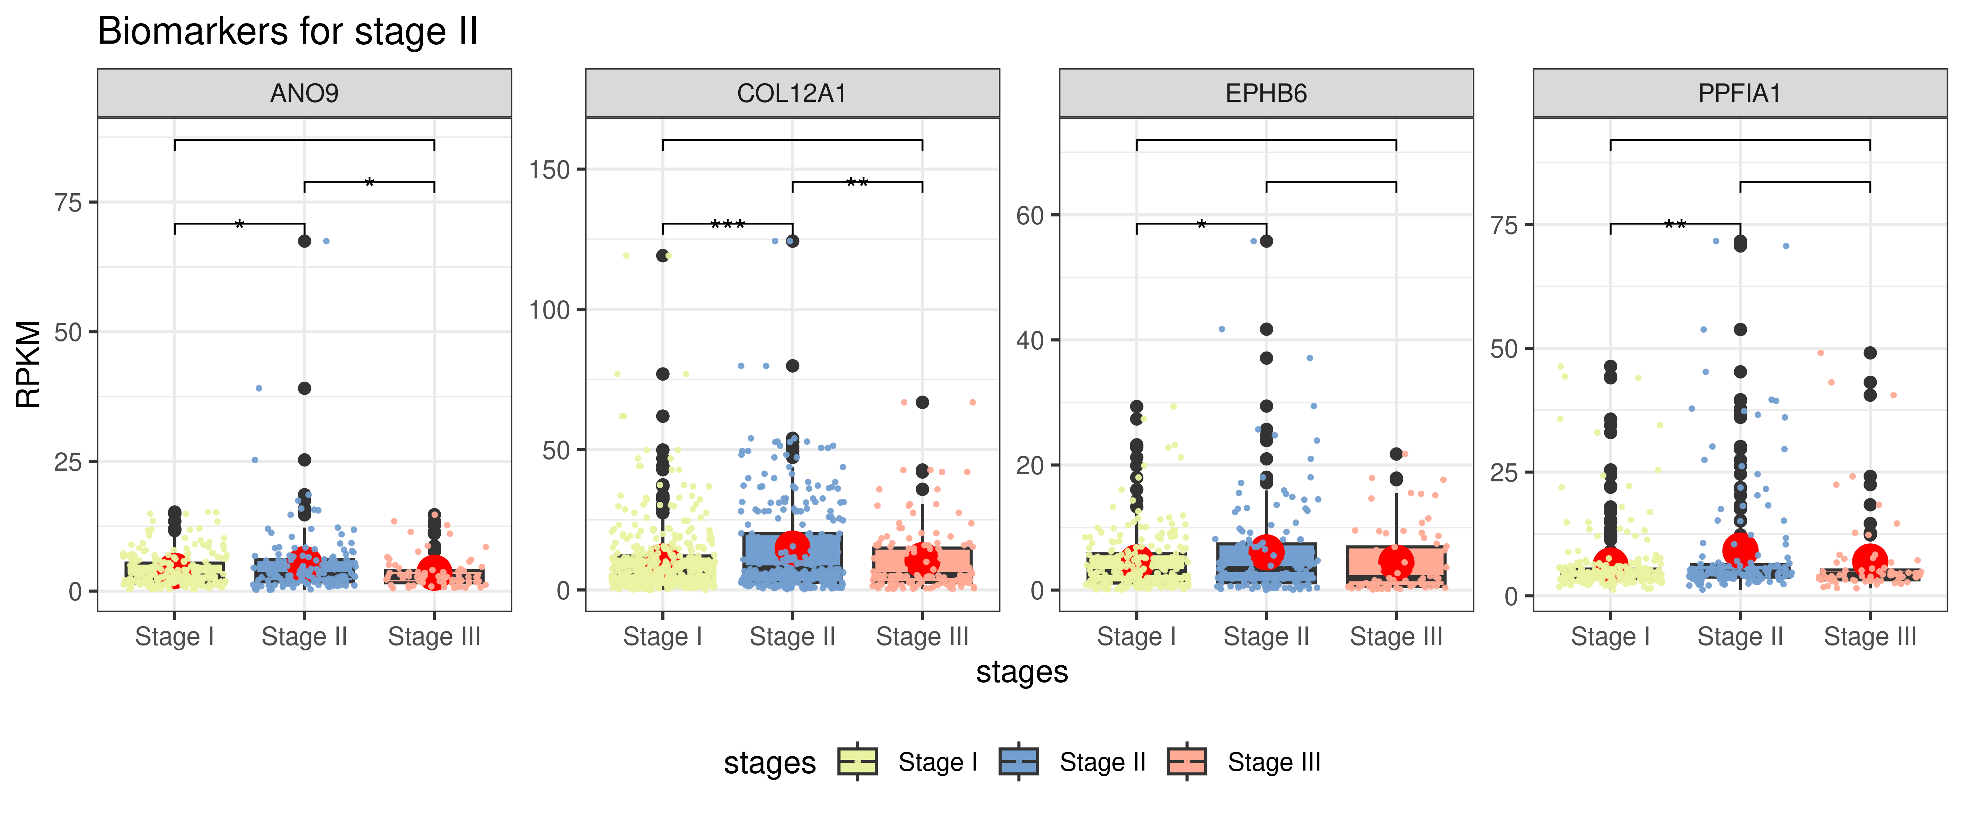
Figure 10 : Selected biomarkers for staging squamous cell lung cancer, stage II.
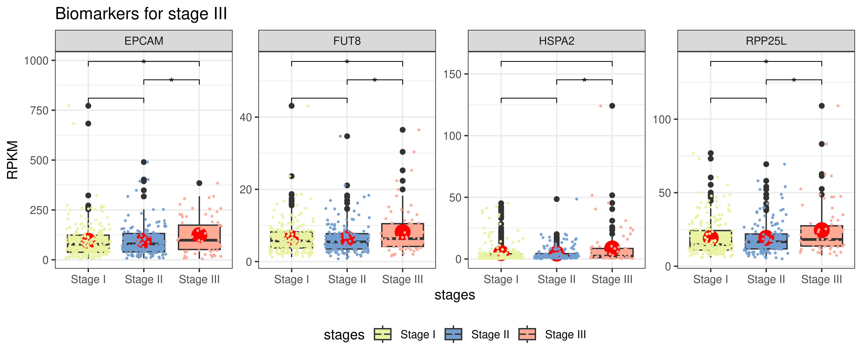
Figure 11 : Selected biomarkers for staging squamous cell lung cancer, stage III.

3. Materials and Methods

RNA-seq materials
RNA-seq from TCGA samples of lung squamous cell carcinoma (LUSC) were downloaded from the GDC portal (https://portal.gdc.cancer.gov/) accessed on 2024-04-04. Among the 486 lung samples, 45 were paired samples (45 tumor and 45 non-tumoral samples, each from a same patient), and the remaining (441) were non-paired, which means that no control from healthy lung was available for them. The clinical sheet informed that (I) for stage I, 198 LUSC samples were non-paired while 24 were paired, (ii) for stage II, 130 LUSC samples were non-paired, while 17 were paired, (iii) and for stage III, 68 LUSC samples were non-paired, while 4 were paired.

Signature detection framework
RNA-seq counts were normalized according to the reads per kilobase per million mapped reads (RPKM) methodology as described by (Mortazavi et al., 2008) and genes with average RPKM ≤ thresholds were filtered out. Then, we identified tumor genes by comparing expression on 441 tumor samples by reference to the 45 normal samples. The average expression in tumor samples and the average expression in normal samples were used to calculate FDR of paired t-test (method="BH"). Once this list of up-regulated tumor gene has been calculated, we obtained stage-specfic genes by comparing expression of genes in samples of each stage by reference to the normal samples, i.e. log2(fold change) = log2(expression value in stage A/expression value in stages normal samples), Then, unpaired t-test is applied and FDR (method="BH") is calculated for each stage-specfic gene.

Sub-interactome networks
To uncover the pathways in which up-regulated genes being specific of a given stage were involved, we crossed them with interactome data. Sub-interactome networks were constructed for each stage by sampling the IntAct interactome (Orchard et al., 2013) with their respective specific up-regulated genes. The IntAct interactome was obtained from the intact-micluster.txt file (version updated December 2017) accessed on January 11, 2018, at ftp://ftp.ebi.ac.uk/pub/databases/intact/current/psimitab/intact-micluster.txt. We excluded incomplete and non-human interactions from this file, and the resulting file presented 151,631 interactions among 15,526 human proteins with UniProtKB accessions. To construct sub-interactome networks, pairwise combinations among stage-specific genes are created, and then filtered to keep only those edges that overlap with the interctome.

Shannon entropy
Quoting Enneking et al. (1980), the purposes of a staging system are to “(1) incorporate the significant prognostic factors into a system that describes progressive degrees of risk of local recurrence and distant metastases to which a patient is subject, (2) stratify the stages so they have specific implications for surgical management, and (3) provide guidelines for adjunctive therapies”. Staging is correlated with 5-year overall survival (OS) in lung (Jeon et al., 2015). 5-year OS is, therefore, a measure of aggressiveness and it has been shown that it is correlated to Shannon entropy of up-regulated gene sub-networks (Conforte et al., 2019). Thus, we postulated that tumor staging could be correlated to Shannon entropy (Shannon, 1948) implemented in R package according to formula 1.
$H=−\sum_{k=1}^{n}{p\left(k\right)log2\left(p\left(k\right)\right)}$(1)
where p(k) is the probability of occurrence of a vertex with a rank order k (k edges) in the sub-network considered. Since entropy is an extensive thermodynamic function of states, it should not be normalized for network size. The sub-networks were generated automatically from gene lists found to be up-regulated and specific of a given stage regarding the others.

Functional annotation analysis
ClusterProfiler [7] was used to annotate stage-specific genes against GO , KEGG databases. For each of these three layer, top ten anonontations in number of genes were selected and combined for further analysis if selection had more than one gene. The Human Gene Database [cite] was queried for each ENSEMBL identifier and corresponding Genecards summary was stored. Diseases associated, related pathways and gene ontology annotation were extrated from summary.

4. Discussion
The increase in entropy across the stage is modest when it tests whether there is indeed more information about cancer on later stages, or it is statistical artefact. This is further tested by comparing entropy values ​​of stage-specific genes against equivalent random set of tumor genes. We find this [to be done] and that [to be done].
Our work corroborates previous researches in finding bioinformatics evidence that gene expression can be used for diagnosis [cite] and staging of cancer [cite]. The proposed bioinformatics method invites collaboration with cancer biologists for validation of proposed biomarkers.

Genes XXXX, YYYY, ZZZZ, YYYY are annotated to this and this pathways [cite], are significantly more expressed in tumor, and specific to Stage III. The feasibility of applying such a framework to select biomarkers for laboratory diagnosis and cancer staging can be seen and evaluated in our results. Furthermore, experimental evidence exists for the role of mitochondrial activity on lung cancer [cite]. our results also corroborate this, when functional annotation to mitochondrial activity as achieved in later cancer stages, in reference to the pathways annotated to first stages.
We did find stage-specific genes from XX samples of squamous cell Lung cancer. The total number of samples per stage met requirement proposed by previous work of minumum 30 samples per stage [cite Conforte et at., but the number of paired sampĺes per stage fall short this criteria. The statistical power of our analysis can be increased by combining data of multiple types of lung cancer. Combining all lung cancer samples will facilitate captiuring funcional properties of plasticity and progression. Besides of increasing statistical power, using multiple cancer types can too allow comparrisson of biomarkers for cancerstaging accorss the different lung cancer types, and to test if core progression mechanisms are consistent among them.
We note too that we tested how values of shannon entrpy we find from stage-specific genes quantify progression across the stages. The progression we measure from shannon entrpy is modest. We hope to test if there is more cancer information on latter stages of cancer on stage-specific genes obtained from bigger number of samples. If there is more cancer information on later stages to state progression, or if we assume plasticiy in the tumor, this can be tested on a more robust dataset such as all lung cancer sub-types.
Using different types of lung cancer will improve statistical power and also allow horizontal comparisson ammong the disease variation. The directive of World Health Organization is to support development for methods of fast screening for cancer, and the classification of tumors for proper treatment. The most common types of cancer by 2020 was breast (2.26 million cases), lung (2.21 million cases), colon and rectum (1.93 million cases), prostate (1.41 million cases), skin (non-melanoma) (1.20 million cases), stomach (1.09 million cases). Therefore, for the continuation of this work we propose to find stage-specific genes in the cancer of these different tissues, while sepparating the cancer from lung in different sub-types present in the GDC portal (e.g. lung nodules, non-small cell lung cancer, small cell lung cancer and mesothelioma).

5. Conclusion
Our concern for the patient's well-being motivates us to look at the classification of lung cancer in order to provide appropriate treatment. For hospitals, I can be concerned about reducing the cost of lung cancer diagnosis and staging methods. For laboratories, the results indicate stage-specific biomarkers for development of tests. For scientific colleagues, this work will suggest pathways to comprehensive information about the molecular mechanisms of lung cancer. In this work, we focus on reproducibility of results, consistency of data, and coherence in testing the hypothesis that cancer staging can be done accurately at the level of transcripts. The bioformatics challenge was to model the amount of information about cancer at each cancer stage through Shannon entropy. we provide a framework for the selection of stage-specific genes and propose lung cancer genes already annotated as biomarkers.

Acknowledgement
Aqui, os detalhes da sua bolsa.

References
1. Conforte AJ, Tuszynski JA, da Silva FAB, Carels N. Signaling Complexity Measured by Shannon Entropy and Its Application in Personalized Medicine. Front Genet. 2019 Oct 21;10:930. doi: 10.3389/fgene.2019.00930.
2. Enneking WF, Spanier SS, Goodman MA. A system for the surgical staging of musculoskeletal sarcoma. Clin Orthop Relat Res 1980;153:106–120
3. Jeon DS, Kim HC, Kim SH, Kim TJ, Kim HK, Moon MH, Beck KS, Suh YG, Song C, Ahn JS, Lee JE, Lim JU, Jeon JH, Jung KW, Jung CY, Cho JS, Choi YD, Hwang SS, Choi CM; Korean Association for Lung Cancer; Korea Central Cancer Registry. Five-Year Overall Survival and Prognostic Factors in Patients with Lung Cancer: Results from the Korean Association of Lung Cancer Registry (KALC-R) 2015. Cancer Res Treat. 2023 Jan;55(1):103-111. doi: 10.4143/crt.2022.264.
4. Mortazavi A, Williams BA, McCue K, Schaeffer L, Wold B (2008) Mapping and quantifying mammalian transcriptomes by RNA-Seq. Nature Methods 5: 621–628. pmid:18516045
5. Orchard S, Ammari M, Aranda B, Breuza L, Briganti L, Broackes-Carter F, Campbell NH, Chavali G, Chen C, del-Toro N, Duesbury M, Dumousseau M, Galeota E, Hinz U, Iannuccelli M, Jagannathan S, Jimenez R, Khadake J, Lagreid A, Licata L, Lovering RC, Meldal B, Melidoni AN, Milagros M, Peluso D, Perfetto L, Porras P, Raghunath A, Ricard-Blum S, Roechert B, Stutz A, Tognolli M, van Roey K, Cesareni G, Hermjakob H. The MIntAct project--IntAct as a common curation platform for 11 molecular interaction databases. Nucleic Acids Res. 2014 Jan;42(Database issue):D358-63. doi: 10.1093/nar/gkt1115.
6. Shannon C. E. (1948). A mathematical theory of communication. Bell. Syst. Tech. J. 27 (July 1928), 379–423. 10.1002/j.1538-7305.1948.tb01338.x
7. “clusterProfiler: an R package for comparing biological themes among gene clusters.” OMICS: A Journal of Integrative Biology, 16(5), 284-287. doi:10.1089

