**Queue**

### What is a Queue?

Queue is the data structure that is similar to the queue in the real world. A queue is a data structure in which whatever comes first will go out first, and it follows the FIFO (First-In-First-Out) policy. Queue can also be defined as the list or collection in which the insertion is done from one end known as the **rear end** or the **tail** of the queue, whereas the deletion is done from another end known as the **front end** or the **head** of the queue.

The real-world example of a queue is the ticket queue outside a cinema hall, where the person who enters first in the queue gets the ticket first, and the last person enters in the queue gets the ticket at last. Similar approach is followed in the queue in data structure.

The representation of the queue is shown in the below image -

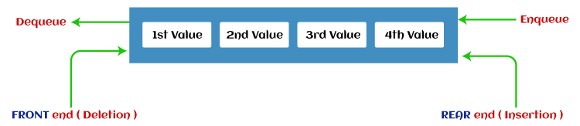

1. A queue can be defined as an ordered list which enables insert operations to be performed at one end called **REAR** and delete operations to be performed at another end called **FRONT**.

2. Queue is referred to be as First In First Out list.

3. For example, people waiting in line for a rail ticket form a queue.

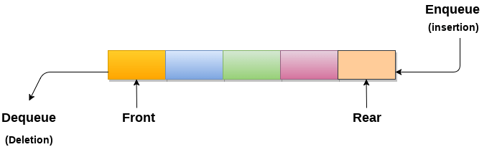

**Applications of Queue**

Due to the fact that queue performs actions on first in first out basis which is quite fair for the ordering of actions. There are various applications of queues discussed as below.

1. Queues are widely used as waiting lists for a single shared resource like printer, disk, CPU.
2. Queues are used in asynchronous transfer of data (where data is not being transferred at the same rate between two processes) for eg. pipes, file IO, sockets.
3. Queues are used as buffers in most of the applications like MP3 media player, CD player, etc.
4. Queue are used to maintain the play list in media players in order to add and remove the songs from the play-list.
5. Queues are used in operating systems for handling interrupts.

### **Types of Queue**

There are four different types of queue that are listed as follows -

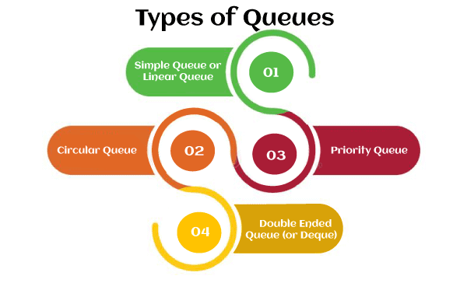

* Simple Queue or Linear Queue
* Circular Queue
* Priority Queue
* Double Ended Queue (or Deque)

### **Simple Queue or Linear Queue**

In Linear Queue, an insertion takes place from one end while the deletion occurs from another end. The end at which the insertion takes place is known as the rear end, and the end at which the deletion takes place is known as front end. It strictly follows the FIFO rule.

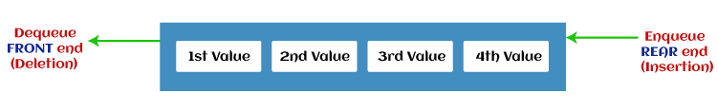

The major drawback of using a linear Queue is that insertion is done only from the rear end. If the first three elements are deleted from the Queue, we cannot insert more elements even though the space is available in a Linear Queue. In this case, the linear Queue shows the overflow condition as the rear is pointing to the last element of the Queue.

### **Priority Queue**

It is a special type of queue in which the elements are arranged based on the priority. It is a special type of queue data structure in which every element has a priority associated with it. Suppose some elements occur with the same priority, they will be arranged according to the FIFO principle. The representation of priority queue is shown in the below image -

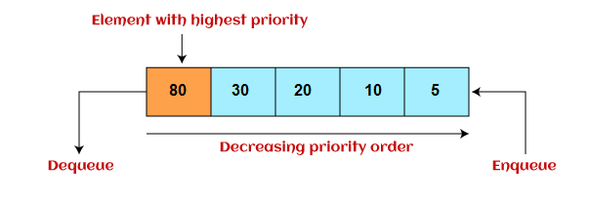

Insertion in priority queue takes place based on the arrival, while deletion in the priority queue occurs based on the priority. Priority queue is mainly used to implement the CPU scheduling algorithms.

There are two types of priority queue that are discussed as follows -

* **Ascending priority queue -** In ascending priority queue, elements can be inserted in arbitrary order, but only smallest can be deleted first. Suppose an array with elements 7, 5, and 3 in the same order, so, insertion can be done with the same sequence, but the order of deleting the elements is 3, 5, 7.
* **Descending priority queue -** In descending priority queue, elements can be inserted in arbitrary order, but only the largest element can be deleted first. Suppose an array with elements 7, 3, and 5 in the same order, so, insertion can be done with the same sequence, but the order of deleting the elements is 7, 5, 3.

### **Deque (or, Double Ended Queue)**

In Deque or Double Ended Queue, insertion and deletion can be done from both ends of the queue either from the front or rear. It means that we can insert and delete elements from both front and rear ends of the queue. Deque can be used as a palindrome checker means that if we read the string from both ends, then the string would be the same.

Deque can be used both as stack and queue as it allows the insertion and deletion operations on both ends. Deque can be considered as stack because stack follows the LIFO (Last In First Out) principle in which insertion and deletion both can be performed only from one end. And in deque, it is possible to perform both insertion and deletion from one end, and Deque does not follow the FIFO principle.

The representation of the deque is shown in the below image -

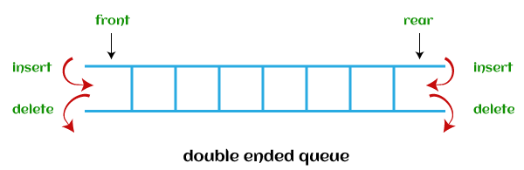

There are two types of deque that are discussed as follows -

AD

* **Input restricted deque -** As the name implies, in input restricted queue, insertion operation can be performed at only one end, while deletion can be performed from both ends.  
  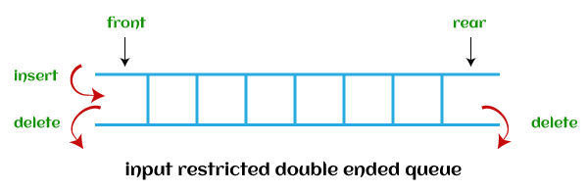
* **Output restricted deque -** As the name implies, in output restricted queue, deletion operation can be performed at only one end, while insertion can be performed from both ends.  
  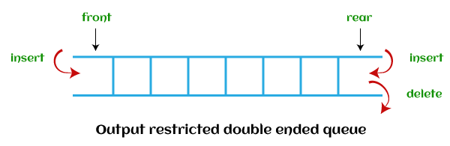

**Operations performed on queue**

The fundamental operations that can be performed on queue are listed as follows -

* **Enqueue:** The Enqueue operation is used to insert the element at the rear end of the queue. It returns void.
* **Dequeue:** It performs the deletion from the front-end of the queue. It also returns the element which has been removed from the front-end. It returns an integer value.
* **Peek:** This is the third operation that returns the element, which is pointed by the front pointer in the queue but does not delete it.
* **Queue overflow (isfull):** It shows the overflow condition when the queue is completely full.
* **Queue underflow (isempty):** It shows the underflow condition when the Queue is empty, i.e., no elements are in the Queue.

**Ways to implement the queue**

There are two ways of implementing the Queue:

* **Implementation using array:** The sequential allocation in a Queue can be implemented using an array
* **Implementation using Linked list:** The linked list allocation in a Queue can be implemented using a linked list.

**Array representation of Queue**

We can easily represent queue by using linear arrays. There are two variables i.e. front and rear, that are implemented in the case of every queue. Front and rear variables point to the position from where insertions and deletions are performed in a queue. Initially, the value of front and queue is -1 which represents an empty queue. Array representation of a queue containing 5 elements along with the respective values of front and rear, is shown in the following figure.

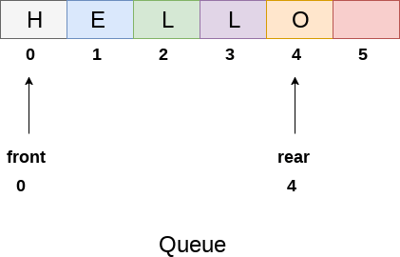

The above figure shows the queue of characters forming the English word **"HELLO"**. Since, No deletion is performed in the queue till now, therefore the value of front remains -1 . However, the value of rear increases by one every time an insertion is performed in the queue. After inserting an element into the queue shown in the above figure, the queue will look something like following. The value of rear will become 5 while the value of front remains same.

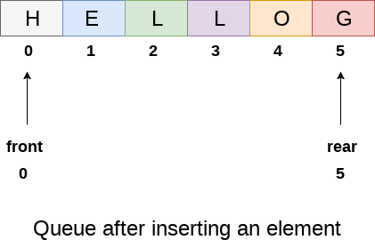

After deleting an element, the value of front will increase from -1 to 0. however, the queue will look something like following.

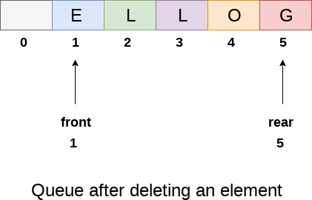

**Algorithm to insert any element in a queue**

Check if the queue is already full by comparing rear to max - 1. if so, then return an overflow error.

If the item is to be inserted as the first element in the list, in that case set the value of front and rear to 0 and insert the element at the rear end.

Otherwise keep increasing the value of rear and insert each element one by one having rear as the index.

**Algorithm**

* **Step 1:** IF REAR = MAX - 1  
  Write OVERFLOW  
  Go to step   
  [END OF IF]
* **Step 2:** IF FRONT = -1 and REAR = -1  
  SET FRONT = REAR = 0   
  ELSE  
  SET REAR = REAR + 1   
  [END OF IF]
* **Step 3:** Set QUEUE[REAR] = NUM
* **Step 4:** EXIT

**Algorithm to delete an element from the queue**

If, the value of front is -1 or value of front is greater than rear , write an underflow message and exit.

Otherwise, keep increasing the value of front and return the item stored at the front end of the queue at each time.

**Algorithm**

* **Step 1:** IF FRONT = -1 or FRONT > REAR  
  Write UNDERFLOW   
  ELSE   
  SET VAL = QUEUE[FRONT]  
  SET FRONT = FRONT + 1   
  [END OF IF]
* **Step 2:** EXIT

**Drawback of array implementation**

Although, the technique of creating a queue is easy, but there are some drawbacks of using this technique to implement a queue.

* **Memory wastage :** The space of the array, which is used to store queue elements, can never be reused to store the elements of that queue because the elements can only be inserted at front end and the value of front might be so high so that, all the space before that, can never be filled.

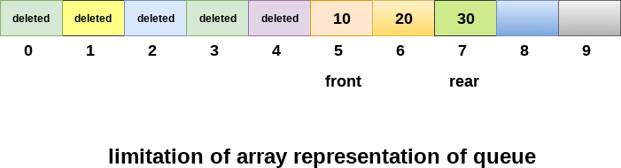

The above figure shows how the memory space is wasted in the array representation of queue. In the above figure, a queue of size 10 having 3 elements, is shown. The value of the front variable is 5, therefore, we can not reinsert the values in the place of already deleted element before the position of front. That much space of the array is wasted and can not be used in the future (for this queue).

* **Deciding the array size**

On of the most common problem with array implementation is the size of the array which requires to be declared in advance. Due to the fact that, the queue can be extended at runtime depending upon the problem, the extension in the array size is a time taking process and almost impossible to be performed at runtime since a lot of reallocations take place. Due to this reason, we can declare the array large enough so that we can store queue elements as enough as possible but the main problem with this declaration is that, most of the array slots (nearly half) can never be reused. It will again lead to memory wastage.

**Linked List implementation of Queue**

Due to the drawbacks discussed in the previous section of this tutorial, the array implementation can not be used for the large scale applications where the queues are implemented. One of the alternative of array implementation is linked list implementation of queue.

The storage requirement of linked representation of a queue with n elements is o(n) while the time requirement for operations is o(1).

In a linked queue, each node of the queue consists of two parts i.e. data part and the link part. Each element of the queue points to its immediate next element in the memory.

In the linked queue, there are two pointers maintained in the memory i.e. front pointer and rear pointer. The front pointer contains the address of the starting element of the queue while the rear pointer contains the address of the last element of the queue.

Insertion and deletions are performed at rear and front end respectively. If front and rear both are NULL, it indicates that the queue is empty.

The linked representation of queue is shown in the following figure.

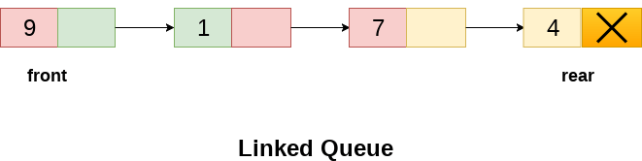

**Operation on Linked Queue**

There are two basic operations which can be implemented on the linked queues. The operations are Insertion and Deletion.

1. **Insert operation**

The insert operation append the queue by adding an element to the end of the queue. The new element will be the last element of the queue.

**Algorithm**

* **Step 1:** Allocate the space for the new node PTR
* **Step 2:** SET PTR -> DATA = VAL
* **Step 3:** IF FRONT = NULL  
  SET FRONT = REAR = PTR  
  SET FRONT -> NEXT = REAR -> NEXT = NULL  
  ELSE  
  SET REAR -> NEXT = PTR  
  SET REAR = PTR  
  SET REAR -> NEXT = NULL  
  [END OF IF]
* **Step 4:** END

## Deletion

Deletion operation removes the element that is first inserted among all the queue elements. Firstly, we need to check either the list is empty or not. The condition front == NULL becomes true if the list is empty, in this case , we simply write underflow on the console and make exit.

Otherwise, we will delete the element that is pointed by the pointer front. For this purpose, copy the node pointed by the front pointer into the pointer ptr. Now, shift the front pointer, point to its next node and free the node pointed by the node ptr.

**Algorithm**

* **Step 1:** IF FRONT = NULL  
  Write " Underflow "  
  Go to Step 5  
  [END OF IF]
* **Step 2:** SET PTR = FRONT
* **Step 3:** SET FRONT = FRONT -> NEXT
* **Step 4:** FREE PTR
* **Step 5:** END

**# Queue implementation in Python**

class Queue:

def __init__(self):

self.queue = []

# Add an element

def enqueue(self, item):

self.queue.append(item)

# Remove an element

def dequeue(self):

if len(self.queue) < 1:

return None

return self.queue.pop(0)

# Display the queue

def display(self):

print(self.queue)

def size(self):

return len(self.queue)

q = Queue()

q.enqueue(1)

q.enqueue(2)

q.enqueue(3)

q.enqueue(4)

q.enqueue(5)

q.display()

q.dequeue()

print("After removing an element")

q.display()

OUTPUT:

[1, 2, 3, 4, 5]

After removing an element

[2, 3, 4, 5]