**Data Structure - Recursion Basics**

Some computer programming languages allow a module or function to call itself. This technique is known as recursion. In recursion, a function **α** either calls itself directly or calls a function **β** that in turn calls the original function **α**. The function **α** is called recursive function.

**Example** − a function calling itself.

int function(int value) {

if(value < 1)

return;

function(value - 1);

printf("%d ",value);

}

## **Implementation**

Many programming languages implement recursion by means of **stacks**. Generally, whenever a function (**caller**) calls another function (**callee**) or itself as callee, the caller function transfers execution control to the callee. This transfer process may also involve some data to be passed from the caller to the callee.

This implies, the caller function has to suspend its execution temporarily and resume later when the execution control returns from the callee function. Here, the caller function needs to start exactly from the point of execution where it puts itself on hold. It also needs the exact same data values it was working on. For this purpose, an activation record (or stack frame) is created for the caller function.

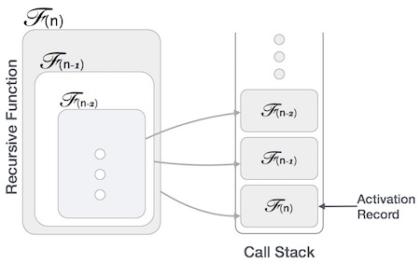

This activation record keeps the information about local variables, formal parameters, return address and all information passed to the caller function.

### **Example of a recursive function**

def factorial(x):

"""This is a recursive function

to find the factorial of an integer"""

if x == 1:

return 1

else:

return (x * factorial(x-1))

num = 3

print("The factorial of", num, "is", factorial(num))

**Output**

The factorial of 3 is 6

**Understanding what goes behind Recursion:**

In the above example, factorial() is a recursive function as it calls itself.

When we call this function with a positive integer, it will recursively call itself by decreasing the number.

Each function multiplies the number with the factorial of the number below it until it is equal to one. This recursive call can be explained in the following steps.

factorial(3) # 1st call with 3

3 * factorial(2) # 2nd call with 2

3 * 2 * factorial(1) # 3rd call with 1

3 * 2 * 1 # return from 3rd call as number=1

3 * 2 # return from 2nd call

6 # return from 1st call

Let's look at an image that shows a step-by-step process of what is going on:

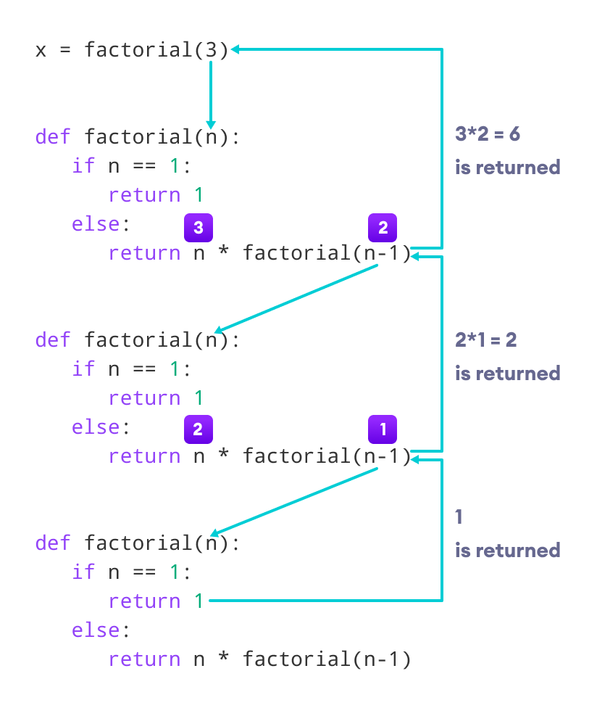

Our recursion ends when the number reduces to 1. This is called the base condition.

Every recursive function must have a base condition that stops the recursion or else the function calls itself infinitely.

## **Advantages of Recursion**

1. Recursive functions make the code look clean and elegant.
2. A complex task can be broken down into simpler sub-problems using recursion.
3. Sequence generation is easier with recursion than using some nested iteration.

## **Disadvantages of Recursion**

1. Sometimes the logic behind recursion is hard to follow through.
2. Recursive calls are expensive (inefficient) as they take up a lot of memory and time.
3. Recursive functions are hard to debug.