KAMPALA INTERNATIONAL UNIVERSITY
DIRECTORATE OF HIGHER DEGREES AND RESEARCH
SCHOOL OF ENGINEERING AND APPLIED SCIENCES
DEPARTMENT OF CIVIL ENGINEERING

ANALYSIS OF TRICYCLE PASSENGER CAR UNIT VALUES FOR ENHANCED TRAFFIC FLOW IN KAMPALA CITY, UGANDA
CONTROLLED GOVERNED EVIDENCE EXTRACT
Public replacement for the unreconciled thesis draft
SSERUNJOGI AMBROSE
Student number: 2022-08-12043
Evidence cut-off: 18 October 2026

STATUS: This document is an evidence extract, not the final university thesis. The earlier full thesis remains withheld until every claim, table, test and figure is reconciled to a governed source.

Document control
This controlled extract removes unsupported claims from the public download while preserving the study topic and the validated evidence that can be reproduced from repository sources.
Field | Controlled value
Document status | Governed evidence extract, not the final thesis
Public filename | Final_Thesis.docx, retained for link stability
Prepared | 17 October 2026, 22:30 UTC
Language | UK English
Coverage | Five Kampala study sites, 2 and 3 August 2026, 07:00 to 18:00
Superseded material | Earlier unreconciled thesis narrative, random appendices and unsupported simulation claims
Table 1: Document Control
Evidence status | Meaning in this document
Measured | Direct aggregation of the governed repository extract, with no Top-N filtering.
Modelled | Calculated from measured site-hour rows using disclosed, editable assumptions.
Unavailable | Required dimension or analysis not supported by the governed source and not fabricated.
Table 2: Evidence Status Definitions

Executive summary
Measured evidence: the governed extract contains 1,272 classified movement records from five study sites and 120 complete site-hour rows. Across this population, 472,852 motorised vehicles were recorded, including 2,447 passenger tricycles and 2,269 cargo tricycles. These figures are descriptive totals for the supplied study period and are not network-wide estimates.
Modelled evidence: passenger and cargo PCU values are derived from a speed-area equivalency formula and a demand-pressure adjustment. Vehicle dimensions, speeds and the demand sensitivity coefficient are assumptions recorded in the governed analytical code, not measured field observations.
Unavailable evidence: the governed tricycle counts do not contain Surface Type, Functional Class, Road Type or Sub-Region. Wet-weather observations, measured headways, measured speeds, capacity, saturation flow, queue length, signal timing outcomes and VISSIM calibration records are also unavailable. This extract does not report those items as findings.

1. Scope and governance

1.1 Purpose
The purpose of this extract is to publish the reproducible evidence currently available for the tricycle PCU study without presenting unverified material as completed research. The full university thesis remains withheld until its literature, methodology, results, appendices and narrative claims have been independently reconciled.

1.2 Named governed sources
Repository source | Evidence class | Use in this extract
data/raw_movements.csv | Measured | 1,272 classified movement records; retains every included record and source-workbook name.
data/site_hour.csv | Measured plus modelled fields | 120 complete site-hour rows; dynamic PCU fields are explicitly modelled.
data/incidents.csv | Measured extract | 840 incident type and severity records.
website/src/lib/trafficStats.js | Method | Governed PCU assumptions, formulas, category definitions and statistical methods.
docs/SSERUNJOGI AMBROSE_Proposal_V2.1.pdf | Proposal reference | Study rationale and literature context only; not treated as observed results.
Table 3: Governed Source Register
The movement extract records five source-workbook names: BAKULI JUNCTION.xlsx; Bwaise CROSS JUNCTION- Junction_count_data_entry.xlsx; KIBUYE ROUNDABOUT.xlsx; NATETE.xlsx; Wandegeya CROSS JUNCTION- Junction_count_data_entry - Copy.xlsx. The public repository does not contain those original workbooks under these names, so the CSV extract is the controlled public source used here. This limitation prevents a fresh workbook-to-record reconciliation within the public package.

1.3 Required dimension coverage
Required dimension | Status | Governance treatment
Surface Type | Unavailable | Not present; no Paved or Unpaved allocation is fabricated.
Functional Class | Unavailable | Not present; not fabricated.
Road Type | Unavailable | Not present; not fabricated.
Sub-Region | Unavailable | Not present; not fabricated.
Financial Year | Available | Derived from the recorded dates using July to June, giving FY2026/27.
Annual trend | Available, one period | All observed records fall in 2026; no other year is inferred.
Monthly trend | Available, one period | All observed records fall in August 2026; no other month is inferred.
Other categorical fields | Available | Every category in the governed movement extract is reported in Appendix A.
Table 4: Required Reporting Dimension Coverage

2. Method

2.1 Measured population
All rows with IncludedInAnalysis equal to Yes are retained. No Top-N filter is applied. Seven high-concentration review flags remain in the primary population exactly as recorded. Category labels are preserved, with blank labels displayed as Not recorded.
Measure | Value | Status
Movement records | 1,272 | Measured
Site-hour rows | 120 | Measured aggregation
Study sites | 5 | Measured
Incident records | 840 | Measured extract
Observation dates | 2 | Measured
Observation hours | 07:00 to 18:00 | Measured window
Table 5: Governed Study Population

2.2 PCU model
Static PCU is modelled as (car speed / subject vehicle speed) x (subject vehicle area / car area), where area equals length x width. The governed assumptions are: car 4.0 m x 1.65 m at 45 km/h; passenger tricycle 2.9 m x 1.4 m at 27.5 km/h; cargo tricycle 3.2 m x 1.5 m at 27.5 km/h.
Dynamic PCU is modelled as Static PCU x [1 + beta x (Demand Pressure - 0.5)], where beta equals 0.4 and Demand Pressure equals hourly motorised flow divided by the maximum recorded hourly flow at the same site. This relationship is definitional and is not reported as an independently observed causal effect.
Parameter | Value | Status
Passenger tricycle static PCU | 1.0066 | Modelled assumption
Cargo tricycle static PCU | 1.1901 | Modelled assumption
Demand sensitivity beta | 0.4 | Modelled assumption
Wet-pavement multiplier | 1.10 | Sensitivity assumption only, not used as a measured finding
Table 6: PCU Model Assumptions

2.3 Statistical method
One-way ANOVA and Kruskal-Wallis tests compare tricycle counts across the complete site and time-period populations. Pearson correlation evaluates paired hourly motorised flow and tricycle totals. The incident chi-square test evaluates the complete Incident Type by Severity table. These tests describe association or distributional difference and do not establish causality.

3. Results

3.1 Complete measured population by site
Category | Records | Motorised vehicles | Passenger tricycles | Cargo tricycles | Total tricycles | Tricycle share
Bakuli | 288 | 128,708 | 144 | 515 | 659 | 0.5%
Bwaise | 288 | 129,281 | 11 | 536 | 547 | 0.4%
Kibuye | 120 | 53,342 | 1,830 | 613 | 2,443 | 4.6%
Natete | 288 | 21,253 | 444 | 332 | 776 | 3.7%
Wandegeya | 288 | 140,268 | 18 | 273 | 291 | 0.2%
Table 7: Complete Measured Traffic Population by Study Site
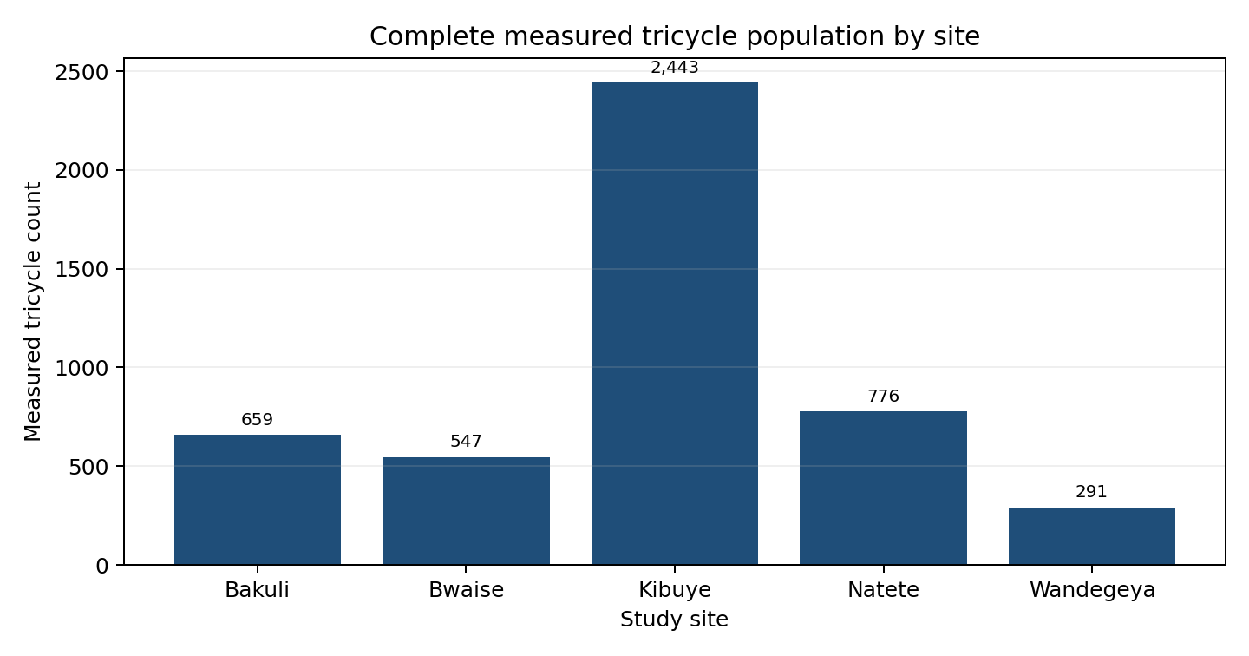
Figure 1: Complete Measured Tricycle Population by Study Site

3.2 Modelled PCU by site
Site | Junction type | Measured tricycles | Mean demand pressure | Peak demand pressure | Passenger PCU, modelled | Cargo PCU, modelled | Combined PCU, modelled
Bakuli | Cross Junction | 659 | 0.631 | 1.000 | 1.054 | 1.242 | 1.201
Bwaise | Cross Junction | 547 | 0.701 | 1.000 | 1.069 | 1.314 | 1.309
Kibuye | Roundabout | 2,443 | 0.557 | 1.000 | 1.100 | 1.238 | 1.135
Natete | Cross Junction | 776 | 0.820 | 1.000 | 1.147 | 1.344 | 1.231
Wandegeya | Cross Junction | 291 | 0.658 | 1.000 | 1.090 | 1.268 | 1.257
Table 8: Modelled Dynamic PCU by Study Site
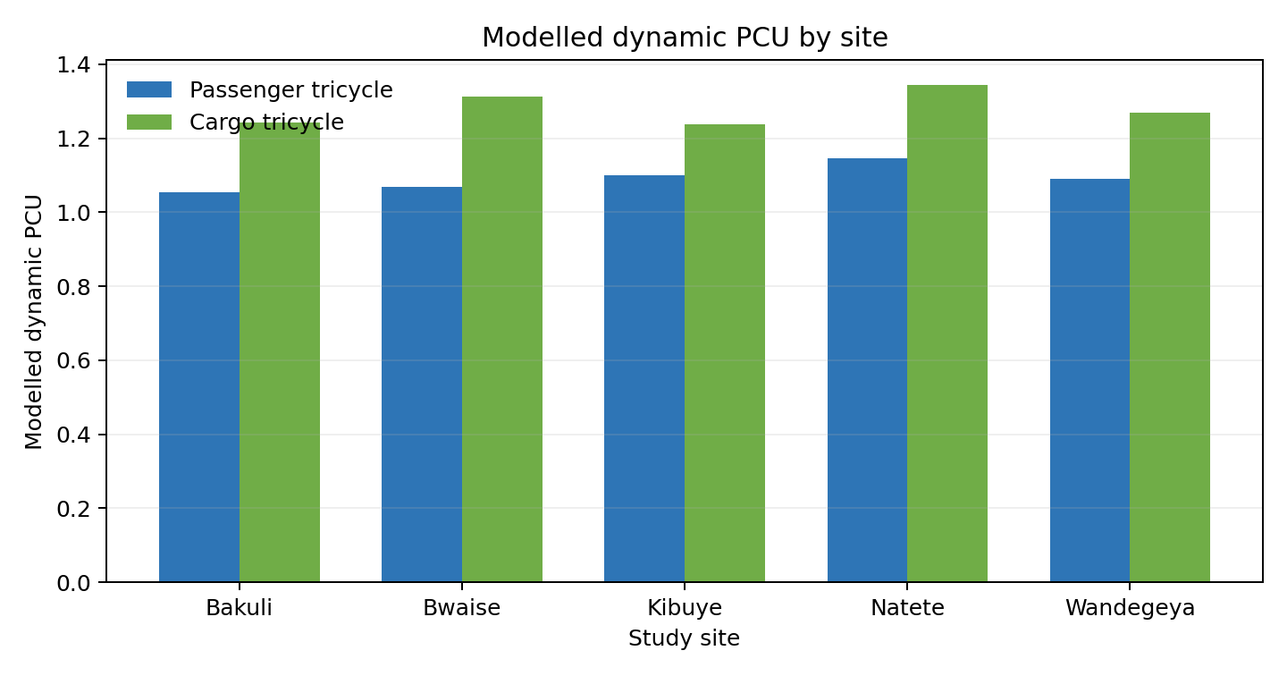
Figure 2: Modelled Dynamic PCU by Study Site

3.3 Modelled PCU by time period
Time period | Site-hour rows | Measured tricycles | Mean demand pressure | Passenger PCU, modelled | Cargo PCU, modelled | Combined PCU, modelled
Evening Peak | 30 | 1,040 | 0.664 | 1.056 | 1.278 | 1.182
Midday / Off-Peak | 60 | 1,859 | 0.640 | 1.036 | 1.265 | 1.190
Morning Peak | 30 | 1,817 | 0.748 | 1.153 | 1.304 | 1.188
Table 9: Modelled Dynamic PCU by Time Period

3.4 Reproducible statistical results
Test | Complete population | Statistic | p-value | Evidence status | Bounded interpretation
One-way ANOVA by site | n=1272, 5 sites | F=13.923 | 4.05e-11 | Measured counts | Tests mean differences; no causal claim.
Kruskal-Wallis by site | n=1272, 5 sites | H=197.620 | 1.22e-41 | Measured counts | Rank-based robustness check.
One-way ANOVA by period | n=1272, 3 periods | F=1.247 | 0.288 | Measured counts | Tests mean differences; no causal claim.
Kruskal-Wallis by period | n=1272, 3 periods | H=4.266 | 0.118 | Measured counts | Rank-based robustness check.
Pearson flow correlation | n=120 site-hours | r=-0.115 | 0.209 | Measured paired totals | Association only.
Incident type x severity | n=840 incidents | chi-square=13.715, df=18 | 0.747 | Measured extract | Association only; no exposure denominator.
Table 10: Reproducible Statistical Tests

3.5 Complete annual, monthly and financial-year trends
Category | Records | Motorised vehicles | Passenger tricycles | Cargo tricycles | Total tricycles | Tricycle share
2026 | 1,272 | 472,852 | 2,447 | 2,269 | 4,716 | 1.0%
Table 11: Complete Annual Traffic Trend
Category | Records | Motorised vehicles | Passenger tricycles | Cargo tricycles | Total tricycles | Tricycle share
2026-08 | 1,272 | 472,852 | 2,447 | 2,269 | 4,716 | 1.0%
Table 12: Complete Monthly Traffic Trend
Category | Records | Motorised vehicles | Passenger tricycles | Cargo tricycles | Total tricycles | Tricycle share
FY2026/27 | 1,272 | 472,852 | 2,447 | 2,269 | 4,716 | 1.0%
Table 13: Complete Financial-Year Traffic Trend
All governed observations fall in August 2026 and FY2026/27. The one-row trend tables are the complete available population. No missing month or year is estimated or projected.

4. Conclusions and evidence boundary
The controlled evidence supports descriptive reporting of the supplied two-day count population, source-reconciled site-hour aggregation, a disclosed modelled PCU framework, and reproducible distributional tests. It does not support claims about a 20-day survey, measured speed or headway, capacity change, queue reduction, signal optimisation, wet-weather effects, VISSIM validation, economic benefits or network-wide traffic conditions.
The modelled PCU values are analytical scenarios rather than empirically calibrated PCU measurements. Before a final thesis is released, the original source workbooks, field protocols, enumerator records, speed and headway observations, calibration files, literature citations and academic approvals must be supplied and reconciled.

Appendix A: Complete governed categorical breakdowns
Every categorical field in data/raw_movements.csv is reported below. No category is suppressed. Date is reported in addition to the annual, monthly and financial-year tables above.

Study Site
Category | Records | Motorised vehicles | Passenger tricycles | Cargo tricycles | Total tricycles | Tricycle share
Bakuli | 288 | 128,708 | 144 | 515 | 659 | 0.5%
Bwaise | 288 | 129,281 | 11 | 536 | 547 | 0.4%
Kibuye | 120 | 53,342 | 1,830 | 613 | 2,443 | 4.6%
Natete | 288 | 21,253 | 444 | 332 | 776 | 3.7%
Wandegeya | 288 | 140,268 | 18 | 273 | 291 | 0.2%
Table 14: Complete Measured Traffic Breakdown by Study Site

Junction Type
Category | Records | Motorised vehicles | Passenger tricycles | Cargo tricycles | Total tricycles | Tricycle share
Cross Junction | 1,152 | 419,510 | 617 | 1,656 | 2,273 | 0.5%
Roundabout | 120 | 53,342 | 1,830 | 613 | 2,443 | 4.6%
Table 15: Complete Measured Traffic Breakdown by Junction Type

Recorded Source Workbook
Category | Records | Motorised vehicles | Passenger tricycles | Cargo tricycles | Total tricycles | Tricycle share
BAKULI JUNCTION.xlsx | 288 | 128,708 | 144 | 515 | 659 | 0.5%
Bwaise CROSS JUNCTION- Junction_count_data_entry.xlsx | 288 | 129,281 | 11 | 536 | 547 | 0.4%
KIBUYE ROUNDABOUT.xlsx | 120 | 53,342 | 1,830 | 613 | 2,443 | 4.6%
NATETE.xlsx | 288 | 21,253 | 444 | 332 | 776 | 3.7%
Wandegeya CROSS JUNCTION- Junction_count_data_entry - Copy.xlsx | 288 | 140,268 | 18 | 273 | 291 | 0.2%
Table 16: Complete Measured Traffic Breakdown by Recorded Source Workbook

Source Sheet
Category | Records | Motorised vehicles | Passenger tricycles | Cargo tricycles | Total tricycles | Tricycle share
Day 1 | 636 | 205,083 | 369 | 1,159 | 1,528 | 0.7%
Day 2 | 636 | 267,769 | 2,078 | 1,110 | 3,188 | 1.2%
Table 17: Complete Measured Traffic Breakdown by Source Sheet

Observation Date
Category | Records | Motorised vehicles | Passenger tricycles | Cargo tricycles | Total tricycles | Tricycle share
2026-08-02 00:00:00 | 636 | 205,083 | 369 | 1,159 | 1,528 | 0.7%
2026-08-03 00:00:00 | 636 | 267,769 | 2,078 | 1,110 | 3,188 | 1.2%
Table 18: Complete Measured Traffic Breakdown by Observation Date

Date Imputation Status
Category | Records | Motorised vehicles | Passenger tricycles | Cargo tricycles | Total tricycles | Tricycle share
No | 1,248 | 459,268 | 2,407 | 1,941 | 4,348 | 0.9%
Yes | 24 | 13,584 | 40 | 328 | 368 | 2.7%
Table 19: Complete Measured Traffic Breakdown by Date Imputation Status

Origin Direction
Category | Records | Motorised vehicles | Passenger tricycles | Cargo tricycles | Total tricycles | Tricycle share
BUSEGA | 72 | 6,078 | 104 | 96 | 200 | 3.3%
ENTEBBE ROAD | 24 | 4,766 | 36 | 110 | 146 | 3.1%
KAMPALA TOWN | 60 | 31,724 | 43 | 154 | 197 | 0.6%
KATWE | 24 | 16,222 | 8 | 90 | 98 | 0.6%
LUBAGA ROAND | 36 | 31,851 | 0 | 0 | 0 | 0.0%
MAKINDYE | 24 | 5,222 | 10 | 73 | 83 | 1.6%
MBALE | 24 | 10,277 | 2 | 27 | 29 | 0.3%
MENGO | 72 | 21,723 | 22 | 90 | 112 | 0.5%
MOROTO | 36 | 16,033 | 1 | 65 | 66 | 0.4%
NAKAWUKA | 72 | 4,379 | 66 | 130 | 196 | 4.5%
NAKULABYE | 72 | 18,657 | 34 | 142 | 176 | 0.9%
NALOKOLONGO | 24 | 2,050 | 30 | 30 | 60 | 2.9%
NALUKOLONGO | 48 | 2,820 | 104 | 0 | 104 | 3.7%
NDEEBA | 24 | 21,300 | 33 | 288 | 321 | 1.5%
Not recorded | 480 | 228,233 | 26 | 698 | 724 | 0.3%
QUEENS WAY | 24 | 5,832 | 1,743 | 52 | 1,795 | 30.8%
RUBAGA | 36 | 13,212 | 35 | 104 | 139 | 1.1%
SERERE | 36 | 15,006 | 0 | 19 | 19 | 0.1%
TOWN | 12 | 11,541 | 10 | 25 | 35 | 0.3%
WAKALIGA | 72 | 5,926 | 140 | 76 | 216 | 3.6%
Table 20: Complete Measured Traffic Breakdown by Origin Direction

Destination Direction
Category | Records | Motorised vehicles | Passenger tricycles | Cargo tricycles | Total tricycles | Tricycle share
BUSEGA | 72 | 5,411 | 132 | 90 | 222 | 4.1%
CITY CENTER | 12 | 15,378 | 0 | 19 | 19 | 0.1%
CITY CENTRE | 12 | 8,950 | 0 | 15 | 15 | 0.2%
GAYAZA | 72 | 21,775 | 3 | 72 | 75 | 0.3%
KAMPALA | 12 | 5,411 | 0 | 7 | 7 | 0.1%
KAMPALA CITY | 96 | 54,019 | 7 | 73 | 80 | 0.1%
KAMPALA TOWN | 84 | 28,135 | 34 | 142 | 176 | 0.6%
KAWEMPE | 72 | 34,491 | 2 | 211 | 213 | 0.6%
KEITH | 120 | 53,342 | 1,830 | 613 | 2,443 | 4.6%
KUBILI | 60 | 15,474 | 0 | 14 | 14 | 0.1%
LIRA | 24 | 6,670 | 1 | 55 | 56 | 0.8%
MAKERERE | 48 | 30,646 | 13 | 56 | 69 | 0.2%
MBALE | 24 | 5,657 | 0 | 9 | 9 | 0.2%
MENGO | 24 | 12,361 | 10 | 25 | 35 | 0.3%
MOROTO | 12 | 12,527 | 0 | 14 | 14 | 0.1%
MULAGO | 48 | 27,841 | 3 | 76 | 79 | 0.3%
NABWERA | 24 | 8,167 | 0 | 59 | 59 | 0.7%
NABWERU | 48 | 16,358 | 0 | 123 | 123 | 0.8%
NAKAWUKA | 72 | 5,013 | 222 | 56 | 278 | 5.5%
NAKULABYE | 60 | 13,027 | 35 | 138 | 173 | 1.3%
NALUKOLONGO | 72 | 4,576 | 54 | 106 | 160 | 3.5%
NANKULABYE | 24 | 25,017 | 2 | 27 | 29 | 0.1%
NATETE | 12 | 8,084 | 0 | 0 | 0 | 0.0%
RUBAGA | 60 | 22,868 | 44 | 129 | 173 | 0.8%
SERERE | 12 | 6,185 | 0 | 6 | 6 | 0.1%
TOWN | 24 | 19,216 | 19 | 54 | 73 | 0.4%
WAKALIGA | 72 | 6,253 | 36 | 80 | 116 | 1.9%
Table 21: Complete Measured Traffic Breakdown by Destination Direction

Weather Label
Category | Records | Motorised vehicles | Passenger tricycles | Cargo tricycles | Total tricycles | Tricycle share
Cloudy | 156 | 89,772 | 16 | 262 | 278 | 0.3%
Sunny | 528 | 193,153 | 169 | 701 | 870 | 0.5%
Unknown | 588 | 189,927 | 2,262 | 1,306 | 3,568 | 1.9%
Table 22: Complete Measured Traffic Breakdown by Weather Label

Observation Start Hour
Category | Records | Motorised vehicles | Passenger tricycles | Cargo tricycles | Total tricycles | Tricycle share
07:00:00 | 106 | 39,882 | 289 | 147 | 436 | 1.1%
08:00:00 | 106 | 46,911 | 907 | 161 | 1,068 | 2.3%
09:00:00 | 106 | 47,195 | 193 | 120 | 313 | 0.7%
10:00:00 | 106 | 41,083 | 163 | 217 | 380 | 0.9%
11:00:00 | 106 | 39,167 | 87 | 224 | 311 | 0.8%
12:00:00 | 106 | 39,143 | 85 | 236 | 321 | 0.8%
13:00:00 | 106 | 32,634 | 102 | 162 | 264 | 0.8%
14:00:00 | 106 | 35,587 | 81 | 207 | 288 | 0.8%
15:00:00 | 106 | 36,855 | 92 | 203 | 295 | 0.8%
16:00:00 | 106 | 38,488 | 154 | 178 | 332 | 0.9%
17:00:00 | 106 | 39,562 | 144 | 209 | 353 | 0.9%
18:00:00 | 106 | 36,345 | 150 | 205 | 355 | 1.0%
Table 23: Complete Measured Traffic Breakdown by Observation Start Hour

Observation End Hour
Category | Records | Motorised vehicles | Passenger tricycles | Cargo tricycles | Total tricycles | Tricycle share
08:00:00 | 106 | 39,882 | 289 | 147 | 436 | 1.1%
09:00:00 | 106 | 46,911 | 907 | 161 | 1,068 | 2.3%
10:00:00 | 106 | 47,195 | 193 | 120 | 313 | 0.7%
11:00:00 | 106 | 41,083 | 163 | 217 | 380 | 0.9%
12:00:00 | 106 | 39,167 | 87 | 224 | 311 | 0.8%
13:00:00 | 106 | 39,143 | 85 | 236 | 321 | 0.8%
14:00:00 | 106 | 32,634 | 102 | 162 | 264 | 0.8%
15:00:00 | 106 | 35,587 | 81 | 207 | 288 | 0.8%
16:00:00 | 106 | 36,855 | 92 | 203 | 295 | 0.8%
17:00:00 | 106 | 38,488 | 154 | 178 | 332 | 0.9%
18:00:00 | 106 | 39,562 | 144 | 209 | 353 | 0.9%
19:00:00 | 106 | 36,345 | 150 | 205 | 355 | 1.0%
Table 24: Complete Measured Traffic Breakdown by Observation End Hour

High-Concentration Review Flag
Category | Records | Motorised vehicles | Passenger tricycles | Cargo tricycles | Total tricycles | Tricycle share
No | 1,265 | 471,222 | 892 | 2,267 | 3,159 | 0.7%
Yes | 7 | 1,630 | 1,555 | 2 | 1,557 | 95.5%
Table 25: Complete Measured Traffic Breakdown by High-Concentration Review Flag

Quality-Control Warning
Category | Records | Motorised vehicles | Passenger tricycles | Cargo tricycles | Total tricycles | Tricycle share
Date imputed from same source sheet | 24 | 13,584 | 40 | 328 | 368 | 2.7%
High passenger-tricycle concentration; retained exactly as recorded | 7 | 1,630 | 1,555 | 2 | 1,557 | 95.5%
No | 1,241 | 457,638 | 852 | 1,939 | 2,791 | 0.6%
Table 26: Complete Measured Traffic Breakdown by Quality-Control Warning

Analysis Inclusion Status
Category | Records | Motorised vehicles | Passenger tricycles | Cargo tricycles | Total tricycles | Tricycle share
Yes | 1,272 | 472,852 | 2,447 | 2,269 | 4,716 | 1.0%
Table 27: Complete Measured Traffic Breakdown by Analysis Inclusion Status

Time Period
Category | Records | Motorised vehicles | Passenger tricycles | Cargo tricycles | Total tricycles | Tricycle share
Evening Peak | 318 | 114,395 | 448 | 592 | 1,040 | 0.9%
Midday / Off-Peak | 636 | 224,469 | 610 | 1,249 | 1,859 | 0.8%
Morning Peak | 318 | 133,988 | 1,389 | 428 | 1,817 | 1.4%
Table 28: Complete Measured Traffic Breakdown by Time Period

Appendix B: Complete incident breakdown
Incident Type | Fatal | Minor | Serious | Total
Collision with pedestrian | 22 | 35 | 33 | 90
Head-on collision | 19 | 26 | 23 | 68
Hit & run | 25 | 31 | 27 | 83
Motorcycle crash | 20 | 35 | 33 | 88
Rear-end collision | 28 | 31 | 28 | 87
Rollover | 40 | 42 | 23 | 105
Side-swipe | 26 | 27 | 30 | 83
Single vehicle accident | 21 | 32 | 32 | 85
Vehicle collision | 21 | 25 | 26 | 72
Vehicle-bicycle collision | 24 | 25 | 30 | 79
Table 29: Complete Incident Type by Severity Population

Appendix C: Release conditions for the full thesis
- Original traffic-count workbooks must be present and reconciled record-for-record to data/raw_movements.csv.
- Measured speed and headway observations must be supplied before field-derived PCU claims can be made.
- Wet-weather, capacity, queue, signal timing and simulation claims require their own governed observations and methods.
- Every table and figure must cite its named source and state whether the values are measured, modelled, estimated, assigned, projected or unavailable.
- The literature and reference list must be verified against accessible primary sources.
- The final academic thesis must receive the required university review and approval before being labelled final.

