TITANIC SURVIVAL PREDICTION

PROJECT DOCUMENTATION:

1. Introduction:
The Titanic Survival Prediction project aims to predict whether a passenger survived the Titanic disaster using machine learning techniques. The model is trained on historical passenger data and learns patterns based on features such as age, gender, class, and fare.

2. Objective:
- To build a machine learning model that predicts survival
- To analyze factors affecting survival
- To compare multiple models and select the best one

3. Dataset Description

The dataset contains information about Titanic passengers.
Features:
- Pclass – Passenger class (1, 2, 3)
- Sex – Gender
- Age – Age of passenger
- SibSp – Number of siblings/spouses aboard
- Parch – Number of parents/children aboard
- Fare – Ticket fare
- Embarked – Port of boarding
Target Variable:
- Survived (0 = No, 1 = Yes)
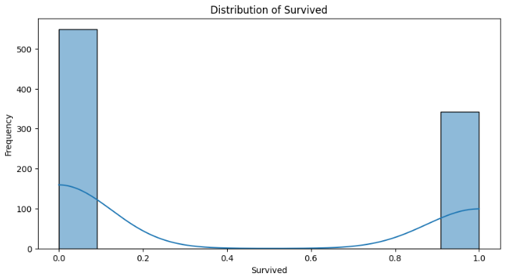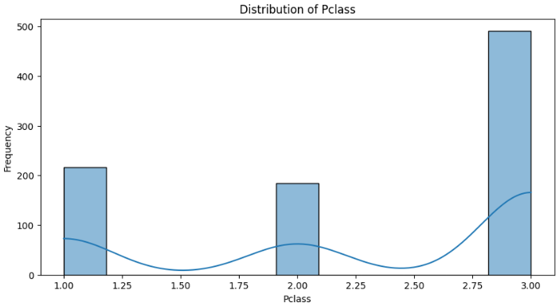

4. Data Preprocessing

Missing Value Handling:
- Age → filled with median
- Embarked → filled with mode
- Cabin → removed (many missing values)
Dropped Columns:
- PassengerId
- Name
- Ticket
These columns do not contribute to prediction.

5. Feature Engineering

New features were created to improve model performance:
- FamilySize = SibSp + Parch + 1
- IsAlone = 1 if passenger is alone, else 0
- AgeBand = grouped age categories
- FareBand = grouped fare categories

6. Data Encoding

Categorical variables were converted using:
👉 One-Hot Encoding (pd.get_dummies)
Examples:
- Sex → Sex_male
- Embarked → Embarked_S, Embarked_Q

7. Train-Test Split
- 80% data used for training
- 20% data used for testing
This helps evaluate model performance on unseen data.

8. Feature Scaling
Used:
👉 StandardScaler
Purpose:
- Normalize numerical values
- Improve performance of models like Logistic Regression and SVM

9. Models Used

The following machine learning models were implemented:
- Logistic Regression
- Decision Tree
- Random Forest
- Gradient Boosting
- Support Vector Machine (SVM)

10. Model Evaluation

Models were evaluated using:
- Accuracy
- ROC-AUC Score
- Precision, Recall, F1-score
- Confusion Matrix
- ROC Curve

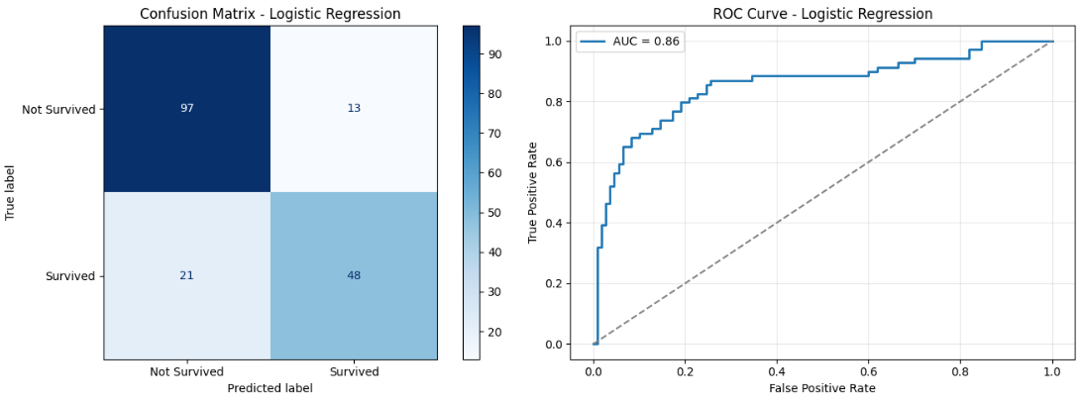

11. Cross Validation
Used:
👉 5-Fold Cross Validation
Purpose:
- Ensure model stability
- Reduce overfitting

12. Best Model Selection
👉 Support Vector Machine (SVM) was selected as the best model
Reason:
- Highest accuracy
- Lowest variance
- Good ROC-AUC score

13. Feature Importance

Using Random Forest, important features identified:
- Sex (Gender)
- Pclass
- Fare
- Age
- FamilySize
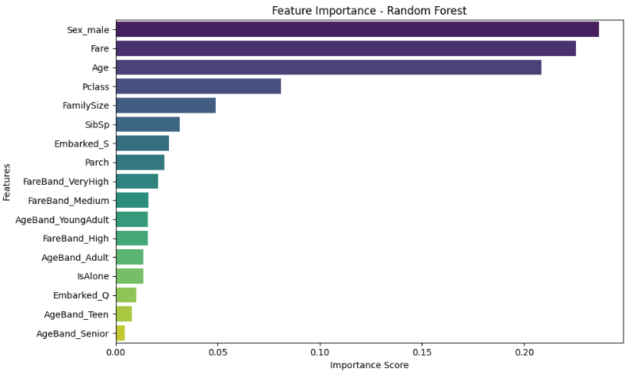

14. Prediction
The trained model is used to predict survival for new passengers.
Example:
- Female
- 1st class
- Age 25
Output:
- Survival prediction
- Probability score

15. Model Saving
The following components were saved using joblib:
- Model → titanic_model.pkl
- Scaler → scaler.pkl
- Clean dataset → titanic_cleaned.csv

16. Key Insights
- Women had higher survival rates
- First-class passengers survived more
- Higher fare increased survival chances
- Smaller families had better survival

17. Conclusion
This project successfully implements a complete machine learning pipeline including:
- Data preprocessing
- Feature engineering
- Model training
- Evaluation
- Prediction
It demonstrates how machine learning can be used for real-world classification problems.
Summary:

Step | What We Did
EDA | Explored data, distributions, survival patterns
Preprocessing | Filled missing values, removed unnecessary columns
Feature Engineering | Created FamilySize, IsAlone, AgeBand, FareBand
Encoding | Applied One-Hot Encoding for categorical data
Modeling | Trained LR, DT, RF, GBM, SVM models
Evaluation | Used Accuracy, ROC-AUC, Confusion Matrix
Cross-Validation | Performed 5-fold validation
Prediction | Predicted survival for new passenger

Short version :
EDA → Cleaning → Feature Engineering → Encoding → Modelling → Evaluation → CV → Prediction

Final Result Summary :

The Titanic Survival Prediction project was successfully completed using a complete machine learning pipeline.
- Multiple models were trained and evaluated, including Logistic Regression, Decision Tree, Random Forest, Gradient Boosting, and Support Vector Machine (SVM).
- Among these, SVM performed the best, achieving approximately 82% accuracy and a ROC-AUC score of around 0.85.
- Cross-validation results confirmed that the model is stable and generalizes well to unseen data.
📊 Key Findings:
- Gender (Sex) was the most important factor affecting survival.
- Passenger class (Pclass) and Fare also had a strong impact.
- Passengers traveling alone had different survival patterns compared to families.
🤖 Model Capability:
- The model can predict survival for new passengers.
- It provides both:
  - Prediction (Survived / Not Survived)
  - Probability score (confidence level)
💾 Project Outcome:
- Cleaned dataset saved
- Trained model saved
- Scaler saved

Built an end-to-end ML model achieving ~82% accuracy to predict Titanic survival using feature engineering and model comparison.

