## Regression- Example with R- Markdown

### By Mandar Gadkari

## Reading the data.

setwd("C:/Courses/BigData")  
myData<- read.csv ("hw1_data.csv")  
summary(lm(Ozone ~ Temp + Wind, data = myData))

##   
## Call:  
## lm(formula = Ozone ~ Temp + Wind, data = myData)  
##   
## Residuals:  
## Min 1Q Median 3Q Max   
## -41.251 -13.695 -2.856 11.390 100.367   
##   
## Coefficients:  
## Estimate Std. Error t value Pr(>|t|)   
## (Intercept) -71.0332 23.5780 -3.013 0.0032 **   
## Temp 1.8402 0.2500 7.362 3.15e-11 ***  
## Wind -3.0555 0.6633 -4.607 1.08e-05 ***  
## ---  
## Signif. codes: 0 '***' 0.001 '**' 0.01 '*' 0.05 '.' 0.1 ' ' 1  
##   
## Residual standard error: 21.85 on 113 degrees of freedom  
## (37 observations deleted due to missingness)  
## Multiple R-squared: 0.5687, Adjusted R-squared: 0.5611   
## F-statistic: 74.5 on 2 and 113 DF, p-value: < 2.2e-16

## Constructing Linear Equation.

### Ozone = 1.8*Temp - 3.1*Wind - 71

## Making Inferences.

#### R-squared: 0.5687

#### Ozone is directly proportional to Temperature.

#### Ozone is inversely proportional to Wind.

#### Wind impacts more than Temperature.

## Calculate Pearsons Coeffcients.

cor(myData)

## Ozone Solar.R Wind Temp Month Day  
## Ozone 1 NA NA NA NA NA  
## Solar.R NA 1 NA NA NA NA  
## Wind NA NA 1.0000000 -0.4579879 -0.178292579 0.027180903  
## Temp NA NA -0.4579879 1.0000000 0.420947252 -0.130593175  
## Month NA NA -0.1782926 0.4209473 1.000000000 -0.007961763  
## Day NA NA 0.0271809 -0.1305932 -0.007961763 1.000000000

## Draws a correlation plot

pairs(myData)

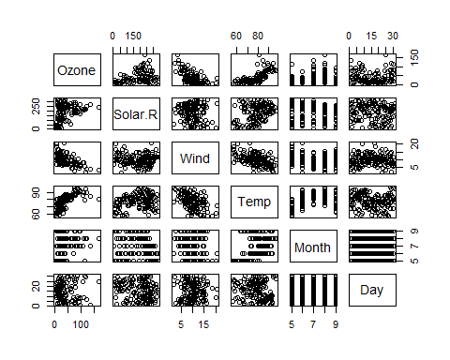 ## Confidence Interval.

model=lm(Ozone ~ Temp+Wind+Temp*Wind, data = myData)  
confint(model,conf.level=0.95)

## 2.5 % 97.5 %  
## (Intercept) -343.899293 -153.1312977  
## Temp 2.911625 5.2398839  
## Wind 5.936518 22.7335434  
## Temp:Wind -0.330884 -0.1169411