Name:Mandar Gadkari

Commands to import data from SQL to HDFS database.

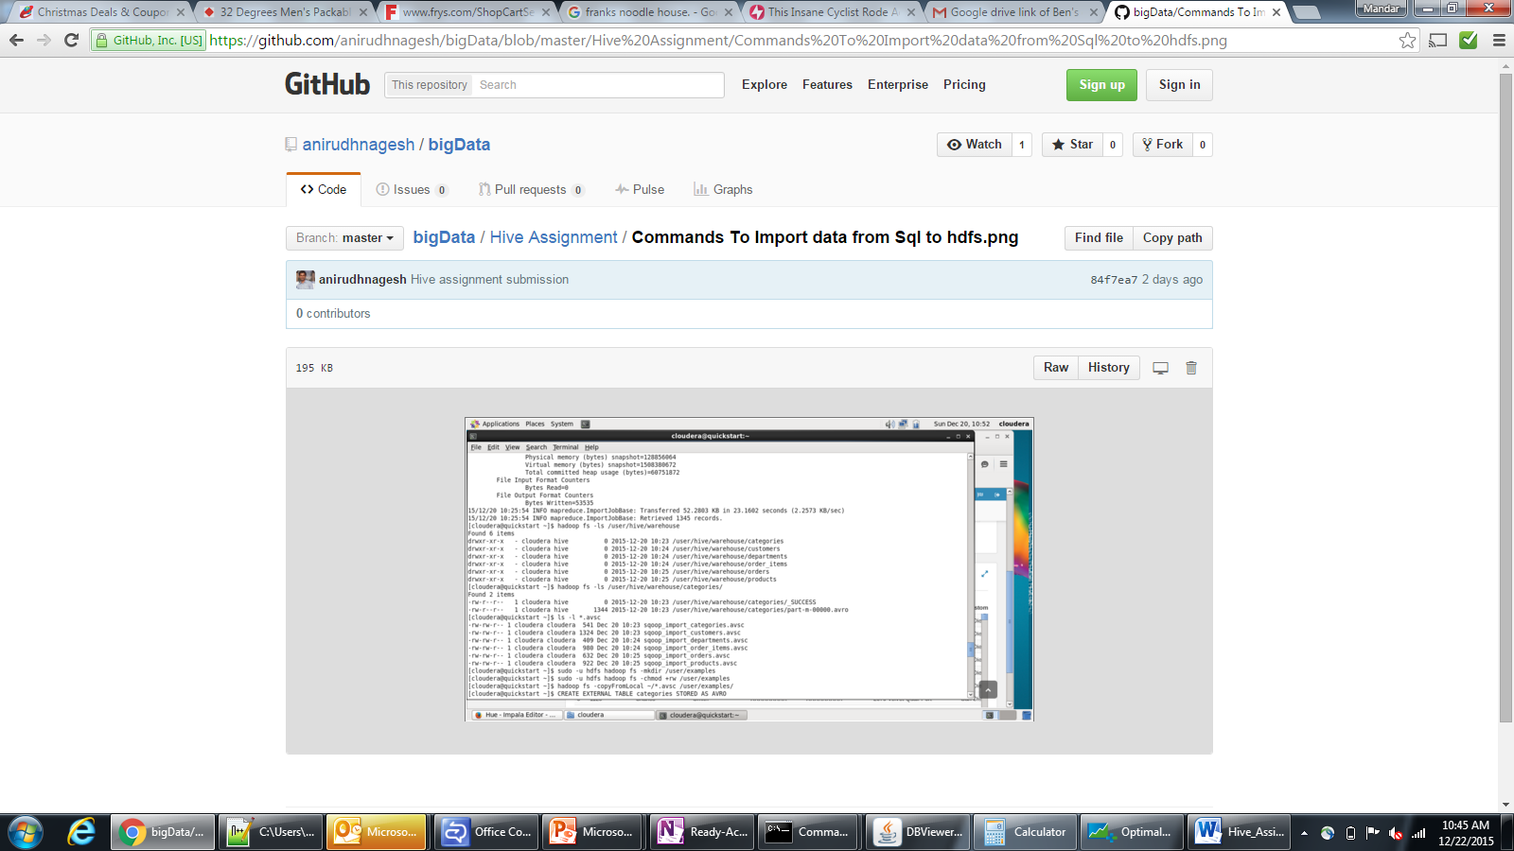

Hive Tables and Query:

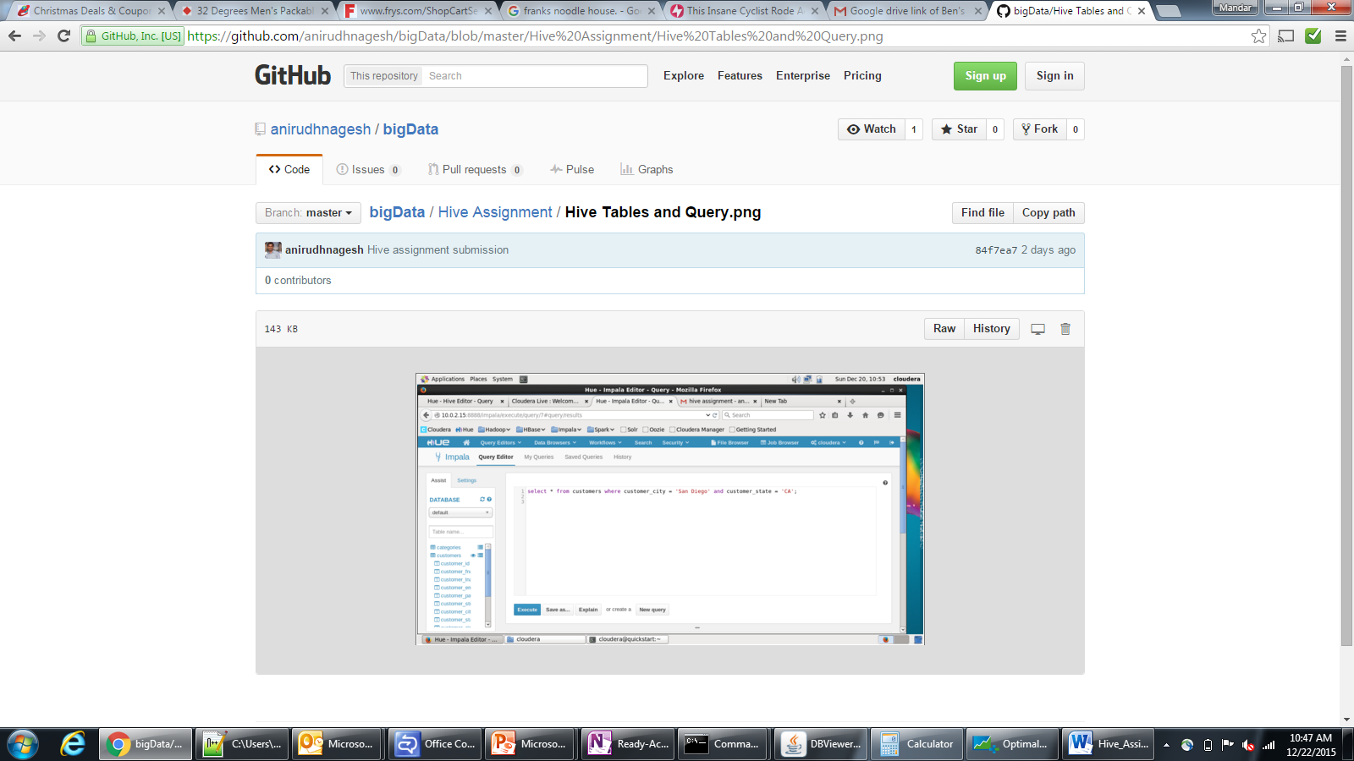

Query Results:

