Exploring The ‘mtcars’ Data Set

Kenneth I. D.

2/1/2020

## Description, Format and Information of the data set

The data was extracted from the 1974 Motor Trend US magazine. It comprises fuel consumption and 10 aspects of automobile design and performance for 32 automobiles of 1973-1974 models.

The data frame consists of 32 observations on 11 numeric variables. These variables are as follows:  
1. mpg: Miles per (US) Gallons  
2. cyl: Number of Cylinders  
3. disp: Displacement  
4: hp: Gross Horsepower  
5. drat: Rear Axle Ratio  
6. wt: Weight (1000lbs)  
7. qsec: Quarter (1/4) Mile Time  
8. vs: Engine (0 = V-Shaped, 1 = Straight)  
9. am: Transmission (0 = Automatic, 1 = Manual)  
10. gear: Number of Forward Gears  
11. carb: Number of Carburetors

### *Source*:

Henderson and Velleman (1981), Building multiple regression models interactively. Bio-metrics, 37, 391-411

To see the structure of the data set

'data.frame': 32 obs. of 11 variables:  
 mpg : num 21 21 22.8 21.4 18.7 18.1 14.3 24.4 22.8 19.2 ...  
 cyl : num 6 6 4 6 8 6 8 4 4 6 ...  
 disp: num 160 160 108 258 360 ...  
 hp : num 110 110 93 110 175 105 245 62 95 123 ...  
 drat: num 3.9 3.9 3.85 3.08 3.15 2.76 3.21 3.69 3.92 3.92 ...  
 wt : num 2.62 2.88 2.32 3.21 3.44 ...  
 qsec: num 16.5 17 18.6 19.4 17 ...  
 vs : num 0 0 1 1 0 1 0 1 1 1 ...  
 am : num 1 1 1 0 0 0 0 0 0 0 ...  
 gear: num 4 4 4 3 3 3 3 4 4 4 ...  
 carb: num 4 4 1 1 2 1 4 2 2 4 ...

The top 6 rows of the data set

mpg cyl disp hp drat wt qsec vs am gear carb  
 Mazda RX4 21.0 6 160 110 3.90 2.620 16.46 0 1 4 4  
 Mazda RX4 Wag 21.0 6 160 110 3.90 2.875 17.02 0 1 4 4  
 Datsun 710 22.8 4 108 93 3.85 2.320 18.61 1 1 4 1  
 Hornet 4 Drive 21.4 6 258 110 3.08 3.215 19.44 1 0 3 1  
 Hornet Sportabout 18.7 8 360 175 3.15 3.440 17.02 0 0 3 2  
 Valiant 18.1 6 225 105 2.76 3.460 20.22 1 0 3 1

The bottow rows of the data set

mpg cyl disp hp drat wt qsec vs am gear carb  
 Porsche 914-2 26.0 4 120.3 91 4.43 2.140 16.7 0 1 5 2  
 Lotus Europa 30.4 4 95.1 113 3.77 1.513 16.9 1 1 5 2  
 Ford Pantera L 15.8 8 351.0 264 4.22 3.170 14.5 0 1 5 4  
 Ferrari Dino 19.7 6 145.0 175 3.62 2.770 15.5 0 1 5 6  
 Maserati Bora 15.0 8 301.0 335 3.54 3.570 14.6 0 1 5 8  
 Volvo 142E 21.4 4 121.0 109 4.11 2.780 18.6 1 1 4 2

##*Exploring the data set*

Number of rows are

[1] 32

Number of columns are

[1] 11

Perform the 5 number summary on every column on the entire data set

mpg cyl disp hp   
 Min. :10.40 Min. :4.000 Min. : 71.1 Min. : 52.0   
 1st Qu.:15.43 1st Qu.:4.000 1st Qu.:120.8 1st Qu.: 96.5   
 Median :19.20 Median :6.000 Median :196.3 Median :123.0   
 Mean :20.09 Mean :6.188 Mean :230.7 Mean :146.7   
 3rd Qu.:22.80 3rd Qu.:8.000 3rd Qu.:326.0 3rd Qu.:180.0   
 Max. :33.90 Max. :8.000 Max. :472.0 Max. :335.0   
 drat wt qsec vs   
 Min. :2.760 Min. :1.513 Min. :14.50 Min. :0.0000   
 1st Qu.:3.080 1st Qu.:2.581 1st Qu.:16.89 1st Qu.:0.0000   
 Median :3.695 Median :3.325 Median :17.71 Median :0.0000   
 Mean :3.597 Mean :3.217 Mean :17.85 Mean :0.4375   
 3rd Qu.:3.920 3rd Qu.:3.610 3rd Qu.:18.90 3rd Qu.:1.0000   
 Max. :4.930 Max. :5.424 Max. :22.90 Max. :1.0000   
 am gear carb   
 Min. :0.0000 Min. :3.000 Min. :1.000   
 1st Qu.:0.0000 1st Qu.:3.000 1st Qu.:2.000   
 Median :0.0000 Median :4.000 Median :2.000   
 Mean :0.4062 Mean :3.688 Mean :2.812   
 3rd Qu.:1.0000 3rd Qu.:4.000 3rd Qu.:4.000   
 Max. :1.0000 Max. :5.000 Max. :8.000

## *To find the mode of every variable in the data set, since this is not an inbuilt function, we have to calculate for each variable.*

For the miles per gallon(mpg) data

[1] "10.4"

[1] "the mode of the miles per gallon is 10.4"

For the cylinder(cyl) data

[1] "8"

[1] "the mode of the cylinder is 8"

For the displacement data

[1] "275.8"

[1] "the mode of the displacement is 275.8"

For the gross horsepower data

[1] "110"

[1] "the mode of the Horsepower is 110"

For the rear axle ratio (drat)

[1] "3.07"

[1] "the mode of the rear axle ratio is 3.07"

For the weight

[1] "3.44"

[1] "the mode of the weight is 3.44"

For the 1/4 mile time

[1] "17.02"

[1] "the mode of the quarter mile is 17.02"

For the engine

[1] "0"

[1] "the mode for the engine type is 0"

For the transmission

[1] "0"

[1] "the most automatic transmission type is 0"

For the number of forward gears

[1] "3"

[1] "the mode for the number of forward gear is 3"

For the number of carburetors

[1] "2"

[1] "the mode for the number of carburetors is 2"

*Exploring the number of cars and their miles per hour*

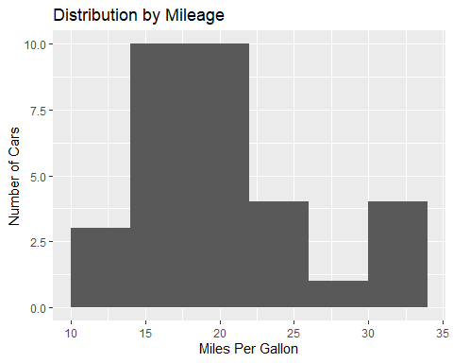

*Exploring the distribution by cylinders*

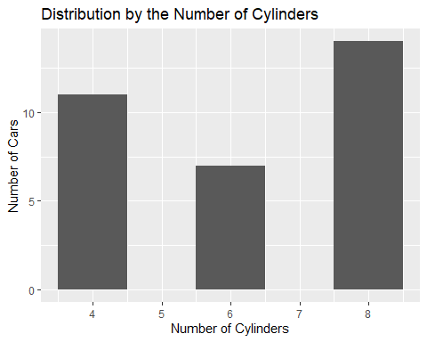

*Exploring the distribution by horsepower*

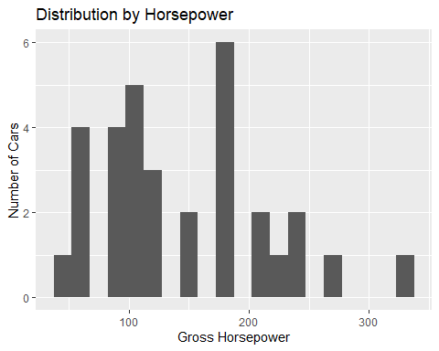

*Exploring the distribution by the number of forward gears*

The cars in this category have forward gears of

gear  
 Mazda RX4 4  
 Mazda RX4 Wag 4  
 Datsun 710 4  
 Hornet 4 Drive 3  
 Hornet Sportabout 3  
 Valiant 3

[1] 4 4 4 3 3 3 3 4 4 4 4 3 3 3 3 3 3 4 4 4 3 3 3 3 3 4 5 5 5 5 5 4  
 Levels: 3 4 5

The frequency of the different categories of forward gears are

3 4 5   
 15 12 5

forward gear type Freq  
 1 3 15  
 2 4 12  
 3 5 5

15 cars have forward gear 3, 12 cars have forward gear 4, while 5 cars have forward gear 5. This is illustrated by the barplot below 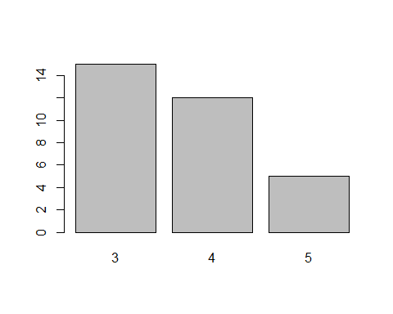

*Exploring the distribution by the engine type*

The cars in this category have engine types of either 0 (V-Shaped) or 1 (Straight)

vs  
 Mazda RX4 0  
 Mazda RX4 Wag 0  
 Datsun 710 1  
 Hornet 4 Drive 1  
 Hornet Sportabout 0  
 Valiant 1

[1] 0 0 1 1 0 1 0 1 1 1 1 0 0 0 0 0 0 1 1 1 1 0 0 0 0 1 0 1 0 0 0 1  
 Levels: 0 1

The frequency of the different categories of engines are

0 1   
 18 14

engine type Freq  
 1 0 18  
 2 1 14

18 cars have V-Shaped engines (0), while 14 cars are have straight shaped engines (1). This is illustrated by the barchart below 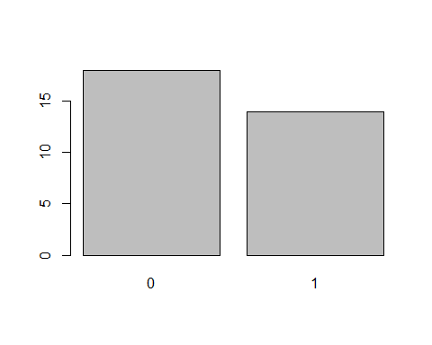

*Exploring the distribution by the transmission type*

The cars in this category have transmission types of either 0 (automatic) or 1 (manual)

am  
 Mazda RX4 1  
 Mazda RX4 Wag 1  
 Datsun 710 1  
 Hornet 4 Drive 0  
 Hornet Sportabout 0  
 Valiant 0

[1] 1 1 1 0 0 0 0 0 0 0 0 0 0 0 0 0 0 1 1 1 0 0 0 0 0 1 1 1 1 1 1 1  
 Levels: 0 1

The frequency of the different categories of transmission are

0 1   
 19 13

Transmission type Freq  
 1 0 19  
 2 1 13

19 cars have automatic transmission, 13 cars are manually transmitted. This is illustrated by the barchart below 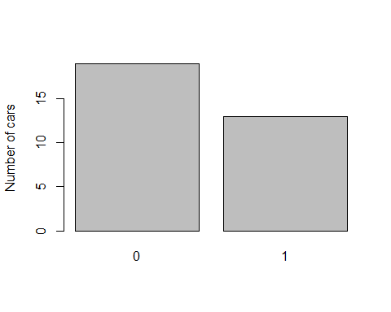

*Exploring the distribution by the Number of Carburetors type*

The cars in this category have carburetors of

carb  
 Mazda RX4 4  
 Mazda RX4 Wag 4  
 Datsun 710 1  
 Hornet 4 Drive 1  
 Hornet Sportabout 2  
 Valiant 1

[1] 4 4 1 1 2 1 4 2 2 4 4 3 3 3 4 4 4 1 2 1 1 2 2 4 2 1 2 2 4 6 8 2  
 Levels: 1 2 3 4 6 8

The frequency of the different categories of number of carburetors are

1 2 3 4 6 8   
 7 10 3 10 1 1

Number of Carburetors Freq  
 1 1 7  
 2 2 10  
 3 3 3  
 4 4 10  
 5 6 1  
 6 8 1

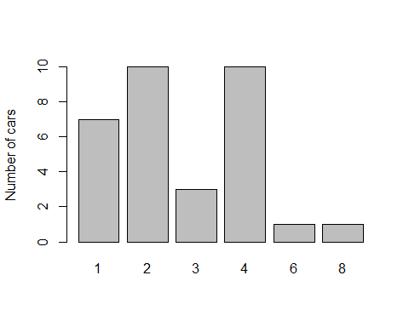

*Correlation between the mileage and the horsepower*

[1] -0.7761684

There is a strong negative correlation between the mileage and the horsepower. This means that the miles per gallons tend to decrease with increasing horsepower of a vehicle and vice versa. Meaning a more powerful vehicle is likely to use up more gas/fuel.

Further testing the correlation of these variables, we find that the correlation implies that the hypothesis is trustworthy.

Pearson's product-moment correlation  
   
 data: mtcars$mpg and mtcars$hp  
 t = -6.7424, df = 30, p-value = 1.788e-07  
 alternative hypothesis: true correlation is not equal to 0  
 95 percent confidence interval:  
 -0.8852686 -0.5860994  
 sample estimates:  
 cor   
 -0.7761684

Fitting the correlation findings in to a plot, 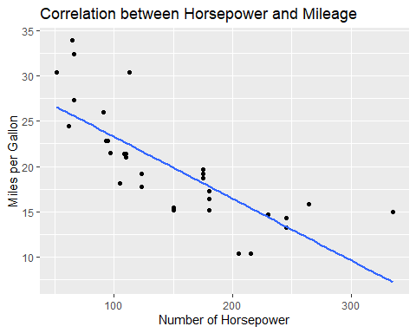

we see that an increase in the horsepower of any car will result in a negative impact on the mileage of that car. According to the hypothesis.

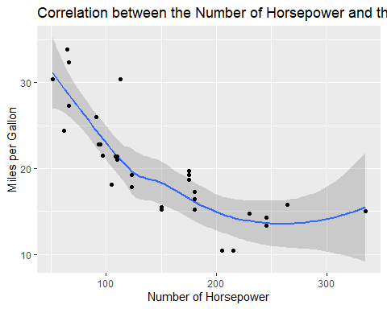

*Exploring the data*

*Correlation between the mileage and the displacement*

[1] -0.8475514

There also is a strong negative correlation between the mileage and the displacement of a car. Meaning that a car is very likely to drop mileage with increasing displacement or distance covered. The test of this hypothesis shows a strong that the hypothesis was correct.

Pearson's product-moment correlation   
 data: mtcars$mpg and mtcars$disp  
 t = -8.7472, df = 30, p-value = 9.38e-10  
 alternative hypothesis: true correlation is not equal to 0  
 95 percent confidence interval:  
 -0.9233594 -0.7081376  
 sample estimates:  
 cor   
 -0.8475514

An increase in the distance a car covers results in a negative impact on its mileage. Putting this in visuals, 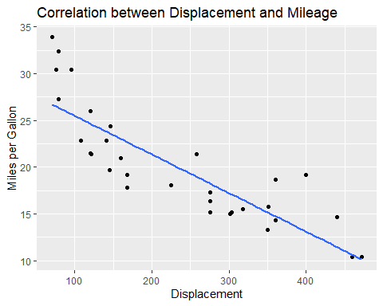

It is shown that here is a steady drop in mileage, with increasing displacement.

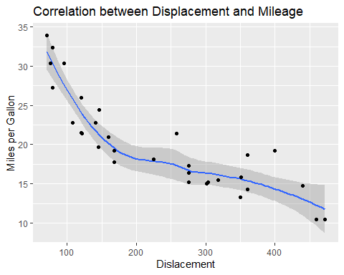

*Correlation between the mileage and the quarter mile ratio*

[1] 0.418684

There is a positive correlation between the mileage and the quarter mile time. This means that an increase in mileage will have a positive impact on the quarter mile time and vice versa. A drop in any will similarly have a negative impact on the other. To test this hypothesis,

Pearson's product-moment correlation  
   
 data: mtcars$mpg and mtcars$qsec  
 t = 2.5252, df = 30, p-value = 0.01708  
 alternative hypothesis: true correlation is not equal to 0  
 95 percent confidence interval:  
 0.08195487 0.66961864  
 sample estimates:  
 cor   
 0.418684

and putting the test into visualization

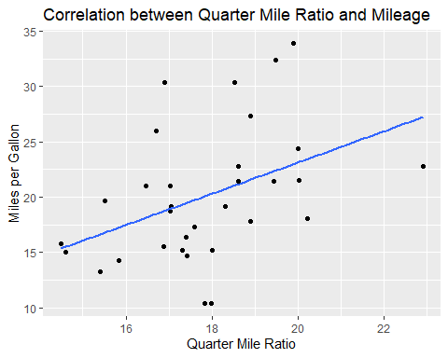

it is shown that the hypothesis was correct and both the mileage and the quarter mile time have similar impact on each other.

`geom_smooth()` using method = 'loess' and formula 'y ~ x'

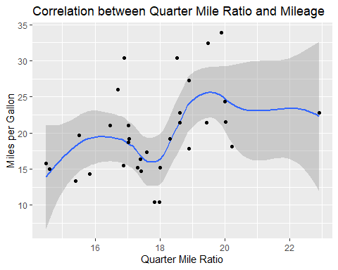

*Correlation between the mileage and the number of cylinders*

[1] -0.852162

There is a strong negative correlation between the number of cylinders and the mileage. This implies that an increase in the number of cylinders in a vehicle will have a negative impact on the miles per gallon To tst this hypothesis

Pearson's product-moment correlation  
   
 data: mtcars$mpg and mtcars$qsec  
 t = 2.5252, df = 30, p-value = 0.01708  
 alternative hypothesis: true correlation is not equal to 0  
 95 percent confidence interval:  
 0.08195487 0.66961864  
 sample estimates:  
 cor   
 0.418684

Putting this test into visualization on a qplot

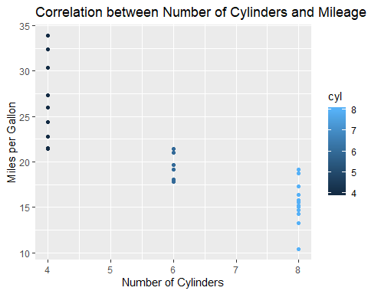

Fitting the points on the qplot

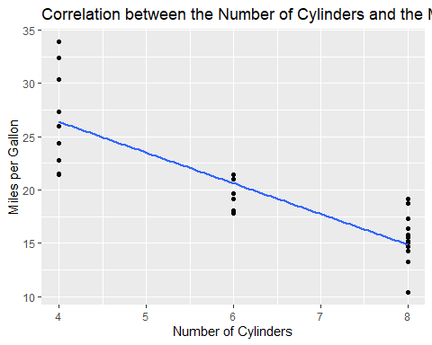

The negative relationship between the miles per gallon and the number of cylinders is shown. The higher the number of cylinders a car has in its engine, the more gallons of gas or fuel it requires to travel, hence low mileage.

*Correlation plot for the mcars data set*

corrplot 0.84 loaded

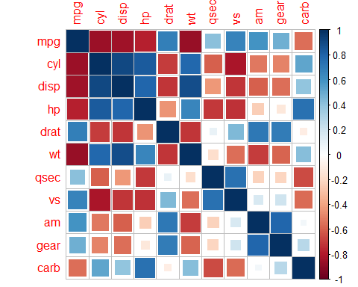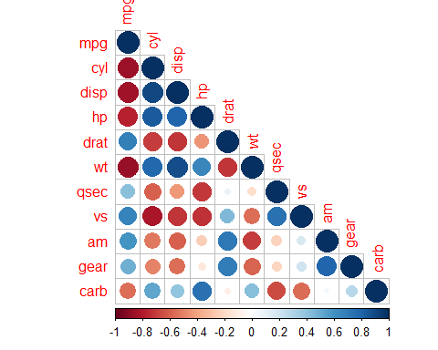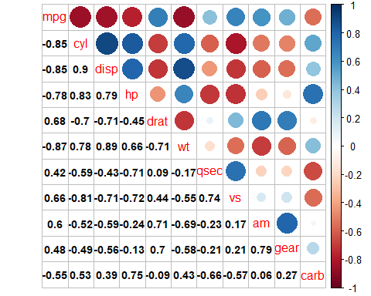

The correlation matrices shown above shows how all the variables in the data set are related to each other. Positive values show positive impact on respective variables while negative value shows negative impact on respective variables.