Exploring The ‘mtcars’ Data Set

Kenneth I. D.

2/1/2020

## Description, Format and Information of the data set

The data was extracted from the 1974 Motor Trend US magazine. It comprises fuel consumption and 10 aspects of automobile design and performance for 32 automobiles of 1973-1974 models.

The data frame consists of 32 observations on 11 numeric variables. These variables are as follows:  
1. mpg: Miles per (US) Gallons  
2. cyl: Number of Cylinders  
3. disp: Displacement  
4: hp: Gross Horsepower  
5. drat: Rear Axle Ratio  
6. wt: Weight (1000lbs)  
7. qsec: Quarter (1/4) Mile Time  
8. vs: Engine (0 = V-Shaped, 1 = Straight)  
9. am: Transmission (0 = Automatic, 1 = Manual)  
10. gear: Number of Forward Gears  
11. carb: Number of Carburetors

### *Source*:

Henderson and Velleman (1981), Building multiple regression models interactively. Bio-metrics, 37, 391-411

To see the structure of the data set

## 'data.frame': 32 obs. of 11 variables:  
## $ mpg : num 21 21 22.8 21.4 18.7 18.1 14.3 24.4 22.8 19.2 ...  
## $ cyl : num 6 6 4 6 8 6 8 4 4 6 ...  
## $ disp: num 160 160 108 258 360 ...  
## $ hp : num 110 110 93 110 175 105 245 62 95 123 ...  
## $ drat: num 3.9 3.9 3.85 3.08 3.15 2.76 3.21 3.69 3.92 3.92 ...  
## $ wt : num 2.62 2.88 2.32 3.21 3.44 ...  
## $ qsec: num 16.5 17 18.6 19.4 17 ...  
## $ vs : num 0 0 1 1 0 1 0 1 1 1 ...  
## $ am : num 1 1 1 0 0 0 0 0 0 0 ...  
## $ gear: num 4 4 4 3 3 3 3 4 4 4 ...  
## $ carb: num 4 4 1 1 2 1 4 2 2 4 ...

The top 6 rows of the data set

## mpg cyl disp hp drat wt qsec vs am gear carb  
## Mazda RX4 21.0 6 160 110 3.90 2.620 16.46 0 1 4 4  
## Mazda RX4 Wag 21.0 6 160 110 3.90 2.875 17.02 0 1 4 4  
## Datsun 710 22.8 4 108 93 3.85 2.320 18.61 1 1 4 1  
## Hornet 4 Drive 21.4 6 258 110 3.08 3.215 19.44 1 0 3 1  
## Hornet Sportabout 18.7 8 360 175 3.15 3.440 17.02 0 0 3 2  
## Valiant 18.1 6 225 105 2.76 3.460 20.22 1 0 3 1

The bottow rows of the data set

## mpg cyl disp hp drat wt qsec vs am gear carb  
## Porsche 914-2 26.0 4 120.3 91 4.43 2.140 16.7 0 1 5 2  
## Lotus Europa 30.4 4 95.1 113 3.77 1.513 16.9 1 1 5 2  
## Ford Pantera L 15.8 8 351.0 264 4.22 3.170 14.5 0 1 5 4  
## Ferrari Dino 19.7 6 145.0 175 3.62 2.770 15.5 0 1 5 6  
## Maserati Bora 15.0 8 301.0 335 3.54 3.570 14.6 0 1 5 8  
## Volvo 142E 21.4 4 121.0 109 4.11 2.780 18.6 1 1 4 2

##*Exploring the data set*

Number of rows are

## [1] 32

Number of columns are

## [1] 11

Perform the 5 number summary on every column on the entire data set

## mpg cyl disp hp   
## Min. :10.40 Min. :4.000 Min. : 71.1 Min. : 52.0   
## 1st Qu.:15.43 1st Qu.:4.000 1st Qu.:120.8 1st Qu.: 96.5   
## Median :19.20 Median :6.000 Median :196.3 Median :123.0   
## Mean :20.09 Mean :6.188 Mean :230.7 Mean :146.7   
## 3rd Qu.:22.80 3rd Qu.:8.000 3rd Qu.:326.0 3rd Qu.:180.0   
## Max. :33.90 Max. :8.000 Max. :472.0 Max. :335.0   
## drat wt qsec vs   
## Min. :2.760 Min. :1.513 Min. :14.50 Min. :0.0000   
## 1st Qu.:3.080 1st Qu.:2.581 1st Qu.:16.89 1st Qu.:0.0000   
## Median :3.695 Median :3.325 Median :17.71 Median :0.0000   
## Mean :3.597 Mean :3.217 Mean :17.85 Mean :0.4375   
## 3rd Qu.:3.920 3rd Qu.:3.610 3rd Qu.:18.90 3rd Qu.:1.0000   
## Max. :4.930 Max. :5.424 Max. :22.90 Max. :1.0000   
## am gear carb   
## Min. :0.0000 Min. :3.000 Min. :1.000   
## 1st Qu.:0.0000 1st Qu.:3.000 1st Qu.:2.000   
## Median :0.0000 Median :4.000 Median :2.000   
## Mean :0.4062 Mean :3.688 Mean :2.812   
## 3rd Qu.:1.0000 3rd Qu.:4.000 3rd Qu.:4.000   
## Max. :1.0000 Max. :5.000 Max. :8.000

## *To find the mode of every variable in the data set, since this is not an inbuilt function, we have to calculate for each variable.*

For the miles per gallon(mpg) data

## [1] "10.4"

## [1] "the mode of the miles per gallon is 10.4"

For the cylinder(cyl) data

## [1] "8"

## [1] "the mode of the cylinder is 8"

For the displacement data

## [1] "275.8"

## [1] "the mode of the displacement is 275.8"

For the gross horsepower data

## [1] "110"

## [1] "the mode of the Horsepower is 110"

For the rear axle ratio (drat)

## [1] "3.07"

## [1] "the mode of the rear axle ratio is 3.07"

For the weight

## [1] "3.44"

## [1] "the mode of the weight is 3.44"

For the 1/4 mile time

## [1] "17.02"

## [1] "the mode of the quarter mile is 17.02"

For the engine

## [1] "0"

## [1] "the mode for the engine type is 0"

For the transmission

## [1] "0"

## [1] "the most automatic transmission type is 0"

For the number of forward gears

## [1] "3"

## [1] "the mode for the number of forward gear is 3"

For the number of carburetors

## [1] "2"

## [1] "the mode for the number of carburetors is 2"

*Exploring the number of cars and their miles per hour*

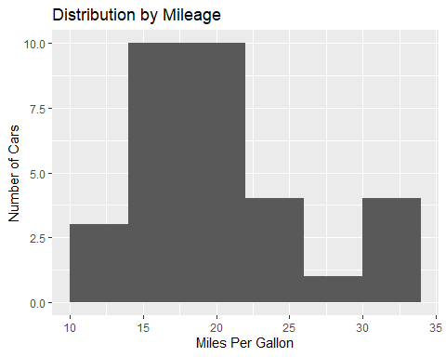

*Exploring the distribution by cylinders*

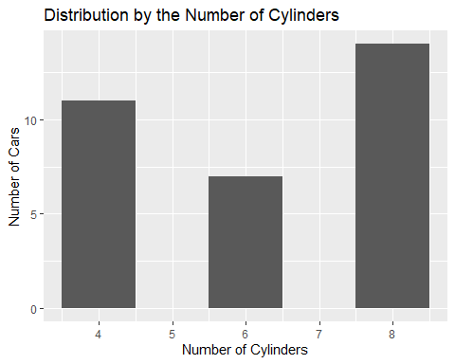

*Exploring the distribution by horsepower*

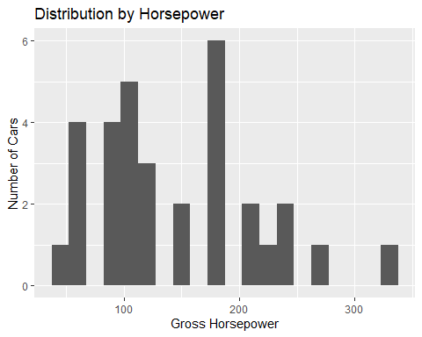

*Exploring the distribution by the number of forward gears*

The cars in this category have forward gears of

## gear  
## Mazda RX4 4  
## Mazda RX4 Wag 4  
## Datsun 710 4  
## Hornet 4 Drive 3  
## Hornet Sportabout 3  
## Valiant 3

## [1] 4 4 4 3 3 3 3 4 4 4 4 3 3 3 3 3 3 4 4 4 3 3 3 3 3 4 5 5 5 5 5 4  
## Levels: 3 4 5

The frequency of the different categories of forward gears are

##   
## 3 4 5   
## 15 12 5

## forward gear type Freq  
## 1 3 15  
## 2 4 12  
## 3 5 5

15 cars have forward gear 3, 12 cars have forward gear 4, while 5 cars have forward gear 5. This is illustrated by the barplot below 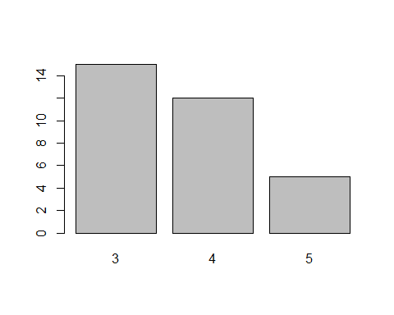

*Exploring the distribution by the engine type*

The cars in this category have engine types of either 0 (V-Shaped) or 1 (Straight)

## vs  
## Mazda RX4 0  
## Mazda RX4 Wag 0  
## Datsun 710 1  
## Hornet 4 Drive 1  
## Hornet Sportabout 0  
## Valiant 1

## [1] 0 0 1 1 0 1 0 1 1 1 1 0 0 0 0 0 0 1 1 1 1 0 0 0 0 1 0 1 0 0 0 1  
## Levels: 0 1

The frequency of the different categories of engines are

##   
## 0 1   
## 18 14

## engine type Freq  
## 1 0 18  
## 2 1 14

18 cars have V-Shaped engines (0), while 14 cars are have straight shaped engines (1). This is illustrated by the barchart below 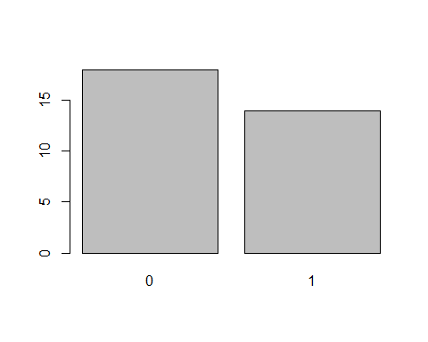

*Exploring the distribution by the transmission type*

The cars in this category have transmission types of either 0 (automatic) or 1 (manual)

## am  
## Mazda RX4 1  
## Mazda RX4 Wag 1  
## Datsun 710 1  
## Hornet 4 Drive 0  
## Hornet Sportabout 0  
## Valiant 0

## [1] 1 1 1 0 0 0 0 0 0 0 0 0 0 0 0 0 0 1 1 1 0 0 0 0 0 1 1 1 1 1 1 1  
## Levels: 0 1

The frequency of the different categories of transmission are

##   
## 0 1   
## 19 13

## Transmission type Freq  
## 1 0 19  
## 2 1 13

19 cars have automatic transmission, 13 cars are manually transmitted. This is illustrated by the barchart below 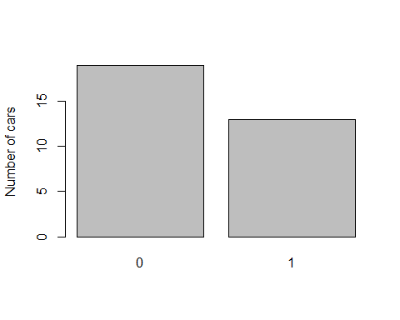

*Exploring the distribution by the Number of Carburetors type*

The cars in this category have carburetors of

## carb  
## Mazda RX4 4  
## Mazda RX4 Wag 4  
## Datsun 710 1  
## Hornet 4 Drive 1  
## Hornet Sportabout 2  
## Valiant 1

## [1] 4 4 1 1 2 1 4 2 2 4 4 3 3 3 4 4 4 1 2 1 1 2 2 4 2 1 2 2 4 6 8 2  
## Levels: 1 2 3 4 6 8

The frequency of the different categories of number of carburetors are

##   
## 1 2 3 4 6 8   
## 7 10 3 10 1 1

## Number of Carburetors Freq  
## 1 1 7  
## 2 2 10  
## 3 3 3  
## 4 4 10  
## 5 6 1  
## 6 8 1

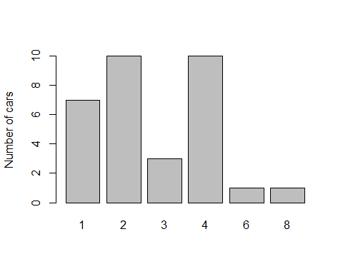

*Correlation between the mileage and the horsepower*

## [1] -0.7761684

There is a strong negative correlation between the mileage and the horsepower. This means that the miles per gallons tend to decrease with increasing horsepower of a vehicle and vice versa. Meaning a more powerful vehicle is likely to use up more gas/fuel.

Further testing the correlation of these variables, we find that the correlation implies that the hypothesis is trustworthy.

##   
## Pearson's product-moment correlation  
##   
## data: mtcars$mpg and mtcars$hp  
## t = -6.7424, df = 30, p-value = 1.788e-07  
## alternative hypothesis: true correlation is not equal to 0  
## 95 percent confidence interval:  
## -0.8852686 -0.5860994  
## sample estimates:  
## cor   
## -0.7761684

Fitting the correlation findings in to a plot, 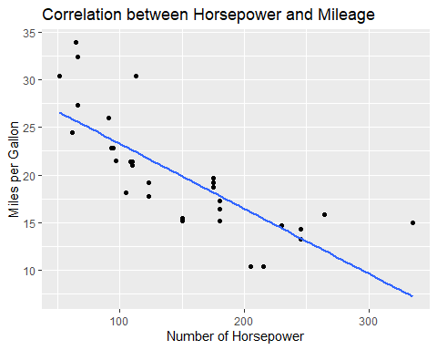 we see that an increase in the horsepower of any car will result in a negative impact on the mileage of that car. According to the hypothesis.

## `geom_smooth()` using method = 'loess' and formula 'y ~ x'

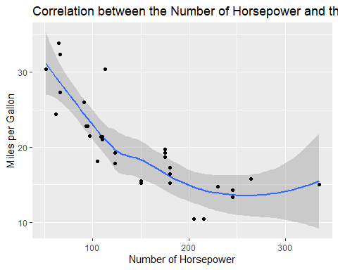

*Exploring the data*

*Correlation between the mileage and the displacement*

## [1] -0.8475514

There also is a strong negative correlation between the mileage and the displacement of a car. Meaning that a car is very likely to drop mileage with increasing displacement or distance covered.

The test of this hypothesis shows a strong that the hypothesis was correct.

##   
## Pearson's product-moment correlation  
##   
## data: mtcars$mpg and mtcars$disp  
## t = -8.7472, df = 30, p-value = 9.38e-10  
## alternative hypothesis: true correlation is not equal to 0  
## 95 percent confidence interval:  
## -0.9233594 -0.7081376  
## sample estimates:  
## cor   
## -0.8475514

An increase in the distance a car covers results in a negative impact on its mileage.

Putting this in visuals, 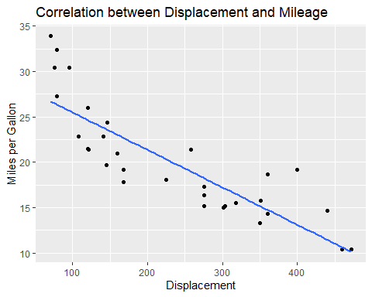

There is a steady drop in mileage, with increasing displacement.

## `geom_smooth()` using method = 'loess' and formula 'y ~ x'

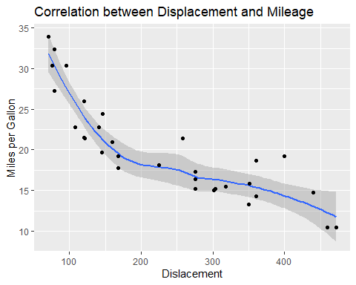

*Correlation between the mileage and the quarter mile ratio*

## [1] 0.418684

There is a positive correlation between the mileage and the quarter mile time. This means that an increase in mileage will have a positive impact on the quarter mile time and vice versa. A drop in any will similarly have a negative impact on the other.

To test this hypothesis,

##   
## Pearson's product-moment correlation  
##   
## data: mtcars$mpg and mtcars$qsec  
## t = 2.5252, df = 30, p-value = 0.01708  
## alternative hypothesis: true correlation is not equal to 0  
## 95 percent confidence interval:  
## 0.08195487 0.66961864  
## sample estimates:  
## cor   
## 0.418684

and putting the test into visualization

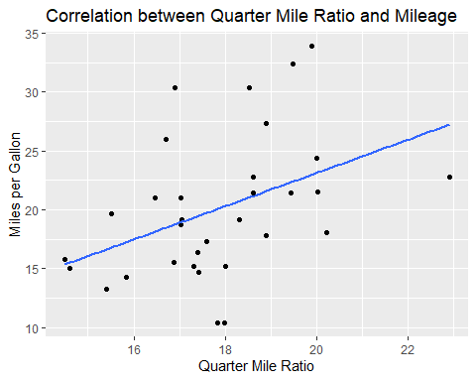 it is shown that the hypothesis was right and both the mileage and the quarter mile time have similar impact on each other.

## `geom_smooth()` using method = 'loess' and formula 'y ~ x'

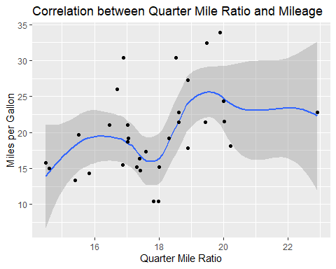

*Correlation between the mileage and the number of cylinders*

## [1] -0.852162

There is a strong negative correlation between the number of cylinders and the mileage. This implies that an increase in the number of cylinders in a vehicle will have a negative impact on the miles per gallon To tst this hypothesis

##   
## Pearson's product-moment correlation  
##   
## data: mtcars$mpg and mtcars$qsec  
## t = 2.5252, df = 30, p-value = 0.01708  
## alternative hypothesis: true correlation is not equal to 0  
## 95 percent confidence interval:  
## 0.08195487 0.66961864  
## sample estimates:  
## cor   
## 0.418684

Putting this test into visualization on a qplot 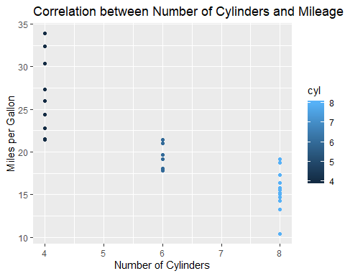 Fitting the points on the qplot 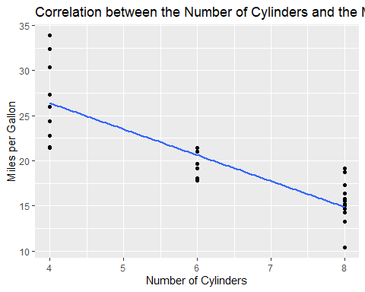 The negative relationship between the miles per gallon and the number of cylinders is shown. The higher the number of cylinders a car has in its engine, the more gallons of gas or fuel it requires to travel, hence low mileage.

*Correlation plot for the mcars data set*

## corrplot 0.84 loaded

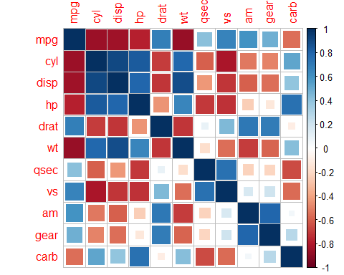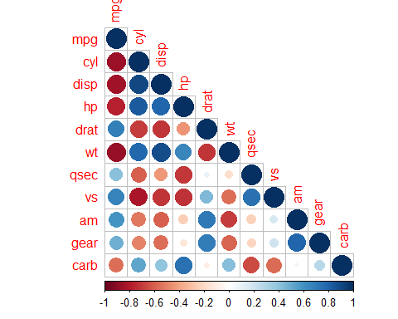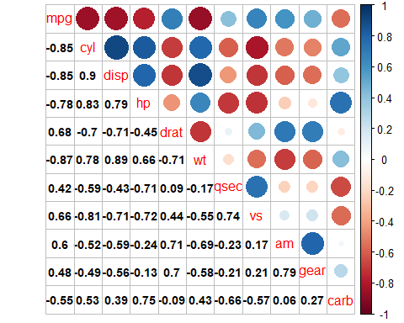 The correlation matrices shown above shows how all the variables in the data set are related to each other. Positive values show positive impact on respective variables while negative value shows negative impact on respective variables.

### *Predictive Analysis*

Dividing the data into train and test subsets

*Multivariate Linear Regression Models* In building a multiple regression model, I believe using any combination of the cyl, disp, hp and wt variables would form the best regeression models since they have the highest correlation to mpg (even if the correlation is negative). We will create a multivariate regression model using all four of these variables. However, we will develop other models with other combinations of three of the four variables to compare which is the best, using the train dataset.

Fitting all four variables into a model (Model 1)

##   
## Call:  
## lm(formula = mpg ~ hp + wt + cyl + disp, data = train)  
##   
## Residuals:  
## Min 1Q Median 3Q Max   
## -4.3817 -1.5893 -0.4974 1.3581 5.6652   
##   
## Coefficients:  
## Estimate Std. Error t value Pr(>|t|)   
## (Intercept) 40.603346 3.982336 10.196 6.62e-09 ***  
## hp -0.017903 0.030380 -0.589 0.5630   
## wt -3.304283 1.458734 -2.265 0.0361 *   
## cyl -1.394781 0.864794 -1.613 0.1242   
## disp 0.006155 0.016712 0.368 0.7170   
## ---  
## Signif. codes: 0 '***' 0.001 '**' 0.01 '*' 0.05 '.' 0.1 ' ' 1  
##   
## Residual standard error: 2.824 on 18 degrees of freedom  
## Multiple R-squared: 0.8286, Adjusted R-squared: 0.7905   
## F-statistic: 21.75 on 4 and 18 DF, p-value: 1.082e-06

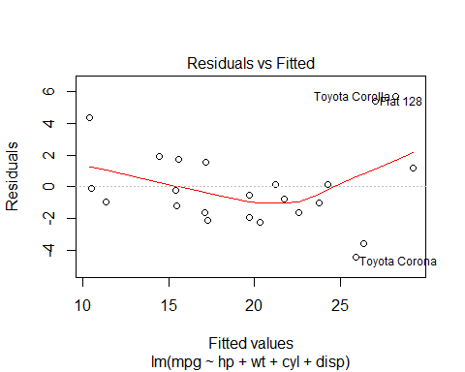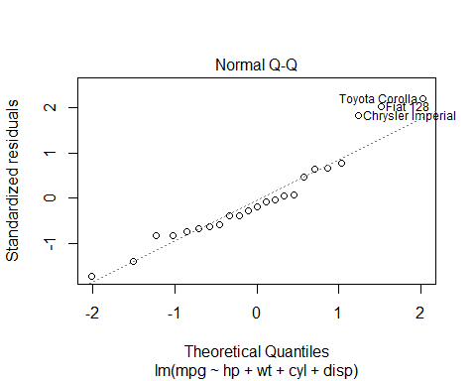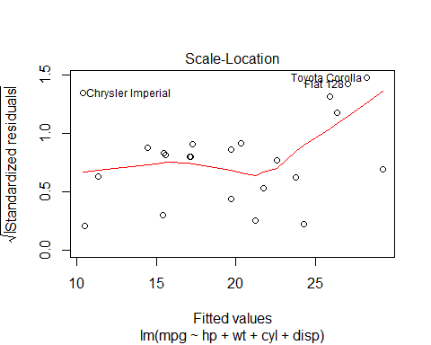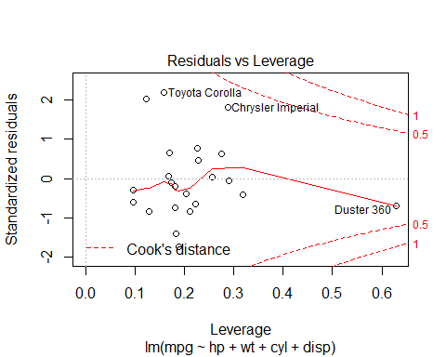

Fitting the hp, wt and cyl variables into a model (Model 2)

##   
## Call:  
## lm(formula = mpg ~ hp + wt + cyl, data = train)  
##   
## Residuals:  
## Min 1Q Median 3Q Max   
## -4.3531 -1.5338 -0.6171 1.4230 5.7341   
##   
## Coefficients:  
## Estimate Std. Error t value Pr(>|t|)   
## (Intercept) 39.58913 2.81041 14.087 1.65e-11 ***  
## hp -0.01423 0.02803 -0.508 0.6176   
## wt -2.94841 1.06762 -2.762 0.0124 *   
## cyl -1.27202 0.77961 -1.632 0.1192   
## ---  
## Signif. codes: 0 '***' 0.001 '**' 0.01 '*' 0.05 '.' 0.1 ' ' 1  
##   
## Residual standard error: 2.759 on 19 degrees of freedom  
## Multiple R-squared: 0.8273, Adjusted R-squared: 0.8   
## F-statistic: 30.33 on 3 and 19 DF, p-value: 1.888e-07

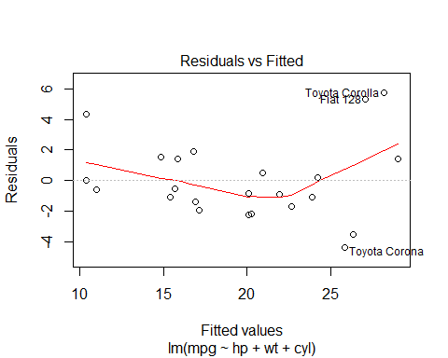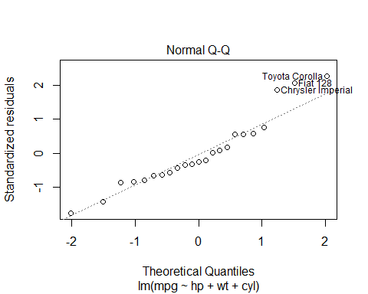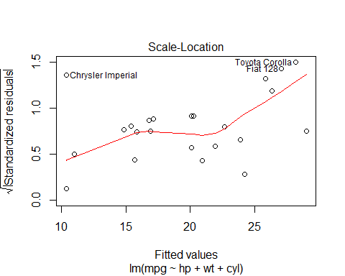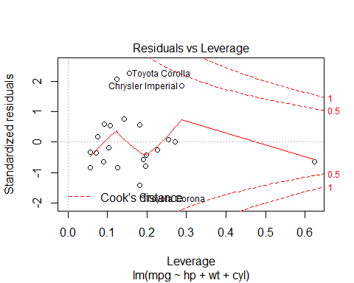

Fitting the hp, wt and disp variables into a third model (Model 3)

##   
## Call:  
## lm(formula = mpg ~ hp + wt + disp, data = train)  
##   
## Residuals:  
## Min 1Q Median 3Q Max   
## -3.4702 -2.2837 0.1919 0.7211 6.0975   
##   
## Coefficients:  
## Estimate Std. Error t value Pr(>|t|)   
## (Intercept) 36.042796 2.919959 12.344 1.61e-10 ***  
## hp -0.043196 0.027094 -1.594 0.1274   
## wt -2.796448 1.483153 -1.885 0.0748 .   
## disp -0.004235 0.016057 -0.264 0.7948   
## ---  
## Signif. codes: 0 '***' 0.001 '**' 0.01 '*' 0.05 '.' 0.1 ' ' 1  
##   
## Residual standard error: 2.941 on 19 degrees of freedom  
## Multiple R-squared: 0.8038, Adjusted R-squared: 0.7728   
## F-statistic: 25.94 on 3 and 19 DF, p-value: 6.259e-07

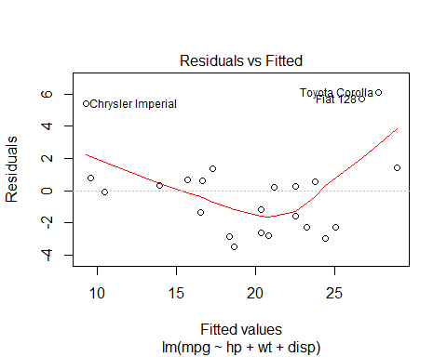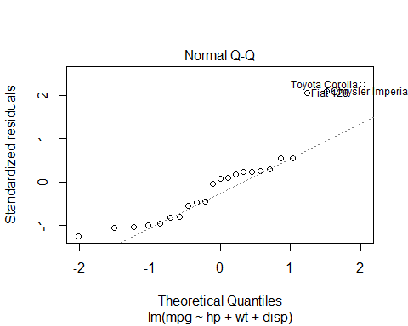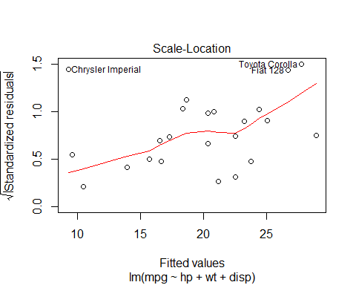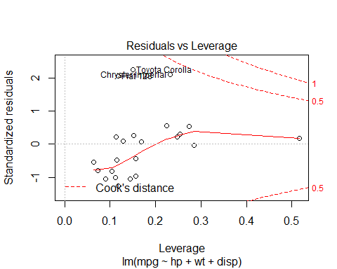

Fitting the hp, cyl and disp variables into a fourth model (Model 4)

##   
## Call:  
## lm(formula = mpg ~ hp + cyl + disp, data = train)  
##   
## Residuals:  
## Min 1Q Median 3Q Max   
## -3.875 -1.729 -1.186 1.445 6.814   
##   
## Coefficients:  
## Estimate Std. Error t value Pr(>|t|)   
## (Intercept) 34.15812 3.07421 11.111 9.4e-10 ***  
## hp -0.02829 0.03314 -0.854 0.404   
## cyl -0.97195 0.93169 -1.043 0.310   
## disp -0.01892 0.01381 -1.370 0.187   
## ---  
## Signif. codes: 0 '***' 0.001 '**' 0.01 '*' 0.05 '.' 0.1 ' ' 1  
##   
## Residual standard error: 3.116 on 19 degrees of freedom  
## Multiple R-squared: 0.7797, Adjusted R-squared: 0.7449   
## F-statistic: 22.41 on 3 and 19 DF, p-value: 1.856e-06

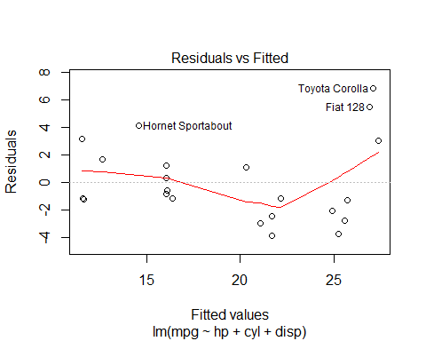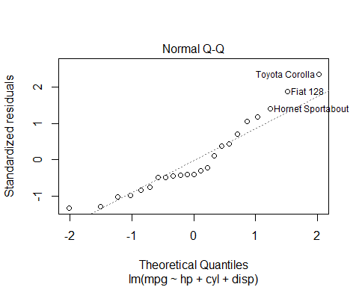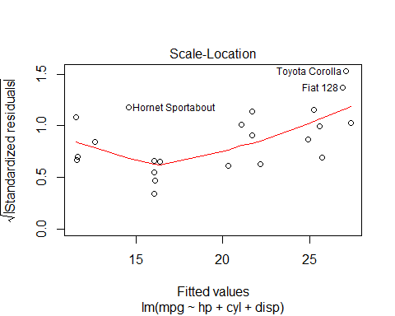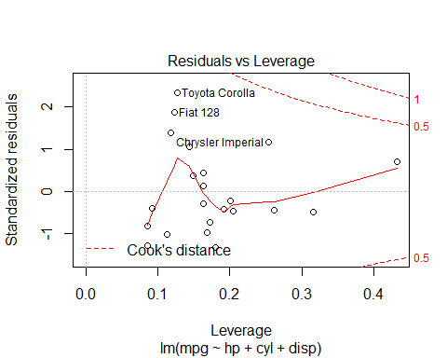

Fitting the wt, cyl and disp variables into a fifth model (Model 5)

##   
## Call:  
## lm(formula = mpg ~ wt + cyl + disp, data = train)  
##   
## Residuals:  
## Min 1Q Median 3Q Max   
## -4.7745 -1.5959 -0.5492 1.4414 5.6051   
##   
## Coefficients:  
## Estimate Std. Error t value Pr(>|t|)   
## (Intercept) 41.020264 3.851086 10.652 1.89e-09 ***  
## wt -3.434084 1.417024 -2.423 0.0255 *   
## cyl -1.657850 0.727836 -2.278 0.0345 *   
## disp 0.002919 0.015511 0.188 0.8527   
## ---  
## Signif. codes: 0 '***' 0.001 '**' 0.01 '*' 0.05 '.' 0.1 ' ' 1  
##   
## Residual standard error: 2.775 on 19 degrees of freedom  
## Multiple R-squared: 0.8252, Adjusted R-squared: 0.7977   
## F-statistic: 29.91 on 3 and 19 DF, p-value: 2.106e-07

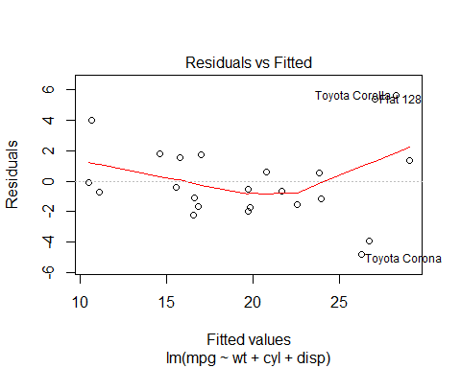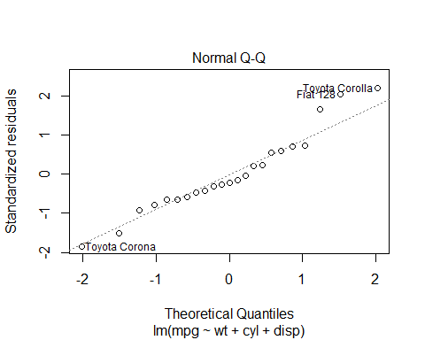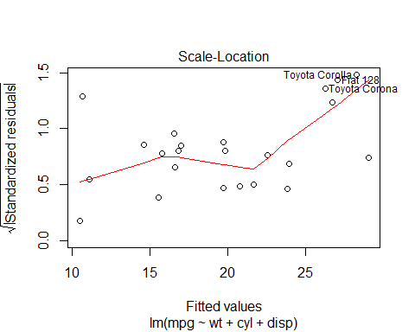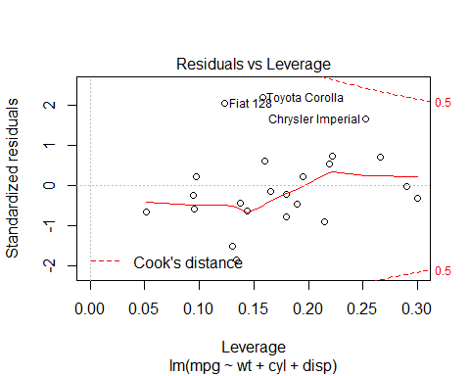

*Prediction Analysis using the multivariate regression analysis*

Model 1

## Mazda RX4 Mazda RX4 Wag Datsun 710 Hornet 4 Drive   
## 22.59283 21.75024 26.35799 21.22994   
## Hornet Sportabout Valiant Duster 360 Merc 240D   
## 17.16098 20.30680 15.47820 24.27645   
## Merc 230 Merc 280 Merc 280C Merc 450SE   
## 23.78150 19.69736 19.69736 14.47155   
## Merc 450SL Merc 450SLC Cadillac Fleetwood Lincoln Continental   
## 15.59500 15.42979 11.33245 10.50462   
## Chrysler Imperial Fiat 128 Honda Civic Toyota Corolla   
## 10.37402 27.05756 29.22275 28.23475   
## Toyota Corona Dodge Challenger AMC Javelin Camaro Z28   
## 25.88173 17.08572 17.28042 14.52450   
## Pontiac Firebird Fiat X1-9 Porsche 914-2 Lotus Europa   
## 16.06893 27.93504 27.06427 28.58709   
## Ford Pantera L Ferrari Dino Maserati Bora Volvo 142E   
## 16.40436 20.84117 13.50380 24.63158

Model 2

## Mazda RX4 Mazda RX4 Wag Datsun 710 Hornet 4 Drive   
## 22.66713 21.91529 26.33757 20.91283   
## Hornet Sportabout Valiant Duster 360 Merc 240D   
## 16.78059 20.26160 15.40136 24.21351   
## Merc 230 Merc 280 Merc 280C Merc 450SE   
## 23.86193 20.06447 20.06447 14.85196   
## Merc 450SL Merc 450SLC Cadillac Fleetwood Lincoln Continental   
## 15.85442 15.70700 11.01714 10.36184   
## Chrysler Imperial Fiat 128 Honda Civic Toyota Corolla   
## 10.38135 27.07552 28.99953 28.16592   
## Toyota Corona Dodge Challenger AMC Javelin Camaro Z28   
## 25.85313 16.90041 17.15103 14.60529   
## Pontiac Firebird Fiat X1-9 Porsche 914-2 Lotus Europa   
## 15.58649 27.85685 26.89673 28.43238   
## Ford Pantera L Ferrari Dino Maserati Bora Volvo 142E   
## 16.31040 21.30007 14.12088 24.75365

Model 3

## Mazda RX4 Mazda RX4 Wag Datsun 710 Hornet 4 Drive   
## 23.286982 22.573888 25.080455 21.208094   
## Hornet Sportabout Valiant Duster 360 Merc 240D   
## 17.339208 20.878690 13.951946 23.822740   
## Merc 230 Merc 280 Merc 280C Merc 450SE   
## 22.534112 20.400162 20.400162 15.718029   
## Merc 450SL Merc 450SLC Cadillac Fleetwood Lincoln Continental   
## 16.668821 16.528999 10.507468 9.639742   
## Chrysler Imperial Fiat 128 Honda Civic Toyota Corolla   
## 9.297415 26.706399 28.959770 27.802483   
## Toyota Corona Dodge Challenger AMC Javelin Camaro Z28   
## 24.450946 18.373252 18.670236 13.239252   
## Pontiac Firebird Fiat X1-9 Porsche 914-2 Lotus Europa   
## 16.037258 27.446188 25.618121 26.527895   
## Ford Pantera L Ferrari Dino Maserati Bora Volvo 142E   
## 14.287913 20.123292 10.314149 23.047901

Model 4

## Mazda RX4 Mazda RX4 Wag Datsun 710 Hornet 4 Drive   
## 22.18656 22.18656 25.59540 20.33221   
## Hornet Sportabout Valiant Duster 360 Merc 240D   
## 14.61916 21.09810 12.63858 25.74024   
## Merc 230 Merc 280 Merc 280C Merc 450SE   
## 24.91818 21.67493 21.67493 16.07092   
## Merc 450SL Merc 450SLC Cadillac Fleetwood Lincoln Continental   
## 16.07092 16.07092 11.65107 11.59520   
## Chrysler Imperial Fiat 128 Honda Civic Toyota Corolla   
## 11.54923 26.91376 27.36664 27.08586   
## Toyota Corona Dodge Challenger AMC Javelin Camaro Z28   
## 25.25327 16.12123 16.38614 12.82780   
## Pontiac Firebird Fiat X1-9 Porsche 914-2 Lotus Europa   
## 13.86228 26.90808 25.41925 25.27362   
## Ford Pantera L Ferrari Dino Maserati Bora Volvo 142E   
## 12.27129 20.63128 11.20851 24.89671

Model 5

## Mazda RX4 Mazda RX4 Wag Datsun 710 Hornet 4 Drive   
## 22.54295 21.66726 26.73707 20.78576   
## Hornet Sportabout Valiant Duster 360 Merc 240D   
## 16.99516 19.84808 16.54873 23.86240   
## Merc 230 Merc 280 Merc 280C Merc 450SE   
## 23.98254 19.74919 19.74919 14.58589   
## Merc 450SL Merc 450SLC Cadillac Fleetwood Lincoln Continental   
## 15.75347 15.58177 11.10643 10.47387   
## Chrysler Imperial Fiat 128 Honda Civic Toyota Corolla   
## 10.68678 27.06363 29.06381 28.29488   
## Toyota Corona Dodge Challenger AMC Javelin Camaro Z28   
## 26.27446 16.59783 16.84885 15.59234   
## Pontiac Firebird Fiat X1-9 Porsche 914-2 Lotus Europa   
## 15.72113 27.97454 27.39112 29.47072   
## Ford Pantera L Ferrari Dino Maserati Bora Volvo 142E   
## 17.89609 21.98405 16.37649 25.19535

*Univariate Linear Regression Models* In my opinion, a linear regression model with the cyl variable will be the best as it has the highest correlation with mpg. However, I will build models with the other variables and make predictions with them just to verify.

The cyl model

##   
## Call:  
## lm(formula = mpg ~ cyl, data = train)  
##   
## Residuals:  
## Min 1Q Median 3Q Max   
## -5.0408 -2.6047 0.4453 1.3814 7.3592   
##   
## Coefficients:  
## Estimate Std. Error t value Pr(>|t|)   
## (Intercept) 38.5131 2.7037 14.245 2.90e-12 ***  
## cyl -2.9931 0.4168 -7.182 4.44e-07 ***  
## ---  
## Signif. codes: 0 '***' 0.001 '**' 0.01 '*' 0.05 '.' 0.1 ' ' 1  
##   
## Residual standard error: 3.397 on 21 degrees of freedom  
## Multiple R-squared: 0.7107, Adjusted R-squared: 0.6969   
## F-statistic: 51.58 on 1 and 21 DF, p-value: 4.439e-07

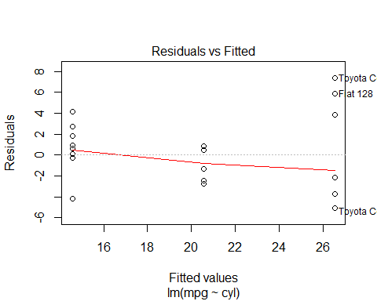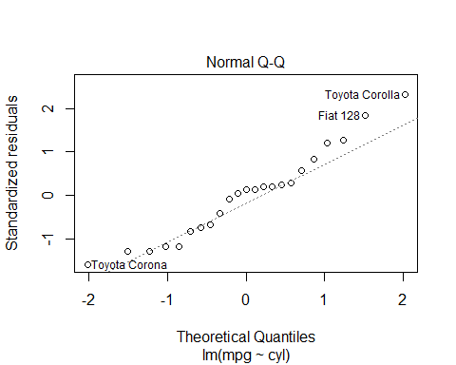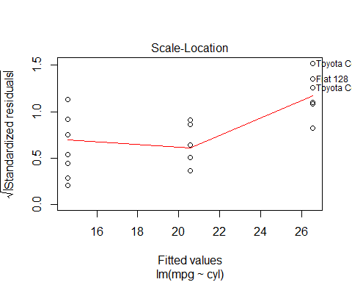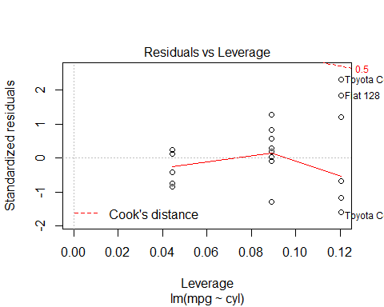

## Mazda RX4 Mazda RX4 Wag Datsun 710 Hornet 4 Drive   
## 20.55471 20.55471 26.54084 20.55471   
## Hornet Sportabout Valiant Duster 360 Merc 240D   
## 14.56859 20.55471 14.56859 26.54084   
## Merc 230 Merc 280 Merc 280C Merc 450SE   
## 26.54084 20.55471 20.55471 14.56859   
## Merc 450SL Merc 450SLC Cadillac Fleetwood Lincoln Continental   
## 14.56859 14.56859 14.56859 14.56859   
## Chrysler Imperial Fiat 128 Honda Civic Toyota Corolla   
## 14.56859 26.54084 26.54084 26.54084   
## Toyota Corona Dodge Challenger AMC Javelin Camaro Z28   
## 26.54084 14.56859 14.56859 14.56859   
## Pontiac Firebird Fiat X1-9 Porsche 914-2 Lotus Europa   
## 14.56859 26.54084 26.54084 26.54084   
## Ford Pantera L Ferrari Dino Maserati Bora Volvo 142E   
## 14.56859 20.55471 14.56859 26.54084

The disp model

##   
## Call:  
## lm(formula = mpg ~ disp, data = train)  
##   
## Residuals:  
## Min 1Q Median 3Q Max   
## -4.8747 -2.0638 -0.7667 1.7059 7.1138   
##   
## Coefficients:  
## Estimate Std. Error t value Pr(>|t|)   
## (Intercept) 29.815534 1.470303 20.279 2.84e-15 ***  
## disp -0.042607 0.005544 -7.686 1.56e-07 ***  
## ---  
## Signif. codes: 0 '***' 0.001 '**' 0.01 '*' 0.05 '.' 0.1 ' ' 1  
##   
## Residual standard error: 3.234 on 21 degrees of freedom  
## Multiple R-squared: 0.7377, Adjusted R-squared: 0.7252   
## F-statistic: 59.07 on 1 and 21 DF, p-value: 1.556e-07

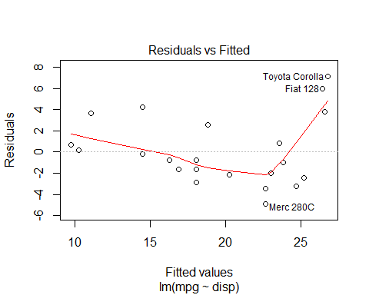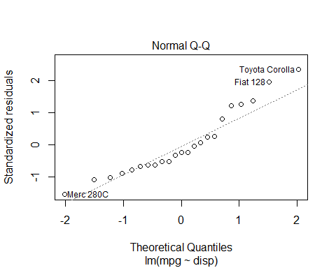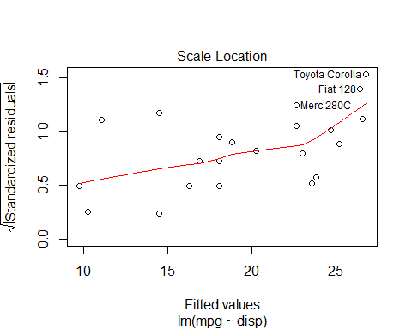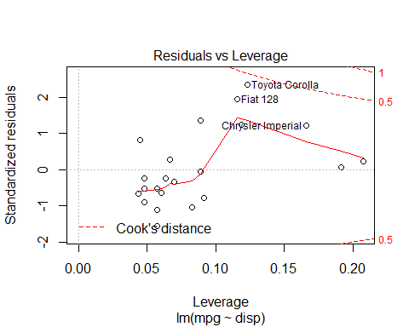

## Mazda RX4 Mazda RX4 Wag Datsun 710 Hornet 4 Drive   
## 22.998487 22.998487 25.214027 18.823046   
## Hornet Sportabout Valiant Duster 360 Merc 240D   
## 14.477179 20.229062 14.477179 23.565154   
## Merc 230 Merc 280 Merc 280C Merc 450SE   
## 23.816533 22.674678 22.674678 18.064650   
## Merc 450SL Merc 450SLC Cadillac Fleetwood Lincoln Continental   
## 18.064650 18.064650 9.705246 10.216525   
## Chrysler Imperial Fiat 128 Honda Civic Toyota Corolla   
## 11.068656 26.462399 26.590219 26.786209   
## Toyota Corona Dodge Challenger AMC Javelin Camaro Z28   
## 24.698488 16.266654 16.863145 14.903244   
## Pontiac Firebird Fiat X1-9 Porsche 914-2 Lotus Europa   
## 12.772917 26.449617 24.689967 25.763652   
## Ford Pantera L Ferrari Dino Maserati Bora Volvo 142E   
## 14.860638 23.637585 16.990965 24.660142

The hp model

##   
## Call:  
## lm(formula = mpg ~ hp, data = train)  
##   
## Residuals:  
## Min 1Q Median 3Q Max   
## -4.5341 -2.1126 -0.9523 2.1214 7.5387   
##   
## Coefficients:  
## Estimate Std. Error t value Pr(>|t|)   
## (Intercept) 32.41797 1.81781 17.834 3.66e-14 ***  
## hp -0.09318 0.01241 -7.511 2.23e-07 ***  
## ---  
## Signif. codes: 0 '***' 0.001 '**' 0.01 '*' 0.05 '.' 0.1 ' ' 1  
##   
## Residual standard error: 3.289 on 21 degrees of freedom  
## Multiple R-squared: 0.7287, Adjusted R-squared: 0.7158   
## F-statistic: 56.41 on 1 and 21 DF, p-value: 2.231e-07

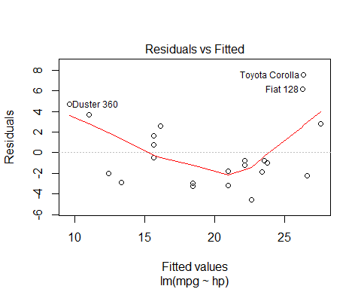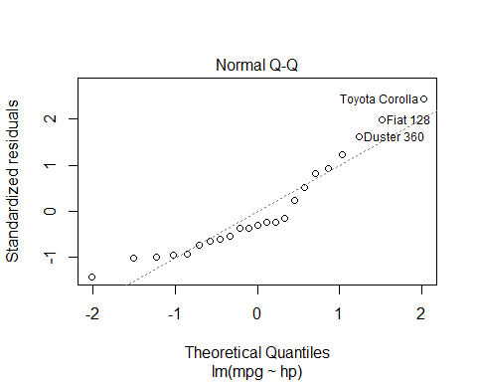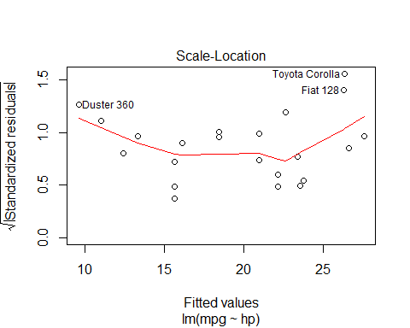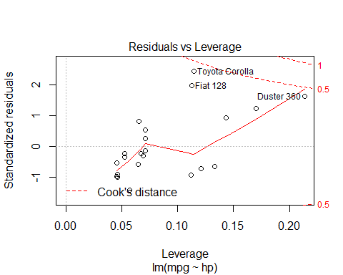

## Mazda RX4 Mazda RX4 Wag Datsun 710 Hornet 4 Drive   
## 22.168221 22.168221 23.752273 22.168221   
## Hornet Sportabout Valiant Duster 360 Merc 240D   
## 16.111553 22.634119 9.588987 26.640838   
## Merc 230 Merc 280 Merc 280C Merc 450SE   
## 23.565914 20.956888 20.956888 15.645656   
## Merc 450SL Merc 450SLC Cadillac Fleetwood Lincoln Continental   
## 15.645656 15.645656 13.316168 12.384373   
## Chrysler Imperial Fiat 128 Honda Civic Toyota Corolla   
## 10.986680 26.268120 27.572633 26.361299   
## Toyota Corona Dodge Challenger AMC Javelin Camaro Z28   
## 23.379555 18.441041 18.441041 9.588987   
## Pontiac Firebird Fiat X1-9 Porsche 914-2 Lotus Europa   
## 16.111553 26.268120 23.938632 21.888683   
## Ford Pantera L Ferrari Dino Maserati Bora Volvo 142E   
## 7.818576 16.111553 1.202831 22.261401

The wt model

##   
## Call:  
## lm(formula = mpg ~ wt, data = train)  
##   
## Residuals:  
## Min 1Q Median 3Q Max   
## -4.3852 -2.4432 -0.5366 1.4469 6.4485   
##   
## Coefficients:  
## Estimate Std. Error t value Pr(>|t|)   
## (Intercept) 37.6200 2.3753 15.838 3.76e-13 ***  
## wt -5.3039 0.6777 -7.826 1.17e-07 ***  
## ---  
## Signif. codes: 0 '***' 0.001 '**' 0.01 '*' 0.05 '.' 0.1 ' ' 1  
##   
## Residual standard error: 3.191 on 21 degrees of freedom  
## Multiple R-squared: 0.7447, Adjusted R-squared: 0.7325   
## F-statistic: 61.25 on 1 and 21 DF, p-value: 1.169e-07

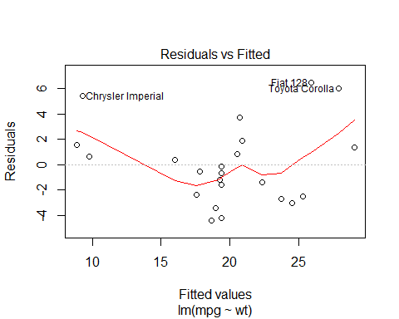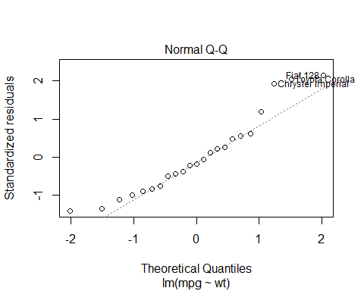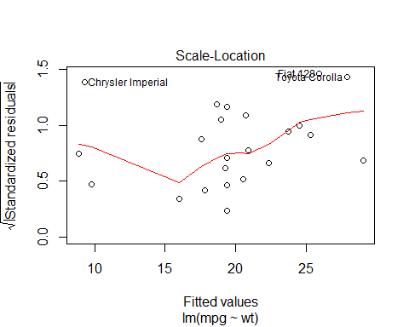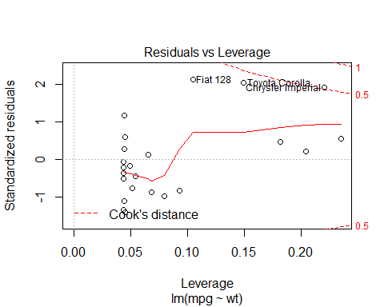

## Mazda RX4 Mazda RX4 Wag Datsun 710 Hornet 4 Drive   
## 23.723907 22.371422 25.315065 20.568109   
## Hornet Sportabout Valiant Duster 360 Merc 240D   
## 19.374740 19.268663 18.685238 20.700705   
## Merc 230 Merc 280 Merc 280C Merc 450SE   
## 20.912860 19.374740 19.374740 16.033307   
## Merc 450SL Merc 450SLC Cadillac Fleetwood Lincoln Continental   
## 17.836620 17.571427 9.774750 8.851878   
## Chrysler Imperial Fiat 128 Honda Civic Toyota Corolla   
## 9.270883 25.951529 29.054288 27.887438   
## Toyota Corona Dodge Challenger AMC Javelin Camaro Z28   
## 24.546005 18.950431 19.401259 17.253195   
## Pontiac Firebird Fiat X1-9 Porsche 914-2 Lotus Europa   
## 17.226676 27.357052 26.269760 29.595282   
## Ford Pantera L Ferrari Dino Maserati Bora Volvo 142E   
## 20.806783 22.928327 18.685238 22.875289

After my analysis, it is shown that all our regression models (both univariate and mutivariate models) accepts the null hypothesis. On a more personal basis, I would adopt Model 1 for a multivariate model and the cyl_model for a univariate model.

These are Model 1

## Mazda RX4 Mazda RX4 Wag Datsun 710 Hornet 4 Drive   
## 22.59283 21.75024 26.35799 21.22994   
## Hornet Sportabout Valiant Duster 360 Merc 240D   
## 17.16098 20.30680 15.47820 24.27645   
## Merc 230 Merc 280 Merc 280C Merc 450SE   
## 23.78150 19.69736 19.69736 14.47155   
## Merc 450SL Merc 450SLC Cadillac Fleetwood Lincoln Continental   
## 15.59500 15.42979 11.33245 10.50462   
## Chrysler Imperial Fiat 128 Honda Civic Toyota Corolla   
## 10.37402 27.05756 29.22275 28.23475   
## Toyota Corona Dodge Challenger AMC Javelin Camaro Z28   
## 25.88173 17.08572 17.28042 14.52450   
## Pontiac Firebird Fiat X1-9 Porsche 914-2 Lotus Europa   
## 16.06893 27.93504 27.06427 28.58709   
## Ford Pantera L Ferrari Dino Maserati Bora Volvo 142E   
## 16.40436 20.84117 13.50380 24.63158

The cyl_model

##   
## Call:  
## lm(formula = mpg ~ cyl, data = train)  
##   
## Residuals:  
## Min 1Q Median 3Q Max   
## -5.0408 -2.6047 0.4453 1.3814 7.3592   
##   
## Coefficients:  
## Estimate Std. Error t value Pr(>|t|)   
## (Intercept) 38.5131 2.7037 14.245 2.90e-12 ***  
## cyl -2.9931 0.4168 -7.182 4.44e-07 ***  
## ---  
## Signif. codes: 0 '***' 0.001 '**' 0.01 '*' 0.05 '.' 0.1 ' ' 1  
##   
## Residual standard error: 3.397 on 21 degrees of freedom  
## Multiple R-squared: 0.7107, Adjusted R-squared: 0.6969   
## F-statistic: 51.58 on 1 and 21 DF, p-value: 4.439e-07

## Mazda RX4 Mazda RX4 Wag Datsun 710 Hornet 4 Drive   
## 20.55471 20.55471 26.54084 20.55471   
## Hornet Sportabout Valiant Duster 360 Merc 240D   
## 14.56859 20.55471 14.56859 26.54084   
## Merc 230 Merc 280 Merc 280C Merc 450SE   
## 26.54084 20.55471 20.55471 14.56859   
## Merc 450SL Merc 450SLC Cadillac Fleetwood Lincoln Continental   
## 14.56859 14.56859 14.56859 14.56859   
## Chrysler Imperial Fiat 128 Honda Civic Toyota Corolla   
## 14.56859 26.54084 26.54084 26.54084   
## Toyota Corona Dodge Challenger AMC Javelin Camaro Z28   
## 26.54084 14.56859 14.56859 14.56859   
## Pontiac Firebird Fiat X1-9 Porsche 914-2 Lotus Europa   
## 14.56859 26.54084 26.54084 26.54084   
## Ford Pantera L Ferrari Dino Maserati Bora Volvo 142E   
## 14.56859 20.55471 14.56859 26.54084

Mean Square Error for the multivariate regression model

## [1] 5.439183

Mean Square Error for the cyl regression model

## [1] 9.68737