patgrid

━━━━━━━━━━
PATENT LANDSCAPE
ANALYSIS

IoT Device Communication and Platform Systems
━━━━━━━━━━

TECHNOLOGY FOCUS
IoT Devices
REPORT DATE
March 2026

Table of Contents
Right-click and select "Update Field" to populate table of contents.

Executive Summary
The Internet of Things device patent landscape represents a mature yet dynamic technology domain, with 1,859 patents analyzed across a two-decade span from 2002 to 2023. The landscape organizes into six distinct technology clusters, with IoT Device Integration Platforms commanding the largest concentration at 581 patents, followed by IoT System Architecture Frameworks with 410 patents and IoT Device Security Authentication with 343 patents. China emerges as the dominant filing jurisdiction, reflecting the region's aggressive positioning in IoT infrastructure development and manufacturing capabilities. The competitive structure reveals moderate fragmentation with clear market leaders establishing differentiated positions. Samsung Electronics dominates the landscape with 64 patents, nearly double the holdings of its nearest competitor, the Electronics and Telecommunications Research Institute at 35 patents. IBM and Intel maintain meaningful positions with 25 and 20 patents respectively, while Afero rounds out the top five with 18 patents. Notably, the primary technology cluster exhibits significant competitive overlap among all major players, indicating intense rivalry for foundational IoT platform technologies where differentiation remains challenging. Strategic analysis reveals several noteworthy trends warranting attention. Filing activity followed a classic technology adoption curve, with exponential growth through 2017 before reaching maturation. Samsung Electronics demonstrates the most pronounced strategic pivot, with observable shifts in R&D focus between early and recent filing periods suggesting repositioning toward emerging application areas. The concentration of activity in integration platforms and system architecture frameworks signals that interoperability and ecosystem control remain the primary battlegrounds. Organizations seeking to establish defensible positions should evaluate white space opportunities in specialized vertical applications where cluster boundaries remain less contested.

Dashboard Overview
Patent Families  1859  unique inventions | Total Documents  1859  all filings | Unique Assignees  1288 | Top Jurisdiction  CN  42.3% of filings
Most Active Year  2017  237 families | Dominant IPC  H (Electricity) | HHI Index  439  Low | Tech Clusters  6

Methodology & Scope

Data Currency & Publication Lag
Patent applications are typically published approximately 18 months after their initial filing date. As a result, recently filed applications are not yet visible in patent databases. To avoid presenting misleading trends—where recent years would appear to show a dramatic decline in filing activity that is actually just a data availability artifact—this analysis includes data only through 2023, the last calendar year for which complete filing data is available.

How We Analyze the Data
This analysis is conducted at the patent family level rather than counting individual patent publications. A patent family groups all patent documents sharing the same priority filing—representing a single invention regardless of how many jurisdictions it was filed in or how many continuation applications were made. This approach avoids inflating counts by treating the same invention filed in US, EP, CN, and JP as four separate innovations, provides a cleaner measure of genuine R&D output, and better reflects strategic investment in innovation rather than filing strategy.

Analysis Pipeline
1. Semantic Search & Retrieval: Starting from the seed patent, semantic similarity analysis identifies patent families addressing similar technical problems across 160+ million global patent documents, regardless of terminology used.
2. Citation Network Expansion: Results are enriched through citation analysis—backward citations (prior art), forward citations (subsequent developments), co-citations, and bibliographic coupling—ensuring foundational patents with high influence are captured.
3. Metadata Enrichment: Each patent family is enriched with standardized metadata including priority dates, normalized assignee names (grouping corporate entities and subsidiaries), and IPC classification codes.
4. Dimensionality Reduction & Clustering: High-dimensional patent embeddings are projected to 2D using t-SNE for visualization. HDBSCAN clustering identifies natural technology groupings.
5. Competitive & Trajectory Analysis: For leading assignees, technology centroids are calculated across time periods. Movement magnitude measures how far a company's centroid has shifted.
6. Gap Analysis: Geometric relationships between clusters identify white spaces—areas with limited patent activity representing potential innovation opportunities.

Statistical Overview

Filing Trend by Year
Note: Filing data shown through 2023 only. More recent years are excluded as their data is incomplete due to the ~18-month publication delay for patent applications.
The IoT devices patent landscape exhibits a pronounced technology adoption curve characteristic of transformative digital innovations, with filing activity spanning from minimal early-stage exploration through rapid commercialization and into market maturity. Between 2009 and 2014, annual filings grew steadily but modestly, rising from just 1 patent to 59 patents as the foundational concepts of connected device ecosystems began crystallizing within the intellectual property domain.
The period from 2014 to 2015 marked a critical inflection point, with annual filings nearly tripling from 59 to 156 patents, signaling the transition from emerging technology status to mainstream commercial viability as major industry players recognized the strategic importance of securing IoT-related intellectual property positions. Patent activity reached its apex in 2017 with 237 filings, representing the culmination of aggressive portfolio-building strategies across the industry.
This peak coincided with widespread enterprise and consumer adoption of connected device platforms, smart home technologies, and industrial IoT applications. The subsequent trajectory reveals a sustained contraction, with filings declining approximately 51 percent from the 2017 peak to 115 patents in 2023.
Notably, the decline has been consistent rather than precipitous, with year-over-year decreases from 2021 onward suggesting a structural shift rather than cyclical fluctuation. From a strategic perspective, this filing pattern indicates that IoT device technology has transitioned decisively from a growth phase into maturity, where foundational intellectual property positions have been largely established by incumbent players.
The declining filing volumes suggest that opportunities for broad, foundational patent claims have diminished, with innovation likely migrating toward specialized applications, incremental improvements, and adjacent technology domains such as edge computing, AI-enabled IoT systems, and enhanced security architectures. Organizations seeking to enter this space should anticipate a competitive landscape dominated by established portfolios, with strategic value increasingly concentrated in niche applications and integration technologies rather than core IoT device functionality.
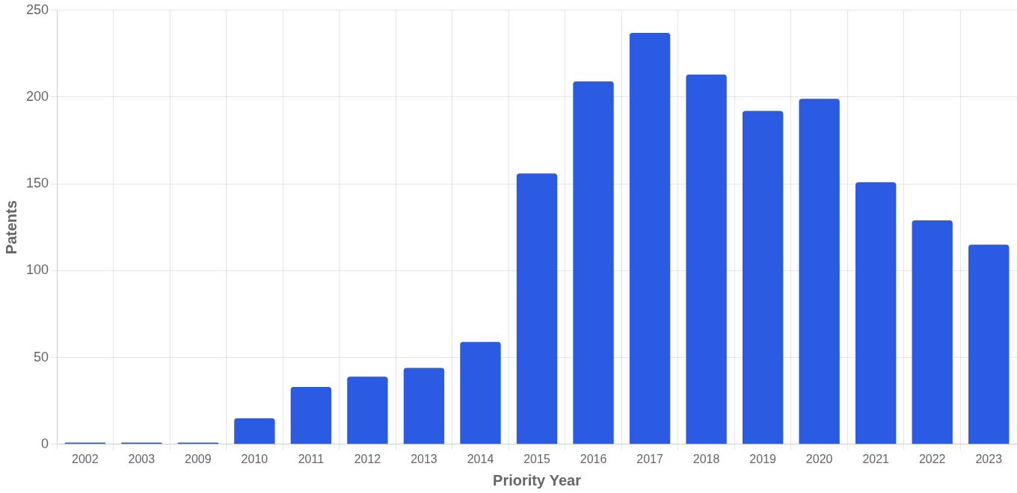
Bar chart showing patent family filings by priority year (deduplicated—one count per invention regardless of jurisdictions filed). Height indicates innovation volume. Rising trends suggest growing R&D activity; declining trends may indicate market maturity or a shift to adjacent technology areas.
2014 | 2015 | 2016 | 2017 | 2018 | 2019 | 2020 | 2021 | 2022 | 2023
59 | 156 | 209 | 237 | 213 | 192 | 199 | 151 | 129 | 115

Geographic Distribution
The geographic distribution of IoT device patents reveals a pronounced concentration within Asian jurisdictions, with China commanding a dominant position at 42.3 percent of total filings, representing 786 patents. South Korea follows as the second most significant jurisdiction with 29.2 percent market share encompassing 543 patents, while the United States maintains a substantial but comparatively smaller presence at 20.7 percent with 385 patents.
International filings through the World Intellectual Property Organization account for 4.7 percent of the portfolio, with European Patent Office filings representing a modest 2.6 percent. Minimal filing activity is observed across other jurisdictions including Great Britain, Canada, Hong Kong, Australia, and Brazil, each representing less than one percent of total patents.
This geographic concentration pattern indicates that commercialization strategies within the IoT device sector are predominantly oriented toward Asian manufacturing ecosystems and rapidly expanding consumer markets in the region. The substantial Chinese and South Korean filing volumes suggest that patent holders are prioritizing protection in jurisdictions characterized by high production capacity and accelerating IoT adoption rates.
The relatively limited European Patent Office presence is noteworthy given the European Union's influential role in establishing IoT regulatory frameworks and technical standards, suggesting potential underexploitation of this market or alternative protection strategies. Similarly, the absence of significant filing activity in Japan represents a notable gap considering that nation's historical strength in electronics and connected device technologies, potentially indicating either market maturity constraints or strategic decisions to focus resources on higher-growth territories.
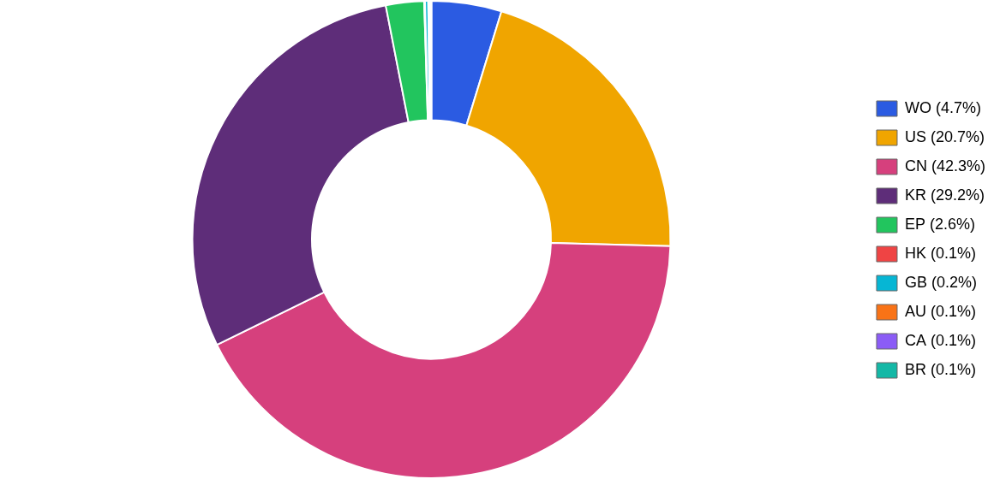
Doughnut chart showing filing jurisdictions (document-level). Segment size reflects share of all patent filings in each country/region. US=United States, EP=European Patent Office, WO=WIPO (international), JP=Japan, CN=China, KR=Korea, DE=Germany, GB=United Kingdom. Large segments indicate key target markets for patent protection.
Jurisdiction | Count | Share
CN | 786 | 42.3%
KR | 543 | 29.2%
US | 385 | 20.7%
WO | 88 | 4.7%
EP | 48 | 2.6%
GB | 4 | 0.2%
CA | 2 | 0.1%
HK | 1 | 0.1%
AU | 1 | 0.1%
BR | 1 | 0.1%

IPC Classification Distribution
The patent landscape for IoT devices demonstrates a pronounced concentration within Section H (Electricity), which accounts for 61.1 percent of all classifications, with Section G (Physics) contributing an additional 36.3 percent. This distribution reflects the fundamental technical architecture of IoT systems, which depend critically on electronic circuitry, wireless communication protocols, and data transmission infrastructure.
The dominance of IPC class H04, encompassing 3,728 patents related to electric communication technique, underscores the centrality of connectivity and network communication to IoT innovation. Complementing this, the substantial presence of class G06 (computing and calculating) with 954 patents and G16 (information and communication technology) with 495 patents indicates significant development activity in data processing, algorithmic intelligence, and information management systems that enable IoT devices to collect, analyze, and act upon sensor-derived data.
The technical coverage of this patent portfolio reveals a highly specialized field with limited cross-domain diversification at present. The combined 97.4 percent concentration in Sections H and G suggests that innovation remains firmly anchored in core electronic and computational technologies rather than extending broadly into adjacent technical domains.
The modest representation of Section A (Human Necessities) at 1.0 percent indicates emerging applications in healthcare monitoring and consumer wellness devices, while the minimal presence of Sections F (Mechanical Engineering) and B (Operations and Transport) at 0.8 percent and 0.5 percent respectively points to nascent integration with industrial automation and logistics systems. The virtual absence of Sections C (Chemistry and Metallurgy), D (Textiles), and E (Fixed Constructions) suggests that IoT patent activity has yet to substantially penetrate material science applications or smart construction technologies, representing potential areas for future expansion as the technology matures and finds broader industrial application.
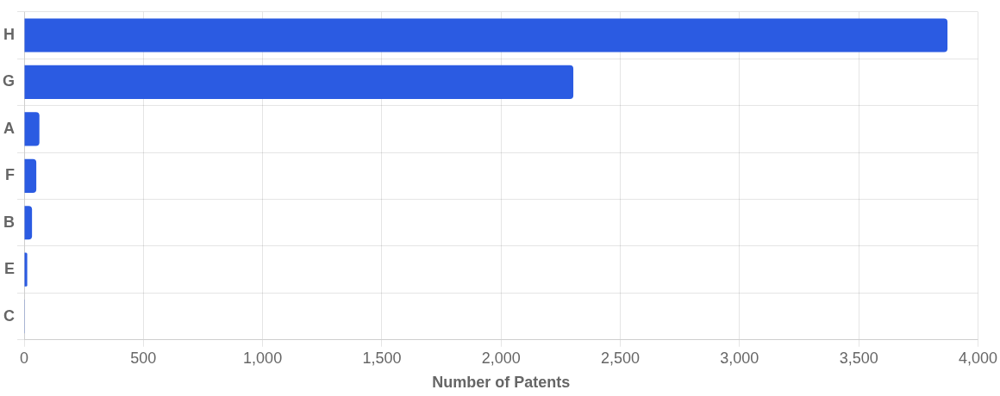
IPC sections distribution: A=Human Necessities, B=Operations/Transport, C=Chemistry/Metallurgy, D=Textiles/Paper, E=Fixed Constructions, F=Mechanical Engineering, G=Physics, H=Electricity. Bar length shows patent count per section. Multiple sections indicate cross-domain innovation.

Application Trend by Jurisdiction
Geographic filing patterns over time reveal shifting market priorities and regional R&D activity. Increasing filings in a jurisdiction typically indicate growing market interest or regulatory developments in that region.
The United States dominated IoT device patent filings from 2014-2018, peaking at over 300 filings in 2016-2017, but has experienced a pronounced decline since then, dropping to approximately 40 filings by 2023—suggesting either market maturation or strategic portfolio consolidation. China emerged as a significant jurisdiction beginning around 2015, maintaining relatively strong filing activity through 2021 before moderating, while South Korea demonstrates the most consistent growth trajectory, sustaining filings near 75-100 annually and showing resilience even as other major jurisdictions decline. European filings (EP) and WIPO (WO) international applications remain modest throughout the period, indicating that applicants have prioritized national-level protection in key manufacturing and consumer markets rather than pursuing broad regional coverage. This geographic distribution reflects market priorities centered on the US-China technology competition and Korea's strength in semiconductor and electronics manufacturing, with the recent convergence across jurisdictions potentially signaling a maturing technology space with more selective filing strategies.
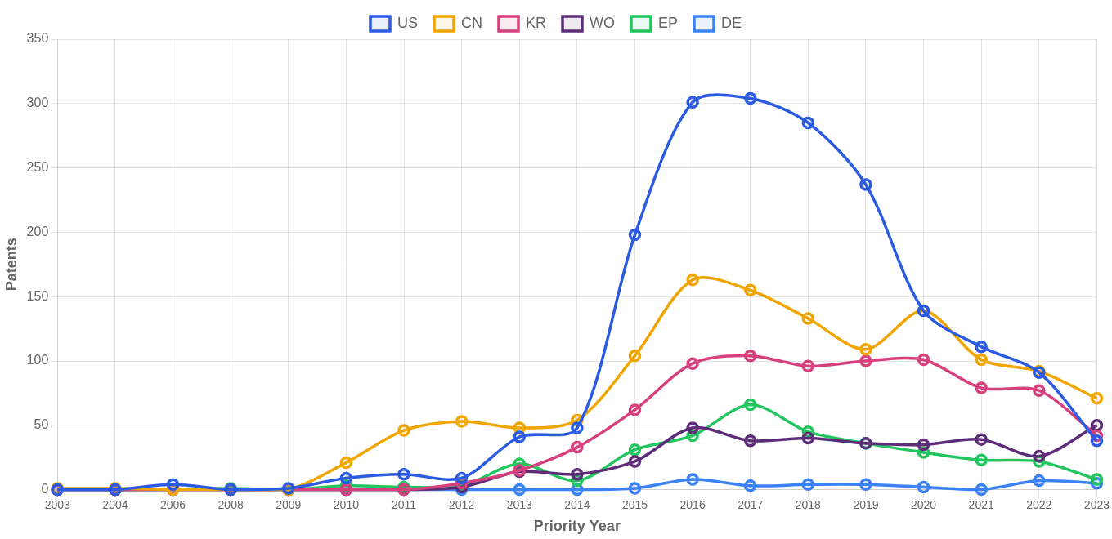
Multi-line chart showing patent document filings by jurisdiction over time. Each colored line represents a filing authority (US, EP, CN, etc.). Rising lines indicate growing market importance; crossing lines reveal shifting geographic priorities. Note: counts are document-level to reflect actual filing activity in each jurisdiction.

IPC Subclass Distribution
The subclass-level breakdown provides a more granular view of the specific technology areas within this patent landscape. Each subclass represents a distinct technical domain within the broader IPC sections.
The IoT device patent landscape is overwhelmingly dominated by Section H (Electricity) and Section G (Physics), which together comprise approximately 90% of all classifications, reflecting the fundamental nature of IoT as an electronics and sensor-driven technology domain. This concentration indicates a technically specialized field centered on electronic circuitry, wireless communications, data transmission protocols, and measurement/computing systems that form the backbone of connected device architectures. The moderate presence of Section A (Human Necessities) suggests meaningful application development in healthcare monitoring, wearable devices, and smart home consumer applications, while smaller contributions from Sections F (Mechanical Engineering) and B (Operations/Transport) indicate emerging integration with industrial automation and logistics systems. The minimal representation of Sections C (Chemistry), D (Textiles), and E (Construction) reveals that IoT innovation remains primarily focused on core electronic infrastructure rather than material science or specialized construction applications, though this may evolve as smart building and industrial IoT applications mature.
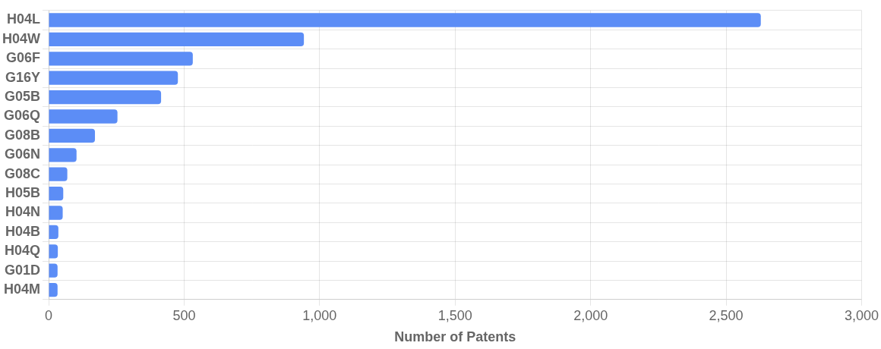
Top 15 IPC subclasses by patent count. Subclasses (4-character codes like G06F, H04L) represent specific technology domains within the broader IPC sections, providing actionable intelligence on core technology focus areas. Bar length indicates relative patent volume in each technical domain.

Top Subclass Details
Code | Description | Patents | Share
H04L | TRANSMISSION OF DIGITAL INFORMATION, e.g. TELEGRAPHIC COMMUNICATION (arrangements common to telegraphic and telephonic communication H04M) | 2628 | 41.5%
H04W | WIRELESS COMMUNICATION NETWORKS (broadcast communication H04H;communication systems using wireless links for non-selective communication, e.g. wireless extensions H04M0001720000) | 942 | 14.9%
G06F | ELECTRIC DIGITAL DATA PROCESSING (computer systems based on specific computational models G06N) | 532 | 8.4%
G16Y | INFORMATION AND COMMUNICATION TECHNOLOGY SPECIALLY ADAPTED FOR THE INTERNET OF THINGS [IoT] | 477 | 7.5%
G05B | CONTROL OR REGULATING SYSTEMS IN GENERAL; FUNCTIONAL ELEMENTS OF SUCH SYSTEMS; MONITORING OR TESTING ARRANGEMENTS FOR SUCH SYSTEMS OR ELEMENTS (systems for controlling or regulating non-electric variables G05D; systems for regulating electric or magnetic variables G05F; control devices or systems insofar as characterised by mechanical features only G05G) | 415 | 6.5%
G06Q | INFORMATION AND COMMUNICATION TECHNOLOGY [ICT] SPECIALLY ADAPTED FOR ADMINISTRATIVE, COMMERCIAL, FINANCIAL, MANAGERIAL OR SUPERVISORY PURPOSES; SYSTEMS OR METHODS SPECIALLY ADAPTED FOR ADMINISTRATIVE, COMMERCIAL, FINANCIAL, MANAGERIAL OR SUPERVISORY PURPOSES, NOT OTHERWISE PROVIDED FOR | 254 | 4.0%
G08B | SIGNALLING OR CALLING SYSTEMS; ORDER TELEGRAPHS; ALARM SYSTEMS | 171 | 2.7%
G06N | COMPUTING ARRANGEMENTS BASED ON SPECIFIC COMPUTATIONAL MODELS | 103 | 1.6%
G08C | TRANSMISSION SYSTEMS FOR MEASURED VALUES, CONTROL OR SIMILAR SIGNALS (fluid pressure transmission systems F15B; mechanical means for transferring the output of a sensing member into a different variable G01D0005000000; mechanical control systems G05G) | 69 | 1.1%
H05B | ELECTRIC HEATING; ELECTRIC LIGHT SOURCES NOT OTHERWISE PROVIDED FOR; CIRCUIT ARRANGEMENTS FOR ELECTRIC LIGHT SOURCES, IN GENERAL | 54 | 0.9%

Technology Treemap
The treemap visualization shows the relative size of each technology area based on patent counts. Larger rectangles indicate more patent activity in that IPC subclass. Colors indicate IPC sections (A-H), grouping related technologies together.
The IoT device patent landscape is heavily dominated by Electricity (Section H) and Physics (Section G) classifications, with H04L (Transmission of Digital Information) commanding the largest position at 2,043 patents, followed by H04W (Wireless Communication Networks) at 900 patents. This concentration in communication and data transmission technologies reflects the fundamental connectivity requirements inherent to IoT architectures. The portfolio demonstrates moderate diversity within its core technical domains, spanning digital computing (G06F with 555 patents), control systems (G05B with 385 patents), and dedicated IoT-specific classifications (G16Y with 392 patents), though it remains tightly focused on electrical and computing technologies with minimal presence in mechanical engineering, chemistry, or human necessities sectors. The significant presence of G06Q (Information and Communication Technology for Business) at 244 patents indicates notable commercial application development beyond pure device technology, while signaling systems (G08B/G08C) reveal security and monitoring as key implementation domains. Overall, this distribution confirms that IoT innovation centers on communication protocols, network architectures, and data processing—the essential technical pillars enabling device interconnectivity and intelligent system integration.
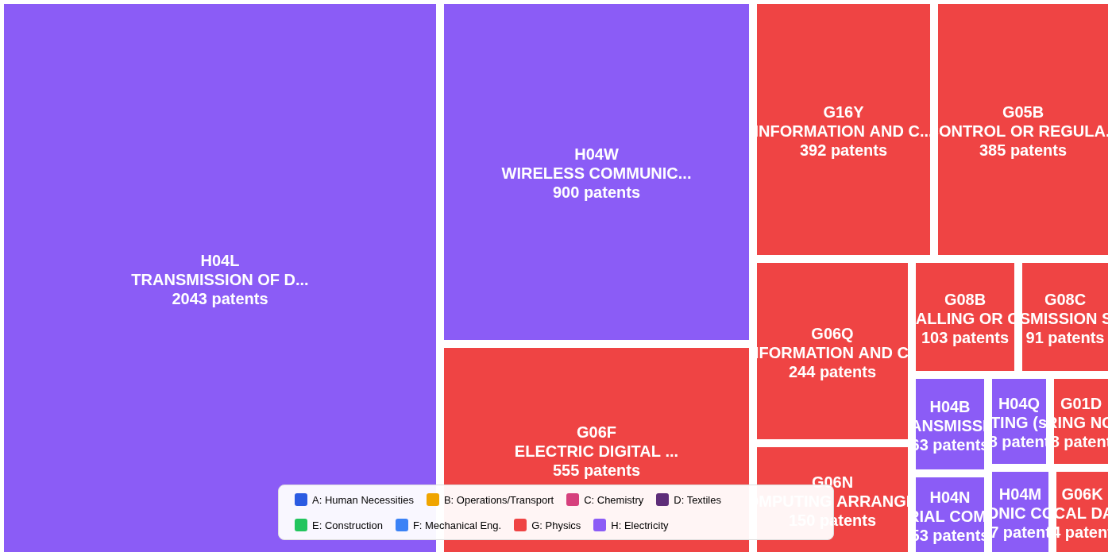
How to read this chart: Rectangle area is proportional to patent family count in each IPC subclass. Colors indicate IPC sections (see legend): red=Human Necessities, orange=Operations, yellow=Chemistry, green=Construction/Textiles, blue=Physics, purple=Electricity. Labels show subclass code and count. Dominant rectangles reveal core technology focus; small scattered rectangles suggest technology breadth.

Innovation Wheel
The Innovation Wheel provides a hierarchical view of technology classification. The inner ring shows IPC sections (broad categories), while the outer ring shows specific subclasses within each section. This reveals both the breadth and depth of technology coverage in the landscape.
The IoT devices patent landscape is overwhelmingly dominated by Section H (Electricity) and Section G (Physics), which together constitute approximately 90% of all patent activity, reflecting the core technological foundations of connected device ecosystems. Within these dominant sections, H04L (Transmission of Digital Information) and H04W (Wireless Communication Networks) represent the primary innovation focus, alongside G06F (Electric Digital Data Processing), G16Y (Information and Communication Technologies for IoT), and G05B (Control or Regulating Systems). This concentration demonstrates a relatively narrow but deep technology coverage centered on communication protocols, data processing, and network infrastructure—the essential building blocks enabling device connectivity and interoperability. Minor but notable activity across Sections A (Human Necessities), B (Operations/Transport), C (Chemistry), E (Construction), and F (Mechanical Engineering) indicates emerging cross-domain applications spanning smart home systems, industrial automation, healthcare monitoring, transportation logistics, and building management, signaling IoT's expanding penetration into diverse vertical industries beyond its telecommunications core.
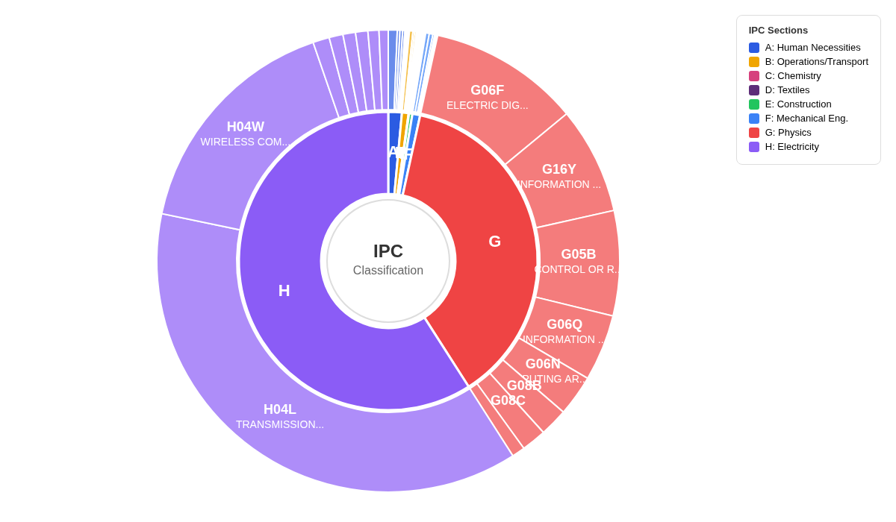
How to read this chart: This two-level sunburst shows IPC hierarchy. Inner ring segments represent IPC sections (A-H); arc size proportional to patent count. Outer ring shows subclasses within each section. Dominant inner segments reveal primary technology domains; outer ring detail shows specific focus areas. Narrow outer slices indicate specialized niches; wide slices show core competencies.

Application Trend by Technology Area
This chart shows how patent filing activity in different IPC subclasses has evolved over time. Rising trends indicate growing technology areas, while declining trends may suggest maturing or obsolete technologies.
IoT Device Patent Filing Trends by Technology Classification H04L (transmission of digital information) dominated IoT patent activity through 2017, reaching nearly 280 filings at peak, though it has experienced significant decline since then—indicating market maturation in core networking protocols. G16Y (information and communication technology for IoT-specific systems) emerged rapidly from 2019, achieving the fastest growth trajectory among all classifications and reflecting a strategic R&D pivot toward purpose-built IoT architectures rather than adapted general networking solutions. H04W (wireless communication networks) maintained steady growth through 2016 before stabilizing, while G06F (electric digital data processing) demonstrated consistent but moderate activity, suggesting ongoing but not accelerating focus on device-level computing capabilities. The convergence of declining H04L activity with rising G16Y filings signals an industry transition from foundational connectivity innovation toward integrated, application-specific IoT system development, with R&D investment increasingly directed at holistic IoT frameworks rather than discrete communication components.
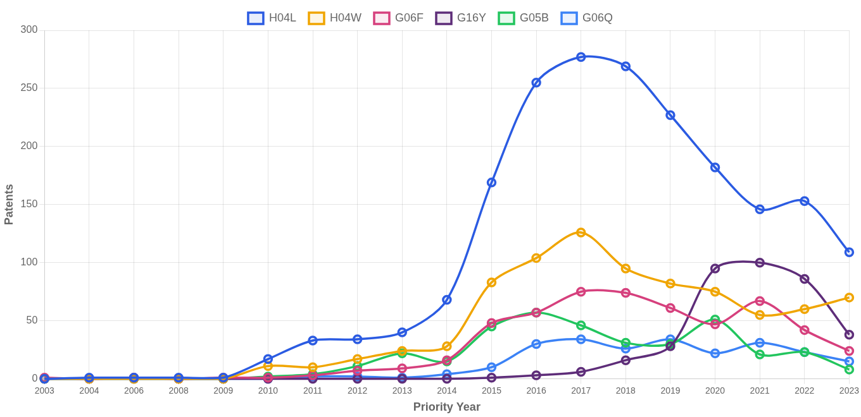
Multi-line chart showing patent family counts by IPC subclass over priority years. Each colored line represents a distinct technology category (4-character IPC code). Steepening slopes indicate accelerating R&D investment; converging lines suggest technology convergence; diverging lines reveal shifting priorities across domains.

Application Trend by Assignee
This chart tracks the patent filing activity of the top assignees over time. Peaks indicate periods of intensive R&D investment, while declining trends may suggest strategic shifts or market exit. Comparing trajectories reveals competitive dynamics and timing of market entry.
Samsung Electronics demonstrates the most aggressive growth trajectory in the IoT device space, with filings surging dramatically from near-zero in 2012 to peak activity of 16-17 patents annually during 2021-2022, establishing clear market leadership in recent years. Intel's filing pattern reveals a classic technology lifecycle curve, with rapid acceleration from 2014 to a dominant peak of 21 patents in 2016, followed by a sustained decline to minimal activity by 2023—suggesting either strategic pivoting away from IoT or consolidation of their core patent position. IBM and the Electronics and Telecommunications Research Institute exhibit more moderate, synchronized filing patterns that peaked in the 2016-2019 period before tapering, indicating these players may have secured foundational IP and shifted to maintenance mode. Qualcomm's notable resurgence in 2023, climbing to 11 patents after years of minimal activity, signals potential renewed strategic interest in IoT technologies, possibly driven by emerging connectivity standards or new market opportunities that warrant continued competitive monitoring.
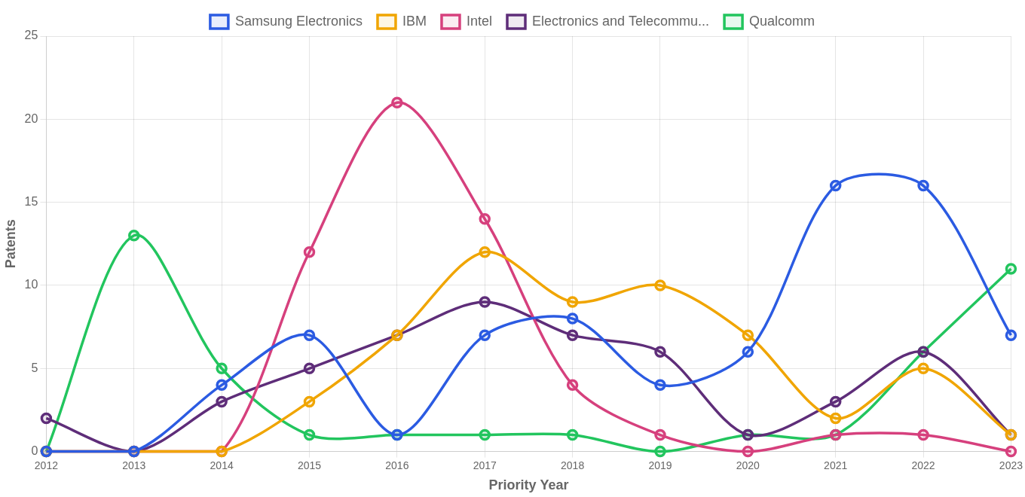
Multi-line chart showing patent family filing trends for top assignees over time. Each colored line represents one company. Steep rises indicate aggressive R&D investment; peaks followed by declines may suggest portfolio maturation or strategic pivots. Lines crossing reveal shifting competitive positions.

Assignee Concentration Trend
This chart shows the combined market share of the top 10 assignees over time. An increasing trend indicates market consolidation, while a decreasing trend suggests fragmentation or new entrant activity. Stable concentrations indicate an established competitive landscape.
The IoT device patent landscape remains notably fragmented, with the top 10 assignees collectively holding only 13-21% of total patents in recent years, indicating a highly dispersed competitive environment. Market concentration experienced a significant rise from near-zero levels pre-2012 to a peak of approximately 24% in 2015, followed by a gradual decline through 2019-2020 before a modest resurgence in 2021-2022, with the most recent data suggesting another downward trend. This persistently low concentration level presents favorable conditions for new market entrants seeking to establish meaningful patent positions, while incumbents face challenges in achieving dominant intellectual property control, suggesting that strategic partnerships and targeted portfolio development may prove more effective than attempts at broad market consolidation.
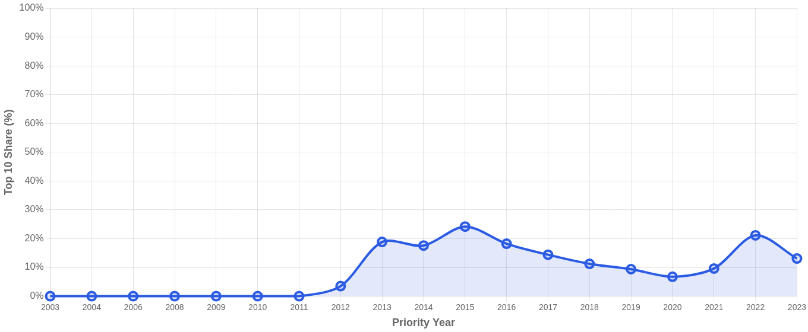
How to read this chart: The Y-axis shows the percentage of all patent families held by the top 10 assignees each year. Rising line indicates consolidation (fewer players controlling more IP); falling line suggests fragmentation (new entrants gaining share). Values above 50% indicate a concentrated market; below 30% suggests a highly competitive, fragmented landscape.

New Market Entrants
New entrants are assignees who first appeared in the patent landscape since 2018. These companies represent emerging competitors or new market participants that may disrupt established players.
The IoT device patent landscape demonstrates significant volatility among new market entrants, with most players maintaining modest portfolios of 1-4 patents annually, substantially below the filing volumes typical of established technology incumbents. Nippon Telegraph and Telephone (NTT) emerges as the most notable entrant to monitor, demonstrating aggressive portfolio acceleration from minimal activity pre-2022 to 8 patents in 2024, signaling a strategic commitment to IoT expansion. Entry patterns reveal cyclical interest with several players like Bank of America and BOE Technology Group showing early spikes followed by declining activity, suggesting either strategic pivots away from IoT or portfolio consolidation phases. The sustained entry of diverse players—spanning financial services, telecommunications, display technology, and cybersecurity sectors—underscores the broad market attractiveness of IoT technologies and their cross-industry applicability, with Guangdong OPPO Mobile and AO Kaspersky Lab representing emerging players worthy of continued observation.
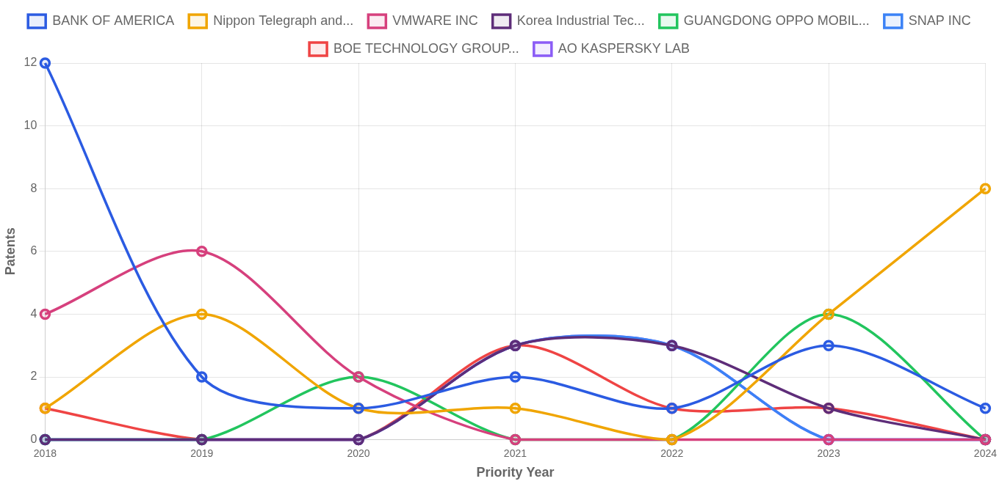
Filing activity of companies that first appeared in the landscape in recent years. Each line shows one new entrant's patent filing trajectory. Steep upward slopes indicate aggressive market entry; sustained activity suggests committed long-term players rather than one-time filers.

Recent Entrants
Assignee | First Year | Patents
BANK OF AMERICA | 2018 | 22
Nippon Telegraph and Telephone | 2018 | 19
VMWARE INC | 2018 | 12
Korea Industrial Technology Institute | 2021 | 7
GUANGDONG OPPO MOBILE TELECOMMUNICATIONS CORP | 2020 | 6
SNAP INC | 2021 | 6
BOE TECHNOLOGY GROUP CO LTD | 2018 | 6
AO KASPERSKY LAB | 2021 | 6
Ubivelox Mobile | 2018 | 5
BEIJING XIAOMI MOBILE SOFTWARE CO LTD | 2019 | 5

Market Concentration Analysis
The Herfindahl-Hirschman Index (HHI) measures market concentration by summing the squared market shares of all participants. An HHI below 1,500 indicates a competitive market, 1,500–2,500 indicates moderate concentration, and above 2,500 indicates high concentration.
HHI Index  439  Low | Top 5 Share  8.7%  of total patents | Unique Assignees  1288  active in landscape

Top 20 Assignees by Portfolio Size
Rank | Assignee | Patents | Share
1 | Samsung Electronics | 64 | 3.4%
2 | Electronics and Telecommunications Research Instit | 35 | 1.9%
3 | IBM | 25 | 1.3%
4 | Intel | 20 | 1.1%
5 | Afero | 18 | 1.0%
6 | VERIZON PATENT & LICENSING INC | 15 | 0.8%
7 | Qualcomm | 14 | 0.8%
8 | CISCO TECH INC | 13 | 0.7%
9 | Chengdu Qinchuan IoT Technology | 13 | 0.7%
10 | Huawei Technologies | 10 | 0.5%
11 | CHENGDU ZHENGGUANGHENG ELECT TECH CO LTD | 10 | 0.5%
12 | AT&T | 10 | 0.5%
13 | AMAZON TECH INC | 9 | 0.5%
14 | Hewlett Packard Enterprise | 9 | 0.5%
15 | BANK OF AMERICA | 9 | 0.5%
16 | Korea Advanced Institute of Science and Technology | 8 | 0.4%
17 | Alibaba Group | 8 | 0.4%
18 | KT Corporation | 8 | 0.4%
19 | LG ELECTRONICS INC | 8 | 0.4%
20 | Sichuan Changhong Electric | 7 | 0.4%

Proximity Radar
The following table presents the patents most semantically similar to the search query. These represent the closest prior art and most directly related technologies in the landscape. See Appendix B for an extended list of the top 100 similar patents.
# | Patent No. | Title | Applicant | Fwd Cit | Sim %
1 | KR20200094002A | IoT 서비스 플랫폼 장치 | ELECTRONICS & TELECOMMUNICATIONS RES INST | 1 | 65%
2 | EP4604623A1 | Ambient iot device and node | PANASONIC IP CORP AMERICA | 0 | 65%
3 | WO2025007304A1 | Devices and methods for communication | NEC CORP | 0 | 63%
4 | KR20230129142A | IoT 웨어러블 조끼, 밴드, 헬멧, 워치, 멜빵, 벨트, 수단 | KOREA IND TECH INST | 17 | 62%
5 | WO2025043655A1 | Devices and methods of communication | NEC CORP | 0 | 62%
6 | WO2025102380A1 | Device and method of communication | NEC CORP | 0 | 62%
7 | WO2025118297A1 | Devices, methods, and medium for communication | NEC CORP | 0 | 61%
8 | EP3275123B1 | Goal-driven provisioning in iot systems | MCAFEE LLC | 104 | 61%
9 | EP4059321A1 | Iot device and system | EQUANS HOLDING UK LTD | 2 | 61%
10 | WO2025054783A1 | Ambient iot system | GUANGDONG OPPO MOBILE TELECOMMUNICATIONS CORP LTD | 0 | 61%
11 | KR20200123508A | IoT 장치 및 이를 포함하는 IoT 시스템 | PARK JOUNG HWA | 0 | 60%
12 | KR20240151676A | AI, VR, IoT, ICT, 스마트, 메타버스 수단 및 장치 | KOREA IND TECH INST | 35 | 60%
13 | EP3584992A1 | Internet of things device | UNIONPLACE CO LTD | 26 | 60%
14 | KR102231915B1 | 통합 IoT 모듈 및 이를 이용한 IoT 기반의 설비 환경 통합 관리 시스템 | 주식회사 네오세미텍 | 19 | 60%
15 | RU2759011C2 | Автоматическая инициализация iot-устройств | MICROSOFT TECHNOLOGY LICENSING LLC | 53 | 60%
16 | WO2025043671A1 | Devices, methods, and medium for communication | NEC CORP | 0 | 60%
17 | KR102821940B1 | IoT 기기와 비IoT 기기를 통합적으로 제어하기 위한 오토메이션 시스템 | ALICORN INC | 0 | 60%
18 | KR20160109245A | 사물 인터넷 디바이스 및 사물 인터넷 통신 방법 | SAMSUNG ELECTRONICS CO LTD | 10 | 60%
19 | US10310832B2 | Internet-of-things device blank | INTEL CORP | 32 | 60%
20 | US2019273784A1 | Internet of things system | CHENGDU QINCHUAN IOT TECH CO LTD | 36 | 60%

Most Cited Families
The following table presents the patent families with the highest forward citation counts within this landscape. These represent the most influential patents—those that have been cited by the greatest number of subsequent patent applications. High citation counts indicate foundational technologies or key innovations that have shaped the direction of R&D in this space. Similarity scores are relative to the search query.
# | Patent No. | Title | Applicant | Fwd Cit | Sim
1 | CN110024330A | 对IoT装置的服务提供 | INTEL CORP | 2013 | 0.56
2 | US2018117446A1 | Smart device | TRAN BAO | 808 | 0.57
3 | US2018117447A1 | Smart device | TRAN BAO | 496 | 0.59
4 | US2018001184A1 | Smart device | TRAN BAO | 473 | 0.54
5 | US2019361917A1 | Smart device | TRAN BAO | 319 | 0.54
6 | US2016147506A1 | Internet of things platforms, apparatuses, and methods | KIBAN LABS INC | 312 | 0.58
7 | US2017006141A1 | Cognitive Intelligence Platform for Distributed M2M/ IoT Systems | BHADRA PRASENJIT | 289 | 0.54
8 | US2018007055A1 | Technologies for distributed acting and knowledge for the internet of things | INFANTE-LOPEZ GABRIEL G | 168 | 0.57
9 | KR20150121113A | 이종 사물 인터넷 (iot) 디바이스들 간의 콘텍스트 인식 액션들 | QUALCOMM INC | 165 | 0.54
10 | US10149335B2 | Connectivity module for internet of things (IOT) devices | QUALCOMM INC | 161 | 0.57
11 | DE112017004996T5 | Gatewaykoordination für das Internet der Dinge | INTEL CORP | 161 | 0.57
12 | US2020074085A1 | Iot device risk assessment | ZINGBOX INC | 145 | 0.54
13 | US2018262571A1 | Integrated IoT (Internet of Things) System Solution for Smart Agriculture Management | AKHTAR SABRINA | 121 | 0.55
14 | US11373505B2 | Alert system for internet of things (IOT) devices | INTEL CORP | 115 | 0.54
15 | WO2018232111A1 | Internet of things (iot) device management | CRYPTOGRAPHY RES INC | 108 | 0.54
16 | EP3289752B1 | Systems, methods, and devices to defend against attacks | PCMS HOLDINGS INC | 107 | 0.55
17 | EP3275123B1 | Goal-driven provisioning in iot systems | MCAFEE LLC | 104 | 0.61
18 | US10455029B2 | Internet of things (IOT) device discovery platform | DISH NETWORK LLC | 95 | 0.59
19 | US9974015B2 | Embedded internet of things (IOT) hub for integration with an appliance and associated systems and methods | AFERO INC | 94 | 0.54
20 | US2017099353A1 | Design and Systems Architecture for Internet of Things | MICROSOFT TECHNOLOGY LICENSING LLC | 87 | 0.57

Forward Citations (Fwd Cit): The number of subsequent patents that cite this family, indicating technological influence. Citation counts are aggregated at the family level, combining citations to all family members. Similarity (Sim): Semantic similarity score to the seed patent (0-1 scale). Patents with high citations but lower similarity may represent foundational technologies in adjacent fields.

Technology Landscape Map
The technology landscape visualization reveals a structured yet dynamic patent ecosystem surrounding IoT devices, with 1,859 patents organized into six distinct technology clusters. This clustering analysis illuminates the fundamental architecture of innovation in this domain, demonstrating how research and development efforts have coalesced around specific technical challenges while simultaneously revealing areas of technological convergence and specialization.
The overall landscape exhibits a moderately fragmented structure characterized by both well-defined cluster boundaries and significant areas of overlap. Most notably, the IoT Device Integration Platforms cluster emerges as the dominant technology area with 581 patents, followed by IoT System Architecture Frameworks with 410 patents and IoT Device Security Authentication with 343 patents.
These three clusters collectively represent the core infrastructure of IoT innovation. The upper-left region of the landscape demonstrates considerable technological convergence, where integration platforms, system architecture frameworks, and device control management intersect, suggesting that foundational infrastructure technologies are increasingly interrelated and mutually dependent.
Several distinctive features merit attention within this landscape. The IoT Device Security Authentication cluster displays exceptional density and maintains clear separation from adjacent technology areas, indicating a mature and specialized sub-domain where innovation activity has concentrated around well-established technical paradigms.
In contrast, the IoT Smart Home Control Systems cluster occupies a relatively isolated position, suggesting that this application-specific technology has evolved along an independent trajectory with limited integration into broader IoT architectural frameworks. The substantial proportion of unclustered patents, representing approximately 39.6 percent of the total corpus, forms bridge regions between major clusters throughout the landscape.
This distribution pattern indicates an actively evolving technology domain where emerging innovations are establishing new technological intersections that have not yet consolidated into defined research trajectories.
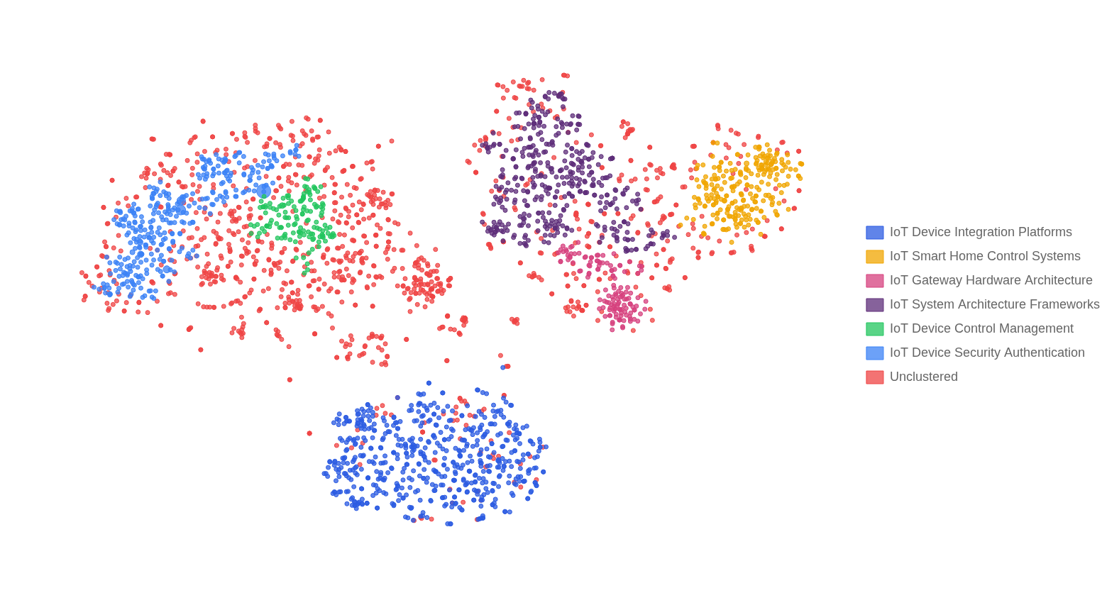
How to read this chart: Each point represents a patent family. The X and Y axes have no inherent meaning—they are a 2D projection of high-dimensional patent content created using t-SNE dimensionality reduction. What matters is relative position: patent families addressing similar technical problems appear close together, while unrelated technologies are far apart. Colors indicate technology clusters discovered automatically through density-based clustering (HDBSCAN), which groups patents that form natural "neighborhoods" in the technology space without requiring predefined categories.
Important: Empty regions in this visualization do NOT represent "white space" or patenting opportunities. The X and Y axes are a mathematical projection created solely for visualization purposes—empty areas simply reflect where the algorithm placed fewer points for visual clarity, not gaps in technology coverage. For actual innovation opportunities identified through cluster gap analysis, see the "White Space Analysis" section later in this report.

Technology Cluster Profiles
Each cluster represents a distinct technology sub-domain identified through unsupervised machine learning. Labels and summaries are generated based on analysis of representative patents from each cluster.
Cluster 1: IoT Device Integration Platforms (581 patents)
These patents address the technical challenges of connecting, managing, and controlling heterogeneous IoT devices across smart home, industrial, and infrastructure environments through unified gateways, protocol conversion, and centralized monitoring systems.
Cluster 2: IoT Smart Home Control Systems (250 patents)
These patents address the integration and remote control of household appliances, environmental monitoring sensors, and security devices through wireless communication networks and centralized gateway systems to enable automated, intelligent home management.
Cluster 3: IoT Gateway Hardware Architecture (136 patents)
These patents address the design and implementation of multi-protocol IoT gateway devices that enable data collection, protocol conversion, and communication bridging between diverse sensor networks and cloud platforms.
Cluster 4: IoT System Architecture Frameworks (410 patents)
These patents address the design and implementation of comprehensive IoT system architectures that enable device connectivity, data collection, protocol conversion, and cloud-edge coordination for unified management of heterogeneous sensors and smart devices across various application domains.
Cluster 5: IoT Device Control Management (139 patents)
These patents address methods and systems for centralized monitoring, control, and orchestration of heterogeneous Internet of Things devices through unified interfaces, abstraction layers, and automated workflows that enable seamless device interaction and management across diverse protocols and platforms.
Cluster 6: IoT Device Security Authentication (343 patents)
These patents address secure authentication, identity verification, and encrypted communication protocols for Internet of Things devices to protect against unauthorized access and cyber threats across networked environments.

Competitive Intelligence
The leaderboard identifies the most active patent filers in this technology space. Portfolio size indicates R&D investment and strategic commitment to the technology domain.

Competitor Territory Map
The IoT device patent landscape exhibits a highly fragmented competitive structure, with a Herfindahl-Hirschman Index of 439.87 indicating low market concentration and the top five assignees collectively controlling only 8.7 percent of total patent activity. Samsung Electronics maintains the leading position with 64 patents, nearly doubling the portfolio of the second-ranked Electronics and Telecommunications Research Institute at 35 patents.
This substantial gap between the market leader and subsequent competitors, which include IBM with 25 patents, Intel with 20 patents, and Afero with 18 patents, suggests that while Samsung has achieved relative scale advantages, no single entity has established dominant control over the technology space. Analysis of competitive positioning reveals that the primary technology cluster demonstrates significant overlap among all major players, indicating direct competition for core IoT functionality and suggesting that differentiation in fundamental device capabilities remains challenging.
Samsung Electronics and the Electronics and Telecommunications Research Institute have adopted broad portfolio strategies, maintaining presence across multiple technology clusters and positioning themselves as comprehensive solution providers capable of addressing diverse IoT applications. In contrast, IBM and Intel have pursued more concentrated positioning strategies, with IBM demonstrating particular strength in isolated technology niches that likely correspond to specialized enterprise, security, or industrial IoT applications where technical barriers to entry may be higher.
The competitive dynamics present meaningful opportunities for strategic market entry and differentiation. The secondary technology cluster in the lower region of the landscape, where Samsung and ETRI maintain presence but competitor activity remains limited, represents an underserved segment where new entrants or existing players such as Qualcomm with 14 patents or Cisco Technology with 13 patents could establish positions without direct confrontation with established leaders.
Furthermore, the fragmented nature of the market suggests that targeted innovation in specific vertical applications or emerging IoT subsegments could enable smaller players to achieve defensible competitive positions, particularly given that even mid-tier competitors like Huawei Technologies with 10 patents maintain viable market presence despite significantly smaller portfolios than the leading assignees.
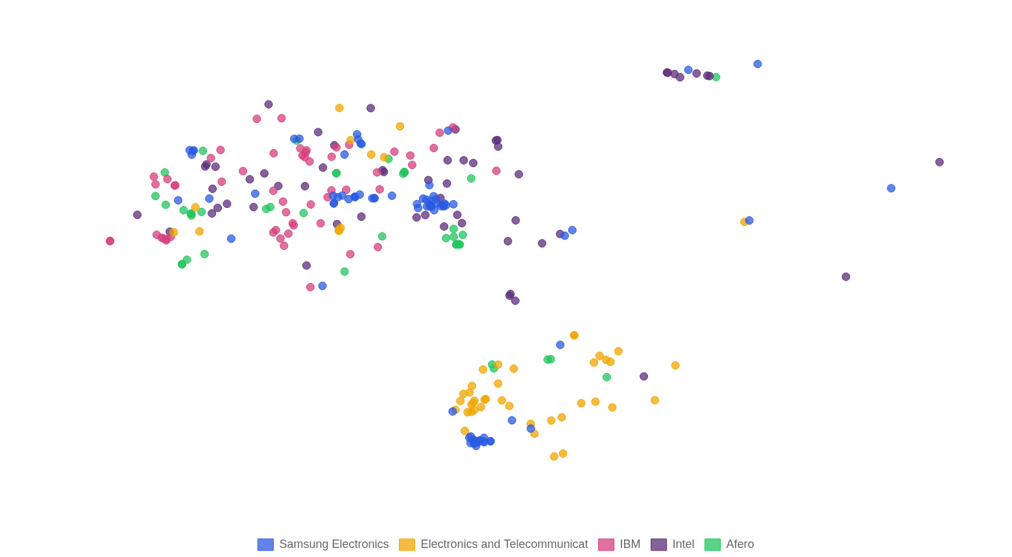
How to read this chart: This uses the same 2D projection as the Technology Landscape Map, but highlights only the top 5 assignees by portfolio size. Each color represents a different company's patent families. The X and Y axes reflect semantic similarity—nearby points address similar technical problems. Overlapping territories indicate direct competition in the same technology areas, while separated clusters suggest companies pursuing differentiated strategies. Dense clusters of a single color reveal a company's core competency areas.

Competitive & Temporal Dynamics
This section reveals the intersection of competitive positioning and technology focus. The heatmaps below show which companies dominate which technology clusters, and how activity in each cluster has evolved over time.

Technology vs. Assignee Heatmap
Rows show top assignees; columns show technology clusters. Cell values indicate patent family volume. This reveals whether companies are "specialists" (concentrated in few clusters) or "generalists" (spread across many).
Note: Rankings in this section are based on patents within identified technology clusters and may differ from overall portfolio size shown earlier. Patents excluded as noise (not fitting any cluster) are not counted here. See the Excluded Patents appendix for details on noise exclusion methodology.
How to read this table: Rows show top assignees; columns show technology clusters. Cell values indicate patent family count. Higher values (darker cells) show concentration. Companies with patents spread across many columns are "generalists"; those concentrated in few columns are "specialists" focused on specific technology areas.
Assignee | IoT Device Integration Platforms | IoT Smart Home Control Systems | IoT Gateway Hardware Architecture | IoT System Architecture Frameworks | IoT Device Control Management | IoT Device Security Authentication | Total
Samsung Electronics | 20 |  | 1 |  | 33 | 10 | 64
Electronics and Telecommu | 31 |  |  |  |  | 4 | 35
IBM |  |  |  |  | 4 | 21 | 25
Intel | 1 |  |  |  | 6 | 13 | 20
Afero | 5 |  |  |  | 3 | 10 | 18
VERIZON PATENT & LICENSIN |  |  |  |  | 3 | 12 | 15
Qualcomm | 6 |  |  |  |  | 8 | 14
CISCO TECH INC |  |  |  |  | 4 | 9 | 13
Chengdu Qinchuan IoT Tech |  |  | 3 | 10 |  |  | 13
Huawei Technologies |  |  |  | 7 |  | 3 | 10

The competitive landscape reveals a clear distinction between generalist and specialist patent strategies among leading assignees. Samsung Electronics emerges as the dominant generalist, maintaining substantial portfolios across four distinct technology clusters with particular strength in IoT Device Control Management (33 patents) and IoT Device Integration Platforms (20 patents).
This broad coverage suggests a comprehensive platform strategy aimed at controlling multiple layers of the IoT ecosystem. In contrast, several assignees demonstrate highly concentrated specialist approaches.
The Electronics and Telecommunications Research Institute has focused almost exclusively on IoT Device Integration Platforms (31 of 35 patents), while IBM has pursued a security-centric strategy with 21 of its 25 patents concentrated in IoT Device Security Authentication. Chengdu Qinchuan IoT Technology similarly specializes in IoT System Architecture Frameworks, representing a focused regional player in foundational infrastructure.
The IoT Device Security Authentication cluster emerges as the most contested technology area, attracting significant investment from eight of the ten analyzed assignees. This intense competitive pressure reflects the critical importance of security in IoT commercialization and suggests that freedom to operate in this space may require careful navigation of overlapping patent rights.
Conversely, the IoT Gateway Hardware Architecture cluster shows remarkably low competitive density, with only Samsung Electronics and Chengdu Qinchuan IoT Technology maintaining meaningful positions. The IoT Smart Home Control Systems cluster is notably absent from the portfolios of all top assignees analyzed, representing either a strategic gap or an area where patent protection may be pursued by different market participants not captured in this analysis.
Several strategic patterns warrant attention. The absence of major semiconductor players such as Intel and Qualcomm from the IoT System Architecture Frameworks cluster suggests these companies may be ceding system-level architectural innovation to platform integrators while focusing on component-level security solutions.
Telecommunications-oriented assignees including Verizon Patent and Licensing Inc and Cisco Tech Inc demonstrate concentrated positions in security authentication, aligning with their network infrastructure heritage. The relatively modest portfolio of Huawei Technologies (10 patents) compared to other global technology leaders may indicate either a nascent IoT patent strategy or geographic filing preferences not fully captured in this dataset.

Technology vs. Time Heatmap
Rows show filing years; columns show technology clusters. Cell values indicate patent family volume. This reveals which clusters are emerging (recent growth), mature (historical peaks), or declining.
How to read this table: Rows show priority years; columns show technology clusters. Cell values indicate patent family count. Clusters with increasing values in recent years represent emerging technologies; those with peaks in earlier years and declining recent values suggest mature or declining areas. Compare column trends to identify technology lifecycle stages.
Year | IoT Device Integration Platforms | IoT Smart Home Control Systems | IoT Gateway Hardware Architecture | IoT System Architecture Frameworks | IoT Device Control Management | IoT Device Security Authentication | Total
2003 |  | 1 |  |  |  |  | 1
2009 |  |  |  |  |  | 1 | 1
2010 |  | 6 | 1 | 4 | 1 | 3 | 15
2011 |  | 5 | 5 | 17 | 2 | 4 | 33
2012 | 2 | 10 | 12 | 12 | 1 | 2 | 39
2013 | 7 | 14 | 6 | 10 | 1 | 6 | 44
2014 | 18 | 14 | 3 | 10 | 3 | 11 | 59
2015 | 42 | 36 | 7 | 18 | 21 | 32 | 156
2016 | 63 | 44 | 13 | 35 | 18 | 36 | 209
2017 | 70 | 46 | 17 | 28 | 19 | 57 | 237
2018 | 74 | 29 | 10 | 39 | 14 | 47 | 213
2019 | 79 | 11 | 9 | 40 | 10 | 43 | 192
2020 | 70 | 11 | 16 | 53 | 12 | 37 | 199
2021 | 54 | 8 | 13 | 34 | 17 | 25 | 151
2022 | 52 | 4 | 9 | 33 | 11 | 20 | 129
2023 | 40 | 2 | 9 | 40 | 8 | 16 | 115

The temporal analysis of IoT device patent activity across the six identified technology clusters reveals a dynamic and evolving innovation landscape characterized by sustained growth across all segments, though with notable variations in peak activity periods and maturation trajectories. IoT Device Integration Platforms emerges as the dominant cluster with 571 patents and peak activity in 2019, indicating this remains a primary focus area for research and development investment.
The cluster addressing IoT System Architecture Frameworks, with 373 patents peaking in 2020, represents the most recently active area, suggesting ongoing innovation in foundational infrastructure design. Notably, IoT Device Security Authentication demonstrates substantial activity with 340 patents, reflecting the industry's sustained commitment to addressing security vulnerabilities inherent in connected device ecosystems.
An examination of peak activity years reveals an interesting temporal pattern suggesting technology maturation cycles. Three clusters—IoT Smart Home Control Systems, IoT Gateway Hardware Architecture, and IoT Device Security Authentication—reached peak activity in 2017, indicating these areas may be transitioning from rapid innovation phases toward more mature, incremental improvement stages.
IoT Device Control Management peaked earliest in 2015, suggesting this foundational capability has become well-established within the prior art landscape. The progression from early control management innovations through gateway and security developments, culminating in more recent platform integration and system architecture focus, demonstrates a logical evolution from basic connectivity solutions toward comprehensive, secure, and interoperable IoT ecosystems.
Forward-looking analysis indicates that innovation momentum is shifting toward higher-level integration challenges and architectural frameworks capable of supporting increasingly complex IoT deployments. The sustained growing trend across all clusters, despite varying peak years, suggests the IoT device sector has not yet reached saturation and continues to present opportunities for meaningful patent protection.
Organizations seeking strategic positioning should note that while foundational areas such as device control and gateway architecture may offer fewer opportunities for pioneering claims, the integration platform and system architecture spaces remain active frontiers where novel approaches to interoperability, scalability, and cross-platform coordination may yield valuable intellectual property assets through 2025 and beyond.

Cross-Dimensional Analysis
Matrix visualizations reveal relationships between different dimensions of the patent landscape. Bubble size indicates patent volume at each intersection, highlighting strategic concentrations and potential white spaces.

Technology Focus by Jurisdiction
This matrix shows which technology areas are most active in each jurisdiction. Large bubbles indicate strong patent activity at the intersection of a specific technology and geographic market. This reveals regional technology preferences and market-specific innovation patterns.
The United States dominates IoT device patent activity across all technology categories, with particularly strong concentrations in H04L (transmission of digital information) at 1,473 patents and H04W (wireless communication networks) at 762 patents, reflecting its leadership in core connectivity infrastructure. China demonstrates significant strength in H04L (919 patents) and G05B (control/regulating systems, 319 patents), indicating a strategic focus on both communication protocols and industrial IoT applications. South Korea exhibits notable specialization in G06Q (data processing for business/financial purposes, 193 patents) and G16Y (information/communication technologies for IoT, 192 patents), suggesting emphasis on commercial IoT implementations and dedicated IoT classification systems. For regional IP strategy, companies should prioritize U.S. filings for foundational communication technologies while considering China for industrial control innovations and Korea for business-oriented IoT solutions. The relatively modest activity in Japan, Germany, and Australia across all categories presents potential white-space opportunities for establishing early IP positions in these developed markets.
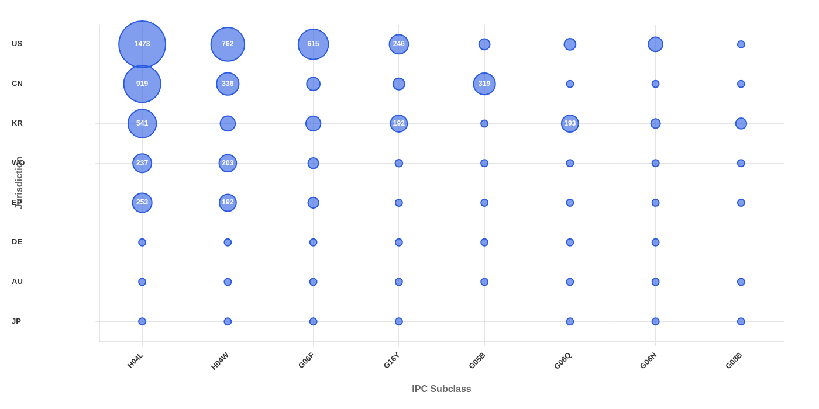
How to read this chart: Rows represent filing jurisdictions; columns represent IPC subclasses. Bubble size is proportional to patent count at each intersection. Large bubbles reveal regional technology strengths; empty cells indicate gaps in geographic coverage for that technology. Compare rows to see which technologies dominate in each market; compare columns to see where specific technologies are being protected globally.

Technology Focus by Assignee
This matrix reveals the technology specialization of top assignees. Companies with large bubbles concentrated in few columns are technology specialists, while those spread across many columns are technology generalists. Empty intersections may represent market opportunities or strategic gaps.
Samsung Electronics maintains the broadest portfolio across IoT technology areas, with significant depth in transmission protocols (H04L: 61 patents), computing systems (G06F: 30), and information/communication technology infrastructure (G16Y: 27), positioning it as a comprehensive IoT platform player. Intense competitive clustering occurs in the core communication technologies of H04L and H04W, where Samsung, IBM, Intel, and Qualcomm all demonstrate substantial investment, reflecting the foundational importance of network transmission and wireless protocols to IoT architecture. Qualcomm exhibits a notably focused strategy, concentrating heavily on wireless communication (H04W: 37 patents) relative to other technology areas, consistent with its core competency in wireless semiconductors and connectivity solutions. ETRI and Afero demonstrate differentiated positioning through meaningful presence in G06N (machine learning/AI) and signaling systems respectively, while telecom operators Verizon and T-Mobile maintain narrower portfolios centered primarily on communication protocols, suggesting they are securing IP around network infrastructure rather than pursuing broader device or platform innovation.
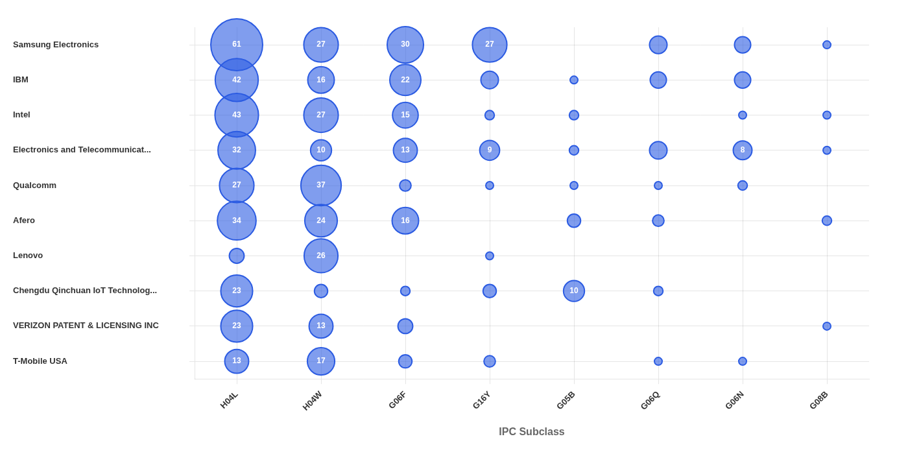
How to read this chart: Rows represent top assignees; columns represent IPC subclasses. Bubble size is proportional to patent family count. Companies with large bubbles in few columns are "specialists" focused on specific technologies; those spread across many columns are "generalists" with broad portfolios. Empty cells at row/column intersections may reveal strategic gaps or differentiation opportunities.

Geographic Focus by Assignee
This matrix shows where each top assignee files patents, revealing their geographic market strategy. Companies focused on single jurisdictions have concentrated filing strategies, while those with broad geographic spread pursue global market protection.
Intel and Samsung Electronics demonstrate the broadest geographic coverage in IoT device patents, maintaining substantial filings across the US, China, Korea, WIPO, and European jurisdictions, reflecting mature global commercialization strategies aimed at protecting technology across all major manufacturing and consumer markets. In contrast, regional specialists such as Verizon Patent & Licensing and Electronics and Telecommunications Research Institute exhibit highly concentrated filing patterns—Verizon focusing almost exclusively on the US market (53 patents) while ETRI prioritizes Korean protection (48 patents)—indicating domestically-oriented business models or licensing-focused strategies. Qualcomm and IBM pursue balanced international coverage with particular emphasis on WIPO filings (32 each), suggesting a strategic approach to preserving optionality for future market entry while maintaining strong US positions. The relative underrepresentation of Chinese players like Huawei Technologies across Western jurisdictions, combined with emerging Chinese entities like Chengdu Qinchuan focusing primarily on US and CN filings, reveals a bifurcated competitive landscape where established multinationals pursue defensive global portfolios while newer entrants prioritize protection in their primary commercialization targets.
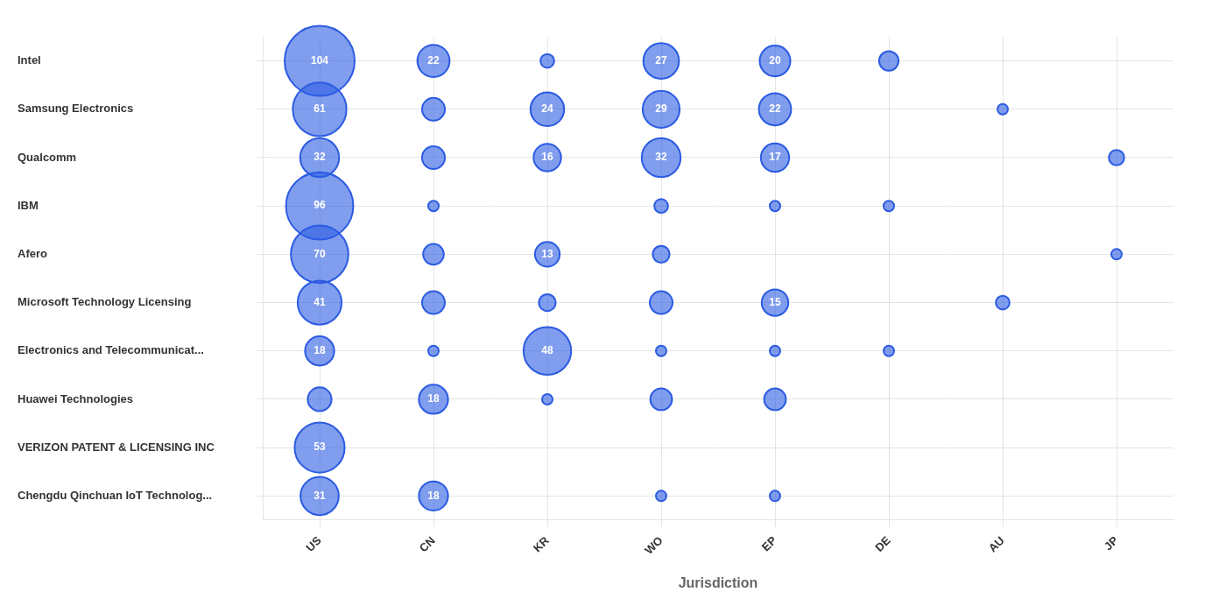
How to read this chart: Rows represent top assignees; columns represent jurisdictions. Bubble size is proportional to patent document count. Companies with bubbles concentrated in one column have focused geographic strategies; those spread across columns pursue global protection. Compare column totals to identify most contested markets; compare rows to understand each competitor's geographic priorities.

R&D Strategic Movement
The analysis of R&D strategic movement among leading IoT device patent holders reveals a landscape characterized by meaningful differentiation rather than technological convergence. Samsung Electronics demonstrates the most pronounced strategic evolution, expanding its patent portfolio from 15 filings in the early period to 49 in the recent period while simultaneously exhibiting a movement magnitude of 0.18, indicating a substantial eastward shift in its technology focus areas.
This trajectory suggests that Samsung has not merely scaled its IoT investments but has fundamentally redirected its research priorities toward emerging application domains or adjacent technology spaces. In contrast, the Electronics and Telecommunications Research Institute shows a slight contraction in patent output from 19 to 16 filings, coupled with the highest movement magnitude of 0.21, suggesting a strategic repositioning that prioritizes depth and specialization over breadth of coverage.
IBM presents a notably different strategic posture, maintaining relative portfolio stability with only marginal growth from 12 to 13 patents and a movement magnitude of 0.19. This measured approach indicates that IBM has elected to refine and consolidate its existing IoT technology positions rather than pursue aggressive expansion or dramatic pivots.
The company's incremental adjustments suggest confidence in its established technology domains and a strategy focused on strengthening core competencies rather than exploring new frontiers. The divergent trajectories observed across these three major competitors carry significant implications for the broader IoT technology landscape.
Rather than converging toward common technology targets, these organizations appear to be establishing distinct strategic positions, with each occupying differentiated quadrants of the technology space. This pattern is characteristic of a maturing market where initial exploratory phases give way to specialized niche development.
Samsung's pronounced movement, combined with its substantial portfolio growth, positions the company as the most aggressive pursuer of next-generation IoT opportunities, while the research institute's repositioning and IBM's stability suggest alternative strategies focused on specialized applications and foundational technologies respectively.
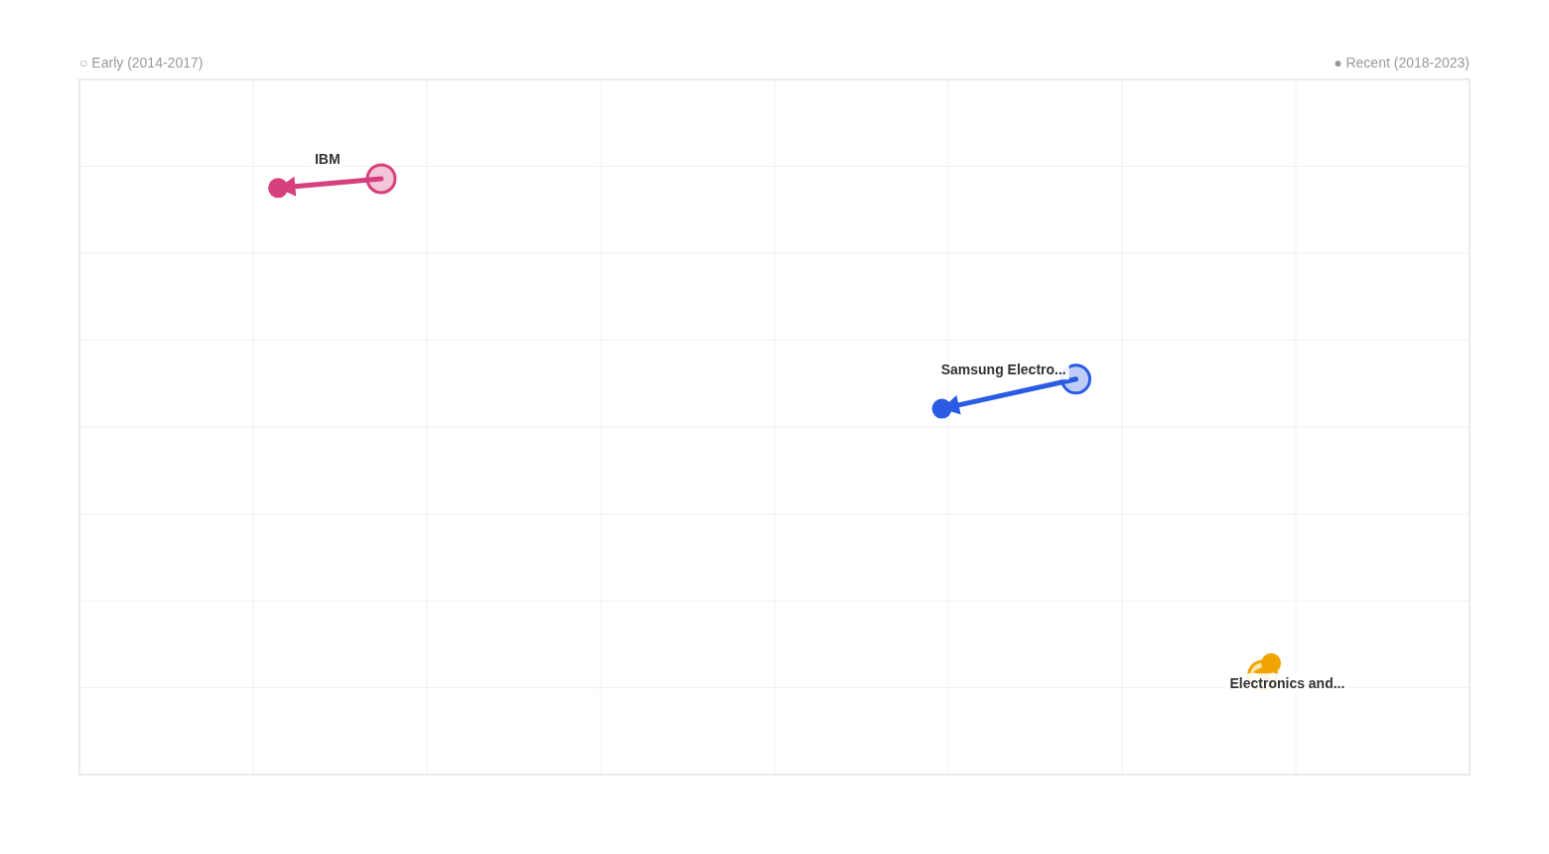
How to read this chart: The X and Y axes represent the 2D projection of the technology space (derived from t-SNE dimensionality reduction of patent embeddings). Position reflects semantic similarity—patent families addressing similar technical problems appear close together. Each arrow starts at the company's early-period centroid (hollow circle) and points to their recent-period centroid (filled circle). Movement magnitude is the Euclidean distance between these centroids, measuring how far a company has shifted its R&D focus. Converging arrows suggest competitors moving toward similar technology areas; diverging arrows indicate differentiation.

Trajectory Analysis: Samsung Electronics
Early Period (2014-2017)  15  patents | Recent Period (2018-2023)  49  patents | Movement  0.18  magnitude

Samsung Electronics has significantly expanded its IoT patent portfolio from 15 to 49 patents, demonstrating sustained commitment to smart home and connected device ecosystems. Their evolution reflects a strategic shift from basic connectivity infrastructure toward intelligent, context-aware automation systems.

Trajectory Analysis: Electronics and Telecommunications Research Institute
Early Period (2012-2017)  19  patents | Recent Period (2018-2024)  16  patents | Movement  0.21  magnitude

Electronics and Telecommunications Research Institute (ETRI) has maintained steady IoT research focus while evolving from foundational service platforms toward sophisticated edge computing and intelligent data management systems. Their portfolio shows moderate evolution with emphasis on practical, domain-specific IoT applications.

Trajectory Analysis: IBM
Early Period (2015-2017)  12  patents | Recent Period (2018-2023)  13  patents | Movement  0.19  magnitude

IBM demonstrates consistent investment in IoT technologies, evolving from foundational security and device management frameworks toward sophisticated edge computing architectures. Their moderate evolution reflects strategic refinement rather than radical repositioning, building upon established IoT infrastructure expertise to address emerging distributed computing challenges.

White Space Analysis
This section identifies potential innovation opportunities in the gaps between established technology clusters. By analyzing the geometric relationships between clusters in the semantic space, we identify areas where limited patent activity exists.

Gap 1: IoT Device Control Management ↔ IoT Device Security Authentication
Innovation Potential: High
Bridge Concept — Adaptive Security-Aware IoT Device Orchestration Platform: A unified IoT management platform that dynamically adjusts device control workflows based on real-time security authentication states and threat assessments. The system integrates centralized device orchestration with continuous identity verification, automatically modifying access permissions, communication protocols, and control capabilities based on device trust levels, user authentication strength, and detected security anomalies across the heterogeneous IoT ecosystem.
Technical Challenges: Maintaining low-latency device control responsiveness while performing continuous cryptographic authentication and security validation across diverse protocols; Creating unified abstraction layers that simultaneously handle device-specific control interfaces and varying security credential formats without compromising either functionality; Developing adaptive trust scoring algorithms that dynamically balance security enforcement with operational continuity across heterogeneous device networks

Gap 2: IoT Gateway Hardware Architecture ↔ IoT System Architecture Frameworks
Innovation Potential: High
Bridge Concept — Self-Configuring Adaptive Gateway with Dynamic System Architecture Integration: A unified IoT platform that combines intelligent gateway hardware with adaptive system architecture capabilities. The system features auto-discovering multi-protocol gateway modules that dynamically integrate with cloud-edge frameworks, enabling real-time protocol negotiation, automatic device onboarding, and seamless coordination between heterogeneous sensor networks and comprehensive IoT management platforms without manual configuration or custom development.
Technical Challenges: Achieving real-time automatic protocol detection and conversion across diverse hardware interfaces while maintaining low latency and high reliability in edge-cloud communication; Developing a universal device abstraction layer that can dynamically map heterogeneous sensor data formats to standardized IoT object models without predefined configurations; Ensuring secure and seamless handoff between gateway hardware failover mechanisms and cloud platform redundancy systems during network instability or device failures

Gap 3: IoT Smart Home Control Systems ↔ IoT Gateway Hardware Architecture
Innovation Potential: High
Bridge Concept — Self-Configuring Multi-Protocol Smart Home Gateway Architecture: A unified hardware gateway platform that combines adaptive multi-protocol conversion capabilities with intelligent home automation logic. The system features modular interface boards supporting RS-232, RS-485, ZigBee, WiFi, and proprietary protocols, while embedding smart home control algorithms that automatically discover, configure, and orchestrate heterogeneous household devices. The gateway performs real-time protocol translation and device abstraction, presenting a unified API to mobile terminals and cloud platforms for seamless smart home management regardless of underlying device communication standards.
Technical Challenges: Developing universal protocol abstraction layers that can dynamically translate between industrial IoT protocols and consumer smart home communication standards without latency degradation; Creating auto-discovery mechanisms that identify device types and capabilities across multiple protocol domains while maintaining security isolation between network segments; Designing modular hardware architecture that balances cost-effectiveness for residential deployment with the robustness and interface diversity required for multi-protocol industrial gateways

Gap 4: IoT Smart Home Control Systems ↔ IoT System Architecture Frameworks
Innovation Potential: High
Bridge Concept — Adaptive IoT Architecture Framework for Dynamic Smart Home Ecosystems: A unified platform that combines standardized IoT system architecture with intelligent smart home control, featuring a self-configuring edge gateway that automatically discovers heterogeneous home devices, translates diverse protocols through IoT standard object models, and orchestrates cloud-edge coordination for seamless home automation. The system enables plug-and-play integration of any smart home device while maintaining centralized intelligent control through adaptive protocol conversion and unified device management interfaces.
Technical Challenges: Developing universal protocol translation layers that can dynamically adapt to proprietary smart home device communication standards while maintaining real-time responsiveness; Creating intelligent edge computing algorithms that balance local smart home automation decisions with cloud-based analytics without compromising latency or reliability; Establishing secure, scalable device discovery and authentication mechanisms that work across heterogeneous smart home ecosystems from multiple manufacturers

Gap 5: IoT System Architecture Frameworks ↔ IoT Device Control Management
Innovation Potential: High
Bridge Concept — Adaptive Architecture-Aware IoT Device Orchestration Platform: A unified platform that dynamically integrates IoT system architecture frameworks with device control management by creating intelligent middleware that automatically discovers system topology, maps device capabilities to architectural components, and generates adaptive control workflows. The system uses architecture metadata to optimize device orchestration decisions, enabling seamless protocol translation and control abstraction that respects underlying infrastructure constraints while providing unified management interfaces across heterogeneous deployments.
Technical Challenges: Real-time synchronization between architecture-level configuration changes and device control policies without service interruption; Automatic inference and mapping of device capabilities to appropriate architectural layers across diverse protocol ecosystems; Maintaining consistent control semantics when devices migrate between edge and cloud processing contexts within dynamic architectures

Legal Status Intelligence
This section provides legal status intelligence derived from the INPADOC database, covering 2,963 patent families (96.3% of the landscape). Overall portfolio vitality is 80.7%, with 2,390 active patents and 573 that have ceased or lapsed.

Patent Expiry Forecast
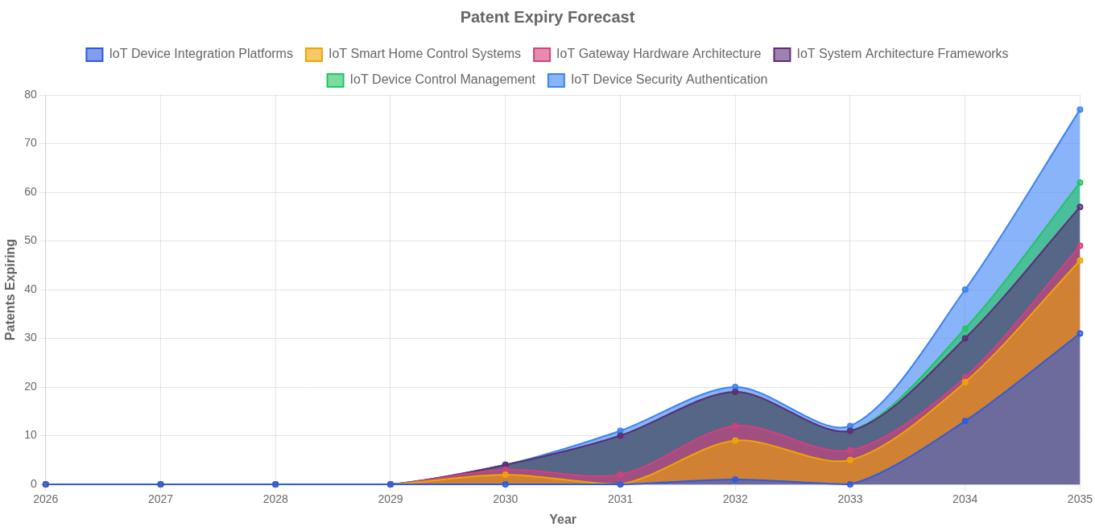
Over the next 10 years, approximately 254 patent families in this landscape are expected to expire, progressively opening up freedom to operate in these technology areas.
Note: Expiry dates calculated as application date + 20 years. Does not account for Patent Term Adjustments (PTAs), Patent Term Extensions (PTEs), or Supplementary Protection Certificates (SPCs).

Portfolio Vitality Analysis

Vitality by Assignee
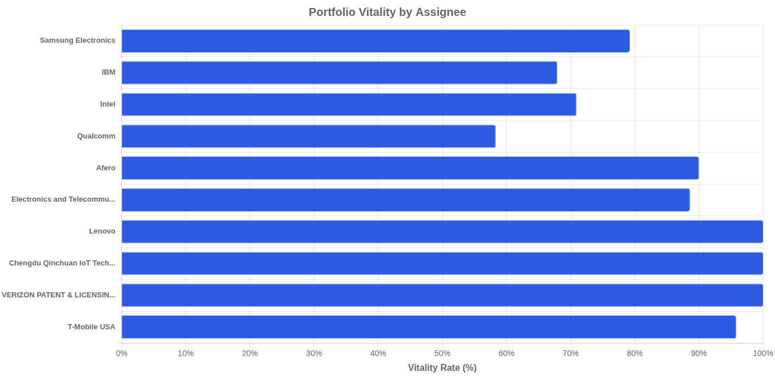
Among major players, Lenovo maintains the highest portfolio vitality at 100.0%, while Microsoft Technology Licensing shows the lowest at 57.1%. Higher vitality rates indicate active portfolio maintenance and continued commercial interest in the protected technologies.

Vitality by Technology Cluster
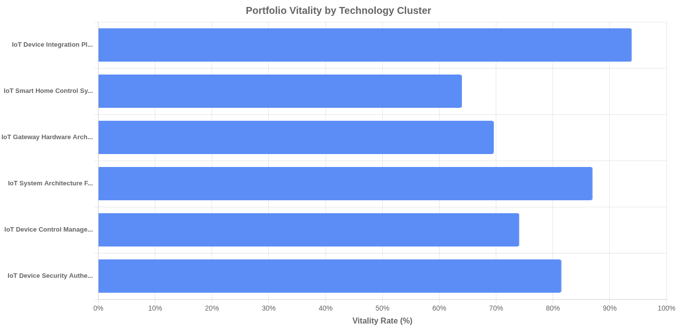
Technology cluster 'IoT Device Integration Platforms' shows the highest vitality rate (93.9%), suggesting continued commercial importance, while 'IoT Smart Home Control Systems' has the lowest (64.0%), potentially indicating either mature technology or reduced market interest.
Note: Portfolio vitality is based on recorded cessation events (H-class) in INPADOC. A patent without a cessation event is presumed active. Actual status should be verified with national registers for critical decisions.

Glossary of Terms
Patent Family: A collection of patent documents that share the same priority filing, representing a single invention.
Priority Date: The filing date of the first patent application for an invention.
Forward Citations: Patents that cite the patent in question, indicating technological influence.
IPC (International Patent Classification): A hierarchical system for classifying patents by technical domain.
Semantic Similarity: A measure (0 to 1) of how closely two patent families address the same technical problem.
Movement Magnitude: The Euclidean distance a company's R&D centroid has moved between early and recent time periods.
HHI (Herfindahl-Hirschman Index): A measure of market concentration. Below 1,500 = competitive; 1,500-2,500 = moderate concentration; above 2,500 = high concentration.
t-SNE Projection: A dimensionality reduction technique that projects high-dimensional data to 2D for visualization.
Technology Cluster: A group of patent families automatically identified as addressing similar technical domains.
White Space: Regions in the technology landscape with limited patent activity, potentially representing innovation opportunities.

Appendix A: Entity Mapping
This appendix documents how different entity name variations were normalized and grouped during the analysis. Corporate subsidiaries, name variations, and spelling differences have been consolidated to provide accurate portfolio counts.
Qualcomm
Variants: QUALCOMM INC; クアルコム，インコーポレイテッド; 퀄컴 인코포레이티드; 高通股份有限公司; QUALCOMM CONNECTED EXPERIENCES INC
Intel
Variants: INTEL CORP; INTEL IP CORP; 英特尔公司; 인텔 코포레이션
Afero
Variants: AFERO INC; 어페로, 인크.; 阿费罗有限公司; アフェロ インコーポレイテッドＡｆｅｒｏ， Ｉｎｃ．
Microsoft Technology Licensing
Variants: MICROSOFT TECHNOLOGY LICENSING LLC; 微软技术许可有限责任公司; 마이크로소프트 테크놀로지 라이센싱, 엘엘씨; МАЙКРОСОФТ ТЕКНОЛОДЖИ ЛАЙСЕНСИНГ, ЭлЭлСи
Electronics and Telecommunications Research Institute
Variants: ELECTRONICS & TELECOMMUNICATIONS RES INST; KOREA ELECTRONICS TECHNOLOGY; 한국전자통신연구원; KOREA ELECTRONICS TELECOMM
Lenovo
Variants: LENOVO BEIJING LTD; LENOVO SINGAPORE PTE LTD; LENOVO UNITED STATES INC; LENOVO BEIJING CO LTD
Samsung Electronics
Variants: SAMSUNG ELECTRONICS CO LTD; 삼성전자주식회사; 三星电子株式会社
Huawei Technologies
Variants: HUAWEI TECH CO LTD; 华为技术有限公司; HUAWEI CLOUD COMPUTING TECH CO LTD
Chengdu Qinchuan IoT Technology
Variants: CHENGDU QINCHUAN IOT TECH CO LTD; CHENGDU QINCHUAN TECH DEV CO; 成都秦川物联网科技股份有限公司
Siemens
Variants: SIEMENS AG; SIEMENS CANADA LTD; SIEMENS INDUSTRY INC
Alibaba Group
Variants: ALIBABA GROUP HOLDING LTD; ADVANCED NEW TECHNOLOGIES CO LTD; 阿里巴巴集团控股有限公司
Nippon Telegraph and Telephone
Variants: NTT DOCOMO INC; NIPPON TELEGRAPH & TELEPHONE; 日本電信電話株式会社
Interdigital Patent Holdings
Variants: INTERDIGITAL PATENT HOLDINGS INC; INTERDIGITAL PATENT HOLDINGS; INTERDIGITAL TECH CORP
Soracom
Variants: 株式会社ソラコム; SORACOM INC; 株式会社宙连
Alipay
Variants: 支付宝（杭州）信息技术有限公司; ALIPAY HANGZHOU INF TECH CO LTD; ALIPAY HANGZHOU TECH CO LTD
Sookmyung Women's University Industry-Academic Cooperation Foundation
Variants: 숙명여자대학교산학협력단; SOOKMYUNG WOMEN'S UNIV INDUSTRY-ACADEMIC COOPERATION FOUNDATION; UNIV SOOKMYUNG WOMENS IND ACAD COOP FOUND
T-Mobile USA
Variants: T MOBILE USA INC; T MOBILE INNOVATIONS LLC
Korea Industrial Technology Institute
Variants: KOREA IND TECH INST; 주식회사 한국산업기술원
McAfee
Variants: MCAFEE LLC; MCAFEE INC
SAP
Variants: SAP SE; SAP PORTALS ISRAEL LTD
Hewlett Packard Enterprise
Variants: HEWLETT PACKARD ENTPR DEV LP; HEWLETT PACKARD DEVELOPMENT CO
Gree Electric Appliances
Variants: GREE ELECTRIC APPLIANCES INC ZHUHAI; ZHUHAI GREE ELEC APPLIANCES
Tran Bao
Variants: TRAN BAO; DAO BANG TRAN
AT&T
Variants: AT & T IP I LP; AT & T MOBILITY II LLC
NEC Corporation
Variants: NEC CORP; 日本電気株式会社
DISH Network
Variants: DISH NETWORK LLC; DISH WIRELESS LLC
Korea Advanced Institute of Science and Technology
Variants: KOREA ADVANCED INST SCI & TECH; 한국과학기술원
Mastercard
Variants: MASTERCARD INTERNATIONAL INC; MASTERCARD TECH CANADA ULC
Google
Variants: GOOGLE LLC; GOOGLE INC
Sichuan Changhong Electric
Variants: SICHUAN CHANGHONG ELECTRIC CO LTD; 四川长虹电器股份有限公司
KT Corporation
Variants: KT CORP; 주식회사 케이티
Nokia
Variants: NOKIA TECHNOLOGIES OY; NOKIA AMERICA CORP
Symantec
Variants: SYMANTEC CORP; NORTONLIFELOCK INC
Hitachi
Variants: HITACHI LTD; HITACHI VANTARA LLC
4STEC
Variants: 4STEC INC; 주식회사 포에스텍
LG Uplus
Variants: LG UPLUS CORP; 주식회사 엘지유플러스
Sony
Variants: SONY CORP; SONY GROUP CORP
Fujitsu
Variants: FUJITSU TECH SOLUTIONS IP GMBH; FUJITSU LTD
Korea Electric Power Corporation
Variants: 한국전력공사; KOREA ELECTRIC POWER CORP
Accenture Global Services
Variants: ACCENTURE GLOBAL SERVICES LTD; ACCENTURE GLOBAL SOLUTIONS LTD
Jeju National University
Variants: JEJU NATIONAL UNIV INDUSTRY ACADEMIC COOPERATION FOUNDATION; 제주대학교 산학협력단
Hsiao Jue-Hsuan
Variants: HSIAO JUE HSUAN; HSIAO JUE-HSUAN
T-Central
Variants: T-CENTRAL INC; T CENTRAL INC
Ubivelox Mobile
Variants: UBIVELOX MOBILE CORP; (주)유비벨록스모바일
VeChain Global Technology
Variants: VECHAIN GLOBAL TECH SARL; VECHAIN GLOBAL TECH S AR L
WINS
Variants: WINS CO LTD; 주식회사 윈스
Korea Electrical Safety Corporation
Variants: KOREA ELECTRICAL SAFETY CORP; 한국전기안전공사
Han Entropy Communication
Variants: 汉熵通信有限公司; HAN ENTROPY COMMUNICATION LTD COMPANY
DKI Technology
Variants: DKI TECH CO LTD; 주식회사 디케이아이테크놀로지
Information Science Research Institute of CETC
Variants: INFORMATION SCIENCE RES INSTITUTE OF CETC; 中国电子科技集团公司信息科学研究院

Appendix B: Top 100 Similar Patents
This appendix lists the top 100 patents most semantically similar to the search query, ranked by similarity score. The similarity percentage indicates how closely each patent's content matches the search query based on semantic vector analysis.
# | Patent No. | Title | Applicant | Sim %
1 | KR20200094002A | IoT 서비스 플랫폼 장치 | ELECTRONICS & TELECOMMUNICATIONS RES INST | 65%
2 | EP4604623A1 | Ambient iot device and node | PANASONIC IP CORP AMERICA | 65%
3 | WO2025007304A1 | Devices and methods for communication | NEC CORP | 63%
4 | KR20230129142A | IoT 웨어러블 조끼, 밴드, 헬멧, 워치, 멜빵, 벨트, 수단 | KOREA IND TECH INST | 62%
5 | WO2025043655A1 | Devices and methods of communication | NEC CORP | 62%
6 | WO2025102380A1 | Device and method of communication | NEC CORP | 62%
7 | WO2025118297A1 | Devices, methods, and medium for communication | NEC CORP | 61%
8 | EP3275123B1 | Goal-driven provisioning in iot systems | MCAFEE LLC | 61%
9 | EP4059321A1 | Iot device and system | EQUANS HOLDING UK LTD | 61%
10 | WO2025054783A1 | Ambient iot system | GUANGDONG OPPO MOBILE TELECOMMUNICATIONS CORP LTD | 61%
11 | KR20200123508A | IoT 장치 및 이를 포함하는 IoT 시스템 | PARK JOUNG HWA | 60%
12 | KR20240151676A | AI, VR, IoT, ICT, 스마트, 메타버스 수단 및 장치 | KOREA IND TECH INST | 60%
13 | EP3584992A1 | Internet of things device | UNIONPLACE CO LTD | 60%
14 | KR102231915B1 | 통합 IoT 모듈 및 이를 이용한 IoT 기반의 설비 환경 통합 관리 시스템 | 주식회사 네오세미텍 | 60%
15 | RU2759011C2 | Автоматическая инициализация iot-устройств | MICROSOFT TECHNOLOGY LICENSING LLC | 60%
16 | WO2025043671A1 | Devices, methods, and medium for communication | NEC CORP | 60%
17 | KR102821940B1 | IoT 기기와 비IoT 기기를 통합적으로 제어하기 위한 오토메이션 시스템 | ALICORN INC | 60%
18 | KR20160109245A | 사물 인터넷 디바이스 및 사물 인터넷 통신 방법 | SAMSUNG ELECTRONICS CO LTD | 60%
19 | US10310832B2 | Internet-of-things device blank | INTEL CORP | 60%
20 | US2019273784A1 | Internet of things system | CHENGDU QINCHUAN IOT TECH CO LTD | 60%
21 | US2020296810A1 | Internet of Things system | TAIWAN OASIS TECH CO LTD | 60%
22 | WO2025039243A1 | Ambient iot device and communication system | GUANGDONG OPPO MOBILE TELECOMMUNICATIONS CORP LTD | 60%
23 | WO2022181929A1 | 기기간 연결을 지원하는 사물인터넷 통신 시스템 | C&TECH | 60%
24 | EP4199473A1 | Iot device and authorization method therefor | HUAWEI TECH CO LTD | 59%
25 | KR102592880B1 | 사물 인터넷 플랫폼들, 장치들, 및 방법들 | 어페로, 인크. | 59%
26 | KR101992981B1 | IoT 허브와 블록체인을 활용한 IoT 플랫폼 시스템 | KEPCO KDN CO LTD | 59%
27 | US2018117447A1 | Smart device | TRAN BAO | 59%
28 | KR101728052B1 | 사용자의 행동을 인지하여 사물을 제어하는 사물인터넷 시스템 | GREENCOMM CO LTD | 59%
29 | KR101876183B1 | ＩｏＴ 기반의 보안성이 강화된 레지덴셜 게이트웨이 장치 | SOOSANG ST CO LTD | 59%
30 | KR20190061557A | 네트워크 기반 제어 장치 및 제어 시스템 | MTCOM CO LTD | 59%
31 | US10455029B2 | Internet of things (IOT) device discovery platform | DISH NETWORK LLC | 59%
32 | WO2025097410A1 | Resource management for communications with ambient internet of things (aiot) devices | QUALCOMM INC | 59%
33 | KR102042688B1 | Iot 가전 제어 시스템 | UBIVELOX MOBILE CORP | 58%
34 | KR20200084424A | 산업용 사물 인터넷 시스템 | MUNTECH CO LTD | 58%
35 | US2024143913A1 | Iot devices and ecosystem supporting cross-device native functionality | CROWDCOMFORT INC | 58%
36 | JP2022033503A | ＩｏＴ機器 | SENSE THINGS JAPAN INC | 58%
37 | KR20220122920A | 기기간 연결을 지원하는 IoT 통신 시스템 | C&TECH | 58%
38 | US2016147506A1 | Internet of things platforms, apparatuses, and methods | KIBAN LABS INC | 58%
39 | WO2015085910A1 | An internet of things (iot) communication method, communication end, and user end | TENCENT TECH SHENZHEN CO LTD | 58%
40 | KR102239317B1 | 사물인터넷(IoT) 장치군의 동시접속 회피 시스템 및 방법 | 한국전기안전공사 | 58%
41 | LU600185B1 | Iot system based on embedded systems and edge computing | HAOJING COLLEGE OF SHAANXI UNIV OF SCIENCE & TECHNOLOGY | 58%
42 | WO2024212112A1 | Device and method of communication | NEC CORP | 58%
43 | KR20180066693A | 사물인터넷용 통신 시스템 | POSTMEDIA CO LTD | 58%
44 | KR20200068085A | 홈 IoT 기기 보안 관리 장치 | KANG SUK HYUNG | 57%
45 | US2017099353A1 | Design and Systems Architecture for Internet of Things | MICROSOFT TECHNOLOGY LICENSING LLC | 57%
46 | US2018117446A1 | Smart device | TRAN BAO | 57%
47 | US10149335B2 | Connectivity module for internet of things (IOT) devices | QUALCOMM INC | 57%
48 | KR101397471B1 | 디바이스 플랫폼이 설치된 ＩｏＴ 장치 및 ＩｏＴ 어댑터 |  | 57%
49 | EP3577873B1 | Sicherheitseinheit insbesondere ein für iot-gerät und verfahren zur ausführung einer oder mehrerer applikationen zum gesicherten datenaustausch mit einem oder mehrere web-dienste bereitstellenden servern | SIEMENS AG | 57%
50 | DE112017004996T5 | Gatewaykoordination für das Internet der Dinge | INTEL CORP | 57%

# | Patent No. | Title | Applicant | Sim %
51 | EP4222928B1 | Global internet of things (iot) connectivity fabric | MICROSOFT TECHNOLOGY LICENSING LLC | 57%
52 | US2021201165A1 | Internet Of Things (IOT) Big Data Artificial Intelligence Expert System Information Management And Control Systems And Methods | PEDERSEN ROBERT D | 57%
53 | US11057345B2 | Security fabric for internet of things (IoT) | FORTINET INC | 57%
54 | US2021037364A1 | Internet of things device hierarchies | INTEL IP CORP | 57%
55 | WO2025118644A1 | METHOD AND APPARATUS OF SUPPORTING INTERNET OF THINGS (IoT) | LENOVO BEIJING LTD | 57%
56 | CN117579651A | 物联网系统 | BEIJING SMARTCHIP MICROELECTRONICS TECH CO LTD | 57%
57 | KR20160114416A | IoT 어댑터 | ELECTRONICS & TELECOMMUNICATIONS RES INST | 57%
58 | KR20190081683A | NB-IoT 단말 장치 및 그 운용 방법 | ELECTRONICS & TELECOMMUNICATIONS RES INST | 57%
59 | JP2017151991A | Ｉｏｔ整合プラットフォーム | HSIAO JUE HSUAN | 57%
60 | US2022272153A1 | Policy-Based Programmable Internet of Things Devices | AT & T MOBILITY II LLC | 57%
61 | KR20190073409A | Iot 보안 서비스 | MICROSOFT TECHNOLOGY LICENSING LLC | 57%
62 | WO2019127397A1 | Technologies for internet of things key management | INTEL CORP | 57%
63 | CN210745567U | 物联网设备 | GUANGZHOU SHIYUAN ELECT TECH | 57%
64 | US2018007055A1 | Technologies for distributed acting and knowledge for the internet of things | INFANTE-LOPEZ GABRIEL G | 57%
65 | US2022337450A1 | Internet-of-things module | PERINET GMBH | 57%
66 | US11546173B2 | Methods, application server, IoT device and media for implementing IoT services | VECHAIN GLOBAL TECH S AR L | 57%
67 | US2023164555A1 | Identity layer for iot devices | INTERDIGITAL PATENT HOLDINGS INC | 57%
68 | DE202023100404U1 | Ein Blockchain- und IoT-fähiges Gerät zur Datenerfassung in einer Computerumgebung | ANANTH KALINGARAYAN RAMASWAMY | 57%
69 | KR20160147595A | 제어 계측 대상 사물 통합 연동형 범용 아이오티(IoT) 모듈 | NX TECH CO LTD | 57%
70 | CN209593485U | 一种AIoT设备、一种物联网控制系统 | NINGBO TECHMATION SOFTWARE DEV CO LTD | 56%
71 | WO2018040125A1 | 一种智能物联网设备 | LIU JIE | 56%
72 | US11463523B2 | Dynamic chain of actions for IOT devices | VMWARE INC | 56%
73 | CN115803722A | IoT系统以及数据收集控制方法 | HITACHI LTD | 56%
74 | KR102520088B1 | 사물 인터넷 플랫폼, 장치, 및 방법 | 어페로, 인크. | 56%
75 | US2019173684A1 | Internet of Things Device Interface | SAP SE | 56%
76 | KR20240107080A | 스마트 안전 장비, 조끼, 밴드, 헬멧, 카메라, cctv, 삼각대, 시스템 | KOREA IND TECH INST | 56%
77 | CN110024330A | 对IoT装置的服务提供 | INTEL CORP | 56%
78 | KR20210095037A | 사물 인터넷을 위한 모듈형 시스템 | INTEL CORP | 56%
79 | DE112017002283T5 | Effiziente bereitstellung von vorrichtungen | INTEL CORP | 56%
80 | US11115823B1 | Internet-of-things device classifier | RAPID7 INC | 56%
81 | KR102317654B1 | 블럭형 모듈 적층 구조를 갖는 IoT 커스터마이징 디바이스 | 동국대학교 산학협력단 | 56%
82 | CN112584557A | 一种基于物联网的终端设备及网络设备 | GUANGHUA LINGANG ENGINEERING APPLICATION TECH RESEARCH AND DEVELOPMENT SHANGHAI CO LTD | 56%
83 | WO2025171516A1 | Unsynchronized ambient internet-of-things communication | QUALCOMM INC | 56%
84 | DE102020119636A1 | Internet-of-Things-Vorrichtung, Verfahren zum Herstellen einer IoT-Vorrichtung und System | ORBIT IIOT SYSTEMS GMBH | 56%
85 | KR20240099001A | IoT 서비스를 위한 장치 | ELECTRONICS & TELECOMMUNICATIONS RES INST | 56%
86 | KR20170085806A | IoT 디바이스의 위치측정 방법 및 장치 | SK TELECOM CO LTD | 56%
87 | US2016065592A1 | Internet Of Things Security | SVIGALS JEROME | 56%
88 | CN109089244A | 一种物联网的局域网设备 | FOSHAN TIANMU LIANKE TECH CO LTD | 56%
89 | KR101975681B1 | 클라우드 컴퓨팅 환경에서 ＩｏＴ 디바이스의 환경측정 모니터링 시스템 | INDUSTRY ACADEMIC COOPERATION FOUNDATION HONAM UNIV | 56%
90 | KR20190065122A | 사물 지능 공유를 통한 실시간 협업 서비스 제공 방법 및 장치 | ELECTRONICS & TELECOMMUNICATIONS RES INST | 56%
91 | KR102062718B1 | 패킷 가상화를 이용한 IoT 허니넷 시스템 | F1 SECURITY INC | 56%
92 | US2017168777A1 | Integrated development tool for an internet of things (iot) system | AFERO INC | 56%
93 | US2019141526A1 | Open public internet-of-things systems and methods | FUJITSU LTD | 56%
94 | CN115480520A | IoT传感器和用于监控工业设备的系统 | HYOSUNG PM CORP | 56%
95 | US11694149B2 | Apparatus and method for secure transport using internet of things (IoT) devices | AFERO INC | 56%
96 | US11770365B2 | Contextual awareness with Internet of Things (IoT) infrastructure for managed devices | VMWARE INC | 56%
97 | EP3512179A1 | Cyber security framework for internet-connected embedded devices | CARRIER CORP | 56%
98 | EP4222993B1 | Internet of things security | BRITISH TELECOMM | 56%
99 | US2019278950A1 | Method of securing devices used in the internet of things | IUZIFOVICH IURII V | 56%
100 | US2021119865A1 | INTELLIGENT PLUG-AND-PLAY POINT-TO-MULTIPOINT INTERNET of THINGS (IoT) PLATFORM AND METHOD OF MANAGING AND USING THE SAME | DAO BANG TRAN | 56%

Appendix E: Patents in Scope
This appendix provides a complete reference list of all 5000 patent documents (representing 3076 unique patent families) included in this landscape analysis, grouped by filing jurisdiction. Multiple documents from the same family appear separately when filed in different jurisdictions.
US (1840 patents)
US10002526B1; US10003654B2; US10004183B2; US10009410B2; US10021100B2; US10022613B2; US10027718B2; US10028321B2; US10038743B2; US10044674B2; US10044687B2; US10046228B2; US10057264B1; US10057382B2; US10063640B2; US10064059B1; US10069834B2; US10079691B2; US10079874B2; US10083291B2; US10083306B2; US10084649B2; US10084760B2; US10087063B2; US10104111B2; US10110697B2; US10111070B2; US10111085B2; US10116573B2; US10127791B2; US10140147B2; US10140191B2; US10148737B2; US10149335B2; US10158536B2; US10164983B2; US10171586B2; US10175666B2; US10176145B2; US10178530B2; US10181978B1; US10185934B2; US10193753B1; US10193981B2; US10195513B2; US10205712B2; US10210344B2; US10219152B2; US10222773B2; US10223101B2; US10231122B2; US10235480B2; US10244392B2; US10248399B2; US10248407B2; US10255067B2; US10257256B2; US10257665B2; US10264066B2; US10270770B1; US10270863B1; US10275962B2; US10275967B2; US10284684B2; US10291477B1; US10291595B2; US10296301B2; US10299091B2; US10305728B2; US10306513B2; US10309438B2; US10310832B2; US10313914B2; US10320583B2; US10320620B2; US10324773B2; US10333929B2; US10338554B2; US10338555B2; US10338895B2; US10341824B1; US10346614B1; US10348831B2; US10353939B2; US10356092B2; US10359751B2; US10362113B2; US10367754B2; US10374869B2; US10375079B2; US10375172B2; US10380348B2; US10382928B2; US10389756B2; US10390172B2; US10394578B2; US10397303B1; US10411898B2; US10411959B1; US10412064B2; US10412736B2; US10416637B2; US10419308B2; US10419540B2; US10420151B2; US10426358B2; US10433140B2; US10437218B2; US10440122B2; US10440579B1; US10454152B2; US10454774B2; US10455029B2; US10455452B2; US10455640B2; US10460117B2; US10476743B2; US10476751B2; US10477395B2; US10484197B2; US10484237B2; US10484477B2; US10491496B2; US10492046B2; US10499223B2; US10499246B2; US10503484B2; US10503581B2; US10511602B2; US10511696B2; US10516735B2; US10516748B2; US10523516B1; US10524116B2; US10528725B2; US10542094B2; US10547731B2; US10548011B2; US10552294B2; US10554382B2; US10555153B2; US10555202B1; US10558187B2; US10565484B2; US10574651B2; US10578144B2; US10581875B2; US10587361B2; US10587482B2; US10592566B2; US10601597B2; US10601898B2; US10609069B2; US10613499B2; US10615982B2; US10616026B2; US10616249B2; US10616342B2; US10623162B2; US10623418B2; US10623919B2; US10628136B2; US10630770B2; US10635839B2; US10637678B2; US10637783B2; US10637873B2; US10637966B2; US10642666B2; US10645108B2; US10645557B2; US10652716B2; US10667328B1; US10673882B2; US10673959B2; US10680845B2; US10681002B2; US10681638B2; US10693795B2; US10700867B2; US10701074B2; US10708069B2; US10708364B2; US10708780B2; US10721132B2; US10721204B2; US10721208B2; US10721307B2; US10728338B2; US10728340B2; US10733311B2; US10735220B2; US10735370B1; US10735422B2; US10735521B1; US10740137B2; US10742624B2; US10742653B2; US10742674B1; US10750364B2; US10750560B2; US10754961B2; US10757571B2; US10764374B1; US10764731B2; US10771502B2; US10772137B2; US10775757B2; US10776080B2; US10778516B2; US10779296B2; US10785617B2; US10785625B2; US10789591B2; US10798216B2; US10798581B2; US10802695B2; US10805104B2; US10805115B2; US10805155B1; US10805165B2; US10805986B2; US10809995B2; US10812521B1; US10812951B2; US10816944B2; US10819796B2; US10819806B2; US10820265B2; US10826902B1; US10826996B2; US10831914B2; US10832665B2; US10833888B2; US10833912B2; US10833926B2; US10834586B2; US10838383B2; US10838705B2; US10838710B2; US10841271B2; US10841303B2; US10841382B2; US10841383B2; US10841874B2; US10848495B2; US10848944B2; US10855566B2; US10855655B2; US10861608B2; US10862911B2; US10868689B2; US10880382B2; US10885174B2; US10887082B2; US10887180B2; US10887189B2; US10887230B2; US10887275B2; US10904086B1; US10904128B2; US10904366B2; US10904990B2; US10908568B2; US10911494B2; US10917706B2; US10917782B2; US10922151B2; US10924466B2; US10924469B2; US10924480B2; US10931660B2; US10943005B2; US10944638B1; US10949417B2; US10965473B2; US10965684B2; US10970060B2; US10972456B2; US10972463B2; US10972474B2; US10972486B2; US10972543B2; US10972888B2; US10979299B1; US10986083B2; US10986126B2; US10993101B2; US10997103B2; US10999738B2; US11005660B2; US11005719B2; US11010812B2; US11012228B2; US11019150B2; US11019484B2; US11025627B2; US11025722B2; US11026090B2; US11038838B2; US11038910B1; US11039412B2; US11044610B2; US11048606B2; US11050630B2; US11050632B2; US11050634B2; US11057344B2; US11057345B2; US11057346B2; US11060546B2; US11063835B2; US11063906B2; US11068876B2; US11070446B2; US11070568B2; US11070574B2; US11070638B2; US11074335B2; US11075894B2; US11075926B2; US11082296B2; US11086743B2; US11087005B2; US11087890B2; US11088830B2; US11095503B2; US11095512B2; US11095539B2; US11095566B2; US11095727B2; US11102064B2; US11108646B2; US11115193B2; US11115799B1; US11115823B1; US11120145B2; US11121925B2; US11122037B2; US11122411B2; US11128438B1; US11128528B2; US11132447B1; US11133984B2; US11134092B2; US11140027B2; US11140144B2; US11140156B2; US11140161B2; US11140193B2; US11140241B2; US11144382B2; US11146449B2; US11153095B2; US11153277B2; US11153376B2; US11153750B2; US11165781B2; US11166120B2; US11172028B2; US11178185B2; US11178506B2; US11178529B2; US11184441B2; US11190861B2; US11190985B1; US11194935B2; US11200582B2; US11200799B2; US11201921B2; US11202228B2; US11221604B2; US11221731B2; US11223936B2; US11228648B2; US11228887B2; US11233696B1; US11238353B2; US11244230B2; US11245545B2; US11245589B2; US11245769B2; US11246171B2; US11252031B2; US11252786B2; US11256828B1; US11257596B2; US11258602B2; US11258830B2; US11262903B2; US11263099B2; US11265363B2; US11265693B2; US11265709B2; US11265718B2; US11269608B2; US11271745B2; US11271767B2; US11271806B2; US11272016B2; US11272038B2; US11272446B2; US11277882B2; US11282612B2; US11283881B1; US11288058B2; US11290537B1; US11290538B2; US11290571B2; US11294786B2; US11294867B2; US11296933B1; US11297165B2; US11301240B2; US11302451B2; US11310203B2; US11310235B1; US11314570B2; US11314618B2; US11315024B2; US11315162B2; US11323517B2; US11323948B2; US11329982B2; US11330473B2; US11330641B2; US11336434B2; US11336613B2; US11336635B2; US11336731B1; US11343318B2; US11343340B2; US11349709B2; US11350248B2; US11350360B2; US11354636B2; US11356341B2; US11356440B2; US11356537B2; US11356845B1; US11363017B2; US11368363B2; US11368536B2; US11368829B2; US11368848B2; US11368850B2; US11369006B2; US11373505B2; US11374909B2; US11375021B2; US11381647B2; US11388035B2; US11388157B2; US11388674B2; US11392611B2; US11392702B2; US11394633B2; US11394729B2; US11397620B2; US11398951B2; US11399276B2; US11405230B2; US11405257B2; US11405357B2; US11405361B1; US11405389B2; US11408871B2; US11409509B2; US11410539B2; US11411739B2; US11411972B2; US11412558B2; US11417212B1; US11418595B2; US11418933B2; US11429474B2; US11431524B2; US11431561B2; US11431581B2; US11431806B2; US11432127B2; US11432156B2; US11438422B2; US11443230B2; US11444794B2; US11451571B2; US11457052B1; US11463130B1; US11463523B2; US11463525B1; US11469893B2; US11469941B2; US11469957B2; US11470168B2; US11470685B1; US11475169B2; US11477663B2; US11483391B2; US11487417B2; US11489676B2; US11489679B2; US11496394B2; US11496480B2; US11502823B2; US11502998B2; US11503049B2; US11507582B2; US11509537B2; US11509644B2; US11509654B2; US11514158B2; US11516239B2; US11516252B2; US11520577B2; US11520880B2; US11522843B2; US11533222B2; US11546173B2; US11546211B2; US11546330B2; US11546379B2; US11550705B2; US11551195B2; US11552975B1; US11553398B2; US11558187B2; US11558488B2; US11570009B1; US11570057B2; US11570187B1; US11575535B2; US11575751B2; US11582233B2; US11595392B2; US11599173B2; US11601436B2; US11606434B1; US11606694B2; US11611861B2; US11619928B1; US11621900B2; US11621988B1; US11625028B1; US11625728B2; US11627107B2; US11627160B2; US11627195B2; US11631803B2; US11632428B2; US11632430B2; US11637695B2; US11637698B2; US11637744B2; US11637746B2; US11647014B2; US11651069B2; US11653467B2; US11658953B2; US11658977B2; US11665059B2; US11665137B2; US11665189B2; US11665190B2; US11665524B2; US11671500B2; US11683224B1; US11683685B2; US11683776B2; US11687331B2; US11687806B2; US11689907B2; US11694149B2; US11695625B2; US11706236B2; US11706246B2; US11711263B2; US11711392B2; US11711394B2; US11722456B2; US11722508B2; US11722528B2; US11722875B2; US11729004B2; US11729156B2; US11729196B2; US11729615B2; US11734578B2; US11736555B2; US11737167B2; US11743691B2; US11743726B2; US11748518B1; US11754995B2; US11757836B2; US11757894B2; US11762647B2; US11770315B2; US11770365B2; US11770459B2; US11774946B2; US11777926B2; US11777932B1; US11782570B2; US11784845B2; US11785021B2; US11791658B2; US11792029B2; US11792080B1; US11799724B2; US11799732B2; US11799983B2; US11805028B1; US11805124B2; US11809680B2; US11811629B2; US11815992B2; US11823016B2; US11823575B2; US11829120B1; US11831628B2; US11832106B2; US11838794B2; US11842527B1; US11848795B2; US11849320B2; US11853191B2; US11863371B2; US11863556B2; US11874647B2; US11874650B2; US11880691B2; US11881992B2; US11881993B2; US11881995B2; US11886866B2; US11936549B2; US11941231B2; US11941390B2; US11953886B2; US11954681B2; US11954774B2; US11957430B2; US11974080B2; US11979373B2; US11991158B2; US11991255B2; US11997202B2; US12002314B2; US12010177B2; US12015622B2; US12019838B2; US12028335B2; US12028443B2; US12028942B2; US12034812B2; US12041049B1; US12047451B2; US12052680B2; US12058130B2; US12058269B2; US12068920B2; US12074914B2; US12081520B2; US12081621B2; US12093005B2; US12093160B1; US12095770B2; US12099832B2; US12101221B2; US12105497B2; US12105503B2; US12107737B2; US12107921B2; US12112031B2; US12112272B2; US12113868B2; US12126686B2; US12132618B2; US12132730B2; US12132808B2; US12132842B2; US12143391B2; US12143448B2; US12149934B2; US12155657B2; US12156294B2; US12166638B1; US12175424B2; US12175746B2; US12177101B2; US12184686B2; US12192056B2; US12197854B2; US12198147B2; US12206546B2; US12212636B2; US12212960B1; US12215977B2; US12216457B2; US12216458B2; US12218795B2; US12218968B1; US12224533B2; US12228914B2; US12231897B2; US12244649B2; US12255906B2; US12261717B2; US12267309B2; US12277852B2; US12278821B2; US12278882B2; US12278893B2; US12284521B2; US12289372B2; US12292868B2; US12301597B1; US12301600B2; US12301664B2; US12302451B2; US12309036B2; US12309160B2; US12309582B2; US12314041B2; US12316490B2; US12316502B2; US12316640B2; US12316760B2; US12322283B2; US12327118B2; US12332833B2; US12332915B2; US12335101B2; US12339830B2; US12340295B2; US12341852B2; US12346193B2; US12348331B2; US12348632B2; US12348643B2; US12349041B2; US12361146B1; US12362928B2; US12363101B2; US12363136B1; US12363767B2; US12368723B2; US12368786B2; US12388643B2; US12388674B2; US12388823B1; US12395372B2; US12395558B2; US2004128669A1; US2011154375A1; US2012213098A1; US2013041997A1; US2013042244A1; US2013173621A1; US2014047322A1; US2014108943A1; US2014244568A1; US2014244710A1; US2014244768A1; US2014244825A1; US2014244834A1; US2014244836A1; US2014244997A1; US2014330959A1; US2014351790A1; US2015019710A1; US2015019714A1; US2015089576A1; US2015094872A1; US2015121470A1; US2015130957A1; US2015143462A1; US2015201022A1; US2015222621A1; US2015222711A1; US2015229654A1; US2015249642A1; US2015249663A1; US2015249672A1; US2015296022A1; US2015296043A1; US2015347114A1; US2015358777A1; US2015365473A1; US2016013980A1; US2016065592A1; US2016072806A1; US2016072839A1; US2016072892A1; US2016105305A1; US2016112268A1; US2016112374A1; US2016128043A1; US2016135241A1; US2016147506A1; US2016150021A1; US2016150057A1; US2016162980A1; US2016182459A1; US2016195859A1; US2016197798A1; US2016198285A1; US2016198536A1; US2016205106A1; US2016239767A1; US2016241641A1; US2016255083A1; US2016255155A1; US2016259932A1; US2016261462A1; US2016261465A1; US2016270054A1; US2016274870A1; US2016277205A1; US2016277530A1; US2016277933A1; US2016285708A1; US2016285840A1; US2016294950A1; US2016308957A1; US2016323156A1; US2016337127A1; US2016345516A1; US2016352732A1; US2016353305A1; US2016357521A1; US2016357523A1; US2016357524A1; US2016359664A1; US2016366123A1; US2016366181A1; US2016378996A1; US2016381016A1; US2016381030A1; US2017004692A1; US2017006135A1; US2017006141A1; US2017006411A1; US2017006595A1; US2017019460A1; US2017024290A1; US2017048060A1; US2017063566A1; US2017063815A1; US2017078875A1; US2017083386A1; US2017091277A1; US2017093861A1; US2017093982A1; US2017099176A1; US2017099353A1; US2017104812A1; US2017123389A1; US2017126525A1; US2017126809A1; US2017126834A1; US2017142073A1; US2017147021A1; US2017149937A1; US2017155703A1; US2017168777A1; US2017169640A1; US2017171180A1; US2017171204A1; US2017171778A1; US2017180380A1; US2017180489A1; US2017187588A1; US2017187642A1; US2017188308A1; US2017195136A1; US2017195294A1; US2017195318A1; US2017195424A1; US2017201385A1; US2017201504A1; US2017208116A1; US2017230832A1; US2017237763A1; US2017237814A1; US2017242674A1; US2017244600A1; US2017250834A1; US2017257270A1; US2017257341A1; US2017264597A1; US2017279620A1; US2017279682A1; US2017279894A1; US2017285595A1; US2017286163A1; US2017289184A1; US2017302669A1; US2017310645A1; US2017315820A1; US2017324936A1; US2017331887A1; US2017339120A1; US2017345019A1; US2017345420A1; US2017346836A1; US2017347224A1; US2017351504A1; US2017351505A1; US2017353462A1; US2017359343A1; US2017366969A1; US2017374155A1; US2017374490A1; US2018001184A1; US2018006961A1; US2018007055A1; US2018007140A1; US2018012488A1; US2018020057A1; US2018034655A1; US2018034914A1; US2018035479A1; US2018041546A1; US2018041566A1; US2018041856A1; US2018048680A1; US2018048710A1; US2018054231A1; US2018054327A1; US2018054376A1; US2018054423A1; US2018054796A1; US2018059716A1; US2018060159A1; US2018063079A1; US2018063879A1; US2018077012A1; US2018084085A1; US2018084424A1; US2018092151A1; US2018097695A1; US2018097710A1; US2018101149A1; US2018102916A1; US2018108973A1; US2018109650A1; US2018109905A1; US2018115612A1; US2018115885A1; US2018117446A1; US2018117447A1; US2018121192A1; US2018121921A1; US2018121931A1; US2018129805A1; US2018131689A1; US2018143825A1; US2018144139A1; US2018152420A1; US2018152889A1; US2018167886A1; US2018168464A1; US2018174434A1; US2018176663A1; US2018176755A1; US2018181091A1; US2018181385A1; US2018183610A1; US2018183685A1; US2018183693A1; US2018183874A1; US2018184267A1; US2018184290A1; US2018184298A1; US2018188704A1; US2018191553A1; US2018191592A1; US2018191674A1; US2018191675A1; US2018191676A1; US2018191719A1; US2018191729A1; US2018198727A1; US2018205486A1; US2018205793A1; US2018208448A1; US2018212768A1; US2018212970A1; US2018219920A1; US2018219978A1; US2018220476A1; US2018225948A1; US2018227199A1; US2018231047A1; US2018232250A1; US2018234266A1; US2018234294A1; US2018234326A1; US2018234489A1; US2018234519A1; US2018241781A1; US2018241813A1; US2018246484A1; US2018247515A1; US2018248954A1; US2018253569A1; US2018261070A1; US2018262571A1; US2018262907A1; US2018262941A1; US2018263071A1; US2018270904A1; US2018285234A1; US2018285580A1; US2018287806A1; US2018288007A1; US2018288095A1; US2018288159A1; US2018288209A1; US2018288617A1; US2018295101A1; US2018295485A1; US2018302412A1; US2018302424A1; US2018302476A1; US2018302481A1; US2018308340A1; US2018309786A1; US2018322314A1; US2018324148A1; US2018326291A1; US2018337769A1; US2018338004A1; US2018338280A1; US2018351792A1; US2018351793A1; US2018359095A1; US2018367329A1; US2018367539A1; US2018373462A1; US2018375638A1; US2018375887A1; US2018376416A1; US2018376417A1; US2019007511A1; US2019007513A1; US2019012142A1; US2019013948A1; US2019014117A1; US2019026716A1; US2019028349A1; US2019036906A1; US2019036928A1; US2019037639A1; US2019045346A1; US2019050696A1; US2019052676A1; US2019057380A1; US2019058586A1; US2019058711A1; US2019065288A1; US2019068592A1; US2019072923A1; US2019072924A1; US2019073286A1; US2019075080A1; US2019081857A1; US2019081980A1; US2019082230A1; US2019087568A1; US2019087581A1; US2019089603A1; US2019089607A1; US2019089693A1; US2019089787A1; US2019089788A1; US2019094829A1; US2019098091A1; US2019098501A1; US2019102855A1; US2019104106A1; US2019104437A1; US2019109816A1; US2019109856A1; US2019121497A1; US2019123967A1; US2019124507A1; US2019132340A1; US2019132363A1; US2019132774A1; US2019137980A1; US2019138716A1; US2019141080A1; US2019141526A1; US2019146442A1; US2019156019A1; US2019158355A1; US2019158482A1; US2019158600A1; US2019166088A1; US2019173684A1; US2019173861A1; US2019174255A1; US2019179277A1; US2019182333A1; US2019182649A1; US2019187651A1; US2019187657A1; US2019190737A1; US2019191284A1; US2019196428A1; US2019196566A1; US2019196855A1; US2019199792A1; US2019200198A1; US2019205552A1; US2019207755A1; US2019208024A1; US2019215180A1; US2019215383A1; US2019215694A1; US2019215755A1; US2019220264A1; US2019222426A1; US2019222590A1; US2019222594A1; US2019230518A1; US2019236493A1; US2019239068A1; US2019245713A1; US2019245845A1; US2019250899A1; US2019260707A1; US2019260751A1; US2019268177A1; US2019268267A1; US2019268332A1; US2019268334A1; US2019268338A1; US2019268370A1; US2019273784A1; US2019278950A1; US2019280867A1; US2019280936A1; US2019281554A1; US2019289002A1; US2019289004A1; US2019289026A1; US2019289082A1; US2019289091A1; US2019294809A1; US2019295547A1; US2019297010A1; US2019297078A1; US2019297086A1; US2019297111A1; US2019306242A1; US2019309786A1; US2019318329A1; US2019327231A1; US2019334865A1; US2019334997A1; US2019335599A1; US2019342297A1; US2019349370A1; US2019349426A1; US2019349434A1; US2019349443A1; US2019349762A1; US2019349848A1; US2019356548A1; US2019358515A1; US2019361917A1; US2019364112A1; US2019372900A1; US2019372952A1; US2019373081A1; US2019373649A1; US2019379638A1; US2019379739A1; US2019384250A1; US2019384584A1; US2019385102A1; US2019386880A1; US2019386954A1; US2019387399A1; US2019387401A1; US2019392328A1; US2019394061A1; US2020007340A1; US2020007346A1; US2020007409A1; US2020007518A1; US2020007625A1; US2020012541A1; US2020014765A1; US2020021504A1; US2020021586A1; US2020026787A1; US2020028759A1; US2020028829A1; US2020029184A1; US2020034454A1; US2020034550A1; US2020037139A1; US2020037226A1; US2020045546A1; US2020059976A1; US2020067938A1; US2020068388A1; US2020068401A1; US2020068408A1; US2020074085A1; US2020082397A1; US2020084113A1; US2020084277A1; US2020089637A1; US2020092173A1; US2020092192A1; US2020092376A1; US2020092704A1; US2020099749A1; US2020104484A1; US2020106743A1; US2020120004A1; US2020120163A1; US2020128114A1; US2020133925A1; US2020134205A1; US2020145338A1; US2020145409A1; US2020145493A1; US2020149576A1; US2020152340A1; US2020153697A1; US2020153839A1; US2020153846A1; US2020154448A1; US2020162447A1; US2020162500A1; US2020162556A1; US2020162557A1; US2020167337A1; US2020169460A1; US2020169890A1; US2020177589A1; US2020178354A1; US2020184014A1; US2020186383A1; US2020186431A1; US2020186524A1; US2020186985A1; US2020195545A1; US2020195679A1; US2020203026A1; US2020203027A1; US2020204673A1; US2020205081A1; US2020211364A1; US2020211721A1; US2020213193A1; US2020213305A1; US2020213360A1; US2020219106A1; US2020220860A1; US2020220931A1; US2020225655A1; US2020226566A1; US2020227178A1; US2020228401A1; US2020228497A1; US2020235994A1; US2020244740A1; US2020245148A1; US2020259658A1; US2020259710A1; US2020259848A1; US2020265962A1; US2020267221A1; US2020267543A1; US2020272547A1; US2020273586A1; US2020274931A1; US2020278915A1; US2020280491A1; US2020281044A1; US2020287972A1; US2020288540A1; US2020293663A1; US2020296076A1; US2020296810A1; US2020304358A1; US2020313930A1; US2020314107A1; US2020314148A1; US2020320085A1; US2020323074A1; US2020329368A1; US2020334730A1; US2020336366A1; US2020336548A1; US2020336878A1; US2020357259A1; US2020358766A1; US2020358768A1; US2020358853A1; US2020364583A1; US2020366576A1; US2020366737A1; US2020367057A1; US2020374149A1; US2020380530A1; US2020382596A1; US2020387896A1; US2020389528A1; US2020389776A1; US2020390333A1; US2020393952A1; US2020394657A1; US2020396296A1; US2020403871A1; US2020404505A1; US2020409688A1; US2020409689A1; US2020409690A1; US2020412569A1; US2020412695A1; US2020412733A1; US2021006583A1; US2021014310A1; US2021021589A1; US2021028989A1; US2021029130A1; US2021035697A1; US2021036497A1; US2021036999A1; US2021037049A1; US2021037050A1; US2021037364A1; US2021044972A1; US2021051041A1; US2021051167A1; US2021056141A1; US2021056501A1; US2021058258A1; US2021067411A1; US2021067479A1; US2021068202A1; US2021075813A1; US2021080982A1; US2021083851A1; US2021099340A1; US2021099353A1; US2021099471A1; US2021103322A1; US2021117300A1; US2021119865A1; US2021120086A1; US2021120090A1; US2021125143A1; US2021126796A1; US2021126835A1; US2021126974A1; US2021136088A1; US2021144158A1; US2021144210A1; US2021149551A1; US2021152341A1; US2021152417A1; US2021152434A1; US2021152545A1; US2021152590A1; US2021160224A1; US2021160233A1; US2021160253A1; US2021160314A1; US2021160325A1; US2021160961A1; US2021170600A1; US2021173363A1; US2021185042A1; US2021185091A1; US2021193334A1; US2021194926A1; US2021200530A1; US2021201165A1; US2021203565A1; US2021203615A1; US2021209237A1; US2021211284A1; US2021216298A1; US2021218740A1; US2021218793A1; US2021218811A1; US2021218816A1; US2021224368A1; US2021232107A1; US2021241925A1; US2021248265A1; US2021250244A1; US2021258296A1; US2021258402A1; US2021266151A1; US2021266171A1; US2021274008A1; US2021279549A1; US2021288837A1; US2021288939A1; US2021289031A1; US2021297246A1; US2021297483A1; US2021303699A1; US2021313078A1; US2021313079A1; US2021314183A1; US2021314229A1; US2021325189A1; US2021328880A1; US2021329073A1; US2021329451A1; US2021336775A1; US2021336923A1; US2021342436A1; US2021344758A1; US2021352057A1; US2021359897A1; US2021360406A1; US2021367775A1; US2021367947A1; US2021368303A1; US2021368341A1; US2021373874A1; US2021377361A1; US2021377719A1; US2021377808A1; US2021385102A1; US2021385279A1; US2021392051A1; US2021392150A1; US2021392171A1; US2021399943A1; US2021400036A1; US2021400767A1; US2021409240A1; US2021409286A1; US2021409495A1; US2022014593A1; US2022029831A1; US2022029985A1; US2022030033A1; US2022030066A1; US2022036301A1; US2022037041A1; US2022038290A1; US2022038422A1; US2022045903A1; US2022045911A1; US2022046397A1; US2022058294A1; US2022060322A1; US2022060462A1; US2022078095A1; US2022095092A1; US2022100909A1; US2022108190A1; US2022108806A1; US2022116270A1; US2022116783A1; US2022123936A1; US2022123995A1; US2022124080A1; US2022124470A1; US2022129903A1; US2022131745A1; US2022131905A1; US2022138597A1; US2022141004A1; US2022141086A1; US2022141116A1; US2022141658A1; US2022141811A1; US2022148741A1; US2022150306A1; US2022155977A1; US2022158894A1; US2022158974A1; US2022159076A1; US2022159092A1; US2022159438A1; US2022167174A1; US2022174469A1; US2022182451A1; US2022182452A1; US2022182806A1; US2022189296A1; US2022189646A1; US2022191970A1; US2022197734A1; US2022200851A1; US2022206926A1; US2022210066A1; US2022210236A1; US2022232064A1; US2022232083A1; US2022240088A1; US2022245634A1; US2022248226A1; US2022253535A1; US2022255787A1; US2022255796A1; US2022255910A1; US2022256331A1; US2022261233A1; US2022263738A1; US2022271968A1; US2022272153A1; US2022272162A1; US2022272775A1; US2022278995A1; US2022279623A1; US2022286354A1; US2022286433A1; US2022292482A1; US2022294687A1; US2022294690A1; US2022294789A1; US2022294854A1; US2022301074A1; US2022303174A1; US2022303179A1; US2022303273A1; US2022311747A1; US2022311799A1; US2022312208A1; US2022329989A1; US2022335372A1; US2022337410A1; US2022337450A1; US2022337476A1; US2022337482A1; US2022345391A1; US2022357724A1; US2022365868A1; US2022368772A1; US2022369445A1; US2022374243A1; US2022377048A1; US2022377560A1; US2022377842A1; US2022382697A1; US2022385557A1; US2022393897A1; US2022394032A1; US2022394033A1; US2022394044A1; US2022400118A1; US2022404239A1; US2023006815A1; US2023007006A1; US2023007097A1; US2023014584A1; US2023019525A1; US2023022063A1; US2023029652A1; US2023034512A1; US2023049198A1; US2023049886A1; US2023056814A1; US2023057574A1; US2023062763A1; US2023063194A1; US2023070609A1; US2023073913A1; US2023075387A1; US2023080597A1; US2023080894A1; US2023082852A1; US2023083295A1; US2023086979A1; US2023092015A1; US2023099545A1; US2023107045A1; US2023110131A1; US2023111071A1; US2023113281A1; US2023116654A1; US2023123321A1; US2023125310A1; US2023132999A1; US2023135882A1; US2023155903A1; US2023155905A1; US2023156379A1; US2023164236A1; US2023164555A1; US2023164687A1; US2023177371A1; US2023188422A1; US2023188540A1; US2023189004A1; US2023198850A1; US2023198966A1; US2023198977A1; US2023205187A1; US2023205577A1; US2023208652A1; US2023216355A1; US2023216860A1; US2023216922A1; US2023222480A1; US2023224299A1; US2023224306A1; US2023224371A1; US2023225221A1; US2023231860A1; US2023231935A1; US2023236825A1; US2023246914A1; US2023246923A1; US2023254147A1; US2023262130A1; US2023269224A1; US2023269250A1; US2023269297A1; US2023269588A1; US2023291720A1; US2023291798A1; US2023291799A1; US2023300069A1; US2023306042A1; US2023308266A1; US2023308438A1; US2023309157A1; US2023315066A1; US2023319139A1; US2023336374A1; US2023336994A1; US2023344820A1; US2023353555A1; US2023361629A1; US2023362256A1; US2023362259A1; US2023362581A1; US2023362878A1; US2023367298A1; US2023370484A1; US2023379355A1; US2023385377A1; US2023393961A1; US2023396596A1; US2023396675A1; US2023397301A1; US2023399011A1; US2023400836A1; US2023409010A1; US2023409012A1; US2023409158A1; US2023419745A1; US2023421527A1; US2023422420A1; US2024007533A1; US2024007534A1; US2024013598A1; US2024022493A1; US2024028008A1; US2024031381A1; US2024032117A1; US2024039752A1; US2024039962A1; US2024086301A1; US2024089271A1; US2024089343A1; US2024095107A1; US2024097985A1; US2024106640A1; US2024106896A1; US2024114339A1; US2024119839A1; US2024120688A1; US2024121133A1; US2024126592A1; US2024134680A1; US2024137416A1; US2024143727A1; US2024143913A1; US2024144826A1; US2024146617A1; US2024147232A1; US2024147266A1; US2024147290A1; US2024152481A1; US2024154873A1; US2024155315A1; US2024163292A1; US2024187341A1; US2024187475A1; US2024191565A1; US2024201753A1; US2024205257A1; US2024205665A1; US2024213751A1; US2024214462A1; US2024214905A1; US2024220668A1; US2024223656A1; US2024223662A1; US2024231466A1; US2024236186A9; US2024242516A1; US2024243912A1; US2024243930A1; US2024256905A1; US2024267796A1; US2024273995A1; US2024275844A1; US2024297895A1; US2024302932A1; US2024303327A1; US2024303632A1; US2024305615A1; US2024313956A1; US2024323704A1; US2024324838A1; US2024333826A1; US2024345652A1; US2024349221A1; US2024364575A1; US2024364671A1; US2024364687A1; US2024372784A1; US2024372920A1; US2024380615A1; US2024380768A1; US2024397833A1; US2024403277A1; US2024406249A1; US2024414192A1; US2024419982A1; US2024422915A1; US2025004964A1; US2025007889A1; US2025016056A1; US2025016863A1; US2025030720A1; US2025031041A1; US2025047515A1; US2025053383A1; US2025055909A1; US2025081083A1; US2025088546A1; US2025097505A1; US2025097698A1; US2025097699A1; US2025104098A1; US2025106113A1; US2025119283A1; US2025119735A1; US2025126133A1; US2025126147A1; US2025133077A1; US2025133389A1; US2025141972A1; US2025151001A1; US2025159581A1; US2025159589A1; US2025159640A1; US2025165448A1; US2025184313A1; US2025211502A1; US2025219763A1; US2025219899A1; US2025220087A1; US2025224849A1; US2025232056A1; US2025238021A1; US2025238408A1; US2025244997A1; US2025247684A1; US2025254095A1; US2025259220A1; US2025260691A1; US2025261141A1; US2025265357A1; US7895257B2; US8631063B2; US8984113B2; US9052216B2; US9071657B2; US9191289B2; US9292832B2; US9344437B2; US9413827B2; US9432378B1; US9461976B1; US9497572B2; US9509664B2; US9538311B2; US9553876B2; US9565192B2; US9589397B1; US9600571B2; US9606817B1; US9628691B2; US9633197B2; US9674161B2; US9712491B2; US9716595B1; US9717012B2; US9729340B2; US9756131B2; US9774507B2; US9794965B1; US9800468B2; US9813398B2; US9830166B2; US9832026B2; US9832173B2; US9838204B2; US9841968B1; US9846577B1; US9847961B2; US9853945B2; US9860213B2; US9860677B1; US9871865B2; US9900171B2; US9900382B2; US9906605B2; US9929913B2; US9942235B2; US9948603B1; US9949130B2; US9954978B2; US9955526B1; US9960933B2; US9967343B2; US9974015B2; US9977415B2; US9978237B2
CN (1365 patents)
CN101834891A; CN101834891B; CN101848237A; CN101854281A; CN101854739A; CN101860978A; CN101860978B; CN101917465A; CN102025577A; CN102025577B; CN102111443A; CN102111443B; CN102118393A; CN102118393B; CN102185745A; CN102196046A; CN102196046B; CN102202088A; CN102263680A; CN102281285A; CN102323800A; CN102324203A; CN102324203B; CN102353402A; CN102355389A; CN102385358A; CN102438071A; CN102438336A; CN102457542A; CN102510362A; CN102546324A; CN102546324B; CN102546330A; CN102547680A; CN102547680B; CN102566525A; CN102611594A; CN102611594B; CN102624589A; CN102624590A; CN102624925A; CN102625483A; CN102647459A; CN102684922A; CN102710557A; CN102710781A; CN102739474A; CN102769635A; CN102769635B; CN102801723A; CN102801723B; CN102801773A; CN102801773B; CN102821092A; CN102821092B; CN102868769A; CN102904967A; CN102932217A; CN103001840A; CN103019181A; CN103019194A; CN103048973A; CN103067497A; CN103108413A; CN103108413B; CN103116321A; CN103139232A; CN103152929B; CN103227988A; CN103312848A; CN103345221A; CN103347074A; CN103368810A; CN103389718A; CN103428627A; CN103488147A; CN103592921A; CN103592921B; CN103684933A; CN103684933B; CN103716387A; CN103795598A; CN103810528A; CN103838193A; CN103869759A; CN103957271A; CN103973522B; CN103973717A; CN104062962B; CN104155961A; CN104200406A; CN104301211A; CN104301350A; CN104333602A; CN104333602B; CN104363153A; CN104378236A; CN104468647A; CN104503250A; CN104503398A; CN104506596A; CN104539656A; CN104571055A; CN104618201A; CN104618201B; CN104640237A; CN104640237B; CN104656572A; CN104660498A; CN104660498B; CN104678906A; CN104717288B; CN104796309A; CN104808502A; CN104811357A; CN104811357B; CN104811360A; CN104852957A; CN104869161A; CN104898444A; CN104898453A; CN104936312A; CN104995617A; CN105009104A; CN105009104B; CN105022362A; CN105024896A; CN105049595B; CN105074684A; CN105074684B; CN105075224A; CN105093984A; CN105116753A; CN105119979A; CN105159108A; CN105187528A; CN105205976A; CN105207901B; CN105242593A; CN105286832A; CN105306332A; CN105306332B; CN105323279A; CN105380614A; CN105391607A; CN105450745A; CN105450745B; CN105467847A; CN105471972A; CN105471972B; CN105527874A; CN105634967A; CN105634967B; CN105656657A; CN105657073A; CN105657073B; CN105657219A; CN105675826A; CN105683847A; CN105700369A; CN105700369B; CN105700370A; CN105743751A; CN105759618A; CN105759626A; CN105763576A; CN105764160A; CN105791067A; CN105791359A; CN105812441A; CN105812445A; CN105812445B; CN105825647A; CN105827490A; CN105847093A; CN105847093B; CN105848086A; CN105848086B; CN105872026A; CN105874750A; CN105915422A; CN105938355A; CN105955054A; CN105955054B; CN106027357A; CN106027386A; CN106054631A; CN106054708A; CN106059912A; CN106100906A; CN106100942A; CN106100948A; CN106100962A; CN106125705A; CN106130779B; CN106130848A; CN106130892A; CN106161220A; CN106161660A; CN106162807A; CN106200588A; CN106203877A; CN106227044A; CN106230846A; CN106230955A; CN106254230A; CN106254482A; CN106254512A; CN106302636A; CN106302686A; CN106302689A; CN106302691A; CN106302694A; CN106302695A; CN106330632A; CN106330633A; CN106330637A; CN106338921A; CN106341432A; CN106411592A; CN106411974A; CN106444417A; CN106452852A; CN106452988A; CN106453001A; CN106453482A; CN106453513A; CN106527163A; CN106541405A; CN106549836A; CN106576221A; CN106600890A; CN106603585A; CN106603585B; CN106603662A; CN106603662B; CN106656685A; CN106656694A; CN106657148A; CN106657364A; CN106657364B; CN106657398A; CN106657398B; CN106685946A; CN106685946B; CN106710070A; CN106713090A; CN106789457A; CN106789467A; CN106789479A; CN106789616A; CN106790508A; CN106790569A; CN106790569B; CN106790605A; CN106790605B; CN106790630A; CN106790630B; CN106878381A; CN106899468A; CN106899638A; CN106899638B; CN106936929A; CN106940531A; CN106953923A; CN106972995A; CN106973009A; CN106973094A; CN107079002A; CN107079002B; CN107079055A; CN107079055B; CN107105059A; CN107111515A; CN107111515B; CN107124433A; CN107148784A; CN107148784B; CN107203147A; CN107203147B; CN107231197A; CN107247414A; CN107249026A; CN107249026B; CN107251490A; CN107251490B; CN107251530A; CN107251530B; CN107272432A; CN107277061A; CN107277061B; CN107295058A; CN107395746A; CN107404423A; CN107465608A; CN107465608B; CN107490978A; CN107493214A; CN107493306A; CN107517145A; CN107571865A; CN107571865B; CN107608229A; CN107608318A; CN107612797A; CN107632582A; CN107659475A; CN107678292A; CN107678300A; CN107682238A; CN107682238B; CN107682837A; CN107710718A; CN107710718B; CN107786673A; CN107797457A; CN107817749A; CN107820699A; CN107820699B; CN107834621A; CN107846283A; CN107846467A; CN107861487A; CN107872375A; CN107885091A; CN107888644A; CN107894737A; CN107908161A; CN107918320A; CN107942689A; CN107942702A; CN107942703A; CN107942973A; CN107942974A; CN107944853B; CN107948333A; CN107948335A; CN107959686A; CN107959686B; CN107959721A; CN107980214B; CN107992004A; CN107995251A; CN108009605A; CN108011786A; CN108023791A; CN108055652A; CN108107859A; CN108108313A; CN108111407A; CN108111563A; CN108121212A; CN108156057A; CN108206811A; CN108206811B; CN108234298A; CN108243224A; CN108259523B; CN108270849A; CN108270855B; CN108293010A; CN108293067A; CN108293231A; CN108293231B; CN108306968A; CN108319239A; CN108337138A; CN108366117A; CN108370337A; CN108370337B; CN108377219A; CN108389574A; CN108390804A; CN108400793A; CN108400993A; CN108401013A; CN108418861A; CN108427291A; CN108429658A; CN108432210B; CN108494830A; CN108508757A; CN108512870A; CN108512870B; CN108512912A; CN108521472A; CN108540360A; CN108549248A; CN108597200A; CN108600095A; CN108600367A; CN108646581A; CN108650174A; CN108650245A; CN108663945A; CN108667696A; CN108667870A; CN108667870B; CN108694306A; CN108702322B; CN108737539A; CN108769205A; CN108781224A; CN108781224B; CN108809971A; CN108809972A; CN108810129A; CN108845505A; CN108886501B; CN108900591A; CN108900995A; CN108919668A; CN108934001A; CN108934001B; CN108965078A; CN108965454B; CN108966184A; CN108990009A; CN109005092A; CN109031966A; CN109040313A; CN109040313B; CN109060035A; CN109062065A; CN109064792A; CN109067732A; CN109067732B; CN109067763A; CN109067763B; CN109089244A; CN109104705A; CN109120640A; CN109143948A; CN109143948B; CN109151030A; CN109151030B; CN109212986A; CN109212987A; CN109218416A; CN109257319A; CN109257319B; CN109274771A; CN109314401A; CN109314716B; CN109327515A; CN109361595A; CN109361753A; CN109361771A; CN109379387A; CN109391698A; CN109413652B; CN109416762A; CN109416762B; CN109417555A; CN109417555B; CN109451040A; CN109478179A; CN109479067A; CN109479067B; CN109479073A; CN109479073B; CN109496411A; CN109521688A; CN109522264A; CN109525405A; CN109542464A; CN109542464B; CN109557885A; CN109565442A; CN109565442B; CN109581914A; CN109587660A; CN109600889A; CN109660627A; CN109672720A; CN109672720B; CN109688173A; CN109698857A; CN109698857B; CN109714257A; CN109743290A; CN109756450A; CN109756450B; CN109788009B; CN109788063A; CN109803026A; CN109804648A; CN109804648B; CN109844744A; CN109844744B; CN109845226A; CN109857017A; CN109861907A; CN109870968A; CN109901410A; CN109906594A; CN109906594B; CN109962954A; CN109976230A; CN109981724A; CN109994328A; CN109994328B; CN110018677A; CN110024330A; CN110024352A; CN110024352B; CN110024422A; CN110071823A; CN110086755B; CN110113164A; CN110113164B; CN110139252A; CN110149353A; CN110177107A; CN110177107B; CN110198348A; CN110233781A; CN110268690A; CN110268690B; CN110268729A; CN110278197A; CN110297433A; CN110300117B; CN110301131A; CN110301131B; CN110324302A; CN110324302B; CN110336773A; CN110336773B; CN110383788A; CN110401710A; CN110417818A; CN110418304A; CN110430180A; CN110445774A; CN110445774B; CN110471294A; CN110505266A; CN110519311A; CN110519323B; CN110535889A; CN110535889B; CN110557327A; CN110568824A; CN110570116A; CN110602197A; CN110602258A; CN110609512A; CN110609512B; CN110632875A; CN110636463A; CN110677329A; CN110716974A; CN110806694A; CN110809257A; CN110809257B; CN110848543A; CN110912993A; CN110913356A; CN110933153A; CN110933634A; CN110971666A; CN110995736A; CN110995736B; CN110999258A; CN110999258B; CN111049712A; CN111049930A; CN111077794A; CN111083163A; CN111083180A; CN111083180B; CN111131144A; CN111131144B; CN111131431A; CN111132362A; CN111176124A; CN111176180A; CN111176241A; CN111190398A; CN111193157A; CN111213351A; CN111213351B; CN111221463A; CN111225047A; CN111225375B; CN111294380A; CN111371737A; CN111371822A; CN111371822B; CN111372361A; CN111385332A; CN111416870A; CN111416870B; CN111417076A; CN111434100A; CN111434100B; CN111447093A; CN111510377A; CN111526157A; CN111542017A; CN111543070A; CN111586093A; CN111586125A; CN111624966A; CN111665736A; CN111665773A; CN111683112A; CN111726404A; CN111726788A; CN111726788B; CN111736478A; CN111736480A; CN111740761A; CN111740960A; CN111770553A; CN111787049A; CN111797404A; CN111797404B; CN111800335A; CN111800398A; CN111813059A; CN111865879A; CN111866165A; CN111866165B; CN111901152A; CN111917831A; CN111948949A; CN111953587A; CN111953777A; CN111953778B; CN111970379A; CN111971941A; CN111971941B; CN111988300A; CN111988754A; CN112019639A; CN112019639B; CN112039763A; CN112040051A; CN112042213A; CN112099364A; CN112099364B; CN112099369A; CN112114533A; CN112129354A; CN112152969A; CN112202715B; CN112202881A; CN112202881B; CN112217876A; CN112217876B; CN112291730A; CN112306364B; CN112363417A; CN112420040A; CN112420040B; CN112425113A; CN112448835A; CN112448835B; CN112448940B; CN112449341A; CN112462697A; CN112468489A; CN112468489B; CN112506074A; CN112511576A; CN112513786A; CN112543223A; CN112543223B; CN112565432A; CN112584557A; CN112600881A; CN112632583A; CN112637283A; CN112637283B; CN112698593A; CN112714193B; CN112740336A; CN112769765B; CN112785823A; CN112787869A; CN112787911A; CN112789618A; CN112822165A; CN112822165B; CN112860462A; CN112866096A; CN112887076A; CN112966044A; CN112966044B; CN112969153A; CN112995022A; CN112995153A; CN112995153B; CN113055417A; CN113111543A; CN113111543B; CN113114782B; CN113141384A; CN113141395A; CN113170581A; CN113192237B; CN113219850A; CN113219879A; CN113225329A; CN113316110A; CN113329002A; CN113343296A; CN113382058A; CN113411766A; CN113411766B; CN113474760A; CN113485206A; CN113489802B; CN113518127B; CN113534729A; CN113542365A; CN113542365B; CN113542407B; CN113570486A; CN113595958A; CN113595958B; CN113660348A; CN113703324A; CN113703324B; CN113704167A; CN113711631A; CN113721523A; CN113727336A; CN113727336B; CN113747428A; CN113765713A; CN113778983A; CN113836078A; CN113872782A; CN113872782B; CN113873015A; CN113873015B; CN113873518A; CN113904797A; CN113905073A; CN113934151A; CN113949567A; CN113949567B; CN113949586B; CN113965425B; CN113965426A; CN113965426B; CN113993006A; CN114048017B; CN114124997A; CN114124997B; CN114125579A; CN114143729A; CN114143729B; CN114172928A; CN114172928B; CN114189856A; CN114189856B; CN114205822A; CN114205822B; CN114268931A; CN114281905A; CN114301756A; CN114303144A; CN114328630A; CN114338289A; CN114338289B; CN114341848A; CN114356005A; CN114384818B; CN114402626A; CN114422544A; CN114442504A; CN114442504B; CN114447677A; CN114460855B; CN114488971A; CN114500592A; CN114501430A; CN114501430B; CN114513412A; CN114513412B; CN114513771A; CN114584429A; CN114584522A; CN114594692A; CN114640897A; CN114641094A; CN114641094B; CN114666366A; CN114697362A; CN114710539A; CN114721284A; CN114721338A; CN114726885A; CN114793191A; CN114816800A; CN114816800B; CN114826740A; CN114826740B; CN114827204A; CN114895573A; CN114900384A; CN114928626A; CN115037764A; CN115051884A; CN115052024A; CN115065703A; CN115065703B; CN115086343A; CN115102800A; CN115118486A; CN115118486B; CN115119188A; CN115134386A; CN115174672A; CN115174704A; CN115175206A; CN115175206B; CN115190153A; CN115243309A; CN115250384A; CN115291767A; CN115315921A; CN115315921B; CN115334137A; CN115344400A; CN115348136A; CN115428419A; CN115428419B; CN115480520A; CN115484131A; CN115484599A; CN115486105A; CN115499283A; CN115499474A; CN115499498A; CN115545994A; CN115550191A; CN115604296A; CN115668878A; CN115668878B; CN115767454A; CN115803722A; CN115834628A; CN115865563A; CN115865982A; CN115918035A; CN115941276A; CN116016593A; CN116048264A; CN116055233A; CN116055530A; CN116055544A; CN116094856A; CN116094856B; CN116095104A; CN116112942A; CN116112942B; CN116132479A; CN116132496A; CN116132496B; CN116155928A; CN116170472A; CN116192627A; CN116192627B; CN116208643A; CN116208937A; CN116233181A; CN116248423B; CN116249124A; CN116319859A; CN116320078B; CN116321280A; CN116321355A; CN116325841A; CN116325841B; CN116405522A; CN116418840A; CN116436796A; CN116456436A; CN116471294A; CN116546060A; CN116633958A; CN116647607A; CN116668474A; CN116669032A; CN116684445A; CN116708496A; CN116709575A; CN116743886A; CN116760740A; CN116762063A; CN116781242A; CN116800823A; CN116846918A; CN116974209A; CN116980273A; CN117009997A; CN117014252A; CN117040969A; CN117055427A; CN117082104A; CN117201338A; CN117201550A; CN117319424A; CN117319425A; CN117319426A; CN117319427A; CN117319453A; CN117319454A; CN117319455A; CN117319456A; CN117319458A; CN117320177A; CN117353942A; CN117375996A; CN117376352A; CN117376352B; CN117376382A; CN117406615A; CN117518855A; CN117560401A; CN117560401B; CN117579651A; CN117614798A; CN117614981A; CN117675858A; CN117729063B; CN117763531A; CN117768333A; CN117834300A; CN117872013A; CN117872794A; CN117880933A; CN117882036A; CN117897676A; CN117916692A; CN117957539A; CN117981282A; CN118018574A; CN118075782A; CN118075782B; CN118092325A; CN118131643A; CN118131643B; CN118132481A; CN118170957A; CN118250305A; CN118283068A; CN118295292A; CN118295874A; CN118316950A; CN118316955A; CN118349058B; CN118363327A; CN118393935A; CN118400215A; CN118451686A; CN118509445A; CN118509451A; CN118519350A; CN118524115A; CN118536966A; CN118555293A; CN118612059B; CN118677676A; CN118689816A; CN118694567A; CN118759880A; CN118764832A; CN118778567B; CN118784680A; CN118785308A; CN118802988B; CN118921218A; CN118972385A; CN118972846A; CN118985117A; CN119011338A; CN119011620A; CN119031001A; CN119052277A; CN119071134A; CN119172192A; CN119232808A; CN119270666A; CN119300023A; CN119376316A; CN119376316B; CN119384651A; CN119420783A; CN119442332A; CN119484571A; CN119718654B; CN119731969A; CN119781303A; CN119784983A; CN119814502A; CN119814551A; CN119814551B; CN119817087A; CN119854354A; CN119882469A; CN119967033A; CN120017692A; CN120091284A; CN120103722A; CN120122540A; CN120202684A; CN120226335A; CN120416293A; CN120434252A; CN120456272A; CN120530603A; CN1357996A; CN1529230A; CN1761218A; CN201674528U; CN201758454U; CN201854306U; CN201878181U; CN201898517U; CN201898521U; CN201994954U; CN202009392U; CN202026337U; CN202026471U; CN202041825U; CN202049378U; CN202059589U; CN202077194U; CN202150870U; CN202221632U; CN202255466U; CN202261352U; CN202309767U; CN202310121U; CN202353579U; CN202385126U; CN202385136U; CN202406127U; CN202454105U; CN202475484U; CN202551091U; CN202632288U; CN202650220U; CN202713378U; CN202735830U; CN202841544U; CN202856769U; CN202856780U; CN202873062U; CN202873069U; CN202873076U; CN202873088U; CN202886955U; CN202889369U; CN202906980U; CN202916682U; CN202931564U; CN202998139U; CN203014869U; CN203086496U; CN203151549U; CN203193682U; CN203206276U; CN203241813U; CN203243530U; CN203250184U; CN203278885U; CN203287969U; CN203311299U; CN203338104U; CN203338110U; CN203386053U; CN203414754U; CN203455697U; CN203520112U; CN203552038U; CN203573142U; CN203590261U; CN203590262U; CN203596828U; CN203734848U; CN203883852U; CN203909992U; CN203942111U; CN203950184U; CN203982157U; CN204028664U; CN204188960U; CN204216933U; CN204217165U; CN204241947U; CN204287788U; CN204305056U; CN204305085U; CN204377005U; CN204392302U; CN204408375U; CN204423422U; CN204425456U; CN204463527U; CN204536847U; CN204559607U; CN204597999U; CN204614011U; CN204615847U; CN204707289U; CN204719430U; CN204719433U; CN204731549U; CN204740490U; CN204790346U; CN204791485U; CN204808031U; CN204832807U; CN204836236U; CN204856083U; CN204906423U; CN204945716U; CN204945770U; CN204965042U; CN204965159U; CN204968126U; CN204993411U; CN204993447U; CN205028146U; CN205121206U; CN205176510U; CN205177119U; CN205193460U; CN205210607U; CN205229700U; CN205281140U; CN205283597U; CN205283604U; CN205301847U; CN205302597U; CN205304862U; CN205354307U; CN205407847U; CN205427475U; CN205427671U; CN205430280U; CN205450604U; CN205486726U; CN205490665U; CN205540002U; CN205581542U; CN205582161U; CN205584380U; CN205610661U; CN205665520U; CN205725839U; CN205792653U; CN205827640U; CN205829717U; CN205847316U; CN205847335U; CN205847437U; CN205862512U; CN205864450U; CN205864475U; CN205880617U; CN205899274U; CN205920392U; CN205942291U; CN205961454U; CN206002870U; CN206020949U; CN206039225U; CN206042028U; CN206133616U; CN206181065U; CN206249048U; CN206282090U; CN206341231U; CN206350027U; CN206424429U; CN206461783U; CN206489419U; CN206611588U; CN206620153U; CN206640608U; CN206671854U; CN206686197U; CN206712845U; CN206805177U; CN206849257U; CN206865478U; CN206894654U; CN206894655U; CN206894695U; CN206908623U; CN206922780U; CN206993158U; CN207053531U; CN207053553U; CN207115727U; CN207150636U; CN207184521U; CN207234797U; CN207281493U; CN207337506U; CN207337643U; CN207354298U; CN207354301U; CN207490961U; CN207530842U; CN207676201U; CN207782832U; CN207817444U; CN207819946U; CN207851598U; CN207908880U; CN207926643U; CN207939553U; CN207977978U; CN208013694U; CN208061016U; CN208063234U; CN208094569U; CN208112647U; CN208126125U; CN208172529U; CN208224743U; CN208241681U; CN208257834U; CN208316767U; CN208335190U; CN208424405U; CN208424407U; CN208489863U; CN208508977U; CN208675250U; CN208781007U; CN208834125U; CN208862876U; CN208874586U; CN209055832U; CN209120561U; CN209201097U; CN209375681U; CN209403969U; CN209417562U; CN209562580U; CN209593485U; CN209640719U; CN209728454U; CN209784759U; CN209859821U; CN210109579U; CN210157218U; CN210183360U; CN210225449U; CN210274120U; CN210323811U; CN210327619U; CN210380287U; CN210380888U; CN210469357U; CN210488253U; CN210490925U; CN210745567U; CN210977044U; CN211015068U; CN211046952U; CN211151978U; CN211176222U; CN211184320U; CN211207480U; CN211239883U; CN211264105U; CN211352232U; CN211406051U; CN211528988U; CN211554675U; CN211577683U; CN211786643U; CN211830806U; CN211857230U; CN211959263U; CN212060926U; CN212112224U; CN212231485U; CN212258984U; CN212259355U; CN212300613U; CN212305328U; CN212381406U; CN212543824U; CN212627947U; CN212660282U; CN212727068U; CN212875832U; CN212905931U; CN212905932U; CN213028115U; CN213241133U; CN213302848U; CN213634187U; CN213693745U; CN213783339U; CN213817819U; CN214098667U; CN214308865U; CN214507101U; CN214675188U; CN214751383U; CN214756949U; CN214900905U; CN214958885U; CN215068220U; CN215219446U; CN215376117U; CN215528994U; CN215642296U; CN215647412U; CN215679072U; CN215734303U; CN215990864U; CN216017582U; CN216057079U; CN216361920U; CN216387841U; CN216434716U; CN216487301U; CN216673301U; CN216930055U; CN217009670U; CN217087934U; CN217116116U; CN217133820U; CN217155470U; CN217486505U; CN217904666U; CN218041428U; CN218103147U; CN218336445U; CN218472359U; CN218675749U; CN218958931U; CN219124199U; CN219204512U; CN219227622U; CN220041004U; CN220273873U; CN220368812U; CN220473924U; CN220493014U; CN221354334U; CN221509617U; CN221842564U; CN222071081U; CN222189736U; CN222395688U; CN222691746U; CN222813074U; CN222827267U; CN222996683U; CN223124315U
KR (823 patents)
KR101392868B1; KR101397471B1; KR101452692B1; KR101493166B1; KR101543651B1; KR101560470B1; KR101567333B1; KR101580058B1; KR101601141B1; KR101601761B1; KR101613372B1; KR101618856B1; KR101632389B1; KR101632710B1; KR101634295B1; KR101641787B1; KR101645089B1; KR101648012B1; KR101659736B1; KR101662507B1; KR101674515B1; KR101679578B1; KR101682066B1; KR101688118B1; KR101688812B1; KR101688813B1; KR101690968B1; KR101692917B1; KR101702963B1; KR101717202B1; KR101723984B1; KR101728052B1; KR101730180B1; KR101737345B1; KR101745311B1; KR101748548B1; KR101749023B1; KR101761719B1; KR101769442B1; KR101770083B1; KR101772016B1; KR101772221B1; KR101773768B1; KR101775823B1; KR101776172B1; KR101781031B1; KR101782085B1; KR101785158B1; KR101786290B1; KR101789264B1; KR101796247B1; KR101796583B1; KR101797032B1; KR101803332B1; KR101815821B1; KR101818496B1; KR101830794B1; KR101831373B1; KR101833539B1; KR101837155B1; KR101849670B1; KR101853478B1; KR101854384B1; KR101859715B1; KR101862617B1; KR101863838B1; KR101866415B1; KR101868959B1; KR101876183B1; KR101879605B1; KR101879931B1; KR101887978B1; KR101888472B1; KR101890706B1; KR101897620B1; KR101898569B1; KR101901802B1; KR101902539B1; KR101904804B1; KR101905422B1; KR101906074B1; KR101911874B1; KR101912012B1; KR101913697B1; KR101913722B1; KR101918178B1; KR101918807B1; KR101919472B1; KR101923349B1; KR101925369B1; KR101926367B1; KR101932494B1; KR101933638B1; KR101937350B1; KR101938758B1; KR101947169B1; KR101951797B1; KR101959435B1; KR101969815B1; KR101975681B1; KR101975958B1; KR101976626B1; KR101982551B1; KR101983652B1; KR101986922B1; KR101990803B1; KR101991511B1; KR101992303B1; KR101992981B1; KR101996237B1; KR101997370B1; KR101998064B1; KR101999748B1; KR102004337B1; KR102005361B1; KR102008325B1; KR102010627B1; KR102012400B1; KR102015895B1; KR102021837B1; KR102022010B1; KR102025552B1; KR102028456B1; KR102029751B1; KR102033226B1; KR102042688B1; KR102042689B1; KR102052178B1; KR102052892B1; KR102062063B1; KR102062338B1; KR102062718B1; KR102064892B1; KR102067079B1; KR102070037B1; KR102071402B1; KR102074412B1; KR102075791B1; KR102081273B1; KR102081274B1; KR102081562B1; KR102083114B1; KR102083792B1; KR102085550B1; KR102087926B1; KR102094041B1; KR102098146B1; KR102101347B1; KR102101648B1; KR102106905B1; KR102112401B1; KR102119251B1; KR102120548B1; KR102123576B1; KR102132822B1; KR102133934B1; KR102135315B1; KR102135727B1; KR102138629B1; KR102141922B1; KR102142974B1; KR102143650B1; KR102148010B1; KR102154347B1; KR102154591B1; KR102155638B1; KR102156077B1; KR102157163B1; KR102161647B1; KR102166819B1; KR102168566B1; KR102170323B1; KR102171359B1; KR102178305B1; KR102180149B1; KR102180596B1; KR102190742B1; KR102195882B1; KR102196907B1; KR102199088B1; KR102199594B1; KR102201748B1; KR102212200B1; KR102214060B1; KR102214647B1; KR102217430B1; KR102217434B1; KR102231915B1; KR102232743B1; KR102233935B1; KR102235305B1; KR102238411B1; KR102239317B1; KR102241415B1; KR102242656B1; KR102243627B1; KR102246240B1; KR102247485B1; KR102248727B1; KR102249330B1; KR102249353B1; KR102250855B1; KR102252833B1; KR102262321B1; KR102263202B1; KR102271825B1; KR102273367B1; KR102276011B1; KR102276966B1; KR102286441B1; KR102288331B1; KR102290018B1; KR102293374B1; KR102295660B1; KR102297475B1; KR102298485B1; KR102301407B1; KR102306542B1; KR102308172B1; KR102316464B1; KR102317654B1; KR102318990B1; KR102319511B1; KR102321198B1; KR102324017B1; KR102325083B1; KR102325804B1; KR102325822B1; KR102334975B1; KR102338931B1; KR102339857B1; KR102343324B1; KR102343630B1; KR102344728B1; KR102348300B1; KR102354537B1; KR102355004B1; KR102356627B1; KR102356635B1; KR102358789B1; KR102365675B1; KR102369991B1; KR102373573B1; KR102374649B1; KR102374745B1; KR102376433B1; KR102379865B1; KR102386432B1; KR102387758B1; KR102388673B1; KR102390979B1; KR102393497B1; KR102398675B1; KR102404133B1; KR102412490B1; KR102412496B1; KR102415840B1; KR102416562B1; KR102422815B1; KR102424260B1; KR102432111B1; KR102436624B1; KR102437068B1; KR102439178B1; KR102440233B1; KR102449397B1; KR102454948B1; KR102455874B1; KR102456267B1; KR102463605B1; KR102470494B1; KR102473723B1; KR102478924B1; KR102479951B1; KR102482899B1; KR102499180B1; KR102501671B1; KR102502163B1; KR102502170B1; KR102505765B1; KR102509282B1; KR102510056B1; KR102514435B1; KR102516155B1; KR102519701B1; KR102520088B1; KR102520158B1; KR102524513B1; KR102524542B1; KR102524783B1; KR102534019B1; KR102540052B1; KR102540257B1; KR102540703B1; KR102541542B1; KR102545901B1; KR102546926B1; KR102547157B1; KR102548754B1; KR102552727B1; KR102554237B1; KR102560479B1; KR102561210B1; KR102563818B1; KR102566967B1; KR102567207B1; KR102583785B1; KR102592880B1; KR102601367B1; KR102609706B1; KR102620347B1; KR102629617B1; KR102631082B1; KR102636918B1; KR102655602B1; KR102659439B1; KR102660768B1; KR102663446B1; KR102667524B1; KR102668122B1; KR102672092B1; KR102674186B1; KR102679160B1; KR102680662B1; KR102683298B1; KR102686316B1; KR102688215B1; KR102693332B1; KR102694021B1; KR102694193B1; KR102705738B1; KR102708513B1; KR102709902B1; KR102714388B1; KR102714775B1; KR102714977B1; KR102716378B1; KR102722853B1; KR102723495B1; KR102723973B1; KR102734035B1; KR102735274B1; KR102736712B1; KR102739846B1; KR102743703B1; KR102745199B1; KR102750072B1; KR102753981B1; KR102758953B1; KR102760219B1; KR102760646B1; KR102763478B1; KR102767795B1; KR102773767B1; KR102774300B1; KR102778903B1; KR102780849B1; KR102781832B1; KR102789097B1; KR102790918B1; KR102808624B1; KR102810356B1; KR102821940B1; KR102835184B1; KR102838550B1; KR102842105B1; KR102843319B1; KR200488268Y1; KR20140008667A; KR20140048659A; KR20140048660A; KR20140118925A; KR20150082743A; KR20150085640A; KR20150090937A; KR20150116344A; KR20150121091A; KR20150121113A; KR20150121126A; KR20150122181A; KR20150122199A; KR20150123573A; KR20150123839A; KR20160009422A; KR20160025380A; KR20160041528A; KR20160068703A; KR20160073209A; KR20160074028A; KR20160080319A; KR20160084680A; KR20160086140A; KR20160086332A; KR20160086364A; KR20160089747A; KR20160091624A; KR20160097623A; KR20160099256A; KR20160099314A; KR20160104667A; KR20160109245A; KR20160109920A; KR20160114416A; KR20160116416A; KR20160134895A; KR20160139249A; KR20160143307A; KR20160144124A; KR20160147595A; KR20170009029A; KR20170013285A; KR20170022578A; KR20170025885A; KR20170043701A; KR20170043895A; KR20170052151A; KR20170053238A; KR20170055295A; KR20170058600A; KR20170059109A; KR20170062009A; KR20170072405A; KR20170072409A; KR20170072417A; KR20170072419A; KR20170074732A; KR20170083240A; KR20170084074A; KR20170084636A; KR20170085352A; KR20170085806A; KR20170086332A; KR20170086334A; KR20170088904A; KR20170094877A; KR20170095082A; KR20170097143A; KR20170102937A; KR20170103318A; KR20170111954A; KR20170112361A; KR20170119882A; KR20170121891A; KR20170124187A; KR20170126613A; KR20170126703A; KR20170127080A; KR20170130044A; KR20170131204A; KR20170132820A; KR20180000189A; KR20180004537A; KR20180017954A; KR20180023314A; KR20180023571A; KR20180025887A; KR20180027176A; KR20180027995A; KR20180035292A; KR20180040357A; KR20180045620A; KR20180046335A; KR20180046756A; KR20180047305A; KR20180048765A; KR20180049421A; KR20180049634A; KR20180053868A; KR20180054157A; KR20180058415A; KR20180060387A; KR20180062610A; KR20180062714A; KR20180062837A; KR20180063695A; KR20180066356A; KR20180066693A; KR20180072438A; KR20180072464A; KR20180072468A; KR20180073894A; KR20180082489A; KR20180082789A; KR20180085567A; KR20180094584A; KR20180100923A; KR20180105868A; KR20180110410A; KR20180112138A; KR20180112540A; KR20180114341A; KR20180116306A; KR20180117989A; KR20180118262A; KR20180118972A; KR20180122199A; KR20180125780A; KR20190001138A; KR20190003258A; KR20190010007A; KR20190011555A; KR20190012114A; KR20190012248A; KR20190013964A; KR20190014969A; KR20190024644A; KR20190026394A; KR20190029217A; KR20190033376A; KR20190035019A; KR20190038715A; KR20190041919A; KR20190043019A; KR20190043774A; KR20190044911A; KR20190046522A; KR20190048769A; KR20190051452A; KR20190052190A; KR20190054532A; KR20190057806A; KR20190059120A; KR20190061018A; KR20190061557A; KR20190065121A; KR20190065122A; KR20190065136A; KR20190065166A; KR20190065409A; KR20190067495A; KR20190073409A; KR20190074669A; KR20190075299A; KR20190076763A; KR20190078714A; KR20190079917A; KR20190081683A; KR20190088401A; KR20190093294A; KR20190093761A; KR20190093804A; KR20190095574A; KR20190100177A; KR20190100983A; KR20190102885A; KR20190105184A; KR20190105757A; KR20190106862A; KR20190109633A; KR20190112847A; KR20190115487A; KR20190115489A; KR20190116060A; KR20190121842A; KR20190127546A; KR20190130220A; KR20190134645A; KR20190134913A; KR20190134930A; KR20190136712A; KR20190136752A; KR20190143538A; KR20200017577A; KR20200017590A; KR20200019298A; KR20200021607A; KR20200022698A; KR20200025387A; KR20200028880A; KR20200031732A; KR20200033438A; KR20200034017A; KR20200037520A; KR20200044210A; KR20200052442A; KR20200053877A; KR20200054651A; KR20200060880A; KR20200063034A; KR20200063354A; KR20200063492A; KR20200065702A; KR20200068085A; KR20200071187A; KR20200077694A; KR20200082638A; KR20200084377A; KR20200084424A; KR20200084721A; KR20200085603A; KR20200087313A; KR20200090599A; KR20200090652A; KR20200094002A; KR20200094819A; KR20200099226A; KR20200100418A; KR20200101530A; KR20200103198A; KR20200103206A; KR20200105761A; KR20200110982A; KR20200117160A; KR20200120968A; KR20200123062A; KR20200123497A; KR20200123508A; KR20200130006A; KR20200131299A; KR20210000784A; KR20210002367A; KR20210012344A; KR20210012550A; KR20210031149A; KR20210033123A; KR20210033229A; KR20210052371A; KR20210053090A; KR20210055259A; KR20210056747A; KR20210060979A; KR20210061766A; KR20210064839A; KR20210066334A; KR20210067230A; KR20210068301A; KR20210069494A; KR20210073098A; KR20210073105A; KR20210073714A; KR20210073963A; KR20210077031A; KR20210078307A; KR20210082599A; KR20210082745A; KR20210083829A; KR20210085518A; KR20210086831A; KR20210087650A; KR20210087828A; KR20210089867A; KR20210090375A; KR20210094211A; KR20210095037A; KR20210096453A; KR20210097469A; KR20210103108A; KR20210108558A; KR20210111373A; KR20210113777A; KR20210115440A; KR20210123135A; KR20210123709A; KR20210124101A; KR20210131518A; KR20210137360A; KR20210149367A; KR20210154791A; KR20220007194A; KR20220009244A; KR20220012007A; KR20220014752A; KR20220017147A; KR20220033773A; KR20220036789A; KR20220040809A; KR20220041527A; KR20220042644A; KR20220048508A; KR20220064092A; KR20220064426A; KR20220068851A; KR20220069806A; KR20220070590A; KR20220071157A; KR20220072136A; KR20220072232A; KR20220075164A; KR20220076027A; KR20220078835A; KR20220079133A; KR20220080596A; KR20220082346A; KR20220083432A; KR20220086724A; KR20220091236A; KR20220095287A; KR20220095763A; KR20220097956A; KR20220100259A; KR20220108257A; KR20220110366A; KR20220120839A; KR20220121744A; KR20220122170A; KR20220122181A; KR20220122920A; KR20220122921A; KR20220129183A; KR20220130494A; KR20220135509A; KR20220138744A; KR20220143477A; KR20220144618A; KR20230010512A; KR20230016596A; KR20230020216A; KR20230021147A; KR20230025681A; KR20230028330A; KR20230028341A; KR20230029384A; KR20230030086A; KR20230030723A; KR20230042415A; KR20230048689A; KR20230051137A; KR20230053041A; KR20230071307A; KR20230073921A; KR20230079632A; KR20230083027A; KR20230087434A; KR20230087547A; KR20230087761A; KR20230090086A; KR20230090191A; KR20230096626A; KR20230100168A; KR20230103434A; KR20230104404A; KR20230111792A; KR20230114082A; KR20230115105A; KR20230120753A; KR20230121017A; KR20230126687A; KR20230127812A; KR20230128243A; KR20230129138A; KR20230129139A; KR20230129140A; KR20230129141A; KR20230129142A; KR20230129143A; KR20230129144A; KR20230129145A; KR20230129147A; KR20230142190A; KR20230157023A; KR20230161402A; KR20230161921A; KR20230171159A; KR20240000006A; KR20240002767A; KR20240003405A; KR20240003708A; KR20240008962A; KR20240011077A; KR20240032567A; KR20240032568A; KR20240036201A; KR20240043024A; KR20240047271A; KR20240049609A; KR20240049831A; KR20240051224A; KR20240051897A; KR20240056481A; KR20240060552A; KR20240062761A; KR20240063084A; KR20240063827A; KR20240069478A; KR20240070747A; KR20240070784A; KR20240073080A; KR20240073255A; KR20240074932A; KR20240075119A; KR20240092642A; KR20240099001A; KR20240107080A; KR20240108050A; KR20240108837A; KR20240110211A; KR20240112777A; KR20240114494A; KR20240120387A; KR20240122696A; KR20240122697A; KR20240122933A; KR20240123461A; KR20240124385A; KR20240141877A; KR20240147081A; KR20240151676A; KR20250000708U; KR20250019964A; KR20250021945A; KR20250022194A; KR20250022404A; KR20250027013A; KR20250042220A; KR20250045349A; KR20250046189A; KR20250046682A; KR20250056120A; KR20250056995A; KR20250056996A; KR20250063564A; KR20250069912A; KR20250070843A; KR20250075971A; KR20250078230A; KR20250078756A; KR20250084245A; KR20250085408A; KR20250094054A; KR20250107345A; KR20250112553A; KR20250113304A; KR20250114583A
WO (415 patents)
WO2013123445A1; WO2014010784A1; WO2014124318A1; WO2014131005A2; WO2014131009A1; WO2014131021A2; WO2014131029A2; WO2014175721A1; WO2015006045A1; WO2015006080A1; WO2015052478A1; WO2015052479A1; WO2015052483A1; WO2015061678A1; WO2015073730A1; WO2015085910A1; WO2015163677A1; WO2015187744A1; WO2015187744A9; WO2015193849A1; WO2016002993A1; WO2016056864A1; WO2016060371A1; WO2016070106A1; WO2016076986A1; WO2016081582A1; WO2016094575A1; WO2016100200A1; WO2016118979A2; WO2016118979A9; WO2016153717A1; WO2016156656A2; WO2016172492A1; WO2016189460A1; WO2016200526A1; WO2016200528A1; WO2016209589A1; WO2017007721A1; WO2017007723A1; WO2017014602A1; WO2017052578A1; WO2017052954A1; WO2017053048A1; WO2017053319A1; WO2017073819A1; WO2017084554A1; WO2017099472A1; WO2017099479A1; WO2017106219A1; WO2017112147A1; WO2017122849A1; WO2017127169A1; WO2017143114A1; WO2017143114A9; WO2017143227A1; WO2017143238A1; WO2017147892A1; WO2017153093A1; WO2017165105A1; WO2017172088A1; WO2017172210A1; WO2017208356A1; WO2017216811A1; WO2017219184A1; WO2017219185A1; WO2017219186A1; WO2017219187A1; WO2017219190A1; WO2017222320A1; WO2017222354A1; WO2018004677A1; WO2018005128A1; WO2018005362A1; WO2018017718A1; WO2018028060A1; WO2018038799A1; WO2018038845A1; WO2018038896A1; WO2018038902A1; WO2018040125A1; WO2018049629A1; WO2018053878A1; WO2018063345A1; WO2018063603A1; WO2018065660A1; WO2018071312A1; WO2018085165A1; WO2018085166A1; WO2018093351A1; WO2018096566A1; WO2018105804A1; WO2018113737A1; WO2018118358A1; WO2018121574A1; WO2018125989A2; WO2018126029A2; WO2018126065A1; WO2018126077A1; WO2018128475A1; WO2018145056A1; WO2018151390A1; WO2018153362A1; WO2018156747A1; WO2018170206A1; WO2018172776A1; WO2018177174A1; WO2018182916A1; WO2018194608A1; WO2018194971A1; WO2018196758A1; WO2018198110A1; WO2018206965A1; WO2018208295A1; WO2018208337A1; WO2018211274A1; WO2018220494A2; WO2018232111A1; WO2019009928A1; WO2019010068A1; WO2019011140A1; WO2019018672A1; WO2019021041A1; WO2019035700A1; WO2019036365A1; WO2019040662A1; WO2019055004A1; WO2019074462A2; WO2019079110A1; WO2019079112A1; WO2019085803A1; WO2019091722A1; WO2019093536A1; WO2019097531A1; WO2019103696A1; WO2019118503A1; WO2019127397A1; WO2019135830A1; WO2019135973A1; WO2019140047A1; WO2019144038A2; WO2019144963A1; WO2019145474A1; WO2019147682A1; WO2019156265A1; WO2019156716A1; WO2019157060A2; WO2019168341A1; WO2019168435A1; WO2019175868A1; WO2019178149A1; WO2019207335A1; WO2019222604A1; WO2019232389A1; WO2020007701A1; WO2020013365A1; WO2020022953A1; WO2020023240A1; WO2020023325A1; WO2020023550A1; WO2020040396A1; WO2020042773A1; WO2020045787A1; WO2020050424A1; WO2020056272A1; WO2020062175A1; WO2020072137A1; WO2020089895A1; WO2020102294A1; WO2020105853A1; WO2020106415A1; WO2020107040A2; WO2020123179A1; WO2020123692A2; WO2020131121A1; WO2020132508A1; WO2020138828A2; WO2020142179A1; WO2020145599A1; WO2020146749A1; WO2020149548A1; WO2020155047A1; WO2020166339A1; WO2020172852A1; WO2020185225A1; WO2020190527A1; WO2020190761A1; WO2020205309A1; WO2020209714A1; WO2020217099A1; WO2020217240A1; WO2020241911A1; WO2021003816A1; WO2021011126A1; WO2021024348A1; WO2021033861A1; WO2021034410A1; WO2021038598A1; WO2021064008A1; WO2021071032A1; WO2021079463A1; WO2021080035A1; WO2021080833A1; WO2021090981A1; WO2021091490A1; WO2021094778A1; WO2021095926A1; WO2021099831A1; WO2021100986A1; WO2021105746A1; WO2021107256A1; WO2021111380A2; WO2021120010A1; WO2021134058A1; WO2021177504A1; WO2021180666A1; WO2021181200A1; WO2021194362A1; WO2021201398A1; WO2021206413A1; WO2021237098A1; WO2021242237A1; WO2021242697A1; WO2021246607A1; WO2021247597A1; WO2021252125A1; WO2021252219A1; WO2022025408A1; WO2022035376A1; WO2022042170A1; WO2022053062A1; WO2022055022A1; WO2022059826A1; WO2022060296A1; WO2022060296A9; WO2022064208A1; WO2022069514A1; WO2022072018A1; WO2022080568A1; WO2022083695A1; WO2022097821A1; WO2022102888A1; WO2022108215A1; WO2022108427A1; WO2022110941A1; WO2022124596A1; WO2022132146A1; WO2022154983A1; WO2022170555A1; WO2022171303A1; WO2022176128A1; WO2022179429A1; WO2022181928A1; WO2022181929A1; WO2022194220A1; WO2022215086A1; WO2022215865A1; WO2022221389A1; WO2022224006A1; WO2022249171A1; WO2022251708A2; WO2022256202A1; WO2022257181A1; WO2022258131A1; WO2022262127A1; WO2022263884A1; WO2023012832A1; WO2023031804A1; WO2023033970A1; WO2023033971A1; WO2023033986A1; WO2023038229A1; WO2023048745A1; WO2023050221A1; WO2023054935A1; WO2023055851A1; WO2023075028A1; WO2023076127A1; WO2023085781A1; WO2023093129A1; WO2023096098A1; WO2023102714A1; WO2023105519A1; WO2023113425A1; WO2023115195A1; WO2023120875A1; WO2023148373A1; WO2023153718A1; WO2023164214A1; WO2023173924A1; WO2023179097A1; WO2023184137A1; WO2023186522A1; WO2023191707A1; WO2023197281A1; WO2023202633A1; WO2023214411A1; WO2023219230A1; WO2023225929A1; WO2023232709A1; WO2023241331A1; WO2023244490A1; WO2023281050A1; WO2024020915A1; WO2024036001A1; WO2024045166A1; WO2024049277A1; WO2024071542A1; WO2024085412A1; WO2024106612A1; WO2024108416A1; WO2024111976A1; WO2024113183A1; WO2024148575A1; WO2024149429A1; WO2024153650A1; WO2024159533A1; WO2024164488A1; WO2024174140A1; WO2024198688A1; WO2024198688A9; WO2024210534A1; WO2024212112A1; WO2024222063A1; WO2024227497A1; WO2024239676A1; WO2024245580A1; WO2024250709A1; WO2024259182A1; WO2025007304A1; WO2025009737A1; WO2025014466A1; WO2025015617A1; WO2025025227A1; WO2025030897A1; WO2025030899A1; WO2025033714A1; WO2025035788A1; WO2025035789A1; WO2025039243A1; WO2025039259A1; WO2025039570A1; WO2025039571A1; WO2025043523A1; WO2025043655A1; WO2025043671A1; WO2025046594A1; WO2025046754A1; WO2025048322A1; WO2025050374A1; WO2025054295A1; WO2025054782A1; WO2025054783A1; WO2025055355A1; WO2025059989A1; WO2025064082A1; WO2025064282A1; WO2025065398A1; WO2025066375A1; WO2025073080A1; WO2025073091A1; WO2025081317A1; WO2025090022A1; WO2025094315A1; WO2025094325A1; WO2025094326A1; WO2025097410A1; WO2025099504A1; WO2025102380A1; WO2025107612A1; WO2025107669A1; WO2025107674A1; WO2025107692A1; WO2025107712A1; WO2025118259A1; WO2025118297A1; WO2025118644A1; WO2025120420A1; WO2025120434A1; WO2025123687A1; WO2025123732A1; WO2025123740A1; WO2025129451A1; WO2025129480A1; WO2025129645A1; WO2025137981A1; WO2025138059A1; WO2025141552A1; WO2025148296A1; WO2025150015A1; WO2025152141A1; WO2025156389A1; WO2025160415A1; WO2025160806A1; WO2025163726A1; WO2025163742A1; WO2025163743A1; WO2025163916A1; WO2025165490A1; WO2025166727A1; WO2025167118A1; WO2025168686A1; WO2025169706A1; WO2025170226A1; WO2025171516A1; WO2025171600A1; WO2025171732A1; WO2025172885A1; WO2025173197A1; WO2025173198A1; WO2025173265A1; WO2025173271A1; WO2025174156A1; WO2025174553A1; WO2025174688A1; WO2025174709A1
EP (339 patents)
EP2099199A1; EP2563092A1; EP2566281A1; EP2566281B1; EP2723038A1; EP2723038B1; EP2806356A1; EP2874068A1; EP2874068B1; EP2911468A1; EP2954666A1; EP2959396A2; EP2959396B1; EP2959398B1; EP2959399A2; EP2959434B1; EP2959641A2; EP2959641B1; EP3019919A1; EP3019919B1; EP3019970A1; EP3019970B1; EP3043585A1; EP3054651A1; EP3056026A1; EP3056027A1; EP3056030A1; EP3069479A1; EP3073709A1; EP3073709B1; EP3148226B1; EP3155761B1; EP3157229A1; EP3192218A1; EP3192218B1; EP3208991A1; EP3208991B1; EP3211862A1; EP3211865A1; EP3219118A1; EP3219118B1; EP3243302A1; EP3252997A1; EP3252997B1; EP3253095B1; EP3275123A1; EP3275123B1; EP3278213A2; EP3278213B1; EP3286871A1; EP3286871B1; EP3289752B1; EP3308518A1; EP3308531A1; EP3313112A1; EP3314854A1; EP3314854B1; EP3318046B1; EP3324601A1; EP3324601B1; EP3324654A1; EP3332532A1; EP3332532B1; EP3337096A1; EP3337096B1; EP3353759A1; EP3353995A1; EP3353995B1; EP3360309A1; EP3360309B1; EP3367289A1; EP3371989B1; EP3373657A1; EP3373657B1; EP3379801A1; EP3382928A2; EP3383078A1; EP3383078B1; EP3386151A1; EP3386219A1; EP3386219B1; EP3387800B1; EP3399698B1; EP3402138A1; EP3410759A1; EP3417599A1; EP3417600A1; EP3417600B1; EP3425853B1; EP3425873B1; EP3427443A1; EP3427443B1; EP3433791B1; EP3435320A1; EP3451248A1; EP3454607A1; EP3457227A1; EP3461106A1; EP3461106B1; EP3462707A1; EP3462707B1; EP3466136B1; EP3474517A1; EP3474517B1; EP3479305A1; EP3479626B1; EP3486800A1; EP3488563B1; EP3493484A1; EP3496357A1; EP3501189B1; EP3501190A1; EP3506549A2; EP3512179A1; EP3512179B1; EP3518490A1; EP3523989A1; EP3526713A1; EP3526713B1; EP3535942A1; EP3535942B1; EP3535943A1; EP3535943B1; EP3535992B1; EP3549004A1; EP3556054A1; EP3557406A2; EP3557406B1; EP3562087B1; EP3563521A1; EP3563545A2; EP3563546A1; EP3565127A1; EP3565191A1; EP3570513A1; EP3573285A1; EP3573285B1; EP3573423A1; EP3576066A1; EP3576066B1; EP3576373A1; EP3577873B1; EP3577878A1; EP3577878B1; EP3582532A1; EP3582532B1; EP3584992A1; EP3584992B1; EP3591926A1; EP3596948A1; EP3596948B1; EP3609152A1; EP3613231A1; EP3616359A1; EP3616359B1; EP3619886A1; EP3622405A1; EP3625982A1; EP3625982B1; EP3632142B1; EP3633959B1; EP3646538B1; EP3654587A1; EP3654587B1; EP3659131A1; EP3662370A1; EP3672159A1; EP3672160A1; EP3672160B1; EP3685276A1; EP3695581B1; EP3697070B1; EP3698533A1; EP3698537A1; EP3698537B1; EP3706023A1; EP3707878A1; EP3707878B1; EP3718373A1; EP3718373B1; EP3720019A1; EP3723876A1; EP3723876B1; EP3724826A1; EP3729780A1; EP3729780B1; EP3729782A1; EP3738060A2; EP3738060B1; EP3741143A2; EP3741143B1; EP3747178B1; EP3751870A1; EP3751870B1; EP3779826A1; EP3783549A1; EP3787326A1; EP3794778A1; EP3794857A1; EP3799451A1; EP3799451B1; EP3818671A1; EP3818671B1; EP3820108A1; EP3820108B1; EP3823249A1; EP3829268A1; EP3832989A1; EP3843433A1; EP3846085A1; EP3850798B1; EP3857861B1; EP3859584A1; EP3871402A1; EP3874685B1; EP3874726A1; EP3874726B1; EP3876495A1; EP3879790A1; EP3879790B1; EP3883190B1; EP3906655B1; EP3906714A1; EP3906714B1; EP3923223A1; EP3925197B1; EP3928543B1; EP3931790A1; EP3934182A1; EP3939213A1; EP3939234A1; EP3939234B1; EP3942779A1; EP3952319A1; EP3954084A1; EP3958535A1; EP3959845A1; EP3987411A1; EP3987412A1; EP3993326A1; EP4002905A1; EP4013020A1; EP4013020B1; EP4027675A1; EP4027675B1; EP4030723A1; EP4037351A1; EP4038350A1; EP4047908A2; EP4049428A1; EP4057569A1; EP4057570A1; EP4059159B1; EP4059321A1; EP4060477A1; EP4060965A1; EP4060965B1; EP4062625B1; EP4064615B1; EP4066136A1; EP4066441B1; EP4081957A1; EP4085593A2; EP4092998A1; EP4102315A1; EP4109841A1; EP4122183B1; EP4140118A1; EP4140157A1; EP4140157B1; EP4148589A1; EP4152772A1; EP4158923A1; EP4161017B1; EP4173041B1; EP4184892A1; EP4184892B1; EP4192197A1; EP4196653A1; EP4199473A1; EP4206832A1; EP4220596A1; EP4222928A1; EP4222928B1; EP4222993A1; EP4222993B1; EP4236232A1; EP4239488A1; EP4239966A2; EP4243354A1; EP4250642A1; EP4254864A1; EP4262146A1; EP4266627A1; EP4293987A1; EP4297344A1; EP4311170A1; EP4336803A1; EP4344139A1; EP4348620A1; EP4349044A1; EP4349044B1; EP4356632A1; EP4367836A1; EP4373057A1; EP4373058A1; EP4391743A1; EP4393113A1; EP4395370A1; EP4395420A2; EP4396645A1; EP4396652A1; EP4396654A1; EP4408042A2; EP4409944A1; EP4436142A2; EP4436220A1; EP4443918A1; EP4462734A1; EP4468682A1; EP4475576A1; EP4476877A1; EP4476879A1; EP4489375A1; EP4495815A1; EP4500962A1; EP4506809A1; EP4519854A1; EP4533721A1; EP4537496A1; EP4540685A1; EP4557675A1; EP4568188A1; EP4572199A1; EP4586589A1; EP4589880A1; EP4590029A2; EP4597302A2; EP4604623A1
AU (41 patents)
AU2016206266A1; AU2017100593A4; AU2017343991A1; AU2017343991B2; AU2017354886A1; AU2017354886B2; AU2018101604A4; AU2018217275A1; AU2018217275B2; AU2018282400A1; AU2018358934A1; AU2018371657A1; AU2018371657B2; AU2019100541A4; AU2019208328A1; AU2019211897A1; AU2020101430A4; AU2020101466A4; AU2020102634A4; AU2020280677B2; AU2020314384A1; AU2020321986A1; AU2020321987A1; AU2021100048A4; AU2021100084A4; AU2021101443A4; AU2021101788A4; AU2021102022A4; AU2021102050A4; AU2021102086A4; AU2021102409A4; AU2021102961A4; AU2021104364A4; AU2021105712A4; AU2021105865A4; AU2021107059A4; AU2021370143A1; AU2021370143B2; AU2022240331A1; AU2022240331B2; AU2022336869A1
DE (41 patents)
DE102016011192A1; DE102016101729A1; DE102016101729B4; DE102019103663A1; DE102019126341A1; DE102019126341B4; DE102019126686B4; DE102019127134A1; DE102019132052A1; DE102019209546A1; DE102020119636A1; DE102024130157A1; DE112016001336T5; DE112016006813T5; DE112017002283T5; DE112017004996T5; DE112017006518T5; DE112017006701T5; DE112017008033T5; DE112017008311T5; DE112018000731B4; DE112018007704T5; DE112020006991T5; DE202022102631U1; DE202022103700U1; DE202022104472U1; DE202022104933U1; DE202022106318U1; DE202022106760U1; DE202022107131U1; DE202023100403U1; DE202023100404U1; DE202023100406U1; DE202023100880U1; DE202024100529U1; DE202024105441U1; DE202024105754U1; DE202024106817U1; DE202024107370U1; DE202025100477U1; DE202025101046U1
OTHER (31 patents)
ES2739815T3; ES2767048T3; ES2791552A1; ES2807149T3; ES2824175T3; ES2906101T3; ES2984953T3; HK1245533A1; HK1250578A1; HK1257325A1; HRP20192293A2; HRP20192294A2; HRP20192297A2; HRPK20192293B3; HRPK20192294B3; HRPK20192297B3; IL265941A; IL266963B2; IL291751A; IL291955A; IL318742A; IT201900007323A1; IT202000022930A1; LU100586B1; LU500285B1; LU502742B1; LU600185B1; LU600186B1; NL2030405B1; NZ751347A; SE1930377A1
JP (28 patents)
JP2016517638A; JP2017102627A; JP2017151991A; JP2018506868A; JP2018507451A; JP2019071573A; JP2019071603A; JP2019535151A; JP2021508189A; JP2022009324A; JP2022009832A; JP2022033503A; JP6196326B2; JP6352311B2; JP6509413B1; JP6596091B2; JP6689842B2; JP6811304B2; JP6907114B2; JP6971118B2; JP7164004B2; JP7215583B2; JP7233773B2; JP7262550B2; JP7283103B2; JP7421771B2; JP7533753B2; JPWO2019235311A1
CA (23 patents)
CA2936732A1; CA2936732C; CA2980114C; CA3001304A1; CA3002086A1; CA3024061A1; CA3027909A1; CA3027909C; CA3027918A1; CA3037379A1; CA3041330A1; CA3056351A1; CA3069190A1; CA3070449A1; CA3088668A1; CA3112774A1; CA3122328A1; CA3126149A1; CA3138006A1; CA3161834A1; CA3174654A1; CA3178440A1; CA3234964A1
TW (21 patents)
TW201437944A; TW201814608A; TW201835784A; TW201902159A; TW201935263A; TW202009769A; TW202105967A; TW202133592A; TW202135593A; TW202232915A; TW202324187A; TW202324440A; TW202444137A; TWI526971B; TWI626836B; TWI656446B; TWI758914B; TWI764971B; TWI823204B; TWI875017B; TWM529976U
GB (15 patents)
GB2543856A; GB2559310A; GB2560896A; GB2584565A; GB2599133A; GB2599487A; GB2603240A; GB2603996A; GB2607570A; GB2612917A; GB2612918A; GB2614141A; GB2614637A; GB2622653A; GB2637302A
RU (14 patents)
RU194703U1; RU2015113233A; RU2019110987A; RU2019110992A; RU2019113327A; RU203650U1; RU2693293C1; RU2695487C1; RU2731744C1; RU2756693C2; RU2758594C2; RU2759011C2; RU2760282C1; RU2769632C1
BR (4 patents)
BR102021003139A2; BR102022015989A2; BR202019026986U2; BR202022011751U2

Appendix F: Search Methodology
This appendix documents the search seed used to generate this patent landscape analysis and the family deduplication methodology applied.

Search Seed
Seed Type: Description-based search
Search Title: IoT Devices
Search Description:
"Internet of Things (IoT) devices are physical objects embedded with sensors, computing power, and network connectivity that enable them to continuously collect, exchange, and act upon data. Within a landscape analysis, these devices are best understood not just as standalone hardware, but as the foundational endpoints of a broader digital ecosystem that bridges the physical and digital worlds. Ranging from everyday consumer wearables and smart home systems to complex industrial sensors and smart city infrastructure, IoT devices drive automation, real-time analytics, and operational efficiency across virtually all sectors. While the market is rapidly expanding due to the integration of Artificial Intelligence (AIoT) and high-speed networks like 5G, the landscape must continuously navigate critical challenges regarding cybersecurity, data privacy, and cross-platform interoperability."

Family Deduplication
Patent families are deduplicated using DOCDB family identifiers. When multiple patent documents share the same priority filing (representing the same invention), only the highest-scoring family member is retained for analysis. This ensures that counts reflect unique inventions rather than filing strategies.

Important Notice
This patent landscape analysis has been prepared based on the seed patent and search parameters provided. The purpose of this report is to provide strategic intelligence regarding the technological and competitive environment surrounding the specified technology domain.

Scope and Limitations
- Patent applications remain confidential for 18 months after filing and cannot be discovered in this type of search.
- Not all relevant technical information is contained in patent databases. Scientific publications, trade shows, and other public disclosures may also be relevant.
- The semantic search methodology, while comprehensive, may not capture all relevant documents, particularly those using significantly different terminology.
- The status of patent rights (in force, lapsed, or abandoned) has not been verified.

Nature of This Report
This report provides technology intelligence and competitive analysis. It is not intended as legal advice regarding patentability, freedom to operate, or infringement matters. For specific legal guidance, a detailed opinion from a qualified patent attorney is recommended.

Data Sources
Primary patent data sourced from global patent databases including USPTO, EPO, WIPO, and major national offices. Citation data derived from official examination records. Semantic analysis performed using vector embeddings across 160+ million patent documents.

Search Query: IoT Devices
Patent Families Analyzed: 1859 unique inventions
Total Documents: 1859 patent filings

