Andrew Schell
DA460 Discussion

Explore a command (or function) that describes regression in R that is NOT listed in the Handout 7, and answer the following questions:
1) What is this command (or function)? What does it do? Why are you interested in it? (3 points) So the instructions explicitly say to explore a ‘command’ or function that “That is NOT listed in the Handout 7. So while handout7 did mention ‘least squares’ regression formula we ran the linear model or ‘lm’ So we didn’t technically use the ‘least squares fit “function” that is lsfit(parameters) Running a linear model is different than running a part of the model that comes before it in the full calculations, so they are both part of the same family they are not identical twins. Stack overflow gave me a great quote here “Linear Regression of a linear model assums a linear relationship between the independent and the depentdent variables, but it doesn’t tell you how the model is fitted. Least squares fitting is simple one of the possibilities”
A linear model is just that a mostly straight line indicator that is possibly flat or at an angle, but thats one aspect of least squares which might be better fitted or more accurately represented in a curve or hyperparabolic plot.
The gift as shown here provides six different least squares models but only one of them is a linear model as we used in the handout.
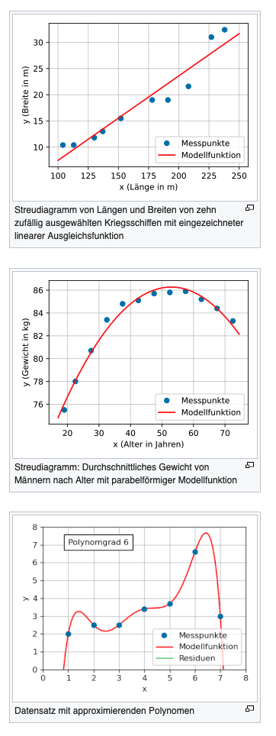
2) Run with the same data set introduced in the handout, what is the output? Is the output as you expected? (3 points)
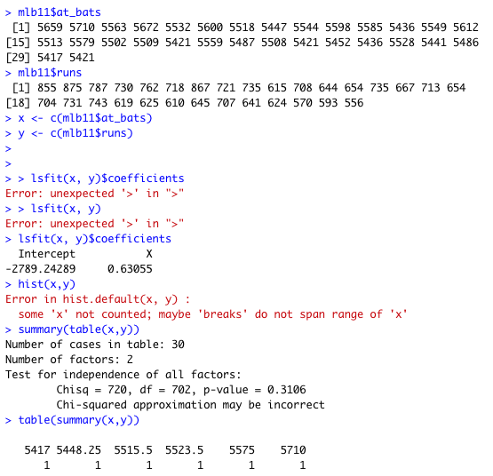

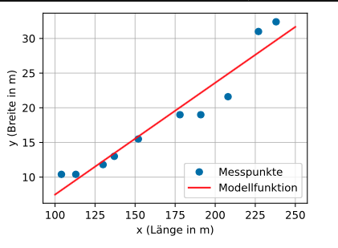

https://i.stack.imgur.com/eYEpL.gif

3) If you know a different language/application/software, what is the commend (or function) that does the SAME THING in that language/application/software? Now run with the same data set from above, What is the output? Is the output the same as the one from R? (4 points) So with python being my second programming language but definitely my favorite there is a very simple formula in python to take a list of numbers and run a least squares regression upon them.

4) Compare with questions 2) and 3), for this command (or function), which language/application/software would you prefer to use? Why? (3 points)
5) Reply to AT LEAST TWO other students for "comments" in a meaningful way. (2 points)

