Azure data factory etl with Blob and S3
Part 1: Create and link S3 into azure data factory,
One of the greatest features of azure data factory its it’s capacity to source data and sink (only through data flows, copy doesn’t work for s3) into s3 buckets. Allowing a simple and out of the box capability to work multicloud and leverage the advantages of s3 within azure. Start by creating your aws account and creating an s3.

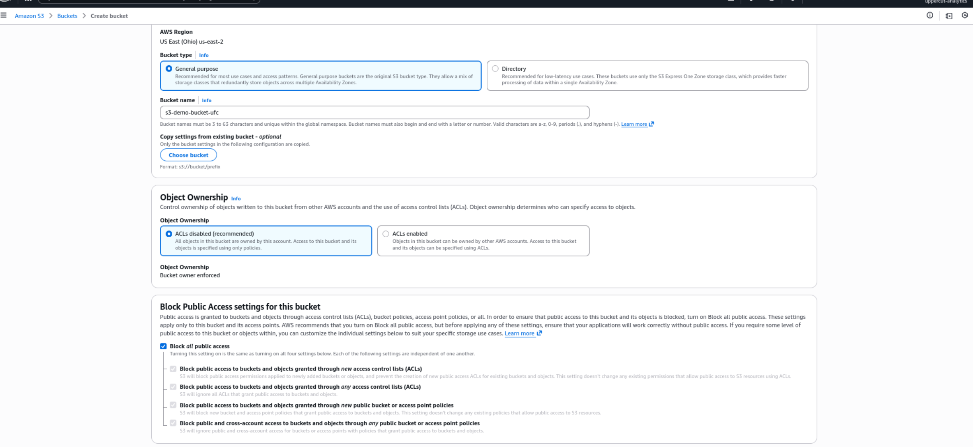

Make sure you don’t allow public access unless you strictly need it, by creating an Iam role and group, you’ll be able to access it from adf seamlessly. Then go ahead and create a iam grou and add AmazonS3fullaccess policy. I’m sure aws champions should be able to define a least access policy for it, but for the general project this one works.

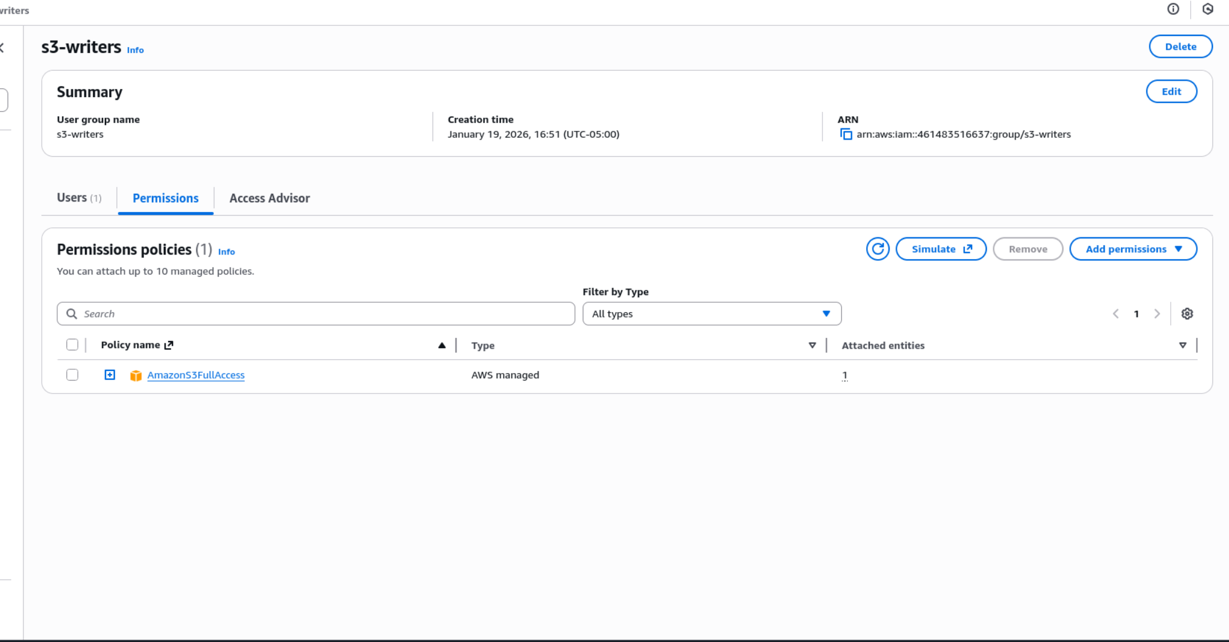

Proceed to create the s3 user and add the s3 memebership to it, int his case the group is called s3-writers and the user azure-data-reader.

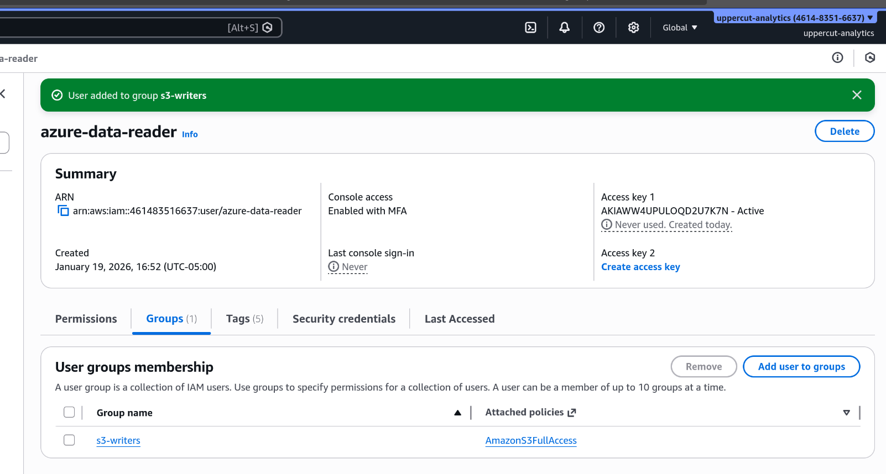
Within your iam user/security credentials, scroll down to access keys and create an access key that will later be used on the linked service for the adf.

Pro tip: Use temporary security credentials instead of access key, I didn’t do it in this tutorial since I wanted it to strictly keep it simple however its better since you don’t retain a hardcoded key for that long.

Then once you have created your data factory, launch the studio, and go straight to Managed, Linked Services and create the link service to amazon s3
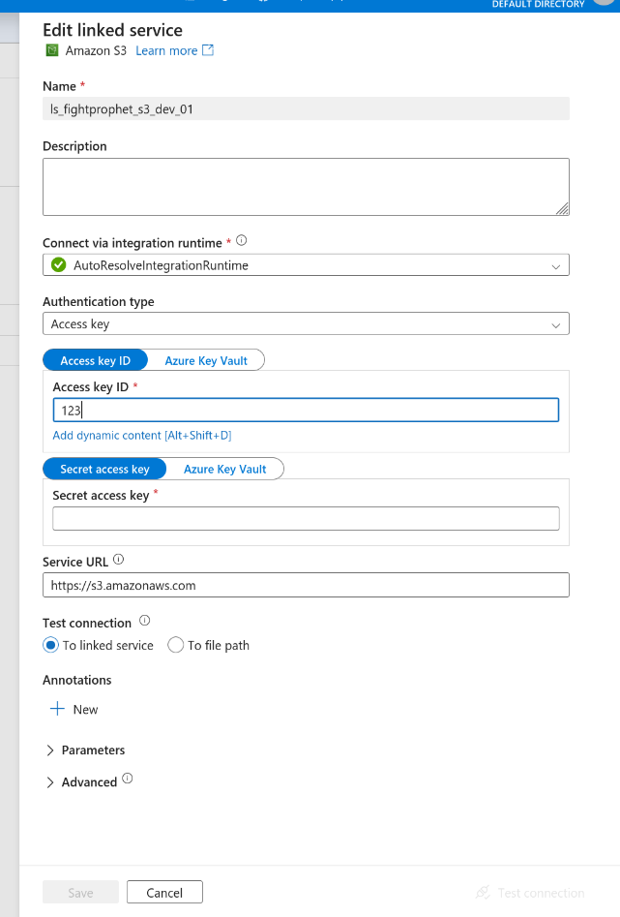
In here, you will copy and paste the access key and secret access key you’ve previously gotten from your aws iam user. You can specify the linked service to all the buckets the iam user has acces to , or specify a file path and give it the bucker/directory where to connect if you want to be more specific.

Part 2: Create the azure storage and link it to adf
The order does not affect the product so feel free to start with part 1 or part 2, you now should create your azure storage, ideally you’ll create a vnet, a private endpoint for the blob and then another private endpoint from the azure data factory into the azure storage and approve it, but for the sake of the exercise I created a public azure storage (not recommended) and only limited it with allowing access only from my public ip. This is a lot cheaper however since you’ll not pay for vnet manteinance and vnet outbound/inbound traffic but if your data is highly confidential make sure to follow the vnet creation process and ideally create a firewall or nsg rules to further enhance its security. I will attach a bicep file.

Bicep file

For the linked service you’ll have a few ways to do it as you see below.
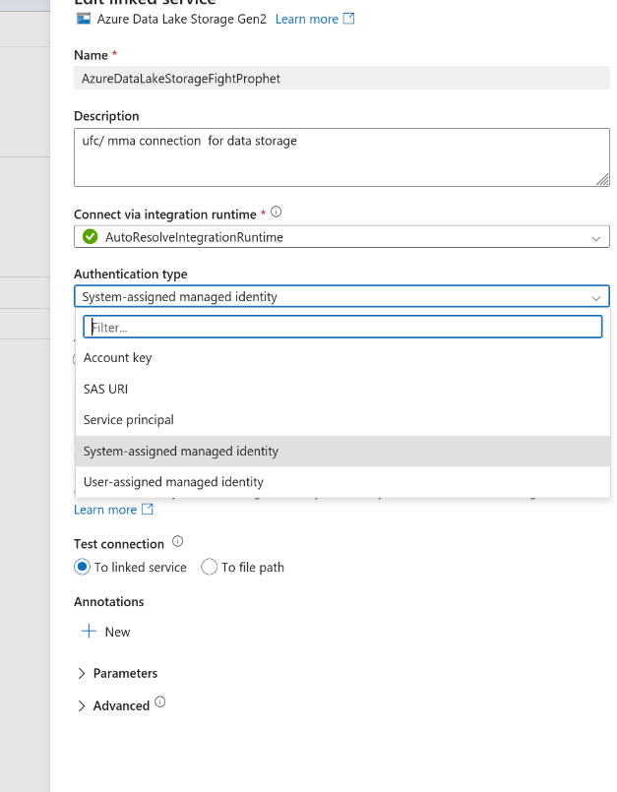
However I recommend you to create it based on System-Assigned managed identity since it will allow you to later disable access key on the storage and maintain a passwordless conneciton between the two. You can go to adf, managed identity and system assigned / user assigned identity, you can turn on system assigned identity and copy the object principal. Which then you’ll use to give it iam access as storage blob data owner to keep it least privilege. Then you can proceed to use that authentication type and test the connection on the linked service within the adf, it should go through.

Part 3 Datasets and Pipelines, the fun part.
Once you have created your storage resources and stablished the linked services, we should go ahead and create a pipeline I will create one pipeline using the two move and transform native adf options. Copy data and data flow. Let’s start with the simplestone, copy data. The goal of this is to get all files from the s3 folder which contain separate dates for ufc events, and merge them.
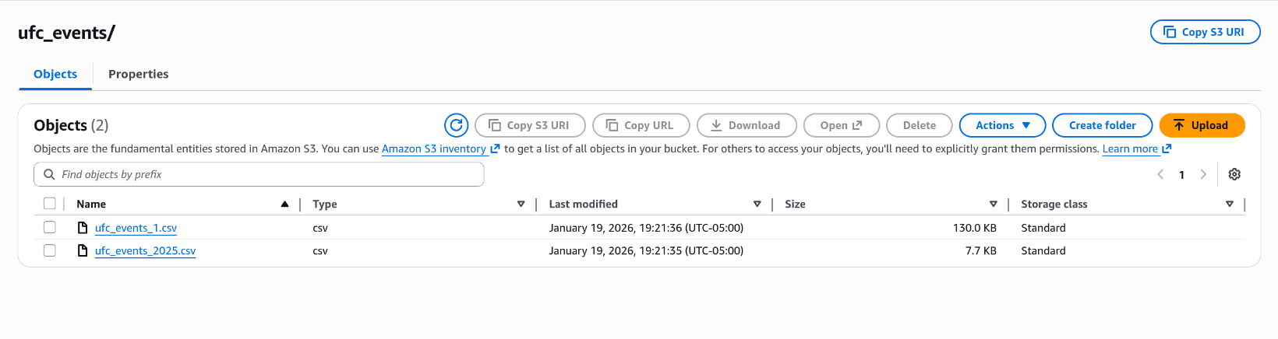
You can either create the dataset before hand or create it in the process, from within author, datasets click on the three dots and create a new data set. It will ask you to select from a series of non azure and azure option and you can go ahead and select Amazon S3. Since the goal is not to point to a specific file but to all the files in the folder, you’ll select the bucket/the folder/ leave file name empty. Int this case, for simplicity I used csv’s but if you’re going to use it for analytical workloads Parquet might be a better option due to its columnar storage and precision.

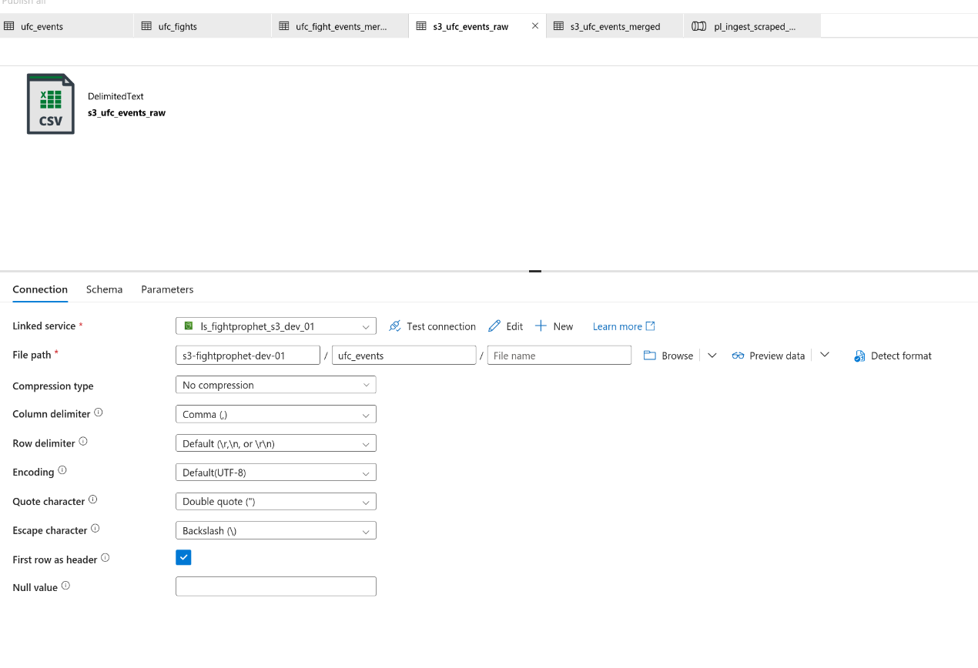
With this you created the source dataset, now you’ll create the sink data set, in azure data factory sink works as a synonym of target dataset, meaning any transormation or copy process you do here, will be targeted into a sink location. Since we’re pulling from (source) s3 and targeting the blob storage now we’ll create the sink dataset. Which we’ll call blob_ufc_events_merged. IN here, pretty much follow the same process, create a new data set, but in this case use the link service we previously created for the storage. The main difference will be that the file path will include the blob/directory/file.csv because int his case you don’t want to point at all the folder files but actually create an specific file. The file pointer you give it will create the file name and the extension you give it as well.
Once you’ve created both data sets you can proceed to drag a nd dorp the copy activity. From general, you can set a name to it and a description, as well as a retry interval, and if your data is sensitive, you can check on secure output and input. Then from source, you’re going to select the data set we created before for the s3, and here comes the tricky part: instead of selecting from file path in data set, you’ll select a wildcard file path, so the copy action actually selects all the csv fileswithin the ufc_events folder in the s3 bucker. The wild card pattern follos the *filetype format. So in this case is *.csv but if you were to have parquets it would be *.parquet

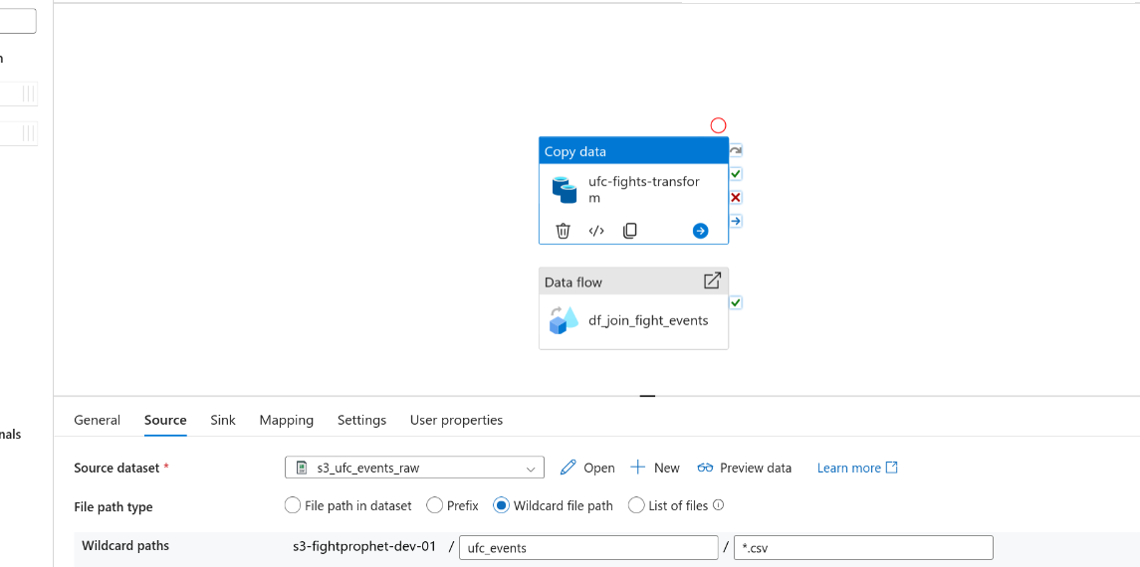
Then as we just mentioned before, the sink (target) file from here you’ll select the blob data set and here’s were we will select the copy behavior that will allow us to merge the files. There’s 3 main copy behaviors

1) PreserveHierarchy (default):
Meaning: Keeps the same folders + subfolders exactly like the source.
Source:
ufc_events
├─ pride_events.csv
└─ ufc_yearly_events
├─ ufc_events_1996
├─ ufc_events_2000

Target:
ufc_events
├─ pride_events.csv
└─ ufc_yearly_events
├─ ufc_events_1996
├─ ufc_events_2000

2) FlattenHierarchy
Source:
ufc_events
├─ pride_events.csv
└─ ufc_yearly_events
├─ ufc_events_1996
├─ ufc_events_2000

Target:

ufc_events
├─ufc_events_1996
├─ufc_events_2000

3) MergeFiles

Meaning: Copies everything into one single folder level (no subfolders).
Files usually get auto-generated names.

Source:
ufc_events
├─ pride_events.csv
└─ ufc_yearly_events
├─ ufc_events_1996
├─ ufc_events_2000

Target:
ufc_transformed
├─ufc_events_merged.csv

In this case, we’ll go with merge files since this is the goal of the copy data.
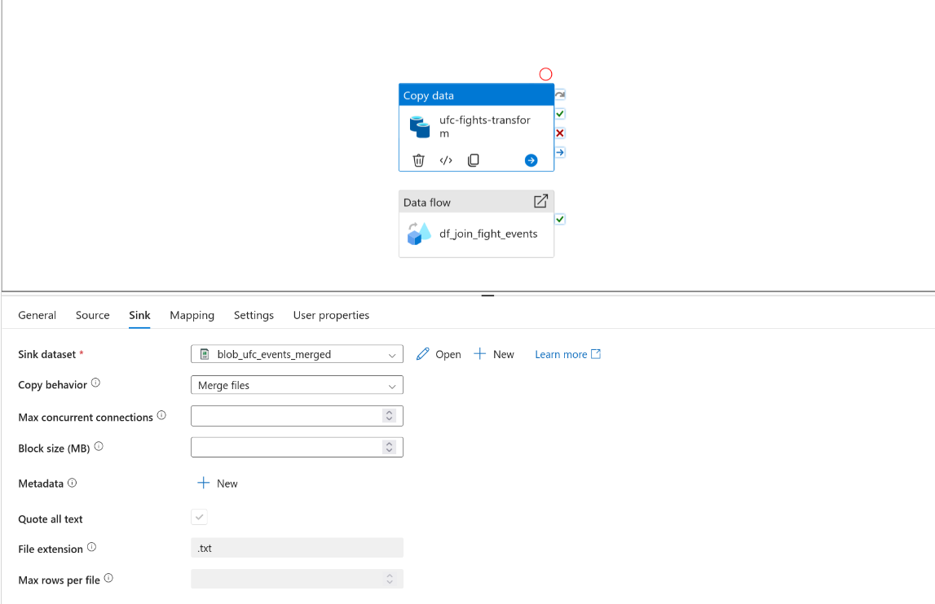

As shown on the sink image, you can also decide the max concurrent connections, copied directly from azure “The upper limit of concurrent connections established to the data store during the activity run. Specify a value only when you want to limit concurrent connections.” so if you leave it empty it will not create any limitations. This setting let’s you cap the parallelism to prevents hammering your destination storage, since it might then start responding slower or throttling, in case you’re running multiple pipelines to the same file you might want to create a limit here.
You can also limit the block size between 4 and 100 mb. Finally on other relevant sink properties, the metadata box is for adding custom key/value tags into the output file, specially on blob storages or file based storages, you can add data base to the file like source = ufc_reader load_data = 2026-01-19 env = dev , etc. It doesn’t change the file contents, they’re stored as file/blob metadata in the storage system. Even if your file extension here is .txt, if you define the .csv on the sink data set it will overwrite the .txt file extension to csv. This is pretty much it, you can add a trigger,

Pro tip: Create replicated tags across both clouds so you can later build finops dashboards.

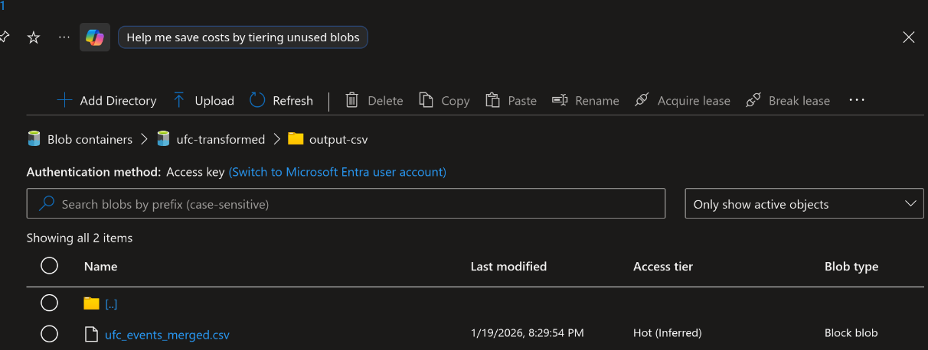

Dataflows, performing a left join:

Even though copy data activity is useful, its a very basic command that the most advanced transformation it does is appending, other than that it only works for moving and copying data from one place to another. If you want to do more advanced etl techniques you’ll have to use a dataflow. You’ll go ahead and drag and drop it form the move and transform group and create it in details from the dataflows page. In this scenario, we want to perform a left join on an ufc fights data set, which only contains event_url and is missing event_date for the fights. For that, we’ll create two new datasets, in this case we’ll pull them from blob storage as we’ve learned before how to do it, and we’ll add it as sources into the data flow. This will create to parallel paths, that will allow us to add new actions into each data source. The first thing we’ll do is set all the variable types we need before hand to make sure the merge works, since merge will only work if the data variables (columns) are the same type.

We can do so from selecting the data source and going to projection, from there you’ll be able to set the variable types.
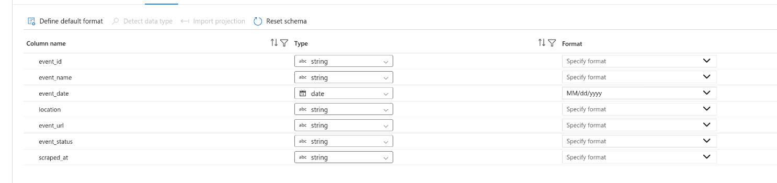
Secondly , since this is a left join we don’t want to add existing columns or unecessary columns from ufc events into ufc_fights , that’s why we’ll add a select action, and click on the trash can to remove all the columns that are not relevant for the left join.

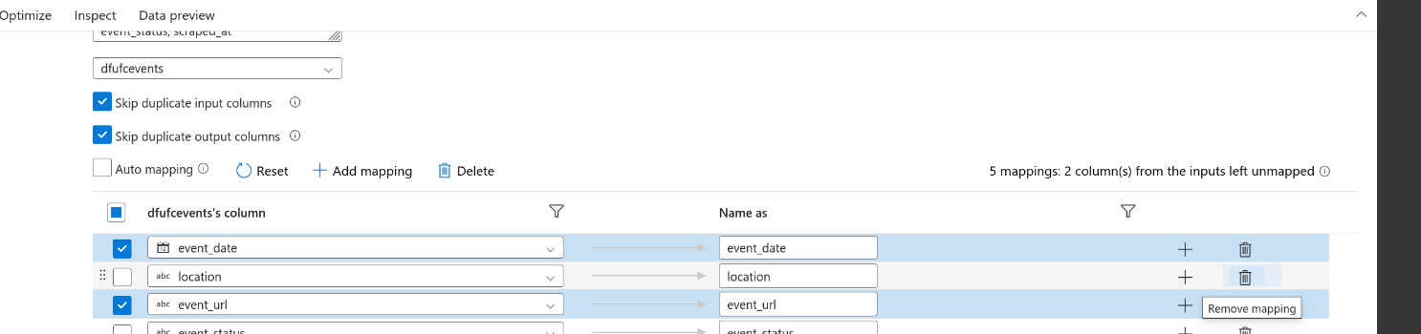

Once that’s done, we’ll proceed to add a join action following the ufc_fights datasets, since that’s the base table we want to left join to we’ll add the join from there . We’ll choose join type, left outer, and on the left stream keep the ufc_fights data set, then on the rights trema, we’ll use the select data set. Make sure not to select the source or your’ll merge all the original columns.
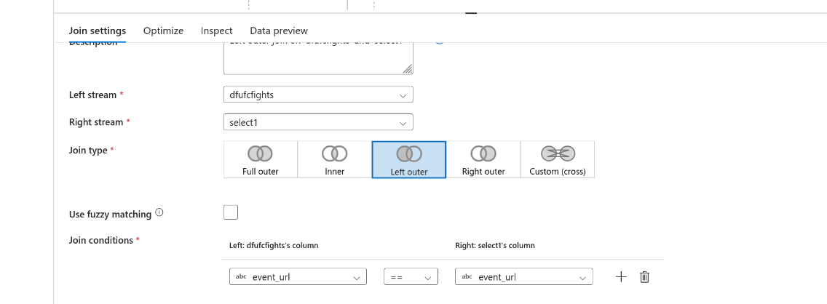

Finally you’ll add a sink action right next tot he join, select the sink type data set, and select the sink data set, which we should have define before hand, as the destiny of this. To make sure you can create empty data sets to use as targets for sinks, you’ll make sure not to parse any schema to them so the schema is parsed at the time of creation. To deep dive into the sink type options available,

1) Dataset (most common)
Meaning: Write your output to a real destination you’ve already defined (like S3, Blob, ADLS, SQL, etc.) as we jus did here.
2) Inline

Meaning: You don’t pick a dataset — you type the location/settings directly inside the sink step.

Use this when:

you don’t want to manage datasets

you want a quick one-off output path

you want dynamic paths without creating datasets

3) Cache
Meaning: Doesn’t write to storage. It stores the results temporarily so other steps in the same Data Flow can reuse it.
Use this when:
you want faster joins/lookups later in the same flow
you reuse the same output multiple times
you’re optimizing performance

Another important property is Schema drift (Allow schema drift)
This is about how strict ADF should be about your column structure.
Allow schema drift = ON (what you have)

Meaning: Your columns can change and ADF won’t break.
It will still pass through “new” or “unexpected” columns
Allow schema drift = OFF

Meaning: The schema must match exactly what ADF expects.
If a column is missing or new → the job may fail or drop columns depending on your mappings.
Use this when you need strict consistency (like writing into a database table with fixed columns).

Bonus:
You can connect your adf to your repo, so you can follow best ci/cd practices on it. From the adf studio, click on git configuration, and add the repository type, you can choose between azure devops repo and git hub repos.

